Networking Programmability
Assignment 2
Correy Heard

Table of Contents
Scope 2
Snippet 1 2
Snippet 2 2
Snippet 3 2
Snippet 4 3
Snippet 5 3
Snippet 6 4
Snippet 7 4
Snippet 8 4
Conclusion 5
References 6

Scope
Within this assignment I am going to be creating a python application that uses RESTful web service to GET data from the REST API and be able make them readable to the user, to make this readable to the user I am going to be using Discord which is an online messaging service [1]. The REST API I am going to use for my application is Coin Ranking which is an API for crypto currencies this allows me to give the user information about the top cryptocurrencies, with getting this data I made an alert system for the online messaging service so that the user would get hourly updates about the changes within the crypto currency market this contains the price and change of currencies.

Snippet 1:
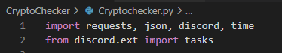
This screenshot shows me importing Libraries this allows me to use the pre-compiled methods, this allows me to do more within my program without needing to write the code that has been pre-made.

Snippet 2:
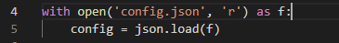
I made an external json file to store data that could be considered sensitive data this file holds API keys which gives access to accounts, so I put it in a separate file so it not hard coded within the program also it allows for ease of changeability.

Snippet 3:
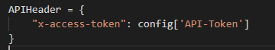
While making the program I used a v1 API but during the development stage the API I used decided to update to a v2 API which required me to change my code to facilitate these changes, to do so I just created a header for my request and changed the URL to be using v2 instead of v1.

Snippet 4:
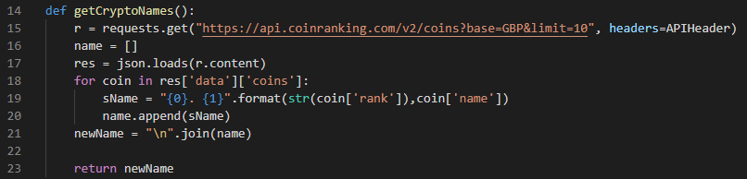
This is my getCryptoName function this gets all the names for the top 10 crypto-currencies, to do this I started with a simple request to the API once I made the request, I made a loop to run through all the crypto-currencies after this I formatted the string and appended it to an array once it was in the array, I made the array into a string so it will be suitable for the Discord API embed.
This is the format that I made the data, I made sure it could be readable by the user.

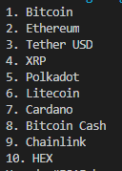

Snippet 5:
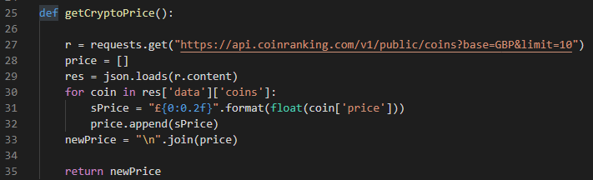
This getCryptoPrice function has similarities with the other 2 functions but this one specifically uses API v1 instead of API v2 this was because the API I was using didn’t support other currencies and only supported USD during the time of the development, So due to only recently the API provider upgrading from v1 to v2 I decided to keep with v1 to be able to get access to GBP prices, In the future when they support GPB on the API v2 I will make changes to make sure that my program functions with the update.

Snippet 6:
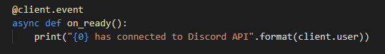
Using the Discord Library, I created an on_ready event in which it will print out that the bot has connected to the Discord API, this allowed the user to know that the bot was active and functional so that the user did not need to check or wait to see if the bot was online manually, this can be useful when the bot is running on an host because it means that you know its on without needing to double check.

Snippet 7:
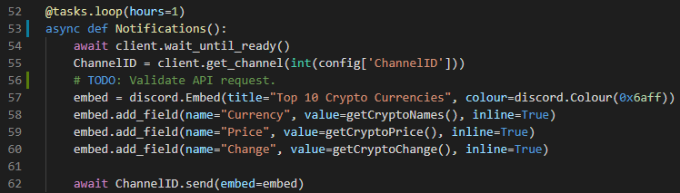
Using the Discord Library and Tasks, I was able to create an automatic alert that will be run every hour to give updates on the crypto-currency market, this uses Embeds within the discord library to make it stand out within the channel, to make this send within a specific channel I needed to define the channel id this allowed me to be able to send a message to the specific channel.

Snippet 8:
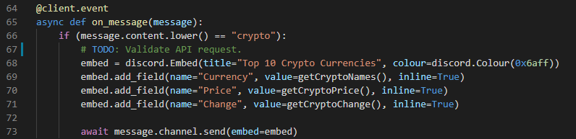
Using the Discord Library, I created a on_message event this registers all the messages that the bot has access to, then I made an If statement so if someone were to type “crypto” it will give the top crypto-currencies I used the Discord Library to create a embed this allows me to format the message sent to the channel so I can make it stand out within the channel. The results of this code can be seen below.
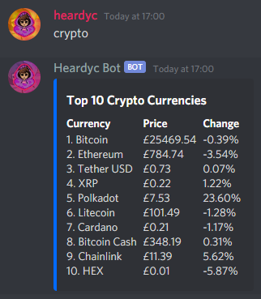

Conclusion
Overall, my development on the program was really good, I did have minor problems which I resolved one of my problems was with the API data, once I created a function to get the data it only allowed me to get one piece of data so I got more of the data by making an array that would hold the data and then converted all the data from the array into a string and then returned it through the function, another problem I encountered was with the API itself during the development of the API had been updated to include more security and more data, so I needed to adapt to these changes and change my code to make sure it functioned with these updates, once I completed that my program ran smoothly and everything was working.
In the future, I think that I would add some more commands to get more information from the API such as getting data about a specific coin, for example, the user could request data about a coin through discord and it would show more data about that specific coin like the market cap, charts, all-time high, and maybe support multiple currencies such as USD, Euro, etc. Another feature I would like to add within the future is alerts on when a coin or a market crashes or when it launches up this can be good to know if you were an investor.

References

[1] | Discord Inc , “Discord,” [Online]. Available: https://discord.com/. [Accessed 12 2020].

