Target 1 | Engage in wider and deeper background reading to ensure greater support from academic literature.
Target 2 | Provide supported counter arguments for recommendations made and critically evaluate aspects to be cautious with.
Target 3 | Ensure that the Harvard referencing guidelines are followed in detail.

A critical analysis and evaluation of the observation research tool, ‘Leuven Scale’

How do Teacher incorporate Emotional and Mental Well-Being Throughout the Classroom?

Introduction

The foundation phase is a key stage within a school associated with children aged three to seven. The foundation phase allows practitioners and teachers to help children with their development and key learning skills. Children within the foundation phase are encouraged to express themselves in different ways through the aspect of play. They are given the opportunity to strengthen and begin to develop their reading, writing, listening and understanding skills throughout this time. Throughout the foundation phase imagination and creativity is a focus as it aids personal development for each child within the setting. Children learn from one another throughout this setting as they all experience different environments beyond of the classroom. (Smith, 2022)

Emotional and mental well-being carries an importance throughout schools as it helps children flourish, it ensures that pupils are well supported and engaged throughout their school day. Lots of children aren’t aware of mental well-being and this could cause them to develop future negative mental health problems. COVID-19 has had a massive impact on the mental well-being of children due to their time away from school throughout lockdowns where they were also unable to visit family and a time where they also had very limited resources to things that could have helped with their mental and emotional well-being. In 2004 one in ten children developed mental health and well-being difficulties and since then there has been a considerable increase where in 2020 one in six children developed mental health and well-being difficulties. (Robson-Kelly, 2022)

Literature Review

There are many different strategies that different schools and classrooms use to aid well-being, some are helpful, but others aren’t. Encouraging children to think about how they feel and helping them understand that one day they feel different to the previous day helps them further communicate and discuss their emotions. Social media and technology are a large cause of well-being difficulties, as much as they are a positive to society, they are it’s as much of a negative to children and young people. (NSPCC Learning, 2021)

The foundation phase is all about aiding children through the aspect of play and exploring. Learning through play and practical experiments allows children to have free and independent choices throughout the classroom. The foundation phase curriculum allows children to achieve their learning and personal development at their own pace. (Foundation Phase Framework Curriculum for Wales, 2015). Play is an important form of growth and development for children. Children always develop holistically throughout play where they can learn methods of communication and problem solving. Play also supports the six areas of learning through forest schools and lots of other classroom activities and areas. (Information for parents and carers. How is my child doing in the Foundation Phase? n.d.)

Well-being is one of the main focuses throughout the foundation phase for active and independent learners. It provides an opportunity for children to express how they may be feeling whilst practitioners use their abilities to incorporate well-being throughout their classroom environment. Practitioners are required to use a variation of the twelve pedagogical principles to have a positive impact and interaction with children’s learning which will aid their well-being (Maynard, Morgan and Waters, n.d.).

It is important for the areas of learning to be planned and incorporated throughout the classroom environment so that children have a balanced, wide range of learning which links throughout the curriculum. Using the areas of learning encourages questioning, thinking and conversations which will further widen children’s knowledge and understanding. Throughout the foundation phase there is an abundance of pupil led learning where the children are given the independency to encourage themselves and complete activities which will aid them and test their abilities using the different experimental areas throughout the classroom and outdoor area (Focus task – involves direct teaching, n.d.).

Positive learning outcomes are vital goals throughout the classroom ideas and activities, where the children’s creative minds are widened and individual to them. Children encourage themselves and present their own ideas through their creative minds and expression. Creativity has a large input on children’s well-being as it is a source of individual expression for the child where they can use the indoor and outdoor areas of the classroom to make their own decisions and free choices. Critical thinking and problem solving are essential skills for children within the learning environment to evaluate and understand information and create their own connections across the areas of learning (Donaldson, 2015).

For children to become more independent and confident a method that is used throughout many schools is the self-register boards. These allow children to self-register, they put their name or a picture of themselves under the emotion that they are feeling that morning which allows the practitioner or professional teacher to communicate with that child. The board being on display within a classroom allows child led conversation with their peers about how they may be feeling and assures them that they all also have someone to talk to aid their well-being throughout the classroom (Corwen Day Nursery, n.d.).

Estyn reports show that many practitioners can’t understand the practices throughout the foundation phase which is causing negative well-being outcomes for children. However, they do state that “in a majority of schools” the wellbeing of children within the foundation phase is positive due to a focus on literature and reading. The well-being of children in the foundation phase can have a large impact on them throughout their education. Child initiated outdoor learning is a positive thing for their well-being as there is a form of enjoyment and participation. Some schools have reported that “children’s behaviour and attendance have also benefited” from outdoor learning environments within the foundation phase. In many schools there are no available resources to provide an outdoor area which can limit their learning enormously. (Literacy and the Foundation Phase, Estyn, 2011)

Methodology

Knowing that well-being is a focus throughout the foundation phase using the Leuven scale as a tool to observe children ensures that it is a top priority. The Leuven scale is a numerical scale from one to five to measure a child’s progress and emotional state. The Leuven scale has many advantages and disadvantages. One of the disadvantages being that the Leuven scale may limit the observation outcome and it doesn’t consider possible uncertain information about the child which can have a large influence on the outcome. One of the main advantages is that the Leuven scale allows the observation to be a focus on a certain child and their learning (Learning Journals, 2021).

To begin my observations, I designed an observation sheet that didn’t limit my observations by including an additional comments section so that if there was anything outside of the observation that I felt may be relevant there was a section available. Using my observation sheet, I was able to use the Leuven scale as a tool to effectively produce an appropriate well-being and observation outcome. I planned to complete a varied number of observations to ensure that I had found the relevant information that I needed for my research. I planned to observe several different children and different activities to aid my research and ensure that I was able to produce a detailed and informative observation.

I planned to complete my research as a non-participant observatory. Which is a research technique whereby the children are aware of someone being present but there is no involvement throughout the activity by the researcher. When researchers are present it can sometimes have an impact on a particular child’s behaviour which will then negatively influence the observation and other children within the small group (encyclopedia, n.d.)

Discussion and Findings

Aiming to be ethically respectful might affect the environment within the classroom and in this case possibly impact research and observations. Veronica (2020) explains that ethics require a lot of patience and understanding as all students are different and they all require different things. Carolyn Blackburn (2015) describes that consent has no age, hence why researchers are at an ethical uncertainty. Consent is dependent on what a child has previously been through within their growth and development. Most children are happy to make their own decisions throughout their day where they may for example remove themselves from a situation that they find uncomfortable. When children notice that there is a researcher present, they may change the way that they normally act or may lose their confidence throughout what they are doing.

Throughout my research and planning, I was required to use the ethical guidelines to ensure that I was respectful to all participants. I ensured that I was mindful throughout my observation and ensured that I only provided the necessary information throughout my observation sheet. I ensured that I was open and honest throughout my research and ensured that there was full confidentiality of any pupil names, genders or religions throughout my work (British Educational Research association, 2019).

Observations are made daily within learning environments where they allow teachers and practitioners to gather information regarding a child’s ability and progress. All children have their preferred learning method or style, and observations allow teachers to identify and assess how successful those methods are. (Department for Children, Education, Lifelong Learning and Skills Observing Children, n.d.). There is various information that teachers record to ensure they gather the relevant information to investigate the progress and ability of children. Observations allow many achievements for teachers, parents and children. Observations allow teachers to help growth throughout development and several different skills, Observations “are about getting to know each child, and what that child needs” (Bruce, Louis and McCall, 2015).

To complete my observations, I observed a small group of learners in the garden. The garden was surrounded by different areas much like the classroom, there was a mud kitchen filled with kitchen essentials and a wide-open area for children to run around and explore. Outdoor learning gives children an opportunity to explore and discover new things. They can use their creative mind in a free and open environment which allows them to be expressive.

I choose to observe a small group who were “digging for treasure” in the garden. They were provided with shovels, buckets and wheelbarrows to help them with their activity. The children were encouraged by the class teacher to work as a team to find the treasure. The four children split into areas around the outdoor space. Pupil one was struggling with the activity on the grounded area that he was in; he was unable to do it and began to get frustrated. Pupil three explained to him that the ground in that section was too hard to shovel. Pupil one then moved himself after thinking about his approach to the previous situation and was able to use the shovel very well in a different area of the garden. Pupil two was unhappy working within a group and was completing the task alone, but again once Pupil three communicated to him that it was a group activity and he understood that he couldn’t work alone and that he was required to help his team members. Not only did Pupils one and two struggle to understanding the activity but they were able to learn how to overcome their problems by learning from a different pupil. Pupil3 was able to communicate with the other pupils and help them understand what was required of them, which overall impacts all the three learners as a collective. It also presented that children help one another with well-being throughout the classroom and learning environment.

After using the Leuven scale as a tool for this activity, I was able to score each child differently on the scale. However, the pupils place on the Leuven scale was in a different place at the beginning of the activity compared to the end of it.

Conclusion and Recommendations

The research days allowed me to observe the different areas and activities within the classroom environment. I was given the opportunity to observe several small groups and understand how well-being is promoted throughout the foundation phase. I was able to observe the different areas of play and have an insight on the popular activities within the classroom and garden area. I learnt that well-being is not only teacher led but also pupil led which benefits children’s learning and abilities to understand certain situations within the classroom environment. They are able to communicate different ideas and worriers with their peers and develop new ideas from each other. I also learnt that the different areas within the classroom help aid children’s well-being, the different areas meet the needs of different children and their interests. Children enjoying trying new things, but they also enjoy doing things that help them be expressive which opens their minds to different things.

There were many ideas within the classroom that I will thinking about throughout my future in teaching, one of these being free choice. Throughout the school that I visited free choice was widely encouraged and the children had many choices of things that they would like to do throughout that school day. There were several different areas within the classroom which gave pupils independence and an opportunity for communication with their peers which overall promotes well-being in a subtle way.

Word Count- 2,197

References

Blackburn, C. (2015) ‘Researching with young and developmentally young children: Ethical considerations, dilemmas and compromises’ [blog]. 22 June 2015. Available at: https://www.bera.ac.uk/blog/researching-with-young-and-developmentally-young-children-ethical-considerations-dilemmas-and-compromises
(Accessed: 15th of February 2023)

British Educational Research association (2019). Ethical guidelines for Educational Research, fourth edition (2018). Bera,ac,uk Available at: https://www.bera.ac.uk/publication/ethical-guidelines-for-educational-research-2018-online

Bruce, T., Louis, S. and McCall, G. (2015). Observing Young Children. https://dx.doi.org/10.4135/9781473910225

Corwen Day Nursery. (n.d.). Personal and social Development, Well-being and Cultural Diversity. Available at: https://corwendaynursery.co.uk/the-foundation-phase/personal-social-development-well-cultural-diversity/

Department for Children, Education, Lifelong Learning and Skills Observing Children. (n.d.) Available at: https://s3-eu-west-1.amazonaws.com/hwb-live-storage/a8/9c/a8/ee/f299432c801d025d875da415/observing-children.pdf

Donaldson, G. (2015). Successful Futures Independent Review of Curriculum and Assessment Arrangements in Wales. Available at: https://www.gov.wales/sites/default/files/publications/2018-03/successful-futures.pdf

Encyclopedia (n.d.). Non-participant observation | Encyclopedia.com. Available at: https://www.encyclopedia.com/social-sciences/dictionaries-thesauruses-pictures-and-press-releases/non-participant-observation

Focus task -involves direct teaching. (n.d.). Available at: http://www.ysgolcarrog.co.uk/index_htm_files/Developing%20Foundation%20Phase.pdf#:~:text=Therefore%20in%20theFoundation%20Phase%20there%20needs%20to%20be,curricular%20areas%20e.g.%20writing%2C%20reading%2C%20numeracy%2C%20welsh%2C%20creative%2C
(Accessed: 16th of February 2023)

Foundation Phase Framework Curriculum for Wales (2015). Available at: https://www.gov.wales/sites/default/files/publications/2018-02/foundation-phase-framework-revised-2015.pdf

Information for parents and carers. How is my child doing in the Foundation Phase? (n.d.). Available at: https://www.gov.wales/sites/default/files/publications/2019-07/how-is-my-child-doing-in-the-foundation-phase-a-guide-for-parents-and-carers.pdf

Learning Journals (2021). What is the Leuven Scale and How to Use it. Learning Journals. Available at: https://learningjournals.co.uk/what-is-the-leuven-scale-and-how-to-use-it/

Literacy and the Foundation Phase. An evaluation of the implementation of the Foundation Phase for five to six-year-olds in primary schools, with special reference to literacy. (2011). Available at: https://www.estyn.gov.wales/system/files/2020-07/Literacy%2520and%2520the%2520Foundation%2520Phase%2520%2520-%2520September%25202011.pdf

Maynard, T., Morgan, A. and Waters, J. (n.d.). The Teaching and Learning Research Programme in Wales: The Foundation Phase. Available at: https://www.gov.wales/sites/default/files/statistics-and-research/2019-09/101206-foundation-phase-briefing-en.pdf#:~:text=The%20Foundation%20Phase%20Frameworki%20emphasises%20a%20practical%2C%20experiential,diversity%20are%20at%20the%20heart%20of%20the%20curriculum.
(Accessed: 15th of February 2023).

NSPCC Learning. (2021). Promoting metal health and well-being. Available at: https://learning.nspcc.org.uk/child-health-development/promoting-mental-health-wellbeing#article-top

Robson-Kelly, L. (2022). Mental health in schools, improving wellbeing of pupils and the whole school. Available at: https://www.worthit.org.uk/blog/school-mental-health-wellbeing-important#:~:text=Good%20mental%20health%20and%20wellbeing%20is%20essential%20for,the%20mental%20health%20and%20wellbeing%20of%20their%20students.

Smith, P. (2022). What Is Foundation Phase In Wales | Historic Cornwall. Available at:
https://www.historic-cornwall.org.uk/what-is-foundation-phase-in-wales/#:~:text=Foundation%20phase%20is%20a%20key%20stage%20in%20the,pupils’%20creativity%20and%20encourage%20them%20to%20think%20critically.
(Accessed: 17th of February)

Twimkl.co.uk. (2023). Available at: https://www.twinkl.co.uk/resources/english-medium-schools-welsh-primary-resources/foundation-phase-welsh-primary-resources/health-and-wellbeing-foundation-phase-english-medium-schools-wales-cymru
(Accessed 17th of February 2023)

Veronica (2020) ‘What are ethics in education’ Ethics in Education [blog]. 08 January 2020. Available at: https://www.eln.co.uk/blog/what-is-ethics-in-education#:~:text=Ethics%20in%20education%20helps%20run%20the%20system%20smoothly.,them%20to%20influence%20their%20personal%20development%20and%20behaviour.
(Accessed: 15th of February 2023)

Appendices

Professional Reflection

- Describe ONE of the observations you carried out. What did you learn from it?

Throughout the school there was a very wide focus on pupil voice, and it was decided that topic books and classroom exercise books were not popular among the pupils. The pupils decided they would have inquiry books. These were large A3 size books where the children displayed their work regardless as to whether it was a mathematics topic or English the pupils added their work throughout with no theme or order. They were able to present their work as they wanted which encouraged many of them to complete the work more, they were excited to complete the book at the end of each day and always looked forward to it throughout the day and thought about how they wanted to present the book.

I was able to observe the children completing their inquiry book at the end of the day and I focused on one pupil who was very happy and excited to show his work and presentation to their teachers and classmates. His well-being was high, and he looked forward to learning new things and presenting them neatly.

I was able to learn different techniques of presenting work for pupils, they were able to make their own decision, I learnt that the decision isn’t always down to the teacher and that children must have a voice within their work and how they may want to show and present their work. Inquiry books allow children to use their creative minds and make individual decisions.

- What were the challenges and opportunities of being a non-participant observer in the classroom?

There were many challenges being a non-participant observer as I was unable to ask the pupils question throughout the task or activity, if a pupil was struggling or if I was curious as to what they were doing I was unable to ask further about what they were doing. However, the opportunities allowed me to view the situation without an interruption, the pupils were able to be comfortable in the learning environment and complete the task as they seen appropriate. Some pupils may have acted differently with a new face being present and all the pupils were asking me different questions which challenged my observations as there was a distraction among most of the pupils.

- In your experience, what were the benefits and limitations of the Leuven Scale as a research tool?

I believe that there were both positives and negatives to the Leuven scale. The positives to the Leuven scale focus on a specific child through an observation. However, the Leuven scale as a tool doesn’t allow explanations for a child, all children have experienced things differently in their lives to that point. All children go home to different houses, environments and family but they are all ranked based on a five-scale tool. There are several different things that can massively impact a child’s well-being, behaviour and general attitude.

- What were the main points of learning for you in terms of being a researcher in the classroom?

Being a researcher in the classroom, I learnt the importance of observations within the classroom environment for children. There are a number of benefits of observations within the classroom. Observations aid children’s well-being, growth and development. Different learning methods and activities work for different children, it is the role and responsibility of the teacher to help that child throughout. The teachers within the classroom ensured that they knew each child as well as they could and ensure that there was a learning method that suited each of them.

- What would you do differently if you were to conduct this research again? Why?

If I were to conduct this research again, I would allow more time. Although I had plenty of time throughout the two visit days, I found that some pupils saw me as a distraction which didn’t allow me to be a full non-participant observer, I believe that I would have completed more detailed observation if I had an extra day to complete more observations, which would have possibly allowed the pupils to be familiar with an observer being present, allowing them to behave normally.

- Discuss any other methods of research you could use in the classroom to improve your practice. What are the positives and negatives?

The Outdoor/Garden Area
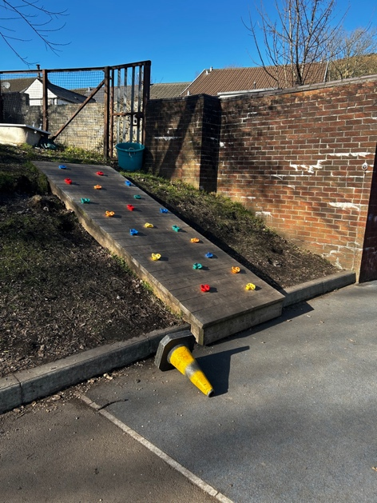
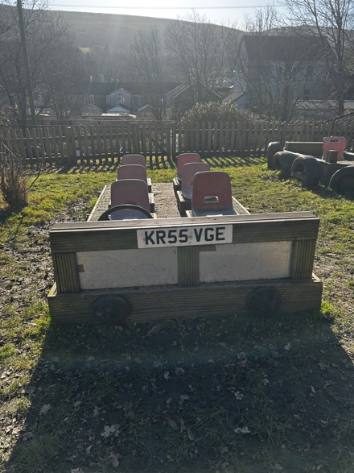

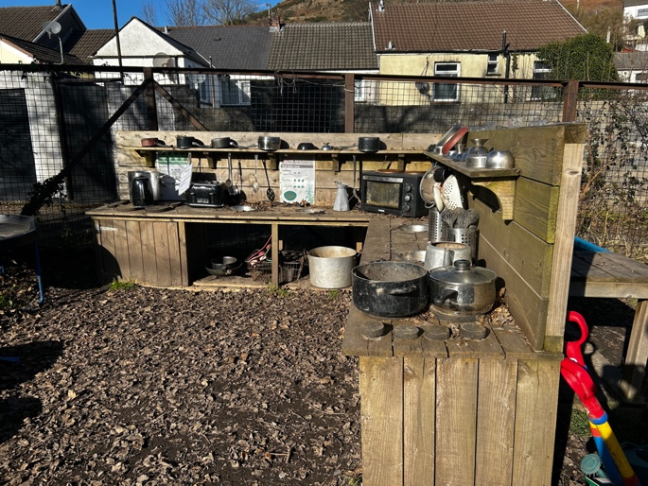
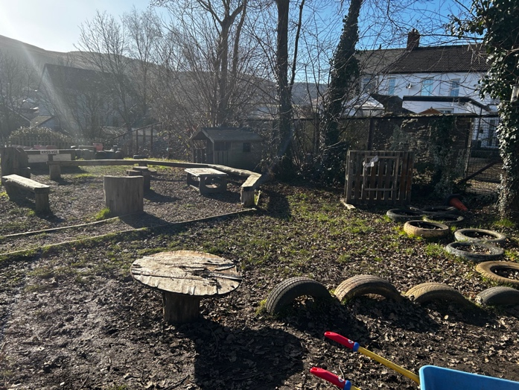
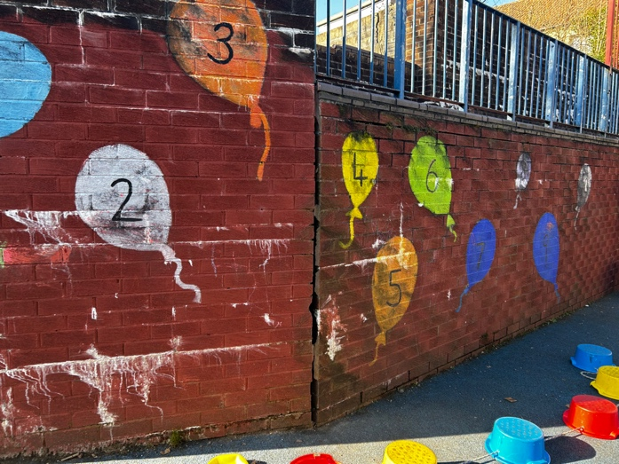

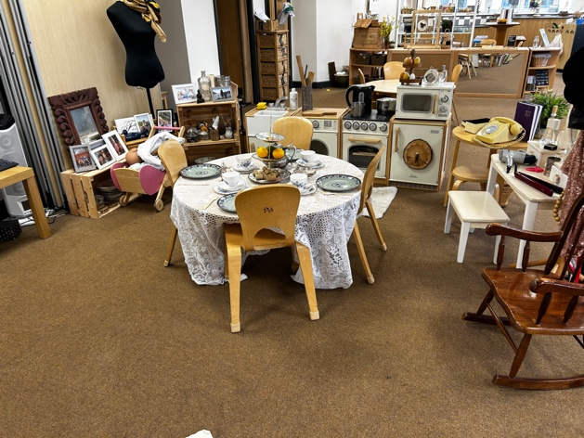
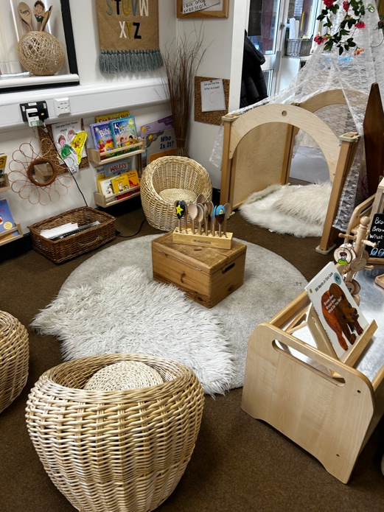
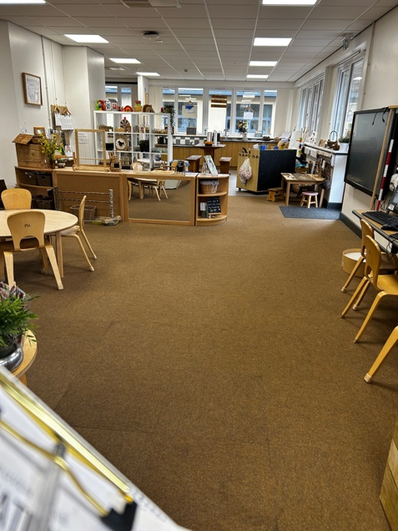

Observation Sheet


