

Material selection report and GD&T Drawings
ACHA4001
Engineering Design and materials
Ryan Boardman
21/04/24

Contents
1.0 - Introduction 3
2.1 - Component design specification 4
2.1 – What is a connecting rod 4
2.2 – Design specification 4
2.2 – Design evolution 5
Figure 2 – 5
Figure 1- 5
3.0 – Material selection 6
3.1 – Alternative materials 6
4.0 – Manufacturing process 7
4.1 – Manufacturing of titanium 7
4.2 – Manufacturing of the connecting rod 7
5.0 – Conclusion 8
6.0 – References 9

1.0 - Introduction
The main aim of this technical report is to choose a particular material and manufacturing process that is suitable for a suspension or engine component. In this case this particular report will cover these variables for an engine component, specifically for an engine piston connecting rod, also this specific connecting rod will be for an Audi RS6 Avant performance carbon vorsprung.
Through the means of research and studies, which will be used to help give reasonable materials for such a component. The research will help decide on a material based on the environment that the component will be used in, the cost of the material, what’s required of the material and the overall maintenance of the material of the connecting rod. The overall design specification will be given in stages, for example in prototype phase and then into a few more revised options changing things where necessary based on these variables. The type of vehicle that is chosen also matters as the vehicle chosen is a very high-performance car that produces 591BHP from a 4L V8, which means the chosen component needs to withstand high stress and temperatures to be capable of handling the demands of the car. After a design has been chosen on, it will then be the phase of deciding a material, based on the variables discussed previously, this will be to find what is most suited for the part, this section will also include material property tables and charts to back up the research and findings of the materials considered for the part. Finally in the closing section of the report, the manufacturing process will be discussed, this will be aimed to achieve the most cost-effective route for the art and materials in question.

- Component design specification
This section of the report will discuss and decide the design specification for the component that has been chosen.

2.1 – What is a connecting rod
To understand the kind of design specification warranted for the part, understanding what the part is and its role is necessary.
A connecting rod is a component in the engine, located within the cylinders, that connects the piston head to the crankshaft. As the crankshaft turns the connecting rod and piston head move in an up and down motion in time with the engine speed.
Since the vehicle this particular connecting rod will be in is a very high performance this means the engine speeds will be capable of reaching extremely high rates of revolutions per minute (RPM).
This means that due to the role the connecting rod plays within the engine, it will need to be designed in a way that will withstand the high stresses and temperatures from the engine.

2.2 – Design specification
- The connecting rod will be 154mm x 25mm in length by width.
- Inner diameter of small end (piston head end) - 20mm
- Outer diameter of small end - 34mm
- Inner diameter of big end (crankshaft end) – 49mm
- Outer diameter of big end – 59mm

The design will be aimed to target a lightweight style to keep with the performance ideology of the vehicle, whilst remaining as a stable part within the engine and remaining to withstand the high temperatures and the high stress when reaching the higher speeds and demands of the car / engine. The connecting rod will have to withstand loads of 1200N*, therefore it will need to be appropriate to reach these demands. By adding a bored oil passage which can usually be seen from diesel cars, it means that there is a possibility for extra lubrication from the oil and a chance to slightly cool the connecting rod. The durability will be increased by featuring a straight cut pin end. The connecting rods will be designed in a way that ensures that they will be secured well, adding to the stability of the part to enhance its role within the engine.
The design will feature changes to its original state, this is for optimisation of the part in order to find the best possible philosophy / design style for the part. The changes will be made based on stress test simulations along with heat resistance simulations, based on what could be experienced in the real world.

– Design evolution
This section will discuss the different design ideas, along with images of the development of the connecting rod. Each design idea will keep in mind and consider the overall philosophy of the vehicle and the nature of the engine it is for.
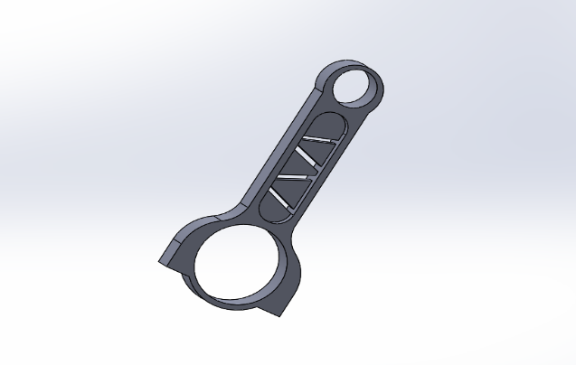
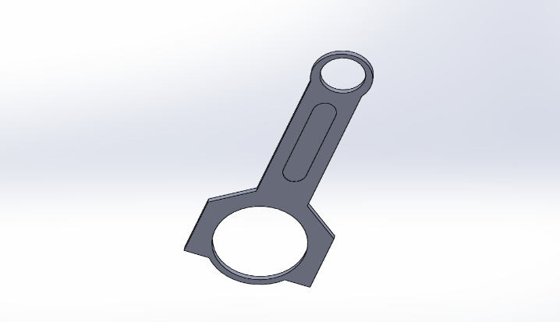
This improvised part shown in figure 2 features extra cutouts and is 5mm thinner than the original design, this is made as a radical attempt to reduce further weight where possible, despite this it aims to remain just as structurally sound as the original.

Figure 2 –
Showcasing the improvised part in SolidWorks
The initial design shown in figure 1 resembles that of a typical connecting rod design it features two dipped cut out sections of 5mm to attempt to reduce the weight of the part.

Figure 1-
SolidWorks CAD model of the initial design

3.0 – Material selection
Material selection is a process of the development phase that is one of the most important, therefore it needs to be done carefully and thoroughly. It is the process of choosing the most ideal material, in the context of this report the material will be a type of metal-based material or alloy. The decision of the material will be based of what the requirements and demands are of the environment that the part in development is for and what it will be experiencing. During this process the most cost-effective option should be targeted and highlighted as a key factor in the decision.
Due to the nature of the connecting rods environment, the choice of material will have to be able to endure and withstand the high stresses and temperatures that are contained within the engine of the vehicle. However, despite those factors it will still need to fit in with the ideology of the vehicle it is in, with it being a high-performance car it will need to be lightweight and efficient for its role. This means the material will need to be able to have these properties to enhance the performance impact to the engine and vehicle. Typically, engine components are made out of iron-based alloys such as various types of steels and also in particular components such as, parts for the piston, cylinder head and cylinder block. The reason for this is due to steels strength and efficiency when under high tension and load, also it is due to the fact that steel is very good at withstanding very high temperatures such as those of 1000 degrees Celsius. Steel is also widely available due to it being produced in such large quantities, also it is very cost effective and comparatively cheaper than other alloys.
Due to these factors, it makes steel a very good material to use for a connecting rod. Typically, they are made from various types of steel such as forged, cast and fabricated steel due to the properties earlier discussed. Also, aluminium is a good option with similar performance to steel.

– Alternative materials
Alternative options include such materials as super alloys. These are very strong and efficient alloys that can also withstand high temperatures whilst remaining just as efficient. The main groups of super alloys are, Nickel based, Cobalt based, Iron based.
These would also be fairly ideal options in terms of what to make a connecting rod from, however these materials are not as easily available due to it not being as easy to manufacture, along with this they are also not as cost effective as they are expensive alternatives.
Alloys such as chromium and titanium are also good alternatives however also not the most cost-effective route. Despite this there are still some various connecting rods that are made from titanium, these types tend to have good performance, that of the degree where it can be better than aluminium and steel.
For this part, it shall use Titanium. Despite the cost it will be a very beneficial material to use for the chosen design due to its strength and lightweight nature of the material.

4.0 – Manufacturing process
This section will discuss the and go through the process of the manufacturing of the material and the component. Also, it will analyse the benefits of which why it is manufactured in the way it is and target the most cost effective way of manufacturing.
The manufacturing process is an important part of the process, it follows on from when there is a definite design for the component and a chosen material. It’s the final part of the process and this is where the component can be put into real life testing, this can then allow for comparing simulation results to real world results in order to help with development. From these tests in particular it will give a real world example of its performance and whether it will withstand the forces and loads it has to go through.

4.1 – Manufacturing of titanium
Titanium is firstly extracted from its ore using a process that is known as ‘Kroll process’. Following this process, it is then to be purified. This purifying process is to extract any of the impurities found within the titanium to achieve the desired purity level. To improve titanium’s mechanical capabilities, it can be alloyed. By undergoing this process, it can improve such features like, strength, corrosion resistance and overall toughness meaning it can withstand higher forces and harsher environments that it can be subjected to. The titanium can then undergo a heat treatment test, by doing this it can help improve their structure and its mechanical properties. These factors are achieved through heating the titanium to a specific temperature and then, in a controlled manor, cooling it back down. Once heat treated applying a finishing process such as milling may be done to give the titanium a clean finished look.

4.2 – Manufacturing of the connecting rod
Once a design has been decided and a material is chosen, it is then possible to move onto the main manufacturing and making of the part.
To start off the process the titanium metal will need to be available and have gone through its own specialised process. Once the material is readily available, the first step is the forging. The forging process can be through using hammer, press or powder forging styles. This process ensures the material is made into the desired shape of the component. A process known as casting can also be used, this process is when a molten form of the metal being used can be poured into a mould of the components design. Once undergone this process it is then onto machining where the rough edges of the component are made smooth, and dimensions are made accurately. Then followed by a heat treatment process to achieve the desired structure. Finishing on the component is also completed following the heat treatment process this is to achieve a presentable finish of the component. The component will also go under quality control, if it passes it is then ready for assembly.

5.0 – Conclusion
In conclusion, it is shown that a possible different approach is shown in which has been targeted to achieve targets. These targets include cost efficiency, weight saving and alternate or new designs. It can be seen that there is a showcase of designs and a reasoning to these designs that has been achieved through the means of research. Also using the means of research, it has helped with choosing on an ideal alternative material for the component compared to the common versions on the market by discussing each material’s characteristics. A showcase of the manufacturing process has been shown for both the titanium that will be used for the component and for the component itself, this is to gain an understanding as to how the component will be made with cost considered.

6.0 – References
Audi 4.2L RS6 C5 V8 twin-turbo ZRP connecting rods (2023) ZRP. Available at: https://zrp-rods.com/shop/audi-4-2l-rs6-c5-v8-twin-turbo-zrp-connecting-rods/ (Accessed: 20 April 2024).
Person and Savree.com (2023) Connecting rod, saVRee. Available at: https://savree.com/en/encyclopedia/connecting-rod (Accessed: 20 April 2024).
Material selection (2023) Corrosionpedia. Available at: https://www.corrosionpedia.com/definition/6939/material-selection (Accessed: 20 April 2024).
Khatabook (2020) Forging and casting of connecting rods: A comprehensive guide, Khatabook. Available at: https://khatabook.com/blog/rod-manufacturing-process-casting-vs-forging/#:~:text=Connecting%20rods%20can%20be%20forged,or%20pounded%20with%20a%20hammer. (Accessed: 20 April 2024).
Titanium - element information, properties and uses: Periodic Table (no date) Titanium - Element information, properties and uses | Periodic Table. Available at: https://www.rsc.org/periodic-table/element/22/titanium (Accessed: 20 April 2024).
Antony, S. et al. (2016) Design and analysis of a connecting rod, International Journal of Engineering Research & Technology. Available at: https://www.ijert.org/design-and-analysis-of-a-connecting-rod (Accessed: 20 April 2024).

