

Corey Taylor
HNC in Electrical Engineering
Microprocessors Assignment

Lecturer: Linton Cook
Table of Contents

- Introduction

- Task 1 – Motor Control

- Task 1 – Code

- Task 2 – Car Park Barrier

- Task 2 – Code

- References

Introduction
As Part of the Microprocessors module of my HNC in Electrical and Electronic Engineering, we have been given the task of producing programs for a D.C. motor control module, as well as a Car Park barrier counter system, involving counting entrance and exit of up to 20 cars. We will need to produce a flow chart of how the program will work, and detail how everything is pieced together.
The first task involves the D.C. motor being controlled using a ‘Pulse Width Modulated Signal’, as described in the manual provided on the briefing sheet. The PWM control requires a positive 5V pulse, with a duration between 0.5mS and 1.5mS, with a ‘repetition rate’ of 20mS, as displayed on figure 1 on the briefing sheet.
Speed control was the main aspect of task 1, this involved writing code which allowed for the input of adjustable speed control into the program on Arduino and then running it, which allowed the speed to be increased or decreased by an assigned key on the laptop’s keyboard.
Task 2 focuses on producing a program on Arduino that will control flow of traffic into a car park. This will mean the entrance & exit barriers will count cars in and out of the car park, and will stop allowing cars in once the maximum capacity has been reached. The car park will then continue to allow cars through the entrance barrier, once a car has been sensed leaving via the exit barrier. This is a good way of monitoring how many cars used the car park throughout the day, and is a common way of communicating with traffic outside to let drivers know whether or not there is space within a car park, before they actually arrive at the entrance.

Task 1: Motor Control
You will be presented with a D.C. motor control module. The speed of the motor may be controlled using a Pulse Width Modulated signal as described in the manual provided.
In summary the PWM control requires a positive 5v pulse that has a duration between 0.5ms and 1.5ms, with a ‘repetition rate’ of 20ms.
A pulse width of:-
- .5mS results in the motor rotating at full speed in an anticlockwise direction
- A pulse width of 1mS results in the motor being stopped
- A pulse width of 1.5mS results in the motor rotating at full speed in the clockwise direction.
There is a linear relationship between these pulse widths and the actual speed of the motor.
You are required to produce a program that controls the motor using an operator interface as shown in figure 2 below. Note that you must use the pins indicated.
Switch A increases the speed by increasing/decreasing the pulse width in increments of 0.01ms depending on the current rotation direction to be set by switch B. This implies that there are 50 speed settings available in both the clockwise and anti-clockwise directions.(Switch A is a momentary acting push to make switch)
The current speed setting will be displayed on the two BC.
Switch B sets the direction of rotation and is a latching switch (Open = Clockwise, Closed = anti clockwise)
Switch C is an overriding enable control and is latching. (Open = Stop, Closed = Run)

For this task, I used the Arduino software to produce a program that controlled the speed of the motor. This involved setting the motor up to receive signals based on the program, which allowed it to be Pulse Width Modulated.
Pulse Width Modulation works by forcing the load on the DC motor to be switched on and off at a rapid speed, this is what the program will create, allowing for efficient speed control and change of direction of the motor (Via Switch B).

Code for Motor Control
int SwitchA = 2; // Pin for switch A.
int SwitchB = 3; // Pin for switch B.
int LatchC = 4; // Pin for switch C.
int AState;
int BState;
int CState;
Int Aconfig;
int Bconfig;
int Cconfig;
int previousA = 0;
int previousB = 0;
int previousC = 0;
int motorPin = 13; // Pin with pulse for motor.
int breakPin = 12; // Pin for disc break.
int varDelay = 1500; // The current pulse width
void setup() {
pinMode(switchA, INPUT);
pinMode(SwitchB, INPUT);
pinMode(latchC, INPUT);
pinMode(motorPin, OUTPUT);
pinModebreakPin, OUTPUT);
digitalWrite(motorPin, LOW);
digitalWrite(breakPin, LOW);
}
void loop() {
// Debounce and read buttons and save config.

Task 2
During this task you will produce a program along with suitable documentation for an Arduino microcontroller that will be used to control the flow of traffic into a car park. The car park can only hold 20 cars at a time.
- If the car park is full, then a ‘Car Park full’ will be illuminated and no more cars will be allowed to enter.
- When the entry barrier is raised a green lamp will be illuminated to allow the car in.
- A red lamp will be illuminated to prevent cars approaching the barrier.
- Sensors will be provided to detect:-
  - Cars arriving at the entrance
  - Cars having passed through the barrier
  - Cars exiting the car park
The barrier will be driven by a stepper motor. The sensors S1, S2 and S3 will provide a logic 1 signal when activated. The lamps are illuminated when a logic 1 level is applied. The stepper motor will be driven using the standard motor shield.
The following interface is defined:-
Sensor 1 = Pin 2
Sensor 2 = Pin 3
Sensor 3 = Pin 4
Red = Pin 5
Green = Pin 6
Car Park Full = Pin 7
Flow Chart
Before producing a program, I created a Flow Chart to show how the program will work. This will simplify the program creation process by enabling me to see exactly what steps need to be taken and when each prompt needs to be carried out.
The sequence of each command is essential when creating a piece of code as it can drastically affect the outcome of the program and can cause major issues with the operation of the program.
I started with a ‘Start’ piece. I then branched off in sections, by thinking of how the program needs to work and what limitations there may be. For example, if the car park is registered as ‘Full’, then no more cars can enter. In this scenario, the program will need to loop back to keep checking whether another car has exited the car park. The program will continuously check for this message on a loop until it receives the signal that a car has exited. It will then allow the program to continue with the next command (which, in this scenario, would be to open the entrance barrier to allow another car to enter). The program will continue to move through the steps until it hits another loop in its routine.
Examples of the above can be seen in the flow chart I have attached below:-
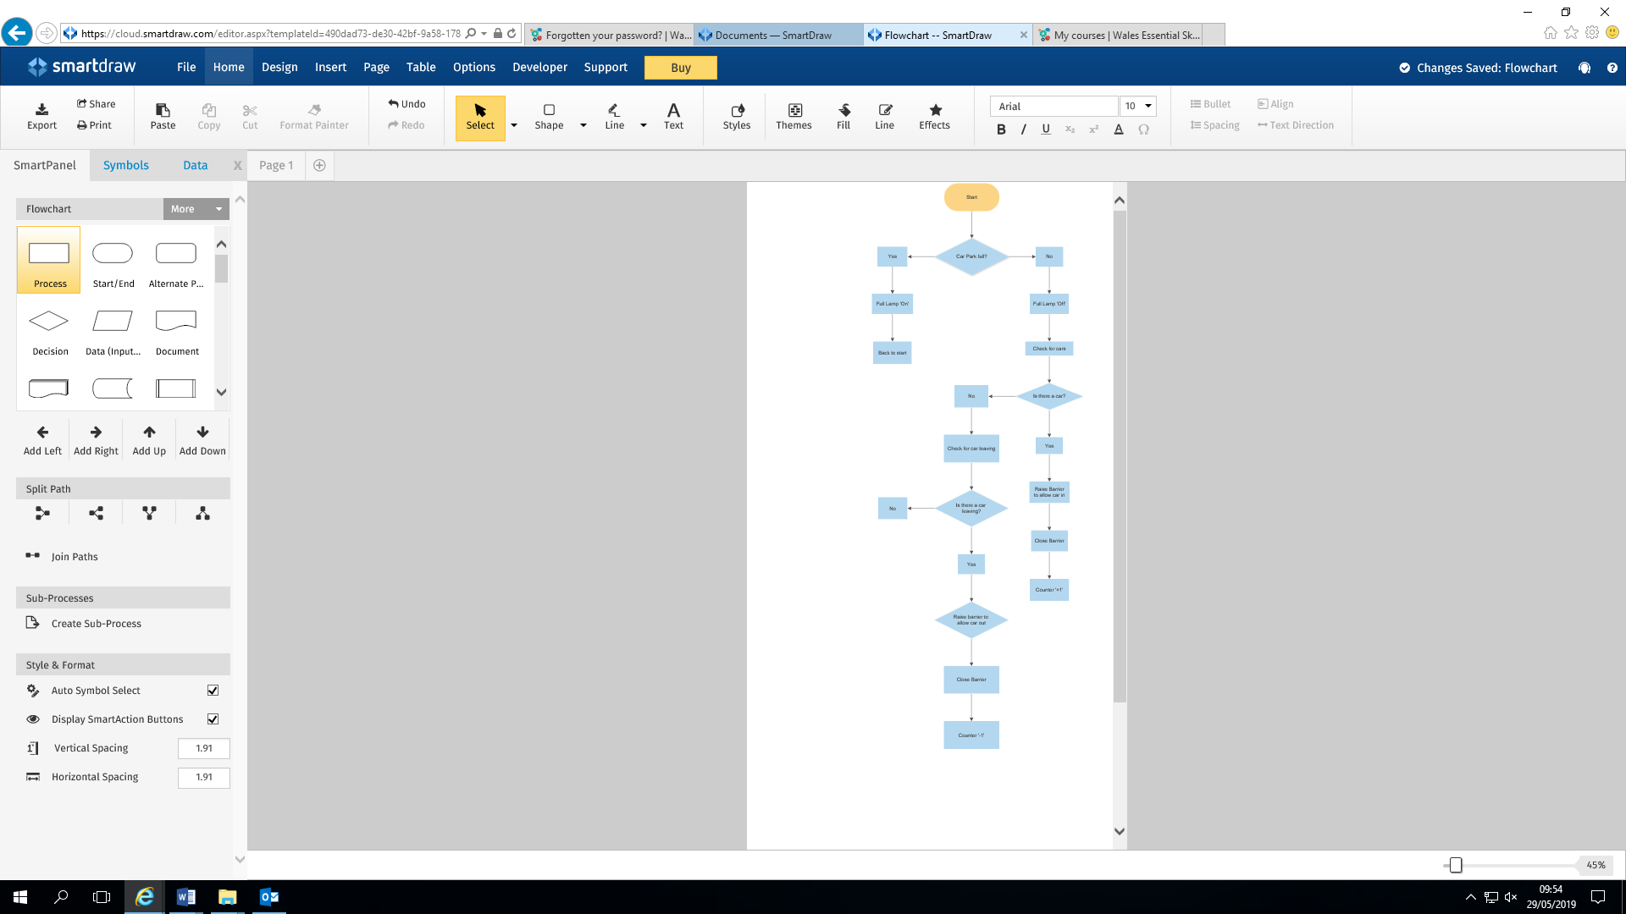
Arduino Screenshots
The screenshots below contain the code for the Car Park Barrier, shown as it was written on the Arduino software:-
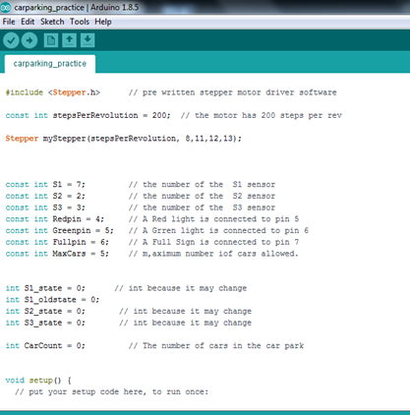

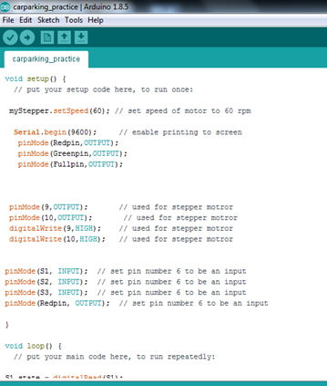

Car Park Program
The code for my Car Park program has been pasted below. I have named each sensor and connected pins to the Arduino, this will allow the program to communicate with the Arduino and allow the different coloured LED lights to illuminate when required.
A green LED light will be illuminated when the car park has availability of space, and the barrier will then be allowed to be raised to give a car entry.
This will be repeated until the car park reaches its maximum capacity. Once this happens, the green LED light will be replaced with a red LED, to show that the car park is full, and the barrier will not raise for any more cars.
Once a car leaves the car park, the red LED will again be swapped for the green LED, and the barrier will be able to be raised again, to allow entrance for another car. This should then work indefinitely, so long as cars are continuing to enter and exit the car park.
My code for the Car Park program is shown below:-
const int S1 = 7; // the number of the S1 sensor
const int S2 = 2; // the number of the S2 sensor
const int S3 = 3; // the number of the S3 sensor
const int Redpin = 4; // A Red light is connected to pin 5
const int Greenpin = 5; // A Grren light is connected to pin 6
const int Fullpin = 6; // A Full Sign is connected to pin 7
const int MaxCars = 5; // m,aximum number iof cars allowed.

int S1_state = 0; // int because it may change
int S1_oldstate = 0;
int S2_state = 0; // int because it may change
int S3_state = 0; // int because it may change

int CarCount = 0; // The number of cars in the car park

void setup() {
// put your setup code here, to run once:

myStepper.setSpeed(60); // set speed of motor to 60 rpm

Serial.begin(9600); // enable printing to screen
pinMode(Redpin,OUTPUT);
pinMode(Greenpin,OUTPUT);
pinMode(Fullpin,OUTPUT);

pinMode(9,OUTPUT); // used for stepper motror
pinMode(10,OUTPUT); // used for stepper motror
digitalWrite(9,HIGH); // used for stepper motror
digitalWrite(10,HIGH); // used for stepper motror

pinMode(S1, INPUT); // set pin number 6 to be an input
pinMode(S2, INPUT); // set pin number 6 to be an input
pinMode(S3, INPUT); // set pin number 6 to be an input
pinMode(Redpin, OUTPUT); // set pin number 6 to be an input

}

void loop() {
// put your main code here, to run repeatedly:

S1_state = digitalRead(S1);
S2_state = digitalRead(S2);
S3_state = digitalRead(S3);
if (S1_state == HIGH) { // there is a car at S1
S1_oldstate = HIGH;

Serial.print("S1 High carcount = ");
Serial.println(CarCount);
if (CarCount == MaxCars) {
digitalWrite(Fullpin,HIGH); // put FULL sign ON

}
else{ // get here if car at S1 and not full
//open barrier
Serial.println("Raise Barrier");
myStepper.step(50);
// switch traffic light
digitalWrite(Greenpin,HIGH); //put green lamp on
} // and more stuff below
}
if (S1_oldstate == HIGH){
if (S2_state == HIGH){
Serial.println("S2 High ");
myStepper.step(-50); // close the barrier

digitalWrite(Redpin,HIGH); // put red lamp on

CarCount++; // added one to car count
S1_oldstate == LOW;

Serial.println(CarCount);
}
if (CarCount == MaxCars) {
digitalWrite(Fullpin,HIGH); // put FULL sign ON }
}

}

else { // *******no car at S1 but check S3

if (S1_state == LOW) { // there is no car at S1

}
if (S3_state == HIGH) { // there is a car at S3

CarCount--; // take one from car count

digitalWrite(Fullpin,LOW); // put FULL sign OFF }

}
// turn LED off: //*******
//digitalWrite(Redpin, LOW);//

References
- Pulse Width Modulation website:-

https://www.electronics-tutorials.ws/blog/pulse-width-modulation.html

- Flow Chart Created via ‘Lucid Chart’ website:-
https://www.lucidchart.com/

