Notes for scrapbook
Mental health
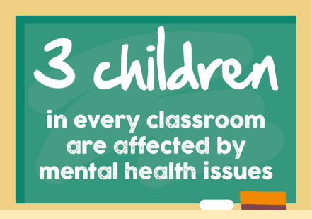
YoungMinds (2019) stated that within the past 5 years ‘90% of school leaders’ reported a raise in the amount of pupils who are suffering from ‘anxiety, stress, low mood or depression’ with ‘3 children in every classroom’ having a diagnosable mental illness. This is partially down to the fact that children have been dealing with a lot more pressure from ‘exams pressure, social media and cyberbullying and pressure over body image’. Schools have an important part in developing skills that children need for them to cope and thrive. Adding to that, children perform better academically if their health and wellbeing is good. However, the ‘education system is unbalanced’ as there is a lot of emphasis on exams and an absence of importance of pupils’ wellbeing. (YoungMinds, 2019)

(SavingSavannah, 2018)
Research done by YoungMinds (2019, p.1) found:
- ‘more than half of parents want more information available on how their child’s school provides wellbeing support for students.
- 73% of parents would choose a school where children are happy even if previous exam results had not been good, over a school where exam results were better.
- 90% of young people we surveyed said that they would like mental health to be more important to their school or college.
- 86% of teachers agreed that the Ofsted framework should be revised, so there is a greater focus on wellbeing and mental health, with other elements scaled back.
- 82% of teachers think the focus on exams has become disproportionate to the overall wellbeing of their students.’
From this research you can see that students, parents and teachers all agree that there should be more focus on the wellbeing of students.
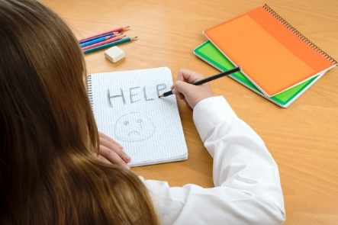

(Smalley, 2019)
The Mental Health Foundation (2018) describes about a campaign they have set up called ‘Make It Count campaign’ to make sure that all children in the UK have an education with a focus on mental health. There isn’t a simple one way for schools to do this, in order to make schools an environment that is healthy mentally for everyone a “whole-school” approach is required. Meaning that all ‘teachers, leadership, the curriculum, children, and access to support’ need to contribute in making a ‘mentally healthy, nurturing environment’.
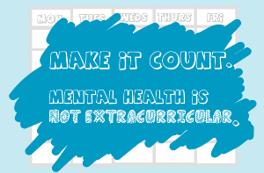

(Mental Health Foundation, 2019)
Sunderland (2019) explains that children spend a lot of time each year in school which is why teachers are in a top position to deliver support to students who have minor to moderate mental health issues. For schools to be able to help with poor mental health, it’s important that they understand mental illnesses. Sunderland (2019) says that the Government Green Paper states evidence shows that school staff that are properly trained and supported can attain results similar to those achieved from mental health professionals the amount of interventions tackling ‘mild to moderate mental health problems such as anxiety, conduct disorder, substance use disorders and post-traumatic stress disorder’. Initially schools should concentrate on offering students a place where they can go to discuss about upsetting events in their life and be given support, as this could prevent pupils’ emotional pain from changing into mental health problems.

(Green, 2017)
‘Our results-driven culture and focus on academic outcomes is also adding to widespread mental health problems in schools’. (Sunderland 2019, p.1)
A National Education Union survey found that 82% of teachers reported tests and examinations had the greatest negative effect on mental health. Adding to that, phone calls to Childline are increased during the SATs and GCSE season. In 2016/17 Childline got ‘3,135 calls from young people about tests and exams’, which was 11% raise from past years. (Sunderland, 2019) This shows us that tests are causing a significant effect on children’s mental health. Due to this the UK should consider having less tests in schools. Finland was ranked fourth in the world in 2016 for reading in the Programme for International Student Assessment whereas the UK was 22. Finland students don’t start school until the age of 7 and only have tests at the age of 18 (Sunderland, 2019). Clearly showing that testing children isn’t essential in gaining successful academic results.
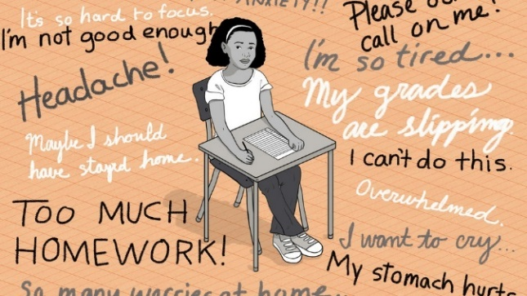

(Johnson, 2016)
New school curriculum for Wales
Welsh Government (2017) state that by 2022 there will be a new school curriculum in Wales. It’s said to be the greatest change in education in years, replacing the current curriculum which was introduced in 1988. In 2022 the curriculum will be taught up to Year 7 and will then expand year by year and by 2026 Year 11 will be included (Wightwick, 2019).
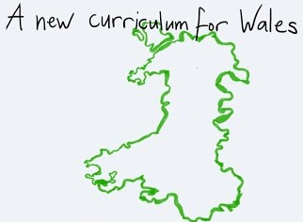
(Whitchurch Primary School, 2019)
Welsh Government (2017) say that the new curriculum is going to have more importance on preparing students for life, by developing their capability to learn new skills and utilise ‘subject knowledge more positively and creatively’. Digital skills will be introduced throughout the curriculum. Furthermore, teacher will be allowed more ‘freedom’ to teach how they think will be best for their students. A lot of teachers are excited about having more freedom with the new curriculum, but some are concerned about not having enough clarification about what’s expected from them. Damian Benney, deputy head teacher of Penyrheol Comprehensive in Swansea, said ‘he was excited about having more freedom, but that the draft remained too vague’ (Lewis, 2019).

(Povey, 2019)
Beacon (2018) states that the objective of the new curriculum is to help students to be:
- ‘ambitious, capable learners, ready to learn throughout their lives
- enterprising, creative contributors, ready to play a full part in life and work
- ethical, informed citizens of Wales and the world
- healthy, confident individuals, ready to lead fulfilling lives as valued members of society.’
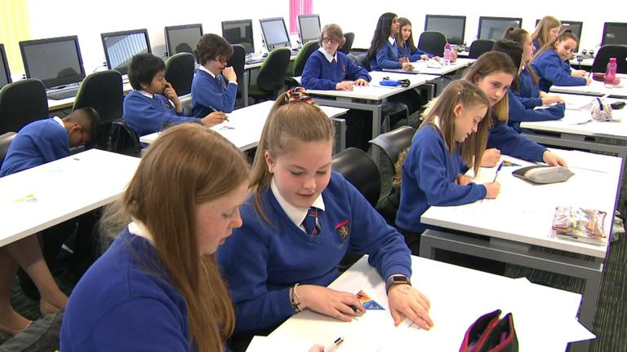
(Whitehead, 2019)
The curriculum will have six ‘Areas of Learning and Experience’ (AoLE) which will be maths and numeracy, health and wellbeing, science and technology, humanities, expressive arts and finally language, literacy and communication. (Welsh Government, 2017). Whitehead (2019) says that school key stages will be replaced with “progression steps” for each AoLE, which will give expectations for achievements of what students aged 5, 8, 11, 14 and 16 should have.
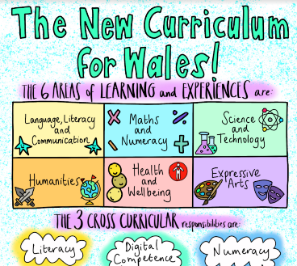
(Aspire2Be, 2019)
The Welsh Government (2017) explain the reason for the change is due technology developments and globalisation which have changed the way we live and work. Meaning that they way students learn and what they learn needs to be altered. The new style was informed in 2015 by ‘Professor Graham Donaldson’s independent review of curriculum and assessment arrangements in Wales’. Education Minister Kirsty Williams stated that they’d been working with teaching professionals to create this curriculum and ensure that students will leave the Welsh education system with the knowledge, skills and experiences to let them be successful (Whitehead, 2019).

(Digi-Classroom Team, 2018)
Education Executive (2019) claim that £44 million has been put away to assist on training teachers. £20 million would go towards development and implementations and the other £24 million ‘the single biggest investment’ to help teachers in Wales since devolution. However, unions are worried that the ambition could be jeopardised because there may not be enough funding for this change (Lewis, 2019). Tim Pratt from the Association of School and College Leaders in Wales says that even though ‘£44m sounds a good amount of money’ it’s a fraction of what’s required (Whitehead, 2019).

(Newton, 2019)
Forest school
Forest schools are set out for children to learn by exploring and discovering the outdoors and are led by trained practitioners (Forest Schools, 2019). Turtle et al (2015) states that there is a raising concern about children in the UK not spending enough time outdoors and engaging with nature. This could lead to children not being able to asses risks to themselves and others. It is also believed to be related to ‘childhood obesity, behavioural problems and poor social skills’ as children are not running around playing outside.
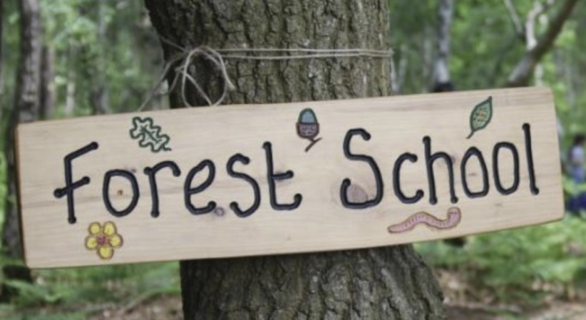
(Conibere, 2019)
Massey (2018) looks at study that was done. Participants in the study were forest school leaders and staff, children in the forest school and their parents. The study involved parents completing questionnaires and the begging and end of the research time, camcorder recorded, and involvement timed observations of the children and informal interviews and anecdotal log and photographs taken by all participants.
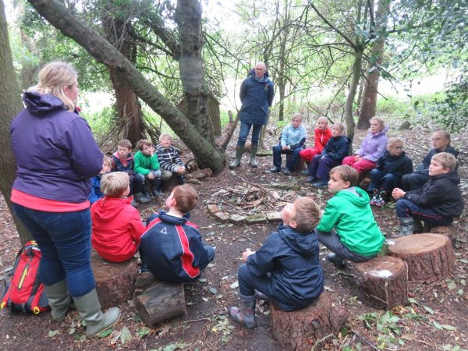
(St Francis School, 2019)
Some of the benefits Massey (2018, pp 4 and 5) found from the study include:
- ‘Personal and social development’ – the children gained a sense of achievement and built their self-esteem when taking part in the activities and give them independence. Adding to that, they made relationships with both other children and adults and they learnt how to work as a team, thinking about other people as well as themselves. It was found that the children were able to adapt to new situations and try new experiences and their ‘confidence in self initiating tasks was seen to develop dramatically’.
- ‘Communication and Language Development’ – as the children were outside interacting with each other they were motivated to use ‘real language in real context’ and slowly expand on their vocabulary.
- ‘Life long learning’ – the children were taught how to safely take risks and how to independently asses risks, this helped to develop their ‘decision process and their problem solving skills’ that they’ll need to use throughout their life. The freedom they had also meant that they often used the 6 main thinking and learning skills which are: ‘enquiry, hypothesis, information processing, decision making, communication and vocabulary, review and evaluation’.
- ‘Providing a safe risk taking environment’ – forest school leaders taught children how use tools correctly and explained how to avoid accidents.
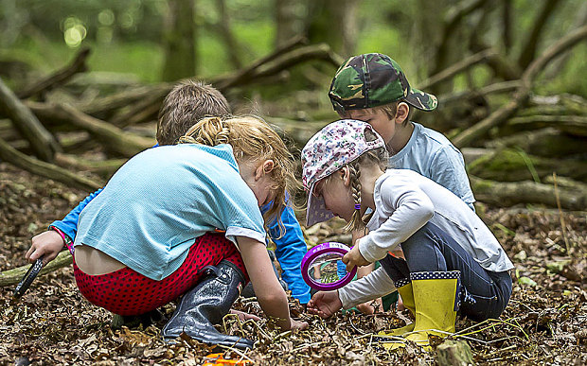
(Dickinson, 2015)
Another study done by The Wildlife Trust (2019) discovered:
- ‘90% of children felt they learned something new about the natural world
- 79% felt that their experience could help their school work
- After their activities 84% of children felt that they were capable of doing new things when they tried
- 79% of children reported feeling more confident in themselves
- 81% agreed that they had better relationships with their teachers
- 79% reported better relationships with their class-mates’
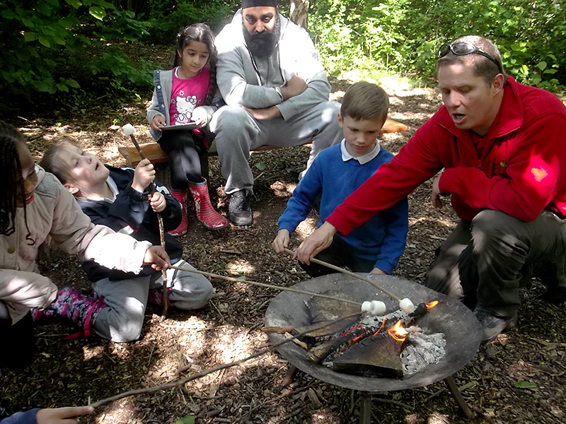
(Stoke, 2015)
Greenfield (2019) states that the conservation organisation has said that all students in primary schools should be spending a minimum of an hour a day outside learning and playing to improve their confidence and wellbeing. Furthermore, The Wildlife Trust has called for the next government to make a ‘network of wild spaces’ for children to learn, climb trees and connect with the natural world when in school. The problem with this is that many teachers are afraid of outdoor learning due to health and safety, with 17% of teachers surveyed conveying fears of risks. Even though 81% of teachers would like to spend more time outdoors with their student, health and safety seems to be a barrier for them (Golding, 2019).
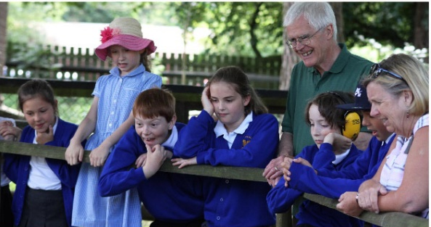
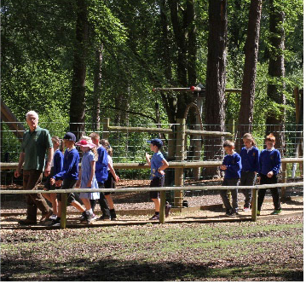
(Cornelius, 2018) (Cornelius, 2018)

References
Aspire2Be. (2019). The New Curriculum In Wales Image. [image] Available at: https://www.aspire2be.eu/the-new-curriculum-in-wales-image/ [Accessed 09 Nov. 2019].
Beacon, A. (2018). The New Curriculum for Wales – What we are doing in St Monica’s. [online] St Monica’s School. Available at: https://www.stmonicasschool.co.uk/news/detail/new-curriculum-for-wales-parent-help-sheet/ [Accessed 09 Nov. 2019].
Conibere, D. (2019). Forest Schools. [online] Available at: https://familylife.guide/2019/02/07/forest-schools/ [Accessed 11 Nov. 2019].
Cornelius, F. (2018). A Wild Day Out For Gosport School Children [image] Available at: https://www.variety.org.uk/news/2018/06/wild-day-out-gosport-school-children [Accessed 12 Nov. 2019].
Dickinson, B. (2015). Reading, writing and mud: the growth of Forest Schools. [image] Available at: https://www.telegraph.co.uk/education/primaryeducation/12038625/Reading-writing-and-mud-the-growth-of-Forest-Schools.html [Accessed 12 Nov. 2019].
Digi-Classroom Team. (2018). 5 Benefits of Using Technology in the Classroom for Students and Teachers. [image] Available at: https://digi-classroom.com/technology-in-the-classroom/ [Accessed 09 Nov. 2019].
Education Executive. (2019). New Welsh curriculum to replace traditional subjects with targeted areas of learning. [online]. Available at: https://edexec.co.uk/new-welsh-curriculum-to-replace-traditional-subjects-with-targeted-areas-of-learning/ [Accessed 09 Nov. 2019].
Forest Schools. (2019). What is Forest School? An Introduction. [online] Available at: https://www.forestschools.com/pages/what-is-forest-school-an-introduction [Accessed 10 Nov. 2019]
Golding, J. (2019). Outdoor learning helps children build ‘invaluable life skills’. IE Today, [online] Available at: https://ie-today.co.uk/Blog/outdoor-learning-helps-children-build-invaluable-life-skills/ [Accessed 11 Nov. 2019].
Green, B. (2017). Student Support at Christ Church. [image] Available at: https://blogs.canterbury.ac.uk/studentnews/student-support-at-christ-church-2017/ [Accessed 07 Nov. 2019].
Greenfield, P. (2019). Children should spend an hour a day in wild, says Wildlife Trusts. The Guardian, [online] Available at: https://www.theguardian.com/environment/2019/nov/07/children-should-spend-an-hour-a-day-in-wild-says-wildlife-trusts [Accessed 11 Nov. 2019].
Johnson, L. (2016). A Silent Epidemic: The Mental Health Crisis In Our Schools. [image] Available at: https://www.npr.org/series/494272685/a-silent-epidemic-the-mental-health-crisis-in-our-schools?t=1573164180356 [Accessed 07 Nov. 2019].
Lewis, B. (2019). Education: Draft school curriculum for Wales published. BBC News, [online] Available at: https://www.bbc.co.uk/news/uk-wales-48094118 [Accessed 09 Nov. 2019].
Massey, S. (2018). Forest School In Worcestershire LEA, [online] pp. 2,4 and 5 Available at: https://circleoflifetraining.com/wordpress/wp-content/uploads/2018/01/Worcs-Forest-School-Research-Academic-Journal.pdf [Accessed 10 Nov. 2019].
Mental Health Foundation, (2018). Mental health in schools: Make it Count. [online] Available at: https://www.mentalhealth.org.uk/campaigns/mental-health-schools-make-it-count?gclid=EAIaIQobChMI4u_0mLnU5QIVkBsYCh01UgLkEAAYAiAAEgLYF_D_BwE [Accessed 05 Nov. 2019].
Newton, N. (2019). New Welsh curriculum may make education more holistic but students might miss out on subject knowledge. [image] Available at: http://theconversation.com/new-welsh-curriculum-may-make-education-more-holistic-but-students-might-miss-out-on-subject-knowledge-111853 [Accessed 09 Nov. 2019].
Povey, T. (2019). Wales' new curriculum will deliver 'a truly twenty-first century education' says education minister Kirsty Williams as first details are revealed. [image] Available at: https://www.southwalesargus.co.uk/news/17606123.your-views-wanted-on-todays-new-draft-curriculum-for-your-children/ [Accessed 09 Nov. 2019].
SavingSavannah, (2018). Mental Health Education: Should It Be Compulsory? [image] Available at: https://savingsavannah.org/2018/01/30/mental-health-education-should-it-be-compulsory/ [Accessed 05 Nov. 2019].
Smalley, B. (2019). Anxiety and Mental Health in schools today. [image] Available at: https://www.tts-group.co.uk/blog/2019/05/08/anxiety-and-mental-health-in-schools-today.html [Accessed 07 Nov. 2019].
St Francis School. (2019). Forest School Sessions at St Francis School. [image] Available at: https://www.st-francis.wilts.sch.uk/curriculum/forest-school/ [Accessed 12 Nov. 2019].
Stoke, B. (2015). Little Stoke Primary’s Forest School featured on national television. [image] Available at: http://www.stokegiffordjournal.co.uk/2015/11/11/little-stoke-primarys-forest-school-featured-national-television/ [Accessed 12 Nov. 2019].
Sunderland, M. (2019). What can schools do to spot and avert mental health issues? [online] p. 1 Open Access Government. Available at: https://www.openaccessgovernment.org/schools-mental-health-issues/56640/ [Accessed 06 Nov. 2019].
The Wildlife Trust. (2019) New report shows how nature nurtures children. [online] Available at: https://www.wildlifetrusts.org/news/new-report-nature-nurtures-children [Accessed 11 Nov. 2019].
Turtle, C., Convery, I. and Convery, K. (2015). Forest Schools and environmental attitudes: A case study of children aged 8–11 years. Cogent Education, [online] p. 1 Available at: https://www.cogentoa.com/article/10.1080/2331186X.2015.1100103.pdf [Accessed 10 Nov. 2019].
Welsh Government. (2017). New school curriculum: overview. [online] Available at: https://gov.wales/new-school-curriculum-overview [Accessed 08 Nov. 2019].
Whitehead, D. (2019). Schools in Wales to replace traditional subjects with six 'areas of learning and experience'. Sky News, [online]. Available at: https://news.sky.com/story/schools-in-wales-to-replace-traditional-subjects-with-six-areas-of-learning-and-experience-11707447 [Accessed 09 Nov. 2019].
Whitehead, D. (2019). Year seven pupils will be taught the new curriculum from 2022. [image] Available at: https://news.sky.com/story/schools-in-wales-to-replace-traditional-subjects-with-six-areas-of-learning-and-experience-11707447 [Accessed 09 Nov. 2019].
Whitchurch Primary School. (2019). A new curriculum for Wales. [image] Available at: https://www.whitchurchprm.co.uk/pioneer-school/ [Accessed 09 Nov. 2019].
Wightwick, A. (2019). The first details of what Wales' new school curriculum will look like have been published. WalesOnline, [online] Available at: https://www.walesonline.co.uk/news/education/first-details-what-wales-new-16197528 [Accessed 08 Nov. 2019].
YoungMinds, (2019). Wise Up to Wellbeing in Schools. [online] p. 1 Available at: https://youngminds.org.uk/get-involved/campaign-with-us/wise-up/?gclid=EAIaIQobChMI35vg7LHU5QIVCPlRCh3g6QfREAAYAiAAEgKPKfD_BwE [Accessed 05 Nov. 2019].

