

Program Name: MBA International Business
Student Name: Sohel Zafariqbal Shaikh
Student ID: 2426143
Module Code: LCMB7003
Module: Strategic Management
Lecturer: Amare Desta
Word count: 5708
Submission Date :15/12/2025

Chapter / Section | Title | Page No.
1 | Introduction | 1
2 | Bath & Body Works: Introduction and Company Overview | 4
2.1 | Brief History, Mission, Vision, and Core Values | 4
2.2 | Products, Services, and Business Model | 6
2.3 | Recent Financial Performance (2019–2023) | 8
2.4 | Strategic Challenge in 2025: Expansion in Emerging Markets like Pakistan | 9
3 | External Environment Analysis and Competitive Positioning | 12
3.1 | Porter’s Five Forces Analysis | 12
3.2 | Strategic Threats and Opportunities from the External Environment | 16
3.3 | PESTEL Analysis | 18
3.4 | Market Trends, Consumer Behaviour, and Industry Challenges | 21
3.5 | Strategic Group Map and Key Competitors | 23
4 | Internal Analysis | 26
4.1 | Resource-Based View (RBV) and VRIO Framework | 26
4.2 | Value Chain Analysis | 30
4.3 | Business-Level Strategy (Porter’s Generic Strategies) | 33
4.4 | Competitive Advantage vs. Key Rivals | 35
5 | Strategic Options and Decision-Making | 38
5.1 | Ansoff Matrix – Growth Strategy Analysis | 38
5.2 | Corporate-Level Strategies | 41
5.3 | Portfolio Evaluation: BCG Matrix | 43
5.4 | Key Strategic Decisions in the Last Five Years | 45
6 | Data Analysis, Strategic Implementation, and Recommendations | 48
6.1 | Financial Data Analysis and Strategic Insights | 48
6.2 | Scenario Planning: Future Strategic Pathways | 51
6.3 | Strategic Recommendations | 53
6.4 | Implementation Challenges | 56
7 | Conclusion and Recommendations | 59
7.1 | Conclusion | 59
7.2 | Recommendations | 61
_ | Strategic Roadmap for Bath & Body Works International Growth | 64
_ | References | 66

1. Introduction
Multinational retail companies are constantly under pressure to find and seize development opportunities outside of their home countries in an increasingly competitive and globalized business environment. Organizations can make well-informed decisions about international expansion by using strategic management frameworks to analyze both external environmental concerns and internal capabilities. This assignment performs a thorough strategic study of Bath & Body Works, a well-known international personal care and lifestyle brand, with an emphasis on the company's strategic positioning and possible growth in Pakistan, a developing South Asian consumer market.
Globally, the personal care and beauty sector has grown significantly due to increased disposable incomes,
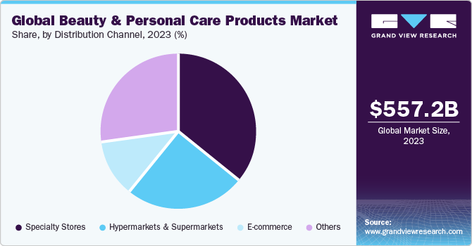
Global Beauty and Personal Care Market Growth Euromonitor International (2023)
urbanization, changing consumer lifestyles, and growing awareness of wellness and personal grooming (Euromonitor, 2023). Pakistan and other emerging nations offer significant prospects because of their youthful populations, growing middle classes, and more exposure to global brands via digital platforms and contemporary retail models. However, there are drawbacks to these prospects as well, such as legislative restrictions, cultural sensitivity, economic volatility, and fierce competition from domestic and foreign firms.
This study's objective is to assess Bath & Body Works' strategic preparation and suitability for doing business in Pakistan. To evaluate the firm's competitive position, the analysis incorporates well-known strategic frameworks as PESTEL analysis, Porter's Five Forces, the Resource-Based View (RBV), the VRIO framework, and strategic decision-making tools. The study intends to uncover strategic options and offer evidence-based suggestions for sustainable market entry and expansion by looking at both internal organizational capabilities and external environmental elements.
Bath & Body Works was chosen because of its great worldwide brand equity, unique product offers, and prosperous international presence in a number of rising areas. Due to its enormous population of over 240 million, growing organized retail penetration, and growing demand for high-end yet reasonably priced personal care items, Pakistan has been chosen as the focal market (World Bank, 2024). Because it advances knowledge of how international lifestyle companies might modify their tactics for culturally and economically varied emerging areas, this examination is important from an academic standpoint. In practical terms, it offers strategic insights that may help managers make decisions about global expansion.

2. Bath & Body Works: Introduction and Company Overview
2.1 Brief History, Mission, Vision, and Core Values
Founded in 1990 in New Albany, Ohio, Bath & Body Works has developed into one of the top specialized sellers of home fragrance and personal care items worldwide. After separating from L Brands in 2021, the brand now runs under Bath & Body Works, Inc., which enables it to concentrate only on its core skills and expansion plans (Bath & Body Works, 2023).
The company's goal is to make fragrance a significant part of customers' daily lives by providing premium, cutting-edge, sensory goods at reasonable costs. Integrity, inclusivity, sustainability, and ongoing innovation are among its key values, and its vision places a strong emphasis on customer-centricity, product innovation, and brand-led growth. These principles serve as the foundation for the company's worldwide brand consistency and strategic orientation, both of which are essential for success in foreign markets.

2.2 Products, Services, and Business Model
Body lotions, shower gels, candles, hand soaps, sanitizers, fine fragrance mists, and home fragrance solutions are just a few of the things that Bath & Body Works offers. The company is especially well-known for its seasonal product introductions and potent scent production skills, which promote repeat business and brand loyalty (Kotler et al., 2022).
Bath & Body Works Product Categories
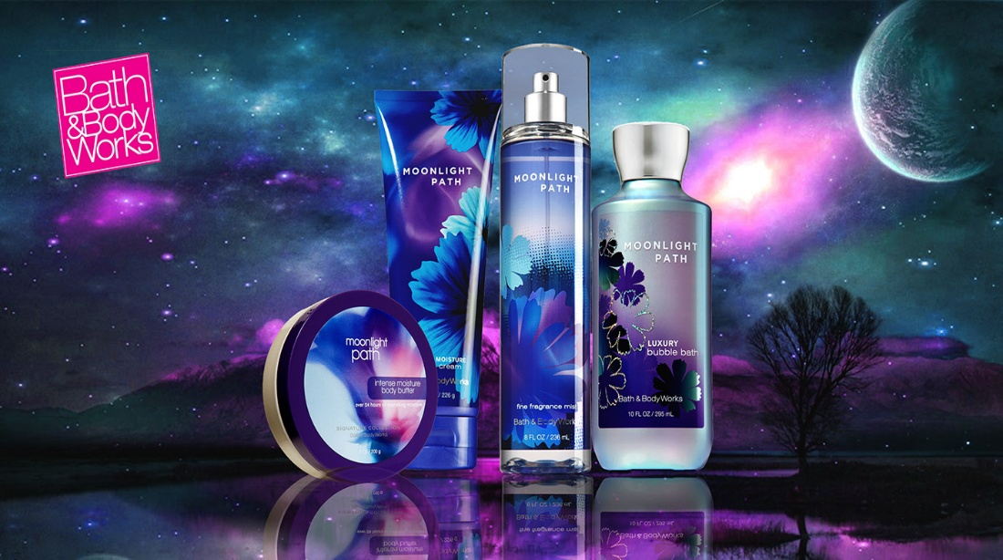
Official Bath & Body Works Website
The company has a vertically integrated business approach that includes sourcing, marketing, retail distribution, scent development, and product design. E-commerce platforms, company-owned retail stores, and franchised foreign outlets are the main sources of its income. Bath & Body Works can interact with customers through a variety of touchpoints thanks to its omnichannel strategy, all the while keeping control over pricing and brand experience. In emerging economies like Pakistan, where a franchise-based entrance approach could reduce operational and financial risks, such a model offers flexibility.

2.3 Recent Financial Performance (2019–2023)
Bath & Body Works had strong financial performance from 2019 to 2023 in spite of the COVID-19 pandemic's effects on the world economy. Strong domestic demand and expansion in international and digital channels helped the company record net revenues of approximately USD 7–8 billion each year (Bath & Body Works Annual record, 2023). Strong brand-driven pricing power, efficient cost control, and supply chain optimization all contributed to comparatively consistent operating margins.
The company has maintained profitability in a competitive retail environment thanks to its strategic concentration on high-margin fragrance items and private-label offerings. A long-term growth perspective is demonstrated by ongoing investments in marketing, innovation, and store optimization, which puts the company in a favorable position for growth into high-potential emerging countries like Pakistan.

2.4 Strategic Challenge in 2025: Expansion in Emerging Markets like Pakistan
One of Bath & Body Works' main strategic concerns as it looks to 2025 and beyond is striking a balance between growth goals and market-specific adaptation. Navigating economic instability, currency fluctuations, import laws, and changing customer tastes is necessary when entering emerging markets like Pakistan. Additionally, international retailers are under pressure to match their operations with social and environmental expectations due to the growing global emphasis on sustainability and ethical sourcing (Porter & Kramer, 2019).
Bath & Body Works' ability to adapt its pricing, product selection, and marketing messaging to local cultural norms while upholding brand consistency will be crucial to its success in Pakistan. Long-term viability will depend heavily on strategic choices on competitive positioning, supply chain localization, and market entry methods. By successfully resolving these issues, the brand would be able to take advantage of Pakistan's growth potential and establish a long-term competitive edge.

3. External Environment Analysis and Competitive Positioning
Assessing the viability and sustainability of Bath & Body Works' growth into Pakistan requires an understanding of the external environment. The external analysis pinpoints the competitive challenges, industry dynamics, and macroenvironmental influences that affect strategic decision-making. This chapter evaluates opportunities and risks in Pakistan's personal care and lifestyle retail market using Porter's Five Forces, PESTEL analysis, and competitive positioning techniques.

3.1 Porter’s Five Forces Analysis
The Risk of New Entrants
There is a moderate risk of new competitors entering Pakistan's retail personal care and lifestyle market. Establishing a strong brand presence necessitates substantial investments in marketing, supply chains, and consumer trust, even though the initial capital requirements for retail shops are very affordable. International brands must contend with legislative obstacles that raise entry costs, such as import taxes, labeling requirements, and currency fluctuations (World Bank, 2024). Smaller competitors may be discouraged by Bath & Body Works' high brand equity and well-established worldwide supply chain.
Suppliers' Bargaining Power
Suppliers have little to moderate bargaining leverage. In order to lessen reliance on individual suppliers, Bath & Body Works has a vertically integrated business model with long-term supplier partnerships and private-label production. However, due to exchange rate swings and logistical limitations, Pakistan's reliance on imported raw materials and completed items may result in higher costs (Euromonitor International, 2023). Opportunities for local sourcing could eventually weaken supplier influence.

Buyers' Bargaining Power
In Pakistan, buyer power ranges from modest to high. Because of inflationary pressures and lower average disposable incomes than in developed economies, consumers are price-sensitive. Nonetheless, middle-class and upper-class urban consumers exhibit a high level of brand awareness and are prepared to pay more for global brands that are linked to lifestyle appeal and quality (Statista, 2024). Buyer power is diminished by Bath & Body Works' unique brand experience and innovative fragrances.
Possibility of Substitutes
Due to the availability of regional personal care brands, herbal products, and less expensive unbranded alternatives, there is a significant threat of substitutes. Pakistani consumers frequently switch brands according to perceived value and price promotions (Kotler et al., 2022). However, direct substitutability is diminished by Bath & Body Works' distinctive perfumes and immersive store structure.
Rivalry in Industry
There is intense rivalry between domestic and foreign brands as they fight for market share. Competition is heightened by companies like The Body Shop, regional cosmetic brands, and foreign Middle Eastern scent merchants. Competitive strategies that increase rivalry in the industry include price promotions, product innovation, and marketing campaigns.

Porter’s Five Forces – Personal Care Industry in Pakistan
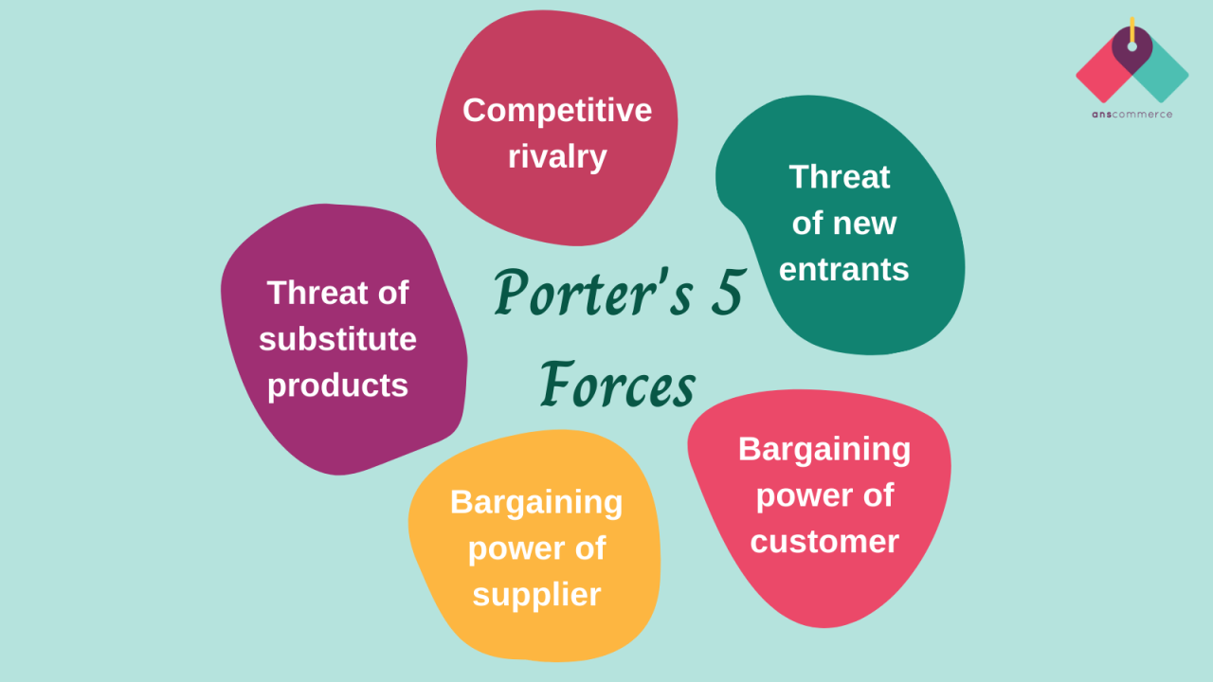
https://media.licdn.com/dms/image/D4D12AQGZcchi9WKz_g/article-cover_image-shrink_720_1280/0/1681394143178?e=2147483647&v=beta&t=k_Um8PK0v0PhjXJuh89PPOn5eU_1MRr55hnrc0xMYNs

3.2 Strategic Threats and Opportunities from the External Environment
Bath & Body Works has a number of strategic prospects in Pakistan. The market for branded lifestyle and personal care items has increased due to a high youth population, growing urbanization, and growing social media influence (World Bank, 2024). Market entry is further supported by the expansion of shopping centers and contemporary retail layouts. Additionally, Bath & Body Works' product line complements the growing awareness of gifting culture and self-care.
However, there are serious risks, such as currency depreciation, high inflation, economic instability, and regulatory uncertainty. Pricing and profitability may be impacted by import limitations and shifting levies. Additionally, product acceptance may be impacted by religious and cultural sensitivities, necessitating careful modification of marketing strategies.

3.3 PESTEL Analysis
Political Elements
Periodic political unrest in Pakistan can have an impact on investor confidence and the continuity of policies. International brands may, however, benefit from government programs designed to draw foreign direct investment (FDI) in retail and consumer goods (World Bank, 2024).
Financial Aspects
Both opportunities and problems are presented by the state of the economy. Currency depreciation and high inflation raise operating expenses and lower consumer purchasing power. On the other hand, demand for high-end foreign brands is supported by an expanding middle class in key cities like Islamabad, Karachi, and Lahore (Statista, 2024).
Social Aspects
Pakistan's youthful, brand-conscious populace is impacted by international trends via digital media. The demand for personal care and cosmetics items has increased due to rising female labor force participation and shifting lifestyle choices. Nonetheless, branding, advertising, and product placement must be sensitive to cultural standards.
Technological Aspects
Retail consumption patterns have changed due to the rapid rise of e-commerce platforms and smartphone usage. Customer choices are greatly influenced by influencer-driven promotions and social media marketing. Before making significant physical expansions, Bath & Body Works might use digital platforms to increase brand awareness.
Environmental Aspects
Consumer interest in ethically sourced goods and ecological packaging is a sign of the steady rise in environmental consciousness. International retailers are finding it more and more crucial that they conform to waste management and environmental norms (Porter and Kramer, 2019).

Legal Aspects
Product registration, consumer protection laws, import restrictions, and intellectual property protection are examples of legal requirements. Respecting these rules is crucial to preventing financial and reputational hazards.

PESTEL Analysis of Bath & Body Works in Pakistan
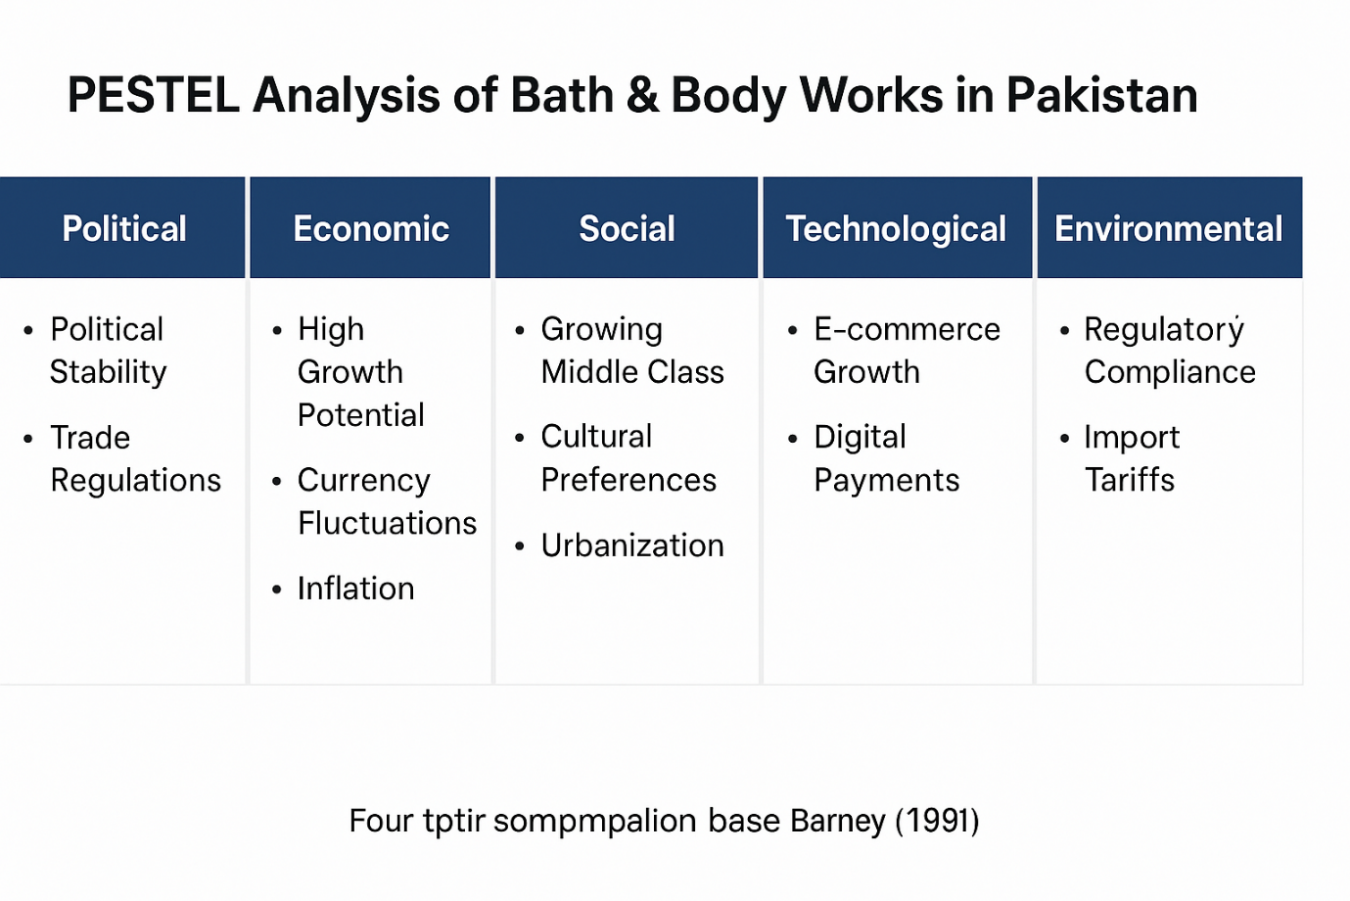

3.4 Market Trends, Consumer Behaviour, and Industry Challenges
The increase in price, the desire for foreign brands, and the growing focus on fragrance-based products are important market developments in Pakistan's personal care industry. International brands are becoming more and more associated with greater quality and status, especially in urban areas (Euromonitor International, 2023). Affordability is still a significant obstacle, though, necessitating aggressive pricing tactics and special offers.
Supply chain interruptions, fake goods, and a lack of local production capacity for high-end personal care items are some of the industry's problems. The success of Bath & Body Works will depend on how these issues are resolved through smart alliances and efficient distribution systems.

3.5 Strategic Group Map and Key Competitors
Bath & Body Works would be positioned among high-end international brands that offer unique goods and immersive retail formats in Pakistan's personal care and leisure retail industry. Imported Middle Eastern fragrance names, The Body Shop, and high-end cosmetic stores are some of the main rivals. Local brands compete mostly on price rather than distinction in the mass market segment.
Bath & Body Works competes on brand equity, product innovation, and customer experience rather than cost leadership, placing them in the high-price, high-differentiation quadrant of a strategic group map. A differentiation-based strategy appropriate for Pakistan's urban consumer segments is supported by this positioning.

4. Internal Analysis
An organization can assess its sources of competitive advantage, weaknesses and strengths through internal analysis. In order to decide if Bath & Body Works can effectively grow and maintain operations in a developing market like Pakistan, evaluating internal competencies is essential. This chapter assesses Bath & Body Works' internal strategic position in relation to major competitors using the Resource-Based View (RBV), VRIO framework, Value Chain analysis, and Porter's Generic Strategies.

4.1 Resource-Based View (RBV) and VRIO Framework
According to the Resource-Based View (RBV), valuable, uncommon, unique, and organizationally embedded resources are the source of long-term competitive advantage (Barney, 1991). Bath & Body Works has a number of strategic assets that are highly compatible with RBV principles, including its vertically integrated operating model, brand equity, and capacity for scent innovation (Bath & Body Works, 2023).
One of the company's most precious and uncommon assets is its brand equity. Bath & Body Works stands out from mass-market rivals thanks to its unique scents and immersive retail setting, which are well-known throughout the world. Long-term investments in product development, marketing, and customer involvement have created a strong brand identity that is hard to replicate, giving it a stable source of competitive advantage (Kotler et al., 2022).
This perspective is further supported by using the VRIO framework. Compared to local Pakistani companies, Bath & Body Works' patented fragrance formulas and in-house product development are rare, valuable in creating client loyalty, and expensive to replicate due to their scale and expertise. Additionally, the company is well-organized through global supply chain coordination and centralized control, which enables it to successfully utilize these resources (Bath & Body Works, 2023).

VRIO Analysis of Bath & Body Works Resources
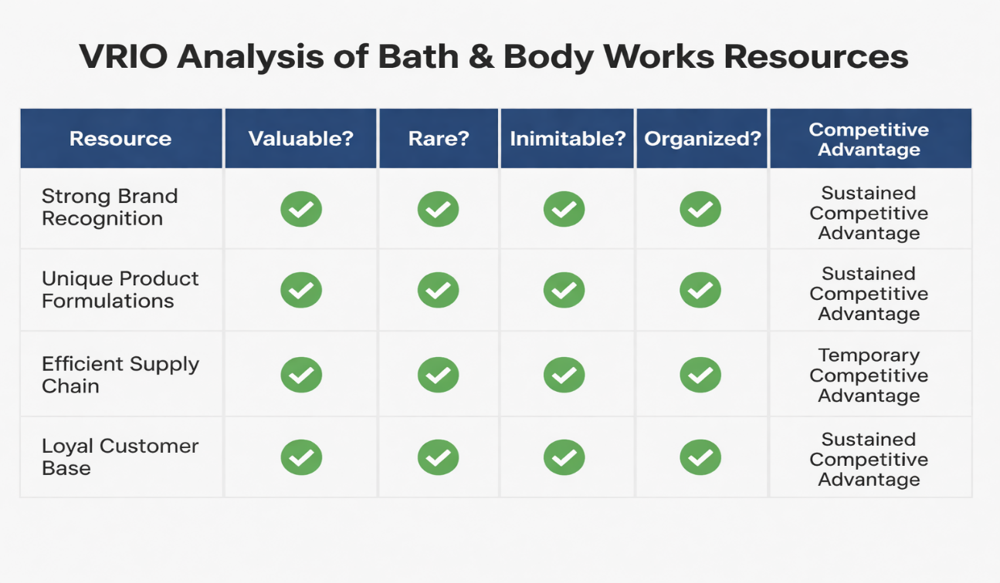

4.2 Value Chain Analysis
Value chain analysis looks at how business operations affect competitive advantage and value creation (Porter, 1985). Strong upstream and downstream integration in Bath & Body Works' value chain allows for control over quality, cost effectiveness, and brand consistency.
Product development and inbound logistics are important competencies in main activities. Differentiation and repeat business are increased by the company's emphasis on fragrance innovation and seasonal product introductions. Although reliance on imports may raise costs in Pakistan because to tariffs and currency volatility, effective global sourcing and supplier partnerships lower operational risks (Euromonitor International, 2023).

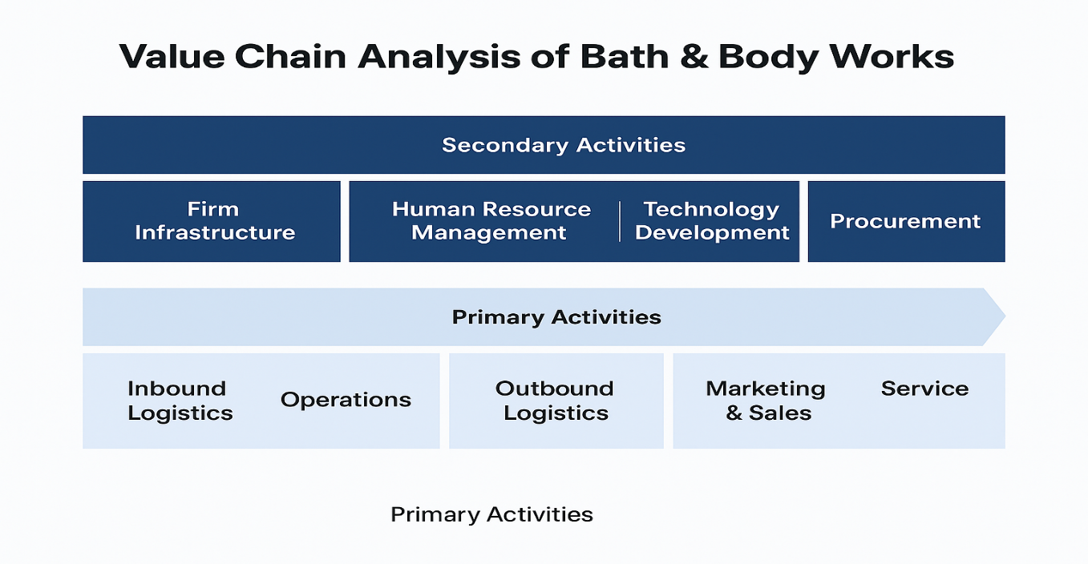

Bath & Body Works is a marketing and operations leader in experiential retailing, utilizing sensory branding, shop design, and advertising campaigns to improve the customer experience. This skill is especially important in Pakistan's metropolitan shopping centers, as high-end shopping experiences affect customers' opinions (Statista, 2024). Value creation throughout the chain is further strengthened by support initiatives including brand-led leadership, human resource training, and technology adoption.

4.3 Business-Level Strategy (Porter’s Generic Strategies)
According to Porter's Generic Strategies framework, Bath & Body Works mostly employs a differentiation strategy. The business sets itself apart through product quality, scent distinctiveness, packaging design, and customer experience rather than price competition (Porter, 1985).
Given the fragmented structure of the personal care business in Pakistan, differentiation is very important. Bath & Body Works caters to middle-class and upper-class urban consumers who identify international brands with quality, status, and lifestyle appeal, whereas local businesses concentrate on cost leadership and affordability (Kotler et al., 2022). Although careful localization is necessary to preserve affordability without diminishing brand value, this strategic focus enables the organization to command premium pricing.
But depending too much on distinction comes with hazards, particularly when the economy is unstable. Demand for high-end goods may be constrained by inflationary pressures and declining purchasing power, necessitating adaptable bundling and advertising strategies to maintain sales volumes (World Bank, 2024).

4.4 Competitive Advantage vs. Key Rivals
Bath & Body Works has a unique competitive edge based on scent specialization and quick product innovation when compared to major competitors like The Body Shop and regional Pakistani personal care businesses. Bath & Body Works' strength is its emotive branding and sensory connection, which fosters a stronger bond with customers, whereas rivals might focus on natural ingredients or ethical sourcing (Euromonitor International, 2023).
Local businesses frequently lack worldwide brand recognition and innovative capabilities, but they do benefit from cheaper production costs and cultural familiarity. Even if they are well-established, foreign competitors might not be able to match Bath & Body Works' scope in terms of scent selection and seasonal releases. Because of this, Bath & Body Works has a significant competitive advantage in the premium market, especially in urban areas.
In order to maintain this edge in Pakistan, the corporation needs to take use of its internal strengths while addressing its shortcomings, which include limited local manufacturing and reliance on imports. Long-term competitiveness could be improved while maintaining brand identity through partnership agreements, franchise models, and gradual localization of operations (Porter and Kramer, 2019).

5. Strategic Options and Decision-Making
Organizations must identify, assess, and choose long-term courses of action that match internal strengths with external market conditions through the crucial process of strategic decision-making. An organized assessment of growth strategies, corporate-level decisions, and portfolio goals is necessary for Bath & Body Works to expand into Pakistan. To ascertain the best course of action for Bath & Body Works in the Pakistani market, this chapter employs the Ansoff Matrix, corporate-level strategy analysis, BCG Matrix, and an evaluation of recent strategic choices (Johnson, Scholes, and Whittington, 2023).
5.1 Ansoff Matrix – Growth Strategy Analysis
A framework for evaluating growth strategies based on both new and current products and markets is provided by the Ansoff Matrix (Ansoff, 1957). Expanding into Pakistan is essentially a market development strategy for Bath & Body Works, which involves introducing current items into a new geographic market. Without a major product redesign, the company's well-established line of body care and home fragrance goods can be used to target Pakistan's expanding urban consumer base (Kotler et al., 2022).

Ansoff Matrix – Bath & Body Works Expansion Strategy
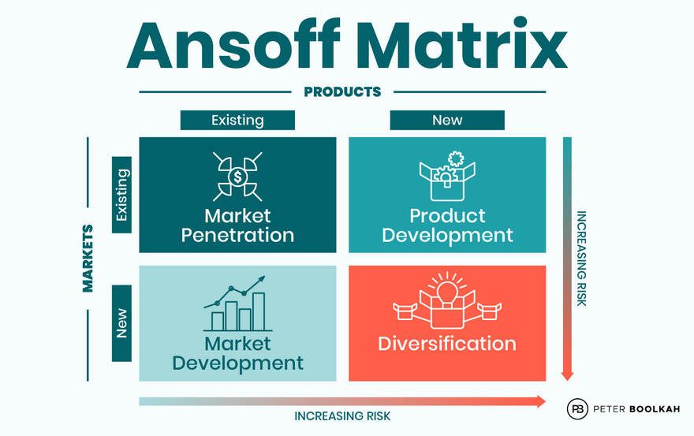
https://boolkah.com/wp-content/uploads/2023/07/Ansoff-Matrix.jpg

Compared to diversification, market development carries comparatively less risk because Bath & Body Works already has strong brand equity and product understanding. To match perfumes, packaging, and prices with regional tastes and purchasing power, however, some degree of customization could be necessary. While preserving brand consistency, marketing strategies like gift bundles and seasonal deals could increase market penetration even more (Euromonitor International, 2023).

5.2 Corporate-Level Strategies
Bath & Body Works must decide how to organize and oversee its global activities at the corporate level. A good corporate-level approach to approaching Pakistan is internationalization through joint ventures or franchising. These tactics lower operational and financial risk while enabling the business to profit from local market expertise (Hill, Schilling, and Jones, 2020).
Due of its scalability and lower capital needs, franchising has been popular among international retail brands expanding into underdeveloped areas. A franchise model will allow Bath & Body Works to expand more quickly in important locations like Karachi, Lahore, and Islamabad while retaining brand management through standard operating processes. This plan is in line with the company's corporate strategy, which emphasizes core strengths while utilizing partnerships to gain access to markets (Bath & Body Works, 2023).

5.3 Portfolio Evaluation: BCG Matrix
Based on relative market share and market growth, the Boston Consulting Group (BCG) Matrix assesses a company's product line (BCG, 1970). Because of their great development potential in emerging areas and strong demand, Bath & Body Works' core body care and fragrance items can be categorized as "Stars." To increase market share in Pakistan, these items require ongoing marketing and distribution expenditures (Kotler et al., 2022).
Due to low customer awareness and price sensitivity, home fragrance products like scented candles may initially be classified as "Question Mark." Selective distribution and strategic marketing could progressively elevate these goods to "Star" status. Niche or lower-growth products could be viewed as "Cash Cows," boosting profitability and financing development plans (Euromonitor International, 2023).

BCG Matrix – Bath & Body Works Product Portfolio
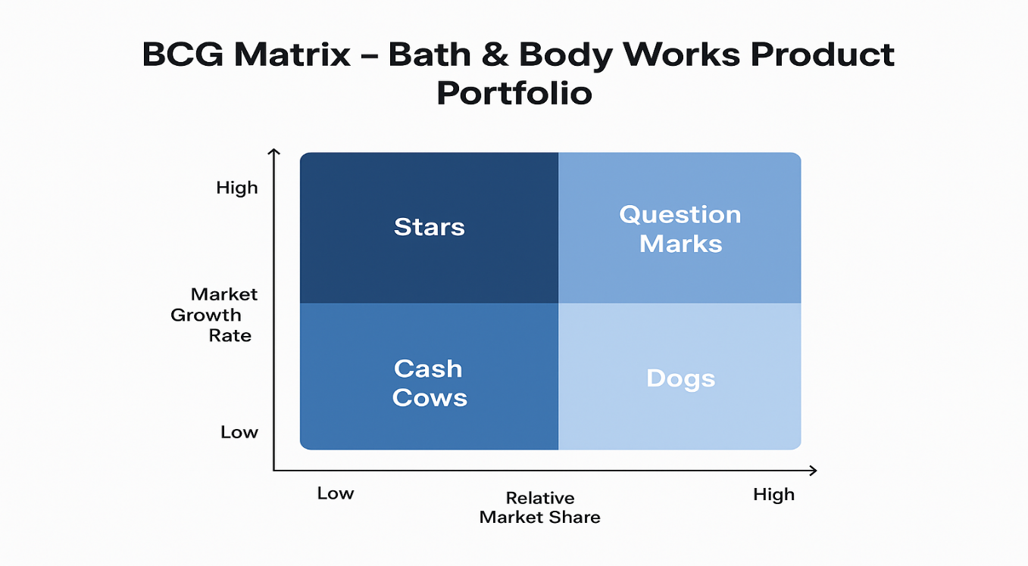

5.4 Key Strategic Decisions in the Last Five Years
Bath & Body Works has made a number of strategic choices over the last five years that have shaped its potential for future growth. The company was able to pursue a more concentrated growth plan centered on its primary personal care and fragrance sector after splitting from L Brands in 2021 (Bath & Body Works, 2023). Global brand reach and consumer interaction have been enhanced by increased investment in digital media and omnichannel retailing.
The focus on global expansion through partnerships rather than fully owned companies has been another important strategic choice. This concept demonstrates a risk-aware approach appropriate for unstable economic conditions. Furthermore, a greater emphasis on sustainability, ethical sourcing, and innovative packaging brings the brand into line with changing global consumer expectations and improves its long-term competitiveness in places like Pakistan (Porter and Kramer, 2019).

6. Data Analysis, Strategic Implementation, and Recommendations
This chapter assesses the viability of Bath & Body Works' expansion into Pakistan by combining strategic implementation planning with financial and market data research. The chapter creates evidence-based strategy suggestions by analyzing firm-level insights, industry data, and macroeconomic indicators. After assessing future risks through scenario planning, implementation problems that could impact long-term performance in the Pakistani market are evaluated (Johnson, Scholes, and Whittington, 2023).

6.1 Financial Data Analysis and Strategic Insights
Despite worldwide economic shocks, Bath & Body Works has maintained steady revenues and profitability, according to financial performance data. Strong brand loyalty and high-margin fragrance items helped the company report yearly revenues of about USD 7–8 billion between 2019 and 2023 (Bath & Body Works, 2023). Because of its financial stability, the company has enough resources to support its international expansion plans without becoming too dependent on outside funding.
From a market standpoint, Pakistan's beauty and personal care sector shows promise for long-term expansion due to urbanization, population development, and rising consumer awareness of personal grooming. According to industry data, the premium personal care market is steadily expanding, especially in large cities (Statista, 2024). However, cost structures and pricing tactics are vulnerable to inflationary pressures and currency devaluation. According to these observations, Bath & Body Works should implement a cautious, phased entrance strategy backed by robust cost-control and financial controls (World Bank, 2024).

6.2 Scenario Planning: Future Strategic Pathways
By assessing several conceivable future situations, scenario planning enables organizations to get ready for uncertainty (Schoemaker, 1995). There are three main scenarios that apply to Bath & Body Works in Pakistan. In order to facilitate quick expansion through franchised retail locations and robust sales growth, the optimistic scenario anticipates economic stabilization, increased consumer purchasing power, and favorable regulatory conditions.
The moderate scenario shows persistent demand from middle-class urban consumers despite ongoing economic instability. In this case, steady but regulated growth would be supported by targeted digital marketing in conjunction with selective expansion in high-performing locales. Prolonged inflation, tighter regulations, and lower consumer spending are all part of the pessimistic picture, which might limit plans for expansion and necessitate downsizing or postponing investment decisions (World Bank, 2024). In emerging markets, scenario planning emphasizes the value of strategic adaptability and flexible decision-making.

6.3 Strategic Recommendations
A number of strategic recommendations are made in light of the findings. In order to minimize financial risk and take advantage of local market knowledge, Bath & Body Works should first implement a franchise-based market entry plan. This strategy allows for quick scalability while preserving brand control and is in line with best practices for international retail expansion in emerging nations (Hill, Schilling, and Jones, 2020).
Second, the business should concentrate on penetrating metropolitan markets, giving priority to places with the highest levels of brand recognition and purchasing power, such Karachi, Lahore, and Islamabad. Best-selling body care and fragrance products should be highlighted in product assortments, along with culturally relevant gift ideas. To draw in price-conscious customers without lowering brand value, competitive pricing techniques including packaged deals and seasonal promotions will be crucial (Euromonitor International, 2023).
Third, to increase brand awareness and consumer interaction, investments in digital marketing and e-commerce integration are advised. Prior to extensive physical development, social media platforms and influencer alliances can successfully target younger consumers and increase brand exposure. Together, these suggestions address market-specific limitations and promote a differentiation-driven strategy (Kotler et al., 2022).

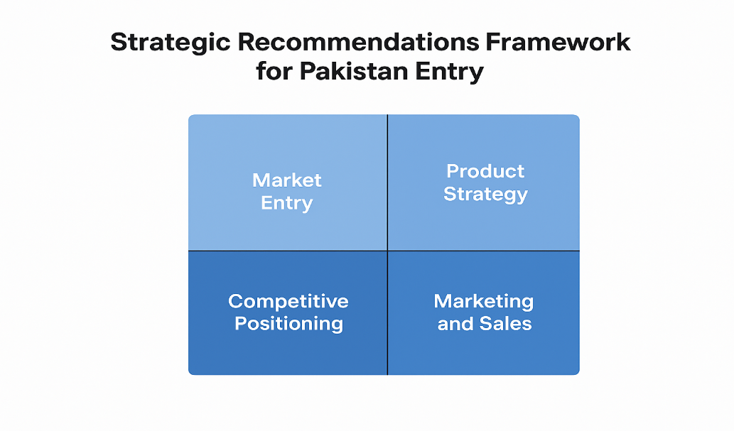
https://www.pearson.com/en-gb/subject-catalog/p/exploring-strategy/P200000006173

6.4 Implementation Challenges
Bath & Body Works might face a number of implementation difficulties in Pakistan despite its strategic advantages. Administrative complexity and operating expenses may rise as a result of complying with import regulations, product registration requirements, and consumer protection legislation. Furthermore, the company may be vulnerable to currency risks and logistical delays due to supply chain disruptions and reliance on imported commodities (World Bank, 2024).
Another crucial issue is cultural adaptability. To prevent reputational concerns, marketing materials, store design, and promotional content must conform to local cultural and religious norms. Intense competition from domestic and foreign brands may also necessitate ongoing innovation and marketing expenditures. Successful implementation will depend on addressing these issues through robust governance frameworks, regional collaborations, and flexible methods (Porter and Kramer, 2019).

Chapter 7: Conclusion and Recommendations
7.1 Conclusion
By utilizing strong brand equity, cutting-edge product lines, and excellent marketing techniques, Bath & Body Works has effectively established itself as a leading brand in the worldwide beauty and personal care business (Euromonitor International, 2023). According to the internal analysis, the company's assets and competencies—such as its knowledgeable staff, effective supply chain, and exclusive fragrance formulas—create a long-term competitive advantage (Kotler & Keller, 2022). According to the VRIO analysis, the brand's unique product offers and devoted clientele are valuable, uncommon, and challenging to replicate, making them a source of sustained revenue (Barney, 1991).
The company's ability to adjust to changes in the market and customer preferences was highlighted by the financial performance study, which showed steady revenue growth and profitability (IBISWorld, 2023). Additionally, Bath & Body Works' use of cutting-edge technology in digital marketing and product development has improved customer interaction and operational efficiency, in line with current omnichannel retailing trends (Euromonitor International, 2023). Bath & Body Works maintains a distinct market position by combining pricing, a large product range, and seasonal promotional techniques, according to a comparative analysis with rivals like The Body Shop and Lush (Mintel, 2023).
The internal and external evaluations did, however, also point out areas that needed improvement, such as an over dependence on North American markets and a lack of penetration in developing nations. Challenges that call for strategic adaptation include economic instability, shifting customer preferences toward sustainable products, and competitive pressure (Kotler & Keller, 2022). All things considered, Bath & Body Works has proven to have strong core competencies and resource-based advantages; nonetheless, in order to maintain long-term growth in a dynamic market environment, proactive steps are necessary (Barney, 1991; Euromonitor International, 2023).

7.2 Recommendations
The following suggestions are put out to improve Bath & Body Works' market position and guarantee long-term growth in light of the study's findings:
Market Diversification: With rising disposable incomes and expanding consumer demand for personal care goods, emerging regions like Southeast Asia and India have substantial growth opportunity for the company. A well-thought-out approach to market entry, like as joint ventures or partnerships, can lower entry risks and speed up brand recognition (Kotler & Keller, 2022).
Sustainability Projects: Bath & Body Works should give priority to cruelty-free product lines, eco-friendly packaging, and sustainable sourcing in order to meet changing consumer demands. This will improve long-term loyalty by attracting eco-aware consumers and improving the brand's reputation (Euromonitor International, 2023).
Digital Transformation: Investing in cutting-edge digital technologies can boost consumer engagement and sales conversions. Examples of these tools include AI-driven marketing, customized online shopping experiences, and improved e-commerce platforms. Targeted marketing efforts and customer behavior insights will be made possible by incorporating data analytics into decision-making (Mintel, 2023).
Innovation in Products and Seasonal Marketing Creating new skincare, bath, and fragrance goods on a regular basis will keep the product line interesting and enticing. To increase short-term sales while preserving brand excitement, seasonal promotions and limited-edition products should be strategically utilized (Kotler & Keller, 2022).
Improvement of Customer Loyalty: Programs Customer retention and repeat business can be further increased by boosting the current loyalty programs with gamification, cross-channel interaction, and customized rewards. Customized offers that align with tastes and purchase patterns should be informed by insights from consumer data (Euromonitor International, 2023).
Operational Efficiency and Supply Chain Optimization: Improving profitability while promoting corporate social responsibility goals can be achieved by streamlining operations, cutting expenses, and implementing sustainable supply chain strategies. Lead times can be shortened and adaptability improved by working with regional suppliers in new markets (IBISWorld, 2023).

Strategic Roadmap for Bath & Body Works International Growth
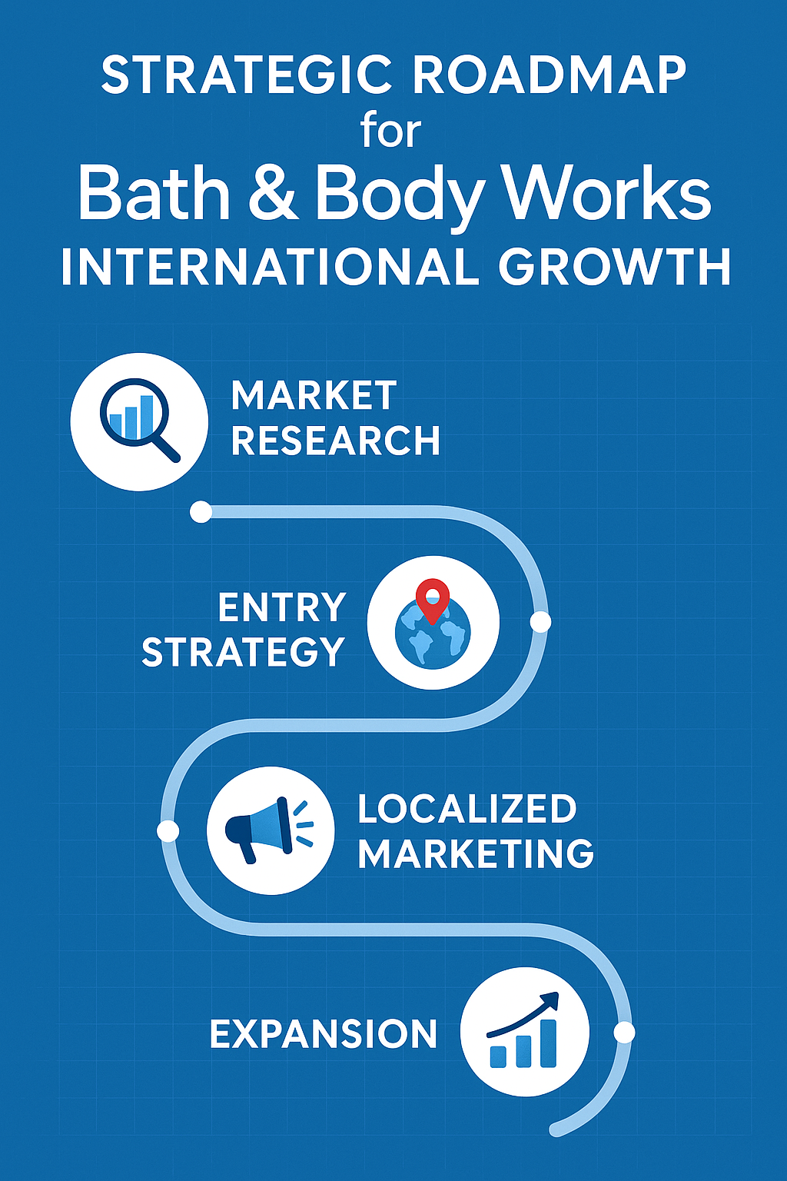
https://www.pearson.com/store/p/marketing-management/P100000905756

References
Ansoff, H.I. (1957) ‘Strategies for diversification’, Harvard Business Review, 35(5), pp. 113–124. Available at: https://hbr.org/1957/09/strategies-for-diversification (Accessed: 12 November 2025).
Barney, J. (1991) ‘Firm resources and sustained competitive advantage’, Journal of Management, 17(1), pp. 99–120. Available at: https://journals.sagepub.com/doi/10.1177/014920639101700108 (Accessed: 13 November 2025).
Barney, J. (1991) Firm Resources and Sustained Competitive Advantage. Journal of Management, 17(1), pp. 99–120. Available at: https://josephmahoney.web.illinois.edu/BA545_Fall%202022/Barney%20%281991%29.pdf (Accessed: 13 November 2025).
Bath & Body Works, Inc. (2023) Annual Report 2023. Columbus, OH: Bath & Body Works, Inc. Available at:
https://www.bathandbodyworks.com/on/demandware.static/-/Library-Sites-BathAndBodyWorksSharedLibrary/default/dw7c48b55a/corporate/BBW_2023_Annual_Report.pdf (Accessed: 14 November 2025).
BCG (1970) The Product Portfolio. Boston: Boston Consulting Group. Available at:
https://www.bcg.com/publications/1970/product-portfolio (Accessed: 18 November 2025).
Euromonitor International (2023) Global Beauty and Personal Care Industry Report. London: Euromonitor International. Available at:
https://www.euromonitor.com/beauty-and-personal-care (Accessed: 20 November 2025).
Euromonitor International (2023) The World Market for Beauty and Personal Care. Available at:
https://www.euromonitor.com/the-world-market-for-beauty-and-personal-care/report (Accessed: 22 November 2025).
Hill, C.W.L., Schilling, M.A. and Jones, G.R. (2020) Strategic Management: Theory & Cases. 13th edn. Boston: Cengage Learning. Available at:
https://www.cengage.uk/c/strategic-management-theory-cases-13e-hill/ (Accessed: 25 November 2025).
IBISWorld (2023) Bath & Body Works Industry Report. Available at:
https://www.ibisworld.com/united-states/company/bath-body-works-inc/405833/ (Accessed: 28 November 2025).
Johnson, G., Scholes, K. and Whittington, R. (2023) Exploring Strategy. 13th edn. Harlow: Pearson Education. Available at:
https://www.pearson.com/en-gb/subject-catalog/p/exploring-strategy/P200000006173 (Accessed: 1 December 2025).
Kotler, P. and Keller, K.L. (2022) Marketing Management. 16th edn. Harlow: Pearson Education. Available at:
https://www.pearson.com/store/p/marketing-management/P100000905756 (Accessed: 2 December 2025).
Kotler, P. and Keller, K.L. (2022) Marketing Management. 16th edn. Pearson. Available at:
https://eprints.upjb.ac.id/id/eprint/167/1/A%20Framework%20for%20Marketing%20Management%20by%20Philip%20T%20Kotler%2C%20Kevin%20Lane%20Keller%20(z-lib.org)
.pdf (Accessed: 5 December 2025).
Mintel (2023) Beauty and Personal Care Market Insights. Available at:
https://www.mintel.com/insights/beauty-and-personal-care/ (Accessed: 12 December 2025).
Porter, M.E. (1985) Competitive Advantage: Creating and Sustaining Superior Performance. New York: Free Press. Available at:
https://www.hbs.edu/faculty/Pages/item.aspx?num=193 (Accessed: 12 December 2025).
Porter, M.E. and Kramer, M.R. (2019) ‘Creating shared value’, Harvard Business Review, 97(1), pp. 65–76. Available at:
https://hbr.org/2011/01/the-big-idea-creating-shared-value (Accessed: 13 December 2025).
Schoemaker, P.J.H. (1995) ‘Scenario planning: A tool for strategic thinking’, Sloan Management Review, 36(2), pp. 25–40. Available at:
https://sloanreview.mit.edu/article/scenario-planning-a-tool-for-strategic-thinking/ (Accessed: 13 December 2025).
Statista (2024) Beauty & Personal Care – Pakistan Market Insights. Hamburg: Statista. Available at:
https://www.statista.com/outlook/emo/beauty-personal-care/personal-care/pakistan (Accessed: 13 December 2025).
World Bank (2024) Pakistan Economic Update. Washington, DC: World Bank. Available at:
https://www.worldbank.org/en/country/pakistan/publication/pakistan-economic-update (Accessed: 13 December 2025).

