Student Name: Laura Balu  Student ID: 2232556  Module Title: Foreign Languages and Cultural Awareness LEVEL 5  Module Code: 5003  Lecturer: Heidi Prosser  Date: 03/02/2024 | 
ASSIGNMENT 1: PORTFOLIO
(4 Components)

Component 1: Professional Reflection (500 words +/- 10%)

Weighting: 25%
In the hotel sector, cultural misunderstandings can arise from differences in language, habits, and beliefs. These misconceptions may have serious repercussions, including upsetting visitors, harming the hotel's reputation, and maybe resulting in legal action. Consequently, workers in the hospitality sector must cultivate cultural awareness and compassion for clients from various cultural backgrounds.
One scenario in which an F&B employee might have a cultural misunderstanding with a hotel guest is when the guest orders a dish that contains ingredients that are not permissible in their culture. For instance, while having dinner in a local restaurant a Muslim couple ordered by mistake a dish containing pork, which is forbidden in Islam, and the servant unaware of the dietary restriction brought the food immediately, after bringing the food the guest asked what the ingredients are saying that it looked delicious and they will like to try to prepare it home, the waiter starts saying the ingredients between which there was pork as well, the guest felt very embarrassed and stopped eating, explaining to the servant that they can’t eat pork meat, I could see the servant feeling very bad started apologies, you could see that he didn’t know, and it wasn’t intentional, he brought straight away them halal speciality, apologising again for the misunderstanding. Another scenario is when the employee uses a phrase that is considered polite in their culture but impolite in the guest’s culture. For example, in some cultures, it is customary to address guests by their first name, while in other cultures, it is considered disrespectful.
Research conducted by Overproof (2020) found that cultural sensitivity is crucial for hospitality professionals to avoid making poor judgements that might have far-reaching effects. As a hospitality sector employee, I must learn to be culturally sensitive and empathic with clients from diverse backgrounds to avoid miscommunications of this kind. Finding out about the guest's nation's history, present events, customs and beliefs is one method to accomplish this. For instance, when a Japanese visitor stays at a hotel in the UK, I can learn about Japanese habits and culture, such as bowing to show respect, taking off shoes before entering a room, and eating with chopsticks. By doing this, I may prevent future cultural blunders and cultivate a sincere openness and empathy with people from different backgrounds.
To further enhance my skills in preventing cultural misunderstandings, I aim to develop a deeper understanding of frameworks such as Trompenaars and Hampden-Turner's Seven Dimensions Model and Hofstede's Cultural Dimensions, which is another technique to cultivate cultural sensitivity. Cultural influences that have been identified by Hofstede and de Mooij (2010), include power distance, individualism vs collectivism, masculinity against femininity, avoiding unpredictability, and long-term versus short-term orientation. As described by Sonawane (2020), the Trompenaars and Hampden-Turner's Seven Dimensions Model includes the following: achievement versus ascription, neutral versus emotional, specific versus diffuse, universality versus particularity, individuality versus communism, sequential versus synchronised, and internal versus external influence (Trompenaars and Hampden-Turner, 1998). By understanding these frameworks, I can develop a deeper understanding of how cultural differences affect organizational behaviour, and how to adapt my behaviour accordingly.

References:
- de Mooij, M. and Hofstede, G. (2010) ‘The Hofstede model: Applications to global branding and advertising strategy and research’, International Journal of Advertising, 29(1), pp. 85-110. [Accessed 22/01/2024]
- Eurac. (n.d.). How Hofstede & Trompenaars Models Of Cultural Dimensions Apply To Global Leadership. European Academy for Executive Education [Accessed 22/01/2024]
- Overproof. (2020, June 15). The Importance of Diversity in Hospitality. Retrieved January 22, 2024, from Overproof website: https://overproof.com/2020/06/15/the-importance-of-diversity-in-the-hospitality-industry/ [Accessed 22/01/2024]
- Reisinger, Y., & Turner, L. (2012). Cross-cultural behaviour in tourism. Routledge. [Accessed 22/01/2024]

Component 2: Training Plan (500 words +/- 10%)

Weighting: 25%

Identified cultural misunderstanding (in a few words) :
Interactions between people from various cultures might lead to cultural misunderstandings. Language, cultures, attitudes, and beliefs can all be different from one another and lead to these misconceptions. It's critical to acquire certain abilities and modify conduct in order to avoid future cultural misunderstandings
Training plan (Why/What//Who/Where/When):
Having cross-cultural communication skills is one method to avoid cultural misunderstandings. Learning about many cultures and their traditions, ideals, and beliefs can help achieve this. Additionally, it's critical to have excellent communication skills with individuals from diverse cultural backgrounds. This entails developing your ability to ask questions, listen intently, and clear up misconceptions. For instance, rather than assuming anything about a guest's request, staff should seek clarification.
Developing cultural awareness is another strategy to avoid cultural misunderstandings. This entails having an open mind to learning about different cultures as well as being conscious of your own cultural prejudices and presumptions. Additionally, it's critical to respect other cultures and refrain from generalising or creating preconceived notions about individuals from other cultures. Employees should refrain from assuming, for instance, that a guest has food limitations only because of their cultural background.
It is crucial to participate in cross-cultural training in order to acquire these abilities and modify these behaviours. Numerous formats, such as online courses, seminars, and workshops, are available for this instruction. The goal of the training should be to provide participants the abilities and information needed to communicate effectively with persons from other cultural backgrounds. For instance, role-playing activities simulating interactions with visitors from other cultures might be incorporated into the training.
Putting the Training Plan into Practice: The plan has to be put into practice in a way that works for every employee. This might entail offering online training courses that staff members can do at their own pace or arranging for training sessions to take place during regular business hours. To make sure that every employee is aware of the training options accessible to them, the training programme should be shared with them all. For instance, an email or a staff meeting might be used to introduce the training programme.
Assessing the Training Programme: It's critical to assess the training program's efficacy following its implementation. Evaluations, surveys, and other forms of feedback are useful for this. The training programme can be modified as necessary to make sure it is accomplishing the training objectives in light of the feedback that has been obtained. For instance, more training can be required if staff members continue to have cultural misconceptions following the training session.

References:
- Amirtharaj, B., Cross, K. R., & Vembar, V. (2011). Role of training and development in promoting the growth of hospitality industry. International Journal of Management (IJM), 2(1), 126-133.
- Iguchi, Y. (2017). Understanding cultural differences in hospitality. Insights
- Tsiopanis, A. (2021). The effectiveness of staff training practices in the hotel industry

Component 3: Student Self-Reflection (500 words +/- 10%)

Weighting: 25%
The hospitality industry places considerable importance on cultural awareness as it creates a warm friendly atmosphere, encourages great guest experiences, and protects the long-term viability and good name of companies in a world where diversity is growing.
Reflecting on my understanding of cultural awareness in the hospitality business using Gibbs' Reflective Cycle model, I can identify six steps: description, feelings, assessment, analysis, conclusion, and action plan.
Description: As an employee in the hotel sector, I've learned how important cultural sensitivity is to the company. It implies appreciating and valuing the distinctions and connections among many cultural traditions and applying this understanding to develop inclusive infrastructure and communication.
Feelings: As time went on, I came to understand that cultural understanding goes beyond simply being politically right or kind. It involves learning about other cultures, beliefs, and customs as well as their language and communication techniques to establish a welcoming atmosphere where everybody feels respected and comfortable regardless of cultural background. By doing this, we might be able to get rid of misconceptions and poor communication, making the environment more accepting and accessible for everyone.
Evaluation: I've discovered that serving a diverse clientele may increase sales and eliminate workplace prejudice. Organizations may create a more courteous and inclusive workplace by teaching employees about diverse cultures and practices. Companies may draw in a more varied clientele and develop an inclusive work environment.
Analysis: Cultural awareness has helped me better to understand the needs of my customers and colleagues. For example, I now know that many nations and faiths have very specific dietary laws, such as Halal, Kosher, and vegetarianism. By adding to the regular foods, and dishes that suit these requirements, I can guarantee that everyone will feel welcome and valued. Another example would be designating specific areas in the workplace for prayer that are open to people of all religions, as well as keeping track of dates that have cultural significance on the calendar—especially when they fall on days other than state holidays.
Conclusion: In conclusion, cultural awareness is essential in the hospitality industry because it fosters inclusivity, enhances customer satisfaction, and creates meaningful connections with visitors from around the world. By embracing cultural diversity, the industry can benefit from fresh approaches, enhanced problem-solving, improved decision-making, and creative ideas by embracing cultural diversity.
Action Plan: I can better understand the requirements and preferences of my clients and coworkers if I actively seek out chances to learn about various cultures and practices. This might involve taking classes on cultural sensitivity and understanding, reading books or articles about various cultures, or going to cultural events. I can make the place more hospitable and inclusive for everyone if I am considerate of and sensitive to the wants and desires of others.

References:

- Adeani, I.S., Febriani, R.B., & Syafryadin, S. (2020). Using Gibbs' Reflective Cycle in Making Reflections of Literary Analysis. Indonesian EFL Journal, 6(2), 1-10.
- Complete Hospitality Training. (2024). Understanding Cultural Awareness in Hospitality. [online] Available at: https://cht.edu.au/news/understanding-cultural-awareness-in-hospitality [Accessed 22 Jan. 2024]
- Regenstein, J.M., Chaudry, M.M. and Regenstein, C.E. (2003). The Kosher and Halal Food Laws. Comprehensive Reviews in Food Science and Food Safety, 2(3), 111-127. doi:10.1111/j.1541-4337.2003.tb00018.x

Component 4: Training Presentation (6 Slides)

Weighting: 25%
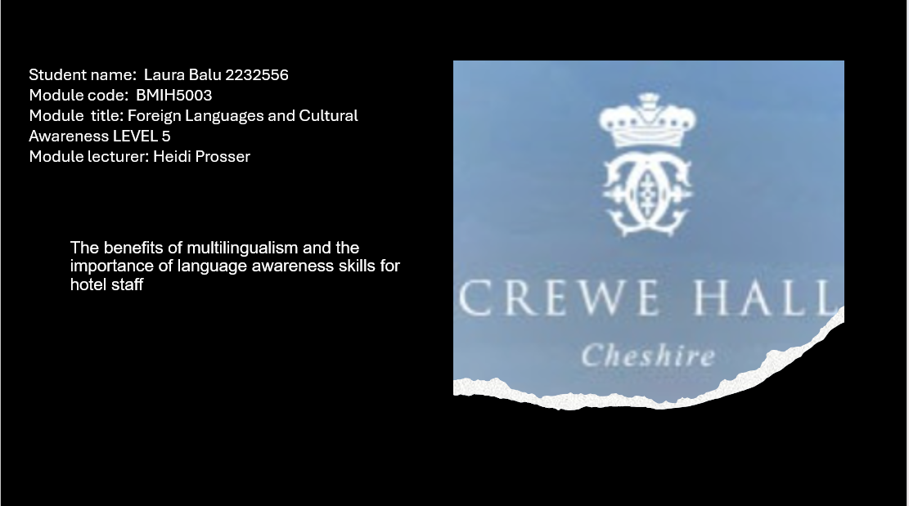
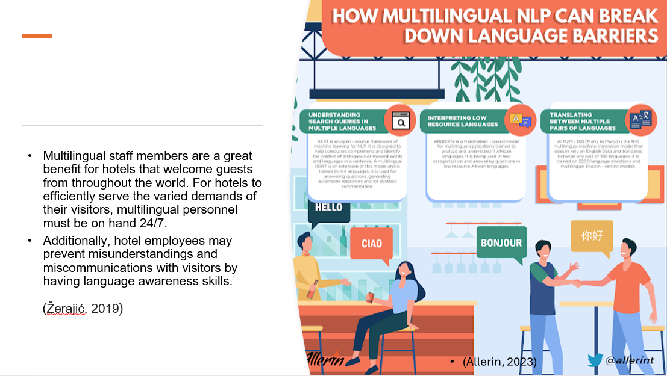
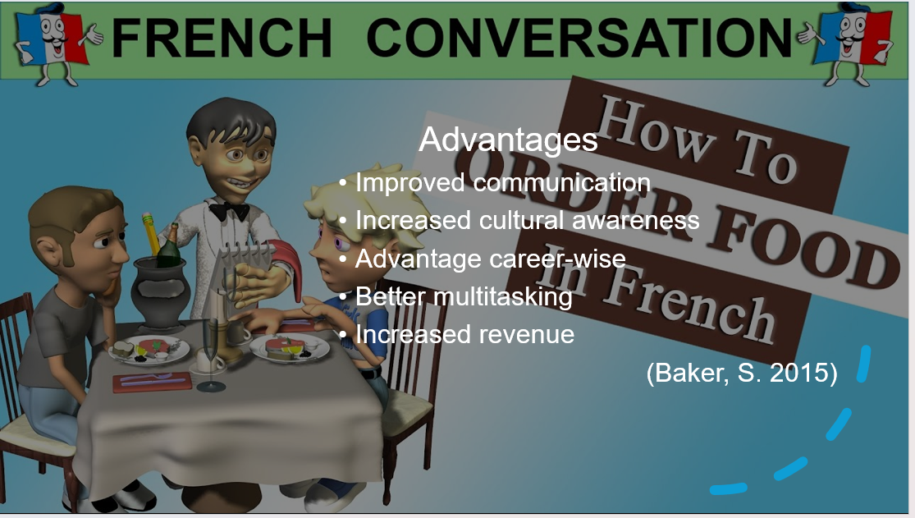
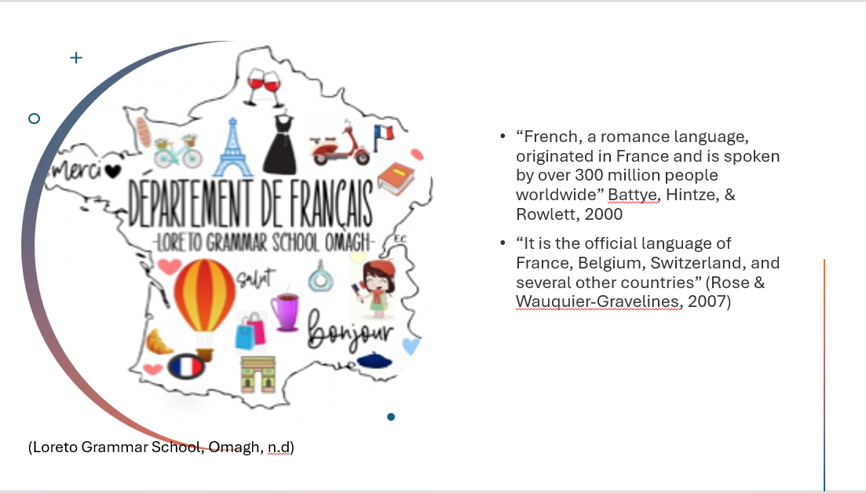
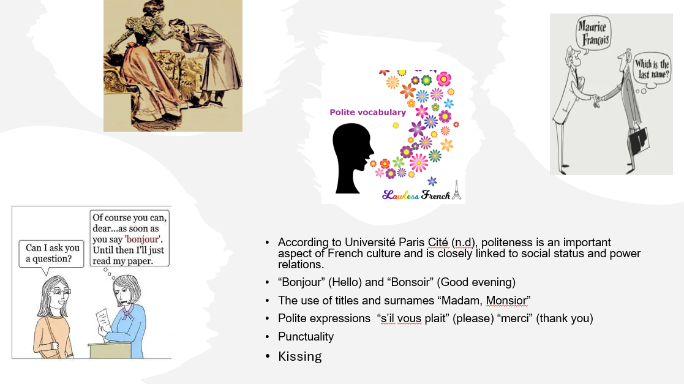
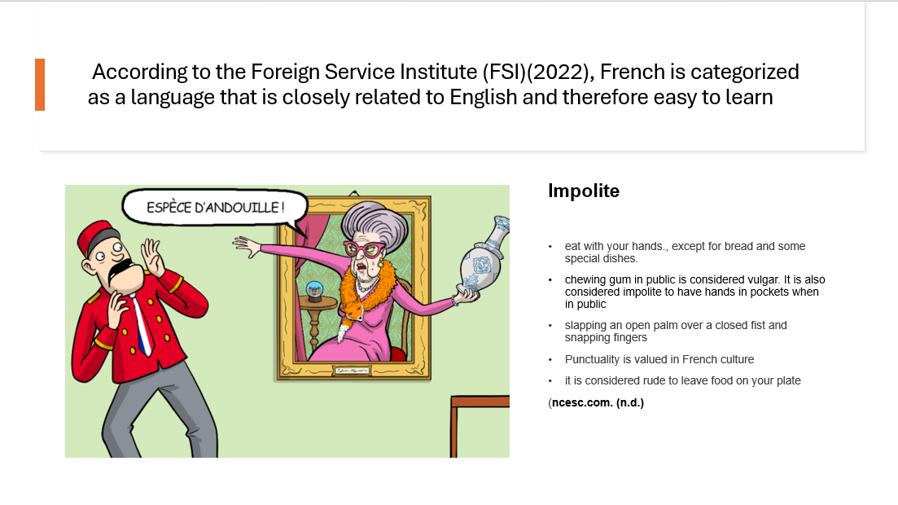
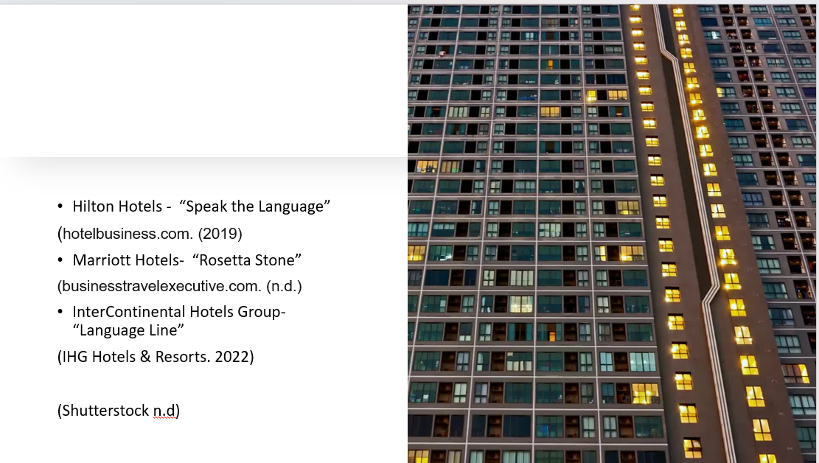
References (no screenshots):
Baker, S. (2015). Hospitality Management and Organisational Behaviour. Routledge
Battye, A., Hintze, M.-A., & Rowlett, P. (2000). The French Language Today: A Linguistic Introduction (2nd ed.). Routledge
CCFS Cours de civilisation française de la Sorbonne. (n.d.). French Courtesy and Social Rules: Examples of Cultural Specificities. CCFS Cours de civilisation française de la Sorbonne. Retrieved from https://www.ccfs-sorbonne.fr/en/french-courtesy-and-social-rules-examples-of-cultural-specificities/
Curious Rambler. (2017, August 10). It Pays to Be Polite in France. Curious Rambler. https://curiousrambler.com/it-pays-to-be-polite-in-france/
Etiquipedia. (2015, August 1). Etiquette and Thinking French. Etiquipedia. Retrieved from https://etiquipedia.blogspot.com/2015/08/etiquette-and-thinking-french.html?m=0
FSI. (2022). FSI Language Difficulty Ranking. [Online] Available at: https://www.fsi-language-courses.org/blog/fsi-language-difficulty/ [Accessed 25 Jan 2024].
hotelbusiness.com. (2019). Hilton Enlists Help to Bridge Language Gap. [online] Available at: https://hotelbusiness.com/hilton-enlists-help-to-bridge-language-gap/ [Accessed 25 Jan. 2024]
IHG Hotels & Resorts. (2022). IHG Hotels & Resorts’ Skills Academy goes global. [online] Available at: https://www.ihgplc.com/en/news-and-media/news-releases/2022/ihg-hotels-and-resorts-skills-academy-goes-global [Accessed 25 Jan. 2024].
J’Ouellette. (n.d.). French Business Etiquette IQ. J’Ouellette. Retrieved from https://learnparisianfrench.j-ouellette.com/french-business-etiquette-iq/
Lawless, L. (n.d.). French Politeness - Essential French - Politeness Vocabulary. Retrieved January 24, 2024, from Lawless French website:
Loreto Grammar School, Omagh. (n.d.). Overview - French. Retrieved January 24, 2024, from Loreto Grammar School website:
ncesc.com. (n.d.). What is Polite and Impolite in France? [online] Available at: https://www.ncesc.com/geographic-faq/what-is-polite-and-impolite-in-france/
Rose, Y., & Wauquier-Gravelines, S. (2007). French speech acquisition. In The international guide to speech acquisition (pp. 364-384)¹
Shutterstock. (n.d.). Hotel Reception Luggage. Shutterstock. Retrieved from https://www.shutterstock.com/vi/search/hotel-reception-luggage
Université Paris Cité. (n.d.). Cultural Tips during your stay in France. Retrieved January 24, 2024,
Verschik, A. (2018). Language Contact, Language Awareness, and Multilingualism. In Encyclopedia of Language and Education. Springer.
Žerajić, A. (2019, June). Intercultural management and the importance of foreign languages in modern hotel industry. In Tourism International Scientific Conference Vrnjačka Banja-TISC (Vol. 4, No. 1, pp. 360-377).

