3000 year old pot reveals culinary disaster

Denmark is a country rich in archaeological finds, with discoveries such as treasure troves of gold, coins, and jewellery, the remains of Viking ships, and bodies found in bogs such as the famous Tollund Man. The country has the perfect natural conditions for the preservation of such historical gems due to a cold, unvarying climate and its boggy wetlands which have offered up some exciting and rare examples for archaeologists to share with us all.
In 2016, in the hilly wetlands north of Silkeborg in Central Jutland in Denmark, a team of archaeologists headed up by Kaj F. Rasmussen made and exciting yet surprising discovery.
The team working at the dig found a waste pit which contained a fully intact 3000 year old Bronze Age clay cooking pot, and inside it was a residue which seemed to be burnt into the pot.
According to Rasmussen (2016) the pot and its contents were in such good condition because very little oxygen or water was able to get to it due to being in a clay deposit within the pit, therefore it was kept in a constant state, at the optimal temperature, which preserved it.
Samples of the pot were sent to the National Museum of Denmark in Copenhagen for analysis by chemist Mads Chr. Christensen, and he reported that the deposit inside the pot seemed to be burnt cheese.
Rasmussen (2016) tells us that the usual finds in pots are normally charred deposits of grains, but in this case there was a white-yellow crust that he hadn't seen before. The find was very exciting for the team as it is rare to dig up and item dating from the Bronze Age that is made from clay and in such good condition, and not in pieces requiring reconstruction, as is the usual case with such finds. To then discover that the contents of the last meal cooked in it were still inside made the find a very special one.
As for the story behind the pot of burnt cheese, it seems that family life and little domestic accidents 3000 years ago were not too different to those of nowadays, and a burnt pot cannot be easily salvaged whether it is made of clay or Pyrex, the problem is the same thousands of years apart.

" It's well and truly burnt and must have smelt terrible.
Perhaps there was a little family drama? You can almost imagine
How quickly he must have acted to get rid of that pot!"

(Rasmussen 2016)

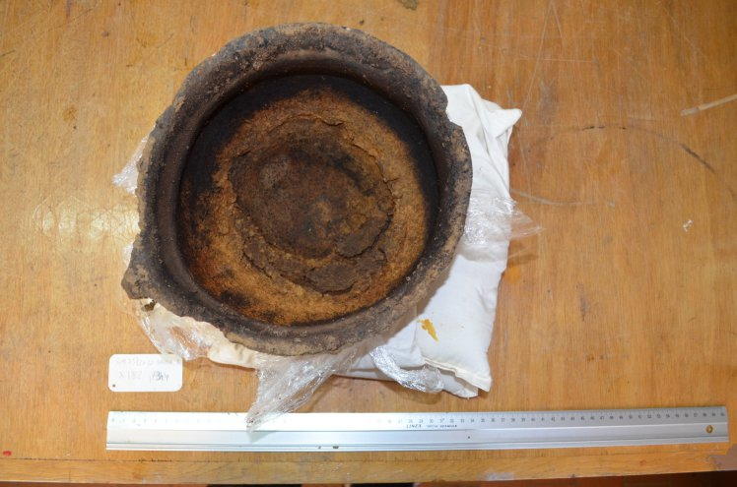
Courtesy Museum Silkeborg

The pot is now on display in the Museum Silkeborg, Denmark where Rasmussen is curator.

References

Beck, M A. 2016. ScienceNordic.com. [http://sciencenordic.com/burnt-cheese-casts-light-3000-year-old-family-drama] [Accessed:16th February 2018]

