Object biography

Introduction
This object is a fragment of spun clay pottery, around 7cm x 8.4cm x 0.7cm. One side is an unglazed light brown colour, and the other is covered in a greeny-brown glaze the clay for the pot also transitions towards a light grey colouring on the the glazed side. This fragment has ridges in circles. It is likely that this fragment was originally a circular piece, with at least a 9cm diameter, especially due to the way the circles seem to continue past where the item has been broken. The edges are smooth, indicating some form of erosion. It was found around Magor Pill in South Wales. The bag the pottery comes in describes it as a ‘c18th bristol/Staffordshire custard cup’.
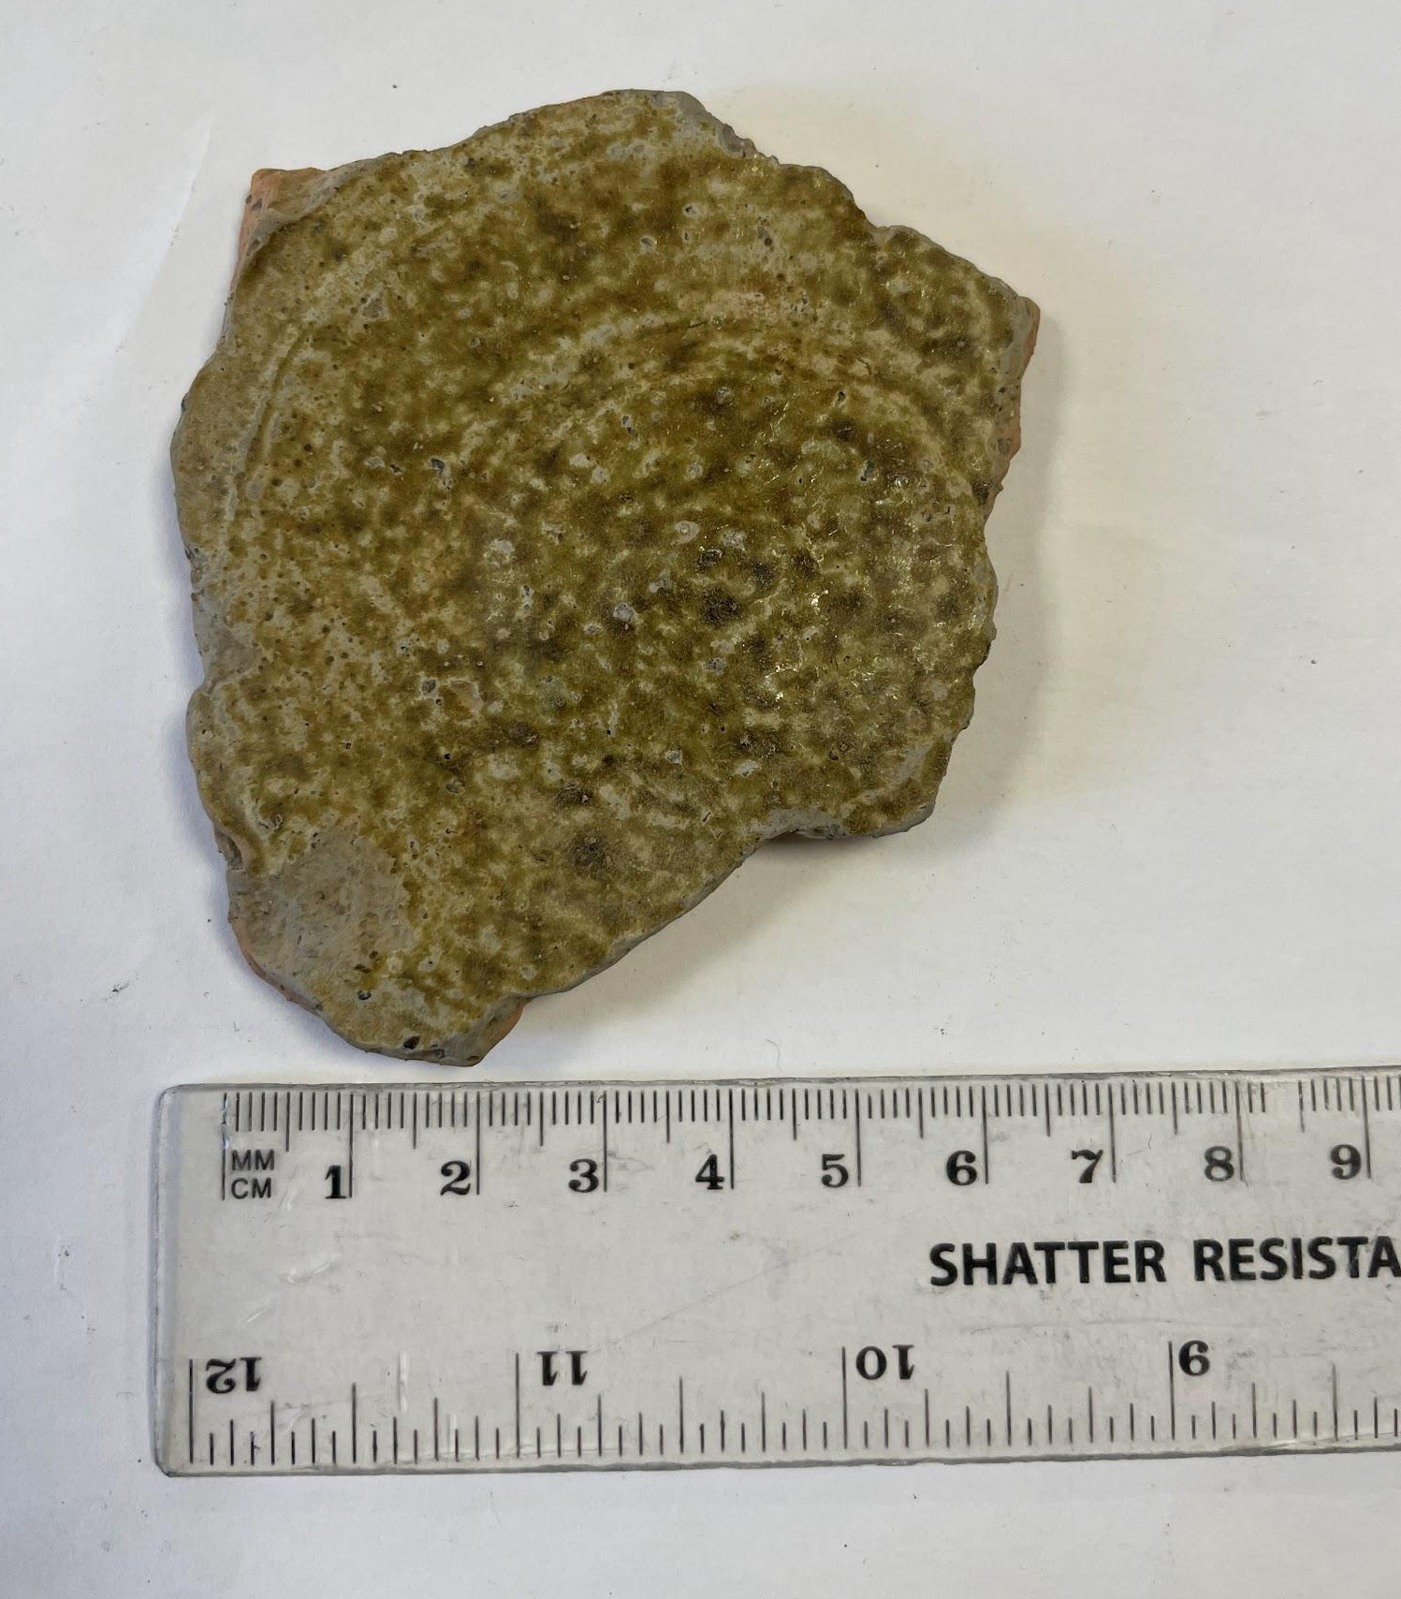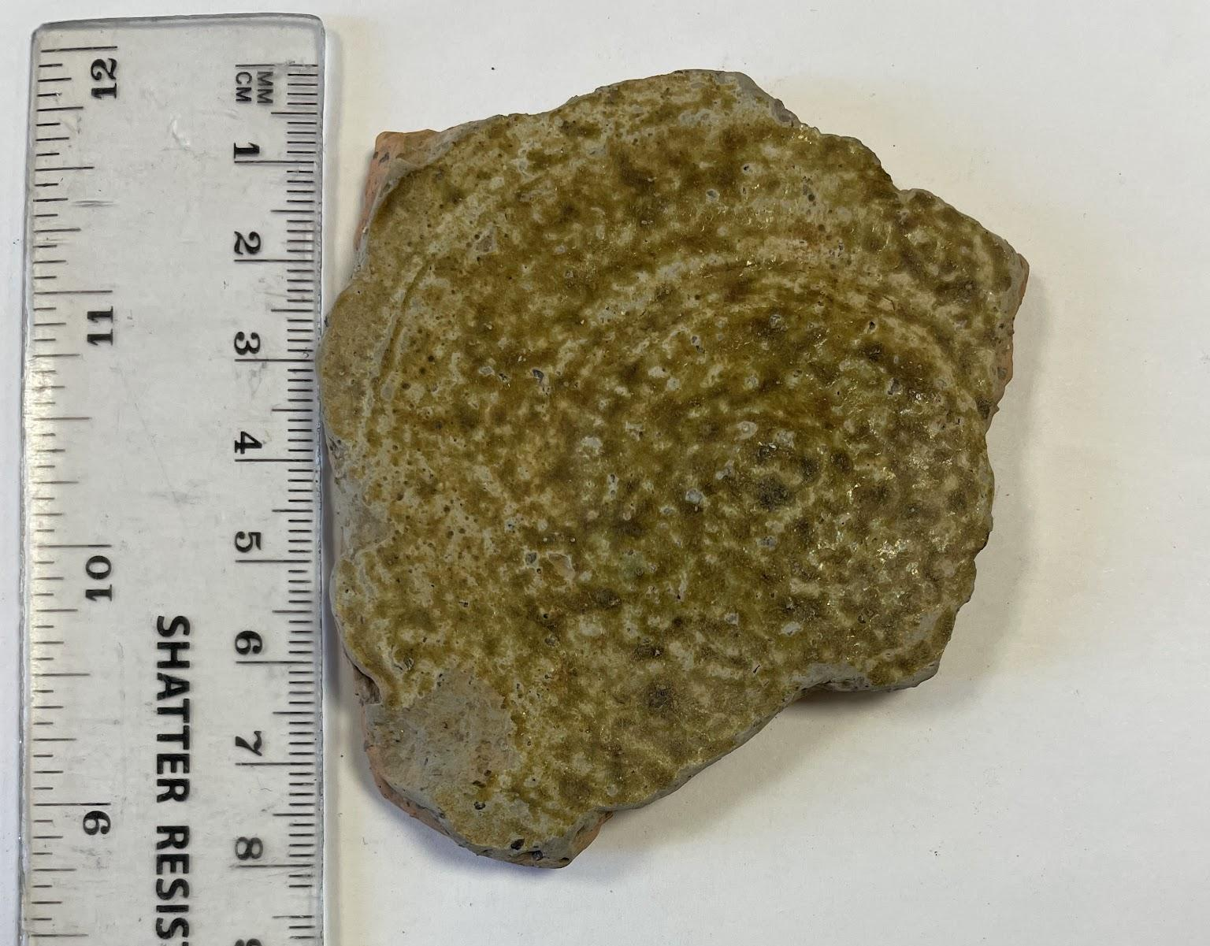
Above left: an image of the fragment with a ruler measuring its horizontal width
Above right: an image of the fragment with a ruler measuring its vertical width

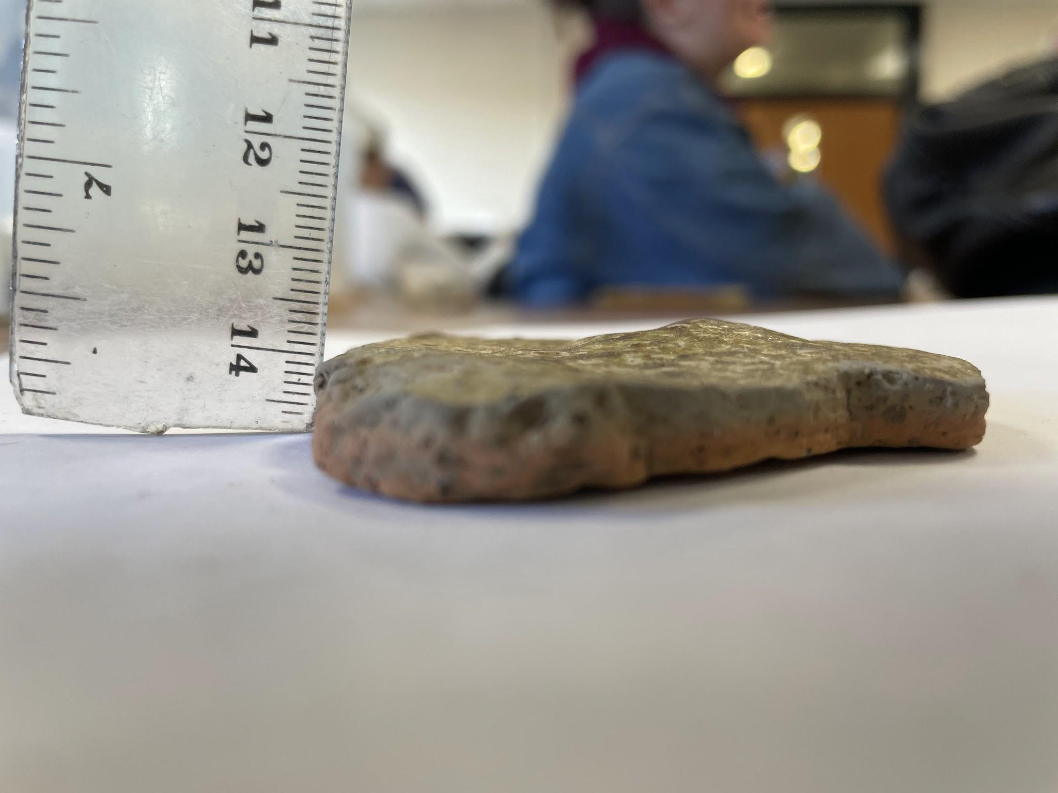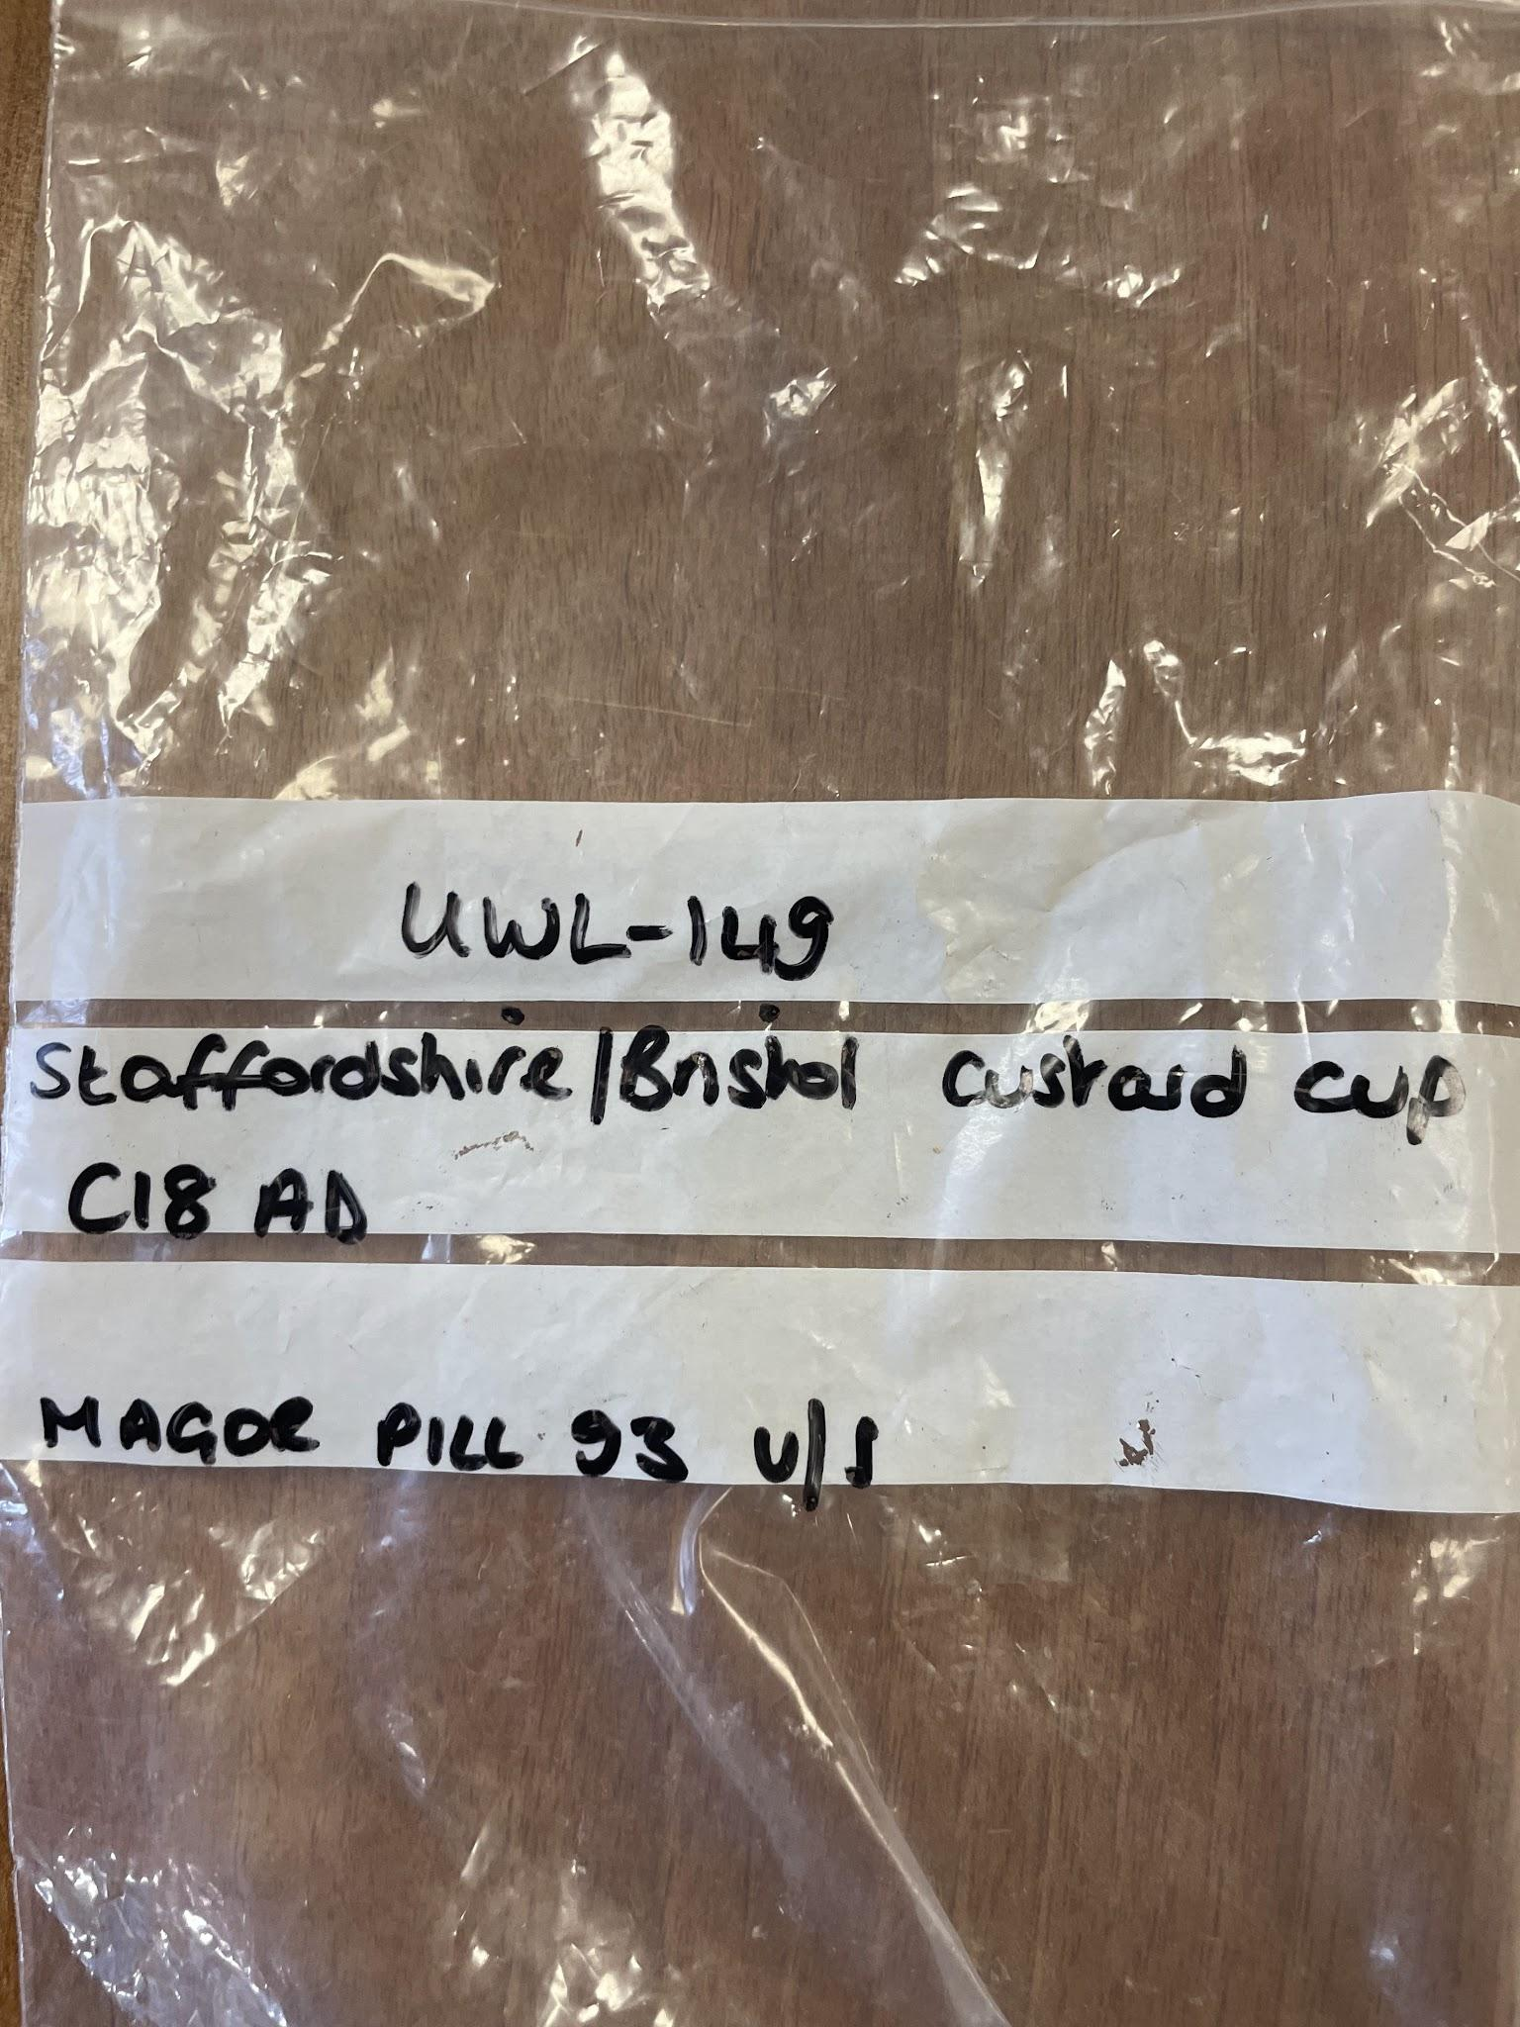
Above left: an image depicting the height of the fragment
Above right: the bag identifying the fragment of pottery

Production
This pot is an example of Staffordshire or bristol ware. Staffordshire ware was popularly distributed in the 18th century across the UK. It is not surprising that the pottery was found in the Magor Pill estuary, as this is in the area surrounding the border between England and Wales, towards Bristol, meaning that this wasn't a large trade area. It is made from an orange-brown clay with a large amount of small inclusions. The clay itself also likely came from the Staffordshire area, as clay mining is extremely common in this area, even in modern times. The reason for these inclusions is likely to strengthen the pot’s structure by reducing shrinkage. There are also some markings of damage in the clay in small, rectangular indents. These don't seem to have been made after the pot was fired, so must have been made whilst the clay was being made. This also indicates the quality of the pot and the status of the individuals who owned it, as it would have reduced the pricing.
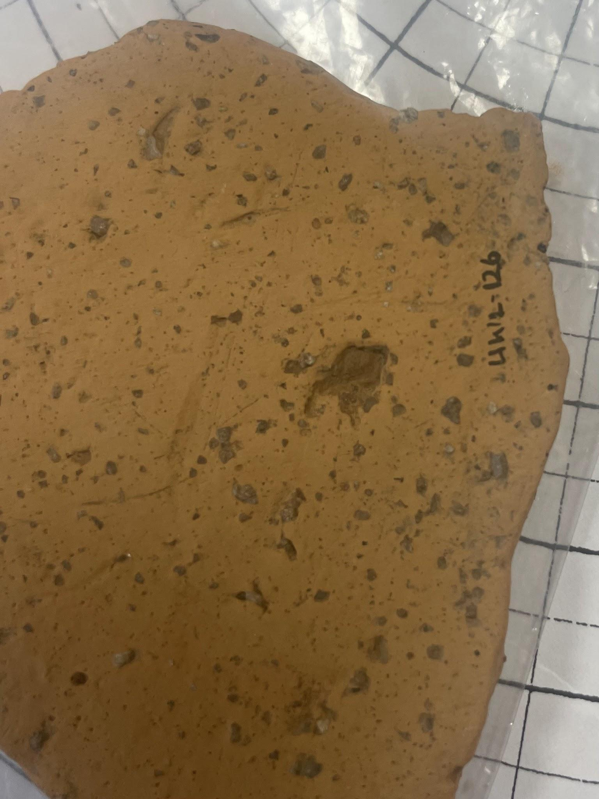Left: an image of the back of the piece of pottery, with the UWL identification number present.
The green colour of the glaze on the pottery is made through the inclusion of copper powders into the glaze, and occasionally lead powder to enhance the colour to a brighter green. Due to the muddiness of the colour in this fragment, it can be assumed that only a small amount of copper was likely used, with no lead. This could have been due to the changing styles of the period in which this item was found, with the brighter greens of the medieval period going out of style in preference to more red and beige decorations

Status/ function
This fragment has been identified as part of a bristol custard cup. These are cups with flat bases, used for serving desserts. It can, therefore, be assumed that this fragment of pot is the base of said cup. It is also possible that this is some form of lid, however, due to the lack of handles or edges to slot into a larger pot, this is unlikely. The use of this cup was likely not as an everyday item, but as some form of formal crockery. This can be seen from its impractical nature, the glazing and the high levels of decoration. However, for the 18th century, this item is not overly sophisticated or high class, due to the change in technologies and fashion of this era moving towards red earthenwares and Staffordshire slipwares, in comparison to the green glazed pottery so indicative of the medieval and Tudor periods. However, this pottery does fit many of the characteristics of late medieval transitional ware. The glaze's muddy colour and the high inclusions indicate that this item, while still a luxury item, was not a high-class or expensive one. It can be assumed that this was owned by a relatively middle-class family, as a formal ware. It is unusual that, if this fragment is the base of the cup, it looks like the inside of the cup was decorated quite intricately with repeating circle patterns and green glazing. Also, if this is a custard cup, it is quite large in comparison with what many contemporary fine items look like, as seen in the image below. 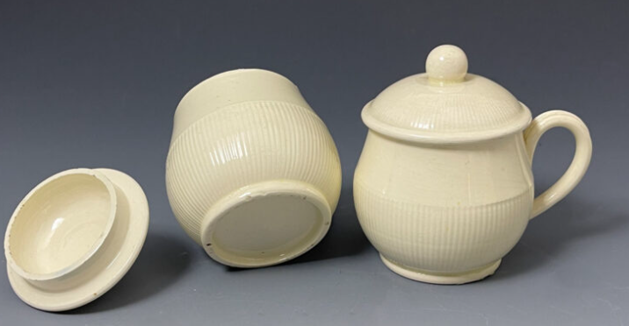
Above: an image of Wedgewood English creamware pottery custard cups
These custard cups are likely later editions, though still 18th century, being dated as 1780, and are instead from the Leeds area as a centre of production in contrast with Staffordshire, where this fragment is from, but still present a distinctly different picture from the ones which are found in the piece of pottery provided. There is a chance that this could be a mislabelling, or that this identifies a strong difference in the styles of pottery which remained intact (likely due to being more wealthy and having more ability to preserve items), and the ones which were destroyed, and therefore likely used by lower classes.
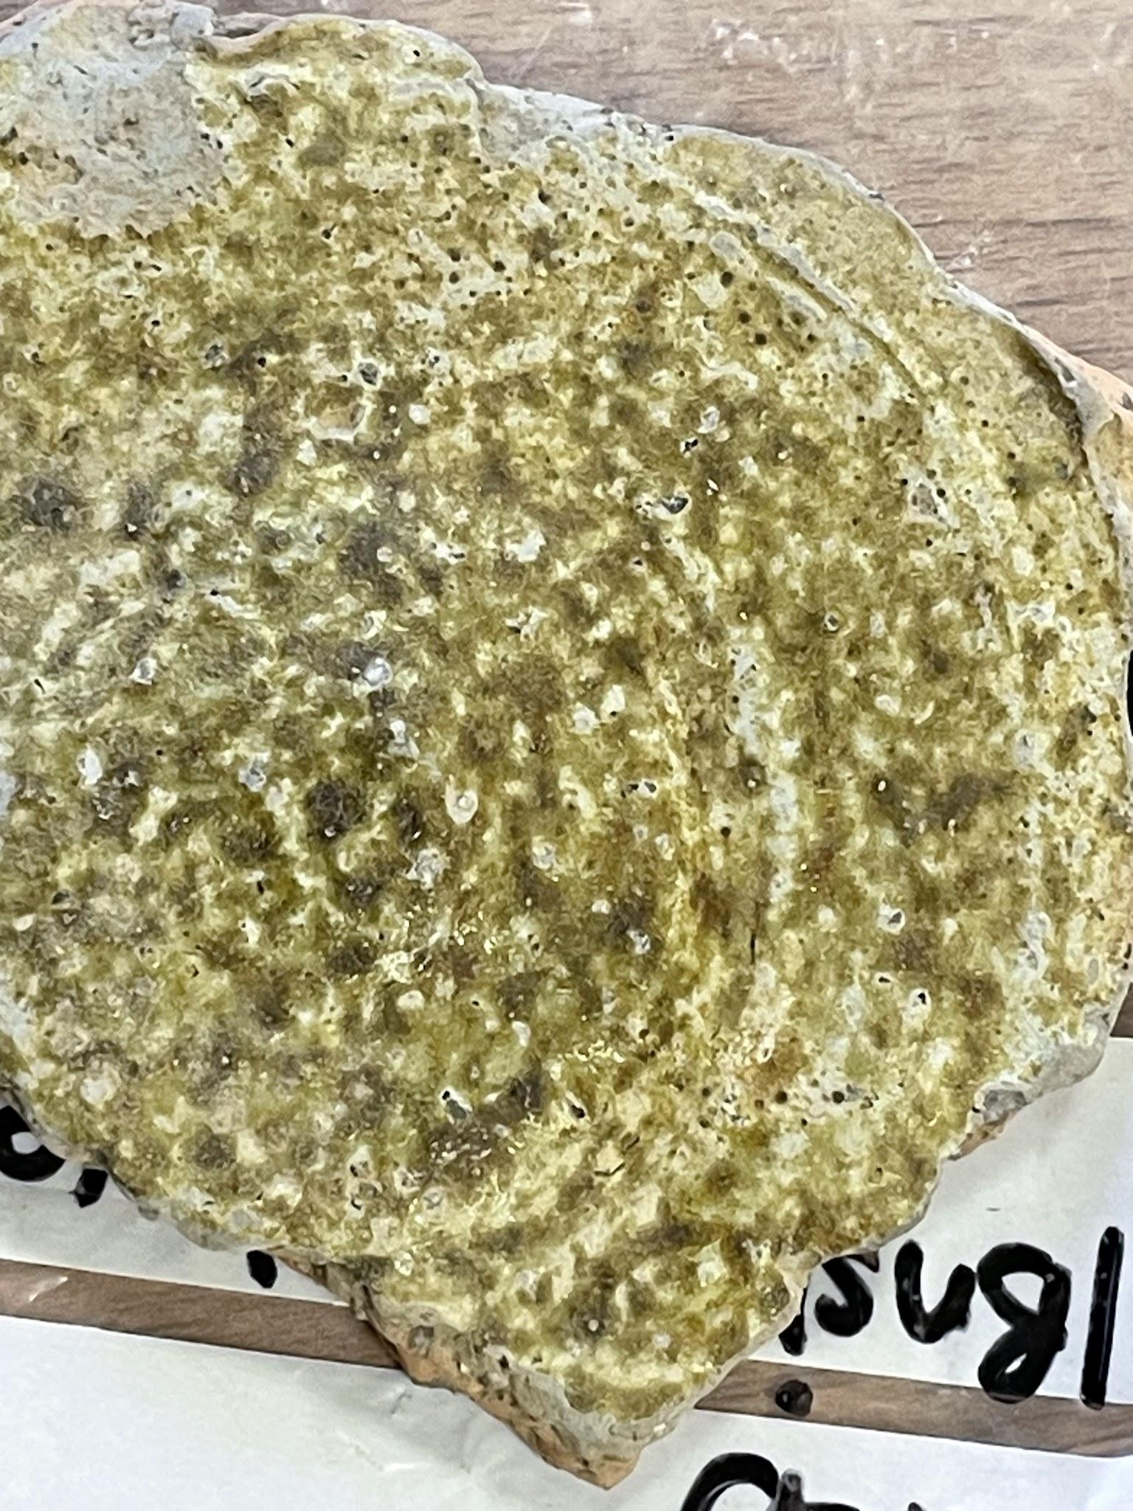 left: an image of the repeating circles and small holes in the pottery.

Condition
This item is a small fragment of what the original item would have been. The larger pot was likely broken, and then discarded. It has not been destroyed recently, as seen by the levels of erosion around the edges, and the cracks along the pottery. The repeating circle ridges found in the pot have also faded in their prominence in the pot. These ridges were likely more prominent and fully formed during the initial making of this custard cup, but they eroded after discard. Magor pill is an estuary, meaning that this pot could have been eroded by water, along with the minerals of the soil in which it was found. There is a multitude of small holes in the pot, indicating a form of erosion that includes either abrasions with a multitude of small stones or some form of dissolving of the material from being in the water for a long amount of time.

Conclusion
Minimal conclusions can be definitively drawn about the function or use of this product during its time as a whole object in its intended form, as it does not operate in the same paradigms for its period, or even particularly its identified structure, being far from the staffordshire slipware which this area is known for at this time. In contrast, it means that this pot is useful for understanding how the styles of pottery found in the late-medieval and post-medieval intersect through the transitional periods. It also shows some indication of the centres of production in the UK during this period and the transport of these materials. Along with this, it also has the potential to help identify the differences in the pottery which different classes were utilising during these periods, providing a wider context of the social history of this area. It must also be noted that the function of this item has changed drastically from its conception as a piece of pottery used for eating, likely in some formal contexts, to becoming a part of materials for teaching. This shows the changes which can occur from the intended use of an object to its meaning further along. Once this material is discarded from the teaching materials here, it will likely once again be discarded into the soil, to continue a lifeline of degrading into the soil and enriching its minerals.

Bibliography
Frag. 2021. “Pottery Identification - Peterborough Archaeology,” Peterborough Archaeology <https://peterborougharchaeology.org/archaeology-skills-techniques/pottery-identification/>

Millard, Shelby. 2023. “How To... Tell What Type Of Pot You’ve Got - the Medieval Dig Edition | DigVentures,” DigVentures <https://digventures.com/2016/02/how-to-tell-what-type-of-pot-youve-got-the-medieval-dig-edition/>
Museum, Horsham. 2022. “Medieval Ceramics,” Horsham Museum <https://horshammuseum.org/collections/blog/posts/medieval-ceramics>
“Pair of English Creamware Pottery Custard Cups with Covers Late 18th Century - John Howard.” 2022. John Howard <https://www.antiquepottery.co.uk/pair-of-english-creamware-pottery-custard-cups-with-covers-late-18th-century/>
Paul Blinkhorn, and L. Laing. [n.d.]. Pottery Identification Guide <https://digschool.org.uk/wp-content/uploads/2020/06/Pottery-Identification-Guide-DigSchool.pdf>
“Stoke-on-Trent Local History - Resources: Water, Clay, Coal Etc.” <https://www.thepotteries.org/local_history/2.htm>
Williams, Kip. 2025. an image of the fragment with a ruler measuring its horizontal width
Williams, Kip. 2025. an image of the fragment with a ruler measuring its vertical width
Williams, Kip. 2025. an image depicting the height of the fragment
Williams, Kip. 2025. the bag identifying the fragment of pottery
Williams, Kip. 2025. an image of the back of the piece of pottery, with the UWL identification number present.
Williams, Kip 2025. an image of the repeating circles and small holes in the pottery.

Frag, “Pottery Identification - Peterborough Archaeology,” Peterborough Archaeology, 2021 <https://peterborougharchaeology.org/archaeology-skills-techniques/pottery-identification/>.
Horsham Museum, “Medieval Ceramics,” Horsham Museum, 2022 <https://horshammuseum.org/collections/blog/posts/medieval-ceramics>.
Kip Williams, taken 6/02/2025
Kip williams, taken 6/02/2025
Kip Williams, taken 24/01/2024
Paul Blinkhorn and L. Laing, Pottery Identification Guide <https://digschool.org.uk/wp-content/uploads/2020/06/Pottery-Identification-Guide-DigSchool.pdf>.
Shelby Millard, “How to... Tell What Type of Pot You’ve Got - The Medieval DIG Edition | DigVentures,” DigVentures, 2023 <https://digventures.com/2016/02/how-to-tell-what-type-of-pot-youve-got-the-medieval-dig-edition/>.
Paul Blinkhorn and L. Laing, Pottery Identification Guide <https://digschool.org.uk/wp-content/uploads/2020/06/Pottery-Identification-Guide-DigSchool.pdf>.
“Stoke-on-Trent Local History - Resources: Water, Clay, Coal Etc.” <https://www.thepotteries.org/local_history/2.htm>.
Kip Williams, taken 24/01/2025
“Pair of English Creamware Pottery Custard Cups with Covers Late 18th Century - John Howard,” John Howard, 2022 <https://www.antiquepottery.co.uk/pair-of-english-creamware-pottery-custard-cups-with-covers-late-18th-century/>.

