Lee Davies
Student number: 1803540
BA Graphic Design
Module: Ways of Perceiving
Word Count: 1450

Tutors:
Julia Lockheart and Gwenllian Beynon, Scott Smith and Martin Bush, Ryan L. Moule and Rob Jones.

“Happiness is not an ideal of reason but of imagination” (Kant, 1998, p. 29)
Living in a Society that moves so fast in pursuing the ideology of owning things to gain happiness and where diversity is feared. One should take a moment to breath and absorb the words of Immanuel Kant who reminds us that Happiness is created within oneself, through self-acceptance and the freedom of self-expression. A wonderful example of this can be seen in people with Autism, although individuals with Autism encounter a number of problems with social interactions and can experience learning difficulties (Jordan, 2001). There is one quality that all Individuals with Autism portray and exhibit so well, this is the ability to truly focus on oneself (Baron-Cohen, 2005) without the fear of being judged by outsiders and the desire for irrelevant materialistic distractions.
With this in mind it is with great pleasure London’s very own Saatchi gallery presents to you for one day only a celebration of all things Autism, Promoting the work of a variety of artists all of which have been diagnosed with Autism Spectrum disorder (ASD). In addition, there will be a live inspiring talk from the influential Dr Temple Grandin who will be discussing the importance of diverse minds and how children with Autism can have good lives and thrive just as she has. There will be a live performance from Britain’s very own Susan Boyle who is promoting her new song “A Million Dreams”. Susan was diagnosed with ASD later in her life, as part of the exhibition she will be discussing the obstacles that came with living for so long without a diagnosis. Another feature of the exhibition will include a sensory room and numerous cosy corners for individuals to desensitise, cuddle up and cocoon themselves.
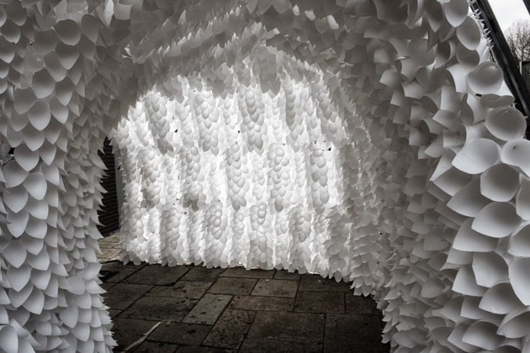

Figure 1. The Breathing Room, (Anna Berry, 2019)

Situated on the ground floor in Gallery two will be a beautiful contemporary piece by the talented artist Anna Berry, titled the Breathing Room. This was originally created as a political piece, mostly built from recycled paper. Since obtaining an unlimited research and development grant it has grown into something more than it was intended (Anna Berry, 2019). Evoking a multi-sensory experience, The Breathing Room is a fantastic addition to the exhibition as it submerges individuals within themselves to experience senses just as one with ASD may experience. Anna believes her work is heavily influenced by her own personal struggle with how she perceives the world (Fenn, 2018). As a person with ASD Anna will see and feel the world differently to a neuro-typical person (DuBois & Ameis, et al. 2016). This installation is a beautiful reminder for people of all diversities to take a moment to stop and breathe.
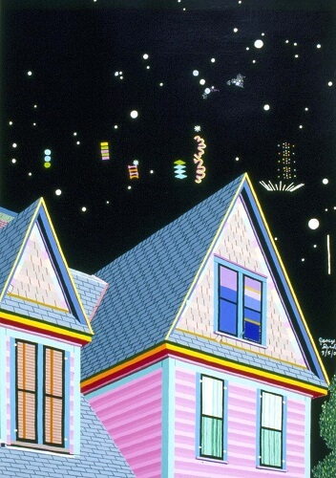

Figure 2. The House on 53 Cole Avenue, (Delmas-Glass, 2019).

On display on the ground floor in Gallery five is the work of the self-taught American ASD artist Jess Park. Her passion for Architecture and Astronomy can be seen in her work through a medium of bright captivating colours. There is also the book Exploring Nirvana: The Art of Jessica Park, which is a beautiful publication featuring some of Parks best work. The life of Jess was closely documented by her mother Clara Park who in 1967 wrote a book “The Siege”. This became a pioneering source of material for psychologists and psychiatrists with a truthful insight of the relationship between a mother and daughter with ASD. This was in a time when Psychologist Bruno Bettelheim was continuing to suggest that Autism was caused by lack of nurturing during early childhood (Jones, 2019). This theory was later dismissed by the psychologist Bernard Rimland, who was a loving father to a son with ASD (Casanova & Casanova, 2018). Clara Park frequently described Autism as a “Spectrum” long before it was ever labelled as a spectrum disorder and both her books are on sale at the exhibition where all profits generated from sales will be donated to National Autistic Society.

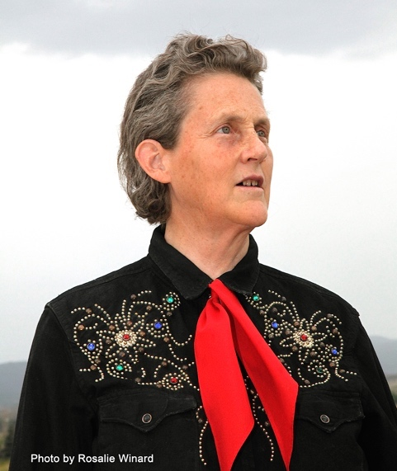

Figure 3. Photograph of Temple Grandin (Felini, 2019).

In the morning, guests will be treated to an inspiring talk located at Gallery three on the ground floor from the influential Dr Temple Grandin who is a pioneer of the livestock industry and a lead advocate in Autism research. Grandin openly credits ASD for giving her the unique style of thinking in the work place (Schmidt, 2018). Grandin will be discussing the importance of diverse minds and how important it is to not let labels define who we are, ensuring children with autism can have good lives and thrive just as she has. Before ASD was widely accepted many intellectually gifted children would have been given the title “gifted” (smith & Wadsworth, et al. 2016) instead are now labelled as less than a normal person or even disabled. This does pose the question are such labels having a negative effect on children with remarkable intellectual qualities, and if so, are labels holding back these children from reaching their full potential? Studies have shown that a range of special skills and qualities that individuals portray can be linked to ASD (Happe, 2018). This is just one reason why it is important to remember a person with ASD is no less than anyone without ASD.
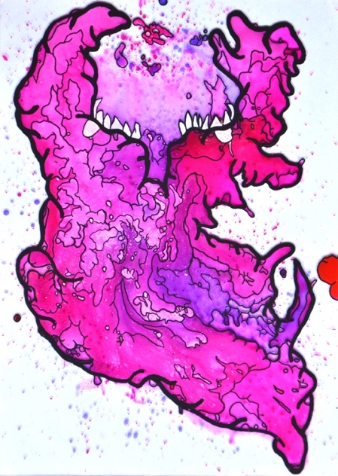

Figure 4. Painting of A Monster (Haydn Gardner) (Messymiscreations, 2019).

Located on the ground floor in gallery one will be the work of Haydn Gardner who has recently moved to Manchester and has ASD. Haydn Works mostly with inks to create paintings of monsters with metaphorical meaning. Exploring the relationship between people and mental health, Haydn’s work is inspired by thoughts, words and feelings of both himself and people around him (Messymiscreation, 2019). Through his artwork he attempts to create a physical manifestation of these relationships he discovers between people and their mental health. Mental health is a very serious concern in the U.K with one in six adults having a mental health disorder (mentalhealth.org), evidently, people are suffering. It is widely known that a good recovery method for mental health disorders is through self-expression, and there is arguably no better way of doing so than through creating art (Saavedra & Arias, et al. 2018). Haydn demonstrates a wonderfully empowering method of combining self-expression with handling feelings and mental health, by giving these negative feelings a face and shaping it in to a physical entity. He is not only expressing himself and releasing these feelings from within but also taking control and taking back the power. Once the art work is complete he has given himself choices as he can simply destroy the monster but instead chooses to display it to the world, this truly is a beautiful display of self-acceptance.
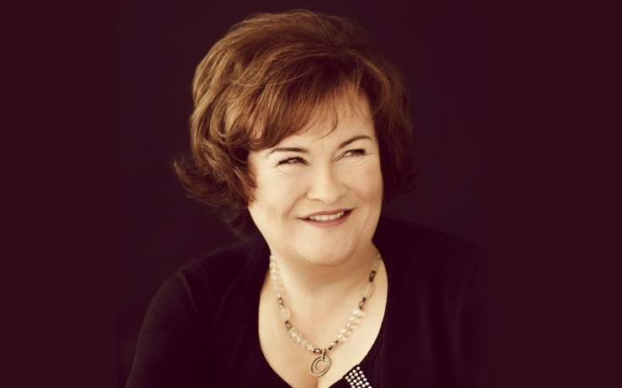

Figure 5. Photograph of Susan Boyle (Ecelebrityfacts, 2018).

The final performance of the night will be given by the one and only Susan Boyle, who will be performing her new Single “A Million Dreams”. Susan appeared on the tv show Britain’s got talent in 2009 captivating the judges with her audition singing I dreamed a dream and went on to finish the contest as runner up. Throughout her Career she has received some negative press due to her outbursts which can now be explained by her late ASD diagnosis. Until her diagnosis, Boyle put a lot of her behaviour issues and personality traits down to a misdiagnosis of brain damage due to being starved of oxygen at birth (Boyle, 2011). She has openly spoken about the problems she encountered whilst growing up as a child who was bullied and tormented, and when faced with adversity and obstacles, music was always there for her and singing was a great way to express herself through a creative output (Boyle, 2011). She has openly said that when she is on Stage, she feels happy and accepted (Harley, 2014). It would appear that through music Susan Boyle have not only found a way to be accepted but have gained world recognition as a talented individual with an exceptionally beautiful voice.
The importance of having the freedom to truly express oneself in order to feel happiness can’t be dismissed and the connection between self-expression and happiness cannot be ignored (Haller & Hadler, 2004). With this said, we look forward to celebrating all things Autism with you at the exhibition and hope we can contribute to your understanding of diversity and happiness, inspiring you to recognise your potential within. Please feel free to take advantage of the Cosy Corners provided if you feel overwhelmed or just want a moment to yourself. Additional pillows and blankets will be provided if necessary, for sensory stimulation or comfort. Lighting and sound can also be managed to suit your requirements within the cosy corner.

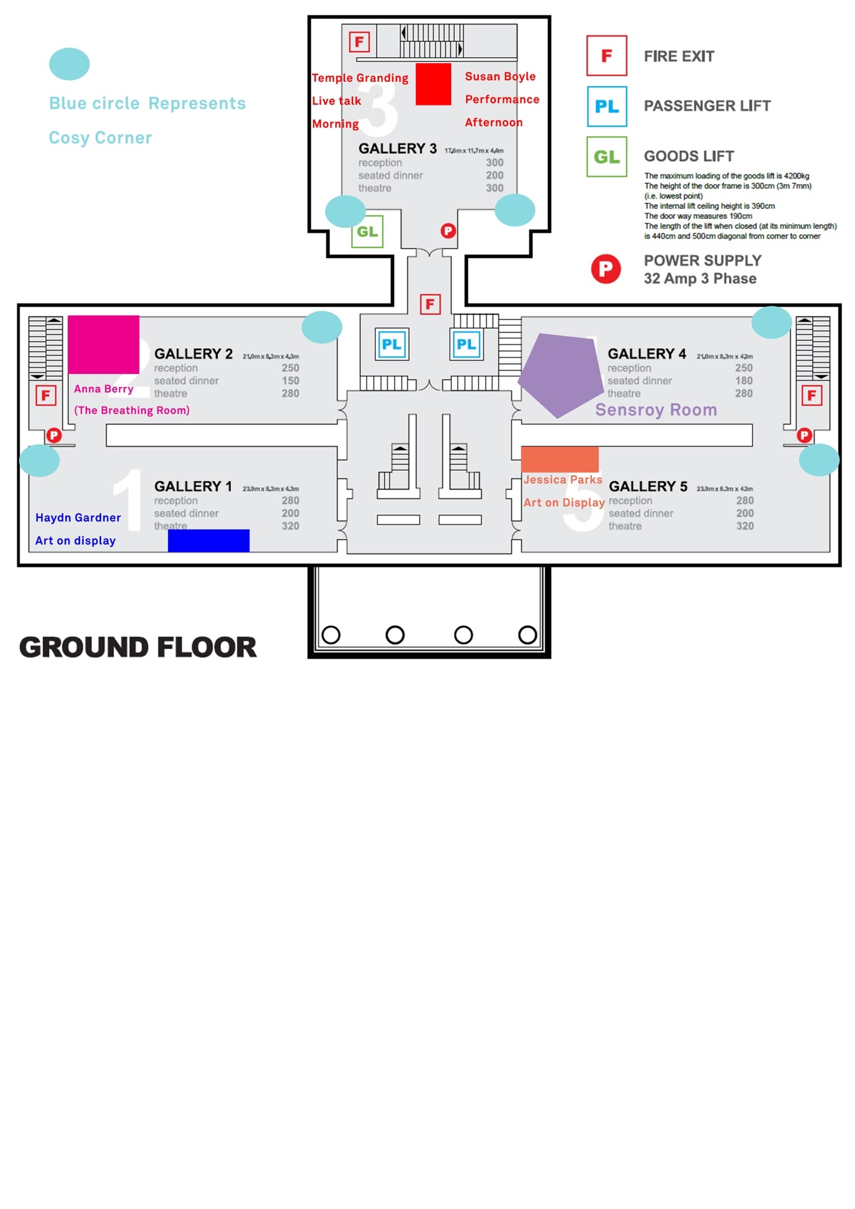
Exhibition floor plan

References

Baron-Cohen, S. (2005). Autism «Autos»: Literally. The Lost Self: Pathologies of the Brain and Identity: Pathologies of the Brain and Identity, 166-180.

Berry, A. (2019). Breathing room. Unlimited. (accessed 6th may 2019). http://www.annaberry.co.uk/3-2/installation-pieces/breathing-room-2/

Boyle, S. (2011). The woman I Was Born To be: My Story. Open Press ltd. London.

Casanova, E. L., & Casanova, M. (2018). Defining Autism: A Guide to Brain, Biology, and Behavior. Jessica Kingsley Publishers.

Delmas-Glass, E. (2019). Folk Art society of America. Painting the world with a rainbow. (Accessed 6th may 2019). https://folkart.org/mag/jessica-park

DuBois, D., Ameis, S. H., Lai, M. C., Casanova, M. F., & Desarkar, P. (2016). Interoception in autism spectrum disorder: A review. International Journal of Developmental Neuroscience, 52, 104-111.

Ecelebrityfacts, (2018). BGT finalist Susan Boyle returning to America’s Got Talent. (accessed 6th May 2019). https://ecelebrityfacts.com/bgt-finalist-susan-boyle-returning-back-to-stage

Felini, A. (2019). Maker Bolder. Who is Temple Grandin? (Accessed 6th may 2019). https://makerbolder.com/who-is-temple-grandin/

Fenn, V. (2018). Metro News. These 10 artists prove autism is no barrier to creativity. (Accessed 6th May 2019). https://metro.co.uk/2018/04/21/these-10-artists-prove-autism-is-no-barrier-to-creativity-7446895/

Haller, M., & Hadler, M. (2004). Happiness as an expression of freedom and self-determination. In Challenges for quality of life in the contemporary world (pp. 207-231). Springer, Dordrecht.

Happé, F. (2018). Why are savant skills and special talents associated with autism?. World Psychiatry, 17(3), 280.

Harley, N. (2014). The Telegraph. Susan Boyle reveals her struggle with Aspergers syndrome. (accessed 6th may 2019). https://www.telegraph.co.uk/news/celebritynews/11233182/Susan-Boyle-reveals-her-struggle-with-Aspergers-syndrome.html

Jones, R. M. (2019). Nature versus nurture in autism. Science Translational Medicine, 11(482), eaaw7626.

Jordan, R. (2013). Autism with severe learning difficulties. Souvenir Press Ltd.

Kant, I. (1999). Practical philosophy. Cambridge University Press.

Messymiscreations, (2019). Portfolio. Paintings. (Accessed 6th May 2019). https://messymiscreation.com

Saavedra, J., Arias, S., Crawford, P., & Pérez, E. (2018). Impact of creative workshops for people with severe mental health problems: art as a means of recovery. Arts & Health, 10(3), 241-256.

Schmidt, M. (2018). Sharing Autism Through Metaphors.(Dis) ability, Difference and Diversity in Temple Grandin’s Portrayals of Autism. Current Objectives of Postgraduate American Studies, 18(2).

Smith, P. A., Wadsworth, A. M., McMahon, W., Cottle, K., Farley, M., Coon, H., ... & Baron, M. (2016). Autism spectrum disorder in mid and later life. Jessica Kingsley Publishers.

