

CONSTRUCTION MATERIALS (ACBA4016)

HNC / HND / BSc Quantity Surveying
Lecturer – Alan Nantel

Bibek Khatri
Student Id – 2503477

Contents
1.0. Introduction 1
2.0. Selection of Concrete Framed Building 1
2.1. Elements of the original design 1
2.2. Purpose and location 2
2.3. Structural and architectural design features 2
2.4. Method of Construction 4
3.0. Framing material (Reinforced Concrete) 5
3.1. Strength, Durability and climatic resistance 5
3.2. Time, Labour, Programme and cost compared to steel framing 6
3.3. Ease of assembly and adaptability over building life cycle 7
3.4. Integration of services and the way to overcome the problems 7
3.5. Concrete demolition challenges 8
4.0. Negative impact of Concrete production 8
5.0. Sieve Analysis 9
5.1. Completed table after passing each sieve 9
5.2. Fine and coarse aggregate mix calculation 10
5.3. Particle size distribution graph 10
5.4. Suitability of given sample 11
6.0. Conclusion 12
7.0. References 12

1.0. Introduction
Concrete is widely regarded as one of the most dominant and commonly used structural materials because of its high durability, allowing it to withstand harsh environmental conditions and chemical attack as well as its versatility in being shaped into different forms for structural and architectural purposes and proven long-term performance (Smarzewski and Stolarski, 2022).
Concrete framed buildings are constructed using a network of columns and beams that form the structural skeleton of the building. This grid of beams and columns is typically constructed on a concrete foundation and is used to support the buildings floors, roof, walls, cladding, and so on. They can withstand significant loads, including seismic and wind forces. The combination of concrete and steel reinforcement creates a robust framework that provides excellent sound insulation making them safe choice for building design (www.designingbuildings.co.uk, 2020).

2.0. Selection of Concrete Framed Building
In this assignment we will explore how concrete framing works, how it performs in different conditions and what challenges come with using it. We will also look at the environment impact of concrete production and study the properties of aggregate used in concrete through a sieve analysis.
For understanding the practical behaviour of concrete framing, this report selects COPR 33- apartment block which is heavily on reinforced concrete frames. The major works involved in apartment block is a reinforced concrete frame consisting of RC columns, shear walls, ramps, in situ stairs and concrete slab floors (Thamesvalleyconstruction.com, 2021).

2.1. Elements of the original design
The £135m copr bay phase one scheme has been led by Swansea council and supported by a range of partners including Rivington hark.
It’s made up of,
- 3500 capacity arenas
- Bay bridge over oyster mouth road
- 1.1-acre coastal park
- 33 apartment blocks being run by Pobl group (we will be looking into this)
- New car parking facilities (Swansea, 2025).

2.2. Purpose and location
The new high-quality apartments, along with other residential schemes in the city centre and beyond, will make a big difference to the quality of living for many people.
All the apartments in Copr Bay are affordable homes, targeted at those working in Swansea city centre - particularly key workers. Funded by Pobl Group and the Welsh Government, the homes consist of 13 one-bed apartments for up to two people, and 20 two-bedroom apartments for up to three people.
The Copr Bay development is an important addition to the city which is already making a positive impact on people's lives by offering much-needed quality, affordable homes for those who want to live and work in the city centre, helping the council in their wider regeneration strategy for the city (Swansea, 2022).

2.3. Structural and architectural design features
The architectural design of this building was carried by AFL Architects and later same team is also responsible for redesigning of 33-unit residential development (Afl-architects.com, 2025)
Taylor Maxwell supplied corium brick cladding tiles, in six colours to the site, which were installed by Buckingham Group. This unique facade design is intended to offer a visually pleasing experience, both day and night as we can see clearly in picture below (Taylor Maxwell, 2017)

Picture showing colourful facade (Taylor Maxwell, 2017)
Picture below shows the Copr bay 33 block apartment during under construction where we can clearly see RC column, beam and slab as its main components (Thamesvalleyconstruction.com, 2021).
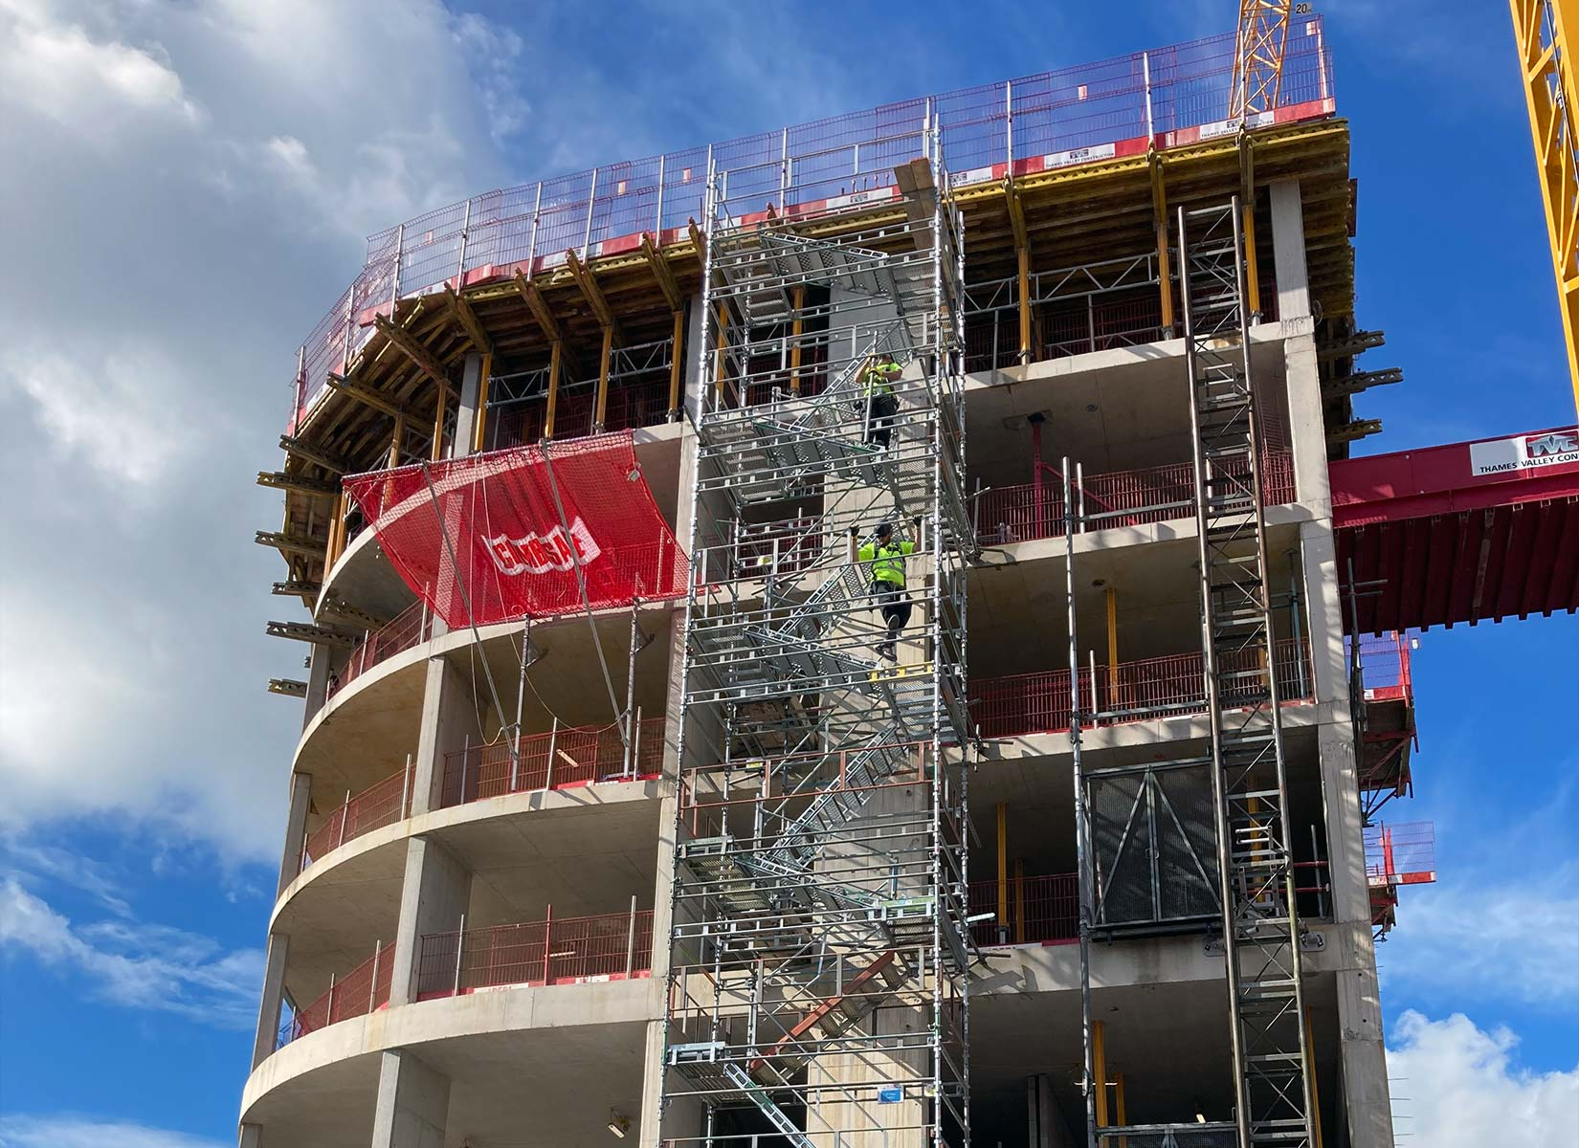
33 block apartment Copr Project Swansea (Thamesvalleyconstruction.com, 2021)

2.4. Method of Construction
Buckingham group was originally contracted for the copr phase 1, £135 million project later they went to administration but the 33 block apartments were already completed before they went to administration. Later Swansea council has appointed Andrew Scott Ltd for carrying out any remaining or unfinished work (Youle, 2024).
By analysing the information provided online and the picture we can clearly say 33 apartment blocks in the copr bay project is a hybrid construction,
- The structure is built using traditional construction method, reinforced concrete frame (Thamesvalleyconstruction.com, 2021).
- The facade clearly uses Corium clip on brick cladding system, which is modern prefabricated, penalised envelope technology (Taylor Maxwell, 2017).

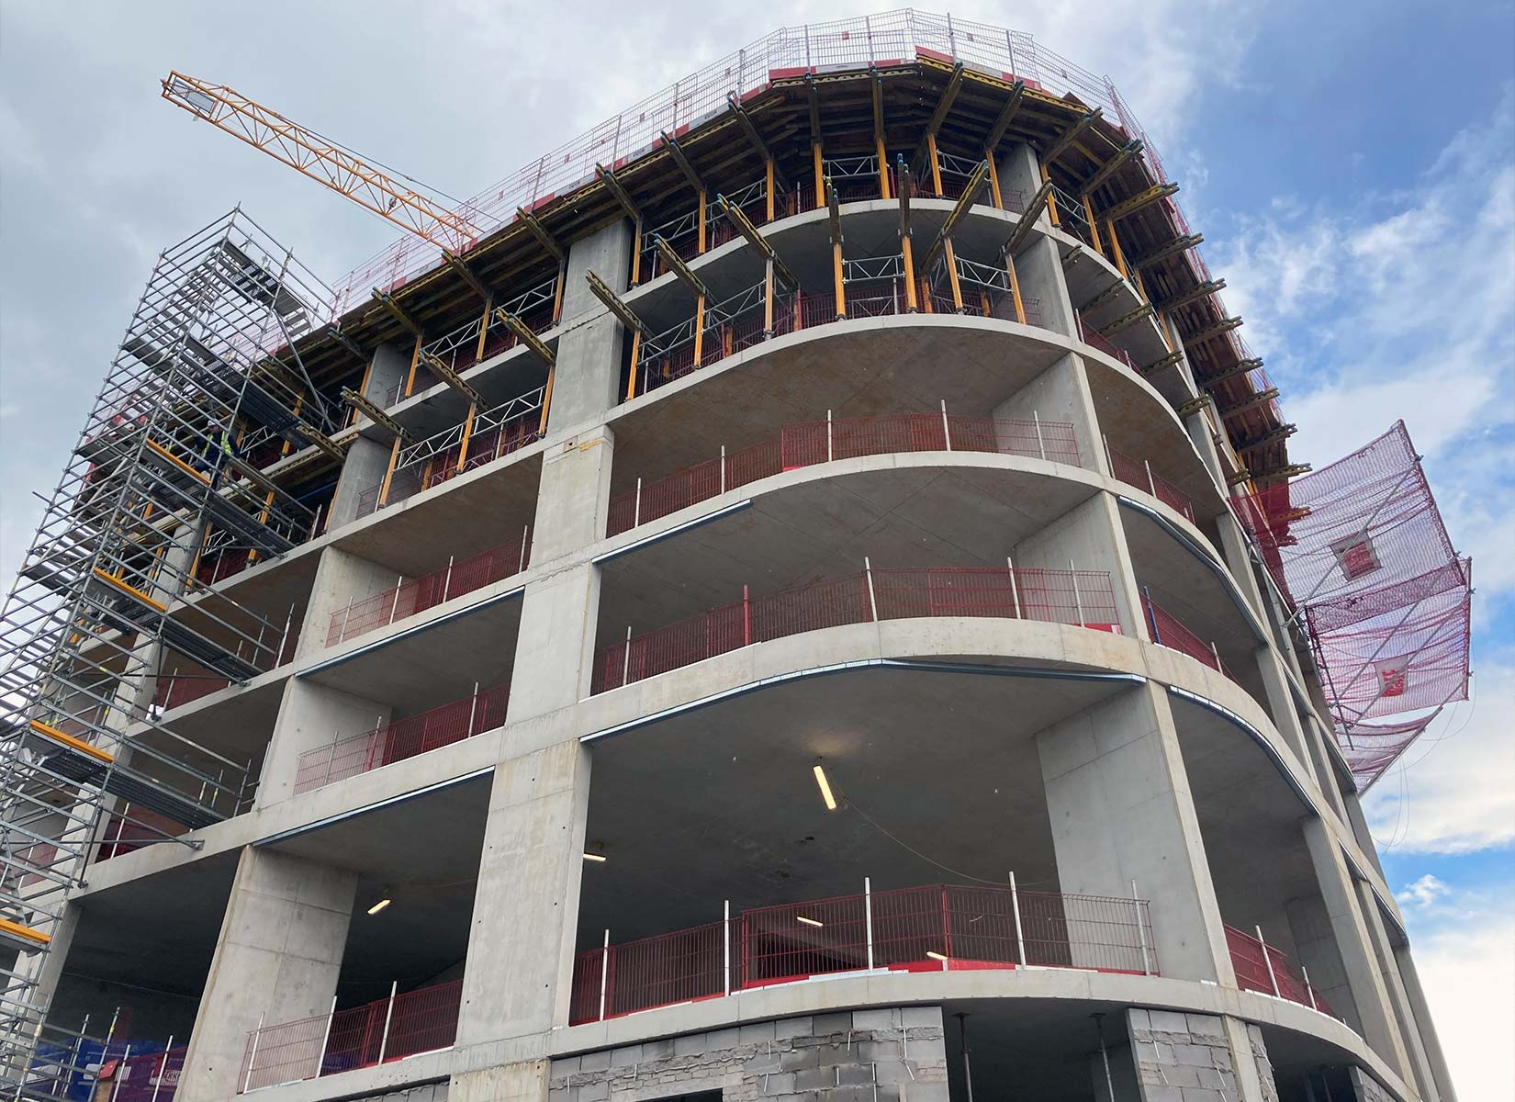

33 block apartment Copr Project Swansea (Thamesvalleyconstruction.com, 2021)

3.0. Framing material (Reinforced Concrete)
A reinforced concrete RC frame is a structural system made up of columns, beams and slabs that carry and distribute the buildings load. Concrete performs exceptionally well under compression, while steel reinforcement (rebar) provides the tensile strength needed to resist bending and stretching forces. Each component plays a critical role,
- Columns transfer loads from the structure above into the foundations
- Beams connect columns and support the floor slabs
- Slabs form the floor and ceilings of each level
This combination creates a rigid framework suitable for wide range of architectural layouts and structural requirements as we discussed about the Copr bay 33 block apartments, these all components has been used there (Frame? 2019).

3.1. Strength, Durability and climatic resistance
Concrete strength refers to the ability of hardened concrete to resist compressive loads without failure typically measured in megapascals (Mpa) or newtons per square millimetre (N/mm2). It is a critical property that determines the durability and performance of concrete structures, as it affects how well concrete can withstand loads, resist cracking and endure environmental conditions. Factors affecting concrete strength are as below,
- Water to cement ratio
- Compaction quality
- Curing temperature and duration
- Cement type and content
- Aggregate quality and grading
- Admixtures and mix additions (Concretemath.co.uk, 2025).
Durability of concrete is defined as its ability to resist weathering, chemical attacks and abrasion while maintaining its desired engineering properties over time. It is influenced by various factors, including the water to cement ratio, aggregate quality and curing conditions. Durability determines the lifespan of concrete structures. There are various ways of test durability of concrete,
- Compressive strength test
- Permeability test
- Rapid chloride Ion Penetration Test
- Carbonation Resistance test
- Freeze Thaw Resistance test
- Abrasion test (Team, 2023).
Climatic Resistance (especially relevant to Swansea coastal conditions) introduce risk such as,
- Chloride attack from seal salts
- Accelerated reinforcement corrosion
- Carbonation due to moisture and air exposure
- Freeze thaw cycles
Despite these risks, Copr bay 33 block apartment Reinforced concrete being in the coastal areas will face significant challenges like corrosion caused by chloride ions, moisture, and oxygen. By understanding the various exposure conditions and applying effective protective measures, the durability of these structures can be significantly enhanced. Using high-quality materials, proper mix designs, and incorporating strategies such as effective compaction, increased concrete cover, low permeability concrete mix, additional protective measures and proper curing can go a long way in ensuring the long-term performance of reinforced concrete structures in coastal environments. Regular maintenance and monitoring remain crucial to preserving their structural integrity over time. If these things are maintained, the even with a long exposure with chloride and freeze thaw condition the Copr bay 33 block apartment RC structure will last for a long period of time. So Reinforced concrete frame is a good option for this location as it can withstand harsh environmental conditions (Moses, 2025).

3.2. Time, Labour, Programme and cost compared to steel framing
When planning a new building one of the most critical cost decisions is choosing between concrete and steel framing. Both offer advantages in terms of design flexibility, and long-term performance.
Concrete itself is not expensive but the reinforcement steel, formwork add the indirect cost. Sometimes complex geometric design can push the cost. On the other hand, steel is prefabricated on the site which help reduce on site like labour expenses. Concrete is generally cheaper on raw materials, but steel may reduce total cost when prefabricated (Profound Estimates, 2025).
with labour and construction speed concrete requires skilled formwork carpenters, reinforcement installers and curing time. Weather delays can significantly impact the project. Whereas stell are prefabricated they arrive ready to assembly which means less labour required on site reducing overhead and schedule risk. Steel work is speed and labour efficiency as compared to concrete (Bob, 2025).
While looking at 33 apartments block it’s a modern design project which demands high fire resistance or sound insulation, low maintenance cost in long term so concrete frame would be more reasonable for this project (Profound Estimates, 2025).
Copr bay 33 block apartment was delivered as part of a large funded £135m regeneration programme meaning the project benefited from planning and efficient delivery. The development brought economic benefits and job creation which helped to boost local economy and worker (Thamesvalleyconstruction.com, 2021).

3.3. Ease of assembly and adaptability over building life cycle
Concrete framing is slower and uses more labour to assemble as it involves formwork, reinforcement and curing (takes 7-28 days). they are heavier weight and higher rigidity which makes it hard to cut through for any kind of alteration. They are durable but difficult to modify if not planned properly (Profound Estimates, 2025).
Copr bay 33 apartments buildings midrise, layout and well-planned design make it suitable for long term residential use with internal adaptability in future. The exterior is corium brick cladding façade enable easy maintenance and replacement without altering the frame anytime over building life (Taylor Maxwell, 2017).

3.4. Integration of services and the way to overcome the problems
The building that are built todays requires extensive mechanical, electrical, plumbing and other services. Concrete frames are heavy and rigid material, cutting after construction for services will weaken the structure. Early planning is crucial which will help for allowing all the necessary services, with the technology moving fast around the globe if any services need to be updated or added in the future concrete frame allows bit lower flexibility so keeping that in mind design should cover all those aspect (jonnyhough, 2025)
Copr bay 33 apartment blocks built with modern service integration allowing for all the services, fire safety with future telecom system. Although RCC service comes with challenges, but it was built under a major high specification with experienced contractors – Buckingham group. The facade uses a cladding system (non-load bearing element) which in future helps to allow if any services need to be updated (Thamesvalleyconstruction.com, 2021).

3.5. Concrete demolition challenges
Demolition itself is a challenging term when it comes with concrete demolition it’s a complex process that begin with planning. There are several methods for selective demolition, mechanical demolition and implosion. Choosing the method depends on factors such as structural size and location.
Copr bay 33 block apartment is part of Swansea long term sustainable urban regeneration project. Building constructed with the modern Reinforced cement concrete and external corium facade. By the name regeneration project, we can know the design itself is about the sustainability.
Reinforcement used is 100% recyclable, facade is mechanically fixed which is removable and concrete can be used in new concrete structures in roadbeds, breakwater as large pieces of concrete (Concrete Reinforcing Steel Institute, n.d.).

4.0. Negative impact of Concrete production
Concrete is one the major component of construction industry which comes with pros and cons, concrete must go through lots of refining process leaving negative impact to community and environment.
The key ingredient of concrete is cement and its production is the biggest contributor to concretes environmental impact. The manufacturing process involves heating extremely high temperature like calcium carbonate which releases lots of carbon dioxide which is the major reason for greenhouse gas emissions. Other items include sand, gravel and water which are extracted from natural resources like from riverbeds, coastlines and quarries leading to habitat destruction, erosion and disruption of ecosystems. The cement industry is responsible for an estimated 8% of global co2 emissions (Team, 2025).
Copr bay 33 block apartment is suitable in regards with environment point of view because it uses modern concrete most of it is recyclable, reinforcement is 100% recyclable and uses the corium block cladding which is removable with these all-modern design and technology. The life of RC frame building will last for a longer period (Concrete Reinforcing Steel Institute, n.d.).

5.0. Sieve Analysis
Sieve analysis is a gradation analysis of particle size distribution. It helps to predict the material behaviours which is very crucial in material selection (hitechciviltestlabspvtltd@gmail.com, 2025).
The following particle size distribution was obtained from a sieve analysis on all aggregate used for concrete production. The original sample size given was 1250g. Here is the table below,

5.1. Completed table after passing each sieve

Sieve Size (mm) | Mass(g) | % on sieve | % Passing
125 | 0 | 0 | 100
75 | 0 | 0 | 100
63 | 0 | 0 | 100
37.5 | 120 | 9.6 | 90.4
20 | 137 | 10.96 | 79.44
10 | 143 | 11.44 | 68.00
6.3 | 105 | 8.4 | 59.60
3.35 | 45 | 3.6 | 56.00
2 | 130 | 10.4 | 45.60
1.18 | 63 | 5.04 | 40.56
0.6 | 105 | 8.4 | 32.16
0.3 | 102 | 8.16 | 24.00
0.212 | 109 | 8.72 | 15.28
0.15 | 98 | 7.84 | 7.44
0.063 | 55 | 4.4 | 3.04

5.2. Fine and coarse aggregate mix calculation
given total sample = 1250 gm
Sieve size >6.3mm will comes under coarse aggregate they are, 37.5, 20, 10 and 6.3 mm.
Total of these 4 sieves is = 120+137+143+105
= 505 gm
Conver to percentage = (505/1250) x 100 = 40.4 %
Rest comes under fine which will be = total sample – coarse aggregate
= 1250 gm – 505 gm
=745 gm
Convert to percentage = (745/1250) x 100 = 59.6 %

5.3. Particle size distribution graph
Below is the graph for particle size distribution,

5.4. Suitability of given sample
The given sample of aggregate cannot be used in Copr bay 33 apartment building because it contains too many fine particle and not enough coarse particle meaning it is poorly graded. Common problem of improper grading is,
- Honeycombing in concrete
- Excessive water demand
- Segregation and bleeding
- Reduced strength and durability
- Higher cost due to increased cement usage
As the project is in coastal region which means apartment will be exposed to harsh climate so it will need high durable well graded aggregate.
Improperly graded aggregates lead to higher cement consumption, more water consumption which eventually weaker concrete strength and reduced durability (https://www.facebook.com/engineerrahulkushwaha, 2025).

6.0. Conclusion
The 33 Copr Bay apartments are well suited to Swansea’s coastal environment because reinforced concrete (RCC) provides strong durability against wind, moisture, and salted air. From a design point of view, RCC allows a stable, long-lasting structure.
Economically, the apartments support the wider Copr Bay regeneration by bringing residents into the city centre, boosting local business and long-term investment.

7.0. References
Smarzewski, P. and Stolarski, A. (2022). Properties and Performance of Concrete Materials and Structures. Crystals, [online] 12(9), p.1193. doi: https://doi.org/10.3390/cryst12091193.
www.designingbuildings.co.uk. (2020). Concrete frame. [online] Available at: https://www.designingbuildings.co.uk/Concrete_frame.
Thamesvalleyconstruction.com. (2021). thamesvalleyconstruction.com | Swansea Arena. [online] Available at: https://thamesvalleyconstruction.com/portfolio_page/swansea-arena/ [Accessed 16 Feb. 2026].
‌LITERATURE REVIEW OF CONCRETE DURABILITY & SERVICE LIFE REQUIREMENTS IN GLOBAL CODES AND STANDARDS. (2020). Available at: https://www.acifoundation.org/Portals/12/Files/PDFs/ACIFDurabilitySLGlobalCodesandStandards-10Aug2020.pdf.
Swansea. (2025). Copr Bay phase one - Swansea. [online] Available at: https://www.swansea.gov.uk/coprbayphaseone?lang=en [Accessed 2 Mar. 2026].
Swansea. (2022). Residents start moving in to new Copr Bay apartments - Swansea. [online] Available at: https://www.swansea.gov.uk/CBapartments?lang=en [Accessed 2 Mar. 2026].
Afl-architects.com. (2025). Page Restricted. [online] Available at: https://www.afl-architects.com/projects/swansea-central.
Taylor Maxwell. (2017). Copr Bay Apartments | Corium Brick Cladding. [online] Available at: https://www.taylormaxwell.co.uk/projects/copr-bay-apartments [Accessed 2 Mar. 2026].
Frame?, C. (2019). HYB Construction. [online] HYB Construction. Available at: https://www.hybconstructionltd.co.uk/blogs/understanding-rc-frames-in-construction.
Concretemath.co.uk. (2025). Understanding Concrete Strength | ConcreteMath.co.uk. [online] Available at: https://concretemath.co.uk/uk-concrete-guide/guide-basics/understanding-concrete-strength/.
Team, C.E. (2023). What is Durability of Concrete? Tests and Factor Affecting. [online] Civil Engicon- Civil Engineering and Construction Technology. Available at: https://www.civilengicon.com/2023/11/test-for-durability-of-concrete.html.
Moses (2025). Protecting Reinforced Concrete Structures in Coastal Areas: Addressing Corrosion and Ensuring Durability. [online] Building and Construction. Available at: https://build-construct.com/structures/protecting-reinforced-concrete-structures-in-coastal-areas/ [Accessed 2 Mar. 2026].
Profound Estimates. (2025). Concrete vs. Steel Framing: Which Is More Cost-Effective? — Profound Estimates. [online] Available at: https://profoundestimates.com/explanations/concrete-vs-steel-framing-cost-effectiveness.
Bob (2025). Is Steel Or Concrete Cheaper? A Comprehensive Cost Comparison For Your Construction Project - ConcreteCaptain.com. [online] ConcreteCaptain.com. Available at: https://concretecaptain.com/steel-or-concrete-cheaper/ [Accessed 9 Mar. 2026].
jonnyhough (2025). Integration of building services | Concrete Society. [online] Concrete Society. Available at: https://www.concrete.org.uk/fingertips/integration-of-building-services/.
Team, I. (2025). Why is concrete bad for the environment? - The Institute for Environmental Research and Education. [online] The Institute for Environmental Research and Education. Available at: https://iere.org/why-is-concrete-bad-for-the-environment/.
‌https://www.facebook.com/engineerrahulkushwaha (2025). Complete Guide to Grading of Aggregates in Construction - Civil Tutorials. [online] Civil Tutorials. Available at: https://civiltutorials.com/grading-of-aggregates/.
Concrete Reinforcing Steel Institute (n.d.). Green Construction. [online] CRSI: Concrete Reinforcing Steel Institute. Available at: https://www.crsi.org/reinforced-concrete-benefits/green-construction/.
hitechciviltestlabspvtltd@gmail.com (2025). What is Sieve Analysis and Why It Matters in Construction - Hitech Civil Test Labs Pvt. Ltd. [online] Hitech Civil Test Labs Pvt. Ltd. -. Available at: https://hitechciviltestlab.com/what-is-sieve-analysis-and-why-it-matters-in-construction/.

