University of Wales
Trinity Saint David



Birmingham

Student name: Rumen Pavlov

Student number: 1902012

Programme: BA – International Hotel Management

Module: Management and Organisational Behaviour

Module code: M5X01924

Assignment Title: Using appropriate theoretical framework, you are required to analyse the effects of structure, culture and leadership upon organisational performance.
Lecturer:
Dr Olu Adegbite

Contents:

- Introduction
- Theoretical framework
- Heathrow airport
- Structure of Heathrow Airport
- Management
- Behaviors
- Culture and leadership upon
- Organizational performance
- Conclusion
- References

Introduction:

This report is to present the theoretical framework and the effects of structure, the culture and the leadership upon and the organizational performance of the management.
This report is to explain what are mean that terminology and how they work and how impact the management.
The structure which that report will present is Heathrow Airport of London. The structure of the management, the effects of the structure and the culture and the leadership, the organizational performance, how is manage that business and why is one of the most important airports in United Kingdom and Europe.

Theoretical framework:

What is theory?
Theory is a set of concepts and relationships among them. The theory explains how things work and why. The theory explains what variables are included and how they are related.
The theory explains how, when, why and under what conditions does a phenomenon take a place. That is the definition of the framework, but every organization have different structure and different behavior, principal and rules.
The theory explains the way how should work some business, but everyone decides the way to achieve the property goals.

Heathrow airport

Heathrow airport is the second busiest airport by international passengers, and the seventh in the world by passenger traffic. That airport is makes 80.8 million passenger per year, that is mean the structure and the management are really high level. Let’s see the structure of the transport organization which most of the people prefer to use today because reduce the time of the travelling and is easier.
The economy of Heathrow airport today is really in bed position of the covid19, but that airport is one of the busiest, the service which is offering is very good and the plains service is also high respect with other company

Structure of Heathrow airport

The structure is need because is important to know how many people run that organization and how they are managing the business.
In the picture is demonstrate how many sectors and manager are making that airport so successful and have a lot of incomes. In every organization is needed to have the right people with the right skills and the right knowledges can manage and doing a well job.
The transport organizational is different in every country, in some county the organization is not very well and the service which is give is not one of the best because the manage is not high and that is not bring a lot of incomes to improve one of the most important organizational business today, its one of the most important because a lot of people are travelling, by bus, by train, by airplane and these services should offer the best to the customer because the people will not stop to travel.

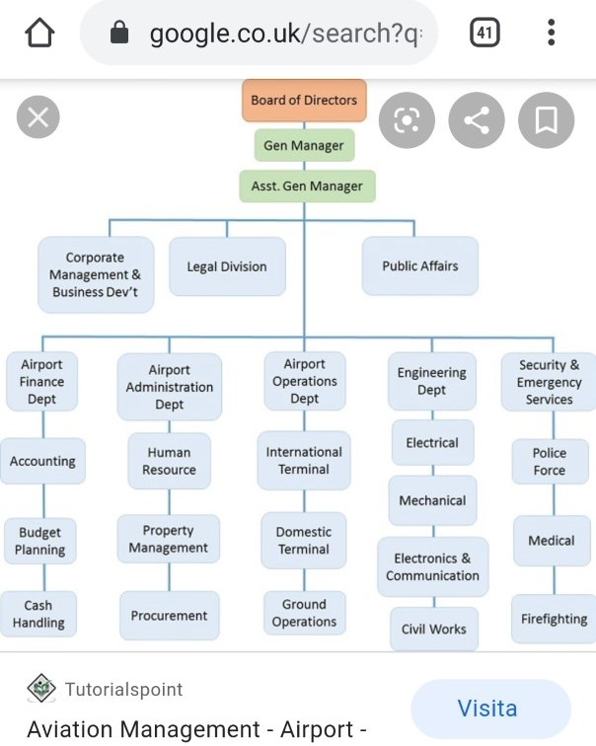

On the top there is the board of directors, after that there is general manager. That structure is showing how many people are needed to run the transport management. In every sector there is a manager and general manager who is control the own department and is communicate with the other department manager.

Management

What is mean management and why is so important in the organizational plans and in general in the live? Management is mean to control, to coordinate the people can achieve the goals of the company.
The management is very important because is to know how to manage and grow up a company’s business. The manager is the person who have one of the most hard position in the organizations of every business because that person have to manage a lot of people, to can be a good manager is request a very good communication skills, to know the business, and to know how to select his staff and what type of people is request because for every department the request are different.

Behaviors

The behaviours are important thing in the lives of everyone and in specific in the management of the people, the behaviours can tell a lot about the person, the way of behaving the other peoples is showing the level of culture. Is important to know how everyone should behave with the other and most in the sector of the management and the hospitality the behave are the most important things for the customers.
The way of talking, non-verbal communication and the not keeping eyes contact is show disrespect for the person who is talking to you, let’s see in the Management and Organizational Behavior which are the factors which can be improve and which not, how is effect the management and the business.

In the next picture you can see the factors affecting the organizational behavior.

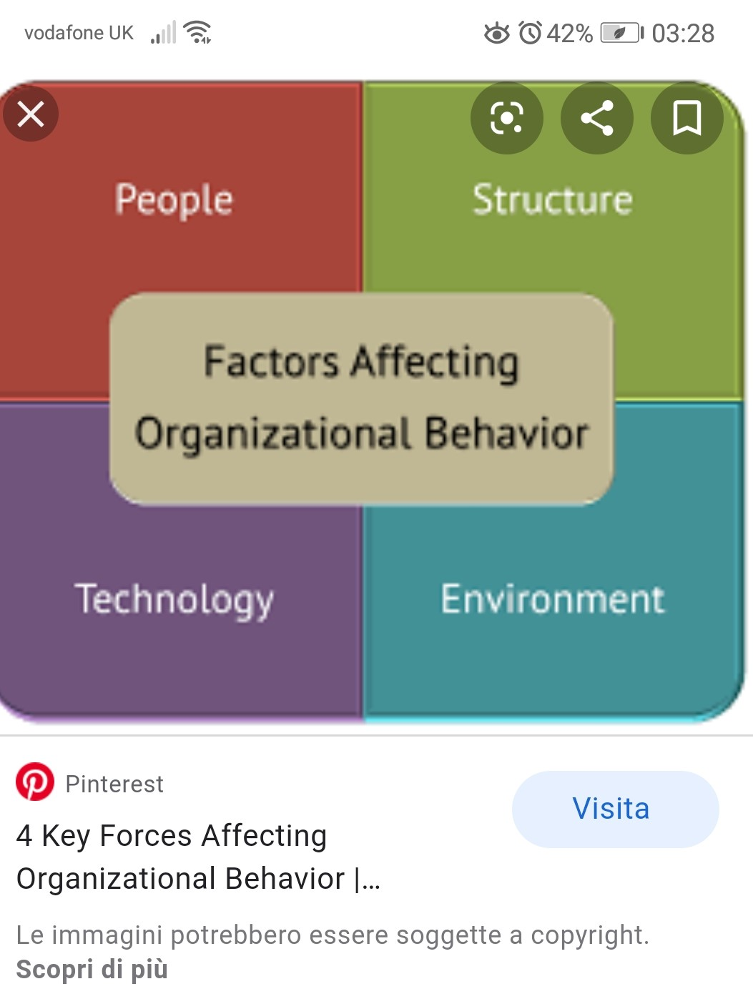
The pictures is presenting the four steps which are affecting the organizational behaviours, every business is affecting of the people, that is because some of them doesn’t have the right skills to be in that organizational or just because there is unlike between the colleagues, there is not a team group, and that is result of bad management and less communication and observation of part of the manager, because the manager have first to be sure between the staff there are communication, and to let know the rules of the company and what type of behave is request inside that is also about the dress.
The structure is also really important because if the organization doesn’t have the team leader or the manager and the staff need to speak with the manager but is not everyday in the place that will bring to a lot of mistakes, for this reason there are the team leader to check and to control, but in the organization which this report is presenting the transport organization in specific Heathrow London, is really important everyone of the staff to have the right skills, good look, good communication skills and education.
The environment and the technology, the technology can be a good and bad depend of the point of view, because is developing every minutes more and more and in some cases the technology is taking the job of the people, but in the sector of the transport the technology is helping a lot the customer, because they know at examples in the train and in the bus the next stop, or the button for emergency at the bus stop of the metro. The technology is helping a lot the world in organizational structure because there is easier for the communication at example by email, the projects of 3D can see how will look the place. The technology affects the behaviour of the people because can help you with some programme to write correct e-mails or video conference, video chat, in the sector of the transport is perfect because also there are the gps and the police to know where is located the airplane, or the bus, train.
The behaviours depend of the psychology, sociology and economically of the country. In the micro they are the individual’s behaviour, but in the macro, they are the organizations and the environment.

Culture and leadership upon

The culture is something different for everyone, because the culture is also what the people are believing and how they are living them live, the culture is considerate result of education, the culture can be on various aspects. But what really mean culture? Why the culture is important in the management organizational?
Culture is mean the ideas and the behaviour of some society or organization, culture is mean believe. In what the people believe and how they live them life and the behave which they have between each other depend of the culture.
In the management is need to have a rich culture because that is mean you know how to communicate, you know how to achieve your goals and you know what you want and how you will do, the culture in the business and in the organizations is really important because that is mean there is people which are fighting for the same cause and for the same reason. But that is depend of the organization and of the manager.
If the culture is more big the progress of the organization will be more high because that is the result of a lot of people and of them creativity and hard work to develop the business and the services which they are offer to the guest like Heathrow London is giving the best service to the guest, they are using the correction with the customer, the staff can talk more than one languages which is helping the customer making the communication more easier.
The culture and the behaviours depend of the psychology, sociology and economically of the country. In the micro they are the individual’s behaviour, but in the macro, they are the organizations and the environment. . Cultural Conceptualisations And Language. John Benjamins Pub. Co., 2011.

Organizational performance

The organizational performance is depending of the manage and of the service which the company is offering, in the transport organization is important the service, the quality of the service, the price and the safety.
The performance is depending of the management and of the staff and the price.
If the service is great the people will pay if they have the possibility but there is also if the service is good or not because if the service is not. well the company will lose customer and incomes. The organizational performance is depending of the trainings which the managers are offering to the people and how they motivate the staff to work, if they are choose the good staff or not. If the manager is a leader and have the skills to help the staff to grow up and to change the way of work the company will achieve the goals, but all is depending from the manager. The manager should know how to talk, understand the people to be friendly and respectively to them, the staff should feel appreciate, and the salary to be high can know way they are working so hard.

Conclusion

The organizational structure is the important because there will be the principals of the company and the rules of the services, is also important to know there is a different structure because in the micro is more specific in the macro not like rules.
To can have a good structure is needed to know well the product which the company will offer and to have a good staff. To can have a good staff is to have a good HR manager to can choose the personal staff, every organization they are different politics, but the same between the company are that every company want to be the best and to have more incomes.
To can have more income the organizational performance should be valuate very well and manage the team, the marketing and the services which the company is offering.
This report is presented the transport organizational of Heathrow because the people are traveling a lot, and there is a lot of marketing, and hospitality in that sector. The successful depend of the management and of the behave in doing that management.

References

"Organizational Performance: Definition, Factors, Model". Iedunote.Com, 2020, https://iedunote.com/organizational-performance.

Fairholm, Gilbert W. Leadership And The Culture Of Trust.

Heathrow Airport - London. [The Authority], 1976.

Nelson, J.B. "Communicative Behaviour And Evolution". Animal Behaviour, vol 26, 1978, pp. 314-315. Elsevier BV, doi:10.1016/0003-3472(78)90044-1.
Sharifian, Farzad. Cultural Conceptualisations And Language. John Benjamins Pub. Co., 2011.

Stacey, Brian et al. "Evaluation Of Ultrafine Particle Concentrations And Size Distributions At London Heathrow Airport". Atmospheric Environment, vol 222, 2020, p. 117148. Elsevier BV, doi:10.1016/j.atmosenv.2019.117148.

WARD, TOM. "MANAGEMENT CONCEPTS". Management Decision, vol 1, no. 4, 1967, pp. 38-38. Emerald, doi:10.1108/eb000817.

