

Student name: | Filippo Mazzamuto | Student ID number: | 2010993
Programme: | Certificate of Higher Education Skills for the Workplace (Health and Social Care)
Module: | Psychology for Health and Social Care
Module code: | BMHP4003_BIRM | Contribution to  Overall Module Assessment (%): | 50%
Lecturer: | Rebecca Kavanagh | Internal Verifier: | Dr Mark Gallagher- Read
Assignment Title: | Case study report | Word count (or equivalent): | 2000 words (+ or – 10%)
Submission deadline: | Week 10 Friday 23 July 15:00 (3 pm) | The return date of provisional marks & written feedback:

Table of Contents
Introduction: 1
Status Quo of obesity in England: 1
Psychological theories of obesity: 2
Social learning theory: 3
Attitude theory: 5
Theory of planned behaviour: 7
Conclusion: 8
Recommendation: 8
References: 9

List of Figures:
Figure 1: Obesity rate of the adult in England 2
Figure 2: Child obesity in England 2
Figure 3: Psychological theories of obesity 3
Figure 4: Social learning strategy framework 3
Figure 5: Four stages of social learning theory 4
Figure 6: Factors influence attitude formation 5
Figure 7: Conditioning on attitudes formation 6
Figure 8: Theory of planned behaviour 7

Introduction:
A person needs a body mass index (BMI) of 30 or greater to be categorized as obese. The BMI is taken as the kilogram-to-height ratio in square meters. Oil, glucose, and salt diets can lead to overweight and obesity, particularly if a person's intake from food and beverage exceeds their consumption of energy. Over a quarter of the United Kingdom's population is fat, and most are the youth people. Poor diet and lack of physical activity are responsible for the obesity of the youth generation. Some 58% of Type 2, 21% of cardiovascular cases and 8% to 42% of certain cancers suffer from excess body fat (Maio and Haddock, 2017). Overweight and obesity are predicted to cost NHS £5.1 billion annually. Obesity costs not only the obese but the rest of Society. These costs include medical fees for treating obesity and its consequent diseases, days off work, Etc. Researchers found that psychological factors are responsible for the obesity of a person. In this task, psychological theories that are responsible for obesity will be described. After that, a link will be established between obesity and these psychological factors and at the end, recommendations will be suggested. Moreover, the current obesity condition of England will be described in this work.

Status Quo of obesity in England:
The Health Survey 2019 calculates that 28.0% of British adults to be obese, and an additional 36.2% to be overweight but not obese. The poll indicated that men tend to be overweight or obese more than women (68.2 per cent of men, 60.4 per cent of women). People 45-74 years of age are most frequently overweight or obese. The overweight prevalence (overweight or obese) in the most deprived districts in England is nine percentage points greater than in the less deprived areas. The following figure represents them:
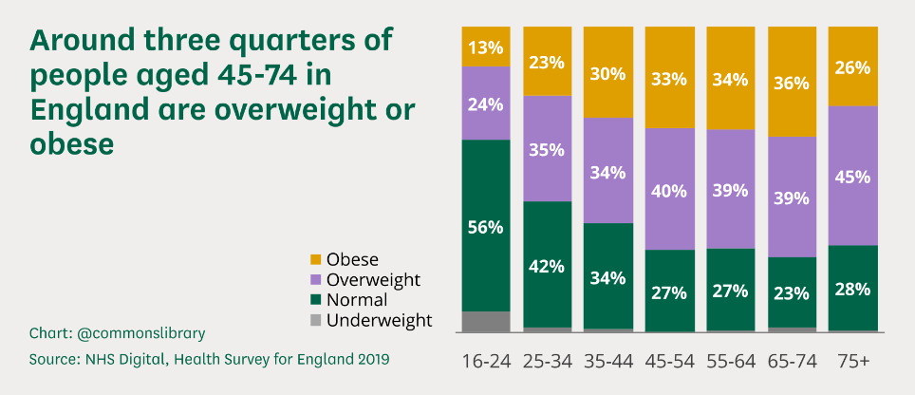
Figure 1: Obesity rate of the adult in England
Source: (Baker, 2021)
9.9% (4-5 years of age) of the child is obese, and 13.1% overweight is additionally. 21.0% are obese and 14.1% overweight at age 10-11. The prevalence of obesity has scarcely altered during 2006/07 in the case of reception children. The incidence of youngsters for year 6 grew from 17.5% to 21.0%. More often, children in poor communities are obese. At 4-5 years of age, 6.7% of individuals in the poorest regions are obese, compared to 13.0% in the least developed regions. 13.9 per cent of youngsters between ten and 11 years old are obese in the least disadvantaged areas compared to 27.2% in the most disadvantaged ones. Since 2006/07, the gap between the least-deprived areas has grown (Kinra, 2019). The following figure represents them:
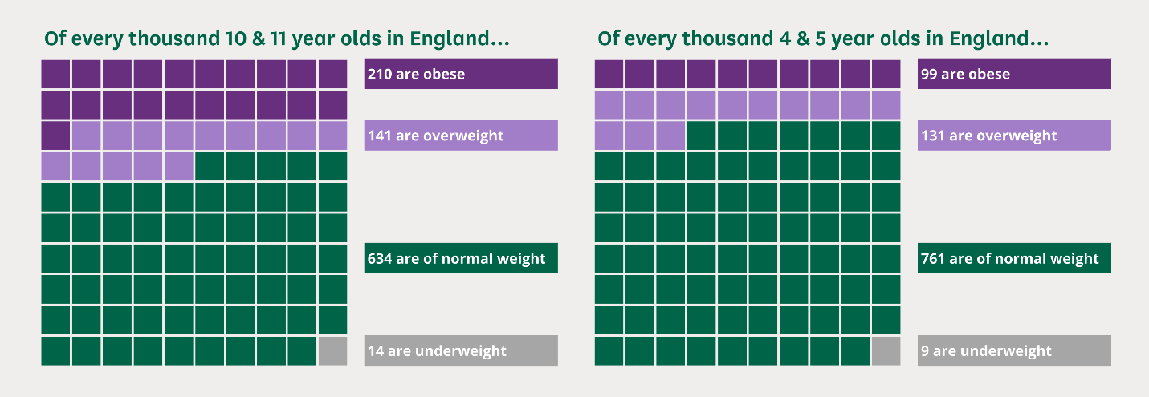
Figure 2: Child obesity in England
Source: (Agha and Agha, 2017)

Psychological theories of obesity:
Obesity was assumed to be linked to a mismatch between energy consumption and expenditure. A more recent study has shown that genetic, physiological and behavioural variables also play an important role in obesity genesis. Psychology has a great impact on becoming a person as obese. The following figure represents the theories that are related:

Figure 3: Psychological theories of obesity
Source: (Self-Made)

Social learning theory:
According to social learning theory, social behaviour is acquired through observation and imitation of others. Albert Bandura, a psychologist, established the social learning theory External link as a counterpoint to the previous work of B.F. Skinner, a renowned psychologist well-known for his impact on behaviourism. While behavioural psychology is concerned with the environment and reinforcement, Bandura argued that humans might acquire behaviour through observation. The following figure represents the social learning framework:
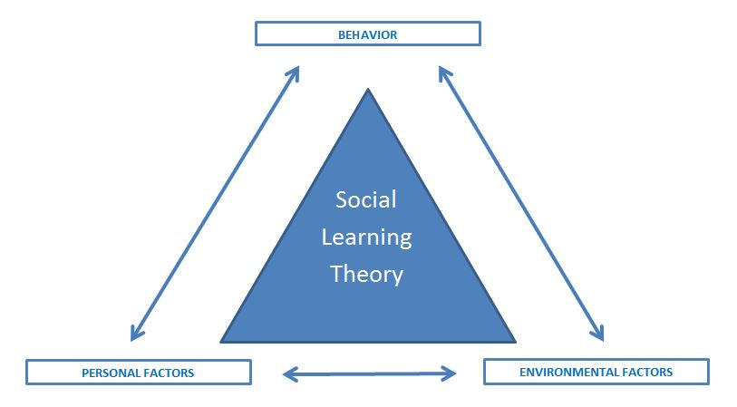
Figure 4: Social learning strategy framework
Source: (Hammer, 2016)
There is a close link between social learning theory and obesity. Most eating practices are taught behaviours that children see at home. Children carry out this behaviour throughout their different stages. Their children then learn this behaviour from their parents, and this is a continuous process. The Theory of Social learns external links have four mediation stages of deciding if a new behaviour has been developed. The following figure represents them and applies how it is responsible for the obesity of a person:
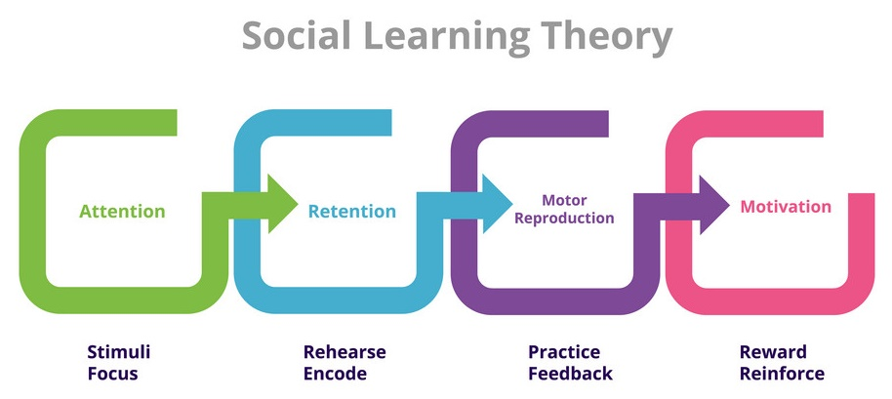
Figure 5: Four stages of social learning theory
Source: (EdTick, 2021)
Attention: It is the degree of observing the behaviour. For example, a child has watched to eat the family member’s Junk food and rich food during any occasion. Retention: People cannot act if they do not retain the conduct. The viewer will not carry out the behaviour unless memory is developed. People cannot copy something if they are not seen several times. After observing it several times, people can keep it in mind. For example, the children have learned that they have to eat rich and junk food on any occasion that has been retained in their minds during repetitive work. Other habits are also related to becoming obese. Moto reproduction: It is nothing but the practice that has been learnt. For example: When this child will be adult, they will repeat it in their life such as any occasion they will arrange rich food and junk food.
Moreover, motivation: One of the major concepts of social learning theory might be motivation, with the rest relying on it. If people see benefits from it, then they motivate to learn it; otherwise abandon it (Hammer, 2016). For example, the child enjoys having rich food, so they find out any occasion of eating junk food and rich food.
Obesity in youngsters can be averted by the parents modelling appropriate eating habits for their children (Bagherniya, Sharma, Mostafavi and Keshavarz, 2015). If a parent only maintains nutritious food at home, a child is no longer allowed to eat sugar or fattened meals. When parents cook their children's healthy and nutritious meals, then that is what the child expects and wants. These adjustments must be implemented as soon as possible. The child will be better able to make healthy food choices if a good starting point for healthy eating behaviours is established if he/she has an option later.

Attitude theory:
An attitude refers to a combination of feelings, thoughts and actions for achieving the goals, person, thing or event of a given subject. Attitudes are typically the product of experience or education, and they can impact behaviour. They can also change as long as attitudes last (Agha and Agha, 2017). For example, People think that eating rich and Junk food shows a person is modern and comply with the demand of the age. Therefore they possess a positive attitude towards eating junk food which results in obesity. On the other hand, older adults think that it is not their age for working. They need to take a rest. If they do physical activity at such age, then Society may neglect them, so they avoid physical activity because calories of their body do not burn, so they become obese over the period. There are certain factors of attitude formation. The following figure represents the stages which include the formation of attitude:
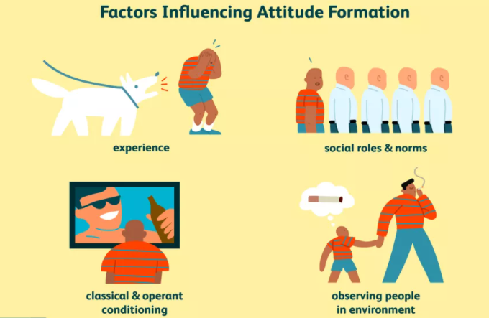
Figure 6: Factors influence attitude formation
Source: (Forgas, Cooper and Crano, 2016)
Many factors can impact how and why attitudes are developed. Here is an insight into how attitudes take shape.
Experience: As a result of experience, attitudes form. They may arise because of direct personal experience or because of observation. For example, an older man, during walking in the garden, experienced muscle cramps. So, he did not do any physical exercise; hence, he suffers from obesity. Social factors: Social roles and social norms can impact opinions strongly. For example: During hangouts or meetings, Junk food and carbohydrate drinks are must result in obesity.
Learning: attitudes in a variety of ways can be learned. Consider how advertisers utilize conventional conditioning to affect the position on a specific product. For example, the children and young people like to drink carbonated beverages because advertisement represents them as a part of the youth generation. Conditioning: Conditioning for operators can also be utilized to impact the development of attitudes. For example, A young man just beginning to smoke. Whenever a cigarette is lit, his friends adore him and praise him for being so much classy and modern. These positive responses lead him to express a favourable view about smoking and to embrace the habit. Smoking reduces metabolism; hence people, after eating junk or rich food, become obese. The following figure represents the impact of conditioning of formatting the attitudes:
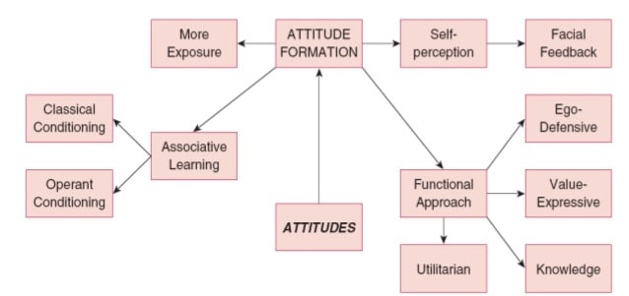
Figure 7: Conditioning on attitudes formation
Source: (Walther, Weil and Düsing, 2017)
Observation: Finally, by studying others all around them, people also learn attitudes. You are most. For example, youngsters spend much time watching their parents' attitudes and generally start showing similar perspectives. If parents are like to avoid physical activity, then their children also like to avoid it (Forgas, Cooper and Crano, 2016). As a result, obesity is highly seen among them.

Theory of planned behaviour:
In the planned behaviour, behavioural purposes are influenced by three factors: attitudes, subjective standards and behavioural control perceived. External influences can also directly force or prohibit comportments, irrespective of the purpose, depending on how much individual controls behaviour and how accurately perceived controls a behaviour control are. A struck line illustrates this connection in the following figure:
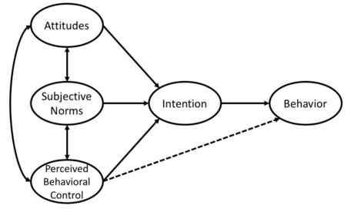
Figure 8: Theory of planned behaviour
Source: (Godin and Kok, 2018)
These three components are described in case of obesity that how these three components are responsible for making a man obese: Attitudes: A person contains positive attitudes towards fast food or junk and carbonated drink. So, a person likes to eat them when they get a chance, which results in obesity. Subjective norms: Social pressure can be regarded, including the apparent demands of others and the value of those expectations. For example, Society wants that an older adult will not do any work and eats and enjoys the relaxing time. So, for fulfilling the society demand, he or she does this. As a result, he or she cannot burn calories that turn into obesity for them and lastly, perceived control behaviour is how an individual feels able to conduct a certain behaviour in its setting. For example, a child likes to eat junk food, so he repeats them while an old lazy person does not like to do physical activity, so he does not do this; hence he becomes obese.
So from the above discussion, it can be stated that psychological theories greatly impact making a person's obese. People possess positive notions regarding fast food, junk food, carbonated drinks, keep themselves away from physical activity, which is ultimately responsible for obesity, and so people become obese.

Conclusion:
Obesity has turned into a great problem in England. People of all ages are suffering from obesity, and the older people of the Society are the most vulnerable in this regard. The condition of obesity is becoming worsen over the period. Public health specialist said that. It was anticipated that around 55% of adults and 25% of youngsters would be obese by 2050. Unsafe diets and physical inactivity lead to NCDs, such as heart disease, diabetes mellitus and certain forms of cancer, obesity diminishes life expectancy by nine years on average and in England accounts for 9,000 early deaths a year (Gortmaker et al., 2019). Moreover, researchers have found that psychological theories are responsible for increasing obesity. Hence, three psychological theories, such as social learning theory, attitude theory, and planned behaviour theory, have been described and analysed concerning obesity. It has been seen that attitudes, family, and peer pressure are mainly responsible for the obesity of a person. If these can be controlled, then obesity can also be controlled, and these recommendations are provided, which can help CCG reduce obesity from England.

Recommendation:
Below recommendations Clinical Commissioning Group for reducing obesity with proper justification:
- As children learn from their parents, the authority needs to make them aware of the nutrients, food and physical activity and present the disadvantages.
- As attitudes can be changed, a mass awareness program needs to be undertaken to make older adults and young people aware of the importance of physical activity and cutting carbonated drinks, junk, and carbohydrate from the food list.
- Fine can be charged for the advertisers to promote attractive advertisements of fast food and provide misleading information regarding food.

References:
Agha, M. and Agha, R., 2017. The rising prevalence of obesity: part A: impact on public health. International Journal of Surgery: Oncology, 2(7), p.17.
Bagherniya, M., Sharma, M., Mostafavi, F. and Keshavarz, S., 2015. Application of Social Cognitive Theory in Predicting Childhood Obesity Prevention Behaviors in Overweight and Obese Iranian Adolescents. International Quarterly of Community Health Education, 35(2), pp.133-147.
Baker, C., 2021. Obesity Statistics. [Online] House of Commons Library. Available at: <https://commonslibrary.parliament.uk/research-briefings/sn03336/> [Accessed 24 July 2021].
Edick, 2021. Social learning theory: Bandura's five key steps of the learning process. [Online] EdTick. Available at: <https://www.edtick.com/en/news/social-learning-theory-bandura-s-5-key-steps-of-the-learning-process> [Accessed 24 July 2021].
Forgas, J., Cooper, J. and Crano, W., 2016. The psychology of attitudes and attitude change. 1st Ed.
Godin, G. and Kok, G., 2018. The Theory of Planned Behaviour: A Review of its Applications to Health-Related Behaviours. American Journal of Health Promotion, 31(2), pp.87-98.
Gortmaker, S., Swinburn, B., Levy, D., Carter, R., Mabry, P., Finegood, D., Huang, T., Marsh, T. and Moodie, M., 2019. Changing the future of obesity: science, policy, and action. The Lancet, 378(9793), pp.838-847.
Hammer, T., 2016. Social Learning Theory. Encyclopaedia of Child Behaviour and Development, 5, pp.1396-1397.
Kinra, S., 2019. Early growth and childhood obesity: a historical cohort study. Archives of Disease in Childhood, 18(11), pp.1122-1127.
Maio, G. and Haddock, G., 2017. The psychology of attitudes and attitude change. 5th ed. Los Angeles: Sage.
Walther, E., Weil, R. and Düsing, J., 2017. The Role of Evaluative Conditioning in Attitude Formation. Current Directions in Psychological Science, 20(3), pp.192-196.

