Module name : Marketing Essentials
Module code : BMIH005
Title: Marketing Plan
Submission deadline : Friday 3th March
Lecturer name : Chris Wilkin
Student name : Alexandra Paunescu
Student ID :2125393

Table of Contents
Component A 3
Introduction 3
Situation Analysis (5’Cs) 3
Company 3
Customers 4
Competitors 4
Collaborators 4
Climate 5
Objectives 5
Smart Target 5
Strategy 6
Tactics 7
Marketing mix of Crown Plaza 7
Action 7
Control 8
Conclusion 9
References 10
Component B - PowerPoint Presentation Slides 11

Component A

Introduction
The purpose of the report is to create a marketing plan for attracting new customers. Premier Inn Hotel is a famous hotel brand that provides limited hotel services internationally. The hotel chain is situated in the UK that was built by Whitbread. The marketing plan is prepared by the CEO of Premier Inn Hotel in the report to increase the number of customers. The Marketing Mix, PESTEL analysis, STP analysis model, Bowman’s strategy clock and Porter’s Five Model will be used to conduct the report.

Situation Analysis (5’Cs)

Company
For analysing Premier Inn Hotel’s microenvironment, the SWOT analysis model can be used.
Strengths | Weaknesses
- There are 827 hotels and 80000 rooms | 1. The hotel provides the limited services
- It provides the quality services | 2. The limited appearance in foreign countries
- Extensive experiences | 3. Hygiene issues
- Higher brand value
Opportunities | Threats
- The hotel can increase its hotel branch | 1. Huge competitors
- The hotel can operate promotional operations for increasing its brand value | 2. Social media rumours and wrong news

Customers
Segmentation: Premier Inn Hotel has divided its customers based on financial abilities, family and profession of the customers (Tautz, 2004).
Targeting: The main customers of the hotel are business travellers and backpackers.
Positioning: The hotel is a renowned brand with quality services.

Competitors
Porter’s five forces are used for analysing the competitors and the level of competitions
Threats of the new entrance | Bargaining power of suppliers | Bargaining power of customers | Threats of new similar products | The intensity of the rivalry
There has a limited chance to establish a new hotel chain due to critical processes. | Huge suppliers are available in the UK and globally and so there has a medium chance of bargaining for suppliers (Gamayanto, 2004) | Customers have a lower chance of bargaining in the on-season and a higher chance in the off-season. | The hotel has a higher threat of substitutes due to the huge number of hotels available globally. | The medium intensity of competitive rivalry has fewer hotel chains in the UK.

Collaborators
B2B relationships: Premier Inn Hotel can operate a B2B connection with suppliers for finding the raw materials (Gil‐Saura et al., 2009)
Partnerships: The hotel deals with both domestic and global hotels for increasing its hotel chain.
Franchises: Premier Inn Hotel can allow the global franchisee to expand its operations in new countries

Climate
The microenvironment of Premier Inn Hotel is analysed by the PESTEL analysis model.
Political: Premier Inn Hotel requires taking into account the rules and regulations of the UK government to conduct its business operations (Sammut-Bonnici & Galea, 2014). The hotel can face challenges with different laws of different countries.
Economic: They can have a huge contribution to the global economy. It requires bearing the largest cost of the hotel chain.
Social: The hotel provides standard services and tries to meet the needs of customers and so customers are positive about the hotel. Sometimes, Premier Inn Hotel faces customer complaints.
Technological: Premier Inn Hotel provides online reservation and registration facilities. The hotel chain requires bearing more cost for using digital technologies.
Environmental: Premier Inn Hotel operates Corporate Social Responsibility. The hotel’s hygiene issues can negatively influence the environment.
Legal: It can conduct business in a country where favourable business rules and regulations have existed. Premier Inn Hotel faces challenges with some business laws.

Objectives

Smart Target
Specific: Attracting potential customers and increasing the number of customers (Day & Tosey, 2011)
Measurable: Operating the successful marketing plan
Achievable: Through the successful implementation marketing plan, the targets are achieved.
Realistic: There must enough resources and ability to implement the plan
Timely: The target can be achieved the target in 1 year.

Strategy
The value proposition is the different services and characteristics that are used by a business organization for attracting customers (Payne et al., 2017). Premier Inn Hotel uses the value proposition strategy and differentiates the brand by giving standard service. It provides parking, staying, a swimming pool, Wi-Fi and other facilities. Besides, it sells different types of rooms and launches loyalty programs. Customers find positive experiences in the hotel and the staff treats well to the customers or guests. The hotel can provide training to its staff for providing good respect and behaving professionally and managing the quality of the services for communicating the value proposition.
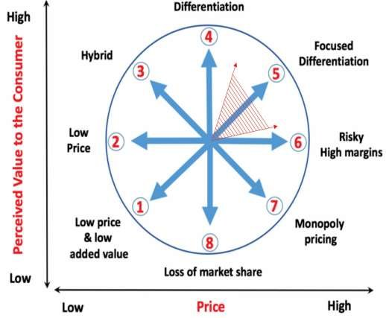
Figure 01: Bowman’s Strategy Clock (Haselwanter et al., 2016)
Premier Inn Hotel can use Bowman’s Strategy Clock because the strategy gives the options for positioning in the market based on its perceived value and pricing strategy. The hotel chain can use the strategy by lower price and differentiation strategy for communicating and providing the value proposition.

Tactics

Marketing mix of Premier Inn Hotel
The marketing mix is the tools which a business organization can use to affect the customer to purchase the products and services.
Product: Crown Plaza provides limited services with huge types of rooms. The hotel services are parking, staying, a swimming pool, Wi-Fi and other facilities (Siakalli et al., 2017). It provides special care for disabled customers, older guests and children. The standard services easily attract customers to stay in the hotel. The delicious breakfast is provided by the hotel and the menu offers huge items.
Price: Premier Inn Hotel uses Penetration pricing strategies for its services selling. It operates market research for knowing the pricing strategies and price conditions of competitors. It targets backpackers and travellers and provides standard services at a reasonable price. It fixes the different pricing points for the different types of rooms. Moreover, the hotel uses a value pricing strategy for providing value to the guests.
Place: The hotel tracks the movement and activities of target customers on social media. Premier Inn Hotel operates the business in different places globally. Moreover, the hotel provides online reservation and registration facilities so that customers can pre-book their rooms from their homes.
Promotion: Premier Inn Hotel can use different media for conducting promotional operations. The hotel uses social media like Facebook, YouTube, Instagram, Twitter and others to conduct its advertising. The hotel uses its website for promotional operations to attract new customers. It can use digital media, Newspapers and outdoors to conduct promotional operations. It uses chatbots to directly communicate with customers.

Action
Premier Inn Hotel needs to create 2 months to make a marketing plan and conduct market research. The hotel will create a schedule for marketing channels and apply them in February 2023. The hotel will conduct the promotions which are advertisement, outdoor and online promotion. To implement the marketing plan and start the promotional operations, it will need 2 or 3 months. In May 2023, the hotel will gather feedback from customers about the marketing channels and marketing operations.
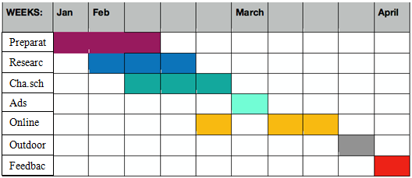
Figure 02: Gantt chart (Maylor, 2001)
Premier Inn Hotel will create a marketing plan and conducts the research in January and it will finish its research in April. It will make a schedule for marketing channels and implement and apply them in March. The Hotel chain will gather feedback in April. Premier Inn Hotel can conduct online marketing by using social media.

Control
USP: Premier Inn Hotel is a famous hotel chain which provides quality services globally.
Features: The standard service, online booking facilities and suitable for visitors.
Benefits: The hotel gives parking, staying, a swimming pool, Wi-Fi and other facilities.

Conclusion
To conclude the report, it can be said that a successful marketing plan is essential for increasing customers. The main customers of the hotel are travellers and backpackers. The hotels have a lower threat of new entrance, a medium chance of bargaining for suppliers, a lower chance of bargaining in the on-season and a higher chance in the off-season, higher threats of substitutes and medium intensity of competitive rivalry. The hotel deals with both domestic and global hotels for increasing its hotel chain. It has both positive and negative micro-environmental impacts. Premier Inn Hotel can use Bowman’s Strategy Clock because the strategy gives the options for positioning in the market based on its perceived value and pricing strategy. The hotel needs to create 2 months to make a marketing plan and conduct market research. Therefore, the marketing plan will be successful by its successful implementation in the market.

References
Day, T. and Tosey, P., (2011). Beyond SMART? A new framework for goal setting. Curriculum Journal, 22(4), pp.515-534.
Gamayanto, I., (2004). Porter s five forces model Scott Morton s five forces model Bakos Treacy model analyzes strategic information systems management. Jurnal informatika, 5(2), pp.127-134.
Gil‐Saura, I., Frasquet‐Deltoro, M. and Cervera‐Taulet, A., (2009). The value of B2B relationships. Industrial Management & Data Systems.
Haselwanter, S., Muskat, B. and Zehrer, A., (2016). Strategic Planning in Micro Businesses: Adapting the Strategic Clock for Micro Firms.
Maylor, H., (2001). Beyond the Gantt chart:: Project management moving on. European management journal, 19(1), pp.92-100.
Payne, A., Frow, P. and Eggert, A., (2017). The customer value proposition: evolution, development, and application in marketing. Journal of the Academy of Marketing Science, 45, pp.467-489.
Sammut-Bonnici, T. and Galea, D., (2014). PEST analysis.
Siakalli, M., Masouras, A. and Papademetriou, C., (2017). e-Marketing in the hotel industry: marketing mix strategies. In Strategic Innovative Marketing: 4th IC-SIM, Mykonos, Greece 2015 (pp. 123-129). Springer International Publishing.
Tautz, D., (2004). Segmentation. Developmental cell, 7(3), pp.301-312.

Component B - PowerPoint Presentation Slides
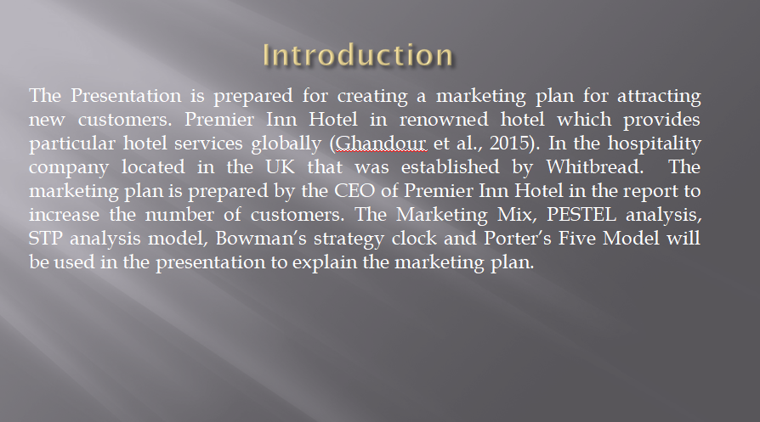
The purpose of the report is to create a marketing plan for attracting new customers. Premier Inn Hotel is a famous hotel brand that provides limited hotel services internationally (Ghandour et al., 2015). The hotel chain is situated in the UK that was built by Whitbread. The marketing plan is prepared by the CEO of Premier Inn Hotel in the report to increase the number of customers. The Marketing Mix, PESTEL analysis, STP analysis model, Bowman’s strategy clock and Porter’s Five Model will be used to conduct the report.
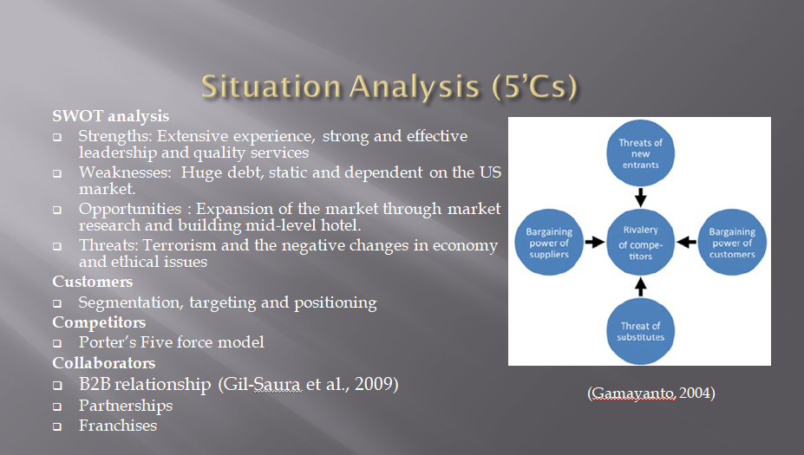

Premier Inn Hotel has more than 827 hotels and 80000 rooms and the occupancy rate is 76.3% (Tempest, 2008). The hotel provides customers with extensive experiences and quality services through strong and effective leadership. The weaknesses of the hotel are dependent on the US market, huge debt and lower flexibility. It has the scope to expand the market and create a mid-level hotel. Hygiene issues and terrorism can be threats to the hotel. The hotel segmented its market based on profession, age, family and disposable income. Its target markets are travelers and backpackers. The hotels have a lower threat of new entrance, a medium chance of bargaining for suppliers, a lower chance of bargaining in the on-season and a higher chance in the off-season, higher threats of substitutes and medium intensity of competitive rivalry. It can deal with suppliers for finding the raw materials, allowing franchisees and creating partnerships to expand branches globally.
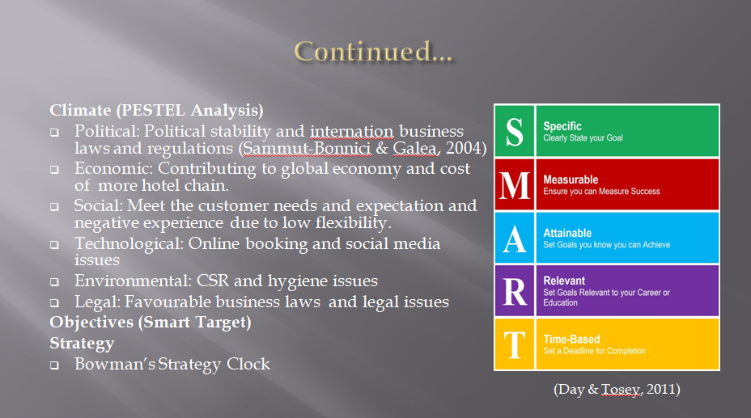
Premier Inn Hotel is influenced by different positive and negative micro-environmental factors. Its smart objectives are attracting potential customers and increasing the number of customers by conducting a successful marketing plan and its implementation with its resources and abilities within 1 year (O'Neill, 2000). Premier Inn Hotel uses the value proposition strategy and differentiates the brand by giving standard service. Premier Inn Hotel can use Bowman’s Strategy Clock because the strategy gives the options for positioning in the market.
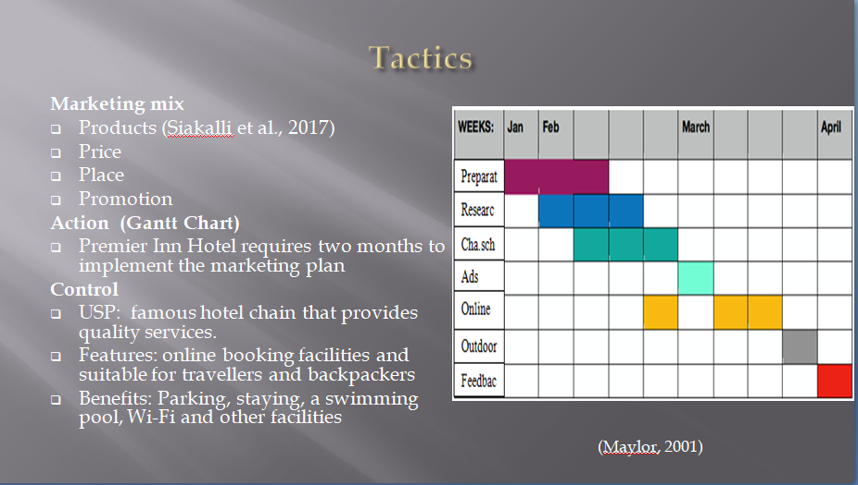
The hotel provides limited service and uses the price penetration strategy (Widardi et al., 2020). It provides online reservation and registration facilities and uses social media for promotion. Premier Inn Hotel needs to create 4 months to make a marketing plan and conduct market research. Premier Inn Hotel is a famous hotel chain which provides quality services and online booking facilities globally. The hotel gives parking, staying, a swimming pool, Wi-Fi and other facilities.
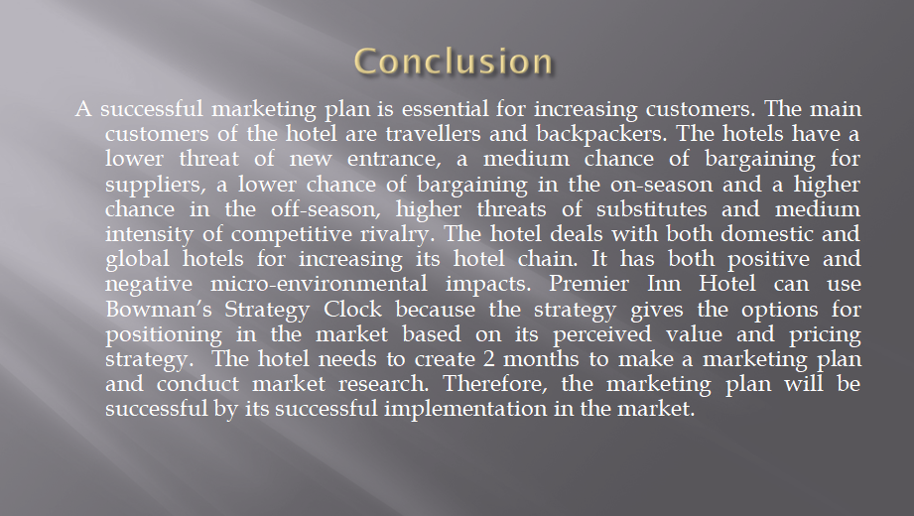
To conclude the report, it can be said that a successful marketing plan is essential for increasing customers. The main customers of the hotel are travellers and backpackers. The hotel needs to create 2 months to make a marketing plan and conduct market research. Therefore, the marketing plan will be successful by its successful implementation in the market.
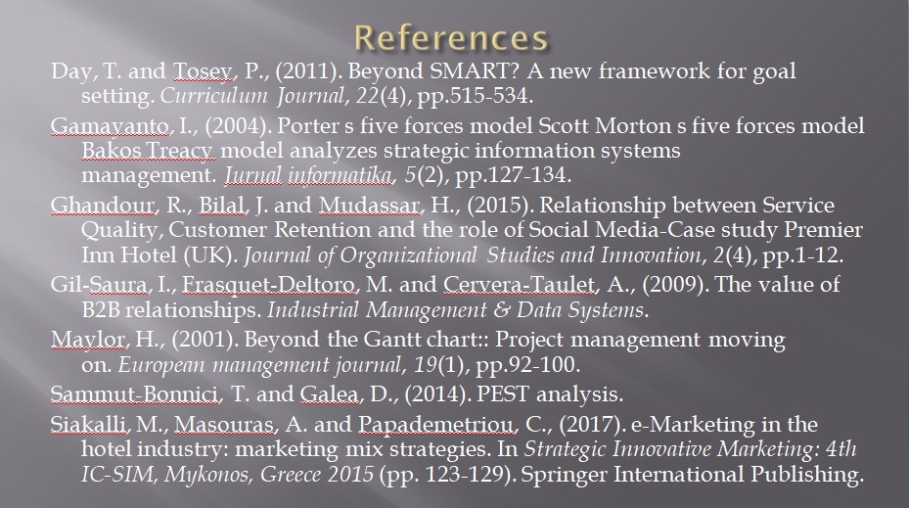
Ghandour, R., Bilal, J. and Mudassar, H., (2015). Relationship between Service Quality, Customer Retention and the role of Social Media-Case study Premier Inn Hotel (UK). Journal of Organizational Studies and Innovation, 2(4), pp.1-12.
O'Neill, J., (2000). SMART goals, SMART schools. Educational Leadership, 57(5), pp.46-50.
Tempest, G., (2008). The development and launch of Premier Inn. Hospitality Review, 10(4), pp.5-11.
Widardi, J., Syah, T.Y.R., Indradewa, R. and Pusaka, S., (2020). Marketing Mix Strategy Implementation for Business Plan at LH Hotel. Journal of Multidisciplinary Academic, 3(5), pp.166-170.

