BA International Hotel Management

Module title: International Meetings Management for the Hotel Industry

Module code: BMIH6007

Assignment title: Feasibility Plan for an International Meeting (Team building) Murder Mystery-Presentation

Student Name: Anca Roxana Iclanzean

Student ID: 2207144

Module Lead: Kathryn Flynn

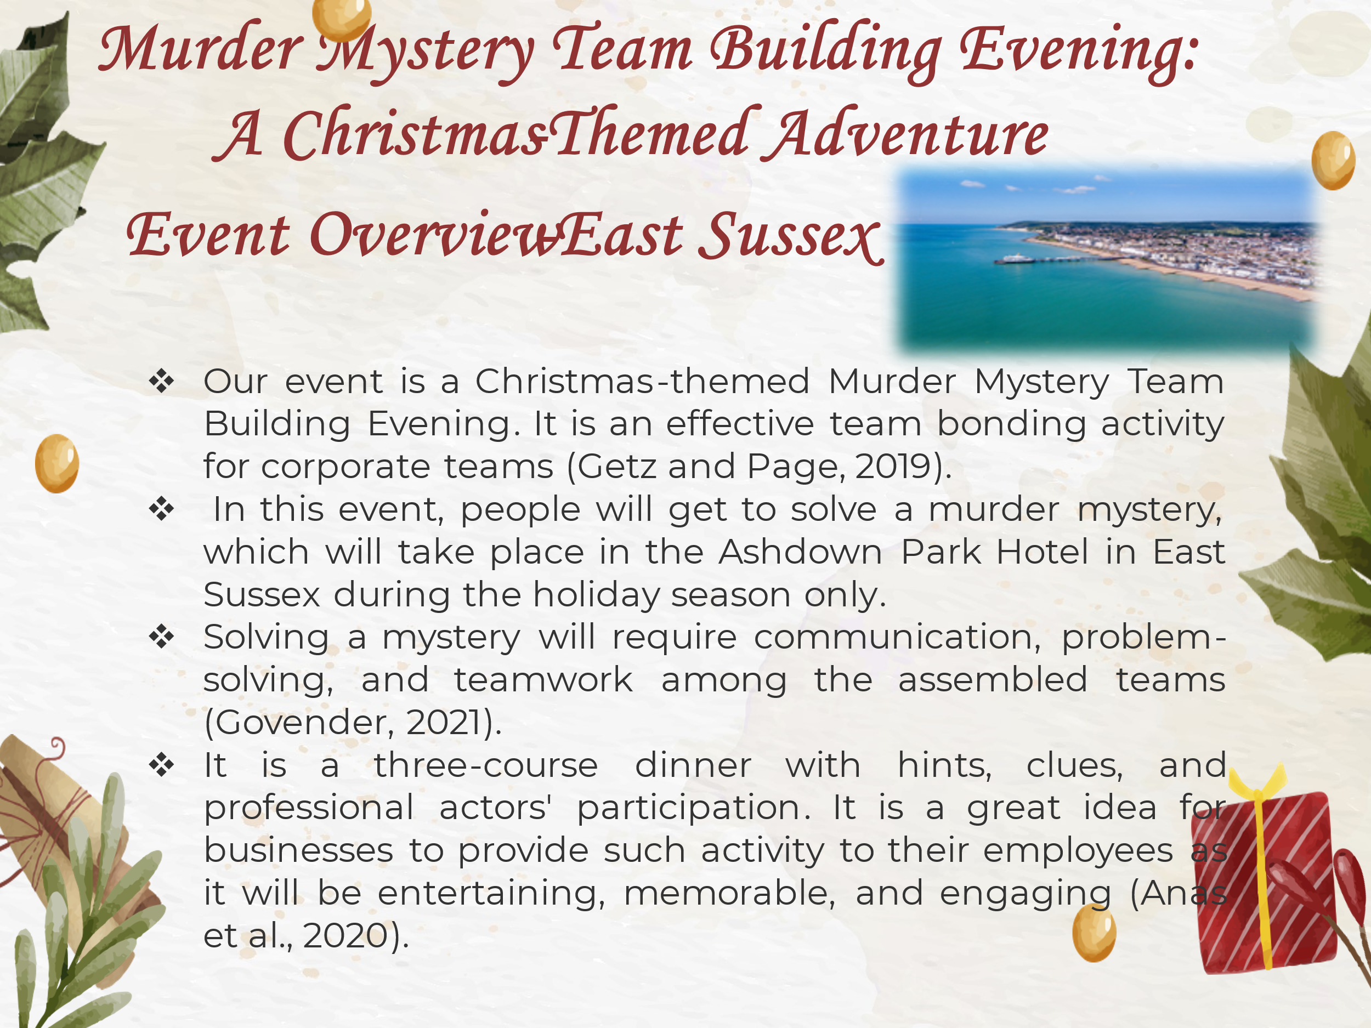

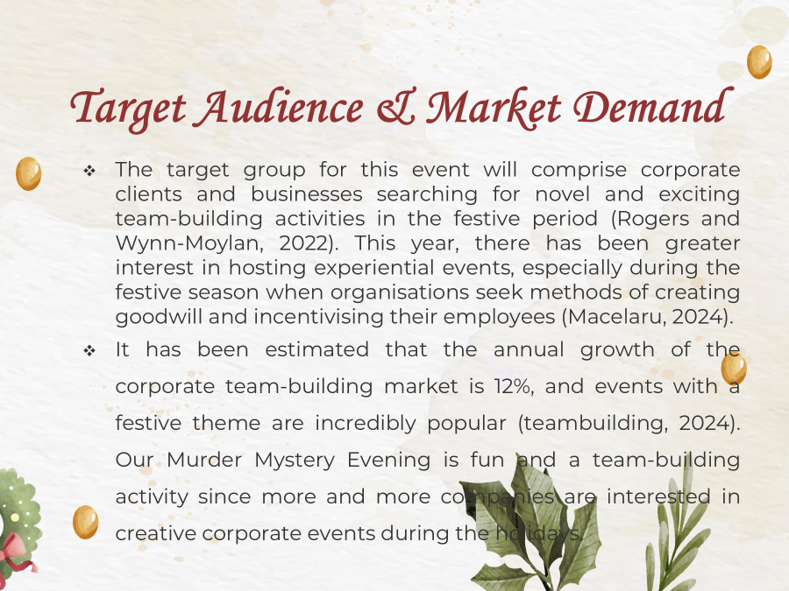

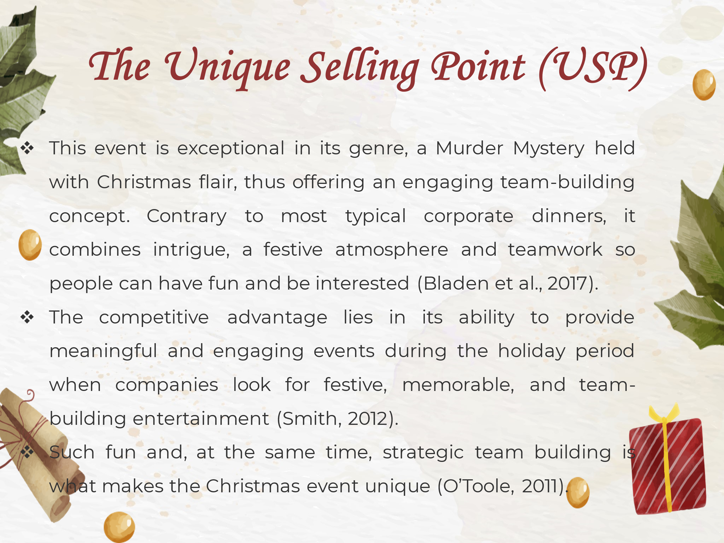



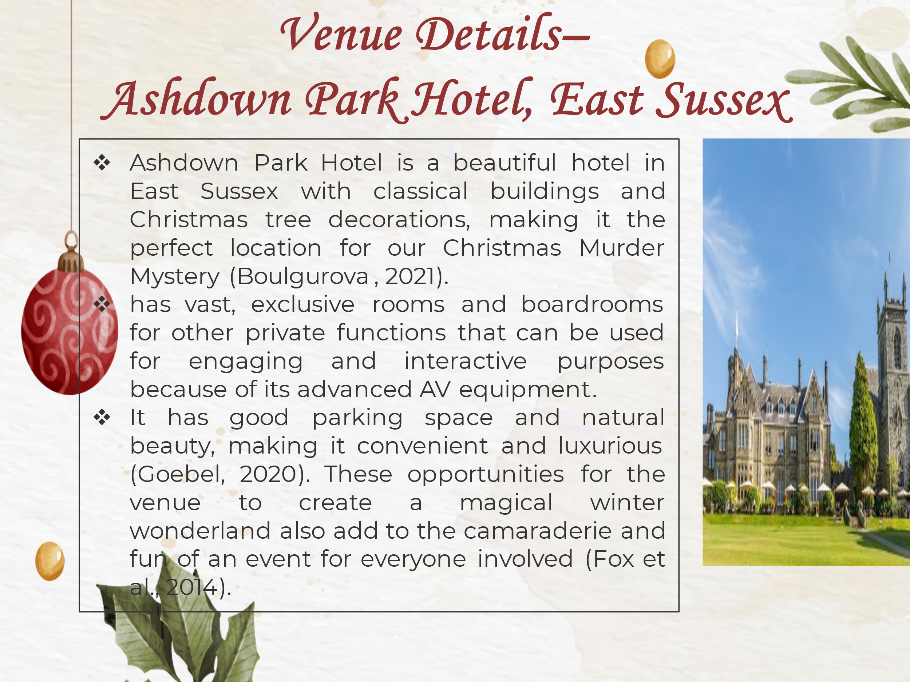

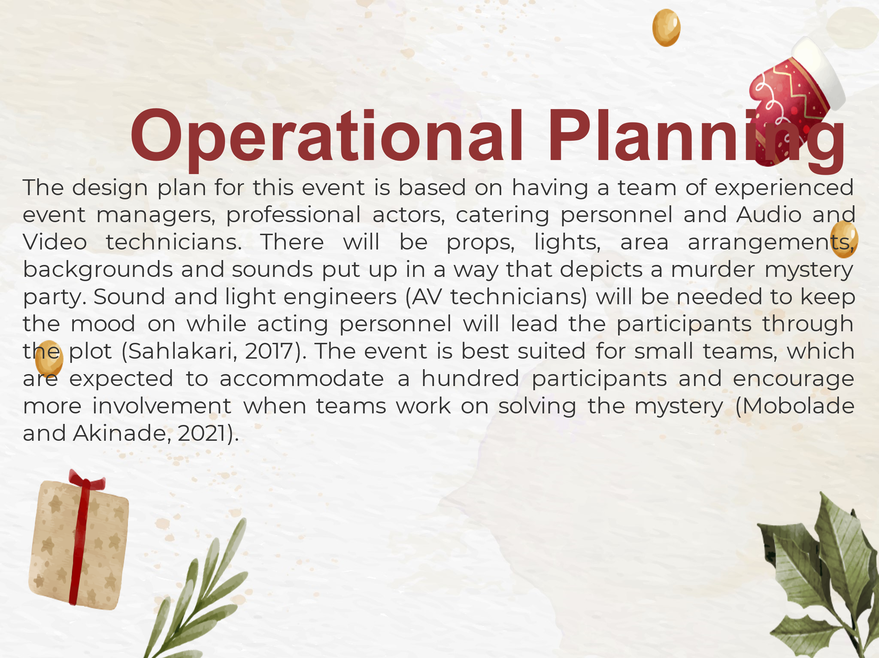

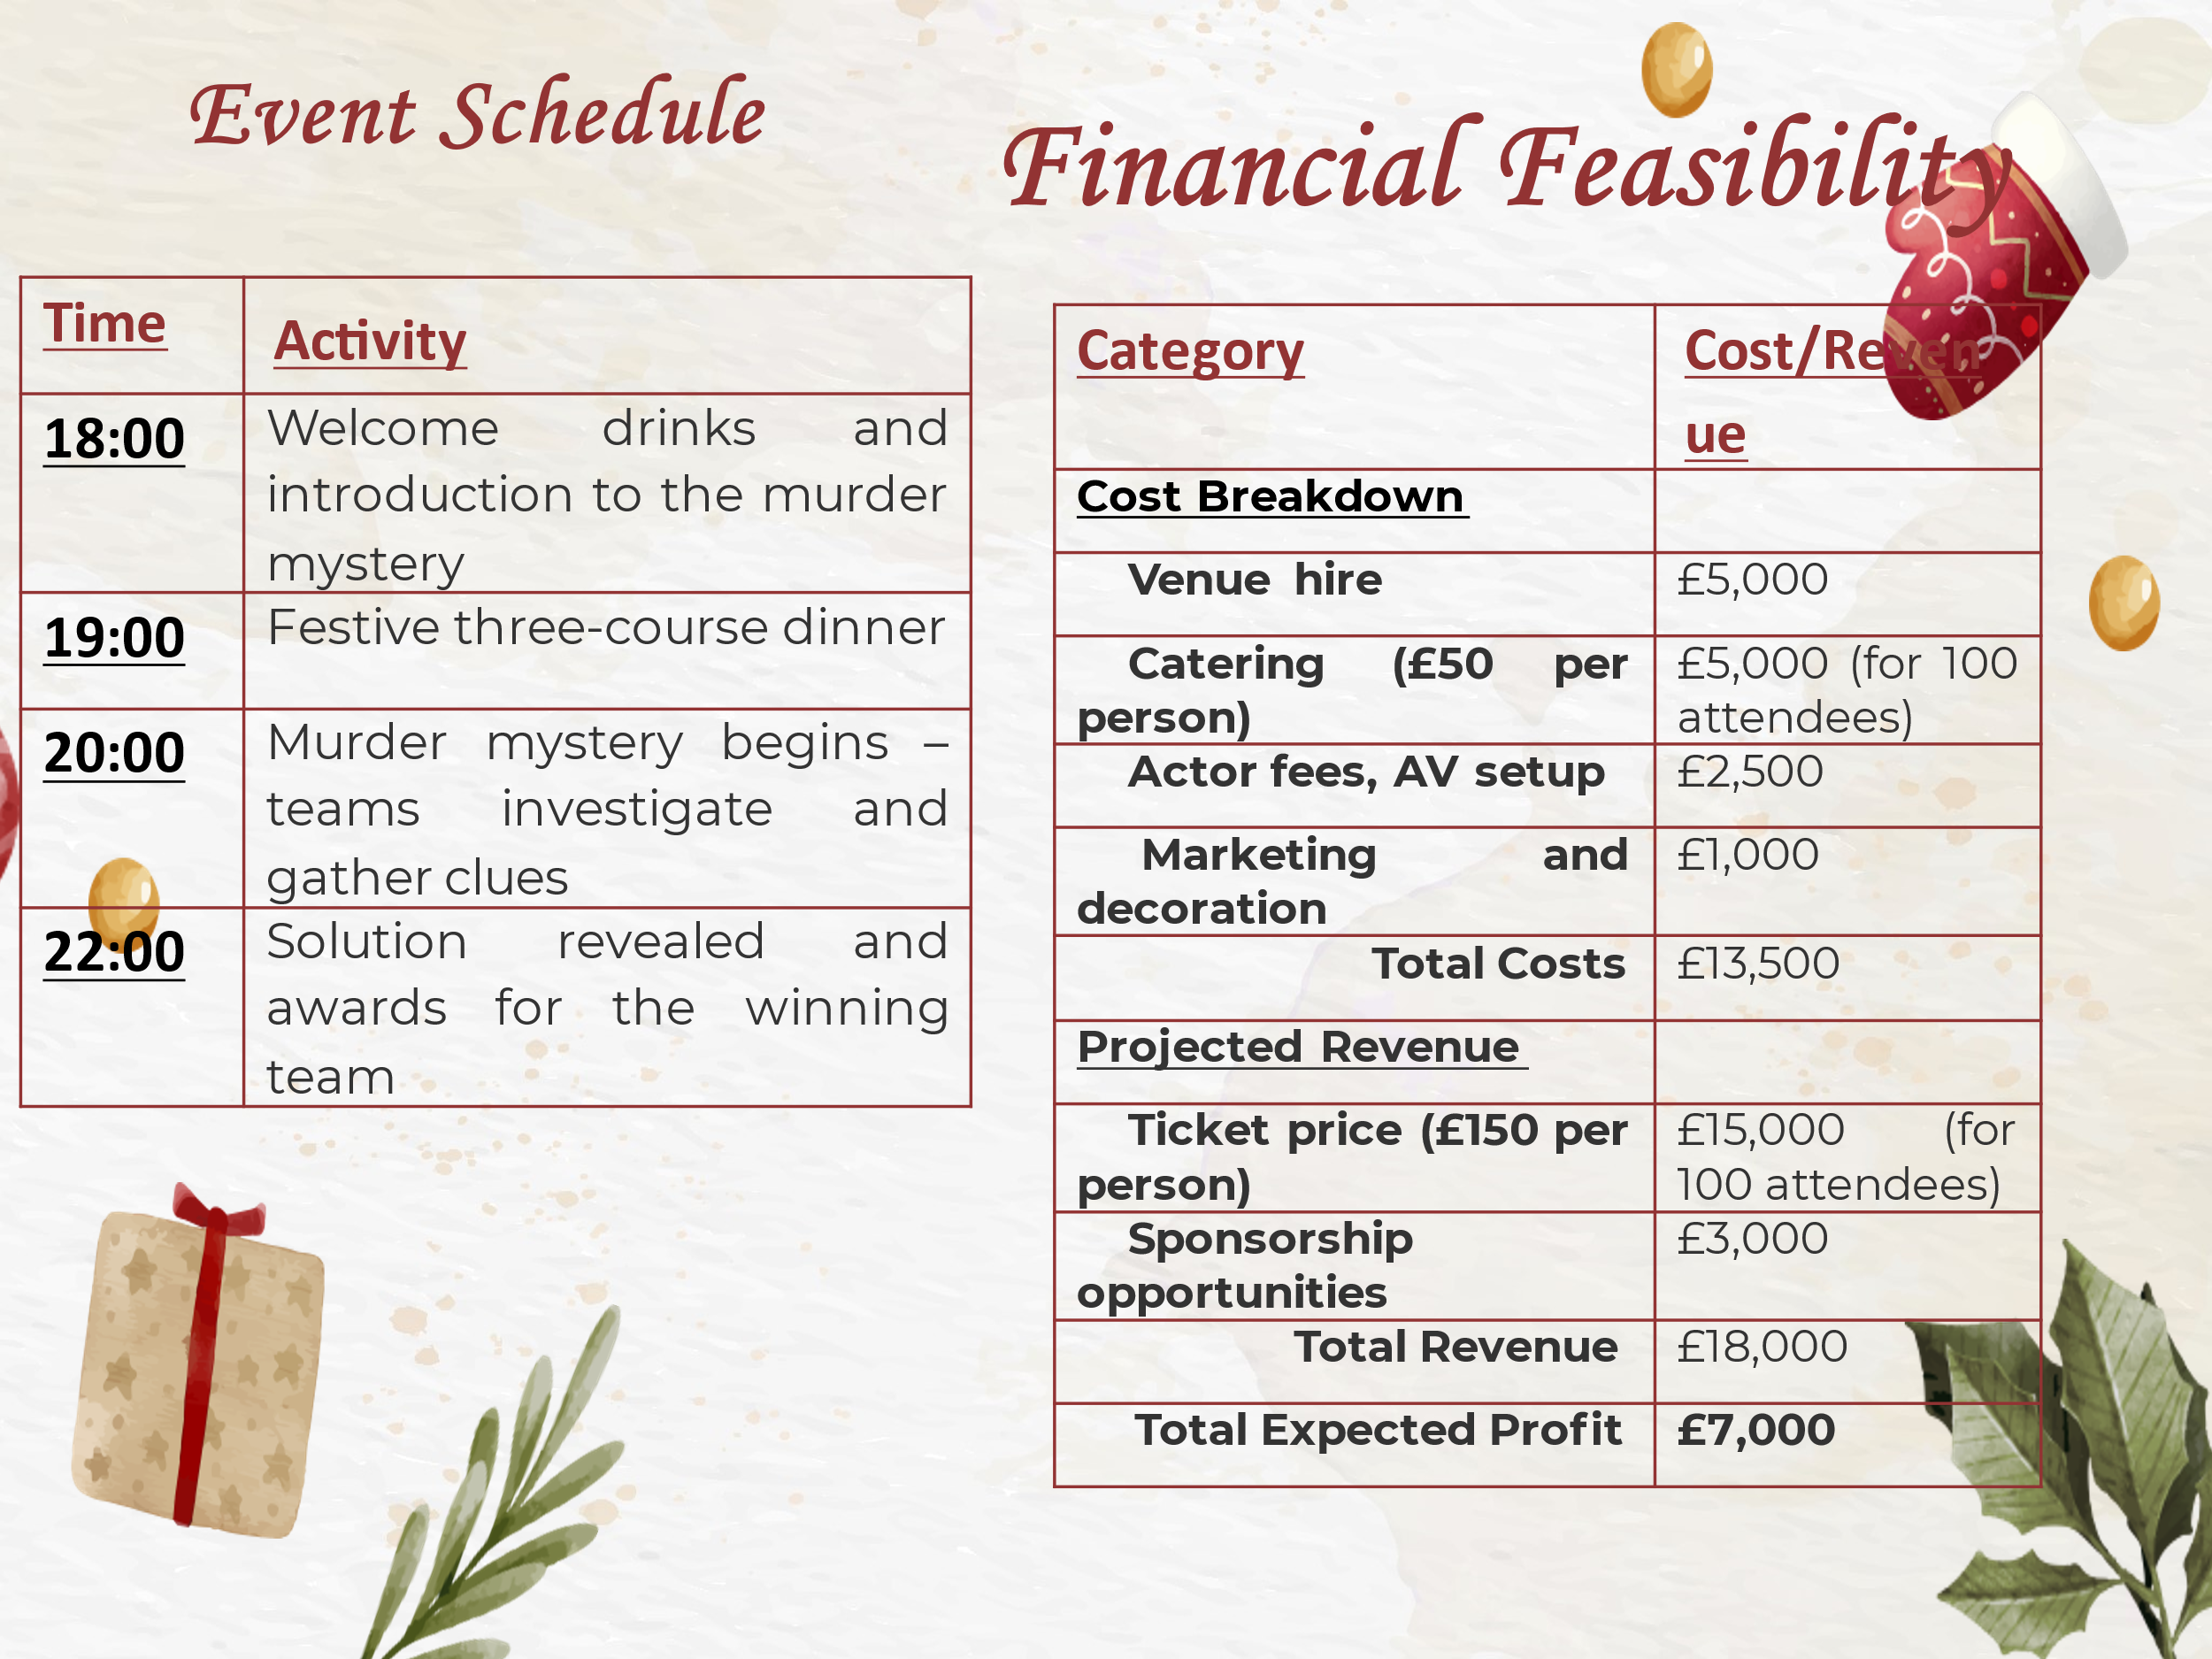

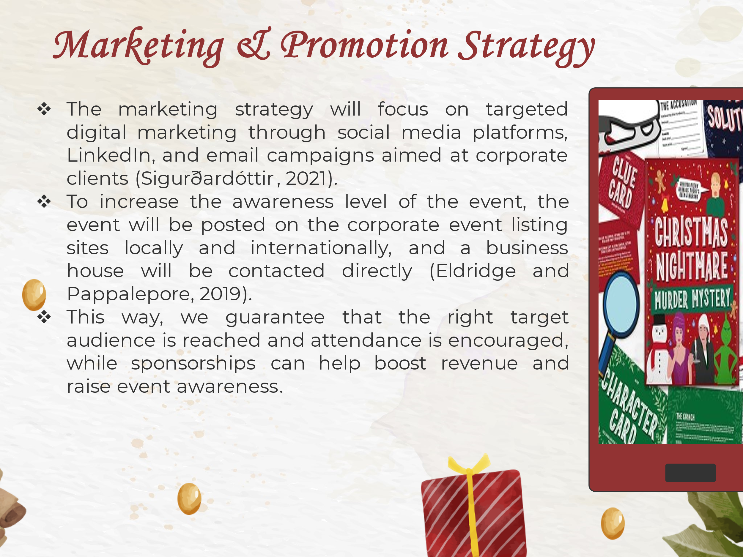

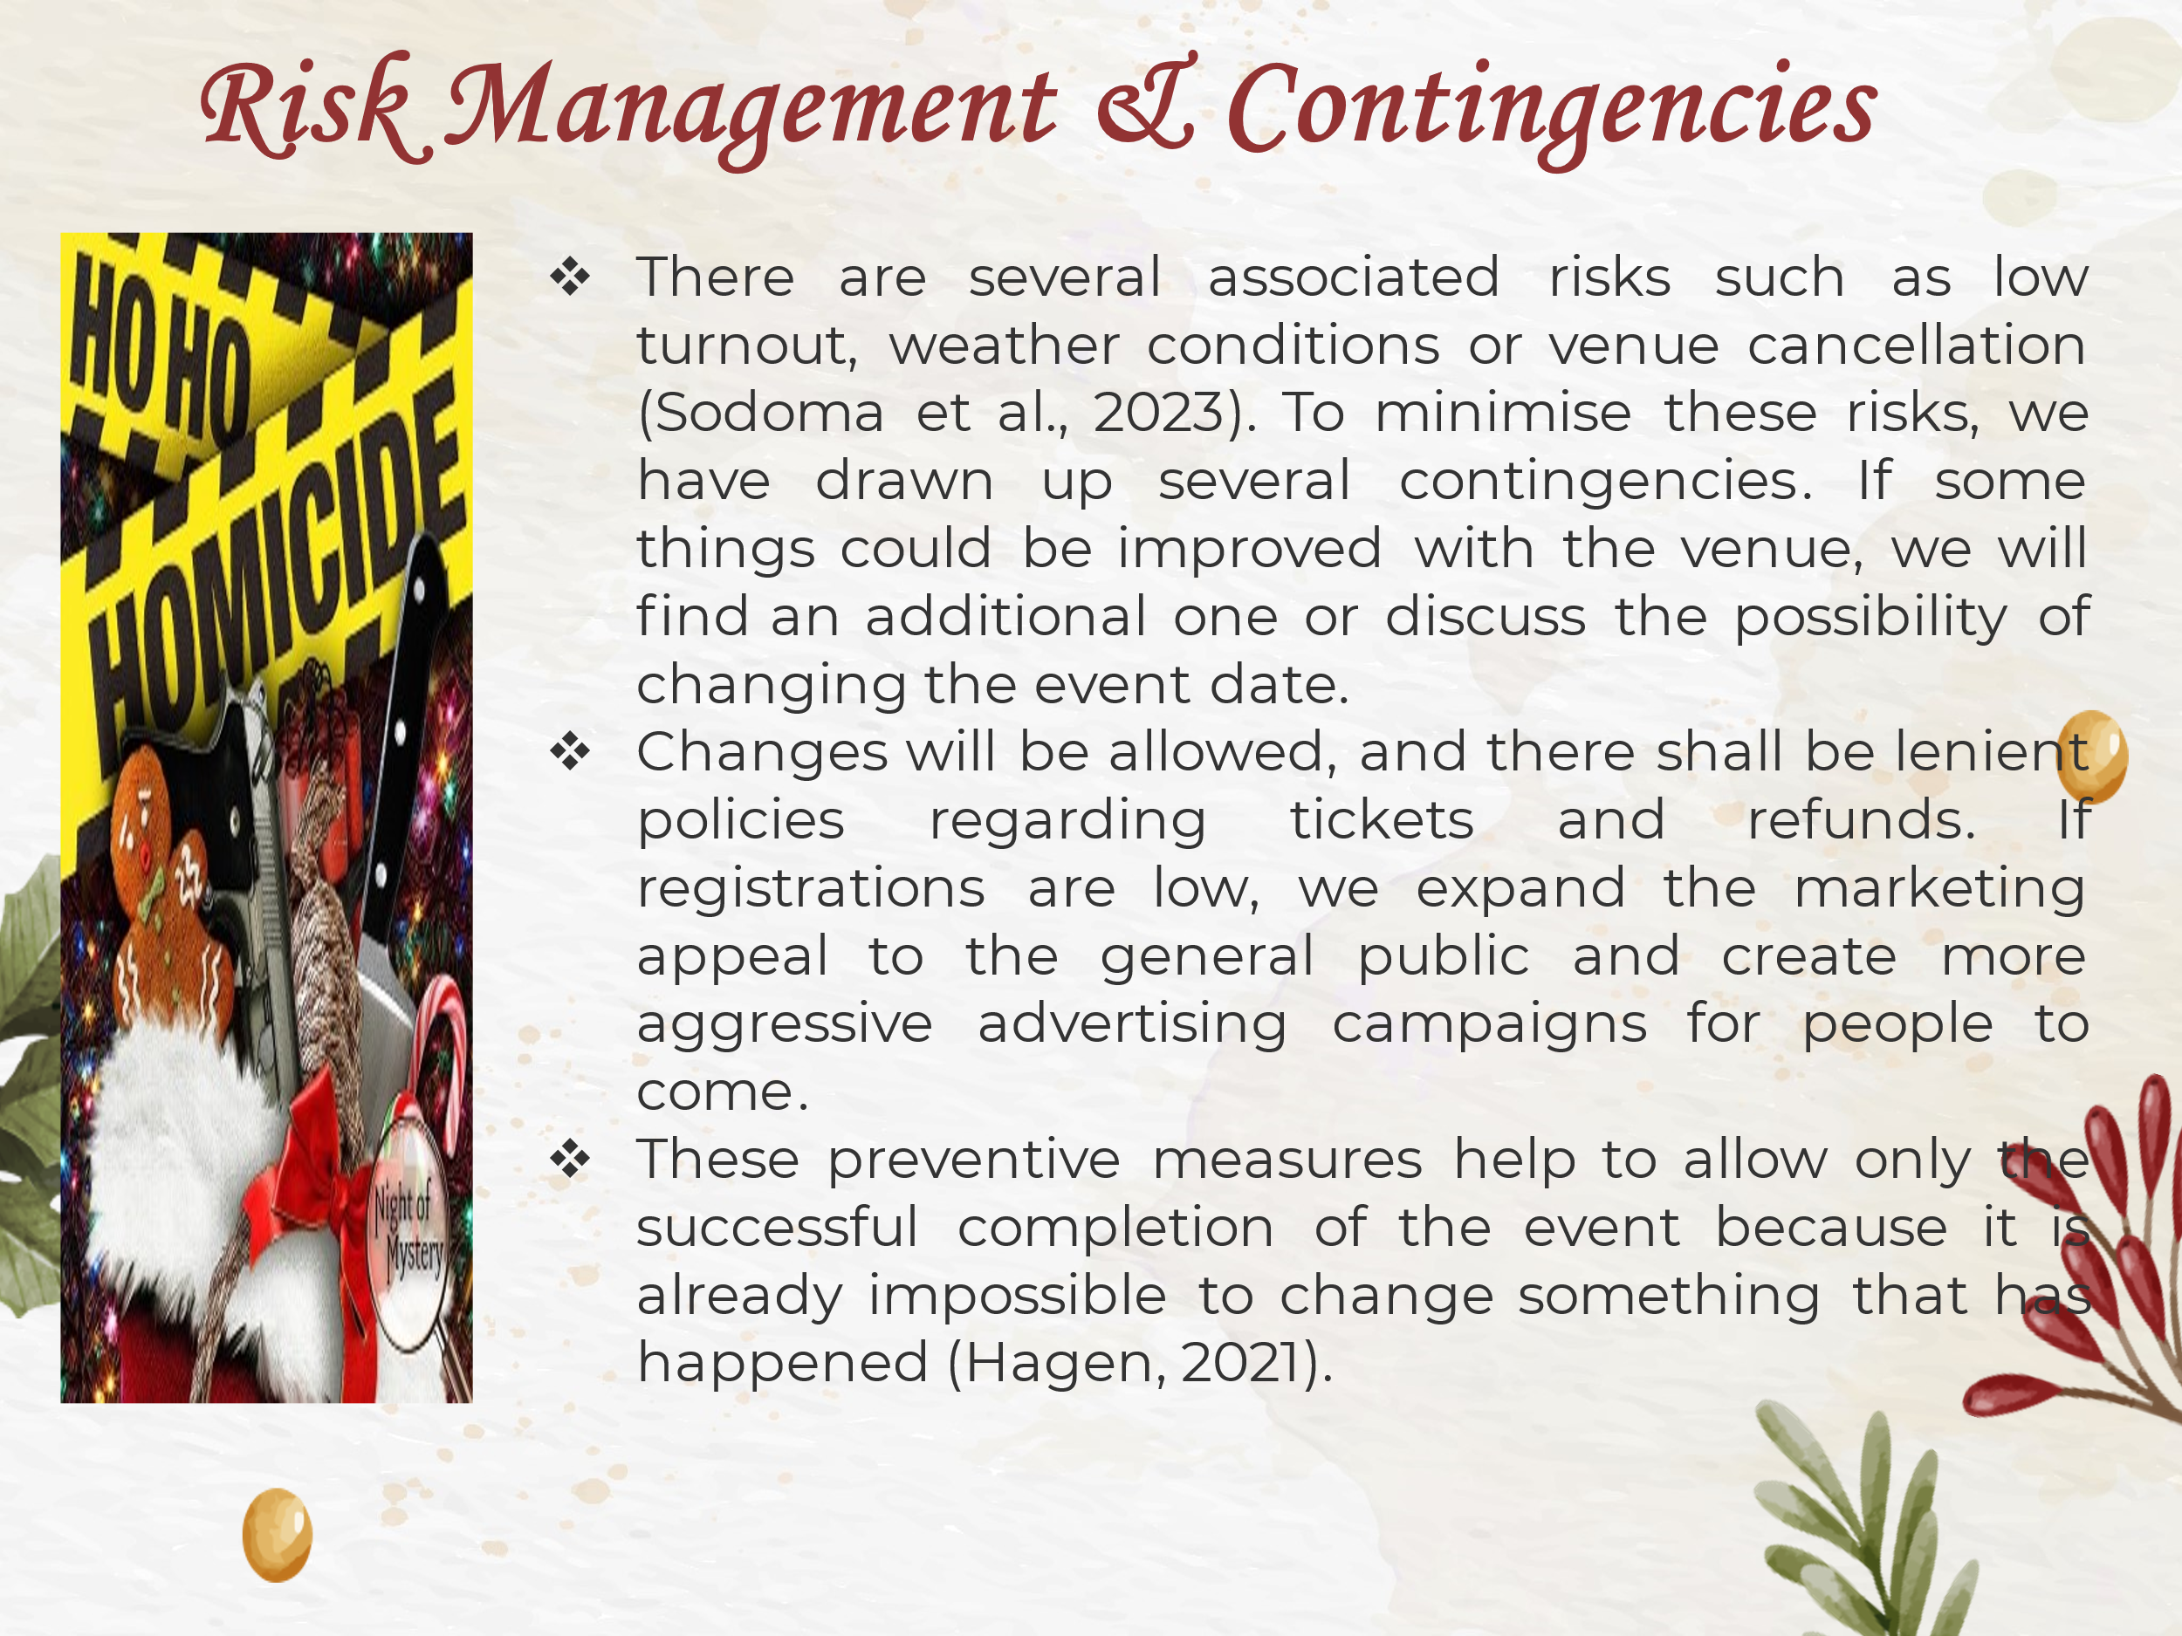

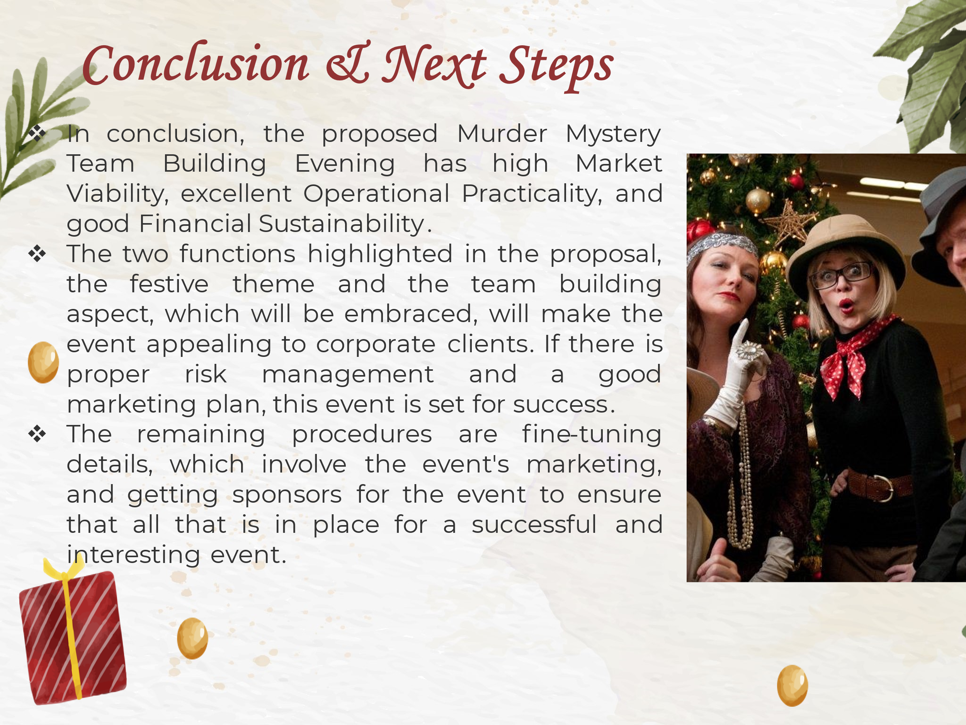

References:
- Anas, M.S., Maddiah, N.A., Noor Eizamly, N.U.E., Sulaiman, N.A. and Wee, H., (2020). Key success factors toward MICE industry: A systematic literature review. Journal of Tourism, Hospitality & Culinary Arts (JTHCA), 12(1), pp.1-34.
- Bladen, C., Kennell, J., Abson, E. and Wilde, N., (2017). Event project management: feasibility, planning, delivery and evaluation. In Events Management (pp. 20-49). Routledge.
- Boulgurova, R., (2021). Corporate Christmas:“My Party is Much Better than your Party”. ETHNOLOGIA BULGARICA. Yearbook of Bulgarian Ethnology and Folklore, 7(1), pp.43-61.
- Dounavi, L.E., Dermitzakis, E., Chatzistelios, G. and Kirytopoulos, K., (2022). Project management for corporate events: a set of tools to manage risk and increase quality outcomes. Sustainability, 14(4), p.2009.
- Eldridge, A. and Pappalepore, I., (2019). Festive space and dream worlds: Christmas in London. In Destination London: The Expansion of the Visitor Economy (pp. 183-203). London: University of Westminster Press.
- Fox, D. et al. (2014) Doing events research: from theory to practice. Routledge: Oxford
- Getz, D. and Page, S. (2019) Event studies: theory, research and policy for planned events. 3rd Edition. Routledge: Oxford
- Goebel, A., (2020). An Inside Look into Event Planning.
- Govender, V., (2021). Assessing the key success factors for the strategic management of corporate events: a supply-side perspective (Doctoral dissertation, North-West University (South Africa)).
- Hagen, D., (2021). Sustainable event management: new perspectives for the meeting industry through innovation and digitalisation?. Innovations and Traditions for Sustainable Development, pp.259-275.
- Macelaru, M., (2024), July. Team Development and Experiential Learning. In RAIS Conference Proceedings 2022-2024 (No. 0388). Research Association for Interdisciplinary Studies.
- Meredith, J. (2022) Project management: a managerial approach
- Mobolade, G.O. and Akinade, M.E., (2021). Team building and teamwork in organizations: Implications to managers and employees in work places. International Journal of Management, Social Sciences, Peace and Conflict Studies, 11(4), p.1.
- O’Toole, W. (2011) Events feasibility and development: from strategy to operations. Elsevier: Oxford
- Rogers, T. Wynn-Moylan, P (2022) Conferences and conventions: a global industry. 4th Edition. Routledge: Oxford
- Sahlakari, S., (2017). New event plan for the annual festival of Christmas traditions.
- Sigurðardóttir, I., (2021). Segmentation, marketing, venue selection and competitiveness of events. In Humans, horses and events management (pp. 74-87). Wallingford UK: CABI.
- Smith, A. (2012) Events and urban regeneration: the strategic use of events to revitalise cities. Routledge: Oxford
- Sodoma, R., Kovalchuk, O., Sadura, O. and Popadynets, N., (2023). Promotions and Team Building for Marketing Campaigns. Journal of Vasyl Stefanyk Precarpathian National University, 10(2), pp.59-68.
- Teambuilding (2024). Murder Mystery Team Building Evening. [online] Teambuilding.co.uk. Available at: https://www.teambuilding.co.uk/activities-evening/murder-mystery-evenings.html [Accessed 13 Oct. 2024].

