Marketing Fundamentals

Assessment 1
Blogging to communicate
LCBB4004

Karolina Kwiecien
2113036

07/01/2022

Table of Contents
Background of L’OREAL 3
Products of L’OREAL 5
Prices offered by L’OREAL 10
Places where the L’OREAL products are available 11
L’OREAL Promotion 16
References 18

Background of L’OREAL
L’OREAL is one of the substantial organisations of France and is the largest manufacturer of cosmetics, skincare, perfume and hair care products in the world. Its headquarters are in Clichy, France and was founded by Eugène Schueller. Popular brands such as Maybelline, Matrix, Lancôme, Garnier and Redken are a part of it. The organisation is noted for its engagement in research as well as development. It has spent 3% of the revenue on cosmetology and dermatological research and holds a 19.5% share in a medical firm named Sanofi/Synthélabo (Referenceforbusiness, 2021). The narration of L'OREAL began in Paris when the ladies of the Haute bourgeoisie coloured their locks in flaming red and the others in coal-black, with just a few options. In 1907, Eugène Schueller, a teenaged scientist had begun, concocting the synthetic colours in his home at night. He then delivered the product to the hair salons in the morning with a brand named Auréole. After two years, his hard work has provided him with results; he opened his own organisation, named Société Française des Teintures Inoffensives pour Cheveux, which was further named L'OREAL (Lamare, 2020). The organisation was very successful and, by 1920, had its branches in over 17 countries, like the Soviet Union Far east, Bolivia and the US. L'Oréal had three research experts and ten sales personnel at the time.
The age of Jazz commemorated at the conclusion of World War 1, and the short hair cuts became trendy from that time, with a focus on new styles and hair colours. By 1920, the nation almost consisted of 40000 salons that customised hair (Loreal, 2021). The blooming market was trapped by various hair colour products of L'OREAL, including Coloral, O'cap and Imédia Liquide. At the end of 1928, the business made its initial foray into diversification by buying a soap manufacturer named Monsavon.
The chief executive officer of the organisation is Jean-Paul Agon, who commits a universalisation path with a transparent mission statement of “Beauty for All.” He mentions that the organisation has approached the 21st Century with a spectrum of great multinational brands that embrace diversity as well as inclusion as a part of the growth strategy internationally (Dmitrievna, 2021). Aside from the commercial aspects, the innovative products of L’OREAL are distinguished by significant ethical as well as socially responsible efforts. Furthermore, the organisation continues to acquire additional acquisitions in order to meet the diverse aesthetic demands of the world, as well as to conduct the social, ecological and digital sustainable activities that serve the common good.

Products of L’OREAL
L’OREAL provides a large scale of makeup, hair care and skincare products. The organisation focuses on providing the potential requirements with all the grooming products. The product range of the organisation is mentioned below:
L’OREAL Hair Care
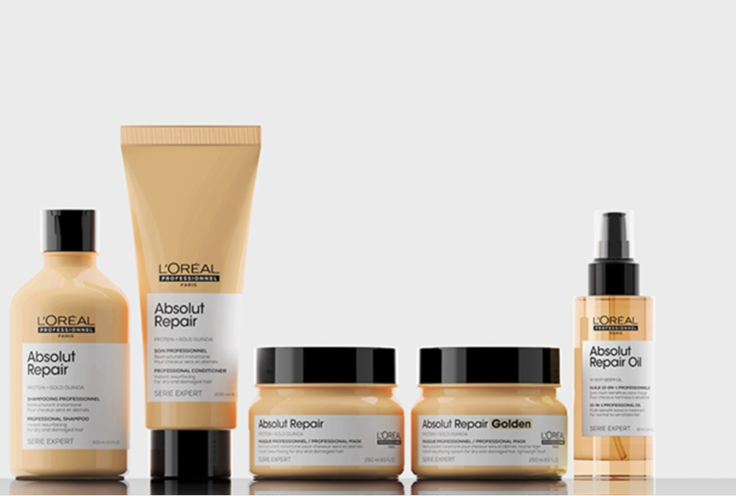
The haircare range was the first inventory of the organisation. Thus, it takes care of the possible outcomes regarding hairs and has produced various hair care products based on the same. For example, the organisation provides an anti-hair fall kit for customers suffering from hair loss. The organisation has named the range "Absolute Repair" (Lorealprofessionnel, 2021). The range consisted of various products, including resurfacing shampoo and conditioner, a hair masque that is resurfacing golden and another that is instant. The range is provided with a multipurpose spray that can be used as oil as well as hairspray (AMBERG, 2019). The range claims to recover the hair damage by 77% and provide more shiner hair.
L’OREAL Makeup
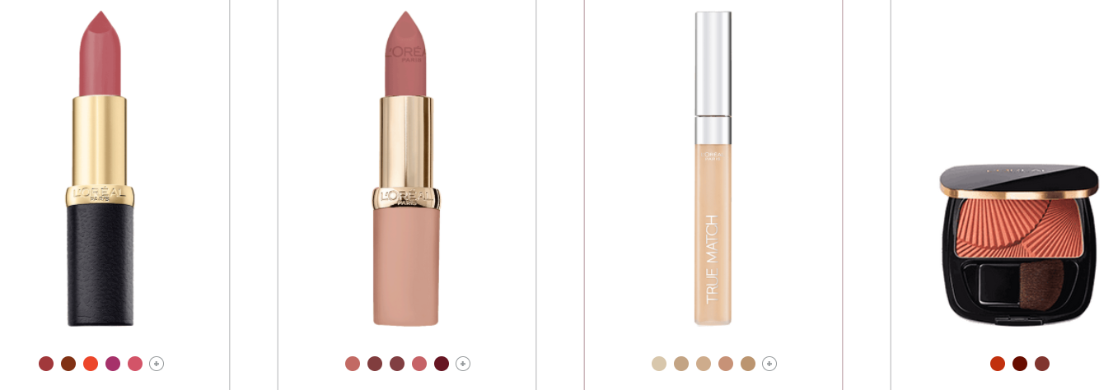
L’OREAL claims to offer innovative makeups with timeless packaging, various colours and pleasant textures. The goods are designed to compartmentalise in the day as well as night. The lip tints, correctors, foundations and mascaras accentuate the face with delicacy and refinement for generating a natural appearance and beautiful skin that matches the daily lifestyle of a woman (Lorealparis, 2021). The lipsticks, eyeliners, blushes and eyeshadows are the cornerstone of a stylish and modern makeup assortment, and they're considered to be more refined. The brow pencil comes in various forms like power and pencil and adds some dimension to the appearance. The cosmetic collection of L'OREAL provides all forms of styles and matches the shades of the customers (LOGVINOVSKAYA and Trubnikova, 2017).
L’OREAL Face Creams
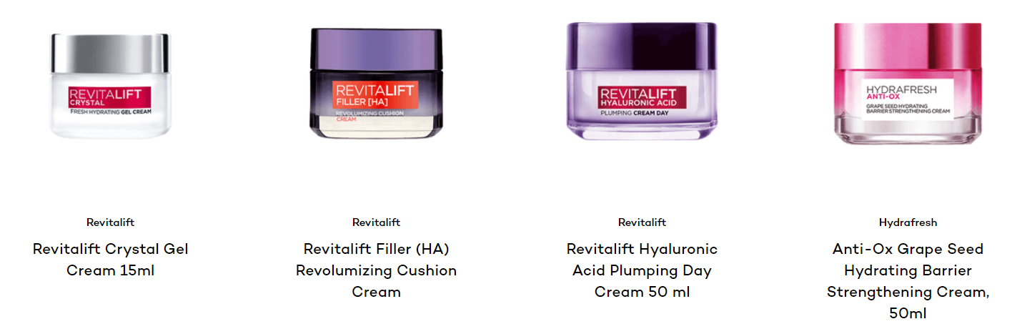
Face creams are a must product in the routine of daily skin care to bring out the natural beauty of the skin. The products of L'OREAL are useful as they moisturise and mattify the skin by providing anti-ageing advantages because they are combined with active substances. L'OREAL provides customers with appropriate skin care products on the basis of their skin orientation (Lorealparis, 2021). In order to enrich the skin so that it becomes smooth, purified and bright, the creams of L'OREAL are one of the best options as it targets a variety of skin issues, including dryness, wrinkle and dullness. They are designed to be suitable for all types of skin (Igorevic, 2021).
L’OREAL Face Wash
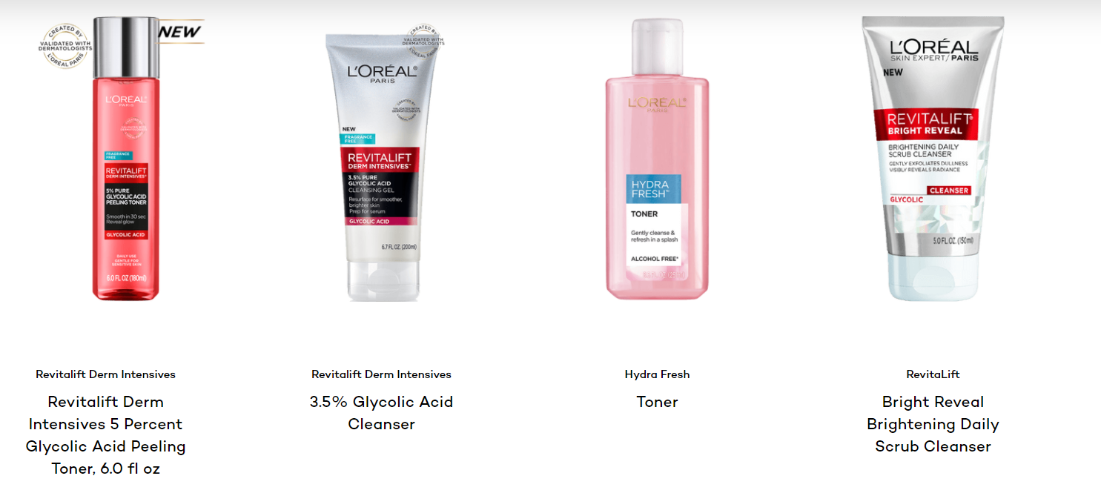
The organisation provides varieties of facewashes, scrubs, toners and cleansers for gently removing impurities and leaving the skin clean and rejuvenated. Appropriate products are provided as per the skin requirements as the daily skin care regimen in the websites that provides the customers with their required products (Lorealparisusa, 2021).
L’OREAL Eye Care
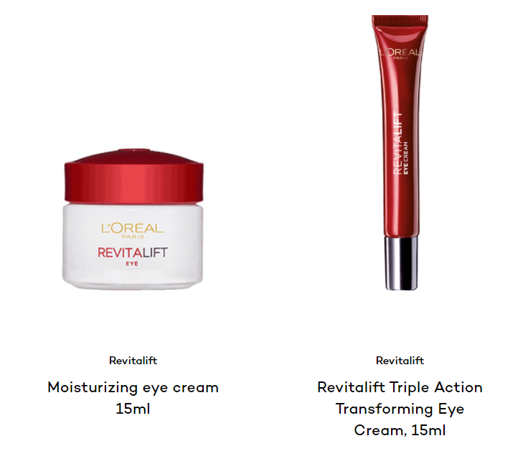
The skin surrounding the eyes is softer and more sensitive than the other parts of the face. The contour of the eye lacks collagens well as elastin fibres, the initial area to exhibit symptoms of ageing (Santos et al. 2018). Eye creams from L'Oréal Paris are designed specifically for delicate skin. Drooping under-eye skin, swollen eye bags, dark circles and fine lines, as well as wrinkles, can be helped with eye treatments (Lorealparis, 2021). The active components of the under-eye creams identify various issues and tackle specific concerns.
L’OREAL Toiletries
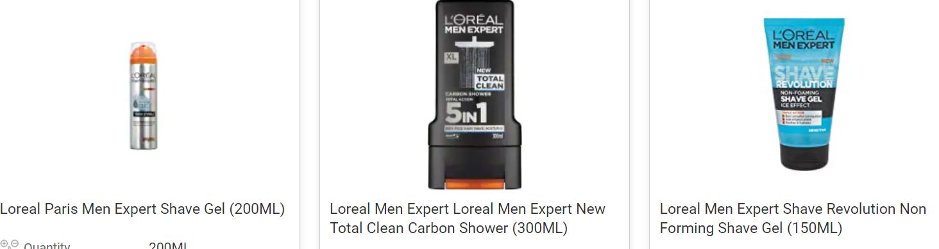
The organisation provides the customers with a wide range of toiletries, mainly in the men section, including after saving lotion and shaving gel. The products have already received a positive response from potential customers (Raftowicz et al. 2021). The organisation does not only take care of the female range but also highlights the men range with higher recognition.

Prices offered by L’OREAL
The pricing strategy of L'OREAL is remarkable and sets an example in the cosmetic industry. The organisation provides the customers with high-quality products at an assured low price. The makeup products are way too cheaper than the other brands producing the same quality of products. It has divided itself into four distinct brands to reach the requirement of the customers. The organisation provides the customers with various offers and discounts that help in bulk selling. For example, they provide 30% off on the products during Christmas (Collin and Taillard, 2021). This enables the buying behaviour of the customers, thus, selling more products. The organisation ensures that the products are easily available to the customers. Thus, they have started using various e-commerce sites for delivering their products to the necessary clients. The prices are up to the qualities, and the brands designed for the customers provide the same products with various price ranges (Pinto, 2020).

Places where the L’OREAL products are available
L'OREAL is one of the most famous cosmetic brands in France and has spread in the worldwide cosmetic industry. The organisation has been successful enough to reach the demands of clients all over the world. The places of the availability of the product are mentioned below:
The online portal of the organisation
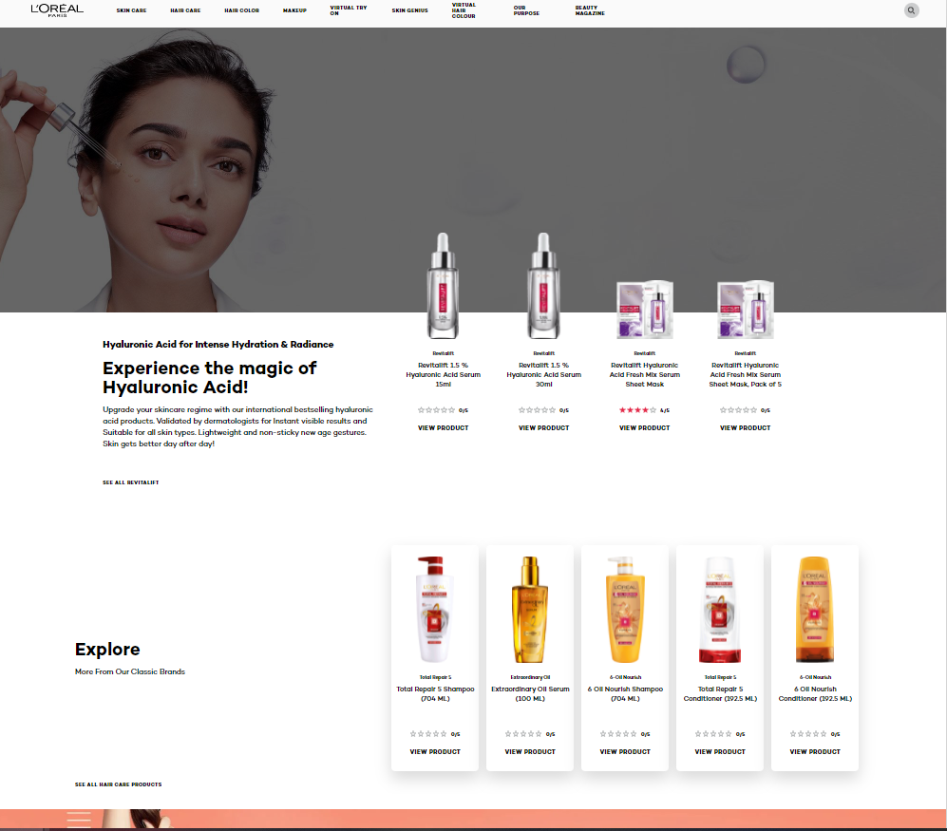
L’OREAL has an official website where it provides the customers with a variety of product ranges with attracting discounts and offers. The official website covers all the ranges of products and provides the customers with information on the product necessitated. The official website of L’OREAL is https://www.lorealparis.co.in/. Professionals and other customer welfare-related services are provided through the official websites to reach the requirements of the clients.
Other e-commerce websites
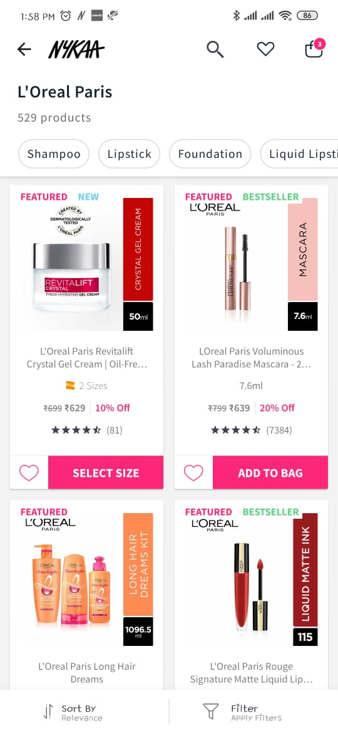
Apart from its original website, L'OREAL avails its products in various e-commerce websites, including Amazon, Flipkart and Nykaa. A customer can easily avail of its products from these websites. They also provide the customers with various offers and discounts on the basis of various occasions and its related sales. These applications are accessible from phone and computer; thus, the customers are able to reach the products as per their requirements.
L’OREAL Application
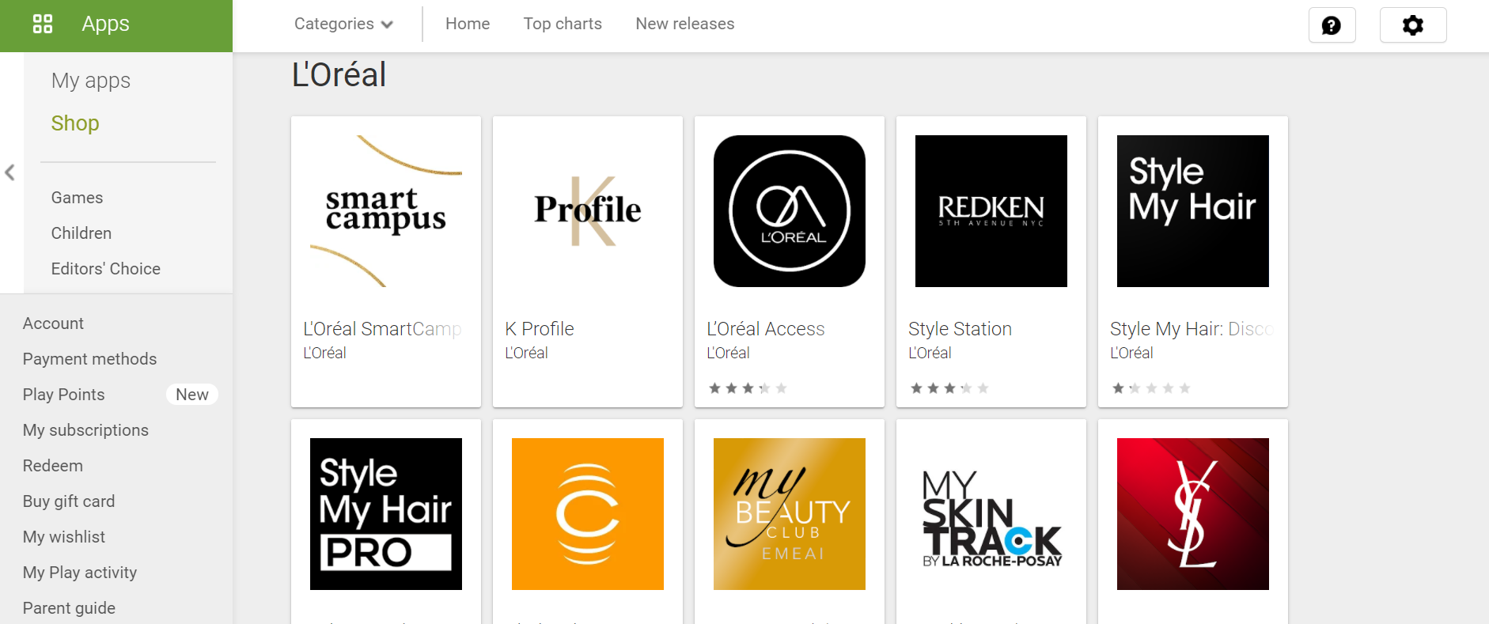
Various applications of L’OREAL are provided on the play store that provides the customers with various applications as per their customisation. It provides quick access and provides extra benefits as well as a wider product range for selection.
Physical Stores
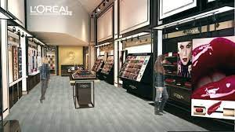
The company sells their products through various physical cosmetic stores. They hold their own showrooms in the malls and other places where they are able to attract clients in a mass and provide them with additional services. L'OREAL has various stores that provide the customers with suggestions on hairstyles and makeup. These stores are provided with professionals who take care of the customised requirements of the clients.

L’OREAL Promotion
The organisation promotes its products through various advertisement strategies, and one of the most common processes is celebrity endorsement. The organisation’s present brand ambassador is Yseult, a French singer.
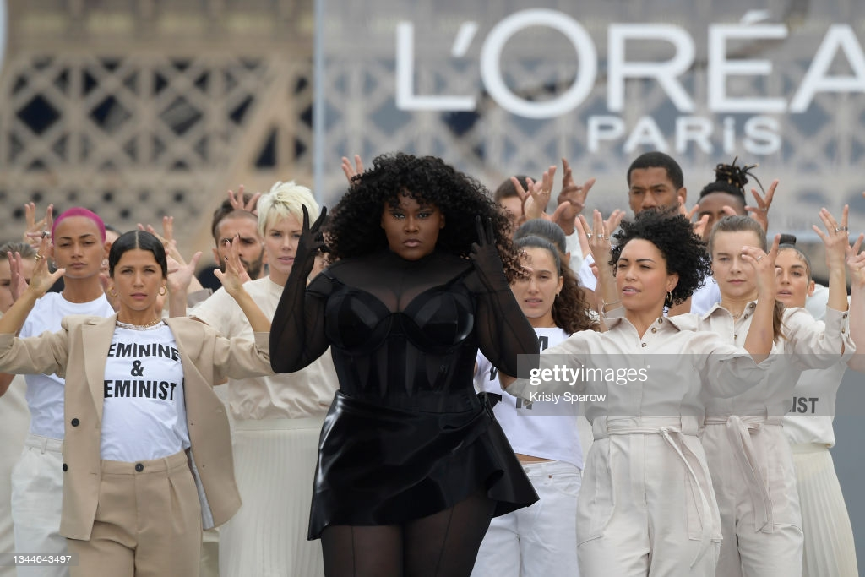
The organisation opts for various celebrities in different nations as it is one of the ways they are able to reach prospective customers. The people of a country generally prefer using the brands that are used by celebrities.
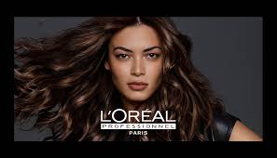
L'OREAL is one of the iconic brands of the world and the largest cosmetic manufacturers. It has its manufacturing units in every nation, thus, preparing [products that match the weather conditions of the locality. For example, the products of the USA will vary from the products of the Eastern regions.

References
Books and authors
AMBERG, N., (2019). THE APPEARANCE OF SUSTAINABILITY IN COSMETICS COMPANIES (AS EXAMPLES OF UNILEVER AND L’ORÉAL), ESPECIALLY ECO-CONTROL AS A SUB-SYSTEM. Acta Oeconomica Universitatis Selye, 8(1), pp.21-41.
Collin, B. and Taillard, M., (2021). Digital Makeover: How L'Oréal Put People First to Build a Beauty Tech Powerhouse. John Wiley & Sons.
Dmitrievna, K.K., (2021). Transformation of Business Sustainability Strategies of FMCG Companies in the 21st Century on the Examples of Unilever and L’Oréal.
Igorevic, B.S., (2021). Advanced Analytics for Prediction of Customers' Preferences: L’Oréal Case.
LOGVINOVSKAYA, V.D. and Trubnikova, N.V., (2017). Corporate culture of cosmetic companies in the digital sphere (on the example of L'Oreal company). Communicology/Kommunikologia, 5(2).
Pinto, M.G.M., (2020). Equity valuation: L´ Oréal SA (Doctoral dissertation).
Raftowicz, M., Kryk, A. and Kurtyka-Marcak, I., (2021). Corporate social responsibility on the example of L'Oréal Polska. Scientific Journal of the Military University of Land Forces, 53.
Santos, R., Au-Yong-Oliveira, M. and Branco, F., (2018), September. L'Oréal and its innovative differentiated positioning process in the beauty industry. In European Conference on Innovation and Entrepreneurship (pp. 717-XII). Academic Conferences International Limited.
Websites
Lamare, A., (2020). A brief history of L'Oréal: A cosmetics dynasty with far-right origins. [Online]
Available at: https://www.businessofbusiness.com/articles/history-of-loreal-far-right-cosmetics/
Loreal, (2021). 1909-1956. [Online]
Available at: https://www.loreal.com/en/group/culture-and-heritage/l-oreal-history/
Lorealparis, (2021). Cream. [Online]
Available at: https://www.lorealparis.co.in/face-care/cream
Lorealparis, (2021). Eye cream. [Online]
Available at: https://www.lorealparis.co.in/face-care/eye-creams
Lorealparis, (2021). Makeup. [Online]
Available at: https://www.lorealparis.co.in/makeup
Lorealparisusa, (2021). Facial Cleanser. [Online]
Available at: https://www.lorealparisusa.com/skin-care/facial-cleansers
Lorealprofessionnel, (2021). ABSOLUT REPAIR. [Online]
Available at: https://www.lorealprofessionnel.co.uk/hair-care/absolut-repair
Pricee, (2021). Loreal Toiletries. [Online]
Available at: https://pricee.com/toiletries/loreal-toiletries-products-price-in-india
Referenceforbusiness, (2021). L'Oréal SA - Company Profile, Information, Business Description, History, Background Information on L'Oréal SA. [Online]
Available at: https://www.referenceforbusiness.com/history2/74/L-Or-al-SA.html

