Control System Design

James Howe
UWTSD
1910319
L5 - Instrumentation and Control (OME) (ACDA5011)

Wales Institute for Science and Art
University of Wales Trinity Saint David



Abstract (250)
Using MATLAB and Simulink a model for a Close-In Weapons System (CIWS) has been designed. A provided transfer function has been used along with a Proportional Integral Derivative (PID) controller to create a closed loop control system (utilises feedback), that can be tuned to manipulate the rotation speed and accuracy of the turret. The results show a comparison between the transfer function of just the turret versus the transfer function of the whole control system, the turret displays significantly faster rotation speed and major decrease in overshoot.
The formula provided from the tuned PID controller and the turret’s transfer function have been used to calculate the transfer function of the whole control system. Nyquist diagrams are used to investigate the stability of the system if the gain or the phase angle were to increase. Pole-Zero plots have been used to determine the behaviour of the decay function and where the transfer function tends to infinity and zero. A formula for time domain response has been used to visualise the turret’s overshoot over time, providing a better visual for the turret’s movement.
Table of Contents
Abstract (250) 1
1. Introduction 2
1.1 Control systems 3
1.2 The PID Controller 3
2. Simulation setups 4
2.1 PID Tuning 4
2.2 CIWS Turret Transfer Function 5
2.3 Closed Loop Transfer Function 5
3. Results 6
3.1 Scope Output 6
3.2 Nyquist Diagrams 6
3.3 Pole-Zero Plots 8
3.4 Time Domain Response Graphs 9
4. Discussion 10
5. Conclusion (250) 11
References 12

1. Introduction
This essay aims to design a control system using a MATLAB model of a closed loop system situated in the area of ordnance, munitions and explosives. The system must be precisely controllable to meet the given requirements, detailed in the simulation setup. The model is an approximation of a Close-In Weapons System (CIWS) such as Phalanx which is used primarily for defence on naval ships. Equipped with a radar guided 20mm Gatling gun which is mobilised on a rotating base, the Phalanx can protect against anti-ship missiles and is used by many Navies globally. [1]
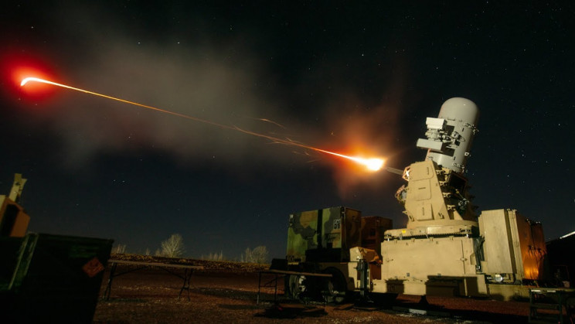
Figure 1 Phalanx CIWS Turret [2]

1.1 Control systems
A system which provides the desired response by controlling the output is known as a control system [3]. These systems are divided into sub categories such as open loop and closed loop systems depending on the path of the feedback. In open loops systems, the output is not fed-back to the input meaning there is no feedback. An example of an open loop system is a set of traffic lights, where a light being activated is not determined by the feedback of other lights being on and is determined beforehand in a set pattern from a traffic study.
The basic traffic light setup could be converted into a closed loop system by adding a sensor as an input which detects when a car is in proximity. This would allow the system to be adjusted automatically to help traffic flow as a light may not need to be red if there is nothing waiting at the other junctions. The system now has an error signal which is the difference between the input and the feedback signal which is used as the input to the system, replacing the original direct input in the open loop variant. The control action is now dependant on the desired output due to the feedback signal so the output of the control system can be adjusted automatically to provide the desired response. Closed loop systems also benefit from being able to respond to exterior stimuli as if these change the output, it will be fed back into the system and the process will adjust the next output. However, an open loop traffic light system would not be able to respond if there was an issue with the clock, it would continue operating using it and this could make the lights change in a different order or at odd timings.
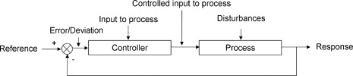
Figure 2 Closed Loop Control Diagram
A closed loop feedback system will be employed in this gun turret example. The goal is to design a control system where the turret can rotate to a desired angle where it can overshoot by no more than 5% and complete the rotation within 2 seconds. These requirements feel like realistic goals as if the turret’s rotation is too slow, it may not be able to keep up with a fast moving target. If the overshoot of the turret is too high, it is likely to miss the target as it won’t be aimed in the correct direction. The system will be using its own output as feedback and the result will be continuously compared [4] with the desired response (angle) which will then modify and adjust the process to minimise the deviation.

1.2 The PID Controller
The PID (Proportional Integral Derivative) block is used to process a continuous input and provide a continuous output. The proportional control corrects any deviation away from the set point back to the set level, the correction is proportional to the amount of error received. If the signal rises above the set point, a correction will be applied and if the signal continues to rise to twice the deviation, the corrective signal will be amplified by a magnitude of four times [5]. This can result in an offset error due to the amplified signal which creates a new set point so Integral and Derivative controls are used alongside this process.
Integral control is added to reset the signal to the original set point but cannot be used by itself. The error is detected along with how long the error has persisted and the product of this is used to create a signal to return to the original set point. This integral control signal is used with the proportional corrective signal to reduce the error signal causing the deviation from the set point and over a relatively long period of time the deviation is minimised.
Derivative control is added to the system to speed up the return from the deviation to the set point. A corrective signal is produced based on the rate of change of the signal, the faster the change occurs from the set point, the larger the corrective signal becomes. This is added to the PI system and gives a fast action than without it.

2. Simulation setups
Simulink within MATLAB is a graphical programming environment for modelling, simulating and analysing systems and has been used to model the circuit of this control system in Figure 3.
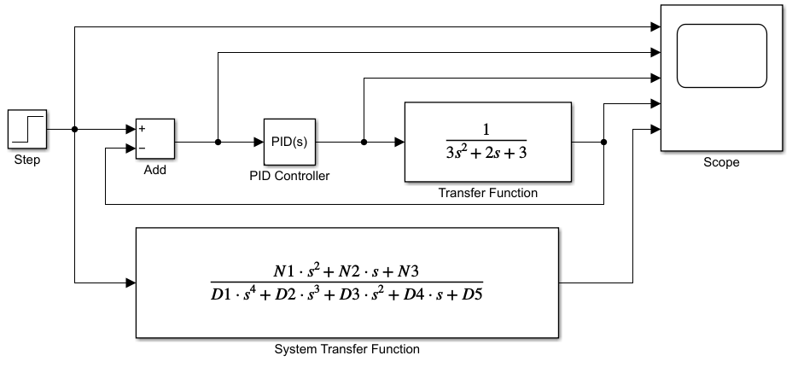
Figure 3 Control System in Simulink

Figure 3 shows the circuit starting with a step input which outputs a 1 signal. This signal is summed with the output of the rest of the system, the feedback. Originally, the output from this will be 1 as there is no feedback, this changes after the first cycle.

2.1 PID Tuning
Tuning the controller allows the proportional, integral and derivative gains of a PID to be determined and changed to suit the design criteria. The turret is required to be settled within 2 seconds and overshoot less than 5%. By changing the Response Time (slower/faster) and the Transient Behaviour (Aggressive/Robust) variables, I was able to produce a system with a settling time of 0.639 seconds and a maximum overshoot of 4.2%.
The PID controller outputs the variable $s$ as seen in Figure 3 and the following equations.

2.2 CIWS Turret Transfer Function
$$G\left(s\right)=\frac{1}{as^{2}+bs+c}$$
The brief has determined that G(s) is the transfer function for the turret where:
$$a=3 \\ b=2 \\ c=3$$

2.3 Closed Loop Transfer Function
$$C\left(s\right)=K_{p}+K_{i}\frac{1}{s}+K_{d}\frac{s}{\frac{1}{N}s+1}$$
The closed loop transfer function of the whole system is derived from the transfer function of the CIWS turret [G(s)] , and the formula of the PID Controller [C(s)].
$$C\left(s\right)×G\left(s\right)=$$
$$\frac{\left(K_{p}+NKd\right)s^{2}+\left(N K_{p}+K_{i}\right)s+NK_{i}}{{as}^{4}+\left(aN+b\right)s^{3}+\left(K_{p}+NK_{d}+bN+C\right)s^{2}+\left({NK}_{p}+K_{i}+CN\right)s+NK}$$
The product of these is simplified in MATLAB into other variables (N1, N2, N3, D1, D2, D3, D4, D5) to produce the “System Transfer Function” in Simulink:
$$C\left(s\right)×G\left(s\right)=$$
$$\frac{N1×s^{2}+N2×s+N3}{D1×s^{4}+D2×s^{3}+D3×s^{2}+D4×s+D5}$$

3. Results

3.1 Scope Output
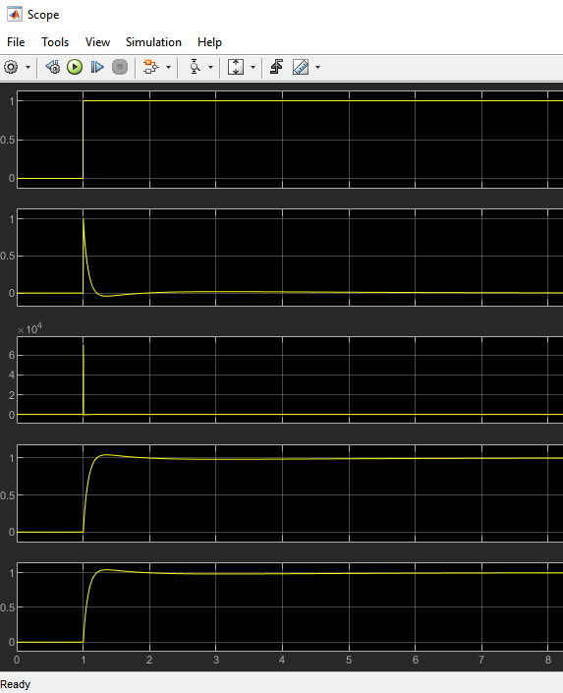
Figure 4 Simulink Scope Output

3.2 Nyquist Diagrams
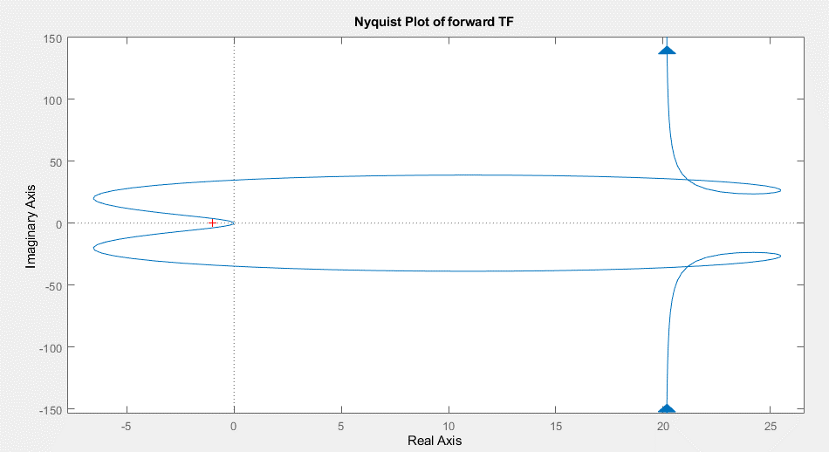
Figure 5 Full Nyquist Diagram
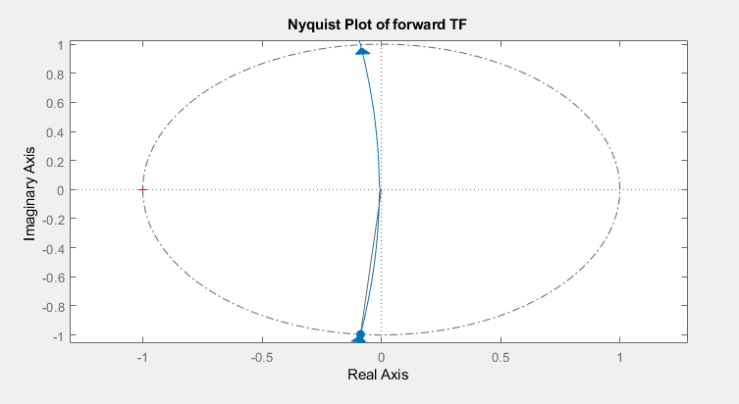
Figure 6 Nyquist Diagram with Zoom and Unit Circle
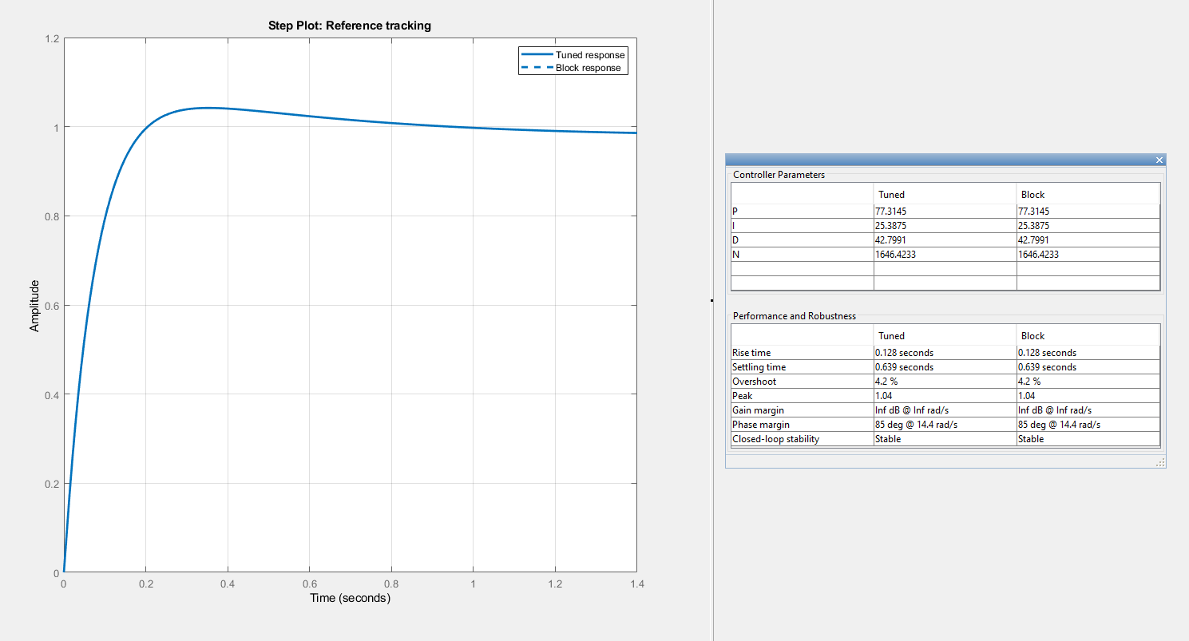
Figure 7 PID Controller Tuning
The results of the controller tuning show that the settling time at 0.639 seconds and the overshoot at 4.2% are within specification.

3.3 Pole-Zero Plots
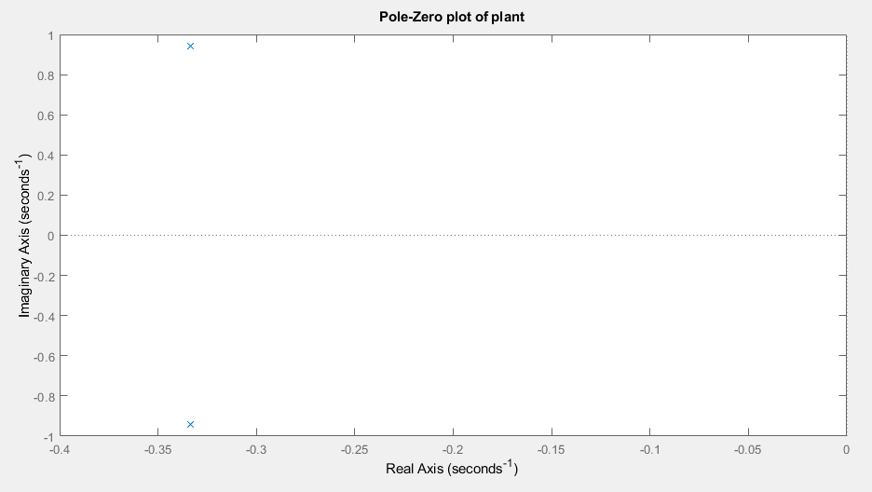
Figure 8 Pole-Zero of G(s)
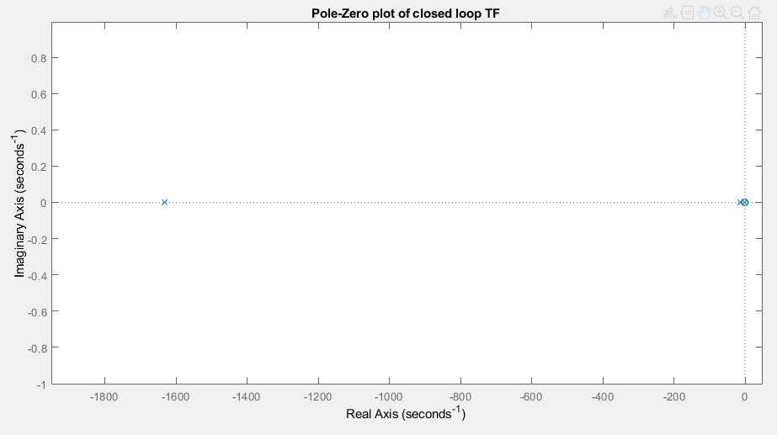
Figure 9 Pole-Zero of C(s)
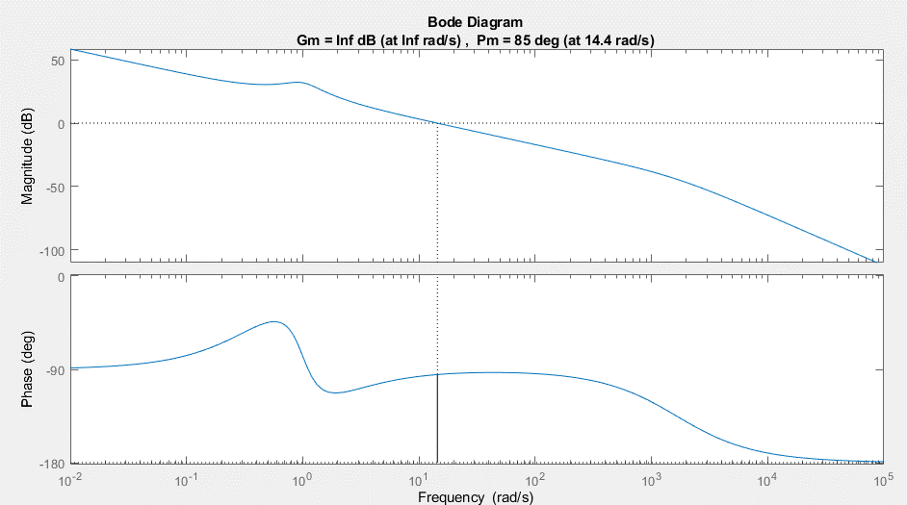
Figure 10 Bode Diagram Showing Gain and Phase Margin

3.4 Time Domain Response Graphs

Figure 11 Overshoot Comparison Between G(s) and C(s)

Figure 12 Zoomed In C(s) Overshoot

A0 | 1 |  | TIME | EXP | COS | RESULT
SIGMA | -0.3333 |  | 0 | 1 | 1 | 1
OMEGA | 0.9428 | RADS | 0.1 | 0.967219 | 0.995559 | 0.962924
PHI | 0 | DEGS | 0.2 | 0.935513 | 0.982275 | 0.918931
 |  |  | 0.3 | 0.904846 | 0.960267 | 0.868894
 |  |  | 0.4 | 0.875185 | 0.929729 | 0.813685
Figure 13 Time Response of G(s)
A0 | 1 |  | TIME | EXP | COS | RESULT
SIGMA | -1630 |  | 0 | 1 | 1 | 1
OMEGA | 0 | RADS | 0.1 | 1.62181E-71 | 1 | 1.62E-71
PHI | 0 | DEGS | 0.2 | 2.6303E-142 | 1 | 2.6E-142
 |  |  | 0.3 | 4.2658E-213 | 1 | 4.3E-213
 |  |  | 0.4 | 6.9183E-284 | 1 | 6.9E-284
Figure 14 Time Response of C(s)

4. Discussion
In Figure 4 the scope displays the output signal after each block, such as the step input at the start and the “System Transfer Function” at the end. The 2nd port shows the sum block in action as it subtracts the feedback (port 4) from the step signal. The 4th and 5th ports can provide evidence that the closed loop transfer function is correctly determined as it displays the same output as the rest of the system combined (Step, sum, PID and transfer function).
Using a Nyquist plot of the System Transfer Function (Figure 5) allows the gain margin to be determined which are used to find the stability of the system. Using a unit circle (dashed line in Figure 6), which is a circle with radius 1 centred on the origin, the phase margin can be calculated. It is the angle between the point on the curve that crosses the unit circle in the negative imaginary axis and the negative real axis. The phase margin of this system is 85° meaning the phase shift can be increased to 85° before the system becomes unstable.
The Bode plot in Figure 10 allows the calculation of the gain margin. The phase against frequency graph never exceeds -180° which provides an infinite gain margin and the greater the gain margin, the more stable the system [6].
Figure 8 and Figure 9 show the Pole-Zero plots of G(s) and C(s) respectively. An X represents a pole and shows where the transfer function tends to infinity whereas a zero (circle) shows where it tends to 0 [6]. Poles in the left half of the P-Z plot shows an exponentially decaying component in the time domain response and the further away from the origin, the more rapid the decay. The pole in Figure 9 exhibits a much faster decay than the pole in Figure 8 due to its position on the X-axis. This is beneficial as the turret should be able to respond fast enough to meet the criteria. Figure 8 contains a complex conjugate pole pair in the left half of the P-Z plot which generates a response that is a decaying sinusoid [7], this can be seen in the shape of the G(s) graph in Figure 11.
Using the coordinates of these poles in the time domain response formula where $y_{h}\left(t\right)$is the time domain response, n is the number of poles, $C_{i}$ is the initial condition of the pole $P_{i}$.
$$y_{h}\left(t\right)=\sum_{i=1}^{n}{C_{i}e^{P_{i}t}}$$
Here the y value of the pole is used as the SIGMA variable and the x value for OMEGA. Comparing the result column of the two tables, it is clear from this and the graph in Figure 11, detailed below, the new control system responds considerably faster. Sigma being
Figure 11 displays the difference between the time response of the system using the G(s) and C(s) transfer functions by plotting the overshoot percentage against time. The latter looks almost instant in comparison as it takes around 0.2 seconds to reach 0% overshoot as seen in the zoomed in version in Figure 12, whereas G(s) takes around 12 seconds, meaning that the transfer function of the system as a whole is a significant improvement over the originally provided transfer function.

5. Conclusion (250)
Requirements were set out for a control system capable of managing a Close-In Weapon System (CIWS) that will overshoot by less than 5% and settle within 2 seconds. This was tackled by creating a model in MATLAB using the Simulink environment using the given transfer function G(s) and a PID controller to calculate the transfer system of the whole control system C(s). The results of the system describe a 0.639 second settling time and a 4.2% overshoot due to the tuning of the PID controller.
A step signal block changes the signal from 0 to 1 representing the command for the turret to rotate from its current position to a target destination. This signal goes through a PID controller which has been tuned to meet the aforementioned requirements and then into the provided transfer function. The output from this is sent back to be subtracted from the step input, creating the feedback loop.
There are however limitations to the model’s reliability in a real world example. The mass of the turret would be quite high and this could cause it to take longer than predicted to rotate. This inertia could also cause more over-rotation (overshoot) than anticipated. So to get a better understanding of the control of the turret, a more complex model could be developed that can handle extra variables such as weight and friction.

References

[1] | G. Allison, “UK award £40m contract for Phalanx CIWS support,” UK Defence Jorunal, 19 November 2021. [Online]. Available: https://ukdefencejournal.org.uk/uk-awards-40m-contract-for-phalanx-ciws-support/. [Accessed 18 December 2021].
[2] | Military Archive, “C-RAM - Counter Rocket, Artillery and Mortar System [Testing & Training],” 8 January 2017. [Online]. Available: https://www.youtube.com/watch?v=O7rc7U61B5E. [Accessed 18 December 2022].
[3] | Tutorials Point, “Control Systems - Introduction,” [Online]. Available: https://www.tutorialspoint.com/control_systems/control_systems_introduction.htm. [Accessed 1 January 2022].
[4] | K. Sharma, “6 - Automation Strategies,” in Overview of Industrial Process Automation, Bangalore, Elsevier, 2011, pp. 53-62.
[5] | J. W. Webb and R. A. Reis, “PID Control of Continuous Processes,” in Programmable Logic Controllers, Fourth Edition, New Jersey, Prentice Hall, 2006.
[6] | E. Cheever, “Determining Stability using the Nyquist Plot,” Swarthmore, 13 October 2011. [Online]. Available: https://lpsa.swarthmore.edu/Nyquist/NyquistStability.html. [Accessed 4 January 2022].
[7] | N. S. Nise, Control System Engineering, vol. VII, Wiley, 2014.
[8] | L. F. Chaparro and A. Akan, “Chaper 3 - The Laplace Transform,” in Signals and Systems Using MATLAB (Third edition), Academic Press, 2019.

