
Contemporary issues in marketing management
Marketing and Sustainability

November 1, 2019
Jessica Rees
1703037

In this essay, I will be considering the importance of sustainability to organisations regarding their marketing. To do this, I will critically evaluate these contemporary issues using different types of literature which will then help develop a better understanding of the potential impact these issues have. Loy (2018) often refers to green marketing when defining sustainability marketing. This is where a company develops their marketing strategies as investments into social and environmental issues. In recent years, companies are often chastised for increased prices, false advertisement and even waste so by developing a more sustainable way of marketing, this counteracts the negative publicity. Companies who make this critical reassessment of their marketing strategies will develop better customer relations and learn new ways to enhance their customer retention. Saren (2007) points out that perhaps the most profound challenge for marketing lies in playing a role in moving industries and economies towards a more environmentally and socially sustainable path since the corporate world has developed a moral duty with use of natural resources and sustainable alternatives. Focusing on the sustainability agenda means that companies are making a commitment to their consumers by incorporating ethical factors, as well as social, economic and environmental factors into their decision-making strategies as these issues can affect the business and its stakeholders with the risks and opportunities they present, of which businesses should take full advantage of. When companies ought to incorporate the sustainability agenda into their practise, the Triple Bottom Line Approach holds three paramount components. Proposed by John Elkington, he suggested that businesses need not only to measure success by traditional means of financial performance but by how they impact the economy, the broader environment and the society they operate within due to the resources every company uses within these sectors such as raw materials, energy, infrastructure and so forth. Savitz (2013) explicates the Triple Bottom Line as the essence of sustainability through measuring the organisations impact on the world, depicting how a positive TBL can increase the company’s value, including shareholder value. The author explains that, within the past few decades, businesses have entered what is known as the Age of sustainability, meaning responsibility for the wider activities is more consequential than ever before. For companies looking to learn more about adopting the TBL into their strategies should answer questions such as how does sustainability work for the business and how can it be measured?

Technological developments are now of scientific knowledge to our human life, using machines, systems, methods and so forth, all to simplify our daily life. The innovation is so vast that the prospect of applications that could be in the future is inevitable. Bailey (1993), suggests that in the coming day and age, it is possible to attain a match between human and technological needs, although new forms of technology, especially internal to a company, calls for new forms of management to maintain the involvement of people and technology within this technological age. A recent technological advancement is E-commerce transactions. Ward (2019) articulates the idea that the apparent death of ‘brick and mortar retail’ are greatly exaggerated. Considering e-commerce shopping is rapidly growing its popularity, traditional retail stores are still doing well under the aegis of those who prefer the in-store shopping experience.

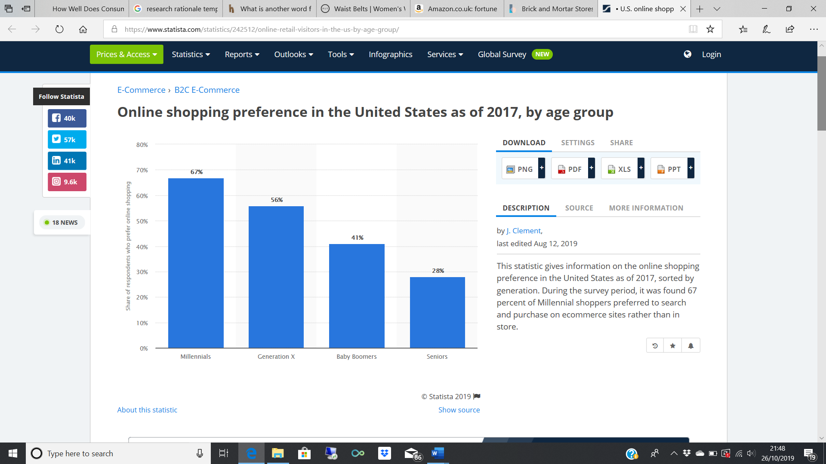
Figure one: Share of respondents who prefer online shopping.SOURCE

As demonstrated in the above graph Clements (2019) displays that there is a decrease in age regarding online vs offline shopping behaviour. 67% of millennials, considered to be the generation with a closer understanding of technology, prefer to shop online, whilst only 56% of ‘gen-xers’ do the same. With consideration of an even bigger decline, only 41% of baby boomers shop online, beating the statistic of only 28% of online shopping seniors. With these statistics, it is evident that the digital age is excelling with millennials becoming more tech savvy and socially conscious, although marketing in traditional methods to baby boomers may become harder. Car manufacturers, such as Toyota, have specific marketing when targeting baby boomers. In 2011, Toyota promoted the Toyota Venza through television ad, with the synopsis of the ad to look at catering to baby boomer’s aspirations, through utilising a middle-aged couple continuing to be active as they age into old age. For Toyota to reinforce the manner of people born between 1946 and 1964 striving to be active if possible, this combats ageism, a term Forbes depicts as a plague to marketing activities. “To reach any demographic, businesses need people who understand that demographic. As long as marketing teams — whether inside the company or at external agencies these businesses hire — see people over 50 as being like their grandparents, they won’t know how to reach them as consumers.” (Anon, 2019) To portray the demographic other than old or technologically inept, is more likely to make baby boomers feel more persuaded to buy from companies such as Toyota because they understand the demographic so to ignore segmentation strategies would be at the peril of the company. By following an act of ethical sustainability, companies should understand that marketing to baby boomers is not any more complex than any other generations, in fact, marketing to baby boomers through digital platforms, as well as traditional media can reach a bigger audience, making the older demographic feel included and not discriminated.

Consumer behaviour, as defined by Engel, et al (2001) is ‘the activities directly involved in obtaining, consuming, and disposing of products and services including the decision processes that precedes and follows these actions. Considering the role of marketing consumer behaviour in the marketing process is vital to for organisations to carry out effective marketing activities. Often considering customer needs and wants, organisations often rely on customer persuasion to buy their products and services, and to do this, it is inevitable that more companies are conducting consumer research studies. Green marketing has a big effect on consumer behaviour as consumers often have a positive perception on greener products, and are influenced by these green marketing activities. Dahlstrom (2011) defines green marketing as “the study of all efforts to consume, produce, distribute, promote, package, and reclaim products in a manner that is sensitive or responsive to ecological concerns.” Green marketing management balances different variables that all contribute to gaining consumer loyalty such as green trust and satisfaction which go together like an equation. More and more businesses are developing a better green marketing strategy, and a most recent example of this is McDonalds. McDonalds introduced paper straws to their restaurants, deducting unnecessary plastic that had been given out and ends up in our oceans and landfill. In June 2018, The Guardian released an article announcing the news. Having carried out research, it was concluded that McDonalds hand out 1.8m straws per day. Consumers retaliated by starting a petition ‘Sum of Us’ that backed up the governments warning of the harm plastic straws and other one-use plastic items can do to marine life and seabirds. The chief executive of UK and Ireland McDonalds, Paul Pomroy, explained how their customers concerns had been received and the process of switching plastic to paper would be underway by 2019. (Vaughan, 2018) However, almost one year into the change and critics have slammed McDonalds for not acknowledging that their paper straws are in fact not recyclable. The fast food chain accredited that the new paper straws are too thick for their recyclers to process, and with this, more than 50,000 people have signed a petition to bring back their old straws, stating the sogginess in drinks puts them off. McDonalds made a pledge to incorporate the sustainability agenda and should understand its risks and opportunities. Although the company took the opportunity of becoming a greener fast food chain, they should understand that the risk of greenwashing is also prodigious. Greenwashing is the practise of misleading consumers on the environmental benefits of a service or product, or even company practise which brandishes a company to be more environmentally aware than it really is. (Benn, 2011) McDonalds should now act accordingly to these sudden accusations, in order to utilise corporate social responsibility to the best standard.

Noble (2000) exemplifies social change as a recondition integrated into society often referring to industrialisation, political revolutions, commercial development, population growth and civil growth. The author also underlines a key theory of the “artistic and intellectual creativity of the eighteenth, nineteenth and twentieth centuries gave rise to modern social theory.” But there is also a stigma for cultural change that has risen over the past decade, reckoned as the influence of cultural capital, or the repositioning of culture, explaining the rapidly and visibly changing world around them. Social change, over the past decade has introduced different social behaviours and social relations, too many to fathom. Social change has brought around diversity and inclusion, with different social groups and political revolutions taking a stand for empowering people by respecting what makes them different by appreciating their gender preference, age, disability, sexual orientation and so forth. In 2015, renowned protein-based company Protein World came under huge backfire after their controversial ‘Are you beach body ready?’ was released, provoking huge outrage and even causing vandalism. The public took it as far as complaining to the UK’s Advertising Standards Agency who in total received 378 complaints. The outrage even caused beer company Carlsberg to scrutinise the ad by parodying ‘Are you beer body ready?’ However, Protein World responded to the outrage through social media, taking shots at feminist groups who voiced their rejection of the ad, labelling them as ‘fatty sympathisers’. Frost, S. & Kalman, D., 2016 refer to the idea of conscious bias as attitudes and beliefs a person or company has, and these biases arise as a result of a perceived threat, and unconscious bias, something that a person can be unaware of and is not within control. To understand Protein Worlds motive, you could argue that there was a undertone of unconscious bias when putting out the controversial campaign, however, journalist Rose Hackman, writing for The Guardian disagrees with the idea of an unconscious bias marketing campaign with the way the company responded to the outrage by name shaming due to the threats the company were facing. However, The Guardian later released an article, elucidating that the ASA defended the ad, by connotating the description of ‘beach body’ to be a broader meaning of one feeling comfortable in their appearance. To debate whether the company followed the sustainability agenda, some could argue is a farce, by not taking ethical factors that relate to their audience seriously. If we were to look into the speculation of an unconscious bias, the company would have followed a better practise following the outrage, following the likes of Pepsi, after the backlash the company faced for it’s ‘Live For Now’ campaign after insensitivity claims regarding the topic of police brutality. Pepsi later removed the ad from their own platforms and apologised from the offense they caused, taking action to protect their social responsibility.

To conclude, sustainability has becoming a thriving factor in consumer buying behaviour and the success of company’s marketing campaigns. Within recent decades, the conception of green marketing and the positive influence this has on consumers is undeniable and is often a tactic that should be adopted into all strategic marketing activities and decision making. Businesses such as Toyota and McDonalds have taken the opportunities sustainability has brought, and making their own advancements within their practise, products and marketing techniques. For other businesses to adopt the same practise, the Triple Bottom Line is a sustainability framework that should be followed to measure success not only from profits or return of investment, but through the wider societies they operate in such as environmental, economic and social. By adopting this framework, companies can look at how their corporate strategy is being utilised through how they measure sustainability, how the impact of sustainability works for them, and more importantly, what being a greener company means for them.

References

(2019) ‘Why Are So Many Companies Ignoring The Baby Boomer Market?’ Available at: https://www.forbes.com/sites/quora/2019/11/15/why-are-so-many-companies-ignoring-the-baby-boomer-market/#6a17e4d62e4b (Accessed: 18th November 2019)

Bailey, J.C., 1993. Managing people and technological change., London: Pitman.

Benn, S. & Bolton, D., 2011. Key concepts in corporate social responsibility, London: SAGE

Dahlstrom, R., 2011. Green marketing management International., Australia: Cengage.

Emerald Group, 2010. Equality, diversity and inclusion : an international journal.

Engel, J. F., Blackwell, R. D. and Miniard, P. W. (2001). Consumer Behaviour. International Edition. 9th edition. Dryden Press.

Figure One: Clement, J. (2019) Online shopping preference in the United States as of 2017, by age group. Available at: https://www.statista.com/statistics/242512/online-retail-visitors-in-the-us-by-age-group/ (Accessed: 26th October 2019)

Frost, S. & Kalman, D., 2016. Inclusive talent management : how business can thrive in an age of diversity,

Hackman, R. (2015) ‘Are you beach body ready? Controversial weight loss ad sparks varied reactions.’ The Guardian, 27th June 2015.

Handley, L. (2011) Baby boomers key to brand segmentation, Available at: https://www.marketingweek.com/baby-boomers-key-to-brand-segmentation/ (Accessed: 10th November 2019)

Loy, B. (2018) Sustainability Marketing: Definition, Strategies & Example Video. Available at: https://study.com/academy/lesson/sustainability-marketing-definition-strategies-example.html (Accessed: 19th October 2019)
Noble, T., 2000. Social theory and social change, Basingstoke: Macmillan.

Parsons, Maclaran & Maclaran, Pauline, 2009. Contemporary issues in marketing and consumer behaviour, Oxford: Butterworth-Heinemann.

Picheta, R. (2019) ‘McDonald's new paper straws aren't recyclable — but its axed plastic ones were’ CNN. 5th August 2019

Richardson, N., 2015. Customer-centric marketing : supporting sustainability in the digital age,

Saren, M. (2007) Critical Marketing: Defining The Field. Edited by Pauline Maclaran, Christina Goulding, Richard Elliot, Avi Shankar, Miriam Catterall.

Savitz, A.W., 2013. The triple bottom line : how today's best-run companies are achieving economic, social, and environmental success - and how you can too Revised and updated.,

Swarbrooke, J. and Horner, S., 2007. Consumer behaviour in tourism. Routledge.

Sweney, M. (2015) ‘Protein World's 'beach body ready' ads do not objectify women, says watchdog’ The Guardian, 1st July 2015.

Vaughan, A. (2018) ‘McDonald's to switch to paper straws in UK after customer campaign’ The Guardian, 18th June 2018

Ward, S. (2019) Brick and Mortar Stores vs Online Retail Sites. Available at: https://www.thebalancesmb.com/compare-brick-and-mortar-stores-vs-online-retail-sites-4571050 (Accessed: 26th October 2019)

