

LEVEL 4 ASSESSMENT SPECIFICATION
Student name: | Anisah hasan | Student ID number: | 2508993
Programme: | Certificate of Higher Education Skills for the Workplace (Health & Social Care)
Module: | Introduction to Health and Social Care
Module code: | LCHS4003 | Contribution to Overall Module Assessment (%): | 50%
Lecturer: | Dr Helen Parsons (Module Lead) | Internal Verifier: | Dr Besty Jose
Assignment Title: | Portfolio – Two Tasks | Word count (or equivalent): | 1,500 words Equivalent
Submission deadline: | To be submitted via Turnitin by Monday, 22nd June 2026, 10 am | Return date of provisional marks & written feedback: | 20th July 2026

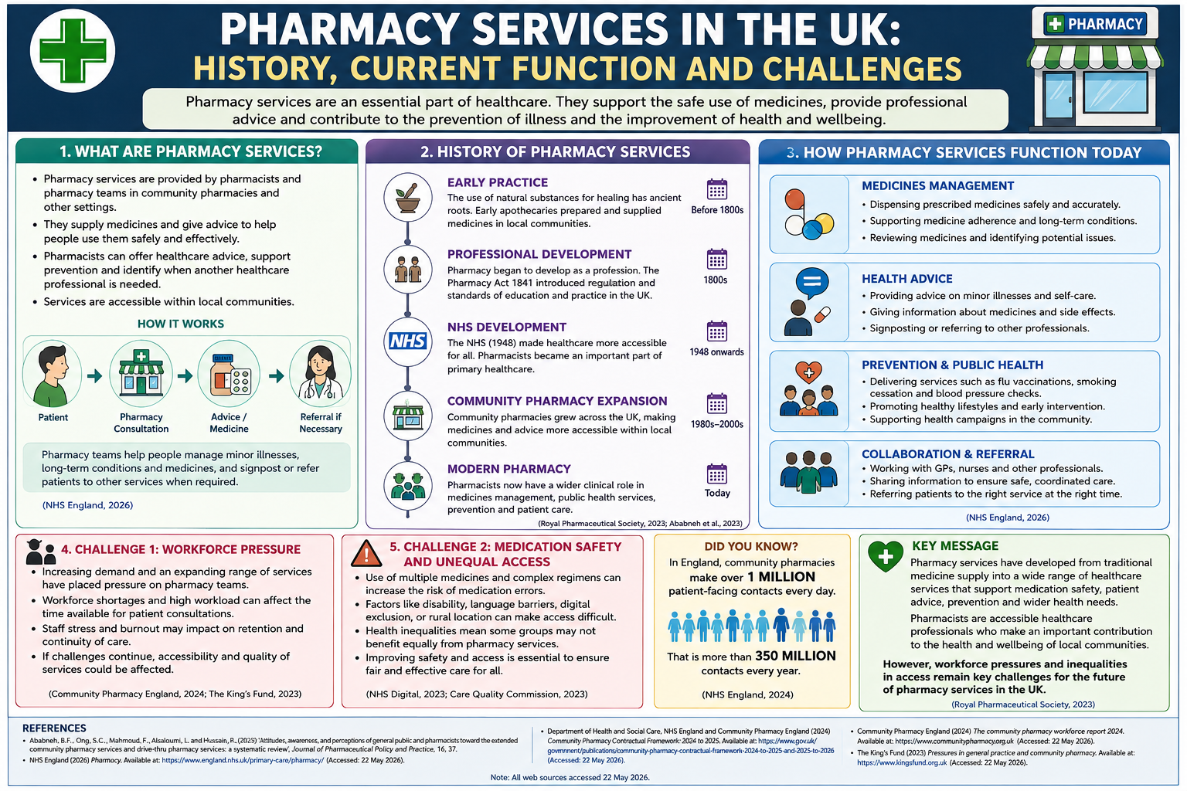
• The usage of multiple medications can create the risk of medication errors.
• Medications can be restricted due to factors like disability, inability to speak English, lack of digital inclusion, and rurality.
• Health inequality in society can mean that everyone may not receive equal benefits from pharmacy care.
• Greater safety and access must be ensured for everyone's sake.
The rising demand for pharmacy services and increased variety of services have created pressure on pharmacy staff.
The lack of sufficient staff and workload may have an impact on the availability of consultation time for patients.
The stress levels of pharmacy staff can influence their turnover and continuity of services.
Continued pressures could influence the quality of the services provided.
Medicines Management
Dispensing medicines according to prescription safely and effectively.
Medicines management and support in the treatment of long-term conditions.
Checking of medicines for any possible problems.

Health Advice
Advice and information for self-management of minor illness.
Information on medicines and their side effects.
Signposting and referral to other health professionals.

Prevention & Public Health
Offering various services like flu injections, stopping smoking clinics and blood pressure measurements.
Healthy living advice.
Helping in health campaigns in the community.

Collaboration & Referral
Collaborating with GPs, nurses and other professionals.
Information sharing for safe coordination of care.
Refer patients to an appropriate service in good time.
Early Practice
The practice of using natural ingredients as remedies is a long-standing one. Early apothecaries would prepare and dispense medicine in their local community.

Professional Development
Pharmacy started to become a profession. The Pharmacy Act 1841 set up standards of practice in pharmacy within the UK.

NHS Development
The NHS (1948) ensured that everyone could receive their healthcare needs. Pharmacists became an integral part of providing primary healthcare services.

Development of Community Pharmacy
The number of community pharmacies increased all over the UK to make medicines available to people in their local community.

Modern Pharmacy
Pharmacists have developed their role into that of medicines management and public health service providers.
Pharmacy teams can assist people in managing minor ailments, chronic diseases and medications, and refer people to other services when necessary (NHS England, 2026).
- Pharmacy services are delivered by pharmacists and pharmacy staff at community pharmacies and other outlets.
- Their function involves delivering medications and givig advice on how these drugs should be used properly.
- Pharmacists may provide health care advice, prevention information and know when there is a need for another healthcare professional’s assistance.
- Services are available to people locally.
5. Challenge 2: Medication Safety and Access Inequities

4. Challenge 1: Staffing Pressure

How It Works

3. HOW PHARMACY SERVICE FUNCTION TODAY
2. HISTORY OF PHARMACY SERVICE
The pharmacy services play an important role in the healthcare sector. They ensure the safe use of drugs, they offer professional guidance and help prevent diseases as well as promote health and wellbeing.
1. WHAT ARE PHARMACY SERVICES?
History, Current Function and Challenges
PHARMACY SERVICES IN THE UK

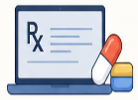
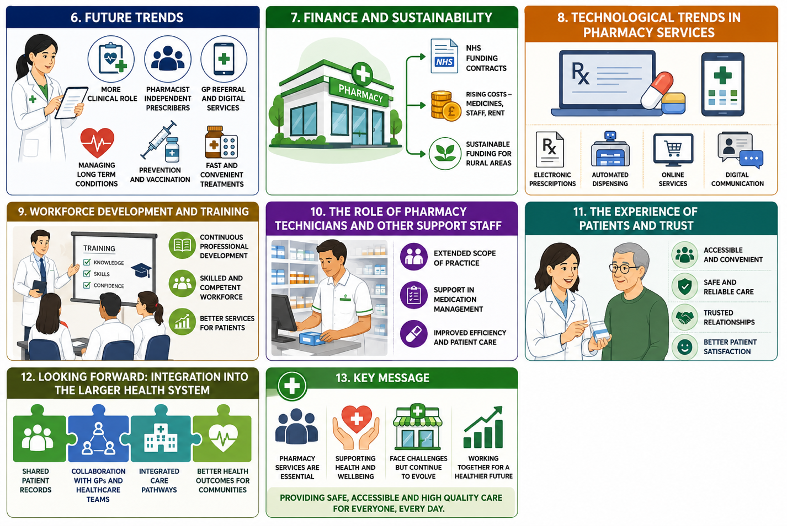
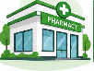
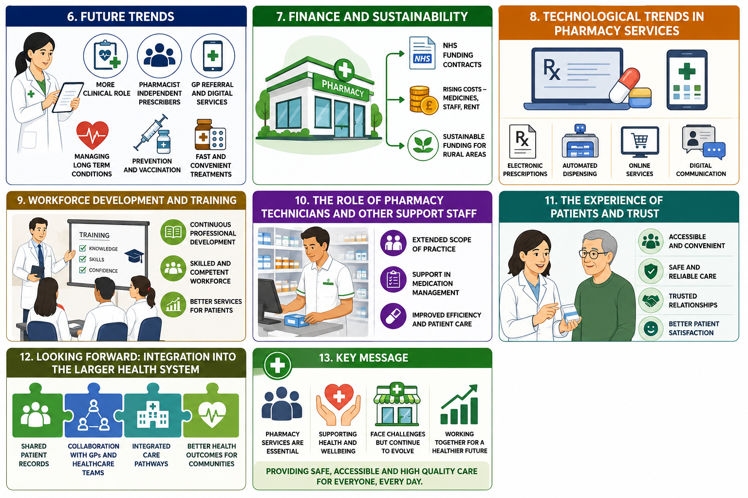
8. TECHNOLOGICAL TRENDS IN PHARMACY SERVICES

The pharmacy practice becomes increasingly technological. Prescriptions become electronic, dispensing becomes automated and ordering becomes available online. There are also digital means of sharing patient information between pharmacies, general practices, and hospitals. At the same time, there still remains the problem of digital exclusion which affects some of the patients including.
The community pharmacies receive funding through contracts with the NHS that define the delivery and finance of services offered by these pharmacies.
Increasing costs, shortage of medicines, and constant funding agreements have led to financial pressures among many pharmacy firms.
Sustainable funding models are regarded as necessary for the provision of services, especially for the underserved/rural areas.
7. FINANCE AND SUSTAINABILITY

The role of the pharmacist is now taking more clinical shape. Prescribing independently is being implemented at all community pharmacies where pharmacists can treat a greater number of conditions without requiring a GP's referral. This comes after Pharmacy First program, which allows pharmacists to issue medications for some common illnesses such as ear infection, sore throat, and UTIs. The purpose is to relieve GP workload while offering fast and convenient treatments to patients.
6. FUTURE TRENDS

10. THE ROLE OF PHARMACY TECHNICIANS AND OTHER SUOOIRT STAFF

There has been an increased reliance on pharmacists’ support staff to assist them in the efficient management of increasing responsibilities. As more responsibilities are added to the list for pharmacists, the task of carrying out verification processes of medications, inventory management, and other administrative activities is increasingly done by pharmacy technicians. The investment in training and regulation of such staff has enabled them to perform an extended scope of activities that allows pharmacy teams to work more effectively following the skill mix approach.
9. WORKFORCE DEVELOPMENT AND TRAINING

11. THE EXPERIENCE OF PATIENTS AND TRUST

In light of the increasing clinical obligations, there have been advancements in the training of pharmacists. Beginning from 2026, all new registrants of pharmacists in Great Britain will emerge as independent prescribers. Professional development, mentoring, and training of pharmacy technicians are vital in ensuring that the team is capable of delivering advanced services while performing their conventional dispensing duties.
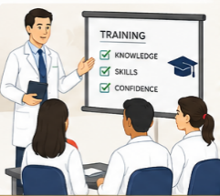

Pharmacies are usually the most accessible aspect of healthcare without appointments required. Patients find the convenience, accessibility and continuity of care provided by their local pharmacy team highly valuable. Taking this into account, pharmacies are perfectly suited for assisting with managing chronic diseases and health promotion, which would make them even more trusted as the initial contact point for care.

13. KEY Message

Pharmacy services have evolved from the mere dispensing of medicines into various healthcare services that aid in medication safety, counselling, prevention and beyond.
Pharmacists are healthcare practitioners who are easily available and play an important role in the health and well-being of their respective communities.
Workforce challenges and inequalities continue to be major obstacles to the development of pharmacy services in the UK (Royal Pharmaceutical Society, 2023).
12. LOOKING FORWARD: INTEGRATION INTO THE LARGER HEALTH SYSTEM

Integration into the larger health system will be key to the future of pharmacy services. Integration will involve sharing patient care records, collaboration with primary care networks, and defined referral processes involving pharmacists, GPs, and other healthcare professionals. Increased integration may assist in resolving workforce issues, which would result in a balanced allocation of patient care within the health system, as well as addressing health care disparities within high-need communities.

5. Challenge 2: Medication Safety and Access Inequities
• The use of more than one medication and complicated medication regimens may pose risks related to medication error.
• Medication access may be affected by conditions such as disability, lack of fluency in English, digital exclusion, and rural status.
• Social health inequities may imply that not everyone will equally benefit from pharmaceutical services.
• Greater safety and access must be ensured for everyone's sake.

Task 2: Domiciliary Care Services within the Community
Domestic care, also referred to as home care, is where services are provided to individuals in their own homes rather than institutional setting, thus allowing them to stay in familiar environment and receive assistance in their daily life activities (Homecare.co.uk, 2025). The current paper examines the origins of the provision and discusses how it is performed nowadays and the contribution of the service to users’ quality of life.

1.1 Origins and Historical Context
Prior to the establishment of the welfare state, the care for older and disabled people had mostly been informal, offered by family members, churches and charities; the Poor Law Amendment Act 1834 allowed only the brutal option of being sent to the workhouse (Homecare.co.uk, 2025). Attitudes changed in the twentieth century: war-time meals-on-wheels programs helped people who had lost their homes and the National Assistance Act 1948 required local authorities to make arrangements for welfare provision for those who were not able to take care of themselves which was the beginning of state funded home help (GOV.UK, 2026). In the 1950s and 1960s more and more emphasis was put by local authorities on helping elderly people live at home rather than going into institutions. It became an officially adopted concept in the 1980s when there was criticism against institutional care along with the 1988 Griffiths Report and "care in the community" became the official policy of the Conservative government (Homecare.co.uk, 2025). The Care and Social Services Inspectorate Wales was founded in 2002 and the Care Quality Commission for England in 2008 (Homecare.co.uk, 2025).

1.2 Current Functioning
Domiciliary care has become a significant element of UK social care services. In March 2025, there were more than 15,000 domiciliary care agencies regulated in England alone, who provided care services to about 499,000 people (Skills for Care, 2025; GOV.UK, 2026). The average cost of a one-hour service of home care increased to £23.56 in 2024–25 (Skills for Care, 2025), while in total, the sector employs around 740,000 employees in England, and tens of thousands in Wales and Scotland (PolicyBee, 2026). People receive individualized care according to their personal care plans, including help with personal care, assistance with medications, cooking meals, housework and the increasing use of assistive technology like electronic reminder of medications to enable independent living (Homecare.co.uk, 2025). Specifically in Wales, the care arrangements are governed by the Social Services and Well-being (Wales) Act 2014, where well-being, prevention and 'voice and control' are central to the delivery of care, and are measured against the National Minimum Standards, monitored by the Care Inspectorate Wales (Social Care Wales, 2025; Care Inspectorate Wales, 2004)

1.3 Significance for Quality of Life
People have the opportunity to maintain their independence, daily routines, and connections with their communities as opposed to moving to residential facilities where the Social Services and Well-being (Wales) Act 2014 clearly emphasizes that they constitute the key elements of people’s well-being (Law Wales, 2014). Living at home contributes to emotional well-being because of being surrounded by familiar surroundings and social interaction that gives individuals a feeling of independence. However, there are some critical aspects of the Welsh Act: being independent is sometimes seen too narrowly as self-reliant, and social care is viewed as the "last resort," thus undermining the importance of good home care (Senedd Research, 2023). Such approach, along with shortage of workforce and funding problems related to local authorities, presents a problem of providing the high-quality domiciliary care when the number of elderly people increases (PolicyBee, 2026; Skills for Care, 2025).

1.4 Conclusion
Domiciliary care has moved from a poorly regulated and even punitive poor law system into a formally regulated person-centred service which plays a crucial part in enabling individuals to live independently in the community.

References
Care Inspectorate Wales (2004) National minimum standards for domiciliary care agencies in Wales. Available at: https://www.careinspectorate.wales/sites/default/files/2018-01/131009nmsdomcareen.pdf (Accessed: 23 July 2026).
GOV.UK (2026) Adult social care provider statistics, England: quarterly update to May 2026. Available at: https://www.gov.uk/government/statistics/adult-social-care-provider-statistics-england-quarterly-update-to-may-2026/adult-social-care-provider-statistics-england-quarterly-update-to-may-2026 (Accessed: 23 July 2026).
Homecare.co.uk (2025) History of home care in the UK. Available at: https://www.homecare.co.uk/advice/a-history-of-home-care (Accessed: 23 July 2026).
PolicyBee (2026) UK domiciliary care statistics 2026. Available at: https://www.policybee.co.uk/blog/domiciliary-care-statistics (Accessed: 23 July 2026).
Senedd Research (2023) The Social Services and Well-being Act: how well is it working? Part 1. Available at: https://research.senedd.wales/research-articles/the-social-services-and-well-being-act-how-well-is-it-working-part-1/ (Accessed: 23 July 2026).
Skills for Care (2025) Domiciliary care services in the adult social care sector 2024/25. Available at: https://www.skillsforcare.org.uk/Adult-Social-Care-Workforce-Data/workforceintelligence/resources/Reports/National/Summary-of-domiciliary-care-services-2025.pdf (Accessed: 23 July 2026).
Social Care Wales (2025) Overview of the Social Services and Well-being (Wales) Act. Available at: https://socialcare.wales/resources-guidance/information-and-learning-hub/sswbact/overview (Accessed: 23 July 2026).

