

Hotel Placement Research Project
BMIH6008

Popescu Felicia
2119254

Executive Summary
This paper examines how staff shortages and multitasking affect Rossington Hotel, a boutique hotel in Doncaster, UK, operational performance and employee well-being. Brexit and the COVID-19 epidemic have caused labour shortages in the UK hospitality business, which has reduced employment. Multitasking—reassigning personnel across departments to fix operational issues—has grown more common at Rossington Hotel. This behaviour deters personnel morale and service quality, according to the research. A qualitative case study employing observational observations, employee feedback, and secondary research examines Rossington Hotel's operational and psychological implications of multitasking. The results show that multitasking helps the hotel run under labour restrictions, but it often lowers service standards and increases staff anxiety. The constant shift of culinary staff to housekeeping chores prevented the hotel from maintaining regular room cleanliness. Without role-specific training, employees felt overworked and underappreciated, which hurt engagement and job satisfaction. Report highlights position reassignment's negative effects on passenger experience and workforce morale. Frequent task shifting caused staff to feel anxious and unprepared, which affected their confidence and well-being. Guest evaluations showed variances in room upkeep and service reliability, which are crucial to the boutique hotel's brand and reputation. According to these findings, the report recommends cross-training programs to improve role readiness, flexible staffing models to reduce peak pressure, and digital booking systems to modernize operations and reduce reservation errors. By improving these areas, Rossington Hotel can boost its boutique appeal, service quality, and staff well-being.

Table of Contents
Executive Summary 2
1. Introduction 5
2. Literature review 7
3. Methodology 9
4. Case Study Discussion 10
4.1. Hotel overview 10
4.2. Location 13
4.3. Geographical and Cultural Context 13
4.4. SWOT analysis 14
4.5. PEST 17
4.5.1. Political factors 17
4.5.2. Economic factors 18
4.5.3. Social factors 19
4.5.4. Technological factors 20
4.6. Competitor Analysis 21
4.7. Netnography 23
5. Theme Exploration 25
5.1. Staffing Shortages and Role Reassignment 25
5.2. Effects on Employee Well-being 26
5.3. Impacts on Service Quality 27
6. Analysis of Multitasking at Rossington Hotel 28
7. Conclusion 29
8. Recommendations 30
9. Reflection 32
References 36

List of figures:
Fig 1. Historic Houses. (2024). Rossington Hall - Historic Houses…….. p. 5
Fig 2. Office for National Statistics (2021). Hospitality businesses are most likely to be struggling to fill vacancies…………………….…………………………….. p. 6
Fig 3. The Wedding Directory. (2023). Rossington Hall…………………. p. 10
Fig 4. The Wedding Directory. (2023). Rossington Hall…………………. p. 10
Fig 5. Mark (2022). Luxury Hotel Accommodation near Doncaster | Rossington Hall……………………………………………………………………………. P. 11
Fig 6. Mark (2022). Luxury Hotel Accommodation near Doncaster | Rossington Hall…………………………………………………………………………….. p. 11
Fig 7. Getnottinghamhotels.com. (2024). Rossington Hall Hotel Doncaster…………………………………………………………………….. p. 11
Fig 8. Endole UK (2024). Rossington Hall Limited………………………. p. 13
Fig 9. Google Maps (2024). Rossington Hall…………………………….. p. 14
Fig 10. Clark (2024). Percentage of businesses experiencing a shortage of workers in the United Kingdom………………………………………………………. p. 20
Fig 11. Statista(2024). Willingness of consumers to pay more for sustainable hotels………………………………………………………………………….. p. 21
Fig 12. Google Maps (2019). Hex Wildlife Hotel…………………………. p. 23
Fig 13. Google Maps (2019). Best Western Premier Doncaster Mount Pleasant Hotel…………………………………………………………………………… p. 23
Fig 14. Google Maps (2019). Travelodge Doncaster Lakeside…………. p. 24
Fig 15. Tripadvisor. (2024). ROSSINGTON HALL………………………... p. 25
Fig 16. Tripadvisor. (2024). ROSSINGTON HALL………………………… p. 25
Fig 17. Tripadvisor. (2024). ROSSINGTON HALL………………………… p. 26
Fig 18. Tripadvisor. (2024). ROSSINGTON HALL………………………… p. 26
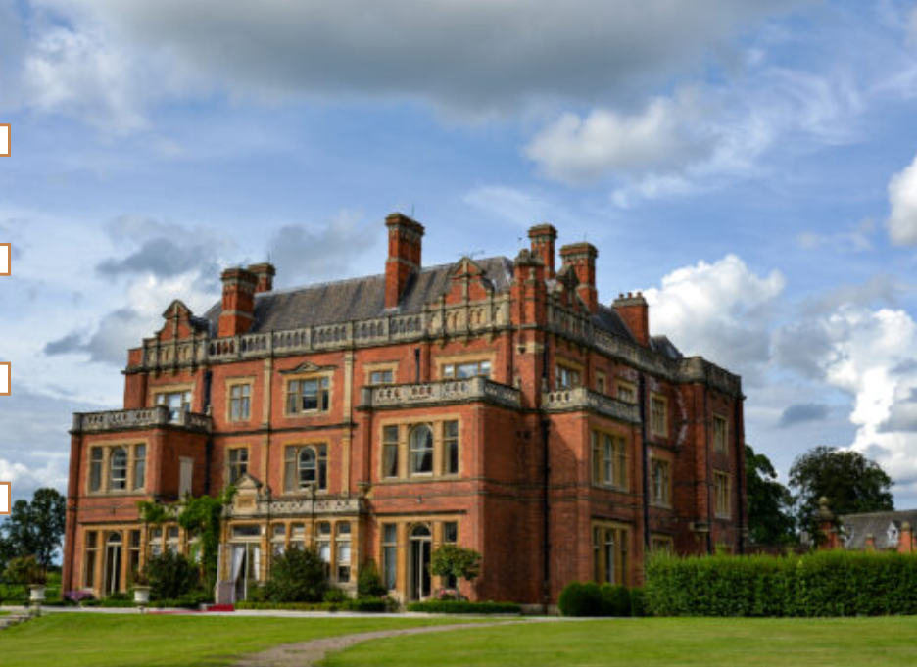
Fig 1. Historic Houses. (2024). Rossington Hall - Historic Houses.

- Introduction
The hospitality industry in the United Kingdom, which generates an annual revenue of more than £130 billion for the national economy, is currently experiencing severe staffing shortages (UK Hospitality, 2023). This issue has been made worse by the COVID-19 pandemic and Brexit, which have resulted in a decrease in labour inflows and a surge in the number of individuals who have departed the industry in search of positions that offer more stability and benefits (Dempsey, 2023). ONS (2021) highlights that the number of vacancies in the hospitality industry has increased by 30% compared to pre-pandemic levels. This has resulted in a greater reliance on multitasking among the remaining employees, which frequently compromises service quality and negatively impacts employee well-being. These challenges are exemplified by Rossington Hotel, a boutique establishment located in Doncaster. The hotel has experienced a substantial impact on operations as a result of personnel shortages, despite its reputation for personalised, high-quality service and 50 rooms. Their job satisfaction is diminished and their tension levels are elevated as a result of the frequent juggling of roles across departments. The aim of this research is to investigate the impact of personnel shortages and multitasking on the well-being of employees and the efficiency of operations at Rossington Hotel. The specific objectives are to identify the underlying causes of staffing shortages and multitasking at the hotel, analyse the impact of these issues on service quality and employee morale, examine solutions such as automation and staff support programs, and provide practical solutions for improving both operational performance and employee satisfaction. The study aims to provide helpful data to support the long-term sustainability of Rossington Hotel and to offer potential solutions that are pertinent to the broader hospitality sector by addressing these issues. In the presence of persistent employment challenges, it is imperative to support staff well-being and service standards in order to perpetuate the industry as a whole and the success of individual establishments.
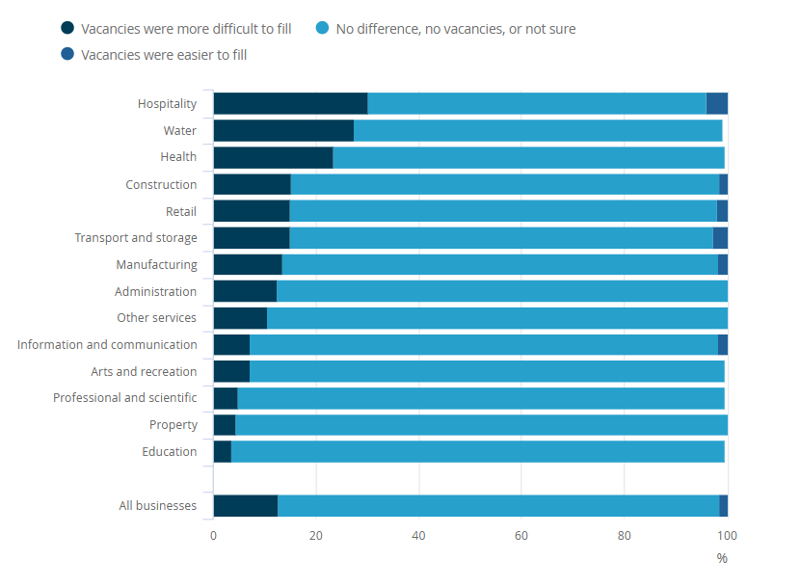
Fig 2. Office for National Statistics (2021). Hospitality businesses are most likely to be struggling to fill vacancies.
- Literature review
Unexpected personnel constraints are currently being experienced by the United Kingdom's hospitality industry. The dual impact of the COVID-19 pandemic and Brexit has further exacerbated this crisis by disrupting labour inflows and intensifying workforce attrition (Butler, 2021). UK Hospitality (2023) reported that the subsequent rise in vacancies—which is 48% higher than pre-pandemic levels—has compelled the remaining employees to multitask across departments, frequently to the detriment of employee well-being and service quality. The labour landscape in the UK hospitality sector has been considerably altered by Brexit, which has restricted the influx of migrant workers from the European Union (Ridgway, 2019). There have been many low-skilled positions within the industry that have been historically supplied by migrant labour. However, the new immigration policies have created obstacles to this labour source (Green, 2019). GOV UK (2023) observes that the decrease in EU workers has not been offset by domestic labour, resulting in employment deficits. Concurrently, the COVID-19 pandemic has resulted in a labour shift, with a considerable number of employees transitioning from the hospitality industry to sectors that are perceived as more stable, such as healthcare and logistics (Aigbedo, 2021). The well-being of employees is significantly impacted by the phenomenon of multitasking, which is a result of staffing shortages. According to the work Demands-Resources (JD-R) paradigm, burnout and diminished work performance are the consequences of excessive job demands, such as multitasking (Bakker, Xanthopoulou, and Demerouti, 2023). According to Dalkhjav, Munkhuu, and Sukhragchaa, (2024), hospitality employees experience elevated stress levels and cognitive workloads when they engage in multitasking. Karatepe, Ozturk and Kim (2019) discovered a direct correlation between emotional exhaustion and role excess, which in turn predicts increased turnover intentions. Xanthopoulou, Bakker and Illies (2012) emphasise that insufficient personnel compromise employees’ psychological resources, resulting in decreased job satisfaction and engagement. Employee efficacy and well-being are intrinsically linked to service quality. The SERVQUAL model emphasises the significance of reliability, responsiveness, and empathy in service delivery, all of which are compromised when employees are overextended (Shi and Shang, 2020). Rydell and Storman (2023) claim that inconsistencies, which are frequently encountered in understaffed environments, result in a decrease in client perceptions of service quality. In the context of boutique hotels such as Rossington Hotel, personalised and high-quality service is a critical differentiator. Moreover, an establishment profitability can be directly impacted by the erosion of service quality as a result of multitasking, which can result in customer dissatisfaction and a loss of loyalty. Automation has been suggested as a potential solution to alleviate staffing pressures and improve operational efficiency (Sun and Jung, 2024). The workload of staff can be reduced by technological innovations, such as self-check-in terminals and service robots, which can handle routine duties. Nevertheless, Lui, Cay, and Gursoy (2019) warns that the personalised experience that visitors anticipate in speciality settings may be compromised by an excessive reliance on automation. Whereas Murphy, Hofacker, and Gretze. (2017) propose that technology should complement, not replace, human interaction. They advocate for an approach that utilises automation to improve service without sacrificing personalisation. Another strategic response to employment challenges is the implementation of staff support programs. Heimerl et al., (2020) contend that initiatives aimed at enhancing employee training and development can enhance job satisfaction and competence. Similarly, employee retention rates are positively correlated with investments in human capital. Additionally, Goh and Okumus (2020) identifies competitive compensation, benefits, and clear career progression pathways as critical factors in the recruitment and retention of talent. At the same time the authors prove that supportive leadership and recognition can mitigate the adverse effects of job stressors, such as multitasking, which is where organisational culture plays a pivotal role. Despite the extensive literature on personnel shortages and their effects, there are still voids, particularly in the case of small-scale, boutique hotels in non-metropolitan areas such as Doncaster. Most research concentrates on urban establishments or large hotel corporations, neglecting the distinctive obstacles encountered by boutique hotels (Mody, Suess, and Lehto, 2017). Boutique hotels often lack the resources to implement extensive staff support programs or large-scale technological solutions. There is a scarcity of research on the long-term efficacy of automation in preserving service quality in the boutique hotel sector. Furthermore, although the adverse consequences of multitasking are extensively documented, there is inadequate empirical evidence regarding interventions that are specifically designed to alleviate these effects in the hospitality industry (Deery and Jago, 2015).
- Methodology
This study uses a qualitative case study methodology to examine the effects of personnel shortages and multitasking on the operational efficacy and well-being of employees at Rossington Hotel. An interpretive approach, qualitative research aims to comprehend social phenomena from the viewpoints of the individuals involved, with a focus on interpretations, experiences, and meanings (Denzin et al., 2023). It is particularly effective for the examination of intricate issues that need a comprehensive understanding (Creswell and Poth, 2016). Rich, comprehensive insights are provided by the case study method, which enables an intensive examination of a particular case within its real-life context. The holistic exploration of the phenomenon and the ability to capture the nuances of specific situations are among the advantages of this approach. Techniques entail the acquisition of data from a variety of sources, including interviews, observations, and documents, in order to develop a thorough comprehension. Nevertheless, potential researcher bias and the difficulty of generalising findings to broader populations are among the limitations (Meier et al., 2016). In this investigation, reflective writing serves as an indispensable methodology. The process of reflective writing entails the critical examination of one's own experiences and observations in order to acquire a more profound understanding and insights (McCarthy, 2011). It is a method of introspection that allows the researcher to establish a connection between personal experiences and more general theoretical concepts. In this context, reflective writing is instrumental in revealing the internal dynamics and employee experiences at Rossington Hotel, by this means enabling a more in-depth examination of the personnel challenges. It also improves reflexivity, enabling the researcher to identify and mitigate personal biases that may affect the study. Netnography is an additional methodology implemented in this investigation. Netnography is a qualitative research methodology that employs ethnographic techniques to investigate online communities and cultures that are established through computer-mediated communication (Kozinets, 2015). It entails the examination of online content, including social media posts, forums, and evaluations, in order to comprehend social interactions and perceptions. Netnography offers access to genuine and unfiltered accounts of the experiences of both employees and customers in connection with Rossington Hotel. The capacity to investigate behaviours in a real-time, cost-effective manner and the abundance of naturally occurring data are among the advantages (Kozinets, 2020). Limitations encompass ethical concerns regarding consent and privacy, as well as enquiries regarding the representativeness and authenticity of online data (Kozinets, 2015). Academic literature, industry reports, and statistical data that are relevant to the hospitality sector are also employed as secondary resources. These sources provide a more comprehensive context for the case study, allowing for comparisons with industry norms and trends (Collis and Hussey, 2021). The credibility and reliability of the findings are improved by the triangulation that is facilitated by the integration of multiple data sources. The study's objectives are supported by a systematic literature review and critical analysis of existing research to identify gaps.
- Case Study Discussion
  - Hotel overview
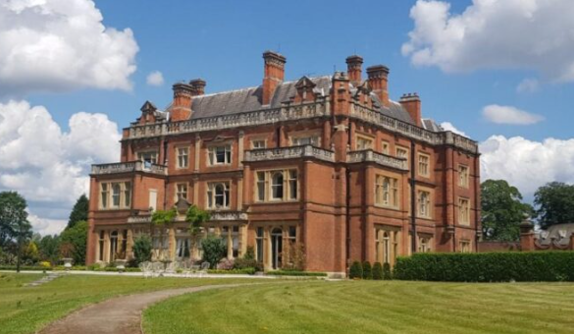
Fig 3. The Wedding Directory. (2023). Rossington Hall
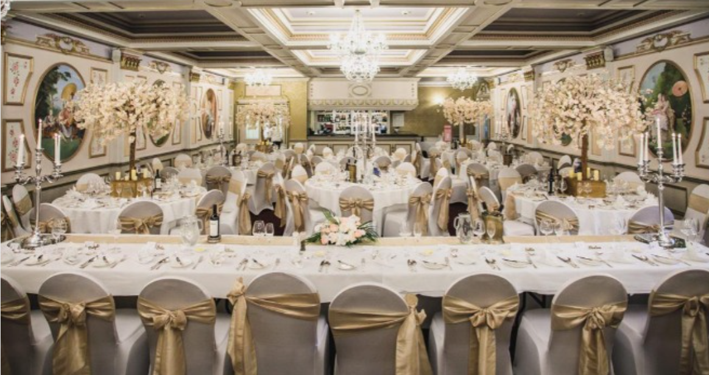
Fig 4. The Wedding Directory. (2023). Rossington Hall

Fig 5. Mark (2022). Luxury Hotel Accommodation near Doncaster | Rossington Hall.

Fig 6. Mark (2022). Luxury Hotel Accommodation near Doncaster | Rossington Hall.
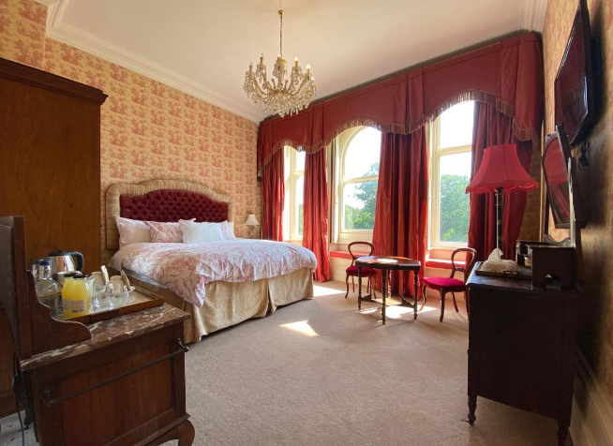
Fig 7. Getnottinghamhotels.com. (2024). Rossington Hall Hotel Doncaster

Rossington Hall, a boutique establishment in Doncaster, South Yorkshire, is famous for its Victorian heritage and personalised visitor services. This hotel, situated on a 250-acre estate, has become known for its meticulously restored architecture, which uniquely combines contemporary amenities with historical appeal. Each of the 21 chambers at Rossington Hall are individually designed to reflect the building's Victorian origins, ensuring that guests have an intimate experience (Rossington Hall, n.d.). The hotel is a highly sought-after location for corporate events and nuptials due to its extensive gardens, restaurant, and specialised event spaces, in addition to its accommodations. As of 2023, Rossington Hall Limited is a privately owned boutique hotel with an average personnel level of 17 employees, which represents an increase from 15 employees in the previous year (Company House, 2024). The hotel's commitment to personalised services is reflected in the modest team size, which also presents challenges in maintaining service quality in the face of personnel shortages. Service delivery and staff well-being may be adversely affected by the necessity for employees to multitask across multiple roles. Rossington Hall's operations are reminiscent of small boutique hotels in terms of their financial structure. As of March 31, 2023, the hotel reported total assets of £1.91 million and total liabilities of £1.98 million, resulting in net liabilities of £66,430 (Endole UK, 2024). The need of financial management to maintain operations and maintain service standards is made clear by these figures, which reveal the financial constraints that the hotel operates under.
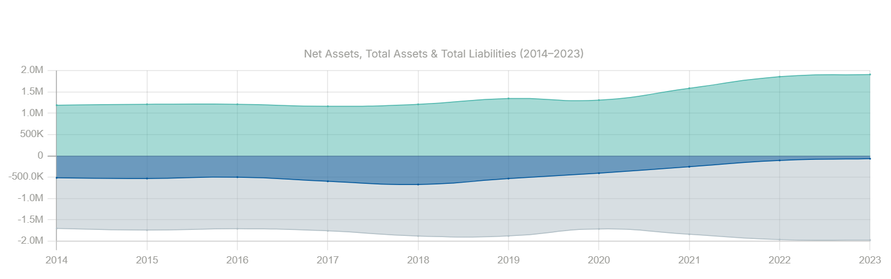
Fig 8. Endole UK (2024). Rossington Hall Limited.
  - Location
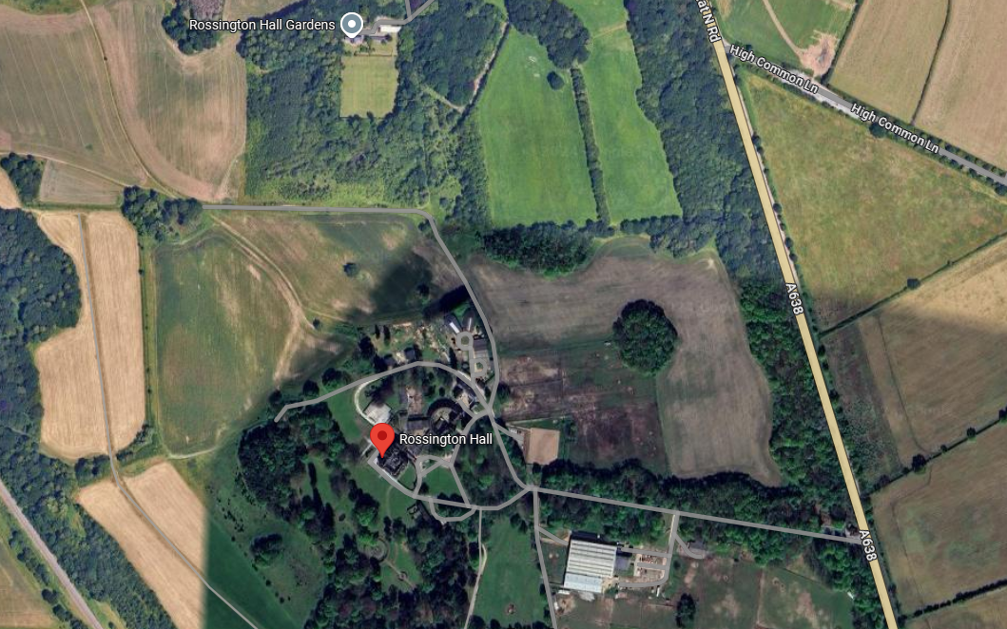
Fig 9. Google Maps (2024). Rossington Hall.
Rossington Hall is an independent establishment that operates without any affiliation to larger lodging corporations or additional branches. This autonomy enables it to preserve a unique identity that originates in its Victorian heritage and emphasises luxury and authenticity. Rossington Hall operates in a niche market, attracting guests who desire exclusivity and historical milieu, in contrast to chain hotels that capitalise on economies of scale and brand-wide resources (Firat, Turker and Metin, 2014). Rossington Hall it is designed to provide visitors with a distinctive experience that is distinct from the standardised offerings of large hotel groups. This positioning is attractive to a select clientele that are prepared to pay higher prices for personalised service and historical elegance. Nevertheless, the hotel's autonomy makes it more susceptible to external influences, including economic fluctuations and labour market fluctuations, necessitating the implementation of innovative retention strategies and operational cost management strategies (Darvishmotevali, Altinay, and Köseoglu, 2020).
  - Geographical and Cultural Context
Rossington Hall, which is situated in Doncaster, South Yorkshire, is fortunate to have a location that blends rural appeal with urban amenities. The estate's expansive grounds offer a serene environment, while its accessibility to major transportation routes, such as the M18 motorway and Doncaster Sheffield Airport, enables visitors to easily reach the property. Doncaster is recognised for its historical significance and landmarks, including the Yorkshire Wildlife Park and the Doncaster Racecourse. The cultural context of the region is vibrant (Visit Doncaster, n.d.). Rossington Hall's attention to offering an authentic Victorian experience is consistent with the local culture's emphasis on traditional British hospitality. The hotel's allure to both domestic and international guests seeking a distinctive and immersive experience is further enhanced by its cultural alignment and location.

  - SWOT analysis
A SWOT analysis is a strategic instrument that is employed to assess an organization's internal strengths and vulnerabilities, as well as other external opportunities and threats. This framework, which has its roots in the field of business management, assists organisations in evaluating their present status and making well-informed strategic decisions (Benzaghta et al., 2021). Organisations can capitalise on competitive advantages by recognising their strengths, while addressing their deficiencies guarantees that there are areas for advancement. Opportunities offer the potential for development, while hazards can be identified to facilitate proactive risk management.
Strengths | Weaknesses
- Historical and architectural importance.  - A distinctive, culturally rich experience is generated by the preserved architecture and Victorian heritage.  - Guest services that are tailored to the individual. Fostering client loyalty is a distinguishing characteristic of boutique lodgings.  - Diversifies revenue streams and capitalises on the estate's extensive grounds. | - Revenue is restricted during periods of increased demand due to the limited capacity of 21 accommodations.  - Service quality is impacted by staffing issues resulting from Brexit and COVID-19.  - Prudent financial management is necessitated by the financial constraints demonstrated in recent financial statements (Company House, 2024).
Opportunities | Threats
- Targeted marketing campaigns implemented to attract international visitors who are interested in unique UK experiences (Beirman, 2020).  - Increasing the range of services available, including spa facilities, guided excursions, and thematic packages.  - The implementation of digital booking platforms to enhance operational efficiency and market reach (Alrawadieh, Alrawadieh, and Cetin, 2021). | - Discretionary expenditure on luxurious accommodations may be diminished during economic downturns.  - Increased competition from alternative lodging options, such as Airbnb.  - Operating costs may be affected by regulatory changes in the hospitality industry, needing additional investments.

Rossington Hall's historical and architectural significance, individualised visitor services, and event-hosting capabilities give it a premium boutique edge. In contrast to chain hotels, Rossington Hall's maintained Victorian architecture and cultural draw attract customers seeking unique, high-end experiences. This historical authenticity attracts guests and boosts the hotel's brand in a saturated market. Heritage as a USP might be a restriction if it is not matched by the conveniences that modern visitors expect (George, 2021). Another feature of boutique hotels is their focus on individualised guest care, which builds loyalty via customised experiences. The COVID-19 epidemic and Brexit have generated employment shortages, reducing the staff needed to maintain this high level of service. Personalisation enhances customer retention and visitor experience, but it relies on a sufficient and well-trained personnel, making it vulnerable (Mañas et al., 2018). In a market where customised attention is expected, performance issues due to staffing shortages might hurt Rossington Hall's image by dissatisfying customers. Rossington Hall relies less on seasonal visitors since it hosts events and weddings, which produce steady revenue. Diversification is necessary for financial stability, but events need significant human and resource deployment (Park and Jang, 2012). Due to the hotel's budgetary and staffing limits, expanding event services may strain resources, necessitating strategic decisions about how to balance these activities with everyday operations. Despite its elite atmosphere, the hotel's 21 rooms limit its profitability, especially during peak seasons. This constraint limits demand-meeting capacity, which may reduce income. Unlike bigger hotels that benefit from economies of scale, Rossington Hall must charge higher rates to compensate for its reduced capacity, making it vulnerable to economic downturns when clients may prefer value above exclusivity. Due to personnel issues, multitasking has become necessary. Dependency can cause employee tiredness and poor service. Boutique hotels like Rossington Hall need reliable service staff. If it does not engage in technology to reduce worker workloads or adopt a flexible employment plan, the hotel risks losing its commitment to individualised visitor experiences. Rossington Hall's latest financial records show net liabilities, indicating financial trouble. This deficiency limits the hotel's ability to spend in client satisfaction-boosting areas like facility renovations or marketing efforts, requiring smart financial management (Company House, 2024). Financial restrictions limit the hotel's ability to innovate and invest in technology to stay competitive and adapt to market changes. Rossington Hall has great potential in worldwide tourist and service expansion. Given its rich history, Rossington Hall is well-positioned to benefit on the global desire for unique, culturally rich UK experiences. Rossington Hall might increase occupancy rates and diversity by targeting international tourists with marketing efforts. However, the hotel's lack of financial resources limits its outreach activities. By adding spa services, guided historical tours, and themed packages, the hotel may attract more customers and earn more revenue. These augmentations need an initial investment and operational capacity increase, which are hindered by financial and staffing restrictions. Without a defined, staged investment strategy, these developments may overextend the hotel's limited resources, lowering service quality and guest experience (Harper, 2016). Digital booking systems and a stronger internet presence might improve Rossington Hall's operations and market reach. Digital systems expedite reservations and increase guest preference data, helping the hotel improve its services (Juliana et al., 2022). However, the hotel's financial situation and personnel limits may prevent the introduction of new technology, which requires investment and training. Despite existing limits, eventual digital tool integration might increase operational efficiency and consumer interaction. Due to its dependency on high-value clientele, Rossington Hall is vulnerable to economic downturns since luxury accommodation expenditure decreases as financial demands rise. A drop in luxury travel would hurt Rossington Hall's profitability since the hotel's restricted room capacity makes it hard to offset occupancy changes by appealing to a wider clientele. Strategic pricing and cost management are needed to ensure resilience amid low demand due to economic fragility. Airbnb, a growing competitor, is threatening Rossington Hall (Li and Srinivasan, 2019). The hotel's historical identity sets it apart, although tourists may find cheaper, equally appealing options. Rossington Hall must focus on its distinct services and brand image through focused marketing to compete. The hotel struggles to attract its target clientele owing to budgetary restrictions that limit marketing efforts. Hospitality legislation changes, especially health and safety standards, pose significant operating challenges. New requirements may need more compliance expenses, straining the hotel's finances. Rossington Hall's dependency on ancient architecture may potentially provide regulatory issues, as preserving older structures is costly and requires respect to heritage regulations (GOV, 2015).

  - PEST
    - Political factors
Government policies, particularly those concerning taxation and labour legislation, have a substantial impact on the hospitality sector in the United Kingdom. The most recent UK Budget implemented a 6.7% increase in the minimum hourly wage for adults and a 1.2 percentage point increase in employers' National Insurance contributions (HM Treasury, 2024). It is anticipated that these modifications will result in an increase in operational expenses for hospitality enterprises, such as Rossington Hall, which could potentially result in higher prices for consumers. Furthermore, the cessation of pandemic-related tax reliefs and business rates relief has deprived numerous hospitality businesses of the financial support they needed to weather difficult economic conditions (Ette, 2024). Strategic financial planning is required to manage the increased expenses and maintain the quality of service in light of these policy changes.
    - Economic factors
The UK hospitality industry, which encompasses establishments such as Rossington Hall, is confronted with substantial economic obstacles as a result of inflation and labour shortages. The Consumer Prices Index (CPI) increased by 1.7% over the previous 12 months as of September 2024, suggesting a general increase in the cost of commodities and services according to the Office for National Statistics (2024). This inflationary pressure increases the operational costs of hotels, which in turn affects their profitability. Operations are further complicated by labour shortages. In October 2023, approximately 9.7% of UK businesses reported worker shortages, with over 25% of accommodation and culinary sector businesses experiencing employment issues (Clark, 2024). These constraints, which are further worsened by the COVID-19 pandemic and Brexit, result in increased duties for current employees and can potentially diminish the quality of service. Discretionary expenditure on luxury accommodations is also affected by economic downturns. The Office for Budget Responsibility (OBR) has issued a warning that the recent budget measures may only provide a transitory economic stimulus, resulting in a downgrade of the UK's GDP growth forecasts. Luxury hotels may experience decreased occupancy rates and revenue as a result of diminished consumer spending power. Rossington Hall may need to investigate cost-saving strategies, diversify revenue streams, and implement strategies to attract and retain staff in order to alleviate these economic pressures. Operational efficiency and market reach can be enhanced by implementing booking systems and enhancing digital marketing strategies. Furthermore, the introduction of supplementary amenities and packages, such as historical excursions or spa services, can appeal to a wide range of visitor demographics. The maintenance of service quality and employee well-being can be achieved by addressing personnel challenges through competitive compensation and training programs.
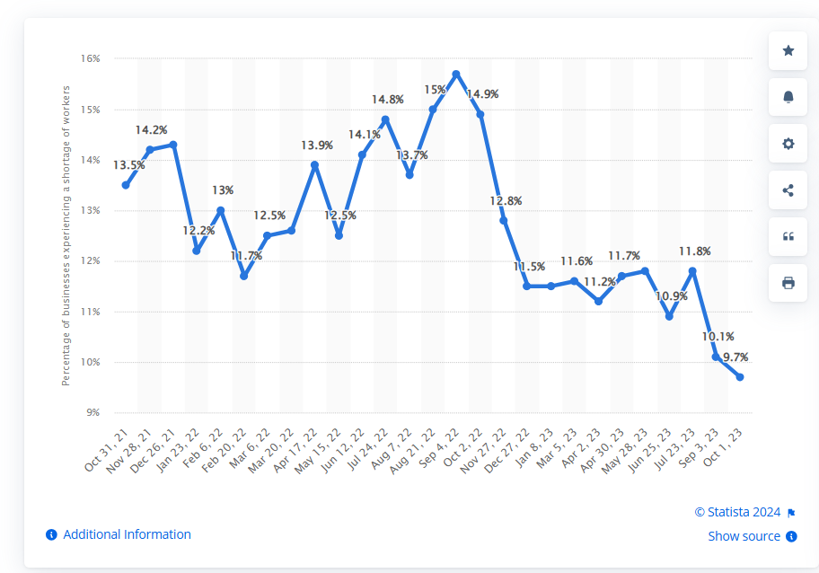
Fig 10. Clark (2024). Percentage of businesses experiencing a shortage of workers in the United Kingdom
    - Social factors
Rossington Hall's boutique offerings are in accordance with the growing demand for personalised services and authentic experiences among guests. Furthermore, there is an increasing demand for sustainable practices in the hospitality industry, as consumers are increasingly inclined to patronise establishments that exhibit environmental responsibility (Deloitte, 2023). To meet visitor expectations and improve its market position, Rossington Hall must maintain high service standards, implement robust health and safety measures, and embrace sustainable practices in order to adapt to these social trends. In the United Kingdom, 78% of consumers prioritise sustainability when selecting hospitality services as indicated by Razgaitis, (2024), and 35% are willing to pay a premium for environmentally sustainable alternatives as shown by Statista, (2024). This transition requires that businesses like Rossington Hall implement sustainable practices, including the procurement of locally grown produce and the reduction of energy consumption, in order to satisfy guests and improve their market position. The COVID-19 pandemic has increased the demand for health and safety protocols. According to a survey conducted by Deloitte (2023), 70% of UK travellers prioritise hygiene and safety measures when selecting accommodations. To foster visitor confidence and guarantee a secure environment, Rossington Hall must prove robust health and safety protocols. Rossington Hall should prioritise the integration of sustainable practices into its operations, maintain high health and safety standards, and provide personalised services in order to accommodate these changing preferences. The hotel can improve guest satisfaction and fortify its competitive edge in the hospitality industry by adhering to these consumer expectations.
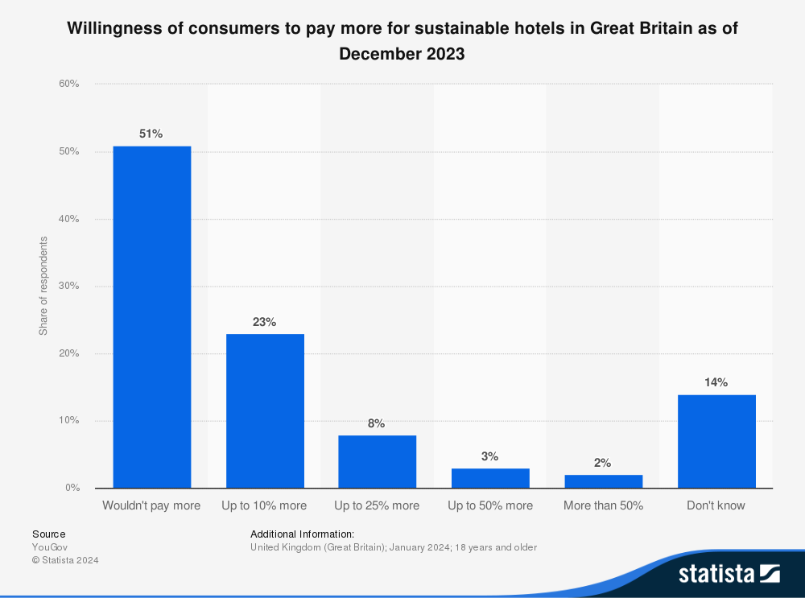
Fig 11. Statista(2024). Willingness of consumers to pay more for sustainable hotels

    - Technological factors
For instance, social media and digital marketing platforms have evolved into critical tools for increasing brand visibility. Rossington Hall may increase brand awareness, attract a varied clientele, and remain relevant in an increasingly digital market by using platforms such as Instagram, Facebook, and targeted online advertising (Baker and Magnini, 2016). This digital presence also allows for more personalised marketing strategies, such as employing analytics to learn guest preferences and personalising promotions to fit their demands. Advanced booking systems and mobile-friendly platforms can greatly improve guest convenience and satisfaction. Integrated booking solutions that enable online check-ins, mobile room keys, and app-based concierge services are becoming more common, particularly among luxury and boutique hotels (Das, 2023). These innovations could help Rossington Hall streamline the check-in process, minimise wait times, and give visitors greater control over their stay, all of which contribute to a more seamless experience. Smaller hotels, such as Rossington Hall, may struggle to implement new technologies due to budget constraints and the need for staff training (Buhalis et al., 2019). Investments in technology frequently necessitate not just initial costs but also continuous support and updates, making it critical for the hotel to thoroughly evaluate the cost-benefit of any new tool. For example, the hotel might start with a scalable property management system that can be upgraded in the future as budget and operational requirements change. Another important aspect is the use of technology to assist sustainable practices, which is increasingly valued by consumers. Energy-efficient technology, such as smart thermostats and lighting systems, can help achieve sustainability goals while lowering operational expenses. This strategy would be consistent with the desires of 78% of UK consumers who value sustainability in hospitality (Razgaitis, 2024).
  - Competitor Analysis
Rossington Hall is situated in a competitive hospitality market in Doncaster, where it competes with adjacent competitors who possess distinct pricing strategies, target markets, and amenities. The Hex Wildlife Hotel at Yorkshire Wildlife Park, which is situated approximately 3.4 km away, offers a distinctive attraction-focused experience that includes family-friendly facilities and access to wildlife observing. The hotel's unique location may attract families and wildlife enthusiasts who are interested in experiential accommodations (Hex Wildlife Hotel, 2024). However, it does not provide the historical and traditional luxury that Rossington Hall does. The Best Western Premier Doncaster Mount Pleasant Hotel is a luxury option that is slightly farther, approximately 4.8 km, from Rossington Hall. It offers a broader range of amenities, such as a spa, fitness centre, and fine cuisine. The brand-affiliated, standardised service of this well-established chain property may appeal to guests seeking a comprehensive luxury experience at competitive rates (Booking.com, 2024). However, it may not have the personalised touch and distinctive character of a boutique hotel. Furthermore, the Travelodge Doncaster Lakeside, which is situated approximately 11 km away, is a budget-friendly option that offers straightforward accommodations and affordable pricing, making it an ideal choice for travellers who prioritise affordability (Travelodge, 2024). Although Travelodge does not directly contend with Rossington Hall's luxury segment, its budget-friendly appeal may appeal to visitors who prioritise affordability and location. Rossington Hall must capitalise on its unique Victorian elegance, prioritise personalised visitor experiences, and potentially broaden its amenities to accommodate a wide range of guest preferences in order to remain competitive.
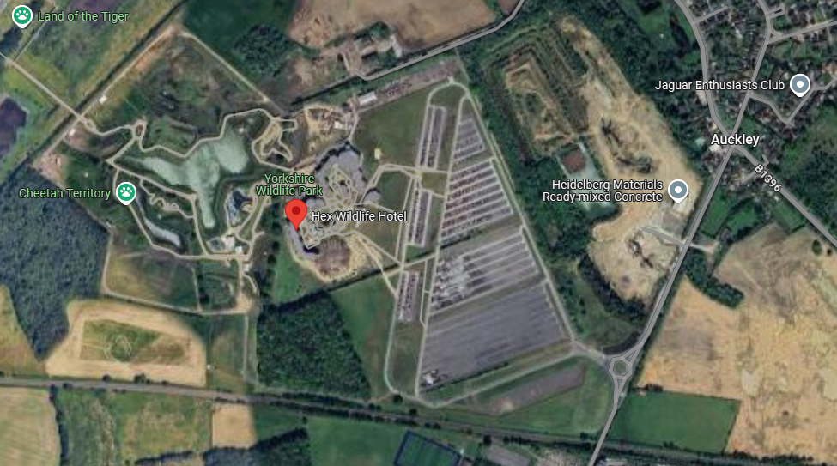
Fig 12. Google Maps (2019). Hex Wildlife Hotel.
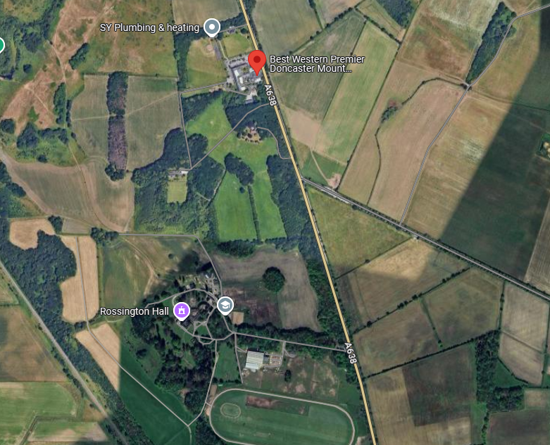
Fig 13. Google Maps (2019). Best Western Premier Doncaster Mount Pleasant Hotel.
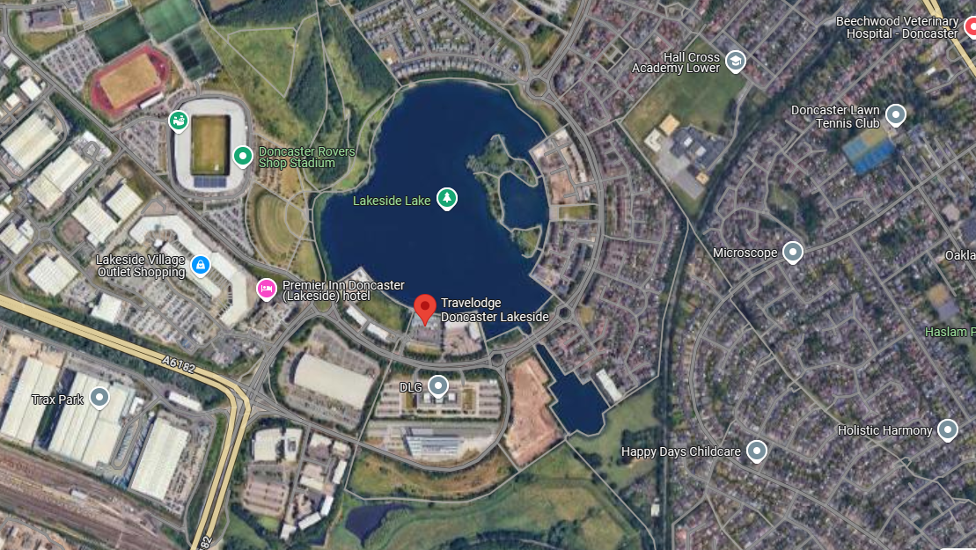
Fig 14. Google Maps (2019). Travelodge Doncaster Lakeside.

  - Netnography
Netnography, the examination of online user interactions, provides valuable insights into the consumer experiences at Rossington Hall. The examination of recent online evaluations reveals a blend of positive feedback and areas that require refinement, particularly in the context of staff performance. The staff's professionalism and hospitality have been much-admired by numerous visitors. As one reviewer put it, "The staff are lovely and our room was spacious and spotless." (Tripadvisor, 2024). According to an additional visitor, " Everyone goes out of their way to make guests feel welcome " (Tripadvisor, 2024). These remarks emphasise the staff's contribution to the improvement of the visitor experience. Nevertheless, certain evaluations suggest inconsistencies. A guest expressed dissatisfaction, stating, " Everyone needs to know Rossington Hall isn’t inclusive. A military veteran (navy) with a service dog wasn’t allowed a room. He was only able to go in areas that weren’t carpeted which meant he was dumped on a table on the wooden floor behind the ‘top table’ with an already limited view obscured by a pillar. Despicable, offensive and wrong on every level” (Tripadvisor, 2024). Another reviewer claimed that “We are intrigued by old Victorian dated decor and settings, and wanted to explore for a future stay and Hall hire. However a man at the bar today, turned and gave us a look which was uncomfortable, so we said we want to take a look around, his reply was prompt, “we don’t allow people to look around”.” These examples indicate that there are areas in which staff training and communication could be enhanced(Tripadvisor, 2024).
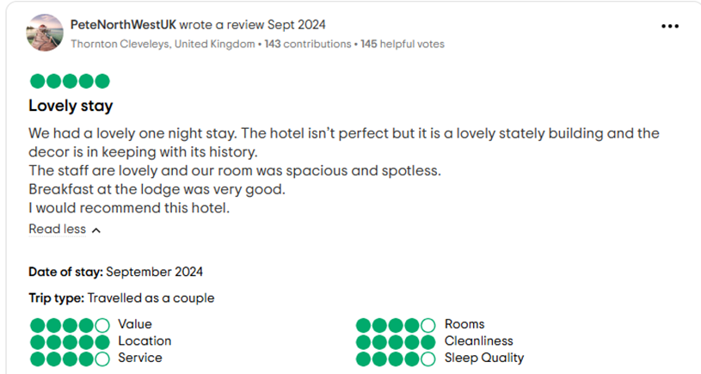
Fig 15. Tripadvisor. (2024). ROSSINGTON HALL
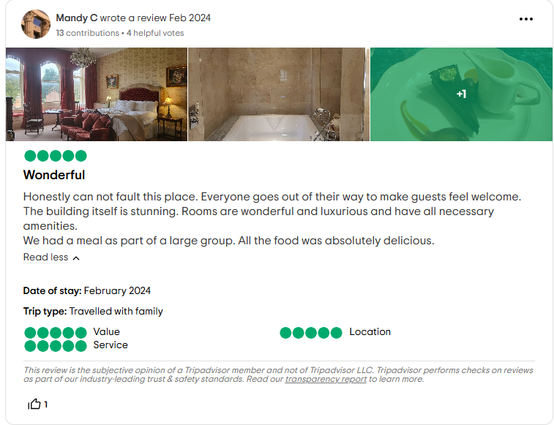
Fig 16. Tripadvisor. (2024). ROSSINGTON HALL
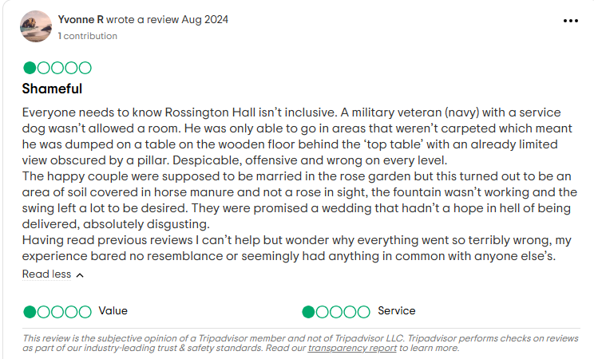
Fig 17. Tripadvisor. (2024). ROSSINGTON HALL
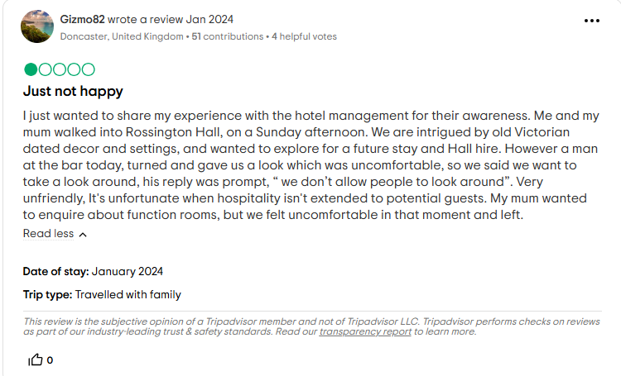
Fig 18. Tripadvisor. (2024). ROSSINGTON HALL

- Theme Exploration
  - Staffing Shortages and Role Reassignment
Staffing constraints have significantly impacted the UK hospitality industry, a crisis that has been further exacerbated by the COVID-19 pandemic and Brexit. The availability of labour, particularly from the EU, has been considerably diminished as a result of these factors, as the EU previously occupied a substantial portion of these positions (Caterer, 2021). Job vacancies in the hospitality sector are higher than they were prior to the pandemic, and nearly 30% of hospitality businesses are experiencing difficulty filling critical positions (ONS, 2021).This scarcity has necessitated that hotels implement a multitasking strategy, in which personnel are transferred between departments to replace the vacancies that remain vacant. Despite their practicality in the short term, these labour reassignments frequently lead to operational inefficiencies and increased burden stress for the current staff. In urban centres such as London, where over half of hospitality positions were previously occupied by EU nationals, the dependence on EU labour has been particularly problematic (Ghani et al., 2022). The sector's labour supply is being strained by the absence of incoming EU workers, which is a component of a broader trend in the UK. A government report also suggests that the reduction in EU nationals has directly resulted in chronic understaffing in critical areas, including sanitation, culinary roles, and guest services. Hotels are progressively reassigning employees across departments without adequate cross-training in order to maintain functionality, a practice that diminishes operational effectiveness and service quality (Harvey, 2023). The restrictive immigration policies of Brexit, as clarified by Sumption et al., (2022), eliminated a substantial labour force, particularly in low-skilled positions. Smaller hotels have been significantly impacted by this change, as they are now required to multitask on a daily basis due to the limited flexibility of their personnel. The UK government's report also indicates that role reassignment has become a common solution for maintaining service in the face of dire labour shortages (GOV UK, 2023).
  - Effects on Employee Well-being
The mental health of employees can be negatively impacted by multitasking in high-contact roles, such as those found in the hospitality industry. According to Lemonakki et al., (2021), exhaustion is induced by the increased cognitive and emotional demands of multitasking. These demands are additionally associated with attrition intentions and job dissatisfaction, as demonstrated by research conducted by Haldorai et al., (2019). Role excess and the constant transition between tasks are factors that contribute to elevated stress levels, particularly when employees are assigned unfamiliar roles, as per Tang and Vandenberghe, (2021). Staff may experience emotional depletion as a result of being overextended in multiple areas, which may exceed their ability to perform at a high level. Additionally, case studies indicate that hospitality personnel who are compelled to multitask frequently report a decline in job satisfaction and engagement. The findings of Butt and Warraich (2022) emphasise that employees' perceived value is diminished by role ambiguity and an increased cognitive burden, frequently leading to feelings of fatigue and frustration. For instance, the assignment of kitchen staff to cleaning responsibilities without adequate training not only results in a decrease in their confidence in their primary roles but also places them under pressure to adhere to unfamiliar standards. This alignment between job demands and resources is essential, as a work environment in which employees feel undervalued is created, thereby increasing attrition (Gangai, 2013). Giousmpasoglou, (2024) indicates that hospitality employees frequently work extended hours as a result of understaffing, which has had a detrimental impact on their productivity and mental health.
  - Impacts on Service Quality
Another critical area is the impact of multitasking on service quality, particularly in boutique hotels where service consistency and personalisation are essential. The SERVQUAL model, has been instrumental in the identification of service defects associated with multitasking. This model evaluates service quality based on responsiveness and reliability (Shi and Shang, 2020). In high-contact environments such as hotels, fluctuations in service standards can be particularly detrimental, as multitasking in roles where employees are not completely trained can result. This is according to Goes et al., (2018). This inconsistency has an impact on guest satisfaction and loyalty, as the expectations of boutique hotel service are frequently more personalised and elevated than those of larger chains. Kefalas, (2019) highlight that the quality of service at smaller hotels is diminished when multitasking replaces specialisation. As an illustration, the absence of specific cleaning abilities can result in substandard room conditions when culinary or front-of-house personnel are rotated into housekeeping. Rossington's reputation as a boutique establishment that provides personalised, high-quality service may be jeopardised by these issues. Moreover, guest reviews frequently emphasise inconsistencies that are the result of untrained staff, with complaints emphasising visible deficiencies in the room quality (Trip Advisor, 2024). These issues have the potential to weaken guest trust. McKinsey, (2023) indicates that although large chain hotels may mitigate these issues through cross-training and technology, smaller hotels, such as Rossington, have restricted resources to implement comparable solutions. The distinctive challenges that boutique hotels encounter in sustaining quality while managing labour shortages are emphasised by this discrepancy. Furthermore, small hotels are unable to implement formal training programs due to insufficient resources, which could potentially mitigate the challenges associated with multitasking.
- Analysis of Multitasking at Rossington Hotel
The operational impact of multitasking was clear during the placement at Rossington Hotel, particularly through the reassignment of kitchen staff to housekeeping duties. Management frequently transferred employees between departments as a result of persistent staffing shortages, which led to numerous service challenges. This practice is indicative of a trend that has been identified. The kitchen staff, who were primarily trained in food preparation, frequently encountered difficulty adhering to the rigorous hygiene standards that are expected of boutique hotels such as Rossington. Research conducted by Jin et al., (2021) emphasises that service quality is negatively impacted by inconsistent role assignments in the absence of adequate training. This is due to the fact that untrained personnel are unable to completely apply specialised skills that are essential to housekeeping, such as deep-cleaning techniques and specific room sanitation practices. This misalignment resulted in guest complaints about room standards, as patrons observed details such as inconsistent linen arrangements and missed areas in bathrooms, which negatively impacted their overall experience. This trend was also reported by Xiang et al., (2022), who highlight the negative guest perception associated with untrained staff handling sensitive tasks. The personal impact of these role reassignments was further emphasised by employee feedback at Rossington. A significant number of employees expressed exasperation and fatigue as a result of the constant role-switching, a conclusion that is corroborated by research on job dissatisfaction and role excess in the hospitality industry (Karatepe, Ozturk and Kim, 2019). In the absence of stable, role-specific responsibilities, employees experienced feelings of undervaluation and overextension, as they were unable to meet unfamiliar expectations without the necessary training. According to Kudesia, Pandey, and Reina, (2022), this type of multitasking results in fatigue and increases cognitive demands, which is consistent with the findings at Rossington. Employees reported that the mental fatigue associated with adapting to new duties contributed to feelings of job insecurity and dissatisfaction. Additionally, Zhang, Hong and Smith, (2022) discovered that role ambiguity resulting from multitasking frequently results in a decrease in morale. This pattern was observed among Rossington's employees, who expressed apprehension regarding their ability to meet performance expectations in these circumstances. Rossington's service quality was directly affected by the consequences of such practices, which extended beyond employee morale. Thus, boutique hotels' consistency can be compromised by multitasking in service roles. This is illustrated by Rossington's dependence on reassigned staff who lacked specialised training. The hotel's brand image was substantially impacted by specific incidents during the placement, such as unmade beds or overlooked restroom details, which highlighted inconsistent room turnovers. According to Rasoolimanesh et al., (2022), visitor satisfaction is fundamentally determined by reliability and consistency. Rossington encountered difficulties in adhering to this standard as a result of labour constraints. In particular, the SERVQUAL framework has demonstrated that service quality frequently declines when multitasking replaces specialised roles. Webb (2024) have observed that post-Brexit labour shortages have exacerbated service inconsistencies in UK hospitality. Observations at Rossington corroborated that guest feedback frequently included comments on lapses in quality. The challenges outlined above serve as a reminder of the difficulty that Rossington Hotel faces in reconciling operational requirements with service quality. The hotel's inability to implement comprehensive cross-training programs, is limited by its limited resources. The placement experience, therefore, highlighted the necessity of more precise role definitions and enhanced training structures to improve employee efficacy and visitor satisfaction.
- Conclusion
- At Rossington Hotel, employees are frequently reassigned across departments due to severe personnel shortages, which have been further exacerbated by the COVID-19 pandemic and Brexit. In response, the hotel has implemented a multitasking strategy. This practice has been indispensable; however, it has also resulted in substantial declines in employee well-being and service quality.
- Staff morale has been substantially affected by the practice of reassigning roles without adequate training. Numerous employees expressed feelings of insecurity and feeling undervalued in their roles, as well as increased stress and exhaustion.
- Multitasking pressures in hospitality have been demonstrated to result in high attrition rates and job dissatisfaction, as employees are unable to meet the diverse demands that extend beyond their primary duties, as per industry research.
- The consistency of service at Rossington Hotel, a critical element of the boutique visitor experience, has been impacted by the multitasking demands placed on staff. Guests have reported issues with room hygiene and attention to detail as a result of inadequate training for reassigned positions. Their complaints are primarily focused on quality deficiencies.
- Rossington's distinctive challenge in reconciling the high service expectations of boutique hotels with labour demands was underscored by the placement observations. The operational inefficiencies that have been generated as a result of inconsistent role assignments and limited personnel resources have had an impact on the overall visitor experience and the performance of the staff.

- Recommendations
- At first, Rossington Hotel should prioritise structured cross-training programs to provide its employees with the necessary skills to perform a variety of responsibilities. Structured cross-training has been shown to substantially reduce role overburden and improve job satisfaction by preparing employees for versatile responsibilities. This, in turn, enhances performance consistency across tasks (Salen and Abdien, 2017). Rossington could mitigate service inconsistencies due to untrained role reassignment by providing targeted training in essential sanitation and visitor service skills to kitchen staff. This would also foster a sense of confidence and competence among employees, thereby alleviating the tension associated with multitasking. Cross-training could be implemented during off-peak seasons to minimise disruption to daily operations and ensure that staff are adequately prepared for role adjustments when necessary (Wang et al., 2016).
- Secondly, the implementation of flexible employment models would alleviate the burden on essential staff and minimise the amount of multitasking that is necessary (Kossek, Gettings and Misra, 2021). Temporary or seasonal positions are implemented during peak seasons to alleviate workload demands without burdening regular employees, as emphasised by Ette (2023). This method is substantiated by a study conducted by Xu and Hall (2021), which asserts that seasonal personnel alleviates fatigue by offering essential assistance during periods of high demand. Part-time employees or temporary hires could be employed to help with specific duties, such as fundamental guest services or room turnovers, thereby enabling full-time staff to concentrate on their primary responsibilities. A strategy of this nature would ensure that Rossington's boutique service quality is maintained by balancing operational requirements with employee well-being.
- Rossington could implement low-cost digital tools for task administration and scheduling in order to enhance operational efficiency and staff well-being. Role clarity can be enhanced, and task adjustments can be anticipated more effectively by staff through the use of technology such as scheduling applications or basic task management platforms (Iranmanesh et al.,2022). These tools would enable employees to more effectively prepare for role changes, thereby reducing the disorientation and mental distress that are often associated with ad hoc multitasking. Furthermore, digital systems can improve transparency by allowing managers to assign tasks based on the availability of staff and their talent levels. This would not only simplify operations but also establish a structured environment that mitigates the tension associated with unforeseen role assignments.
- Lastly, it is imperative to foster an inclusive work environment that prioritises recognition and assistance. De Clercq et al., (2020) conducted research that emphasises the significance of supportive leadership in reducing the adverse effects of job stressors, such as multitasking. Acknowledging employees' adaptability and conducting routine check-ins would cultivate a sense of appreciation and mitigate feelings of undervaluation. Morale is essential in high-stress environments, such as Rossington's, and it can be improved by acknowledging staff contributions and encouraging open communication. Employee retention would be facilitated by this cultural transformation, as a supportive environment frequently results in increased job satisfaction and decreased turnover (Tian et al., 2020).

- Reflection
Concrete Experience
I personally experienced the operational and morale-related issues that emerged as a result of personnel shortages and a significant reliance on multitasking during my time at Rossington Hotel. Employees frequently assumed responsibilities that were not within their area of expertise in order to satisfy the demand for their services. For instance, kitchen personnel were frequently transferred to housekeeping to assist in the cleaning and preparation of guest rooms. The hotel's limited staff and the challenges associated with recruiting additional personnel necessitated this strategy. On the other hand, the transition from one department to another was frequently precipitous, and I observed that employees were feeling unprepared and apprehensive about the expectations of their new positions. A kitchen staff member was at the last minute requested to assume janitorial responsibilities, which served as an example of the approach's limitations. Although this staff member was amenable to assistance, they were not acquainted with the hotel's standard maintenance procedures, which resulted in room presentations that did not meet the hotel's expectations. The employee expressed dissatisfaction with responsibilities such as scrubbing bathroom fixtures and arranging guest amenities in accordance with the hotel's standards. The distinctions were observed by guests, which led to complaints regarding the hygiene and arrangement of the rooms. This experience exemplified the operational challenges and visitor dissatisfaction that can result from the use of multitasking as a solution for understaffing without sufficient preparation. In addition, I observed a dedication to conventional reservation procedures. The hotel significantly depended on phone reservations, rather than implementing an automated system. The manual recording of reservations by the staff resulted in frequent miscommunications and occasionally, double appointments. This manual process imposed a superfluous burden and posed obstacles to the efficient management of bookings. The absence of a streamlined booking system became a visible issue, influencing both visitor satisfaction and staff efficiency, as Rossington's guest volume fluctuated, particularly during high-demand periods.
Reflective Observation
Upon review of these experiences, it became evident that Rossington's method of multitasking, although it appeared to be practicable, had substantial disadvantages. Frustration and stress were conveyed by employees who were often transferred between positions. The culinary staff was inadequate to manage housekeeping responsibilities due to their lack of training in order to adhere to the hotel's cleanliness standards. Their confidence was diminished because of this sense of inadequacy, which caused them to feel disassociated from their primary responsibilities. Based on these observations, it was evident that multitasking imposed an additional burden on employees, resulting in a work environment in which individuals felt overworked and undervalued. The effect on morale was also readily clear. Staff often expressed the belief that their primary skills were disregarded in favour of meeting imminent operational requirements. For example, individuals who have received culinary training may experience feelings of frustration when they are consistently compelled to perform domestic tasks, which diminishes their professional pride and sense of purpose. This diminished morale appeared to have an impact on team dynamics, as employees reported feeling less motivated and less loyal to their positions. This also affected the quality of service, as staff who were less motivated were less likely to consistently maintain the high standards that Rossington promoted as part of its boutique image. Furthermore, the absence of an appropriate reservation system was a substantial impediment to efficiency. The staff was required to maintain a high level of attention due to the significant reliance on phone appointments, which necessitated manual reservation management. This approach was time-consuming and susceptible to errors, including overlapping reservations and incomplete information. Managing these phone reservations became particularly difficult during periods of high demand. I noticed that staff members were devoting valuable time to confirming and clarifying reservations, which impeded their ability to complete other critical tasks. The hotel's service reliability was compromised by the absence of streamlined technology, which not only increased the burden of employees but also resulted in intermittent booking errors that impacted the overall experience of visitors.
Abstract Conceptualisation
After examining Rossington Hotel's issues in the framework of theoretical notions, I found the Job Demands-Resources paradigm fits. The JD-R model suggests that high employment demands, such as multitasking without assistance, can lead to emotional weariness and burnout when resources are few (Bakker and de Vrais, 2021). Due to frequent unprepared duties, Rossington employees experienced heightened cognitive and emotional stress. Without a structured task management system and proper training, employees had to take on complicated tasks without help, which increased stress and diminished job satisfaction. The SERVQUAL model, which considers dependability, helped me understand visitor experience difficulties (Wang et al., 2015). Rossington's repeated reassignments of unskilled staff caused inconsistencies in room cleanliness and booking dependability, which is crucial for tourist satisfaction. In boutique hotels, where individualised and consistent service is crucial, multitasking can jeopardise critical service quality aspects if not managed properly. As I considered the technological gap, I considered how industry norms are increasingly relying on digital booking systems for operational effectiveness. Automated solutions reduce manual entry mistakes and provide real-time booking accuracy, ensuring visitor happiness under high demand (Avula and Sithole, 2024). Lack of technology at Rossington worsened the load and caused needless blunders. Digital reservation systems in the hotel business boost accuracy, speed, and allow workers to focus on service quality, according to research (Wang et al., 2016). These benefits match what Rossington might achieve with this technology.
Active Experimentation
With these insights, I considered some ways Rossington Hotel may address these issues. A planned cross-training program would initially teach staff the basic skills needed for several tasks, improving service and reducing the stress of sudden role transitions. Cross-training would provide kitchen personnel basic housekeeping instruction, ensuring they are ready and confident. Cross-training boosts job satisfaction and prepares workers for flexible positions (Chen and Tseng, 2012). During low-demand periods, the hotel may train personnel without affecting operations. A computerised reservation system would simplify booking, reduce human mistakes, and allow personnel to focus on excellent guest care. Technology in bookings services would prevent multiple appointments and other problems that lower visitor pleasure. Digital booking platforms increase operational efficiency and precision, allowing boutique hotels to deliver more reliable service (Wang et al., 2019). A reservation system might improve Rossington's booking process and help manage variable visitor levels, improving staff and guest experiences. Finally, even while multitasking, a friendly workplace may boost employees' self-esteem. Recognition of multitaskers and frank discussion about position changes can boost morale. Regular check-ins and direct recognition of adaptation might reduce the aggravation of frequent reassignments by making staff feel appreciated. Russ and Crews (2014) found that supportive leadership and frequent feedback reduce stress and boost work satisfaction in multitasking positions.

References

Aigbedo, H. (2021). Impact of COVID-19 on the hospitality industry: A supply chain resilience perspective. International Journal of Hospitality Management, [online] 98(1), p.103012. doi:https://doi.org/10.1016/j.ijhm.2021.103012.
Alrawadieh, Z., Alrawadieh, Z. and Cetin, G., 2021. Digital transformation and revenue management: Evidence from the hotel industry. Tourism Economics, 27(2), pp.328-345.
Avula, M. and Sithole, T., 2024. Artificial Intelligence's Potential to Improve Operational Efficiency and Customer Experience in the Hospitality and Tourism Sectors. In Impact of AI and Tech-Driven Solutions in Hospitality and Tourism (pp. 351-382). IGI Global.
Baker, M.A. and Magnini, V.P., 2016. The evolution of services marketing, hospitality marketing and building the constituency model for hospitality marketing. International Journal of Contemporary Hospitality Management, 28(8), pp.1510-1534.
Bakker, A.B., Xanthopoulou, D. and Demerouti, E., 2023. How does chronic burnout affect dealing with weekly job demands? A test of central propositions in JD‐R and COR‐theories. Applied Psychology, 72(1), pp.389-410.
Bakker, A.B. and de Vries, J.D., 2021. Job Demands–Resources theory and self-regulation: New explanations and remedies for job burnout. Anxiety, stress, & coping, 34(1), pp.1-21.
Beirman, D., 2020. Restoring tourism destinations in crisis: A strategic marketing approach. Routledge.
Benzaghta, M.A., Elwalda, A., Mousa, M.M., Erkan, I. and Rahman, M., 2021. SWOT analysis applications: An integrative literature review. Journal of Global Business Insights, 6(1), pp.54-72.
Booking.com (2024). Best Western Premier Doncaster Mount Pleasant Hotel. [online] Booking.com. Available at: https://www.booking.com/hotel/gb/mountpleasant.en-gb.html [Accessed 1 Nov. 2024].
Buhalis, D., Harwood, T., Bogicevic, V., Viglia, G., Beldona, S. and Hofacker, C., 2019. Technological disruptions in services: lessons from tourism and hospitality. Journal of service management, 30(4), pp.484-506.
Butler, S. (2021). ‘Quite a challenge’: UK restaurants and pubs face staffing crisis after Brexit. [online] the Guardian. Available at: https://www.theguardian.com/business/2021/may/01/uk-restaurants-pubs-brexit-staff-covid.
Butt, N. and Warraich, N.F., 2022. Multitasking behavior in the workplace: A systematic review. Journal of Social Research Development, 3(2), pp.229-247.
Caterer (2021). The impact of Brexit and Covid on the UK hospitality workforce | Caterer.com. [online] Caterer.com. Available at: https://www.caterer.com/recruiter-advice/the-impact-of-brexit-and-covid-on-the-uk-hospitality-workforce.
Chen, L.C. and Tseng, C.Y., 2012. Benefits of cross-functional training: three departments of hotel line supervisors in Taiwan. Journal of Hospitality and Tourism Management, 19, p.e11.
Clark, D. (2024). UK worker shortages 2023. [online] Statista. Available at: https://www.statista.com/statistics/1369207/uk-worker-shortage/.
Collis, J. and Hussey, R., 2021. Business research: A practical guide for students. Bloomsbury Publishing.
Company House (2024). ROSSINGTON HALL LIMITED filing history - Find and update company information - GOV.UK. [online] Available at: https://find-and-update.company-information.service.gov.uk/company/07359556/filing-history [Accessed 1 Nov. 2024].
Creswell, J.W. and Poth, C.N., 2016. Qualitative inquiry and research design: Choosing among five approaches. Sage publications.
Dalkhjav, B., Munkhuu, B. and Sukhragchaa, A.S., 2024. Enhancing job performance in the hospitality sector: exploring the role of employee engagement, multitasking, organizational culture, and recruiting practices. Journal of Tourism, Sustainability and Well-being, 12(2), pp.188-205.
Darvishmotevali, M., Altinay, L. and Köseoglu, M.A., 2020. The link between environmental uncertainty, organizational agility, and organizational creativity in the hotel industry. International journal of hospitality management, 87, p.102499.
Das, M.P., 2023. Technology and Guest experience: innovations reshaping hotel management. International Journal for Multidimensional Research Perspectives, 1(3), pp.76-95.
De Clercq, D., Azeem, M.U., Haq, I.U. and Bouckenooghe, D., 2020. The stress-reducing effect of coworker support on turnover intentions: Moderation by political ineptness and despotic leadership. Journal of Business Research, 111, pp.12-24.
Deloitte (2023). Sustainability in the hospitality industry | Deloitte UK. [online] www.deloitte.com. Available at: https://www.deloitte.com/uk/en/Industries/consumer/blogs/sustainability-in-the-hospitality-industry.html.
Denzin, N.K., Lincoln, Y.S., Giardina, M.D. and Cannella, G.S. eds., 2023. The Sage handbook of qualitative research. Sage publications.
Deery, M. and Jago, L., 2015. Revisiting talent management, work-life balance and retention strategies. International Journal of Contemporary Hospitality Management, 27(3), pp.453-472.
Dempsey, J. (2023). Hospitality sector ‘anxious’ over summer staffing. BBC News. [online] 9 Jul. Available at: https://www.bbc.co.uk/news/business-66021588.
Visit DonCaster (n.d.). Doncaster - Vibrant Culture - Yorkshire’s Newest City. [online] Available at: https://www.yorkshire.com/doncaster/?srsltid=AfmBOoou0fkDbUb3cfuDBDyh_dfyNYQxbxRhJaCxMWTxe6xZ9Plg7jEH [Accessed 2 Nov. 2024].
Endole UK(2024). Rossington Hall Limited - Company Profile - Endole. [online] Available at: https://open.endole.co.uk/insight/company/07359556-rossington-hall-limited [Accessed 1 Nov. 2024].
Ette, S. (2023). Urgent workforce solutions needed to avoid summer slump. [online] UKHospitality. Available at: https://www.ukhospitality.org.uk/urgent-workforce-solutions-needed-to-avoid-summer-slump/.
Ette, S. (2024). Billion pound tax bombshell to hit hospitality - UKHospitality. [online] UKHospitality. Available at: https://www.ukhospitality.org.uk/billion-pound-tax-bombshell-to-hit-hospitality/ [Accessed 2 Nov. 2024].
Firat, A., Turker, G.O. and Metin, I. (2014). SPECIFICATION OF TARGET MARKET IN SMALL AND MEDIUM SCALE ACCOMADATION BUSINESSES: A STUDY ON BOUTIQUE HOTELS OPERATING IN CITY OF MUGLA. tourismos, [online] 9(2), pp.279–299. doi:https://doi.org/10.26215/tourismos.v9i2.421.
Gangai, K.N., 2013. Attrition at work place: how and why in hotel industry. IOSR Journal of Humanities and social science, 11(2), pp.38-49.
George, R., 2021. Marketing tourism and hospitality: Concepts and cases. Springer Nature.
Ghani, B., Zada, M., Memon, K.R., Ullah, R., Khattak, A., Han, H., Montes, A.A. and Castillo, L.A. (2022). Challenges and Strategies for Employee Retention in the Hospitality Industry: A Review. Sustainability, [online] 14(5), p.2885. doi:https://doi.org/10.3390/su14052885.
Giousmpasoglou, C. (2024). Working Conditions in the Hospitality Industry: The Case for a Fair and Decent Work Agenda. Sustainability, [online] 16(19), p.8428. doi:https://doi.org/10.3390/su16198428.
Goes, P.B., Ilk, N., Lin, M. and Zhao, J.L., 2018. When more is less: Field evidence on unintended consequences of multitasking. Management Science, 64(7), pp.3033-3054.
Goh, E. and Okumus, F., 2020. Avoiding the hospitality workforce bubble: Strategies to attract and retain generation Z talent in the hospitality workforce. Tourism Management Perspectives, 33, p.100603.
GOV (2015). Historic Buildings and Ancient Monuments Act 1953. [online] Available at: https://www.legislation.gov.uk/ukpga/Eliz2/1-2/49.
Gov UK (2023). Hospitality strategy: Reopening, recovery, resilience. [online] GOV.UK. Available at: https://www.gov.uk/government/publications/hospitality-strategy-reopening-recovery-resilience/hospitality-strategy-reopening-recovery-resilience.
GOV UK. (2023). Migration Advisory Committee (MAC) annual report, 2023 (accessible). [online] Available at: https://www.gov.uk/government/publications/migration-advisory-committee-annual-report-2023/migration-advisory-committee-mac-annual-report-2023-accessible.
Green, A. (2019). Low-Skilled Employment in a New Immigration Regime: Challenges and Opportunities for Business Transitions. National Institute Economic Review, 248(1), pp.R17–R27. doi:https://doi.org/10.1177/002795011924800110.
Haldorai, K., Kim, W.G., Pillai, S.G., Park, T.E. and Balasubramanian, K., 2019. Factors affecting hotel employees’ attrition and turnover: Application of pull-push-mooring framework. International journal of hospitality management, 83, pp.46-55.
Harper, D., 2016. Hotels and Resorts: An investor's guide. Taylor & Francis.
Harvey, D. (2023). Hotels and bars need more EU workers, say bosses. BBC News. [online] 21 Mar. Available at: https://www.bbc.co.uk/news/uk-england-bristol-65026562.
Hex Wildlife Hotel (2024). Hex Wildlife Hotel | Yorkshire Wildlife Park. [online] Available at: https://www.hex-hotel.com/ [Accessed 10 Nov. 2024].
Heimerl, P., Haid, M., Benedikt, L. and Scholl-Grissemann, U., 2020. Factors influencing job satisfaction in hospitality industry. SAGE open, 10(4), p.2158244020982998.
HM Treasury (2024). Pay boost for millions of workers next year. [online] GOV.UK. Available at: https://www.gov.uk/government/news/pay-boost-for-millions-of-workers-next-year.
Iranmanesh, M., Ghobakhloo, M., Nilashi, M., Tseng, M.L., Yadegaridehkordi, E. and Leung, N., 2022. Applications of disruptive digital technologies in hotel industry: A systematic review. International Journal of Hospitality Management, 107, p.103304.
Jin, Y., Cheng, L., Li, Y. and Wang, Y. (2021). Role Stress and Prosocial Service Behavior of Hotel Employees: A Moderated Mediation Model of Job Satisfaction and Social Support. Frontiers in Psychology, 12. doi:https://doi.org/10.3389/fpsyg.2021.698027.
Juliana, A.P., Lemy, D.M., Pramono, R., Djakasaputra, A. and Purwanto, A., 2022. Hotel performance in the digital era: Roles of digital marketing, perceived quality and trust. Journal of Intelligent Management Decision, 1(1), pp.36-45.
Karatepe, O.M., Ozturk, A. and Kim, T.T., 2019. The effects of nonwork and personal resources on frontline bank employees’ work engagement and critical job outcomes. International Journal of Bank Marketing, 37(3), pp.858-879.
Kefalas, S. (2019). Quality Service in the Hospitality Industry: Achieving Effective Service Processes and Designs. Strategic Innovative Marketing and Tourism, pp.39–47. doi:https://doi.org/10.1007/978-3-030-12453-3_5.
Kossek, E.E., Gettings, P. and Misra, K. (2021). The Future of Flexibility at Work. [online] Harvard Business Review. Available at: https://hbr.org/2021/09/the-future-of-flexibility-at-work.
Kozinets, R.V., 2015. Netnography: Redefined. Sage.
Kozinets, R.V., 2020. Netnography today: A call to evolve, embrace, energize, and electrify. In Netnography unlimited (pp. 3-23). Routledge.
Kudesia, R.S., Pandey, A. and Reina, C.S., 2022. Doing more with less: Interactive effects of cognitive resources and mindfulness training in coping with mental fatigue from multitasking. Journal of Management, 48(2), pp.410-439.
Lemonaki, R., Xanthopoulou, D., Bardos, A.N., Karademas, E.C. and Simos, P.G., 2021. Burnout and job performance: a two-wave study on the mediating role of employee cognitive functioning. European Journal of Work and Organizational Psychology, 30(5), pp.692-704.
Li, H. and Srinivasan, K., 2019. Competitive dynamics in the sharing economy: An analysis in the context of Airbnb and hotels. Marketing Science, 38(3), pp.365-391.
Lu, L., Cai, R. and Gursoy, D., 2019. Developing and validating a service robot integration willingness scale. International Journal of Hospitality Management, 80, pp.36-51.
Mañas, M.A., Díaz-Fúnez, P., Pecino, V., López-Liria, R., Padilla, D. and Aguilar-Parra, J.M. (2018). Consequences of Team Job Demands: Role Ambiguity Climate, Affective Engagement, and Extra-Role Performance. Frontiers in Psychology, [online] 8(2292). doi:https://doi.org/10.3389/fpsyg.2017.02292.
McCarthy, J., 2011. Reflective writing, higher education and professional practice. Journal for Education in the Built Environment, 6(1), pp.29-43.
McKinsey (2023). Hotel staffing shortages | McKinsey. [online] www.mckinsey.com. Available at: https://www.mckinsey.com/industries/travel-logistics-and-infrastructure/our-insights/three-innovations-to-solve-hotel-staffing-shortages
Meier, E.A., Gallegos, J.V., Thomas, L.P.M., Depp, C.A., Irwin, S.A. and Jeste, D.V., 2016. Defining a good death (successful dying): literature review and a call for research and public dialogue. The American Journal of Geriatric Psychiatry, 24(4), pp.261-271.
Mody, M.A., Suess, C. and Lehto, X., 2017. The accommodation experiencescape: a comparative assessment of hotels and Airbnb. International Journal of Contemporary Hospitality Management, 29(9), pp.2377-2404.
Murphy, J., Hofacker, C. and Gretzel, U., 2017. Dawning of the age of robots in hospitality and tourism: Challenges for teaching and research. European Journal of Tourism Research, 15(2017), pp.104-111.
Office for Budget Responsibility. (2024). Economic and fiscal outlook – October 2024 - Office for Budget Responsibility. [online] Available at: https://obr.uk/efo/economic-and-fiscal-outlook-october-2024/.
Office for National Statistics (2021). Hospitality businesses are most likely to be struggling to fill vacancies - Office for National Statistics. [online] www.ons.gov.uk. Available at: https://www.ons.gov.uk/employmentandlabourmarket/peopleinwork/employmentandemployeetypes/articles/hospitalitybusinessesaremostlikelytobestrugglingtofillvacancies/2021-09-16.
Office for National Statistics (2021). Hospitality businesses are most likely to be struggling to fill vacancies - Office for National Statistics. [online] www.ons.gov.uk. Available at: https://www.ons.gov.uk/employmentandlabourmarket/peopleinwork/employmentandemployeetypes/articles/hospitalitybusinessesaremostlikelytobestrugglingtofillvacancies/2021-09-16.
ONS (2024). Consumer price inflation, UK. [online] Ons.gov.uk. Available at: https://www.ons.gov.uk/economy/inflationandpriceindices/bulletins/consumerpriceinflation/september2024.
Park, K. and Jang, S.S., 2012. Effect of diversification on firm performance: Application of the entropy measure. International Journal of Hospitality Management, 31(1), pp.218-228.
Rasoolimanesh, S.M., Seyfi, S., Rather, R.A. and Hall, C.M., 2022. Investigating the mediating role of visitor satisfaction in the relationship between memorable tourism experiences and behavioral intentions in heritage tourism context. Tourism Review, 77(2), pp.687-709.
Razgaitis, R. (2024). Council Post: Sustainability Drives Consumer Choice For Travelers. Forbes. [online] 12 Aug. Available at: https://www.forbes.com/councils/forbesbusinesscouncil/2023/08/18/sustainability-drives-consumer-choice-for-travelers/.
Ridgway, M., (2019). Brexit: Human resourcing implications. Employee Relations: The International Journal, 41(5), pp.1033-1045.
Rossington Hall (n.d.). Luxury Wedding Venue, Dining & Accommodation Doncaster. [online] Rossington Hall. Available at: https://rossingtonhall.co.uk/.
Russ, M. and Crews, D.E., 2014. A survey of multitasking behaviors in organizations. International Journal of Human Resource Studies, 4(1), p.137.
Rydell, A. and Storman, E., 2023. Short-time Work, Redundancies, and Changing Work Environment: The Hospitality Sector During COVID-19. Nordic Journal of Working Life Studies, 13(S10), pp.97-117.
Salem, I.E.B. and Abdien, M.K., 2017. Implementation of employee cross-training during perilous conditions in hotels. Tourism Management Perspectives, 23, pp.68-74.
Shi, Z. and Shang, H., 2020. A review on quality of service and servqual model. In HCI in Business, Government and Organizations: 7th International Conference, HCIBGO 2020, Held as Part of the 22nd HCI International Conference, HCII 2020, Copenhagen, Denmark, July 19–24, 2020, Proceedings 22 (pp. 188-204). Springer International Publishing.
Statista. (2024). Paying more for sustainable hotels Great Britain 2024 | Statista. [online] Available at: https://www.statista.com/statistics/1482159/willingness-pay-sustainable-hotels-great-britain/.
Sumption, M., Forde, C., Alberti, G. and Walsh, P.W., 2022. How is the end of free movement affecting the low-wage labour force in the UK. The Economics of Brexit: What Have We Learned.
Sun, Y. and Jung, H. (2024). Machine Learning (ML) Modeling, IoT, and Optimizing Organizational Operations through Integrated Strategies: The Role of Technology and Human Resource Management. Sustainability, [online] 16(16), pp.6751–6751. doi:https://doi.org/10.3390/su16166751.
Tang, W.-G. and Vandenberghe, C. (2021). Role Overload and Work Performance: The Role of Psychological Strain and Leader–Member Exchange. Frontiers in Psychology, 12(1). doi:https://doi.org/10.3389/fpsyg.2021.691207.
Tian, H., Iqbal, S., Akhtar, S., Qalati, S.A., Anwar, F. and Khan, M.A.S., 2020. The impact of transformational leadership on employee retention: mediation and moderation through organizational citizenship behavior and communication. Frontiers in psychology, 11, p.314.
Travelodge. (2024). Doncaster Lakeside. [online] Available at: https://www.travelodge.co.uk/hotels/534/Doncaster-Lakeside-hotel [Accessed 1 Nov. 2024].
Tripadvisor. (2024). ROSSINGTON HALL - Updated 2023 Reviews, Price Comparison. [online] Available at: https://www.tripadvisor.co.uk/Hotel_Review-g4597293-d4593802-Reviews-Rossington_Hall-Rossington_Doncaster_South_Yorkshire_England.html.
UK Hospitality (2023). Economic contribution of hospitality. [online] UKHospitality. Available at: https://www.ukhospitality.org.uk/insight/economic-contribution-of-hospitality/.
UK Hospitality. (2023). Worker shortages. [online] Available at: https://www.ukhospitality.org.uk/campaign/workforce/.
Wang, Y.L., Tainyi, L.U.O.R., Luarn, P. and Lu, H.P., 2015. Contribution and Trend to Quality Research--a literature review of SERVQUAL model from 1998 to 2013. Informatica economica, 19(1).
Wang, Y.S., Li, H.T., Li, C.R. and Zhang, D.Z., 2016. Factors affecting hotels' adoption of mobile reservation systems: A technology-organization-environment framework. Tourism Management, 53, pp.163-172.
Webb, A., 2024, August. Revisiting the Importance of Employee Retention and Principles of Good Work in Addressing the Current Skills and Labour Shortages in Scotland. In Shortages of Labour and Skills (pp. 29-38). Nomos Verlagsgesellschaft mbH & Co. KG.
Xanthopoulou, D., Bakker, A.B. and Ilies, R., 2012. Everyday working life: Explaining within-person fluctuations in employee well-being. Human relations, 65(9), pp.1051-1069.
Xiang, K., Gao, F., Qiao, G. and Chen, Q., 2022. Hotel employees’ occupational stigma narratives: perceived attributes, formation paths and destigmatization mechanisms. International Journal of Contemporary Hospitality Management, 34(12), pp.4389-4414.
Xu, S. and Hall, N.G., 2021. Fatigue, personnel scheduling and operations: Review and research opportunities. European Journal of Operational Research, 295(3), pp.807-822.
Zhang, J., Hong, Y. and Smith, A.P. (2022). The Relationship between Role Ambiguity and Workers’ Creativity during the COVID-19 Pandemic in China. International Journal of Environmental Research and Public Health, [online] 19(23), p.15977. doi:https://doi.org/10.3390/ijerph192315977.

‌

‌
‌

