Daniel Bridgewater (2218703)

Critical Evaluation of Braun’s Multiplier and Wallace Tree Multiplier Using VHDL
ACDA6001

Contents
Table of Figures 2
Abstract 2
Introduction 3
Braun Multipliers 4
Diagram 4
Wallace Multipliers 5
Diagram 5
Implementing the multipliers in VHDL for an FPGA 6
Simulation results 7
FPGA Implemented Designs 12
Timing diagrams and schematics of the designs 16
Interpretation of Power utilisation and LUTs 20
Deploying on FPGA 22
Conclusion and recommendations 22
References 23
Appendices 23
1. Half Adder VHDL Code 23
2. Full Adder VHDL Code 23
3. Braun VHDL Code 23
4. Braun Generation Python Script 23
5. Wallace VHDL Code 23
6. Wallace Generation Python Script 23
7. Multiplier Testbench VHDL 23

Table of Figures
Figure 1: Diagram of the implemented 8 by 8 Braun Multiplier 4
Figure 2: Dot diagram for 8x8 Wallace multiplier [2] (Figure 4b) 5
Figure 3: Diagram of the implemented 8 by 8 Wallace multiplier 6
Figure 4: Braun computing DEh$×$8Fh=7C02h (222$×$143=31746) 7
Figure 5: Braun computing 20h$×$DBh=1B60h (32$×$219=7008) 8
Figure 6: Braun computing F7h$×$E5h=DCF3h (247$×$229=56563) 8
Figure 7: Braun computing ACh$×$A9h=718Ch (172$×$169=29068) 9
Figure 8: Wallace computing 4Ch$×$DAh=40B8h (76$×$218=16568) 9
Figure 9: Wallace computing 64h$×$B5h=46B4h (100$×$181=18100) 10
Figure 10: Wallace computing 9h$×$27h=15Fh (9$×$39=351) 10
Figure 11: Wallace computing BAh$×$B9h=866Ah (186$×$185=34410) 11
Figure 12: Braun 8x8 RTL Diagram from Vivado 12
Figure 13: Braun 8x8 Implementation Diagram from Vivado, curiously resembling Australia 12
Figure 14: Braun layout on FPGA, with connections to P drawn 13
Figure 15: Braun I/O Planning view 13
Figure 16: Wallace 8x8 RTL Diagram 14
Figure 17: Wallace 8x8 Implementation Diagram 14
Figure 18: Wallace layout on FPGA, with connections to P drawn 15
Figure 19: Wallace I/O Planning view 15
Figure 20: Braun longest chain of computation 16
Figure 21: Sample of Braun combinational delays in nanoseconds 17
Figure 22: Vivado-generated timing summary for 8x8 Braun 17
Figure 23: Wallace longest chain of computation 18
Figure 24: Sample of Wallace combinational delays in nanoseconds 19
Figure 25: Vivado-generated timing summary for 8x8 Wallace 19
Figure 26: Braun power consumption 20
Figure 27: Braun FPGA utilisation summary 20
Figure 28: Braun detailed FPGA utilisation information 20
Figure 29: Wallace power consumption 21
Figure 30: Wallace FPGA utilisation summary 21
Figure 31: Wallace detailed FPGA utilisation information 21
Figure 32: FPGA running Wallace Multiplier, computing 26h$×$93h=15D2Fh (38$×$147=5586) 22

Abstract
This report compares Braun and Wallace multipliers and implements both with VHDL code using the Vivado software suite. Python scripts were written to create VHDL code for any size Braun or Wallace multiplier. The Wallace Multiplier was found to be superior to the Braun multiplier in every measure, so it would be most suitable of the two for use in the real world. Both multipliers were tested on an FPGA, and the FPGA was able to multiply two numbers in binary and display the result on LEDs.

Introduction
This report aims to compare Braun and Wallace multipliers, evaluating their characteristics such as timing, size, and performance. Additionally, this report aims to implement both multipliers in real hardware, using a Field Programmable Gate Array (FPGA). These are special integrated circuits which have programmable hardware, allowing their internal connections, and therefore behaviour, to be changed. This is possible because the FPGA’s wiring configuration is stored in Static Random Access Memory (SRAM), which can be re-written essentially indefinitely to quickly test different designs.
The caveat to using SRAM is that the configuration is lost when power to the FPGA is cut, so typically there’s an accompanying Flash storage or EEPROM to allow programming the FPGA when the device is powered on. This detail is irrelevant for the purposes of this report, as the multiplier does not need to persist through loss of power to test its functionality.
Another trait of FPGAs is utilising Look-Up Tables (LUTs) to condense complex Boolean logic into ‘fixed’ storage. These are blocks inside the FPGA which output a specific set of binary signals for a given input. This greatly reduces the number of logic gate blocks necessary to implement a circuit within an FPGA, as complex portions of circuitry can be condensed into a single block. Some FPGAs additionally have LUTs capable of being changed by the implemented circuitry, allowing their stored values can change. This can be used to implement SRAM storage within an FPGA, which is particularly useful for creating CPUs, as this facilitates data registers.
FPGA behaviour is written in specialised languages which describe how the circuit should be implemented with digital logic gates. This report uses an industry-standard language called VHDL, which stands for VHSIC (Very High-Speed Integrated Circuit Program) Hardware Description Language [3]. VHDL differs from conventional computer programming languages in that it’s describing a digital circuit to perform some behaviour, as opposed to being a computer program which instructs a CPU to execute an algorithm.
The specific FPGA used will directly determine the software used to write the VHDL, as the VHDL must be converted into block interconnections and LUT values, tailored to the FPGA’s layout. FPGA software suites are closely tied to the specific sets of FPGAs and generally do not support those made by other manufacturers. For example, this report aims to build multipliers for a Diligent® Basys 3 FPGA Development Board using a Xilinx Artix-7™ FPGA, which is manufactured by Xilinx. Xilinx created the Vivado software suite for programming their FPGAs, and Intel has a similar software suite for their FPGAs.

Braun Multipliers
Braun multipliers, also called “carry save array multipliers”, are a simple implementation of a combinational binary multiplier, constructed with a grid of And Gates, Half Adders and Full Adders. This grid computes partial products for each bit of inputs while adding them in chains. Their timing characteristics are simple to compute, growing linearly with the size of the multiplier. [1] However, this can lead to relatively long computation time when built to handle long binary numbers.

Diagram
Owing to the simplicity, an 8x8 Braun multiplier can be easily created by extending the grid used in a 4x4 multiplier, resulting in Figure 1. This later served as a reference when implementing the design in VHDL.
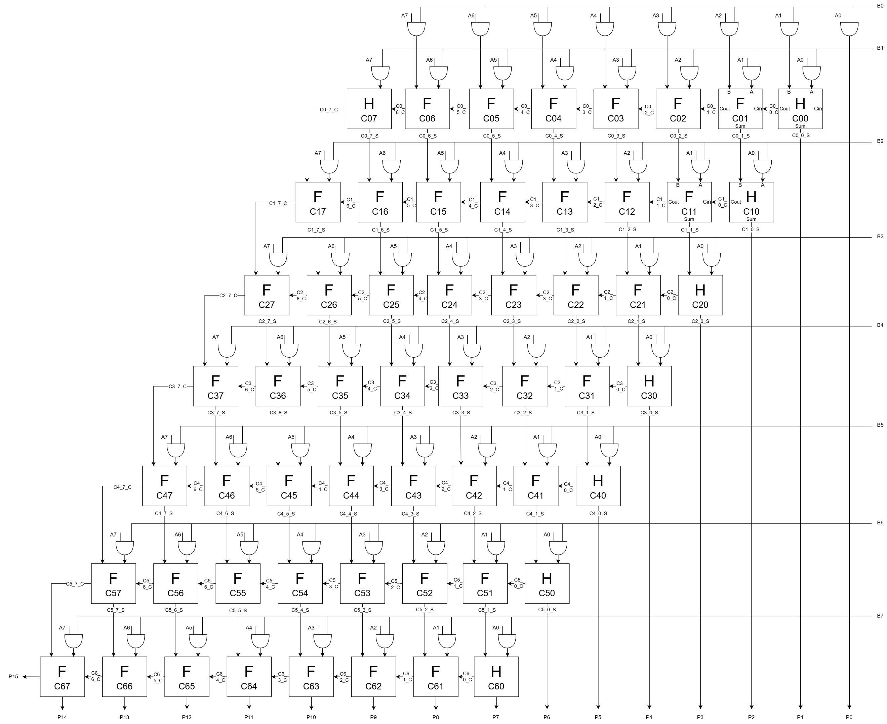
Figure 1: Diagram of the implemented 8 by 8 Braun Multiplier

Wallace Multipliers
The array multiplier can be streamlined by computing all partial products at once and adding them together in stages, which is what the Wallace multiplier does. This is more efficient, since the same result can be achieved with shorter chains of adders.
Use cases for a Wallace Multiplier are similar to that of a Braun Multiplier as both aim to serve the same purpose. However, because the Wallace is more efficient, it is often used in environments where the size of combinational logic is limited, such as in embedded processors.

Diagram
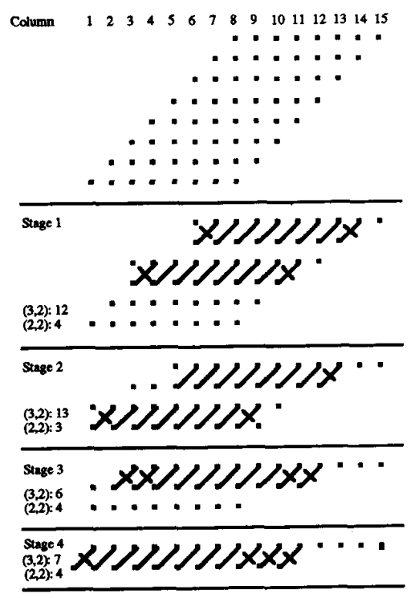
Figure 2: Dot diagram for 8x8 Wallace multiplier [2] (Figure 4b)
Since Wallace multipliers are inherently more complicated than a Braun, it is especially useful to refer to dot diagrams when reasoning about the structure. Dot diagrams represent each bit of partial products with a dot, and lines between dots represent connections to adders. They abstractly represent how the adder should be constructed in hardware, providing a useful guide of connections during implementation. The author used Figure 2 as a guide when drawing the Wallace multiplier logical block diagram, see Figure 3.
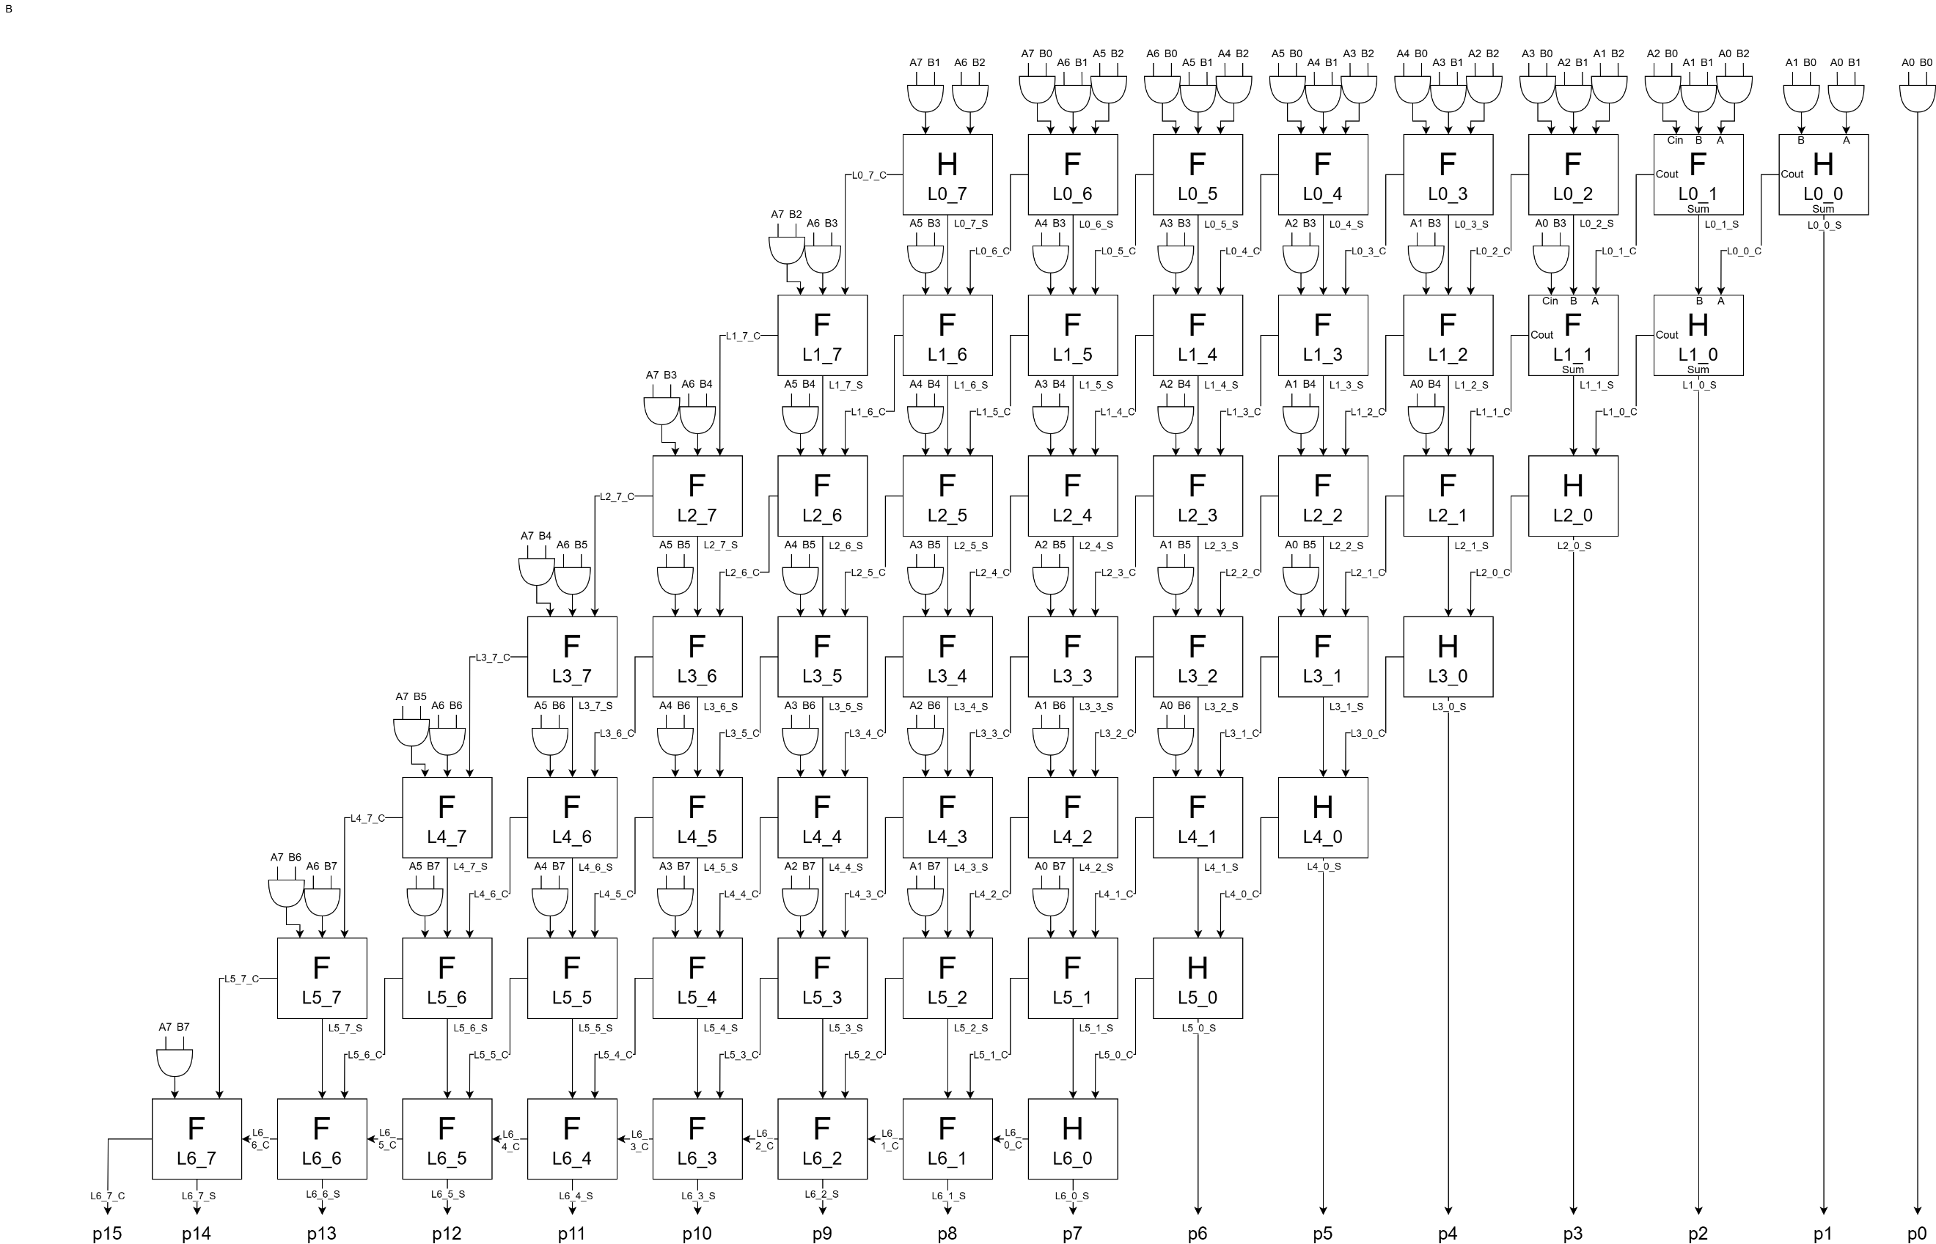
Figure 3: Diagram of the implemented 8 by 8 Wallace multiplier

Implementing the multipliers in VHDL for an FPGA
The multipliers take in two 8 binary digit (bit) numbers, ‘A’ and ‘B’, producing a 16-bit number ‘P’ as an output. P is twice the width of A and B to accommodate the maximum possible result; FFh$×$FFh=FE01h (255×255=65025). The same is true in decimal multiplication; 99 is two digits long, while 99$×$99=9801 is 4 digits long.
See Appendices 3 and 5 for the VHDL implementations of 8-by-8 Braun and Wallace multipliers respectively. This VHDL code conforms to industry-standard practices, such as labelling all components with consistent naming schemes and labelling sections of the code to aid readability. These names match with the diagrams used to create each multiplier (see Figure 1 and Figure 3). Additionally, re-using definitions for Half and Full Adders abstracts their implementation so the code is easier to understand. The low-level adder definitions are provided in Appendices 1 and 2.
Furthermore, to eliminate user error when writing the code, the author wrote two Python scripts capable of producing the VHDL code for any size Braun and Wallace multiplier. There are patterns in the multipliers which the author has translated into Python scripts, allowing flawless reproduction of these patterns, according to any desired input bit length. These scripts are provided in Appendices 4 and 6. This was done because manually typing approximately 450 numbers for each multiplier without making any mistakes, and especially identifying such mistakes, is difficult even when following a diagram.

Simulation results
Once the VHDL code for both multipliers was completed, they were then simulated in Vivado to verify correct functionality before being uploaded onto the FPGA. To achieve this, 4 pairs of two 8-bit numbers were randomly selected as inputs to A and B, then checking if output P contains the correct multiplication result. The correct result is annotated below each figure in hexadecimal and decimal. This was done for both multipliers, yielding 8 tests, all producing correct results (see Figure 4 through Figure 11).
To further verify the multiplier, the author wrote VHDL Test Bench code to control the simulation. This is why each figure shows the value of B changing. The purpose of this is to automatically generate every possible input to A and B while checking output P against its own calculation of A$×$B; when B reaches FFh, it resets to 0 and A is incremented. This approach proves the multipliers work in all scenarios, avoiding the same costly mistake made by Intel in 1995 when manual random tests did not adequately ensure the Floating-Point Division hardware functioned properly inside their Pentium CPU [4].
The aforementioned Test Bench code is provided in Appendix 7. Vivado simulations assume computation happens instantaneously for combinational circuits, so the timestep is measured in picoseconds to maximise simulation performance. Figure 4 through Figure 11 are all taken using these automated simulations, to eliminate the chance of human error by incorrectly entering or reading the values.

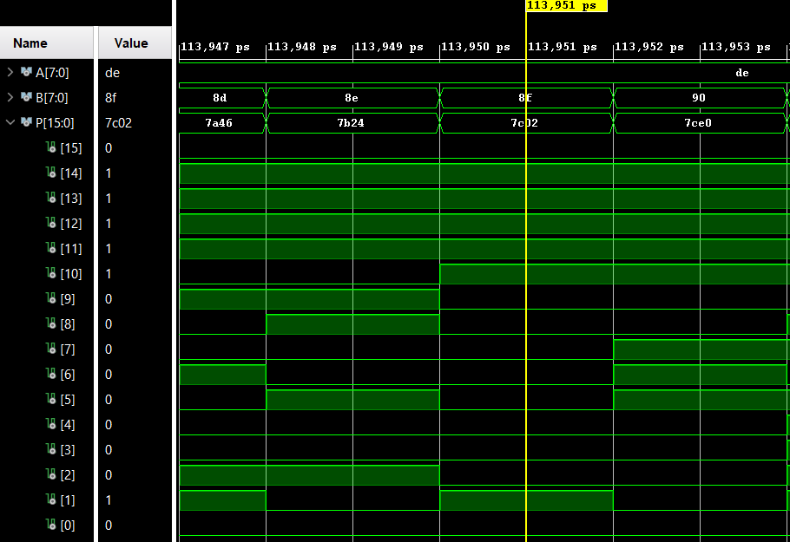
Figure 4: Braun computing DEh$×$8Fh=7C02h (222$×$143=31746)

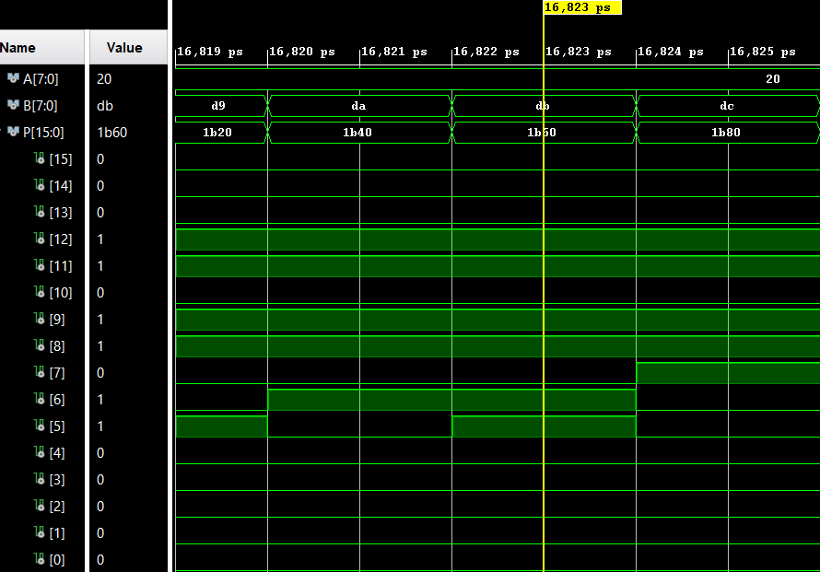
Figure 5: Braun computing 20h$×$DBh=1B60h (32$×$219=7008)
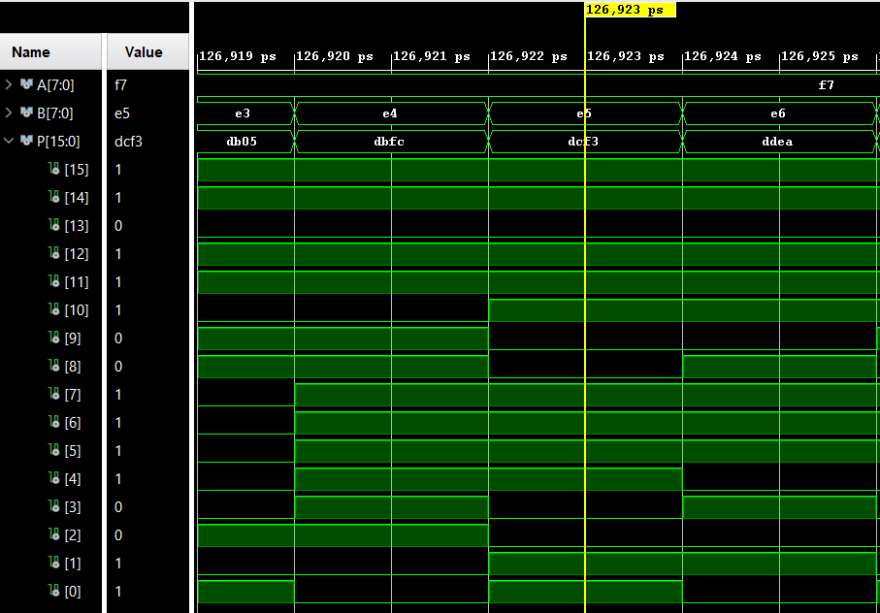
Figure 6: Braun computing F7h$×$E5h=DCF3h (247$×$229=56563)
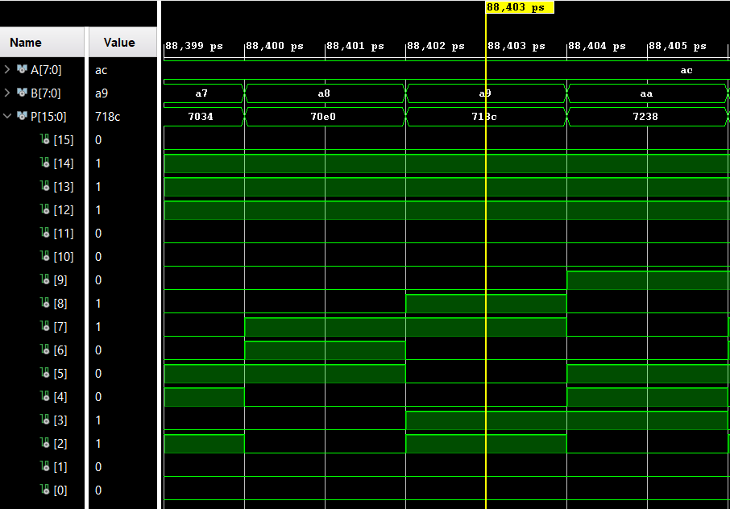
Figure 7: Braun computing ACh$×$A9h=718Ch (172$×$169=29068)

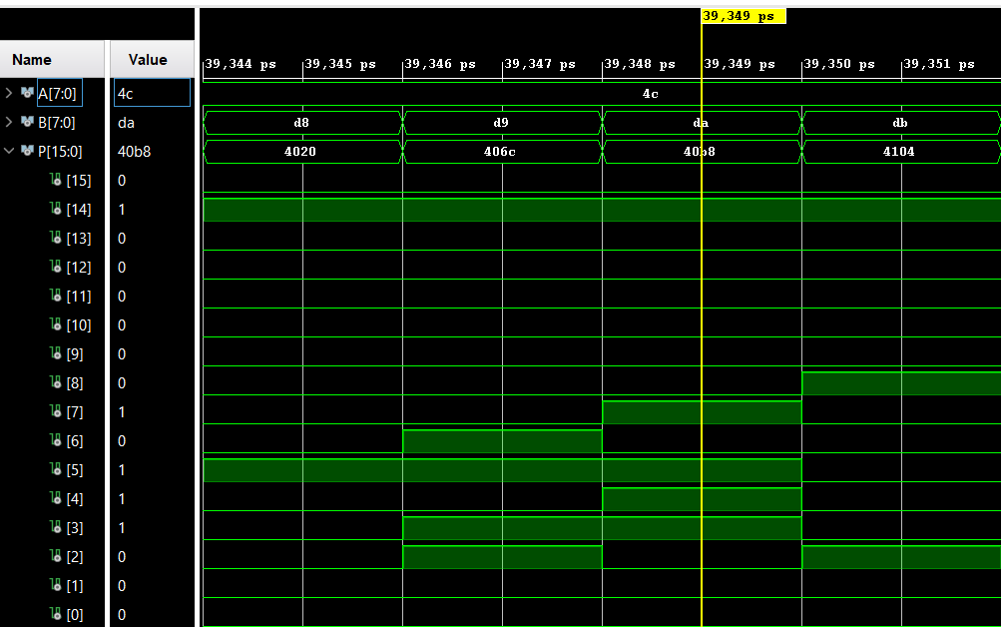
Figure 8: Wallace computing 4Ch$×$DAh=40B8h (76$×$218=16568)
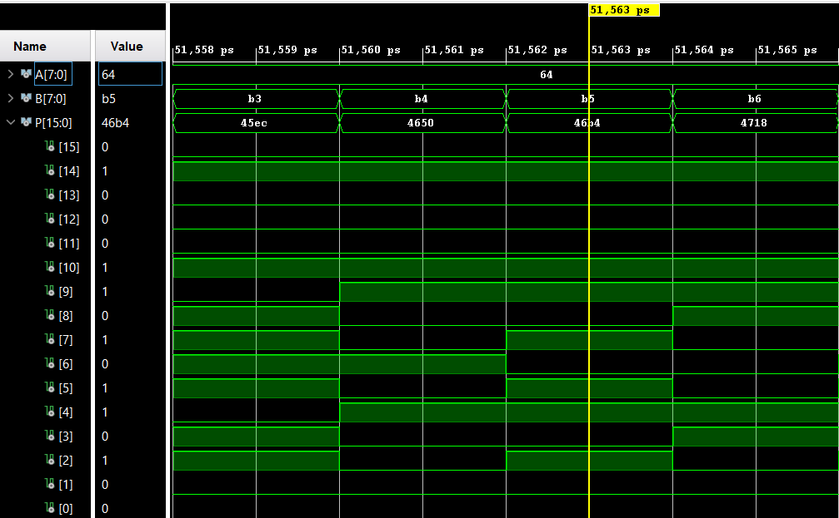
Figure 9: Wallace computing 64h$×$B5h=46B4h (100$×$181=18100)
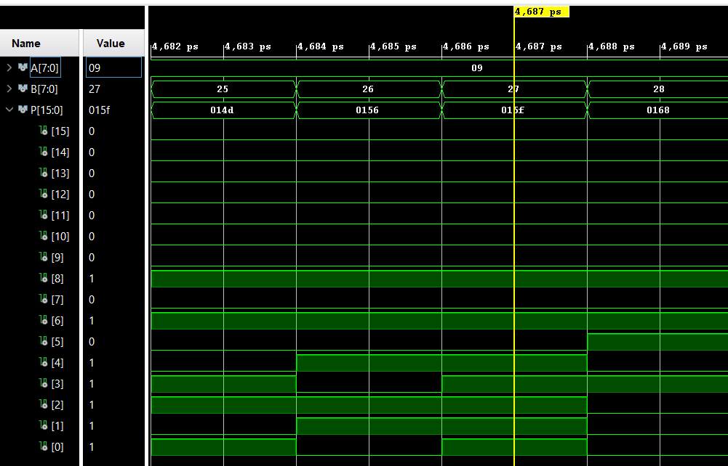
Figure 10: Wallace computing 9h$×$27h=15Fh (9$×$39=351)
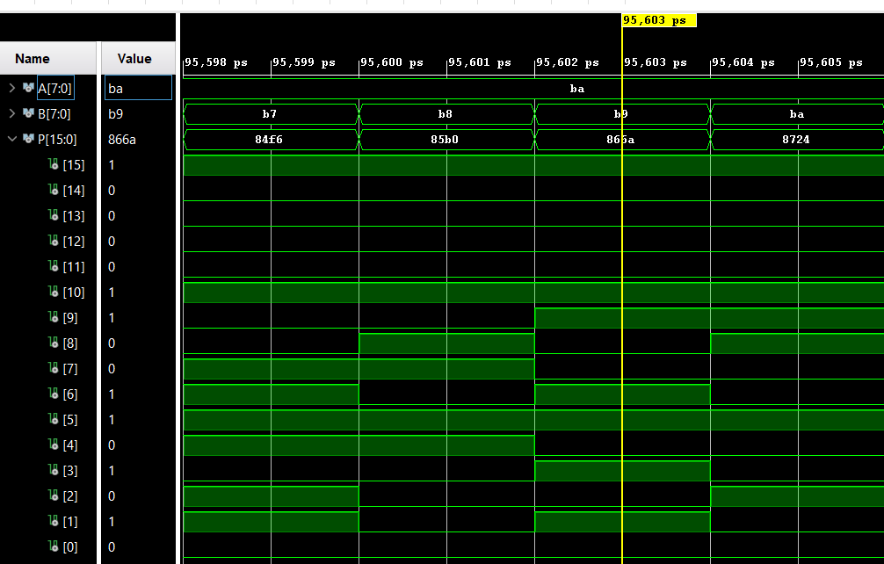
Figure 11: Wallace computing BAh$×$B9h=866Ah (186$×$185=34410)

FPGA Implemented Designs
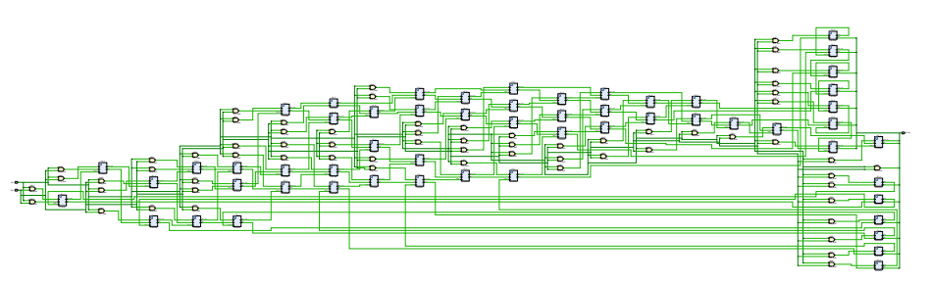
Figure 12: Braun 8x8 RTL Diagram from Vivado
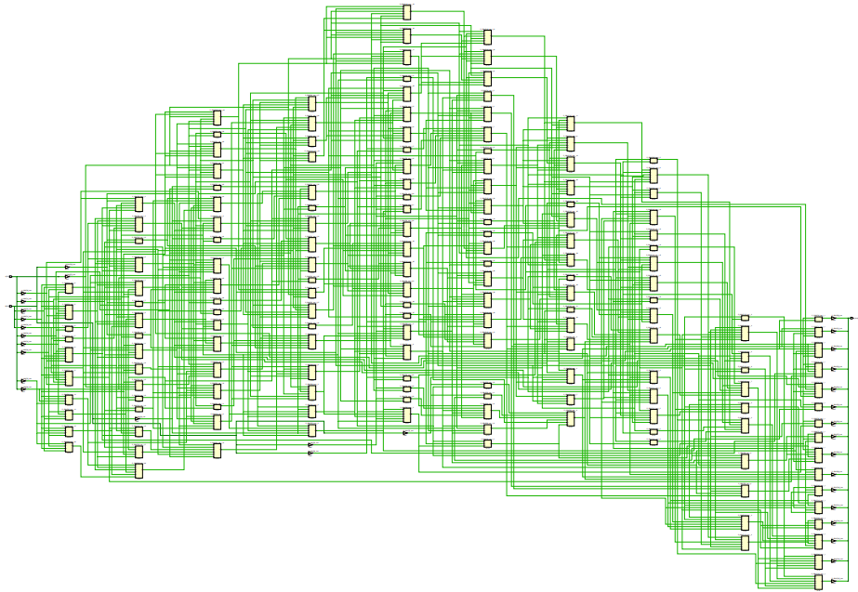
Figure 13: Braun 8x8 Implementation Diagram from Vivado, curiously resembling Australia

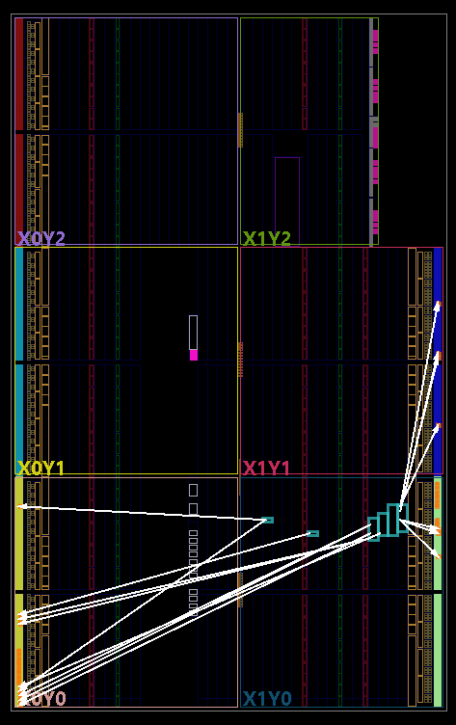
Figure 14: Braun layout on FPGA, with connections to P drawn
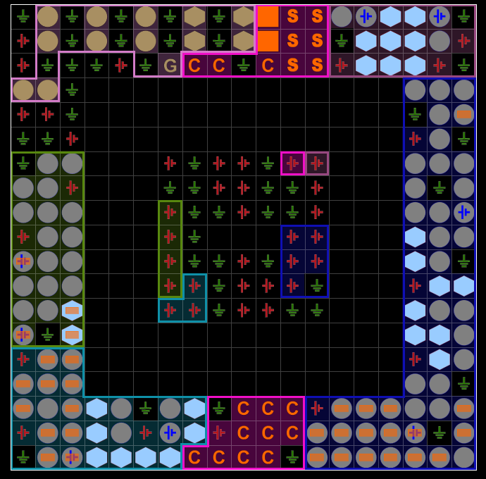
Figure 15: Braun I/O Planning view

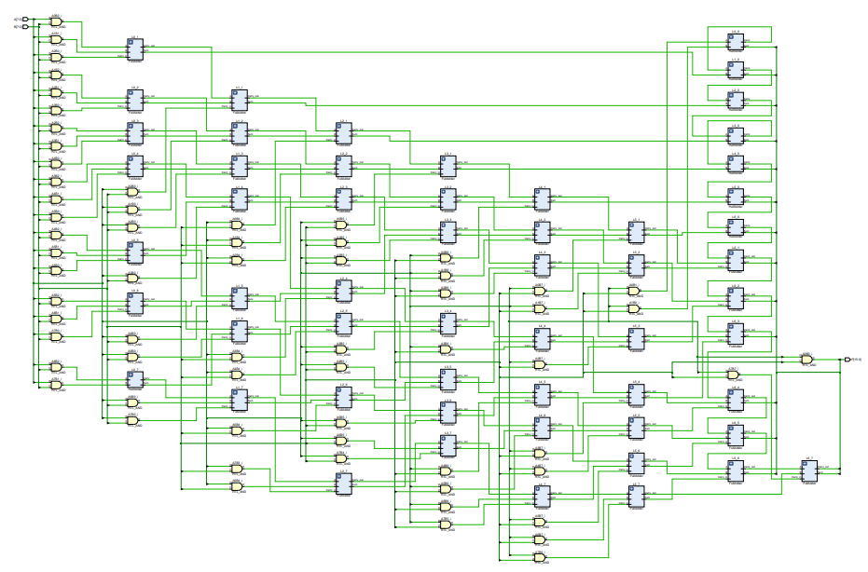
Figure 16: Wallace 8x8 RTL Diagram
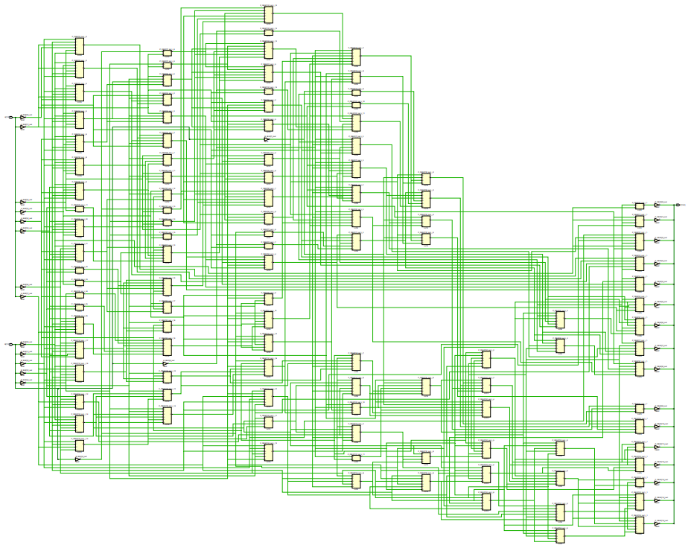
Figure 17: Wallace 8x8 Implementation Diagram
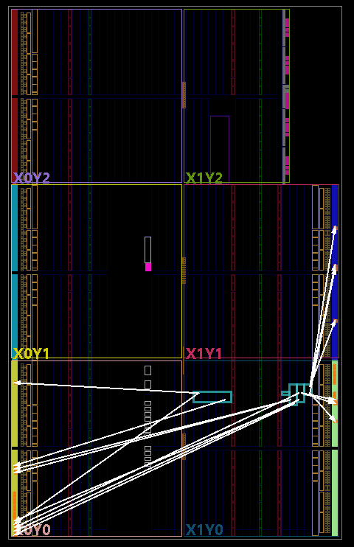
Figure 18: Wallace layout on FPGA, with connections to P drawn
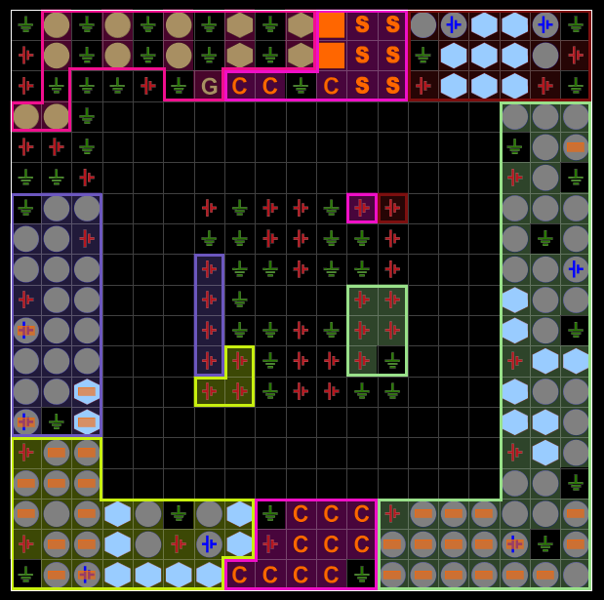
Figure 19: Wallace I/O Planning view
The RTL schematics (Figure 12 and Figure 16) are high-level diagrams of the VHDL code, before the Half and Full adder constructs are reduced to their logic gate implementations. These illustrate how the Braun Multiplier could take longer to get the answer, as it appears much wider than the Wallace Multiplier.

Timing diagrams and schematics of the designs
By analysing the logic diagrams, it is possible to calculate the theoretical time each multiplier will take to perform a calculation, by tracing the longest path of information through the circuit. For a Braun multiplier, the chain looks like Figure 20:
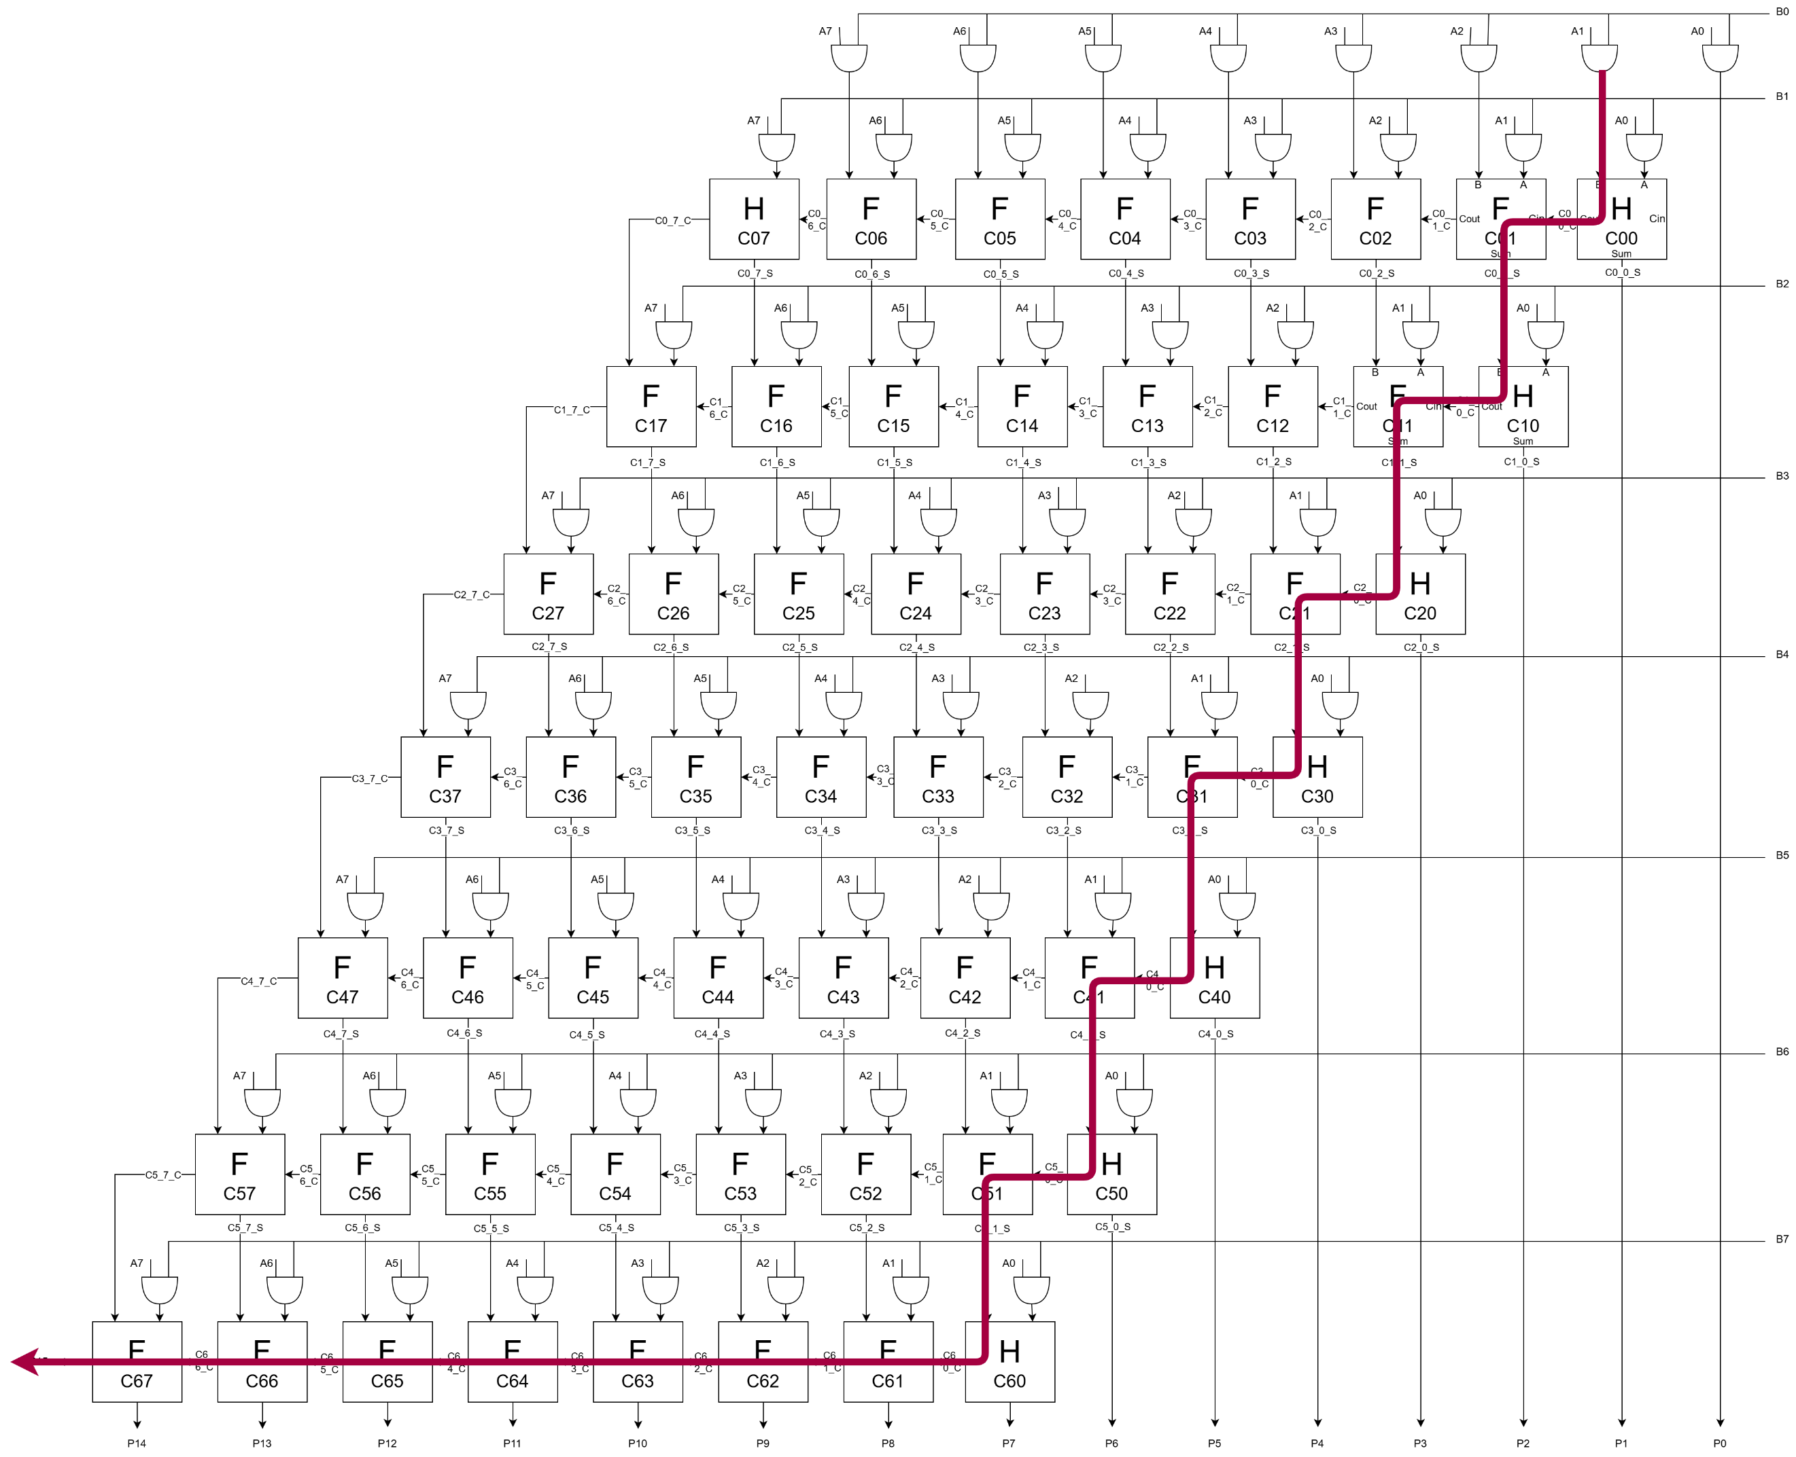
Figure 20: Braun longest chain of computation

Each AND gate will take 1 nanosecond ($t_{g}$) to produce an answer, and each adder takes 2 nanoseconds ($t_{ad}$). Counting the number of AND gates and adders involved in the longest chain, we can predict how long this Braun multiplier will take:
$$1t_{g}+21t_{ad} \\ =1×1+21×2 \\ =1+42 \\ =43ns$$
Equation 1: Braun multiplier time calculation
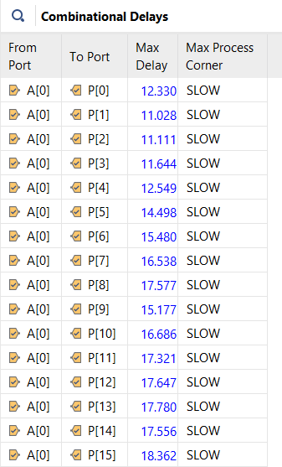
Figure 21: Sample of Braun combinational delays in nanoseconds
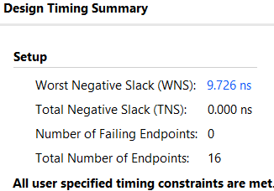
Figure 22: Vivado-generated timing summary for 8x8 Braun
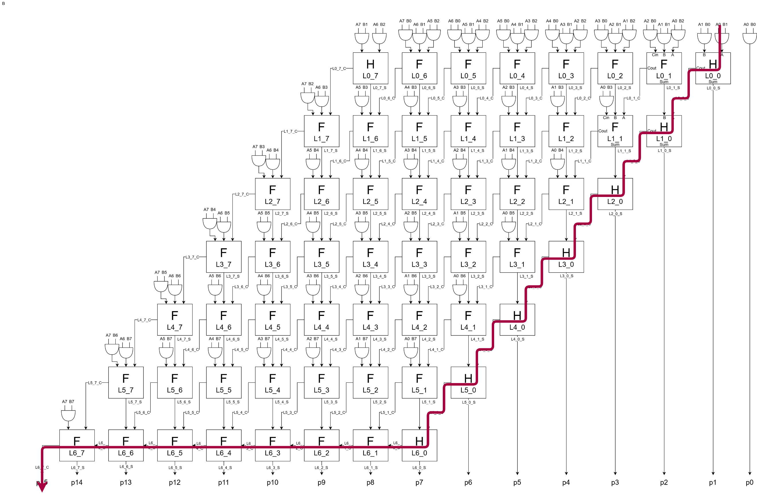
Figure 23: Wallace longest chain of computation
The same principle of calculating the longest chain of computation can be repeated, except the Wallace has fewer adders involved in its chain.
$$1t_{g}+14t_{ad} \\ =1×1+14×2 \\ =1+28 \\ =29ns$$
Equation 2: Wallace multiplier time calculation
Compared to the 43ns value from Equation 1: Braun multiplier time calculation, the Wallace multiplier can be expected to perform around twice as fast than the Braun multiplier.
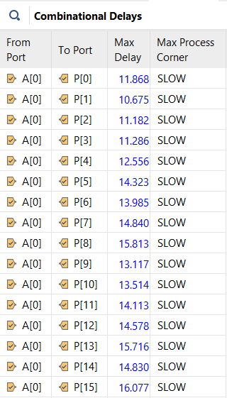
Figure 24: Sample of Wallace combinational delays in nanoseconds
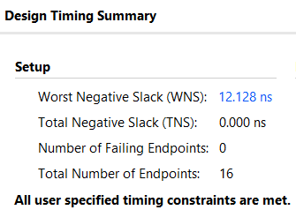
Figure 25: Vivado-generated timing summary for 8x8 Wallace
More Negative Slack is better, as it means the Wallace multiplier finishes the calculation with more time to spare than the Braun multiplier. Indeed, this matches the inferred prediction from the RTL schematics, as Figure 12 is much longer than Figure 16. This higher efficiency would allow the Wallace multiplier to operate at a higher clock speed since it can perform more calculations per second.

Interpretation of Power utilisation and LUTs
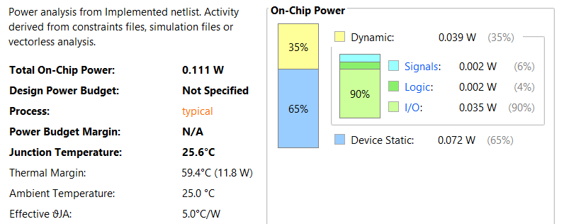
Figure 26: Braun power consumption
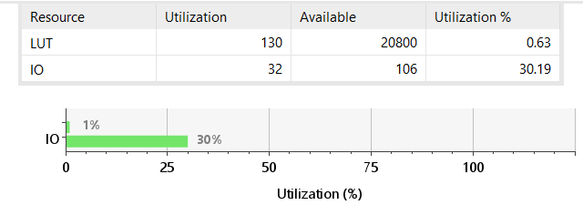
Figure 27: Braun FPGA utilisation summary
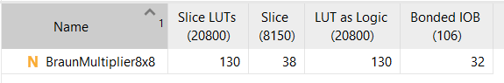
Figure 28: Braun detailed FPGA utilisation information
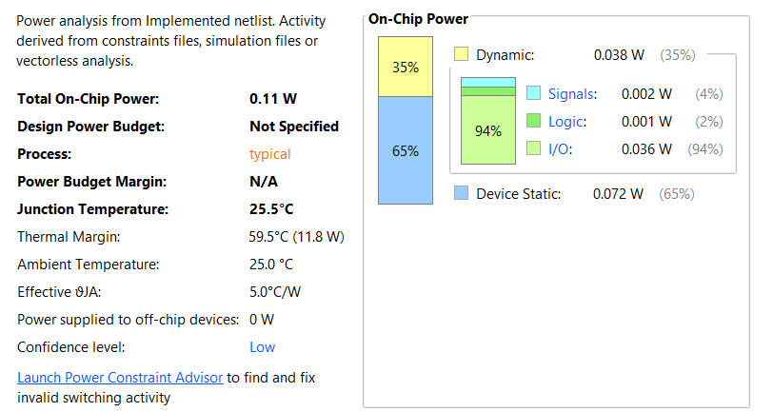
Figure 29: Wallace power consumption
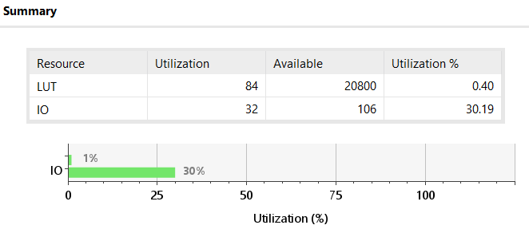
Figure 30: Wallace FPGA utilisation summary
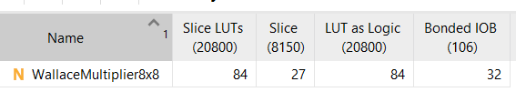
Figure 31: Wallace detailed FPGA utilisation information
From Figures 26 and 29, the Wallace multiplier is shown to have a marginally lower theoretical power consumption. Figures 27-28 and 30-31 show the Wallace multiplier uses less FPGA resources than the Braun, matching the smaller Implementation Diagram as shown in Figure 17, compared to the larger Braun diagram in Figure 13.

Deploying on FPGA
Finally, the multipliers were tested on a real FPGA development board, by uploading the code using Vivado. For testing purposes, inputs A and B are mapped to the 16 input switches, with A occupying the left 8 switches and B occupying the right 8. To display the answer, the 16-bit output P is mapped to the 16 green LEDs above the switches, with most-significant bit on the left. Entering a number using the switches caused the LEDs to display a correct output.
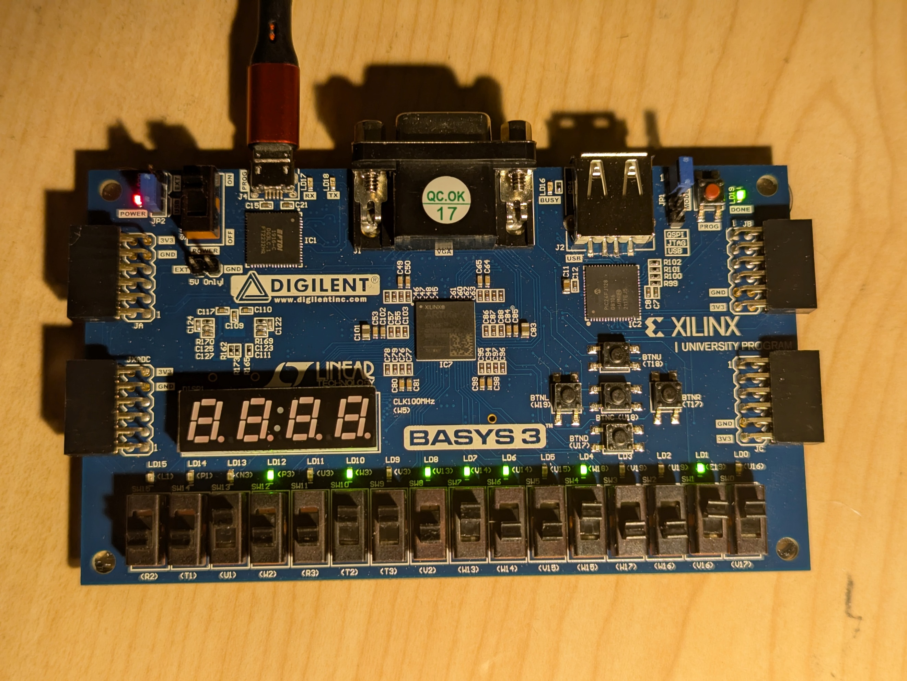
Figure 32: FPGA running Wallace Multiplier, computing 26h$×$93h=15D2Fh (38$×$147=5586)

Conclusion and recommendations
In conclusion, Wallace Multipliers are measurably better in every metric, being more power efficient, faster, and smaller than an equivalent Braun multiplier, but at the cost of being more complex to implement. It is postulated that later research has improved these metrics further, but some of the recent work appears to be proprietary to computer processor manufacturers.
While Equation 1 and Equation 2 do correctly predict the Wallace multiplier is faster than the Braun multiplier, the calculated speed difference is greater than what Vivado reports in Figure 22 and Figure 25. This reveals an incorrect assumption on how long each and gate and adder takes; they must be operating faster than 1 and 2 nanoseconds, respectively. Future work could include directly measuring how long AND gates, half adders, and full adders take to compute a result. This would allow calculations to be more accurate.

References

[1] | S. R. B. Bhargavi Kasturi, “Effective GDI Based Array Multiplier and Braun Multiplier with TSMC 45nm,” IJIRT, vol. 7, no. 5, pp. 46-51, 2020.
[2] | M. S. a. E. E. S. J. K'Andrea C. Bickerstaff, “Reduced Area Multipliers,” International Conference on Application-Specific Array Processors, p. 488, 1993.
[3] | Intel Corporation, “VHDL Definition,” 2017. [Online]. Available: https://www.intel.com/content/www/us/en/programmable/quartushelp/17.0/reference/glossary/def_vhdl.htm. [Accessed 2025 04 2025].
[4] | D. Price, “Pentium FDIV flaw-lessons learned,” IEEE Micro, vol. 15, no. 2, pp. 86-88, 1995.

Appendices

Half Adder VHDL Code

Full Adder VHDL Code

Braun VHDL Code

Braun Generation Python Script

Wallace VHDL Code

Wallace Generation Python Script

Multiplier Testbench VHDL

