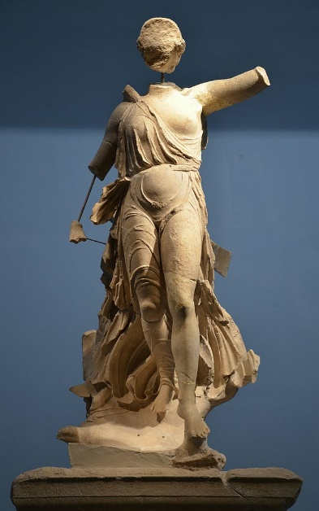
Nike of Paionios

Created by the sculptor Paionios during the 420s, the statue of Nike was dedicated to Zeus, and payed for from the spoils of war. Made from Parian Marble, the sculptor had to be reconstructed from lots of fragments. As such parts of the face, neck, toes, wings drapery and left leg are missing. It shows the Goddess of Victory landing gently upon her left foot, with her dress blowing gently across her body. Nike is presented as descending from flight and is placed upon a pedestal, that makes her far above the viewer. “The Nike with its wings of gilded bronze must have produced an admirable effect” (Perkins, 1880). The statue was painted when first created, and it is believed that Nike’s dress was a tone of red and
Figure 1: Nike of Paionios statue. (Image from https://upload.wikimedia.org/wikipedia/commons/thumb/6/61/Nike_of_Paionios%2C_Olympia_Archaeological_Museum_%2816309967616%29.jpg/1200px-Nike_of_Paionios%2C_Olympia_Archaeological_Museum_%2816309967616%29.jpg)
Excavated at Olympia in 1875, the statue was placed on a triangular six metres high pillar. As such, including the pillar, it stood at twelve metres. It was dedicated to the gods to honour and celebrate the recapture of Sphacteria from the Spartans in 425 BC. The base of the sculpture shows this, since it states that “The Messenians and the Naupaktians dedicated this statue to Zeus Olympios from the spoils of war” (Museum of Classical Archaeology). Built at Olympia, previously Spartan ground, the statue is clearly a symbol of political propaganda. About a century earlier, the Spartans had erected a statue of Zeus to commemorate their victory over the Messenians, and the Greeks clearly did it in retaliation.
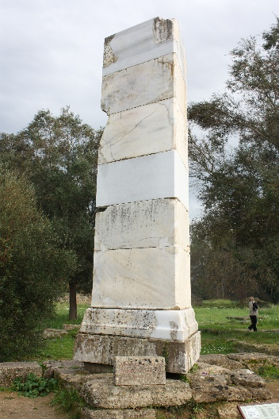
Figure 2 : Base of the statue, engraved with the dedication. (Image from: https://upload.wikimedia.org/wikipedia/commons/thumb/b/bc/Base_of_Nike_of_Paionios_in_Olympia.jpg/600px-Base_of_Nike_of_Paionios_in_Olympia.jpg)

