Problem Solving and Decision Making
Student’s Name: Caruntu Raluca Elena
Student’s ID: 2010421

Contents
Introduction 3
Task 1-Role play on MS team 4
Task 2- Individual report 9
Conclusion 14
References 15

Introduction
Problem solving is the process of identifying the problem and provides the best alternatives for problem (Fischer, Greiff and Funke, 2012). An organisation should define the problem specifically. They can solve the problem by taking appropriate business strategy. One can solve the complex problem by taking the appropriate time and resources. The long term problem is solved by arranging meeting among the top managements. Problem solving and decision making process should be benefitted for all stakeholders.

Task 1-Role play on MS team
Slide No 1
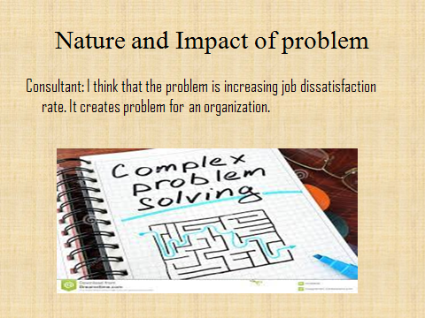

The case study is found that 35% job satisfaction is decreased last year during pandemic. Among 2000 employees, 32% employees don’t feel motivation for work. Another 18% employee dissatisfies about the quality of work in life (Bateman, 2014). Employees also worried about their job safety and 27% employee is not happy about work life balance. For pandemic, employees are facing challenges in working place for balancing the working hours. Few of them are also worried about their wages. They can’t get proper wages during pandemic. In addition to, Seenan said that metal well-being is also required for employee. Employee has lost their mental well-being during pandemic.

Slide No 2
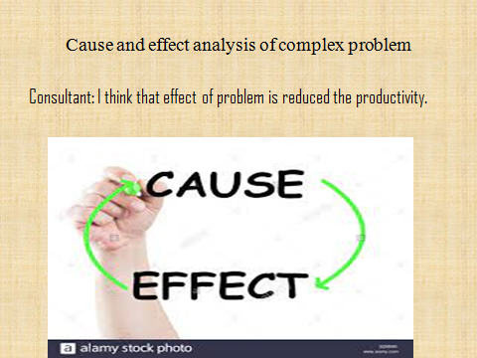

In the above case analysis, it is found that employees have faced challenges. Dissatisfaction rate is increased among employees in UK (Alam and Hasan, 2015). The reason of dissatisfaction in job is increasing for pandemic because employees are worried about job safety. Moreover, they don’t get the appropriate wage for job. They are working unpaid and less wage during pandemic. They can’t balance between job and personal life. The effect of job dissatisfaction is reduced the productivity. Employees can’t work effectively and efficiently when they are worried about job safety. They are producing defect product when they can’t balance between personal and job life.

Slide No 3
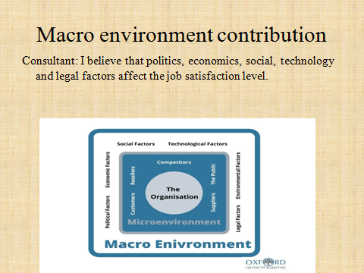

PESTLE refers to the politics, economics, social, technology, legal and environment (Kolios and Read, 2013). Politics of UK is also increased the dissatisfaction rate in job. UK government extends the lockdown period which is increased the problem. Economics of UK is negatively affected for pandemic. It reduces the people income and purchasing power. People can’t communicate one to another for pandemic. It is destroyed the mental health of the employee. Technology is also affected the employee dissatisfaction level because less technology known person is not worked from home. Legal policy is taken by UK government which is not supported for employee. Working place environment is also enhanced the dissatisfaction of employee.

Slide No 4


MS team should find the solutions from alternatives. They should analyse each alternative with pros and cons. They should choose appropriate solution for enhancing the productivity. MS team should improve the mental well-being of the employee because employee has lost their mental support during pandemic. MS team should talk with employees and ensure to develop the mental health. They can also behave friendly with employees. MS team should try to solve the personal problem of employee. They can offer the flexible working schedule for employee. They can provide assurance of job.

Slide No 5
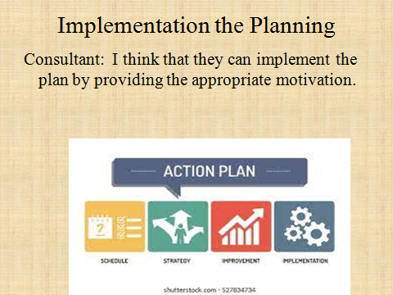

An organisation can implement the chosen solution by taking appropriate strategy (Azizi, 2014). They can improve the mental well-being of employee by providing appropriate motivation. MS team should talk with individual employee because different employees need different motivations. MS team should try to understand the problem of employee. They can also talk about personal problem and working schedule. They should provide compensation and motivation according to the employee needs. They can provide the adequate incentives which improve the mental well-being of the employee. Overall, MS team may enhance the productivity and efficiency by implementing the solution in organisation.

Task 2- Individual report
Working in organisation, HR manager faces different challenges and problem. They should recognize the complex problem and solve the problem (Lahey and Charest, 2019). There are different types of problem coming from business. Some of the problems are simple and daily operation related. In contrast, few problems are critical and take more time for solution. Management should plan for solving the critical and complex problem. They should follow the problem solving steps for making decision. For example, in working place job dissatisfaction is most popular complex problem. The employee job dissatisfaction rate is increasing day by day. Job dissatisfaction arises from miscommunication between employee and employer. When employee can’t participate in decision making process, it enhances the job dissatisfaction because they are performing the job. If they can’t understand the objectives of the job, it is not possible to achieve the organisation goal. Employee should understand their roles and duties. When they fail to understand the job duties and roles, they may not achieve the individual goal. Management should understand the problem in job sector. The job dissatisfaction reduces the productivity and efficiency of the organisation. It reduces the employee skill and efficiency. Job dissatisfaction rate is increasing in United Kingdom. Job dissatisfaction comes from employee compensation package and incentives. Sometimes employees don’t get appropriate salary according to the expectation. One the other hand, management can solve the job dissatisfaction by taking appropriate strategy. When management can solve the job dissatisfaction in working place, it enhances the productivity and efficiency of employee. Higher job dissatisfaction is creating problem in organisation. When job dissatisfaction is existing in organisation for long term, it creates more problems. Management should try to solve the job dissatisfaction as soon as possible. If management can solve the job dissatisfaction properly, it is a good for organisation.
Management should follow sequential steps for solving the problems. A manager should identify the problem initially then they can solve it.
Define the problem: Management should identify the accurate problem of the organisation. They should define the problem based on magnitude. Few problems are minor but some problems are major (Sidorenko, 2019). For example, the dissatisfaction of job is major and complex problem. Management should emphasize on the major problem rather than minor problem. They should find out the major problem based on the magnitude of the problem. They can identify the problem and understand the problem. The manager should understand the complex problem. They need to analyse the problem. They should verify the problem based on the previous experience. After understanding the complex problem, a manager should give priority on the problem. They should distinguish the problem based on the criteria. Management should collect information from employee. A secret group of people observes the activity of employee. HR manager should talk with employee to understand the problem. A good communication can minimize the problem between management and employee. The manager should define the problem based on information and analyse the data for further process.
Potential causes of problem: The manager should evaluate the potential causes of the problem. If the causes are occurring high loss for organisation, a manager should take the problem seriously. The manager should write the potential causes for problem. For example, dissatisfaction pursues the potential cause’sreduction the productivity and efficiency of loss. The magnitude of loss is high for organisation. An organisation should measure the cost of dissatisfaction. They should evaluate the expenses of problem. Experts said that employee dissatisfaction occurs huge loss for organisation. The top management of business organisation should measure in terms of number for better understanding.
Alternatives solution for problem: An organisation can solve the problem in different ways. They can solve the problem in brain storming process (Singh, 2015). Brain storming is a process when many experts give several ideas for solving the particular issues. For example, employee dissatisfaction is a complex problem when top management arranges a brainstorming meeting. Experts provide alternative solutions such compensation and incentives etc. One may give idea for balancing between working hours and personal life. Someone believes that high compensation may reduce the employee dissatisfaction. After seeing the alternative solutions, chief executive officer and director of the organisation are screening the alternatives. After analysis the alternatives with pros and cons, they choose the best alternative which is beneficial both for organisation and staff.
Choose approach for resolving the problem:After selecting the best alternative, a manager should choose the best alternative for long term. They should check the resources available. Management should evaluate the best alternative. They should have available resources for implementing the project. They have enough time to implement the best alternative. They also evaluate the risk associated with the best alternative. They can also evaluate the potential long term benefit from best alternative.
Plan for implementation the best alternative:the top management of organisation should plan for implementing the best alternative (Singh, 2015). They should consider the side effect from best alternative. They should hire adequate people and staff for implementing the plan. For example, the director should plan the time for solving the employee dissatisfaction. They also arrange the required resources and equipment for implementing the best alternatives. The director also identifies the roles for implementing the best alternative. The responsible people are identified by top management. Overall, the top management should make appropriate planning for implementation the problem. They can also arrange a new meeting for making successful the project.
Monitor the implementation plan:The management should monitor the activities of the plan. They should evaluate the plan based on the expectation. They should check that pan is realistic or not. If the activity is going according to the expectation, the management should not do anything. The management should take decision in this stage when they monitor the activity of best alternative. They should check the available resources for the problem. For example, the top management of organisation should measure the dissatisfaction of employee problem. The best solution is balancing of working hours. They should monitor the improvement of employee satisfaction.
Verify the problem is solved or not: In the final stage, the top management should verify the problem with solution. They should check the problem solved or not. The management group should verify the problem with solution. For example, the top management should verify the employee dissatisfaction problem according to the feedback. After balancing the working hours, the employee dissatisfaction is reduced or not. If the employee dissatisfaction is reduced, the management should not need to take any action. When employee satisfaction is not increased, the top management should find the reason of it. They can change the existing plan for implementation the problem.
There are different types of decision making techniques such as brainstorming, complex decision, market research, cost- benefit analysis, decision making tress, game theory, linear programming, paired comparison analysis and trial error method etc.
Mind mapping: In this method, the management generates different ideas and is screening the ideas based on the information (TOFAN, 2014). Finally, they chose the best alternative methods. It is simple and less costly method.
Complex decision: the top management takes the decision based on mathematical analysis. They can’t take the decision randomly. They also analyse each of the decision. They can implement the decision when it gives more benefit.
Market research: This research approach is high benefitted when an organisation wants to launch new product in market. They can collect information from potential consumer and takes the decision based on the data.
Cost benefit analysis: It is the most useful decision making technique. The management always concerns about benefit of the organisation (Rouwendal, 2012). When benefit is higher than cost, an organisation should implement the decision. If cost is higher than benefit, the manager should not implement the decision.
Decision making tree: It is a visual decision making phases. A business may require limited resources for implementing the plan. They can understand the impact of decision visually. When it gives positive review, they should implement the plan practically.
Game theory:The top management should negotiate with third party for solving the problem. Many organisations currently solve the problem from third party service. The top management should pay for it.
Paired comparison analysis:many organisations follow the peer company policy. When the problem is same, the top management may use the same techniques of paired company. If the problem is not identical, it may create negative outcomes for organisation. The management should aware about it.
Management should develop the plan according to the solution. They should follow the seven steps for solving the problem. Previously, it is described in details. The top management should create a time table and chart for solving the problem. A SMART objective can be set up. The plan should be specific, measurable, attainable, relevant and timely. Plan may be challenging but attainable is encouraged the people.
A good plan is always communicated with all stakeholders. The relevant stakeholders of organisation are customer, employee, government, supplier and community. An organisation should inform all stakeholders about plan before implements the plan.
Customer:The customer is the key people of any organisation. An organisation should inform the potential customers about the planning (Rouwendal, 2012). If customer supports the planning, the top management should implement the plan.
Shareholder: Shareholder is the real owner of any organisation. When a management takes any plan, they should give emphasis on shareholder interest. The plan should be executed only when it maximizes the shareholder wealth.
Employee:Employee is performing the planning in action. They are finally performed the task in real action. The management should talk with employee before takes any plan.
Supplier: Suppliers are also an important part of any organisation. They should consider the interest of supplier at the time of taking plan.

There are different types of monitoring and evaluating techniques are used for implementation the solution such as benchmark, observation, surveys and work performance.
Benchmark: The top management can set the benchmark of employee productivity. If benchmark is achieved, it is believed that employee satisfaction is increased and efficiency is also increased.
Observation: The manager can observe the activity of the employee. They can observe the attitude and behaviour of employee (Ruchała and Szczepanek-Parulska, 2013). The positive attitude means that employee satisfaction is increased.
Surveys: the management can also prepare the questionnaire for employee survey. When employee gives positive review about organisation, it means that employee satisfaction rate is increased.
Work performance: The management can measure the work performance for evaluating the performance of employee satisfaction rate.

Conclusion
In business organisation, there are different problems arising. The manager should identify the complex problem and chooses the best alternative solutions for organisation. They should prepare the planning for solving the problem (Ruchała and Szczepanek-Parulska, 2013). They can also follow the decision making techniques like cost benefit analysis. The management should monitor the activity based benchmark which is the most useful method.

References
Alam, J. and Hasan, M. (2015). An Empirical Study about Why Dissatisfaction Arises among the Employees and What It Consequences: Bangladesh Perspective. Management Studies and Economic Systems, 1(3), pp.171–180.
Azizi, M. (2014). Perspective Challenge to Implement an Adaptive Port Planning (APP): Taking Casablanca Port as an Example. Business Management and Strategy, 5(2), p.1.
Bateman, C. (2014). What are we playing with? Role-taking, role-play, and story-play with Tolkien’s legendarium. International Journal of Play, 3(2), pp.107–118.
Fischer, A., Greiff, S. and Funke, J. (2012). The Process of Solving Complex Problems. The Journal of Problem Solving, 4(1).
Kolios, A. and Read, G. (2013). A Political, Economic, Social, Technology, Legal and Environmental (PESTLE) Approach for Risk Identification of the Tidal Industry in the United Kingdom. Energies, 6(10), pp.5023–5045.
Lahey, R. and Charest, T. (2019). 5 Common HR Challenges Every Optometry Practice Faces. Canadian Journal of Optometry, 81(3), pp.64–65.
Rouwendal, J. (2012). Indirect Effects in Cost-Benefit Analysis. Journal of Benefit-Cost Analysis, 3(01), pp.1–27.
Ruchała, M. and Szczepanek-Parulska, E. (2013). Imaging techniques in diagnostics, differentiation and monitoring of different types of thyroiditis. Thyroid Research, 6(S2).
Sidorenko, A. (2019). 30 PRACTICAL STEPS TO IMPLEMENT RISK MANAGEMENT 2. FOLLOW THESE STEPS TO INTEGRATE RISK MANAGEMENT INTO DECISION-MAKING, PROCESSES AND CULTURE. EDPACS, 60(1), pp.11–18.
Singh, R. (2015). Formal Alternatives as a Solution to the Proviso Problem. Semantics and Linguistic Theory, p.264.
TOFAN, C.A. (2014). Optimization Techniques of Decision Making - Decision Tree. Advances in Social Sciences Research Journal, 1(5), pp.142–148.

