

Student name: Sultana Rumi
Student ID: [2434775]
Programme: BSc Health and Social Care
Module name: Introduction to Physiology
Module code: BMHP5023
Lecturer name: [Shaila Hussain]
Assignment title: Component 1: Written Assignment (Case Study Report) – Case Study 1: Diabetes

Introduction

Type 2 diabetes develops when the body can no longer keep blood glucose within a healthy range. Insulin is still being produced, especially in the early stages, but the body does not respond to it properly. This is called insulin resistance. As the condition progresses, the pancreas may also struggle to produce enough insulin to meet the body's needs. Glucose then remains in the bloodstream instead of moving into cells efficiently, where it would normally be used as a source of energy.
This is different from Type 1 diabetes. In Type 1, the immune system mistakenly destroys the beta cells in the pancreas that produce insulin, so the body makes little or no insulin of its own (NHS, 2025). Type 2 diabetes is much more common and has become a major health problem in the UK. Diabetes UK (2025) reports that most people diagnosed with diabetes have Type 2.
Several factors increase the chance of developing the condition. Excess body weight is one of the best-known risks, particularly when fat is stored around the abdomen. Physical inactivity can add to this because muscles use less glucose when they are not active. However, lifestyle is not the whole explanation. Family history can also increase a person's risk.
Ethnicity should also be considered. People from South Asian backgrounds may develop Type 2 diabetes at a younger age and at a lower body weight than people from some other ethnic groups (Diabetes UK, no dates). This matters because someone may not believe they are at risk simply because they are not visibly overweight. Health advice should therefore explain the person's individual risks rather than assuming that the same message will be suitable for everyone.

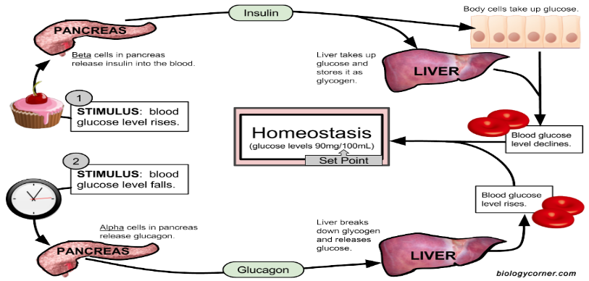
How Blood Glucose Is Maintained(Adapted from online picture) Blood glucose cannot be allowed to rise and fall without control. The brain depends heavily on glucose, while very high levels can gradually damage blood vessels and tissues. The body manages this through homeostasis. In simple terms, it notices when its internal conditions change and produces a response that moves them back towards normal.
This Photo by Unknown Author is licensed under CC BY-SA-NC
After a meal containing carbohydrates, digestion breaks the food down into smaller sugars. Much of this becomes glucose, which is absorbed through the small intestine and enters the blood. The rise in blood glucose is detected by beta cells in the pancreas, causing them to release insulin.
Insulin changes what happens in several tissues. Muscle and fat cells take in more glucose, while the liver stores some of it as glycogen. Glycogen acts as a reserve that can be used later. The liver also reduces the amount of new glucose it releases because glucose is already entering the bloodstream from the meal.
A different response is needed several hours later. When blood glucose falls, alpha cells in the pancreas release glucagon. Glucagon acts mainly on the liver, where glycogen is broken down and glucose is released back into the bloodstream. If these stores become low, the liver can make new glucose from other substances. Insulin and glucagon therefore work against each other, but both help keep enough glucose available without allowing its level to become too high (Tortora and Derrickson, 2020).
In Type 2 diabetes, this balance starts to fail. Muscle cells do not respond to insulin as well as they should, so less glucose is removed from the blood. The liver may also continue producing glucose even when the level is already raised. At first, the pancreas often tries to compensate by releasing more insulin. This may work for some time, which helps explain why Type 2 diabetes can develop gradually and remain unnoticed.
Eventually, the beta cells may not be able to keep up with the extra demand. Blood glucose then remains high for longer after meals and may also be raised when the person has not eaten.
Once the kidneys are filtering large amounts of glucose, they cannot reabsorb all of it. Some glucose passes into the urine and draws water with it. This leads to frequent urination and increased thirst. Tiredness may follow, partly because the person becomes dehydrated and partly because the body is not handling glucose normally.

How Glucose and Oxygen Are Used to Produce Energy

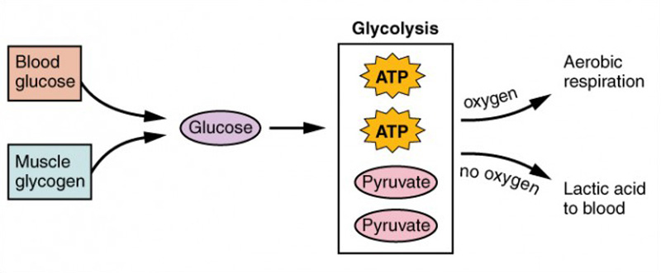
Having glucose in the blood is not the same as having usable energy inside a cell. Before cells can make use of glucose, it must be broken down and the energy released from it must be transferred into adenosine triphosphate, usually called ATP. ATP is the form of energy used for processes such as muscle contraction and moving substances across cell membranes.
(Adapted from online pictures)
The first stage is glycolysis. It takes place in the cytoplasm and splits one glucose molecule into smaller molecules. Only a small amount of ATP is made at this point. Glycolysis does not directly require oxygen, which means that it can still happen when the oxygen supply is limited. Most of the energy is released later, in the mitochondria. Pyruvate enters the mitochondria and is prepared for the Krebs cycle. Carbon dioxide is produced during these reactions and is eventually removed from the body through breathing. Energy carriers are also formed. Their role is to carry high-energy electrons to the final stage of respiration.

The electron transport chain is where most ATP is produced. Energy from the electrons is used to move hydrogen ions across the inner mitochondrial membrane. The ions then pass back through an enzyme called ATP synthase, which helps form ATP.
Oxygen is needed at the end of the chain. It accepts the electrons and combines with hydrogen to form water. Without oxygen, the chain cannot continue and the cell is left with only the much smaller amount of ATP produced during glycolysis (Tortora and Derrickson, 2020).
The overall process can be written as:
Glucose + oxygen → carbon dioxide + water + energy in the form of ATP
During intense exercise, the supply of oxygen may not fully meet the muscles' demand. Glycolysis can continue for a short period, but pyruvate is converted into lactate and much less ATP is produced. This provides enough energy to support brief activity, but it is not an efficient way of meeting the body's long-term energy needs.
The connection with Type 2 diabetes is not that cells receive no glucose at all. The problem is that insulin-sensitive tissues, particularly skeletal muscle, do not take it up as effectively. A person can therefore have a high level of glucose in their blood while their body is still handling that fuel poorly.
This may contribute to tiredness, although it would be too simple to blame the symptom on one process. Dehydration and disturbed sleep caused by frequent urination can also leave someone feeling exhausted.

Recording and Tracking Blood Glucose

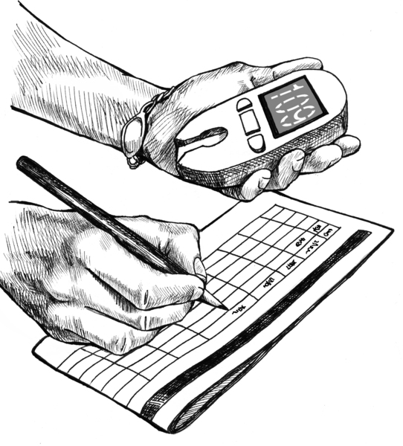
(Adapted from google website)
One blood glucose result is only a snapshot. It becomes more useful when compared with previous readings and with what the person was doing at the time. A high reading after a large meal, for example, does not mean the same as a high reading first thing in the morning. Finger-prick testing gives an immediate reading. A small blood sample is placed on a strip and measured by a glucose meter. It can show whether glucose has fallen too low after medication or risen following food.
NICE (2026) does not recommend routine finger-prick testing for every person with Type 2 diabetes. It is more relevant for people using insulin, those who have had hypoglycaemia, or people on medicines that can cause it, and it may help during illness or when treatment changes. Testing without a clear reason can produce numbers without helping the patient know what to do next.
Continuous and flash glucose monitors give a different kind of information. A sensor worn on the arm measures glucose beneath the skin throughout the day and night, showing whether glucose is rising, falling or steady, and picking up overnight changes that occasional testing would miss. These devices are not offered to everyone with Type 2 diabetes, since their usefulness depends on the treatment used and the patient's individual needs (NICE, 2026).
HbA1c looks at the longer-term picture. Glucose attaches to haemoglobin inside red blood cells. As these cells remain in circulation for around two to three months, the test gives an estimate of average blood glucose over that period (Diabetes UK, no datec).
It cannot show daily highs and lows, and two people could have the same HbA1c result while experiencing quite different patterns during the day.
For many adults, NICE recommends a target of 48 mmol/mol (6.5%) when treatment does not usually cause hypoglycaemia, or 53 mmol/mol (7.0%) where treatment carries a greater risk of low blood glucose (NICE, 2026). This can still be adjusted: an older patient with several health conditions may not be managed the same way as a younger adult who was recently diagnosed.
Keeping records gives both the patient and the practice nurse something concrete to discuss. Repeated high readings after breakfast might prompt a look at meal size or the type of carbohydrate eaten. The aim is not to react to every unusual result, but to notice a repeated pattern and decide whether the care plan needs to change.

Evidence-Based Lifestyle Recommendations
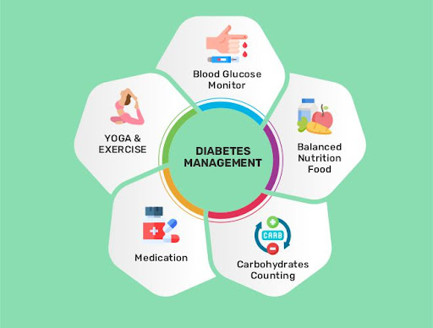

(Adapted from google website)
Lifestyle advice is sometimes presented as though changing habits is easy, but in reality, patients may be trying to change routines they have followed for many years. Lifestyle changes also do not remove the need for medication in every case. Recommendations have to be realistic enough for the person to maintain them.
Weight loss can improve insulin sensitivity when excess fat is stored around the liver and pancreas. The DIRECT trial is especially relevant, since it took place in UK primary care with people diagnosed relatively recently, giving a practical example of how such a programme could work outside a hospital setting.
After 12 months, 46% of participants following the weight-management programme achieved remission, compared with 4% receiving usual care (Lean et al., 2018). This result shows that substantial weight loss can make a major difference for some people.

It does not mean remission is certain: more than half of the intervention group did not reach it, and the programme involved a closely supervised low-calorie diet. Later findings showed that staying in remission was closely linked to keeping the weight off (Lean et al., 2019), so maintaining the change matters as much as losing the weight in the first place.
Dietary advice should focus on changes that can fit into everyday life. Cutting back on sugary drinks or very large portions of refined carbohydrates can help prevent sharp rises in blood glucose, while higher-fibre foods such as wholegrains digest more slowly and can help with appetite. No single food determines whether someone's diabetes is well controlled; the overall pattern of eating matters more.
Culture is part of this discussion too. Rice or chapati may be eaten regularly in a South Asian household, often as part of a meal shared by the whole family, so telling someone to stop eating these completely may not be practical. Looking instead at portion sizes, cooking methods, or what is served alongside them could be easier to maintain.
Physical activity helps because working muscles use glucose and become more responsive to insulin. UK guidance recommends at least 150 minutes of moderate activity each week (Department of Health and Social Care, 2026), though that may feel unrealistic for someone who currently does very little. Starting with short walks and building up gradually would still be a useful improvement.
Smoking needs addressing too, since diabetes already raises the risk of heart and blood vessel disease, and smoking adds further damage and raises the chance of complications. A referral to a stop-smoking service offers more practical support than simply telling the patient to quit (Diabetes UK, no data).
Some patients need more than brief advice during an appointment. Programmes such as DESMOND let people learn about the condition and discuss how food, activity and medication fit together, making self-management feel less like a list of instructions and more like something they can take part in (DESMOND, no date).

Conclusion
Type 2 diabetes begins with a failure of normal blood glucose regulation. Insulin becomes less effective, and the pancreas may eventually be unable to compensate. Too much glucose then remains in the blood, while the body handles its main fuel less efficiently.
Monitoring can help show whether treatment is working, but the different methods do not provide the same information. A finger-prick test gives a result at one moment. HbA1c gives a longer-term average. Neither result is particularly useful unless the patient understands what it means and knows when to seek advice.
Evidence also shows that lifestyle changes can make a real difference, especially when weight loss is achieved and maintained. Recommendations that ignore culture, existing health conditions or what the person can realistically afford are less likely to last.

Reference List
Department of Health and Social Care (2026) UK Chief Medical Officers’ physical activity guidelines. Available at: https://www.gov.uk/government/publications/physical-activity-guidelines-uk-chief-medical-officers-report/uk-chief-medical-officers-physical-activity-guidelines (Accessed: 19 July 2026).
DESMOND (no date) About us. Available at: https://www.desmond.nhs.uk/about-us (Accessed: 19 July 2026).
Diabetes UK (2025) One in five adults now live with diabetes or prediabetes in the UK. Available at: https://www.diabetes.org.uk/about-us/news-and-views/one-five-adults-now-live-diabetes-or-prediabetes-uk (Accessed: 19 July 2026).
Diabetes UK (no datea) Help with giving up smoking. Available at: https://www.diabetes.org.uk/living-with-diabetes/life-with-diabetes/help-with-giving-up-smoking (Accessed: 19 July 2026).
Diabetes UK (no dateb) Risk of Type 2 diabetes in the South Asian community. Available at: https://www.diabetes.org.uk/node/12895 (Accessed: 19 July 2026).
Diabetes UK (no datec) What is HbA1c? Available at: https://www.diabetes.org.uk/about-diabetes/looking-after-diabetes/hba1c (Accessed: 19 July 2026).
Lean, M.E.J., Leslie, W.S., Barnes, A.C. et al. (2018) ‘Primary care-led weight management for remission of Type 2 diabetes: an open-label, cluster-randomised trial’, The Lancet, 391(10120), pp. 541–551. doi: 10.1016/S0140-6736(17)33102-1.
Lean, M.E.J., Leslie, W.S., Barnes, A.C. et al. (2019) ‘Durability of a primary care-led weight-management intervention for remission of Type 2 diabetes: two-year results of the DiRECT open-label, cluster-randomised trial’, The Lancet Diabetes and Endocrinology, 7(5), pp. 344–355. doi: 10.1016/S2213-8587(19)30068-3.
National Health Service (NHS) (2025) Type 2 diabetes. Available at: https://www.nhs.uk/conditions/type-2-diabetes/ (Accessed: 19 July 2026).
National Institute for Health and Care Excellence (NICE) (2026) Type 2 diabetes in adults: management. NICE guideline NG28. Available at: https://www.nice.org.uk/guidance/ng28 (Accessed: 19 July 2026).
Tortora, G.J. and Derrickson, B.H. (2020) Principles of anatomy and physiology. 16th edn. Hoboken, NJ: Wiley.

