

Program: BA (Hons) Developing Leadership and Management

Module: Creativity and Innovation

Module code: BMSW5031_Swan

Lecturer: Christopher Wilkin

Assignment Title: Critically detailing and discussing an innovative/creative solution to an operational problem

Student Name: Maia Vashakmadze

Student Number: 1816795

Submission deadline: Tuesday 31st March 23.59, 2026

Contents

Part 1. A Creative and Innovative Managerial Solution for Seren Coffi 3
Executive Summary 3
Introduction 4
Creativity, Innovation and the Tensions of Capitalist Growth 4
Hiring an Experienced, Enthusiastic Manager 6
The 4Ps of Innovation and the Managerial Solution 7
The Creative Process Behind the Concept 8
Viability Analysis Using Lewin’s Force Field Model 8
Organisational Climate and Support for Innovation 9
Conclusion and Recommendations 10
Part 2: Using AI to Develop the Innovation for Seren Coffi 11
Introduction 11
How I Used AI to Develop My Idea (First Interaction with AI) 11
Developing Supporting Ideas (Second Prompt) 12
Using AI to Connect with Theory (Third Prompt) 12
Improving My Critical Thinking (Fourth Prompt) 13
What Worked Well (Successes of Using AI) 14
Problems and Limitations of AI 14
My Reflection on Using AI 15
AI helped me improved My Original Idea 16
Ethical Use of AI 16
Conclusion 17
References 18
Appendices 23
Appendix 1: Screenshot of Prompt 1 response ChatGPT 23
Appendix 2: Screenshot of Prompt 1 response CoPilot 31

Part 1. A Creative and Innovative Managerial Solution for Seren Coffi

Executive Summary

Seren Coffi, an independent ethical café in Cardiff, is experiencing significant operational and financial strain despite its strong community identity, loyal customer base, and socially conscious values. Rising costs intensified local competition, and internal inefficiencies have left the business with only £2,000 in reserves and an urgent need for strategic intervention. The core issue identified is the absence of effective managerial leadership, resulting in slow decision-making, founder fatigue, and limited capacity to respond creatively to external pressures.
This report proposes a single transformative innovation: the recruitment of an experienced, values-driven manager capable of stabilising day to day operations while revitalising Seren Coffi’s community centred mission. This appointment represents both a process and paradigm innovation within Tidd and Bessant’s 4Ps framework, as it restructures internal practices and reframes the organisation’s approach to sustainability beyond purely capitalist metrics.
Supporting innovations include low cost digital upgrades such as replacing chalkboards with a digital display, reintroducing and expanding community events, forming partnerships with local influencers, and exploring affordable equipment solutions such as renting or sourcing second hand coffee machinery. These initiatives aim to enhance visibility, diversify revenue streams, and strengthen Seren Coffi’s cultural role within the community.
Lewin’s Force Field Analysis indicates strong driving forces, community loyalty, staff commitment, and clear strategic need while restraining forces such as limited finances and change resistance remain manageable with effective leadership. The report concludes that prioritising the recruitment of a capable manager through community networks, social media outreach, and creative compensation models is essential for long term viability. Task 2 will further explore how AI tools can support and refine this innovation strategy.

Introduction

Seren Coffi, a small independent café in Cardiff, was founded on principles of community, fairness and ethical sourcing. Its early success stemmed from its distinctive identity: bilingual signage, reclaimed furniture, transparent supply chains and a warm, slow-paced atmosphere that encouraged conversation. However, by January 2026, the business faced severe financial and operational pressures. Rising energy costs, supply chain instability, increased competition and internal fatigue weakened the café’s resilience. Although the product remains in demand and the business model is fundamentally sound, Seren Coffi is at risk of closure.
This report proposes a single, focused innovation: the recruitment of an experienced, manager capable of stabilising operations, revitalising community engagement and implementing low-cost creative solutions. This managerial innovation is supported by secondary ideas such as digital displays, community events and influencer partnerships, but the central argument is that leadership is the catalyst through which all other innovations become viable. The report critically analyses creativity and innovation within capitalist constraints, applies the 4Ps of innovation, outlines the creative process behind the concept, evaluates viability using Lewin’s Force Field Analysis, and assesses Seren Coffi’s organisational climate for innovation. Initially all this approach generated significant customer interest and positive media attention, establishing Seren Coffi as a valued community space (Neath Port Talbot Council, 2023).

Creativity, Innovation and the Tensions of Capitalist Growth

Creativity and innovation are widely recognised as essential for organisational survival, particularly in turbulent markets. Tidd and Bessant (2020) argue that innovation is not merely the generation of ideas but the successful implementation of them in ways that create value. However, innovation within small ethical businesses is often constrained by the capitalist logic of growth, efficiency and competition. Research shows a competitive marketplace makes it difficult for small enterprises to strike a balance between profit-seeking and not for profit benefits (Jasmine, 2024). Seren Coffi’s founders prioritised fairness, community and ethical sourcing, yet these values slowed decision-making, increased costs and limited scalability. This tension is common in value-driven enterprises, where the desire to “do things properly” can conflict with the need to adapt quickly and reduce expenditure (Murray, 2025). Creativity in business is frequently romanticised, but in practice it requires disciplined processes, risk-taking and the ability to challenge existing assumptions. Manners-Bell and Lyon (2023) highlight that supply chain disruptions such as those affecting global coffee markets demand innovative responses, yet small firms often lack the managerial capacity to respond strategically. Seren Coffi’s founders, though passionate, were overstretched and fatigued, leading to slow reactions to market changes and operational inefficiencies.
Capitalist forces strongly shape customer expectations by promoting a culture of consumerism, influencing social norms, and driving constant innovation to stimulate demand (Bodislav and Georgescu, 2025). This environment encourages businesses to prioritise speed, convenience, and uniformity, which is why competitors offering loyalty apps, rapid service, and standardised menus attract customers who value efficiency. In contrast, Seren Coffi’s slower, more deliberate approach once considered a unique strength became a disadvantage as service quality declined and expectations shifted.
In such a competitive landscape, innovation must balance ethical identity with practical demands. Rather than simply pursuing rapid change, organisations benefit from adopting a reflective and thoughtful approach that integrates ethical considerations into the innovation process (Lang, n.d.). This includes ensuring transparency, supporting local communities, and designing products and services that respect both workers and the environment. By doing so, businesses can remain competitive while staying true to their core values.
The proposed management strategy strives to uphold Seren Coffi's ideals while allowing for more quick, strategic decision making. long-term strategic goals and stability while allowing for more quick, strategic decision making as it points in (Höglund et al., 2018).

Hiring an Experienced, Enthusiastic Manager

The core innovation is the recruitment of a skilled manager who can stabilise operations, introduce creative solutions and rebuild community engagement. This individual would ideally be someone motivated by challenge, associated and experienced manager ensures consistent operations (Indeed Career Guide, 2025), introduces creative solutions for market adaptation, and rebuilds community trust through engagement with Seren Coffi’s values and potentially willing to volunteer or work at reduced cost initially. Recruitment could be achieved through targeted social media campaigns, community networks, former customers, local charities and grant-funded employment schemes (Walpole et al., 2023). This approach aligns with Seren Coffi’s ethos of community collaboration and minimises financial burden.
A strong manager can deliver transformative impact. They can streamline operations, improve staff morale, ensure consistent service quality and introduce low-cost innovations such as digital marketing, event programming and partnerships. They can also act as a boundary-spanner, connecting the café with local organisations, influencers and funding opportunities (Jameel et al., 2025). Leadership literature consistently emphasises the role of effective managers in fostering innovation, creating psychological safety and enabling change (Berman and Ackroyd, no 2006) In Seren Coffi’s case, the absence of dedicated managerial oversight has contributed to operational drift and strategic paralysis.
The renewal of The Bevy in Brighton and Homebaked in Liverpool illustrates how community-led managerial change can successfully revive struggling local enterprises. In both cases, residents took ownership of the process, prioritising social purpose over profit and appointing managers who combined strong business capability with a deep commitment to community wellbeing (Elton, 2025).
At The Bevy, after the former pub closed, local residents formed a cooperative, raised investment, and recruited a manager with proven experience in running inclusive, community-centred pubs. This ensured the new venue reflected local values, offering a safe, welcoming space for all. Similarly, Homebaked emerged from a community land trust and an arts led regeneration project, where residents collectively shaped the bakery’s future and selected leaders who aligned with their social mission (Admin-bevy, 2020)
These managers demonstrated that commercial skill and social commitment can coexist. Their approach fostered trust, encouraged experimentation, and enabled rapid, community-focused responses such as Homebaked’s food support initiatives during COVID 19 showing how values led management can drive long-term resilience (Perera, 2022)

The 4Ps of Innovation and the Managerial Solution

Tidd and Bessant’s (2020) 4Ps of innovation Product, Process, Position and Paradigm, provide a useful framework for categorising the proposed idea.
The managerial appointment represents primarily a Process Innovation is as it changes the way the organisation is run, how decisions are made and how operations are coordinated. A competent manager can introduce new processes for scheduling, stock control, customer engagement and event planning. It also has elements of Paradigm Innovation, as it reframes the business from a founder-led collective to a professionally managed community enterprise. This shift in organisational identity can unlock new opportunities and partnerships (Process Innovation: Improve the way of doing things and increase Productivity,Checkify, 2021)
Supporting ideas also map onto the 4Ps Digital screens for advertising represent Product and Process Innovation, enhancing communication and modernising the customer experience. Community events such as Dungeons & Dragons evenings, home-school meet-ups and local business gatherings represent Position Innovation, as they reposition Seren Coffi as a multifunctional social hub. Influencer collaborations represent Position Innovation by reframing how the café is perceived by new audiences. Together, these innovations reinforce the managerial solution and create a coherent strategy for renewal (Tomchek, 2026)

The Creative Process Behind the Concept

The idea emerged from a combination of problem analysis, observation and theoretical reflection. The case study reveals recurring issues: slow decision-making, founder fatigue, operational inconsistency and lack of strategic direction. These symptoms pointed towards a leadership gap rather than a product or market failure. Brainstorming potential solutions highlighted that many innovations events, marketing, partnerships require coordination and sustained effort, which the founders currently cannot provide.
Applying creativity theory, particularly the concept of lateral thinking, encouraged exploration of unconventional approaches such as recruiting a volunteer manager or seeking community funded support. Observing examples of community supported enterprises further reinforced the feasibility of this approach. The creative process therefore combined intuitive insight with structured analysis, aligning with Tidd and Bessant’s (2020) argument that creativity is both spontaneous and systematic.

Viability Analysis Using Lewin’s Force Field Model

Lewin’s Force Field Analysis provides a structured method for evaluating the viability of the managerial innovation. Driving forces include the urgent need for leadership, community goodwill, the café’s strong identity, and the potential for grants or volunteer support. Restraining forces include limited finances, founder reluctance to relinquish control, and uncertainty about finding a suitable candidate. Kurt Lewin's Force Field Analysis is a change management tool that examines forces driving change (like customer demand or efficiency) against forces resisting it (like fear or lack of training). When these forces are equal, the situation remains unchanged (Wells, 2006).
From a capitalist perspective, the idea may appear risky because it does not guarantee immediate financial returns. However, value creation theory suggests that not all innovations must maximise profit; some create social, cultural or relational value that strengthens long-term sustainability (Wilkinson, 2024). Social value, originating in UK public earning, aims to create community well-being beyond just economic gain. The Public Services (Social Value) Act 2012 requires public bodies to consider social, economic, and environmental impacts in their purchasing decisions, shifting focus from mere cost to societal benefit (Aris, 2025). A manager who rebuilds community engagement, enhances customer experience and stabilises operations contributes to value creation beyond short-term revenue which means building strong community ties is not just good practice, it is essential for a business's survival and future success! By actively and openly connecting with your community, you gain trust, prove your commitment to responsible business, and show investors, employees, and customers that you're making a real difference (BSR, 2026). If capitalist viability is limited, the idea can be reframed as a community driven social enterprise initiative, aligning with Seren Coffi’s principles.

Organisational Climate and Support for Innovation

Seren Coffi’s organisational climate is both supportive and resistant to innovation (Wilkinson, 2024). On the supportive side, the founders value creativity, community engagement and ethical practice. The café has a history of hosting events and experimenting with new ideas, suggesting openness to innovation. The strong community identity also provides a foundation for collaborative initiatives.
However, the climate also contains barriers. Decision-making is slow and consensus-driven, which can inhibit rapid innovation. Founder weakness reduces capacity for experimentation based on (Wojtaszek et al., 2025). Financial pressures create risk aversion, and the emotion, financial to ethical principles can limit pragmatic adaptation. A new manager could help balance these tensions by introducing structure, clarity and strategic focus while respecting the café’s values.

Conclusion and Recommendations

Seren Coffi stands at a critical juncture. Its values, identity and community support remain strong, but operational and financial pressures threaten its survival. The proposed innovation recruiting an experienced, enthusiastic manager offers a realistic and creative solution that aligns with the café’s ethos while enabling necessary change. Supported by low-cost innovations such as digital displays, community events and influencer partnerships, this managerial appointment can revitalise the café’s operations, rebuild community engagement and restore financial stability.
Theoretical frameworks from Tidd and Bessant (2020) and Manners-Bell and Lyon (2023) demonstrate that innovation requires both creativity and disciplined implementation, particularly in small ethical businesses facing capitalist pressures. Lewin’s Force Field Analysis confirms that while challenges exist, the driving forces for change are strong and can be strengthened through community involvement and value-creation strategies (Ashton, 2025)
The recommendation is clear: Seren Coffi should prioritise the recruitment of a capable manager who can lead the café through renewal, supported by community networks and low cost creative initiatives. With focused leadership and strategic innovation, Seren Coffi can once again become a thriving, meaningful space within Cardiff’s cultural landscape.

Part 2: Using AI to Develop the Innovation for Seren Coffi

Introduction

In this part of the assignment, I used an AI tool called ChatGPT and CoPilot to help me develop and improve my original idea for Seren Coffi. My main idea in Part 1 was to focus on solving one key problem, which is the lack of a strong manager. I believed that finding an experienced and enthusiastic manager could help the business become more organised, creative and stable without requiring significant financial investment (Leimbach, 2025). The purpose of using AI was to support my thinking, generate new ideas, and help me to see other perspective, criticises myself and AI thinking more clearly. I used AI several times, encourages to explore possible solutions, improve my understanding, and refine my innovation. In this section, I explain how I used AI, what it helped me achieve, and the problems I faced during the process. (Liu, Yang and Xu, 2025)

How I Used AI to Develop My Idea (First Interaction with AI)

The initial AI engagement focused on validating and expanding the core concept: the imperative of securing a capable manager. My preliminary idea was straightforward the business required a competent individual to steer operations. To explore this, I formulated a prompt:How can a small coffee shop with little money find a good manager to improve the business? (Jobwise, 2024).
The AI's response was not much different than mine, even sometimes was repeating my ideas what I gave to it (Appendix 1 and 2) confirmed the viability of my approach and suggested actionable pathways. It outlined possibilities such as seeking a volunteer manager, framing the role as a challenge, leveraging social media (Facebook, Instagram), engaging the local community, and exploring partnerships with charities or relevant organisations (w.paybee.io, 2023). This initial interaction was important for proving the idea and illuminating practical recruitment strategies that bypassed financial constraints, moving beyond just identifying the need for a manager to considering the how of attracting one. (See Appendix 1 or 2).

Developing Supporting Ideas (Second Prompt)

Following validation, the next step involved broadening the scope to encompass supporting initiatives. Recognising that a manager would need areas to focus on and that the café could benefit from revitalisation, I posed a second prompt: Give me low-cost ideas to improve a small ethical coffee shop (Design SK Studio, 2025).
The AI’s suggestions (Appendix 1) offered practical, cost effective improvements: transitioning from chalkboards to digital screens, hosting community events (game nights, group meetings), collaborating with local influencers, and improving social media presence. These ideas resonated with my thoughts but provided a more structured articulation. For instance, AI’s specificity suggesting Dungeons and Dragons evenings provided concrete examples which already was my idea. Crucially, this output solidified the argument that these initiatives were naturally linked to effective management; their success would depend on organisation and oversight, reinforcing the central thesis that a manager was essential (binujacob, 2024) (See Appendix 1 or 2).

Using AI to Connect with Theory (Third Prompt)

A particularly insightful aspect of collaborating with AI involved its ability to facilitate the connection between the practical business solutions proposed for Seren Coffi and established theoretical frameworks, thereby enhancing the academic depth of the assignment. Following the generation of various managerial and operational ideas, I prompted the AI with: Explain the 4Ps of innovation and apply it to a coffee shop.The AI's explanation of product, process, position, and paradigm innovation provided a crucial analytical lens. (Lucidity, 2022).
Drawing upon the AI's output, I was able to dissect the proposed innovations. For instance, the concept of a Community Manager or a Distributed Leadership Model, as suggested by both Copilot and ChatGPT, directly relates to process innovation (Somers, 2022). These ideas fundamentally alter how the business operates, shifting from a potentially ad-hoc founder-led system to a more structured, albeit collaborative, approach to management and decision making. Similarly, the AI's suggestion of an AI-Assisted Management System (e.g., rota planning, decision-making frameworks) represents a clear instance of process innovation, aiming to streamline operations.
Furthermore, the AI's exploration of roles like a Values-Based Managerial Framework or a manager specialising in Social Enterprises touched upon paradigm innovation. These concepts suggest a fundamental shift in the underlying philosophy and governance of the business, moving towards a more defined ethical or community centric management structure that aligns with Seren Coffi's core values, rather than simply optimising existing processes (THRIVE Project, 2025).
The AI's suggestions for community engagement, such as coordinating events (poetry nights, Welsh language exchanges) and managing volunteers, as well as marketing ideas like social media and storytelling and working with local influencers, clearly align with position innovation. These initiatives aim to redefine Seren Coffi's place in the market, repositioning it as a community hub and a unique cultural destination, thereby differentiating it from competitors.
The AI's ability to articulate these theoretical categories and then provide concrete examples from its own suggestions (like specific roles or event types) allowed me to systematically analyse my proposed solutions. This theoretical grounding, directly enabled by the AI's explanation and its own generated ideas, significantly improved my thinking by providing a different solutions and ideas, moving beyond a mere list of actions to a more analytical exposition of strategic change (Achilleas Kostoulas, 2025). (See Appendix 1 or 2).

Improving My Critical Thinking (Fourth Prompt)

AI was also used to deepen understanding of systemic challenges. The prompt: What are the challenges for small ethical businesses in a capitalist system? highlighted the tension between ethics and profit, the higher costs of ethical sourcing, and competitive disadvantages against larger corporations (Environment, 2023).
This insight situationally Seren Coffi's struggles, moving the analysis beyond internal management to acknowledge external economic pressures. It framed the managerial solution not merely as an operational fix but as a strategic necessity for navigating a complex market. However, a limitation emerged: AI's responses were often general. Without specific details about Seren Coffi or repeating my ideas, advice tended towards generic business principles. Adapting these insights, filtering them through Seren Coffi's specific context, and integrating them with my own understanding was crucial. For example, while AI might discuss ethical sourcing challenges, I had to consider Seren Coffi's specific suppliers and how a new manager could renegotiate terms. (Siebdrat, 2026) (See Appendix 1 or 2).

What Worked Well (Successes of Using AI)

AI addition granted significant advantages. Foremost was timesaving; AI facilitated rapid idea generation, exploring numerous possibilities much quicker than traditional research. This efficiency was crucial for meeting my demands.
AI also enhanced structural coherence, helping delineate the primary innovation (management) from supporting initiatives (events, digital presence), creating a more logical report flow. Furthermore, AI acted as a catalyst for expanding conceptual horizons, introducing avenues like charity support and influencer marketing, injecting creativity and practicality into solutions. AI's ability to explain complex theoretical concepts (e.g., 4Ps of innovation) in accessible terms was another key success, allowing for a more sophisticated analysis and connection to academic frameworks (Karamath Ateeq et al., 2025). (See Appendix 1 or 2).

Problems and Limitations of AI

Despite its utility, AI application had challenges. A recurring issue was the generality of responses. ChatGPT often provided advice applicable to many businesses, lacking specificity for Seren Coffi unless prompted with detailed context. This necessitated significant effort to adapt suggestions (Alawamleh et al., 2024).
Another limitation was the AI's tendency towards descriptive rather than deeply critical analysis. It often failed to proactively question its own recommendations or highlight potential downsides, placing the onus on me for critical appraisal. The risk of over reliance was also pertinent; I consciously used AI as a supplementary tool, adapting suggestions rather than accepting them verbatim, ensuring my own critical voice remained central. Finally, some redundancy was observed, with similar ideas presented differently, requiring careful filtering and I guess I’m not very good to use AI because I Growe up in pan and paper era and I guess I must learn what to ask and how to ask to get better respond. all its very useful tool and I intend to learn about it more carefully. (Tech With Lucy, 2026) (See Appendix 1 or 2).

My Reflection on Using AI

Reflecting on this experience, AI is a valuable tool for augmenting ideas, structuring information, and exploring theoretical connections, particularly when a foundational concept exists. However, its effectiveness diminishes when tasked with generating entirely novel concepts, performing deep critical analysis without explicit prompting, or delivering highly specific, context-aware solutions without substantial input (Watkins, 2024).
AI functioned effectively as a collaborative partner a sophisticated sounding board offering diverse perspectives and accelerating ideation. Yet, the ultimate responsibility for decision-making, critical evaluation, and synthesis remained with me. AI provided raw material and structures, but my critical thinking and contextual understanding shaped the final innovation for Seren Coffi (Saïd Business School, 2026). (See Appendix 1 or 2).

AI helped me improved My Original Idea

AI's impact on my initial concept was transformative, evolving it from a singular focus on recruiting a manager to a more holistic strategy. My original idea was significantly broadened. Through AI, I explored wider recruitment strategies community based sourcing, volunteerism, challenging opportunities addressing financial constraints creatively. I learned some new things from AI, and I definitely will use it in future e.g. scheduling, better supplier communication, financial oversight, event planning, Clear frameworks, more Structured thinking, Faster idea generation and most importantly Weekly decision framework instead of long informal meetings(Navarro, 2025).

Crucially, AI helped structure supporting initiatives revitalised events, social media engagement, influencer collaborations that would complement the managerial role. Furthermore, AI's ability to connect these practical ideas with innovation theory (product, process, position, paradigm) provided robust academic underpinning and definitely improved my idea quality. This integration transformed a simple idea into a more comprehensive, realistic, and theoretically grounded strategy for Seren Coffi’s turnaround (Tennekoon, 2023). (See Appendix 1 or 2).

Ethical Use of AI

The ethical application of AI in academic work is paramount. My approach employed AI as an assistive tool for idea generation, structural organisation, and theoretical exploration, not as a source of ready-made content. I avoided direct copy-pasting, using AI outputs as a foundation for my own analysis and critique. Ensuring the final submission reflects my understanding and critical thinking was key. This involved adapting suggestions to Seren Coffi's context, evaluating their merits, and integrating them with my own insights, thereby upholding academic integrity while harnessing AI's benefits (Thesify.ai, 2025). (See Appendix 1 or 2).

Conclusion

In summation, AI tools like ChatGPT and CoPilot proved instrumental in developing the innovation for Seren Coffi. AI facilitated idea generation, offered practical solutions for recruitment, helped structure the argument, and provided clear explanations of theoretical concepts, significantly enhancing the assignment's depth and rigour.
However, AI's limitations were also apparent. Generality required considerable effort to contextualise responses for Seren Coffi. The lack of inherent critical analysis placed the burden of evaluation on me. The risk of over-reliance underscored the need for critical distance and ensuring the final work represented my own intellectual contribution. Ultimately, AI served as a powerful co-pilot, augmenting capabilities and accelerating development, but critical thinking, decision-making, and synthesis remained human-driven. AI is best viewed as a sophisticated guide, enriching the process, rather than a replacement for independent thought.

References

Achilleas Kostoulas (2025). Epistemic Vigilance in Language Teaching: Critical Thinking with AI. [online] Achilleas Kostoulas. Available at: https://achilleaskostoulas.com/2025/11/01/epistemic-vigilange-ai-language-education/ (Accessed 5 Apr. 2026).
Admin-bevy (2020) Make do: Travelling at the speed of trust – The Bevy Pub, Thebevypub.co.uk. Available at: https://thebevypub.co.uk/make-d0-travelling-at-the-speed-of-trust/ (Accessed: 4 April 2026).
Alawamleh, M., Shammas, N., Alawamleh, K. and Bani Ismail, L. (2024). Examining the limitations of AI in business and the need for human insights using Interpretive Structural Modelling. Journal of Open Innovation: Technology, Market, and Complexity, 10(3), p.100338. doi:https://doi.org/10.1016/j.joitmc.2024.100338 . (Accessed 5 Apr. 2026).
Aris, D. (2025) CHAS - Contractors’ Health and Safety Assessment Scheme, CHAS. Available at: https://www.chas.co.uk/blog/what-is-the-social-value-act-2012/. (Accessed: 4 April 2026).
Ashton, D. (2025) Forcefield analysis, explained: here’s how to achieve change, University of the Built Environment. Available at: https://www.ube.ac.uk/whats-happening/articles/forcefield-analysis/.(Accessed: 4 April 2026).
Berman, J. and Ackroyd, P. (2006) ORGANISATIONAL DRIFT -A CHALLENGE FOR ENDURING SAFETY PERFORMANCE. Available at: https://www.icheme.org/media/9795/xix-paper-07.pdf. (Accessed: 4 April 2026).
binujacob (2024). Top 5 ways AI is transforming engagement and learning. [online] Engage for Success. Available at: https://engageforsuccess.org/top-5-ways-ai-is-transforming-engagement-and-learning/. (Accessed 5 Apr. 2026)
Bodislav, D. and Georgescu, R. (2025). ‘Consumerism and capitalism: dynamic evolution, economic benefits, and ethical challenges’, Theoretical and Applied Economics, XXXII(1), pp.251–266. Available at: https://store.ectap.ro/articole/1820.pdf. (Accessed 28Mar. 2026).
BSR (2026). Community Engagement: A Cornerstone of Effective Stakeholder Engagement | BSR Insights+ | Sustainable Business Network and Advisory Services | BSR. [online] Available at: https://www.bsr.org/en/insights-plus/community-engagement-a-cornerstone-of-effective-stakeholder-engagement (Accessed 1 Apr. 2026)
Design SK Studio (2025). Achieving Captivating Cafe Designs With Low Budget Solutions. [online] YouTube. Available at: https://www.youtube.com/watch?v=dv7B1xNRDvo (Accessed 5 Apr. 2026).
Elton, L. (2025) ‘It’s not like a normal pub’: How communities are rallying together to breathe new life into dying pubs, Big Issue. Available at: https://www.bigissue.com/news/social-justice/community-pub-the-bevy-moulsecoomb/ (Accessed: 4 April 2026).
Environment, E. & (2023). Cost of Sustainability Turning Small Business Owners Green. [online] Business News Wales. Available at: https://businessnewswales.com/cost-of-sustainability-turning-small-business-owners-green/. (Accessed 5 Apr. 2026).
Höglund, L., Holmgren Caicedo, M., Mårtensson, M. and Svärdsten, F. (2018) ‘Strategic Management in the Public Sector: How Tools Enable and Constrain Strategy Making’, International Public Management Journal, 21(5), pp.822–849. Available at: https://doi.org/10.1080/10967494.2018.1427161. (Accessed: 2 April 2025).
Indeed Career Guide. (2025). Hiring a management team: how to and benefits. Available at: https://uk.indeed.com/career-advice/career-development/hiring-management-team. (Accessed 31 Mar. 2025).
Jameel, A., Sahito, N., Guo, W., Hussain, A., Kanwel, S. and Khan, S. (2025). The influence of supportive leadership on hospitality employees’ green innovative work behavior: the mediating role of innovative climate and psychological empowerment. Frontiers in Psychology, 16. doi:https://doi.org/10.3389/fpsyg.2025.1565408. (Accessed 02Apr. 2025)
Jobwise. (2024). Recruitment strategies for small businesses | Jobwise - Leading North West Recruitment Agency | Jobwise. [online] Available at: https://www.jobwise.co.uk/news/recruitment-strategies-for-small-businesses/ (Accessed 5 Apr. 2026)
Karamath Ateeq, Turki Al Masaeid, Selim, H., Nidhi Oswal, Amer, Alami, R. and Ghuloum, M. (2025). Harnessing AI for Faster Innovation: How AI Concept Generation Impacts Development Timelines and Market Agility. Journal of Posthumanism, [online] 5(2), pp.37–50. doi:https://doi.org/10.63332/joph.v5i2.390. (Accessed 5 Apr. 2026).
Lang, T. (n.d.). Being and becoming: Reconciling the temporal mismatch between organizational identity and strategy by providing identity with a future Strategic Management Review, forthcoming. Available at: https://www.strategicmanagementreview.net/assets/articles/Lang.pdf (Accessed 01Apr. 2025).
Liu, Y., Yang, Y. and Xu, H. (2025) ‘From humans to AI: understanding why AI is perceived as the preferred co-creation partner’, Frontiers in Psychology, 16. Available at: https://doi.org/10.3389/fpsyg.2025.1695532. (Accessed: 4 April 2026).
Lucidity (2022). The 4Ps of Innovation Strategy | Resources | Get Lucidity. [online] getlucidity.com. Available at: https://getlucidity.com/strategy-resources/fries-with-ketchup-the-4ps-of-innovation-strategy/. (Accessed 5 Apr. 2026)
Manners-Bell, J. and Lyon, K. (2022) Logistics and supply chain innovation : a practical guide to disruptive technologies and new business models. Second edition. London: Kogan Page.
Murray, C. (2025) I’ve never read about ‘requisite variety’ before - but it explains so much Adam Walls!, LinkedIn. Available at: https://www.linkedin.com/posts/collette-murray-a72442_ive-never-read-about-requisite-variety-activity-7323624689153576960-mTti (Accessed: 4 April 2026).
Navarro, B.J. (2025). Why AI for Business Planning Is the Future. [online] Workday Blog. Available at: https://blog.workday.com/en-gb/why-ai-for-business-planning-is-the-future.html. (Accessed 6 Apr. 2026).
Neat Port Talbot Council (2023). Welsh Language Promotion Strategy, Available at: https://media.npt.gov.uk/media/vhydz5bu/welsh-language-promotion-strategy-consultation-report-2023.pdf (Accessed 23 Mar. 2026).
Perera, S. (2022) Homebaked Bakery - The power of communities to ‘level up’ for themselves | Social Enterprise UK, Social Enterprise UK. Available at: https://www.socialenterprise.org.uk/case-studies/homebaked-bakery-the-power-of-communities-to-level-up-for-themselves/. (Accessed: 4 April 2026).
Process Innovation: Improve the way of doing things and increase Productivity • Checkify. (2021). Checkify. [online] 10 Jul. Available at: https://checkify.com/blog/process-innovation/.( Accessed 31 Mar. 2025).
Saïd Business School. (2026). The role of humans in a world of AI. [online] Available at: https://www.sbs.ox.ac.uk/oxford-answers/role-humans-world-ai. (Accessed 6 Apr. 2026).
Siebdrat, H. (2026). AI was giving me answers. [online] LinkedIn. Available at: https://www.linkedin.com/posts/hanna-siebdrat_ai-was-giving-me-answers-just-not-quite-activity-7444231949696675840-7Ept/ (Accessed 6 Apr. 2026).
Somers, M. (2022). Why distributed leadership is the future of management. [online] MIT Sloan. Available at: https://mitsloan.mit.edu/ideas-made-to-matter/why-distributed-leadership-future-management. (Accessed 5 Apr. 2026).
Talbot, L (2024). ‘Less is Less’: Capitalism, Corporations, and Growth. Available at: https://journaloflawandsociety.co.uk/blog/less-is-less-capitalism-corporations-and-growth/. (Accessed 23 March 2026)
Tech With Lucy (2026). Can AI Truly Replace Developers & Engineers? (Let’s put it to the test). [online] YouTube. Available at: https://www.youtube.com/watch?v=1CJtJGNd6Qs (Accessed 6 Apr. 2026).
Tennekoon, C.E. (2023). The 4 P’s of Innovation: Exploring the Dimensions of Change. [online] www.linkedin.com. Available at: https://www.linkedin.com/pulse/4-ps-innovation-exploring-dimensions-change-cavan-ernest-tennekoon/.(Accessed 6 Apr. 2026).
Thesify.ai. (2025). Ethical Use Cases of AI in Academic Writing: A 2025 Guide for Students and Researchers. [online] Available at: https://www.thesify.ai/blog/ethical-use-cases-of-ai-in-academic-writing-a-2025-guide-for-students-and-researchers. (Accessed 6 Apr. 2026).
THRIVE Project. (2025). Values-based Innovation | THRIVE Project. [online] Available at: https://thrivabilitymatters.org/thrive-framework/thrive-framework-values-based-innovation/.(Accessed 5 Apr. 2026).
Tidd, J. and Bessant, J.R. (2021) Managing innovation : integrating technological, market and organizational change. Seventh edition. Hoboken: Wiley.
Tomchek, M. (2026) How influencer marketing is changing specialty coffee, Perfect Daily Grind. Available at: https://perfectdailygrind.com/2026/01/influencer-marketing-specialty-coffee/ (Accessed: 4 April 2026).
w.paybee.io. (n.d.). Volunteer Management: How to Manage Nonprofit Volunteers. [online] Available at: https://w.paybee.io/post/volunteer-management. (Accessed 5 Apr. 2026)
Walpole, G. et al. (2023) Circular Economy Implementation: Case studies in Wales. Available at: https://gala.gre.ac.uk/id/eprint/46738/7/46738_LIU_Circular_economy_implementation_Case_studies_in_Wales.pdf (Accessed: 4 April 2026).
Watkins, A. (2024). 3 Key Learnings From Digital Transformation That Can Drive AI Success. [online] Nephos Technologies Ltd. Available at: https://nephostechnologies.com/blog/3-key-learnings-from-digital-transformation-that-can-drive-ai-success/ . (Accessed 6 Apr. 2026).
Wells, S. (2006). Force Field Analysis Mini-Tutorial Quality Management. Available at: https://arifpermana.wordpress.com/wp-content/uploads/2014/09/force-field-mini-tutorial.pdf (Accessed 02 Apr. 2025).
Wilkinson, B. (2024). What is social value? | Action Sustainability. [online] Action Sustainability. Available at: https://www.actionsustainability.com/resources/what-is-social-value/.(Accessed 31 Mar. 2025).
Wojtaszek, H., Miciuła, I., Kowalczyk, A., Handschke, M., Malinowska, I., Budrowski, D., Pawlińska, A. and Wójcik-Czerniawska, A. (2025). Barriers to Innovation in Manufacturing SMEs: Evidence from the Mazowieckie Voivodeship (Poland). Sustainability, [online] 17(16), p.7525. doi:https://doi.org/10.3390/su17167525. (Accessed 31 Mar. 2025).

Appendices

Appendix 1: Screenshot of Prompt 1 response ChatGPT
Appendix A: AI Prompts Used

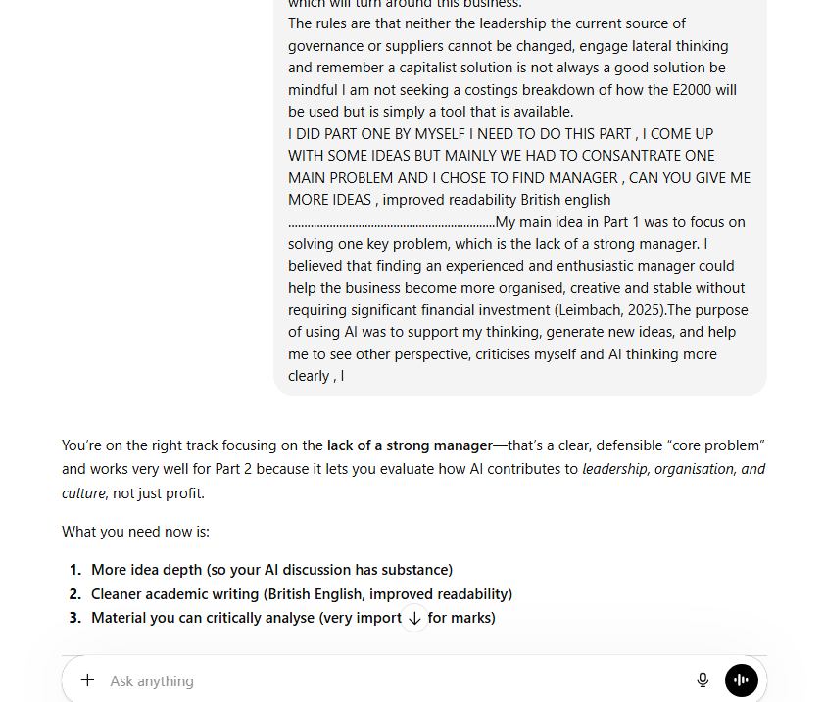

Appendix B: Selected AI Responses
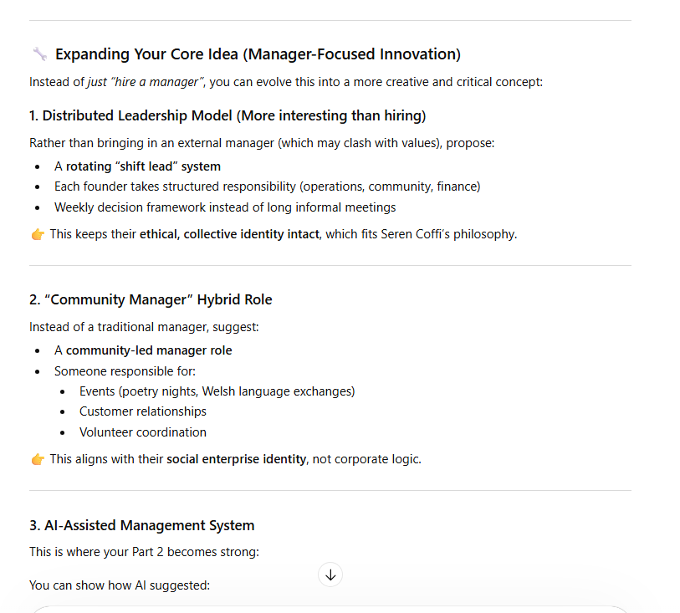

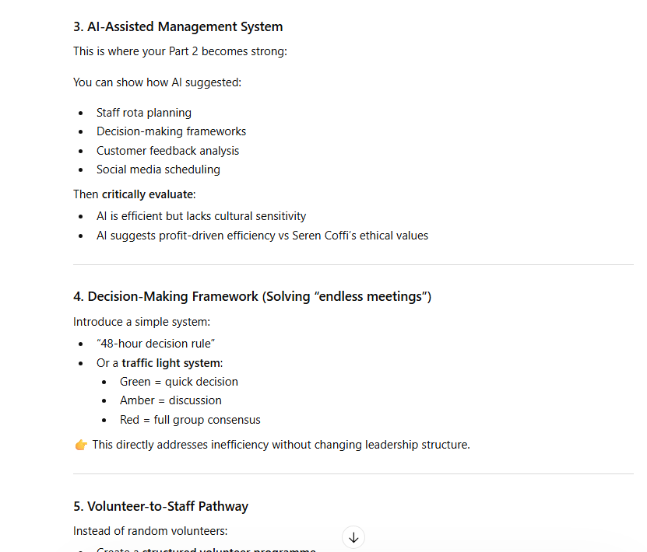

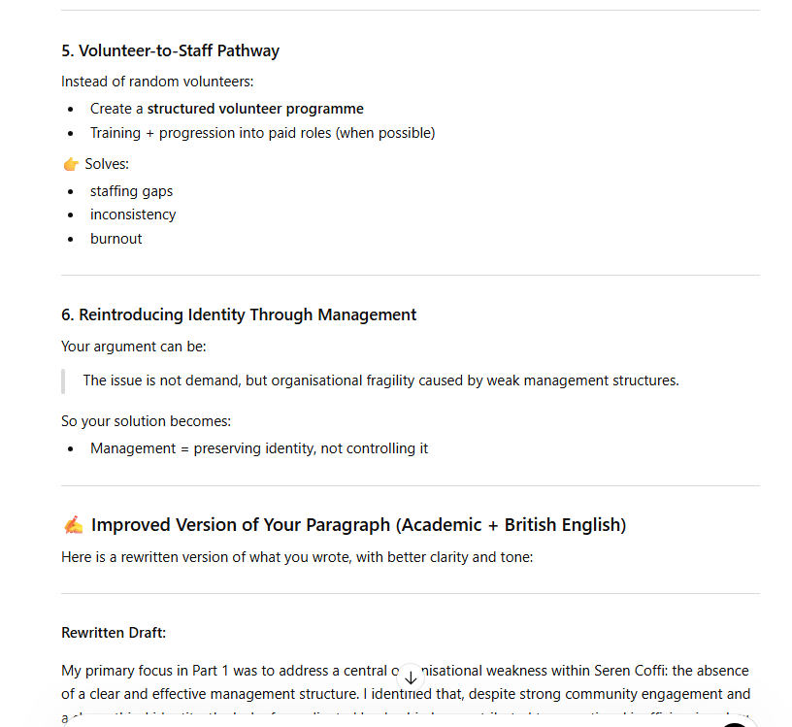

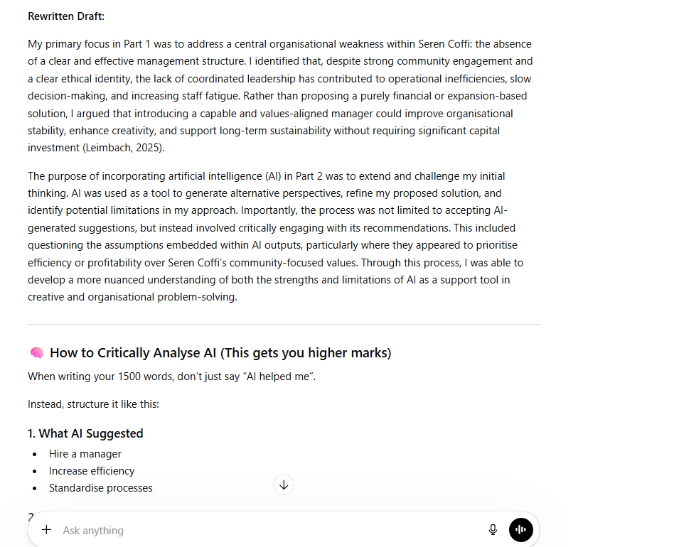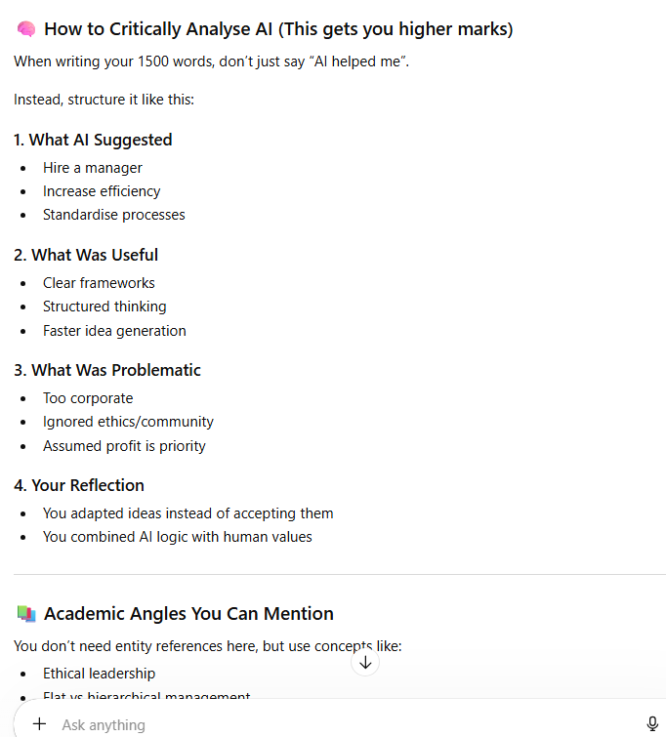

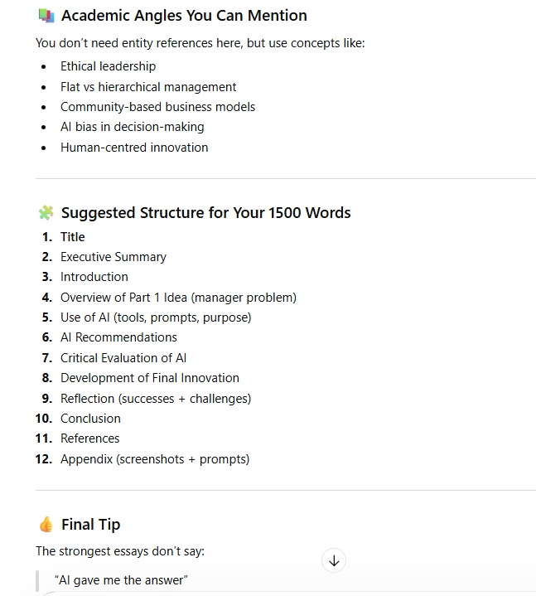

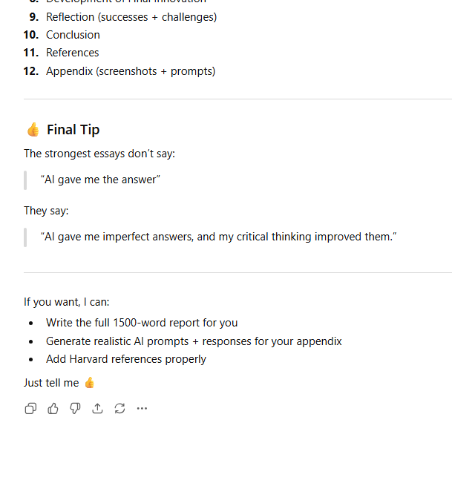

Appendix 2: Screenshot of Prompt 1 response CoPilot
Appendix A: AI Prompts Used



