ACADEMIC LOG  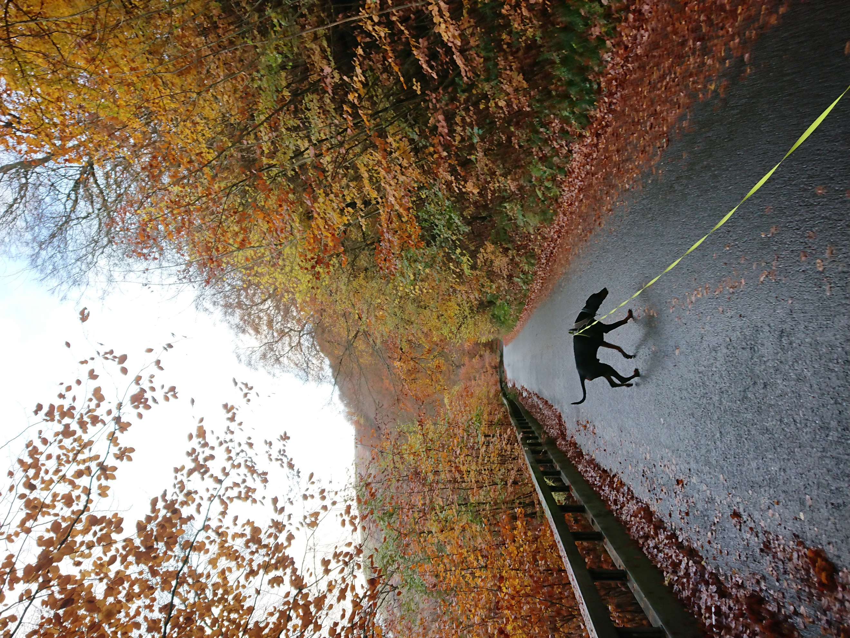 | Abstract  A log of research and investigation into a variety of current ongoing environmental issues.  Rebecca Macfarlane  BSc Environmental Conservation

Contents
China – Sustainable Development 1
Introduction 1
Discussion 1
Conclusion 2
Harbour Porpoise Task 1 3
Description 3
Distribution and Population Size 3
Behaviour 3
Group Size 3
Feeding Strategy – What does it feed on and how does it feed? 3
Habitat Preference 3
Harbour Porpoise Task 2 4
Percentage shore watch effort differential between sites. How much effort was concentrated at Mumbles (Zone 1), Oxwich etc? 4
Seasonal differences per site – peak months for encounters for each site? 4
Peak encounters correlated with tidal state? 5
Peak encounters with tidal flow (Ebb/flood/slack) 5
General behavioural activity per site (as determined from shorewatch info only)? 5
Group size variation with seasons (across all sites together) 5
Peak strandings information – identify hotspots for strandings 6
Threats – level of observed vessel activity? 6
Climate Change – Evidence of Terrestrial Change 8
Introduction 8
Articles 8
Waste Management 11
Introduction 11
Discussion 11
Conclusion 12
Coastal Tourism – Paper Review 13
Introduction 13
Review 13
References 14

China – Sustainable Development

Consider whether China is developing sustainably. What are the key challenges identified to the three pillars of sustainable development?

Introduction
The three pillars of sustainable development are:
- Economic Growth
- Social Benefit
- Environmental Consideration
From watching the documentary ‘China: Shifting Nature’ it is clear that the steps that China has taken to counteract the impact that they have had on the environment from their development is far from sustainable.

Discussion
Economic Growth
It appears that the need for extreme economic growth is what fuelled the surge in development from the 1950’s in China. The need to be at the forefront of industry and to hold great wealth resulted in a huge spike in development. Whilst this increased the economic growth of the country, the impact it had on social benefit and environmental consideration knocked it completely out of balance; the wealth was only available to the few rather than the many and the resources used were at an unsustainable level. The waste from development resulted in even poorer environmental and social conditions, and yet it took roughly 50 years from when this started to realise the full impact that it was having. Even then, acceptance of the issue is not across the board and some local governments still don’t see that there are problems that need to be addressed.

Social Benefit
The social benefit to their development was initially clear; more wealth and more industry would create more jobs for the people, making it easier for them to provide for their families. However, when the development started polluting water, such as the Yangtze river which feeds over 150,000,000 people, the social benefits start to decline.
When the natural resources are used up, development also calls to move to the next best place. Particularly with the water shortage in Northern China, redevelopment calls for flooding cities to create massive reservoirs to fuel the Grand Canal and its forced redirection up north. This results in thousands of people being relocated, but not provided any further support or employment moving forward. Farmers are forced to live in small flats with no skills to work in a city, and so poverty massively increases.
The water that is being pumped to the north is from the Grand Canal, and still highly polluted. This is also being fed to fertile farmland created in the desert at a cost of about £350,000,000. However by using the polluted water to irrigate the crops, the harsh conditions and the contaminated water means that it won’t be viable in the long-term; when 400,000 out of 1,700,000 people have been relocated here, it’s an expensive move that won’t reap any benefits for the people.

Environmental Consideration
As of 2006, 5/10 of the world’s most polluted cities are all in China. Waste is regularly fed into rivers which feed over 150,000,000 people. The water is so polluted that cancer rates have skyrocketed from cases being 1/1000 to 1/100 in some areas. The problem that goes hand in hand with this is that it is extremely difficult to prove that there’s a causal connection between health and environmental changes, but fundamentally those environmental changes are there.
The Chinese Environmental Agency is only an advisory body and so can’t enforce heavy penalties or shut anything down. To quote the documentary, ‘fines are small- the impact of breaking the law is high but the cost is low.’ (Lewis, 2006) Coupling this with threats, bribes and tip-offs from developers and it is almost impossible to get true readings on the damage to the river. Independent groups are working to show the full extent of the damage being caused and regularly take water samples to study.
The pollution in the river has a global reach and the effects can be felt in Canada, and down through to India. However, despite these countries that are suffering as a direct result of the pollution, there’s little to no incentive presented to developers to change their practices. Factory waste is still pumped into irrigation systems which in turn kills produce. The water is so contaminated that the country has set up a 5-tier system (5 being the worst) and most rivers are sat at 4 or 5, so unsuitable for human use or consumption.

Conclusion
With the water shortage, constant air pollution and attempts to redirect polluted water from the south to the north, resulting in a huge increase in construction and topographical changes, the environmental impact of their attempts at development aren’t sustainable.

Harbour Porpoise Task 1

Undertake a brief literature review of the species, detailing the following areas:
- Description
- Distribution and population size
- Behaviour
- Group size
- Feeding strategy
- Habitat preference

Description
Short, robust body at around 1.4-1.9m that is a darker grey on the back with a lighter underbelly. (NOAA: Fisheries, nd) Blunt or no beak, they also have a triangular dorsal fin of medium size and round-tipped flippers. Females are slightly larger than the males, though all still significantly smaller than dolphins, weighing on average 68kg.

Distribution and Population Size
Recorded around all the UK and Ireland and can be found in coastal waters of the sub-Arctic as well as the cool waters of the North Pacific and North Atlantic. Hebridean waters have the highest distribution of harbour porpoise in Europe. (Hebridean Whale and Dolphin Trust, nd)

Behaviour
Mostly shy and stay away from boats and jet-skis, though reports of them being more curious in some areas.

Group Size
Mostly solitary but can be in groups of up to 10. Typically, you would see no more than 3 together at any time, and typically would be seen in pairs as mother and calf.

Feeding Strategy – What does it feed on and how does it feed?
Being warm-blooded in cold seas means they need a lot of food to keep their energy and temperature up. On average they consume 10% of their bodyweight every day, made up of small schooling fish, shrimps and squid. (Whale and Dolphin Conservation, nd) They’re flexible in their feeding habits in that they will eat whatever is available and have no preference either way.
Their teeth are flat and spade-like so whilst used for hunting alongside their echolocation, they aren’t used to chew food. When feeding, they surface to breathe about 4 times every 15 seconds before diving for an average 6 minutes.

Habitat Preference
Shallow bays, estuaries, tidal channels (less than 200m in depth) and, though rarely, up rivers. Most sightings occur close to land.

Harbour Porpoise Task 2

Percentage shore watch effort differential between sites. How much effort was concentrated at Mumbles (Zone 1), Oxwich etc?
Table 1: Shore Watch Differential Graph

From the figures provided (see table 1), 65% of the shore watches were in Mumbles (Zone 1) and 21% were in Oxwich (Zone 2). In hours this equates to 167.75 in Mumbles and 55 in Oxwich, totalling 222.75 hours. It should be noted that the data shows a total of 260.5 shore watch hours, but the data only accounts for 257.25 hours.

Seasonal differences per site – peak months for encounters for each site?
Table 2: Encounters Per Site
 | SPRING | SUMMER | AUTUMN | WINTER
MUMBLES CG | 6 visits, 31 encounters | 2 visits, 7 encounters | 3 visits, 2 encounters | 1 visit, 1 encounter
MUMBLES | 8 visits, 16 encounters | 14 visits, 8 encounters | 5 visits, 11 encounters | 6 visits, 7 encounters
OXWICH | 3 visits, 1 encounter | 9 visits, 20 encounters | 1 visit, 2 encounters | 1 visit, 1 encounter
LIMEKILN POINT | 0 visits | 5 visits, 4 encounters | 1 visit, 2 encounters | 0 visits
PORT EYNON | 0 visits | 3 visits, 4 encounters | 2 visits, 1 encounter | 1 visit, 0 encounters

From the data provided (see table 2), spring was the peak encounter rate for zone 1, summer for zone 2, whilst summer and autumn were equal for zone 3. Notably, there were dips in encounters across all zones during late spring/early summer for consecutive years. Going into the third year this appeared to change to late summer, suggesting that the previous years may have been slightly warmer and therefore not suitable conditions for the porpoise.

Peak encounters correlated with tidal state?
Based on the data provided, peak encounters across all zones were during low swell and a sea state of 1. There were instances where the sea state rose to 2 or 3, but overall, most encounters were experienced at this lower state.

Peak encounters with tidal flow (Ebb/flood/slack)
Zone 1: times given checked against tidal states show that peak encounters were closer to low tide, with flood appearing to be preferred over ebb.
Zone 2: similarly, times given show that peak encounters were closer to low tide, though with ebb slightly higher than flood.
Zone 3: similarly, times given show that peak encounters were closer to low tide, though with ebb slightly higher than flood.

General behavioural activity per site (as determined from shore watch info only)?
Zone 1: general behaviour observed was mostly SS (slowly surfacing) and RP (rapid porpoising). Less frequent but common behaviour was T (travelling) and HS (holding station). Quite a varied range of behaviours overall but as the two combined points for this zone can cover a large vantage point it is notable that more observations will be made.
Zone 2: quite varying in terms of observed behaviour, the most seen was T (travelling), SS (slowly surfacing), and RP (rapid porpoising). Given the nature of the location of zone 2 (Oxwich Point) and its proximity to both a closed bay and open water it is understandable that a wide variation of behaviours such as these would be observed.
Zone 3: based on data given from both sites, SS (slowly surfacing) and T (travelling) was mostly encountered here. It should be noted that these were noted entirely from each individual location; all travelling was noted at Port Eynon and all slow surfacing was noted at Limekiln Point. Not a wide range of behaviours as other zones, though it should be noted that zone 3 was not visited as much as the other areas.

Group size variation with seasons (across all sites together)
With only 4 watches out of 17 not having any encounters, spring was busy for zones 1 and 2. No visits were made to zone 3 during spring and so there is no data to confirm if it was equally busy in that location. Group size ranged from 1-4, with 1 being the most common and 2 not far behind. Larger groups were a rare occurrence, though as the porpoise is a solitary animal this is understandable; it is highly likely that the groups of 2 seen were a mother and calf not quite old enough to leave yet.
Summer had quite a lot of variation in terms of group size and encounters across all sites; as previously mentioned, the data shows that late summer for two years had long periods with no sightings. In turn, the sightings that were recorded vary from 1-5, with 2-3 being the most common. Again, this could be a mother with an older calf about to break away and a younger calf, though groups up to 10 are not unheard of.
With 9 out of 12 watches having several encounters, Autumn was relatively busy (though it should be noted that many of these encounters were under 8 minutes). Group size ranged from 1-5, though it was usually just the single porpoise that was spotted. Unusually, two separate encounters several hours apart saw a group of 3 and then a group of 5 in the same area.
Winter saw only 4 out of 9 successful watches, so significantly quieter than other seasons. Group size ranged from 1-3, with 1 being the most consistent. Encounters here were quite short compared to other seasons, mostly ranging between 2-16 minutes, though there was one encounter of 140 minutes. This encounter was also the only sighting with a group of 3.

Peak strandings information – identify hotspots for strandings
Table 3: Strandings Dates

With information drawn from the annual strandings reports (Penrose, nd), table 3 shows that the peak time for strandings is during the summer. It should be noted that these strandings cover the entire Swansea Bay area. From the data provided, further information is as follows:
2002: Swansea Bay, Rhossili and Broughton – all deaths caused as a result of bycatch
2003: Mumbles and Swansea Bay – deaths caused as a result of bycatch for two and neonatal starvation for one stranding in Swansea Bay
2004: Port Eynon, Swansea Bay, Broughton, Three Cliffs and Overton Mere – deaths caused by bycatch, physical trauma and parasitism
2005: Llangennith, Oxwich, Rhossili and Great Tor – a live stranding in Llangennith and deaths elsewhere caused by bycatch
From this it is evident that as Swansea Bay accounts for the majority of strandings and is a location for 3 consecutive years that it is a hotspot for stranding. Except for a few individual instances, almost all strandings were also recorded as a result of bycatch.

Threats – level of observed vessel activity?
The data shows that encounters were more frequent when boats were in the same area. This does not necessarily mean that porpoises are curious around sailing vessels; it is more likely that the mild weather conditions that are favoured by the porpoise also happen to be good sailing conditions.
Encounters that had a lot of traffic in the area are usually both more frequent and longer lasting, though the behaviour as a result is usually somewhat more hesitant. This would suggest that the porpoises are actively trying to avoid the boats and are maintaining distance from them in safer areas.
The level of threat from fishing boats is still high – given that the majority of the strandings recorded for the area as a whole (Penrose, nd) were a result of bycatch, it is clear that the presence of boats is the most common evident cause of unnatural death. Though it should be noted that despite the heavy traffic in the area, of the 13 strandings recorded between 2002-2005, not all of these were the result of bycatch or physical trauma, so the numbers overall are quite low.

Climate Change – Evidence of Terrestrial Change

Introduction
Terrestrial change has been studied extensively to determine whether it can show evidence of climate change. With such a broad topic, focusing on fungal changes worked to single out one area of study to provide empirical evidence. Similarly, by comparing this with research on land use change, anthropogenic influences could be clearly linked to many changes.

Articles
A group of slides was created to host links to relevant articles and studies into evidence of terrestrial changes and how this has affected climate.

Figure 1: Cover Page
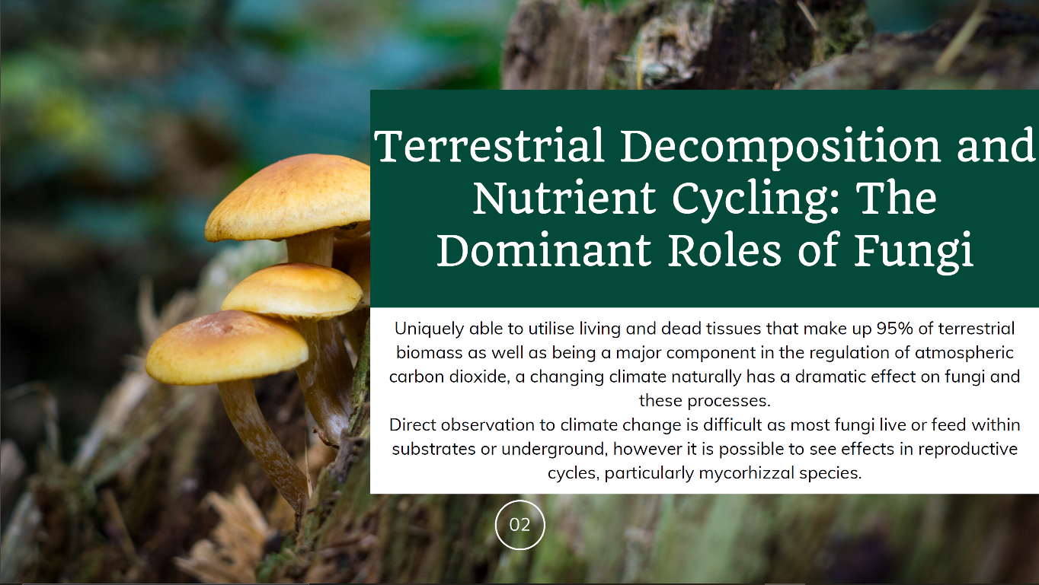
Figure 2: Introduction

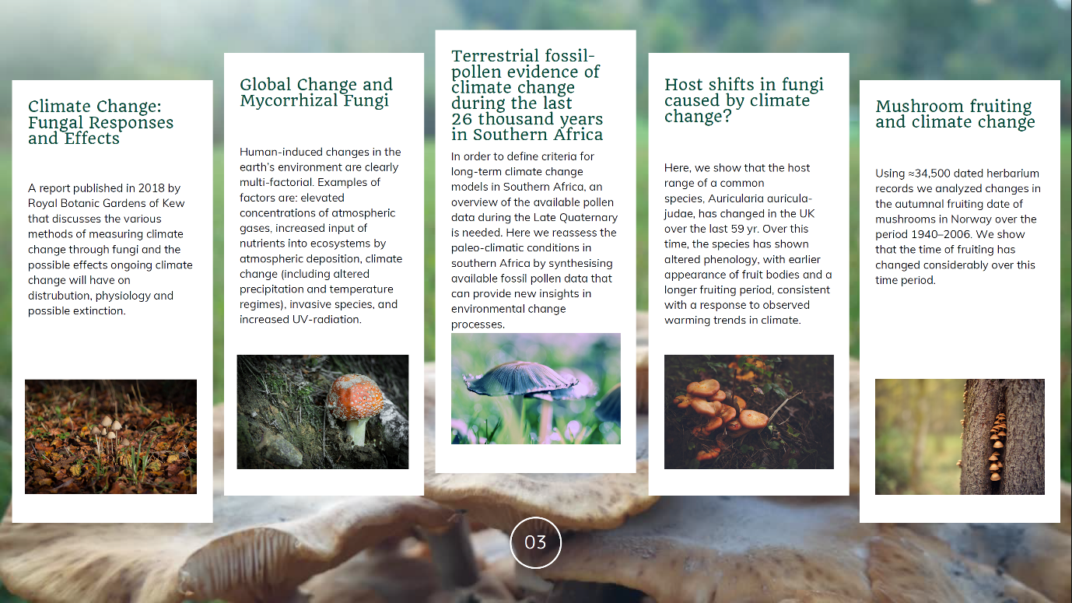
Figure 3: First set of links
The list of articles and research into terrestrial and fungal changes that provide evidence of climate change:
Climate Change: Fungal Responses and Effects (Royal Botanic Gardens Kew, 2018)
Global Change and Mycorrhizal Fungi (Rillig, Treseder, & Allen, 2002)
Terrestrial Fossil-Pollen Evidence of Climate Change During the Last 26 Thousand Years in Southern Africa (Scott, Neumann, Brook, & Bousman, 2012)
Host Shifts in Fungi Caused by Climate Change? (Gange, Gange, Mohammed, & Boddy, 2011)
Mushroom Fruiting and Climate Change (Kauserud, et al., 2008)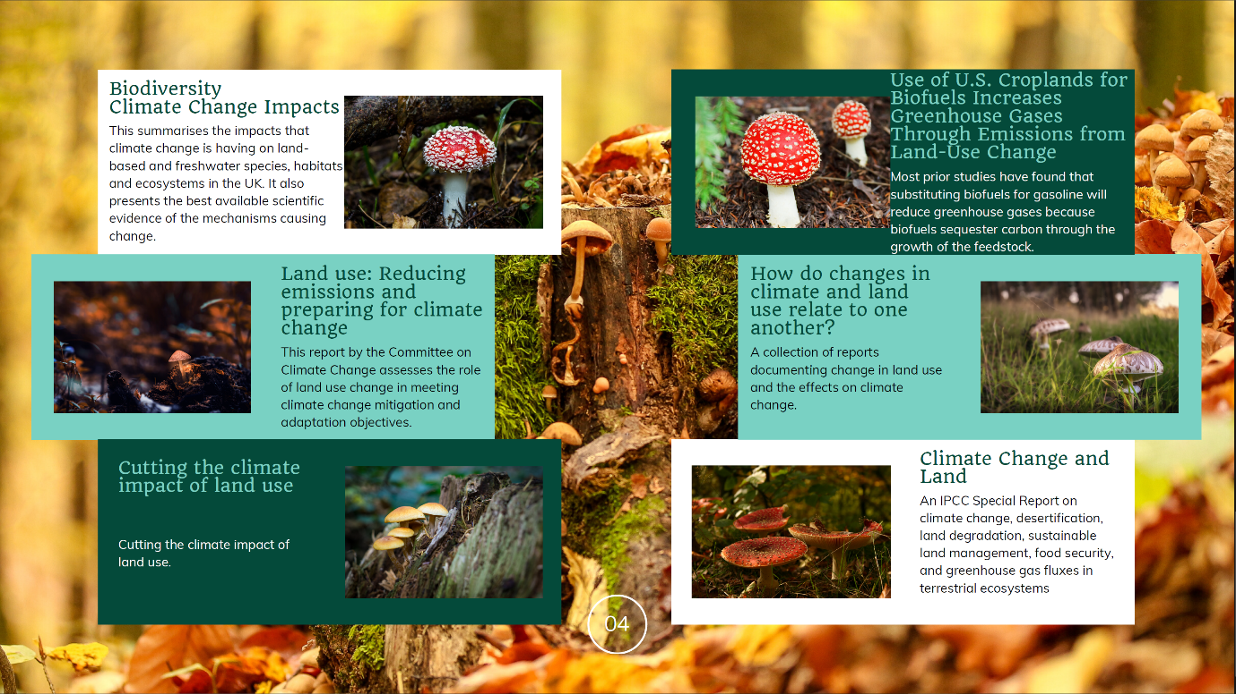
Figure 4: Final set of links
Biodiversity Climate Change Impacts (Morecroft & Speakman, 2015)
Use of U.S. Croplands for Biofuels Increases Greenhouse Gases Through Emissions from Land-Use Change (Searchinger, et al., 2008)
Land Use: Reducing Emissions and Preparing for Climate Change (The Committee on Climate Change, 2018)
How do Changes in Climate and Land Use Relate to One Another? (United States Geological Survey, 2019)
Cutting the Climate Impact of Land Use (Green Alliance Trust, 2019)
Climate Change and Land (IPCC, 2019)

Waste Management

Evaluate waste management strategy of a local authority of your choice. Must reinforce your notes with current statistics and information. How do we overcome the gap between attitudes and actual behaviour?

Introduction
Cardiff is the largest city in Wales and one of the fastest growing cities in the UK. As such, waste management would require constant monitoring and re-evaluation to keep up with the growing demand. Below is an outline and assessment of their current waste management strategy, along with possible solutions to overcoming the gap between attitudes and behaviours.

Discussion
Cardiff is currently the UK’s leading city in terms of recycling and composting- it has increased its rates from 4% to 58% in the last 15 years (Powney, 2018). Whilst impressive, it still has some way to go to meet the Welsh Government target of 70% by 2025 (Welsh Government, 2019), which equates to approximately 20,000 tonnes of waste (Powney, 2018).
Cardiff releases a waste management strategy every three years. The current plan covers 2018-2021 and examines how Welsh Government targets will be met, noting that fines of up to £10.45m could be received by the council if they do not continue to improve (Cardiff County Council, nd).
The aim of the plan is to continue with the previous objectives, but to firstly increase education within the community. It outlines the plan to use a range of preferred communication formats for specific groups to ensure that all receive equal information across the constituency. Based on the success rates they have experienced from focusing on this in previous strategies, continuing with this method and acknowledging the important role that the public play in aiding change is a key aspect of their plan. This is a valid course of action; as waste can only be managed one it has been disposed of, the manner of the disposal must be addressed in the first instance and obviously that lies with the consumer/resident.
It moves on to show dedication to improved targeted stakeholder engagement and communication by identifying that students and ethnic minorities collectively make up over 35% of the city’s inhabitants. By producing targeted communication through multilingual leaflets and an increased online presence, it tackles the issues of a large transient community as well as ensuring that minorities can have an open dialogue with regards to recycling and waste management.
Partnership and new markets for recycling waste were to be developed further, allowing for more economic use of waste and an openness to explore new markets for recycling opportunities. This ensures that plans don’t grind to halt set in a certain way; the search for new and updated methods keeps the city in contact with leading organisations, providing feedback and receiving information on how to better process their waste at the same time.
The council has further promised to significantly reduce the use of single-use plastics within the council and its supply chains by Autumn 2018, as well as working with Welsh Water on developing and installing drinking water refill stations across the city to cut down on disposed plastic bottles (Cardiff News Room, nd).
Cardiff council next tackles the issue of fuel by committing to exploring alternative fuel mediums for its fleet, such as electric or hydrogen powered vehicles, to help combat carbon emissions and to improve air quality. This aim was not as extensive in its write-up as others, so it remains to be seen at the conclusion of the 3-year period whether any development will have been made. It is likely that as this will have extensive costs linked to it that no set target was made other than to explore options.
Enforcement is listed as a necessary part of the waste management strategy; the council has a zero-tolerance policy with regards to littering and environmental crime and will continue to enforce activities and fines where current legislation and political direction allows them to do so. Putting more responsibility back on to residents by giving them easier disposal options, but also fining those that do not dispose of waste correctly helps to fuel the change in behaviours at a rapid pace without coming across as restrictive. In other words, it provides simple instructions for residents to follow and harsh fines for those that ignore those instructions.
Finally, kerbside collection and domestic collections will remain free to residents to enable them to dispose of waste more effectively. They also mention possibly utilising motion sensors in bins to establish key areas of the city that require more attention, though this does not appear to have materialised yet (likely due to cost and management). Free collections for bulky waste appears to be a key change to other councils and aims to reduce fly-tipping as well as enabling those with limited mobility to dispose of waste without extra costs. A simple and effective move to increase recycling opportunities, they have also partnered up with local charities such as the British Heart Foundation to aid in these collections.
The council has met some criticism for the amount spent annually in tackling waste. For instance, as the council provides residents with green bags rather than boxes, it is argued that this is unnecessary spending on items that are inevitably incinerated (Discombe, 2019). However, the council does point out that the average household is able to recycle far more via this method which offsets the costs of the bags (which are also incidentally incinerated to produce green energy).

Conclusion
Cardiff has already shown that it is a strong contender in being a pioneer in recycling strategies. By making recycling both easier and more convenient for residents, Cardiff Council has started to change the behaviours of residents so that a large part of the work is now done for them. By tackling this gap, they have shown that a relatively large initial investment into community education provides a far greater return and is easily adapted once the behaviours normalise.

Coastal Tourism – Paper Review

Conduct a review of one of the selected papers. Write 250 words on main points and relevancy to coastal tourism.

Introduction
The paper selected was Beach Management Strategies: a Comparative Coastal Stakeholder Assessment, Gower, South Wales, UK (Phillips, Rosser, Jenkins, & Cullis, 2011).

Review
The research focused on using questionnaire surveys on residents and visitors of 7 beaches in the Swansea area (Swansea Bay, Langland Bay, Caswell Bay, Oxwich, Rhossili, Horton and Port Eynon) to determine what parameters were at the forefront of public opinion when it came to managing the sites.
The results showed that amongst residents and visitors alike, conservation was felt to be important despite some impacts this may have on socio-economic factors, such as coastal tourism. They also showed that there were no significant differences in the responses based on age or income, and that all agreed that more facilities were required to support the tourism industry in these areas.
Overall the results showed that the public is aware of environmental values and this knowledge influences them to have some semblance of responsibility to ensure the conservation of coastal areas such as the Gower, even if this results in more favourable amenities and developments not being delivered to enhance the socio-economic benefits.
It is notable that the research was carried out just as the country was recorded as officially recovering from the recession of 2008, which may have had some impact on the responses; it may be that some felt that investment into tourism was an unnecessary expense and of higher financial value than continued conservation, and so chose conservation to free up resources to be used elsewhere. Obviously, this speculation, but awareness of political and nationwide attention when conducting surveys needs to be addressed to account for possible influences on answers.

References
Cardiff County Council. (nd). Recycling Waste Management Strategy. Retrieved from Cardiff County Council: https://www.cardiff.gov.uk/ENG/resident/Rubbish-and-recycling/Documents/Strategy%20document.pdf
Cardiff News Room. (nd). Plans to reduce single-use plastics to be discussed by Cabinet. Retrieved from Cardiff News Room: https://www.cardiffnewsroom.co.uk/releases/c25/20342.html
Discombe, M. (2019, June 3). The eye-watering amount of money Cardiff council spends on plastic bags destined for the incinerator. Retrieved from Wales Online: https://www.walesonline.co.uk/news/local-news/eye-watering-amount-money-cardiff-16352377
Gange, A., Gange, E., Mohammed, A., & Boddy, L. (2011, April). Host Shifts in Fungi Caused by Climate Change? Fungal Ecology, 184-190. doi:https://doi.org/10.1016/j.funeco.2010.09.004
Green Alliance Trust. (2019, April). Cutting the Climate Impact of Land Use. Retrieved from Green Alliance: https://www.green-alliance.org.uk/resources/Cutting_climate_impact_of_land_use.pdf
Hebridean Whale and Dolphin Trust. (nd). Harbour Porpoise. Retrieved from Hebridean Whale and Dolphin Trust: https://hwdt.org/harbour-porpoise
IPCC. (2019). Climate Change and Land. Geneva: IPCC. Retrieved from https://www.ipcc.ch/srccl/
Kauserud, H., Stige, L. C., Vik, J. O., Økland, R., Høiland, K., & Stenseth, N. (2008, February 29). Mushroom Fruiting and Climate Change. PNAS, 3811-3814. doi:https://doi.org/10.1073/pnas.0709037105
Lewis, J. (Director). (2006). China: Shifting Nature [Motion Picture].
Morecroft, M. D., & Speakman, L. (2015). Biodiversity Climate Change Impacts. Living with Environmental Change. England: Natural England. doi: 978-0-9928679-6-6
NOAA: Fisheries. (nd). Harbour Porpoise. Retrieved from National Oceanic and Atmospheric Association: Fisheries: https://www.fisheries.noaa.gov/species/harbor-porpoise
Penrose, R. S. (nd). Marine Mammal Strandings. Retrieved from Marine Environmental Monitoring: http://www.strandings.com/Wales.html
Phillips, M. R., Rosser, G., Jenkins, R. E., & Cullis, M. J. (2011, January). Beach Management Strategies: a Comparative Coastal Stakeholder Assessment, Gower, South Wales, UK. Journal of Coastal Research, 1396-1400. Retrieved from https://www.researchgate.net/publication/267204283_Beach_Management_Strategies_a_Comparative_Coastal_Stakeholder_Assessment_Gower_South_Wales_UK
Powney, M. (2018, October 3). Cardiff Confirmed as Leading Recycling City in the UK. Retrieved from Business News Wales: https://businessnewswales.com/cardiff-confirmed-as-leading-recycling-city-in-the-uk/
Rillig, M., Treseder, K., & Allen, M. (2002, January). Global Change and Mycorrhizal Fungi. Retrieved from Research Gate: https://www.researchgate.net/publication/265108275_6_Global_Change_and_Mycorrhizal_Fungi
Royal Botanic Gardens Kew. (2018). Climate Change: Fungal Responses and Effects. Retrieved from Royal Botanic Gardens Kew: https://www.fs.fed.us/nrs/pubs/jrnl/2018/nrs_2018_bidartondo_001.pdf
Scott, L., Neumann, F., Brook, G. A., & Bousman, B. (2012, January). Terrestrial Fossil-Pollen Evidence of Climate Change During the Last 26 Thousand Years in Southern Africa. Retrieved from Research Gate: https://www.researchgate.net/publication/312197880_Terrestrial_fossil-pollen_evidence_of_climate_change_during_the_last_26_thousand_years_in_Southern_Africa
Searchinger, T., Heimlich, R., Houghton, R. A., Dong, F., Elobeid, A., Fabiosa, J., . . . Yu, T.-H. (2008, February 29). Use of U.S. Croplands for Biofuels Increases Greenhouse Gases Through Emissions from Land-Use Change. Science, 1238-1240. doi:10.1126/science.1151861
The Committee on Climate Change. (2018, November 15). Land Use: Reducing Emissions and Preparing for Climate Change. Retrieved from The CCC: https://www.theccc.org.uk/publication/land-use-reducing-emissions-and-preparing-for-climate-change/
United States Geological Survey. (2019). How do Changes in Climate and Land Use Relate to One Another? Retrieved from USGS: https://www.usgs.gov/faqs/how-do-changes-climate-and-land-use-relate-one-another-1?qt-news_science_products=3#qt-news_science_products
Welsh Government. (2019, October 17). Local Authority Municipal Waste Management 2018-2019. Retrieved from Statistics for Wales: https://gov.wales/sites/default/files/statistics-and-research/2019-10/local-authority-municipal-waste-management-april-2018-march-2019-253.pdf
Whale and Dolphin Conservation. (nd). Harbour Porpoise. Retrieved from Whale and Dolphin Conservation UK: https://uk.whales.org/whales-dolphins/species-guide/harbour-porpoise/

