
Managing the Front Desk
Name: Badea Alexandru
Student ID: 2208275
Module title: Managing Hotel Administration
Module code: (BMIH6004)
Lecturer’s name: Kathryn Roberts
Word count: 1202

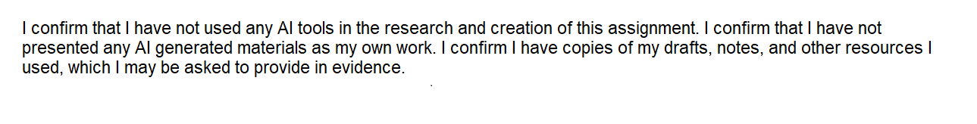
Contents
Introduction 3
Section 1: Reflection on Experience and Personal Development 4
Description 4
Feelings 4
Evaluation 4
Analysis 4
Conclusion: 5
Action Plan 5
Section 2: Analysis of Management Performance 5
Management Style 5
Section 3: Reflection on Cultural Awareness and Teamwork 6
Conclusion and Action Plan 6
References 7

Introduction
This reflective report examines my placement experience at The Yarrow Hotel, located in Broadstairs, Kent. The Yarrow is a distinctive establishment, combining a luxury boutique hotel with an educational facility operated by EKC Broadstairs College. Housed in a Grade II-listed Jacobethan-style building constructed in 1894 by shipbuilder Sir Alfred Yarrow, the hotel has a rich history (Yarrow Hotel, n.d.). Originally designed as a convalescent home for children, the building has been meticulously restored to offer modern hospitality services while preserving its historical charm. The hotel features 23 bedrooms and five suites, a fine dining restaurant, a spa, and event facilities, providing guests with a comprehensive and luxurious experience (Broadstairs College, n.d, Yarrow Hotel, n.d.).
During my placement at The Yarrow Hotel, I had the opportunity to work in various departments, including the reception, where I shadowed experienced staff and interacted directly with guests. My schedule consisted of two full working days each week, on Mondays and Tuesdays, from 07:00 to 15:00. The main objectives of my placement were to enhance my communication and interpersonal skills in a guest-facing role, gain proficiency in using hotel property management systems, and observe leadership and decision-making processes within the Front Office team.
This report provides a detailed reflection on my placement experience, structured around Gibbs’ Reflective Cycle (1988), which outlines six key stages: description, feelings, evaluation, analysis, conclusion, and action plan. This analytical framework enabled me to explore my personal and professional development in depth, identify the skills I acquired, better understand the challenges I faced, and outline clear directions for future improvement (Williams et al., 2023).
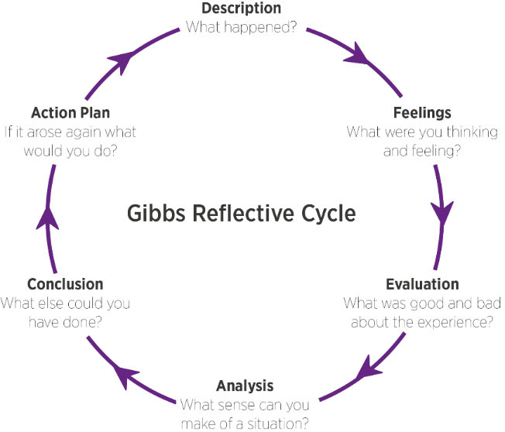
Figure 1: Gibbs' Reflective Cycle
Source: (Williams et al., 2023).

Section 1: Reflection on Experience and Personal Development

Description
During my placement, I worked alongside Leevi, a full-time receptionist, and occasionally under the supervision of the Front Office Manager. My responsibilities included welcoming guests, confirming bookings, updating reservation records , and handling inquiries. I also reported any maintenance issues or irregularities. Although I was not left alone at the front desk, I was encouraged to take initiative under supervision which helped build my confidence.

Feelings
Initially, I felt overwhelmed by the pressure of interacting with guests directly and ensuring accuracy in bookings. However, the supportive nature of my colleague helped ease my anxiety. As the weeks progressed, I started enjoying the fast-paced nature of the work and felt a sense of fulfillment when I successfully assisted guests, especially during busy morning check-outs.

Evaluation
A key strength of this experience was the hands-on involvement. I appreciated the opportunity to take an active role rather than being a passive observer. A challenging moment occurred when a guest attempted to enter the breakfast area accompanied by an additional person not registered under the room booking. Rather than refusing access, the duty manager calmly resolved the issue by charging the registered guest for the additional person. This incident highlighted the importance of applying guest service policies diplomatically to maintain a positive experience. As Cordeiro and Pitacho (2023) suggest, resolving service conflicts with professionalism and flexibility can strengthen customer trust and improve long-term satisfaction, even when policies must be enforced.

Analysis
Effective communication emerged as a vital skill in ensuring guest satisfaction. This aligns with Moreno et al. (2024), who argue that emotional intelligence, especially self-awareness and empathy, is essential in hospitality roles. Working closely with a colleague at the front desk also emphasised the importance of teamwork. We collaborated on guest bookings, handled inquiries together, and supported each other during peak times. I also noticed how transformational leadership, through consistent motivation, clear feedback, and a focus on employee engagement, contributed to a positive work environment and improved service delivery (Helalat et al., 2025).

Conclusion:
The placement at Reception enabled me to apply theoretical concepts to real-world operations. I developed stronger interpersonal skills, gained experience using a hotel system, and observed leadership in action. These experiences clarified the importance of organisational communication and team coordination in delivering consistent guest service

Action Plan
To continue developing professionally, I plan to undertake the following steps:
- Guest Service Confidence: I will continue practicing front-desk tasks and part-time roles
- Time Management: I will improve my multitasking by using prioritisation methods and preparing daily task lists to enhance shift performance.
- Teamwork and Leadership: I aim to develop leadership skills by observing team dynamics and contributing proactively to collaborative tasks.
- Feedback and Reflection: I will continue to request feedback to evaluate my performance.

Section 2: Analysis of Management Performance

Management Style
During my placement, I directly observed how the Reception Manager’s leadership approach influenced staff morale and operational efficiency. Her style was a blend of transformational and participative leadership (Armstrong, 2020), she offered constant guidance, listened to suggestions, and allowed the front desk team to take initiative when resolving issues. For example, when I flagged a booking inconsistency, she encouraged me to find the solution through Rezlynx, the hotel’s digital booking system, rather than solving it for me. This empowered learning mirrors theories discussed in the Management and Organisational Behaviour module, particularly those related to motivational strategies and decentralised decision-making (Halim et al., 2019). The supportive work culture motivated me to engage actively and reduced performance anxiety. According to Armstrong (2020), participative leadership fosters a sense of belonging, which directly contributes to employee satisfaction and productivity.

Section 3: Reflection on Cultural Awareness and Teamwork
I observed that the organisational culture at Yarrow Hotel places great value on inclusion and collaboration. This culture was evident in our daily routine at the front desk, where I worked closely with a colleague to manage guest check-ins, respond to inquiries, and handle unexpected situations. A relevant example was an interaction with a guest who had a limited command of English. In that context, we had to adapt quickly by using a translation app and non-verbal communication. This ability to adapt interculturally and respond effectively to diversity reflects the practical application of theoretical concepts related to intercultural awareness Fernández-Amaya (2022), which I explored in depth during the Foreign Languages & Cultural Awareness course.

Conclusion and Action Plan
My placement in the Reception department at The Yarrow Hotel has significantly contributed to the development of both my practical and interpersonal skills. It gave me the opportunity to apply theoretical knowledge in a real hospitality setting and to experience first-hand the dynamics of guest interaction, front office operations, and team collaboration. Working under the guidance of experienced staff and observing effective leadership helped me better understand the expectations of a guest-facing role and the importance of professionalism, empathy, and clear communication.
Looking ahead, I intend to strengthen my skills by continuing to work in guest service roles, with a focus on enhancing my confidence in handling check-ins, guest inquiries, and service recovery situations. I also aim to develop my time management and multitasking abilities by applying planning techniques and using task prioritisation tools. Furthermore, I aim to secure a permanent role in the hospitality industry where I can apply and refine these skills in a professional setting. This would enable me to take on more responsibility, enhance my operational knowledge, and continue my development through hands-on experience. These steps will support my long-term goal of progressing into a supervisory position within the hospitality industry.

References
- Broadstairs College (n.d.) The Yarrow Hotel – Public Facilities. Available at: https://www.broadstairscollege.ac.uk/public-facilities/the-yarrow-hotel/ (Accessed: 2 June 2025).
- Cordeiro, J.P. and Pitacho, L. (2023) ‘Employees’ conflict management in the hospitality industry: An empirical study on the importance of sociodemographic variables’, Investigaciones Turísticas, 26, pp. 134–161. Available at: https://rua.ua.es/dspace/bitstream/10045/136125/1/InvestigacionesTuristicas_26_06.pdf (Accessed: 2 June 2025).
- Fernández-Amaya, L. (2022) ‘Politeness in hotel service encounter interactions in Spain: The receptionist’s point of view’, Pragmatics and Society, 13(2), pp. 224–249.
- Halim, H.A., Ahmad, N.H. and Ramayah, T. (2019) ‘Sustaining the innovation culture in SMEs: The importance of organisational culture, organisational learning and market orientation’, Asian Journal of Business Research, 9(2), pp. 14–33.
- Helalat, A., Sharari, H., Alhelalat, J. and Al-Aqrabawi, R. (2025) ‘Transformational leadership and employee performance: A further insight using work engagement’, Economics – Innovative and Economics Research Journal, 13(1), pp. 333–352. Available at: https://sciendo.com/article/10.2478/eoik-2025-0015 (Accessed: 2 June 2025).
- Moreno, S.R.L., Manurong, D., Floderliza, F., Lacuata, J.J., Maribao, L.M., Inson, R. and Maquiling, H. (2024) ‘Emotional intelligence and job satisfaction among hospitality industry workers in Valencia City’, International Journal of All Research Writings, 6(5). Available at: https://www.researchgate.net/publication/385534224 (Accessed: 2 June 2025).
- Williams, K., Woolliams, M. and Spiro, J. (2023) ‘Using a framework for reflection: Gibbs reflective cycle’, Reflective Writing, 1(1), pp. 90–102.
- Yarrow Hotel (n.d.) History. Available at: https://www.yarrowhotel.co.uk/about-us/history/ (Accessed: 2 June 2025).

