What is space and place and how do these concepts dictate advertising techniques?

Heather Marion Ashen
0950155

Submitted in partial fulfilment of the requirements for the degree of
BA (Hons) Advertising and Brand Design
University of Wales Trinity Saint David, Swansea.

Date: 10th December 2019

Word Count: 5,514

Tutor: Caroline Jones

Table of Contents

List of Illustrations………………………………………………………………………….i
Summary of Topic…………………………………………………………………………ii
Introduction…………………………………………………………………………………1
Chapter 1: Space, Place and Advertising techniques……………………………2-7
Chapter 2: Advertising as an art form……………………………………………...8-14
Chapter 3: Non-Place and advertising techniques……………………………..15-18
Chapter 4: Hyperreality and its role within advertising………………………..19-21
Conclusion:……………………………………………………………………………22-24
Bibliography:…………………………………………………………………………..25-26

List of Illustrations
Figure 1: Corona "Wave of waste" by Wieden & Kennedy Amsterdam (2018). Taken from: https://www.campaignlive.co.uk/article/corona-wave-waste-wieden-kennedy-amsterdam/1484584 (Accessed: 10th December 2019)
Figure 2: Thinkinvisible – Sherlock Holmes. Taken from: http://piccsy.com/2012/05/thinkinvisible-tumblr-com-e1n8nje8p/ (Accessed: 10th December 2019)
Figure 3: Nike Air Max (2017). Taken from: https://www.youtube.com/watch?v=zGrYiMaAlJs (Accessed: 10th December 2019)
Figure 4: ‘The Starry Night Sky’ Vincent van Gogh (1889). Taken from: https://www.vincentvangogh.org/starry-night.jsp (Accessed: 10th December 2019)
Figure 5: Van Gogh Immersive Exhibition by Gianfranco Iannuzzi, Renato Gatto and Massimiliano Siccardi (2019). Taken from: https://www.carrieres-lumieres.com/en/van-gogh-starry-night (Accessed: 10th December 2019)
Figure 6: Social media example of advertisement (2019). Taken from: https://www.facebook.com/ (Accessed: 10th December 2019)
Figure 7: ‘Visit Great Britain’ London Skyline (2019). Taken from: https://www.visitbritain.com/gb/en (Accessed: 10th December 2019)
Figure 8: Pontiac Advertisement. Taken from: https://www.alamy.com/stock-photo-1960s-usa-pontiac-magazine-advert-85365205.html (Accessed: 10th December 2019)
Figure 9: SEAT Urban Vehicle – Own the City (2019). Taken from: https://www.youtube.com/watch?v=LztpsD66894 (Accessed: 10th December 2019)
Figure 10: McDonalds Ambient Advertising. Taken from: https://www.boredpanda.com/creative-ambient-ads-part-2/?utm_source=google&utm_medium=organic&utm_campaign=organic (Accessed: 10th December 2019)
Figure 11: Ambient BBC World News. Taken from: http://partnersandharrison.com/advertising/the-power-of-ambient-advertising/ (Accessed: 10th December 2019)
Figure 12: Coco-Cola escalator example. Taken from: https://www.youtube.com/watch?v=vkP9fpcdrK8 (Accessed: 10th December 2019)
Figure 13: Ribbon banner screens. Taken from: https://www.thedrum.com/news/2019/01/11/o2-disney-and-google-among-first-advertisers-tfls-digital-ribbon-screens (Accessed: 10th December 2019)

Summary of Topic
To look at definitions of space and place and how this relates to advertising techniques. How ambient advertising is embracing this, and it is coming up with more creative ways to engage with audiences. In modern times advertisers are increasingly moving away from traditional outdoor advertising and more so to the digital realms. This leads to a discussion on how hyperreality is a new space/place in which we inhabit.

Introduction
There is a strong link between Space, Place and advertising, which will be explored within this essay. The purpose is to draw connections between advertising platforms and how they relate to Space and Place highlighting how these theories shape many aspects of life both theoretical and hypothetical.

There have been many definitions of space and place, some key thinkers and their theories that will be looked at including, Michel Foucault, Yi-Fu Tuan and Marc Augé (non-place). This essay looks at theories of space and place, their definitions and how they relate to advertising. Advertising is becoming more embracing of other practises crossing over to sciences, arts, geography and psychology to discover the best ways to advertise and its creative use of space and place will be looked at, with examples. Also Augé’s theory of non-place and how non-places are especially interesting and used locations for advertisers. The technique of ambient advertising is looked at as it specifically uses non-places to display work. Ambient advertising makes use of the area around the non-place and uses this to its advantage for example roads, elevators and street furniture.

Considering this, with an eye on changes in technology and how this is affecting advertising, Jean Baudrillard’s theory of hyperreality is studied. This connects when viewing the space/place we inhabit through digital screens, especially smartphones. Connecting to this are ethical questions on how advertisers target us on social media. How advertisers also are increasingly target us and also sell us an idea of our personal spaces will be looked at with further examples.
Chapter 1: Space, Place and Advertising techniques
Space can be perceived as an abstract concept when considered in multiple ways dependent on its context and subjective interpretation. For the purpose of this dissertation space will be considered as “a continuous area or expanse that is free or unoccupied”, thought of also in terms of its spatial dimensions and the possibilities that exist within this (Compact Oxford English Dictionary, 2000). A continually expanding concept space is arguably defined by the individual, open to interpretation and perception, just as it is defined by the context in which it is used.

Yi Fu Tuan (1932- ) is a Chinese American geographer and a key thinker on space and place. He argues for a concept of space that expands this definition, seeing space as more of a philosophical concept. Tuan suggests that space can be considered a geometrical unit and can create grammatical form with questions such as ‘is there enough space?’ Arguably if space is fixed or dead is it possible to establish if there is enough of it and would the definition of public and private space exist if space is non-existent as a measurable unit. Considering this theory, it creates the concept that space can be extended, seen within the hypothetical space of the internet, where there seems to be no end (Tuan, 1977).

Place is similar to space but is different in the sense of place being tangible rather than abstract. Place is questionably known as a physical concept that can be considered in various ways dependent on context and personal perception. The Oxford English Dictionary (2000) defines place as: “a particular position or area; a location…informal a person’s home…[or in use as a verb] find an appropriate place or role for someone or something”. Similar to space, place is an all-consuming concept, changing according to its context. For the purpose of this dissertation, space and place will be considered in terms of the definitions above and theoretical interpretations of them.
The notion of space traditionally refers to something anonymous, whereas place distinctively accounts for the meaningful experience of a given site; that is, it is ‘consumed space’ (Luca M. Visconti. John F. Sherry JR., 2010, p. 512).

An example of this is a stage in a theatre; the stage is considered a space until it has a set and becomes a ‘consumed space’, once the set has been removed the stage goes back to being a ‘space’. The stage could be considered as a place rather than ‘consumed space’ because it ‘accounts for the meaningful experience of a given site’ as described above. It could be argued therefore that space and place are inextricably linked and referred to as ‘space-place’ rather than two separate ideas.

Space has previously been considered as static or dead, however thinkers such as Tuan have shaped how we consider space and place, with place being known, or safe, and space being free (Barker, 2004). Tuan’s theory looks at three points: one the biological space how we move in surrounding space, the second space being conceptual compared to place and the third the idea of experiences and understanding shaping a space or place (Tuan, 1977). In contrast to Tuan’s theories Michel Foucault (1926-1984) looks at the social construction surrounding space and place. Foucault believed that we culturally as human beings give identity to space through our activity and how we emotionally interact with the place. This gives creditability to the idea that space is an important element for our understanding of social and cultural trends. Space changes according to our movement within it as argued by Tuan and the way we experience it changes our understanding.

If you are Christmas shopping in November, there may be nothing festive in terms of decorations or carols playing yet you still feel festive. The space does not convey Christmas, yet the feeling is inside you. In December the environment changes to become festive with lights and decorations and the mood becomes more festive which arguably heightens the experience you are feeling. The space can change your emotions through your movement but also through the identity you place within it; a person can still shop with full decorations around them yet feel un-festive as this can ultimately be determined by the person driving the emotions and identity of the space.

Considering both Foucault’s and Tuan’s theories it shows how in the modern day there are more possibilities for space to be considered as a movement rather than static; this can be shown in advertising where space is being used as a technique, which can be seen below. The advertisement has diminished the laws of staying within the dimensions of the board itself and expanding on to the street below giving the opportunity for audience participation. There are various techniques of ‘ambient advertising’.
Ambient is designed to disrupt, intrigue, entertain and be memorable. It exists outside the normal rules of engagement of traditional advertising for example; digital, television, radio and press. All of these advertising strategies struggling to find a voice amongst the thousands of brand messages that fight for the attention of consumers everyday. (Williams, 2017, p. 3)
Ambient advertising can be more interactive where advertiser’s intention is for consumers to engage, in this increasingly popular and creative form of advertising. This will be looked at in more depth further in the essay.
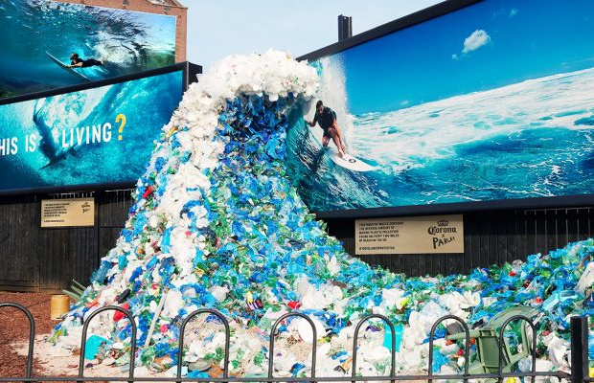
Fig. 1 Corona "Wave of waste"

Space is redefined within this context as the advertisement becomes part of the environment around it. Corona are encouraging the viewer to become engaged with the advertisement and therefore the space, as they move from the two dimensional into the three dimensional. The fact that the wave comes out from the picture and becomes an art piece in its own right suggests that advertisement is not simply linear, and the space encompasses this. Advertisers such as Corona are creating work that interacts with consumers, continually pushing the boundaries of space putting it in the realm of a social construct (Mills, 2003). This is supported by Tuan who is open to the possibility that space could be ever changing dependent on who is perceiving the space and where from. Culturally it could be argued that space is empty or static however from the view of a dancer or artist the use of negative space is a technique used widely, which can be linked to advertisements. One instance of this is the ‘ThinkInvisible’ game which asks you to guess people and objects from few clues as seen below in the Sherlock Holmes example. This is a very different way of using negative space and traditionally more clues are given than taken away in negative space techniques. In comparison to this the Nike Air 2017 advert also used space differently showing space as a movement rather than static as it is traditionally known. Nike depicts air within the advert as a physical presence rather than invisible. The concept of air becomes a movement dictated by the objects that are used to create it. Negative space is used to create the Nike shoe just as it creates the picture in the Sherlock Holmes example. Space in these examples does not have to be linearly defined instead space is arguably dictated by the negative space around it and the movement that is used to create it.
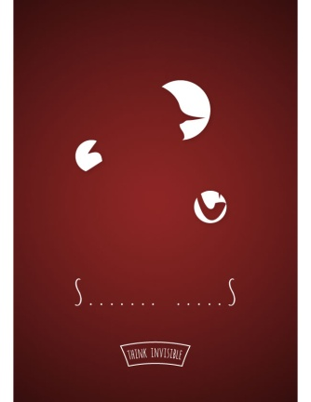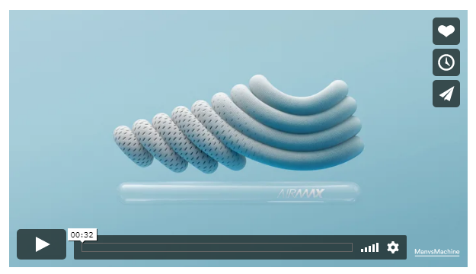
Fig. 2 Thinkinvisible – Sherlock Holmes
Fig. 3 Nike Air Max

In art historically the notion of space moving is not a new idea. This can be seen in Vincent van Gogh’s painting of ‘The Starry Night Sky’ (1889) where the sky is filled with movement rather than being static. This has been taken a step further by art director Michael Couzigou who was a part of creating an interactive projection of many of Van Gogh’s paintings including ‘The Starry Night Sky’ where the innovative use of space and place can be seen.

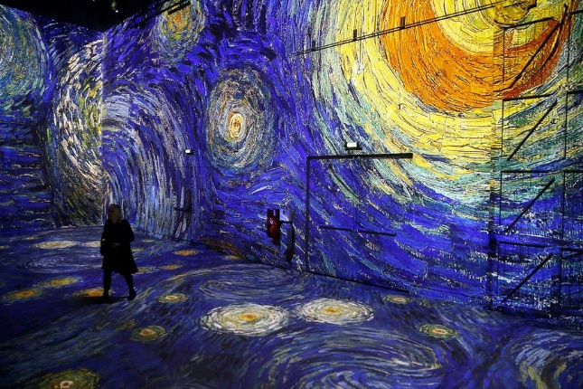
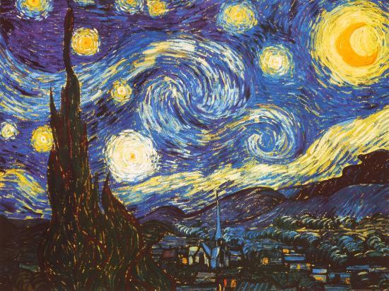

Fig. 4 ‘The Starry Night Sky’
Fig. 5 Van Gogh Immersive Exhibition

Languages differ in their capacity to articulate areas of experience. Pictorial art and rituals supplement language by dictating areas of experience that words fail to frame; their use and effectiveness again vary from people to people. Art makes images of feelings so that feeling is accessible to contemplation and thought (Tuan, 1977, p. 148).

In Tuan’s quote he reflects on art being able communicate to a variety of people. This presents the idea that even when you don’t speak the language of an artist or designer you can still envision the words being communicated through the art. This is relevant to advertising as often big brands are trying to communicate to a large population and do not want to offend anyone as an advertiser’s work is publicly on display.

Chapter 2: Advertising as an Art form
Advertising has been considered as a form of art in recent years (Glancey, 1995). The need to express ourselves publicly can be dated back to prehistoric times where the first evidence of guerrilla art can be found through cave drawings. Similar to this, street artists use their own stencils which could be considered a form of branding as the same symbol is reproduced in varying places making it easily recognisable; examples of this in advertising would be the McDonalds ‘golden arches’ or the Nike ‘swoosh’.

Advertising techniques have evolved over an extensive time period with developments in technology creating new platforms. In the early days of advertising the main platforms were placards, sandwich boards and posters. Spaces were competed for to attain the best spots; posters were particularly popular as they did not have to adhere to advertising duty.
Designated trades were often confined to particular streets and the desideratum then was to differentiate shops through the use of signs which were vivid and easily understood. Gaily coloured signboards informed people of the whereabouts of particular tradesmen (Odih, 2007, p. 23).

Nowadays the use of signs and symbols on brands is ever more relevant with brands having to fit and be recognised in small icons on social media. The use of colour has developed in advertising with the incorporation of psychology being used in brands development colour psychology which has given advertisers insight on how certain colour make us feel and react. Advertisers’ collaborating with other techniques and across other fields is becoming ever more common. Due to the fast paced nature of society we are arguably becoming more visually orientated and this makes colour a pervasive advertising techniques as it immediately catches the consumer’s eye.

Space has become a combined interest between theorists surrounding social and humanity science and geographers. This could be linked to our shared interest in the world, how we relate and react to our surroundings and will possibly be the case for years to come as the overlap between theoretical and physical becomes more frequent (Valentine, 2004). In relation to this, cities are thought to have ‘grey areas’ between public and private places. Although places are designated as private or public this can change with the occupation of a public space by a private company.

Similarly, the internet can operate in the same way. The information posted is private until it reaches the internet domain whereby it becomes public; individual search histories appear private until these same searches are shown alongside social media pages, displaying the items you were shopping for previously. The concept of private information is questionable in this scenario, just as private and public domains are juxtaposed in everyday life, dependent on the occupation of that area. If this is acceptable within society, then it could be argued that we are programmed to believe this as acceptable in our virtual life on the internet also. An example of this is on social media such a Facebook where a search engine has been used to search for a product and afterwards the adverts for the product appear in advertising space on Facebook.

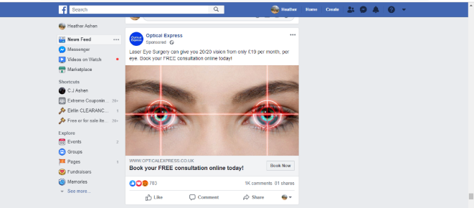
Fig. 6 Social media example of advertisement

When considering the relationship between space, place and advertising, there seems to be two primary approaches that can be taken. Firstly, is the representation of the place in advertising, which in the modern world is seen all around us. “Place, used as setting or symbol, can be a vital component in the graphics and text of modern advertisement” (Roth, 1991). These idealised representations of place can be seen in holiday advertising where advertisers are selective of what is shown. The use of generic place is a big part in representing the perfect home, holiday or country. Holiday advertisement is a perfect example of this as it depicts the place in unrealistic terms focusing purely on positives. Signs and symbols are used to sell the place taking the example of London from the ‘Visit Great Britain’ website. The photo on the website includes the top major London attractions (Big Ben, Westminster and The London Eye) reflecting on an idealistic view of London; the streets featured in the photo are quiet compared to the growing 8.9 million people currently living in London (ONS, 2018).
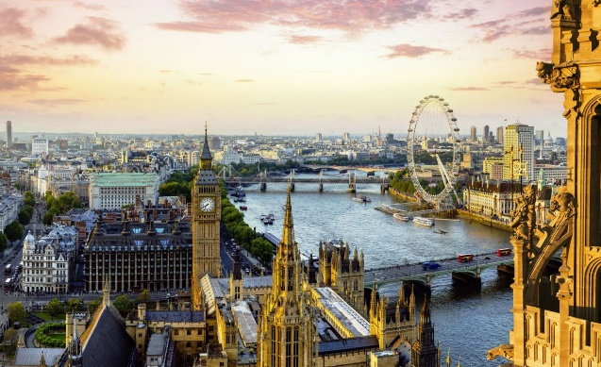

Fig. 7 ‘Visit Great Britain’ London Skyline
These idealised representations of place that have seeped into popular consciousness and may not be a ‘true’ representation. Car advertising became aware of these techniques in the twentieth century when there was an increase between advertisement and the ‘romantic gaze’. The idea was to promote the car as a symbolic key to a romantic getaway. The use of vibrant imagery of luxurious manors with large grounds with lawns and blue skies, selling the perfect view of relaxation away from the day to day.
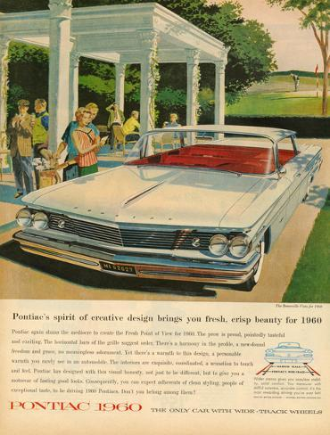
Fig. 8 Pontiac Advertisement
A place is a location where social interactions happen from society which gives it meaning because people decide how the space is used therefore create places. This can be shown in the ‘Home’ the way the rooms are used in a home are dictated by what people put in that room. The culturally bedrooms are upstairs and kitchens and living areas downstairs (Barker, 2004).

An example of a brand demonstrating and understanding of this can be seen in Ikeas 2017 advert ‘Lion Man’. In this advert Ikea are demonstrating how the space can be used depending on your own personal preferences and the experience you wish to create in the space and forming your sense of place. This is shown by the initial scenes of relaxation and adult time where the lion is dozing around waiting for its moment of action, which happens when the children arrive changing the way in which the space is used and becoming child friendly giving this idea of a family home.

Similarly, to this in 2019 SEAT released an advert about their urban vehicles called ‘Own the City’. Within this advert a variety of different spaces are shown in which people interact, providing the space an identity, arguably transforming it into a place. This demonstrates how space can become a personal place depending on how they it is being used; this can be based on the experience they have and the identity that person gives it. When the street is empty, it is just a street. Once there is a band playing music it becomes ‘your radio’; a space filled with merriment and dancing. The space creates an identity through the musicians playing there which changes the space into a place. The advert is creating this idea that your car becomes your place once you fill the space with your belongings. For example you could have a single person and a family with the same car however the way the car is filled is very different, which changes the car space into a place where different interactions are encountered. The ‘Own the City’ slogan is a reflection on how someone experiences the journey giving an increased sense of identity. For instance, one person will travel the same route not experiencing the space around them. A second person will take the time to encounter the surrounding place.
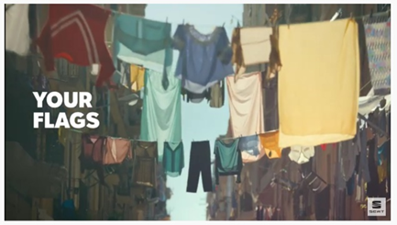
Fig. 9 SEAT Urban Vehicle – Own the City
According to research carried out this year “UK motorists spend 293 hours a year in their cars” (Fielding, 2019). Advertisers are targeting this as a place in which we spend a lot of time. The traditional form of in car advertising has been the radio, but with a decline in radio listeners due to the incline in music streaming via apps such as Spotify and Apple music, it has been become increasing difficult to target a specific audience within their cars (Sweney, 2019).
A different way of targeting drivers can be seen through the use of driving apps which is a new idea and currently being developed. There has already been collaboration between Spotify and Waze, which is a driving app that helps with route planning, car sharing and updates on traffic, with a community of over 115 million people. It could be argued that advertisers are entering this place with ideas such as that developed by Waze. With advances in technology and the use of analytics they can produce profiles of people depending on their location and mindset. Based on this information brands can target the right audience at the right time. Waze are currently in the process of developing this idea and integrating their technology; they have interest from companies such as McDonald’s. With this idea they will initiate an unplanned stop to the user’s journey to places such as McDonalds which could expand to other fast food chains (Clark, 2019).

The second primary approach with relation to space, place and advertising can be seen in the way advertisers strategically place adverts in spaces and places we live in, non-places which we pass through and most recently hyperreality which could arguably be becoming a place.
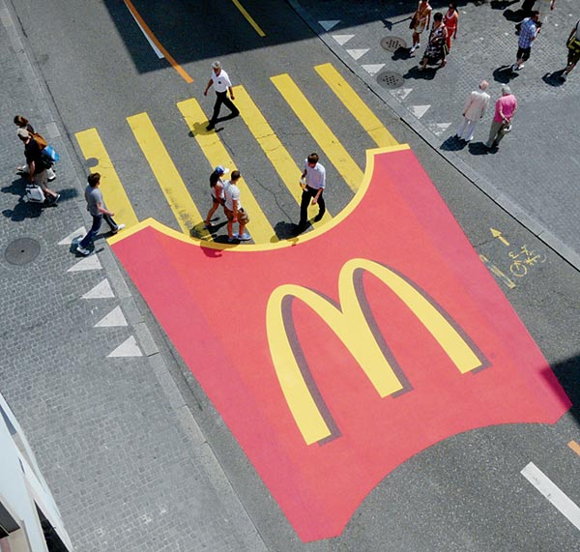
Fig. 10 McDonalds Ambient Advertising
McDonalds here have taken a zebra crossing which is not a usual advertising space and created a unique advertisement, utilising a location which is not conventionally used for advertising. The zebra crossing itself has become the fries in the advertisement this is embracing the environment in which it has been placed. Ambient advertising is being used to create more engaging pieces making more creative use of space-place.

Chapter 3: Non-Place and advertising techniques
In comparison, outdoor advertising has been on the decline and has been described as ‘visual pollution’ however looking at the statistics, it shows there has been a shift from static outdoor advertisement to digital outdoor advertisement. Digital outdoor advertising increased from 1% of outdoor advertising expenditure to 11% in 2010 and predicted to account for 25% by 2020 (Warnaby, 2014). The rise in outdoor advertising is possibly linked to developments in technology, where previously there would have been either a static or rotating prism billboard, there can now be electronic billboard screen. These billboard screens can withstand an array of weather conditions and have unlimited capacity to hold adverts, giving more than one brand the opportunity to advertise in the same space. It could be disputed that billboards are becoming more aesthetically pleasing in a digital focused world and that’s why they are becoming more popular in society, most recently with the increase of InLinkUK kiosks which are replacing old telephone booths, with their multifunctional features most recognisably the high definition advertisement and public notice screen.

In relation to these ideas, there has been innovative to create an event that happen in real life and create human to human conversation. This can be seen in use of non-place in advertisement. One of the key thinkers behind the idea of non-place is Marc Augé (1935- ) is a French anthropologist practical changes to human norms and social interactions within postmodern times and the author of ‘Non-Place An Introduction To Supermodernity’.

Augé term for non-place for example bus depots and airports no matter how substantial did not give any idea of belonging or sense of ‘place’, Augé idea of non-place suggests that anyone can feel at home in these environments as they are created to be equal the same and different to everyone (Auge, 1995). This can be shown when traveling from one airport in our country of origin to an airport in our destination. The destination airport is both familiar and alien to us, procedures and expectations are the same in these non-places we are coming away from human interaction and becoming hyperreality friendly.

It could be considered the reason non-place and ambient advertising link is because of the free accessible space and the foot flow and the amount of people that could interact with the advertisement. There are three factors when looking at ambient advertising and the relationship to nonplaces considered in Angela Williams Thesis Ambient Advertising which are Visual Impact, Environmental Impact and Pedestrian Interpretation.
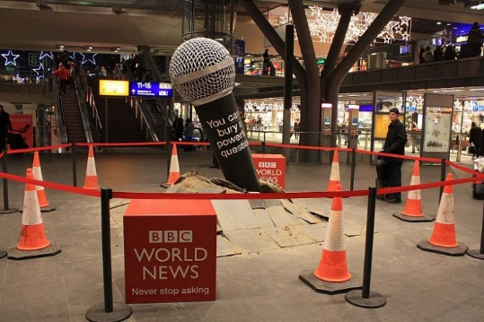
Fig. 11 Ambient BBC World News
As seen in figure 11 the microphone has been created in giant form, the advertisement has been demonstrated in a dramatic way as it is erupting from the floor of a shopping centre. This creates a visual exhibition to be viewed by the audience, this defines the Visual Impact. The Environmental Impact can be related to the physical space in which the microphone is taking not only that but how the idea of care is being included with the use of barriers and warning cones. Pedestrians Interpretation is where the advertisement tactics develop as not only do the people with the shopping centre interact with the advertisement, but this is also shared via social media.

For advertisers these places are prime locations to display advertising as we absorb our surroundings consciously and subconsciously. Augé suggests that the theory of non-place is where people pass through which ‘do not act as localised sites for a celebrations of ‘’real’ culture’ (Phil Hubbard, 2005).

A common example of non-place advertising can be seen in the London Underground where there is an endless display of posters however this has been developing over the years with advertisers competing in this space to create new interaction for example using the steps and escalators as advertisement locations. This has been evolving since the 1990’s as there have been developments in printing and prices have been decreasing making the ability to print anywhere more accessible. The saturation of advertising has perhaps made us more savvy as an audience; therefore, advertisement is now needing to create and experience to become memorable. One of reasons that escalator advertisement is increasing is because of the unique shape and movement of the escalator itself and because it is different it can create an online presence through being shared on social media. In a society where there is a need to share, which advertisers are embracing with the use of hashtags on advertisements which can lead on to integrated campaigns (Webster, 2019).
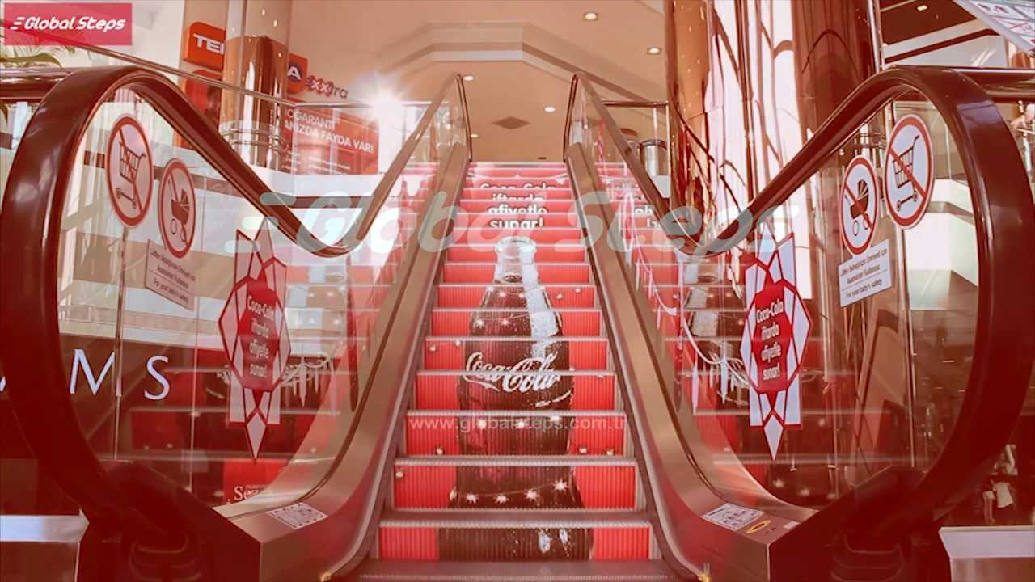
Fig 12 Coco-Cola escalator example
In developments to this Transport for London wanted to come away from the posters which are traditional seen on the walls of the escalators and embrace the digital era. The idea which has been developed by Exterion Media and Bournemouth University and revealed earlier this year are digital escalator panels. In a non-place which previously could have been considered static and limiting to advertisers the full motion digital ribbon is now open for more creative ideas to be executed (Watson, 2019).
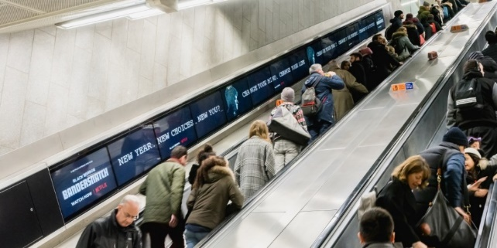
Fig. 13: Ribbon banner screens

Chapter 4: Hyperreality and its role within advertising
Now ‘place’ can be extended beyond even the physical and the hyperreality we inhabit on our phones and the internet. Mobile marketing has transformed advertising; smartphones fall under the ‘always connected category’ and this is not lost on advertisers, who have identified it is a good marketing tool particularly with the youth (Francesco, 2013).

Hyperreality is the idea that simulations and artificial inventions are becoming a ‘real life’ existence in the physical world, with hyperreality having many traits of the real that it possibly creates this idea of, ‘more real than real’. This is where technology is possibly stepping over moral and ethical lines to create the ‘real life’ experience. A key thinker of this idea is Jean Baudrillard (1929-2007), a French sociologist, philosopher and cultural theorist, whose main theory revolves around virtual and real space being an important part of social concepts. He refers to himself as a ‘fatal’ theorist (Valentine, 2004), suggesting that hyperreality is an event which happens to appear so real where the person cannot differentiate between the real and unreal (Barker, 2004). It could be argued that we are spending more time in ‘our hyperreality world’ than in the physical world. Advertisers are able to monitor this through the use of algorithms to decide when best to promote advertisement to target specifically to the right demographics.

Hyperreality is based on the idea of augmented reality where images come to ‘life’ through the use of technology showing the using a real image which does not exist these images can create videos and simulations which are developing into everyday life as seen in the Pokémon Go game which was released in 2016. This was one of the first games that has been popularly used with augmented reality being experienced by users. A platform which see augmented reality use frequently is Snapchat, where the use of lenses are used, to promote brands such as Oasis, Tesco and Just Eat.

Hyperreality has become a more popular idea among artists Joongwon Jeong who is a hyperrealist painter, who is embracing the idea of hyperreality in creating an illusion that the painting is a photograph. He has created images that look like photographs that only ever exist as a painting or sculpture. To achieve this, he takes the original and a model combining them to create one illusion photograph painting which quite possible could never exists, as camera with such definition were not made at that time. Jeong suggest that hyperreality changes the perception of real by creating new order traditionally the impersonation would follow the real in hyperreality this is reversed where the real is basing itself on the impersonation. He uses the example of Facebook. Facebook was created in 2004 where the technology was not available as is today. Initially when Facebook arrived people would go out for dinner for example come home and upload photos, however with developments in technology people now go out somewhere to get the perfect selfies to share on social media instantly (Jeong, 2018).

Advertising is considered by Baudrillard “the most spectacular communication medium in our culture” (Mihaela Frunza, 2018). Advertisers are developing along with technology to create adverts that we interact with on multiple platforms for example Facebook, Instagram and YouTube. In modern times we inhabit this hyperreality as consumers we become more aware of these signs and symbols and therefore advertisers have had to change tactics.

To get a bit of context on how we interpret signs its worth looking back to Edward Bernays (1891-1995) who is often referred to as ‘the father of public relations’, he was the nephew of Sigmund Freud and he applied Freud’s theories to advertising in the 1920’s. Bernays was a key thinker behind how audiences could be manipulated and how to persuade people to buy items that they may not necessarily need. Bernays theory could be considered to have a close relationship to Freuds theory. Freud suggests that we purchase products based on three desires, ID which is the desire to seek happiness/results with little effort, Ego is a development from ID where the desire to seek happiness but with the acceptance from society, and Superego is the ability to rationalise purchases and counteracts the ID to avoid consumers over indulging. It could be suggested that advertisers understanding of this theory and promote the technique of suggestion and semiotics to influence consumers into purchases (Gunderman, 2015). These ideas can be debatably linked with social media where the need to be liked is much more apparent. The internet has opened up many different platforms for advertisers such as Instagram and TikTok where the ability to target specific ads at audiences based on interest and usage time. The idea that advertisement is being customised based on our interests can be seen more apparent on social media where adverts differ from person to person.

Conclusion
As was established at the beginning of this essay there is a direct link between space, place and advertising. Some key theorists were looked at to give definitions on the subject and context to this relationship to advertising. Advertisers are having to become more creative, using space and place in more innovative ways, particularly through ambient advertising. Advertising can be considered as one of the more riskier art forms therefore the use of new technology could be highly sought after by advertisers themselves. This can be seen in the use of augmented reality being used on social media platforms such as Snapchat. This could possible become more common as use of virtual reality becomes widespread.

Further exploring the relationship between space, place and advertising representation of place was looked at demonstrating how adverts can give a misleading depiction of place. Advertiser are using the idea that items can be customised to suit our identity and to sell the idea that we create our own place in our homes, cars and personal spaces. Examples that were looked at include are Ikea and SEAT two companies that have a good understanding of how we create a sense of place in our personal environmental. These examples are demonstrating that space-place should be considered as one fluid notion, and this is something that advertisers clearly identify.

Also investigated was how new technology could benefit advertisers and open new opportunities for advertising which have previously been restricted. This can be seen through new platforms such as TikTok being used and more traditional platforms being digitised to create new use of this unlimited space to advertise in. We are moving away from the physical realm and inhabiting more digital realm which could be termed hyperreality. This could be seen as a negative where there seems to be little restraints on advertising in this ‘space-place’ of hyperreality particularly social media. The Advertising Standards Agency (ASA) could claim that there are restraints on advertising with the use of guidelines and information featuring on the website. In contrast to this it could be argued that there needs to clearer rules on the aspect of social media because of the increased use by younger members of society (Remit: Social media, 2016). The saturation of advertising has perhaps made us more savvy as an audience, begging the question are we getting harder to sell to?

Non-places were particularly seen to be locations that lend themselves to ambient advertising. Examples of this can be seen where advertisers use ambient advertising in places such as shopping centres, airports and train stations. Increasingly ambient advertising is being linked to social media where people are sharing photos of themselves on social media as a form of promotion. This can be seen in the Coca-Cola use of escalators and most recently the ribbon banner screens being installed in the London underground.

With an increase in the digital aspects of advertising and the awareness of the fast pace changing world that we live in today, advertisers are having to match changes in technologies. A part of this may include more creative way of using place.

Raising the question should space and place being considered as ‘space-place’ rather than separate. Advertisers are embarking on the journey of new technology and this leading to the question; where will this lead to in the future? And will creative use of place be key in catching attention for the more modern audiences?

References

Books
Auge, M. (1995). Non-Places: Introduction to an Anthropology of Supermodernity. London: Verso.
Barker, C. (2004). The SAGE Dictionary of Cultural Studies. London: SAGE Publications Ltd.
Compact Oxford English Dictionary. (2000). Oxford: Oxford University Press.
Francesco, C. f. (2013). Advertising strategy, creativity and media. Essex: Pearson Education Limited.
Mills, S. (2003). Michel Foucault. New York: Routledge.
Odih, P. (2007). Advertisng in Modern and Postmodern Times . London: SAGE Publications ltd.
Tuan, Y.-F. (1977). Space and Place: The Perspective of Experience. Minneapolis: University of Minnesota Press.
Valentine, P. H. (2004). Key Thinkers on Space and Place . LONDON: SAGE Publications LTD.
Willams, A. (2017). Ambient Advertising . University of Wales Trinity Saint David .
Journals
Luca M. Visconti. John F. Sherry JR., S. B. (2010). Street Art. Sweet Art? Reclaiming the 'Public' in Public Place . Oxford Journals , 511-529.
Mihaela Frunza, I. G. (2018). Advertising, simulacra and hyper-reality. Research Gate , 247-256.
ONS. (2018).
Roth, D. K. (1991). Place in Advertising. Geographical Review, 281-291.
Warnaby, R. K. (2014). Outdoor advertising in urban context: spatiality, temporality and indivduality. Journal of Marketing Management , 1402-1422.
Online articles
Brown, J. (2018, Janurary 5). Is social media bad for you? The evidence and the unknowns. Available at: https://www.bbc.com/future/article/20180104-is-social-media-bad-for-you-the-evidence-and-the-unknowns (Accessed: 9th December 2019)
Clark, F. (2019, October 8). How Waze is driving performance. Available at: https://www.campaignlive.co.uk/article/waze-driving- (Accessed: 30th November 2019)
Fielding, C. (2019, September 26). Brits spend more than two years of their lives behind the wheel. Available at: https://www.expressandstar.com/news/motors/2019/09/26/brits-spend-more-than-two-years-of-their-lives-behind-the-wheel/ (Accessed: 5th December 2019)
Glancey, J. (1995, July 26). Is advertising art? Available at: https://www.independent.co.uk/arts-entertainment/is-advertising-art-1593252.html (Accessed 9th December 2019)
Gunderman, R. (2015, July 9th). The manipulation of the American mind: Edward Bernays and the birth of public relations. Available at: http://theconversation.com/the-manipulation-of-the-american-mind-edward-bernays-and-the-birth-of-public-relations-44393 (Accessed 9th December 2019)
Sweney, M. (2019, Feburary 8). Is streaming killing the radio star? Available at: https://www.theguardian.com/media/2019/feb/08/is-streaming-killing-the-radio-star (Accessed 8th December 2019)
Watson, I. (2019, Janurary 11). O2, Disney and Google among first advertisers on TfL's digital 'ribbon' screens. Available at: https://www.thedrum.com/news/2019/01/11/o2-disney-and-google-among-first-advertisers-tfls-digital-ribbon-screens (Accessed 8th December 2019)
Webster, N. (2019, August 27). WHAT IS ESCALATOR BRANDING, AND WHY IS IT BECOMING SO POPULAR? Available at: https://www.presson.co.uk/what-is-escalator-branding-and-why-is-it-becoming-so-popular/?nabe=5641468713369600:0&utm_referrer=https://www.google.com/ (Accessed 8th December 2019)
Videos
Jeong, J. W. (2018, June 14). Hyper-reality: What is real? | Joong Won Jeong | TEDxAPU. [video] Available at: https://www.youtube.com/watch?v=q1hf26EEjb0
Website
Advertising Standards Agency (2016). Remit: Social Media Available at: https://www.asa.org.uk/advice-online/remit-social-media.html (Accessed 8th December 2019)

