3rd years – Tuesday 24th March 2020

USING YOUR TECH FOR GREAT RESULTS!

Please see below some interesting inspiration for you all; using phones and devices to support your creativity through app scanning technology, and design & creativity apps also.
I’ve been looking for different ways you can design and use apps to your advantage.
We all have different devices, phones and computers; it is using your technology to the fullest when we all in our homes and can’t access certain technology we usually take for granted.

If you need any support with your digital work; or have any questions, please email me.
claire.savage@uwtsd.ac.uk

Best document scanning apps - at a glance
- Adobe Scan
- Abbyy FineScanner
- Genius Scan
- Scanbot
- CamScanner

SCANNING APPS

- Adobe Scan - https://acrobat.adobe.com/uk/en/mobile/scanner-app.html

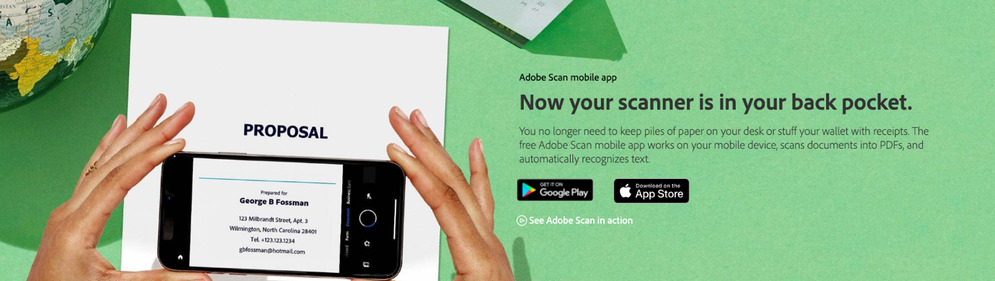

When it comes to scanning documents for digital file storage, chances are you are going to want to save in a portable document format-a PDF file. Adobe Scan is a dedicated scanning app from Adobe, the creators of the PDF file, so expectations are high that this should deliver on most user needs.
Adobe Scan runs as an app on your mobile device, whether it is running Android or iOS and uses your camera to catch a copy of a document to convert into a PDF file. There is a preview option to optimize the file dimensions, and you can rotate, crop, and edit the colour as required.
The biggest advantage of using Adobe Scan is probably its close integration with Adobe's other apps, not least Adobe Acrobat, and Adobe Fill & Sign. This means you can not only scan into PDF document format, but also edit, annotate, sign and work collaboratively with the documents that you do scan.

- Abbyy FineScanner - https://www.abbyy.com/en-gb/news/abbyys-finescanner-now-with-bookscan/#sthash.DlDxFlt9.dpbs

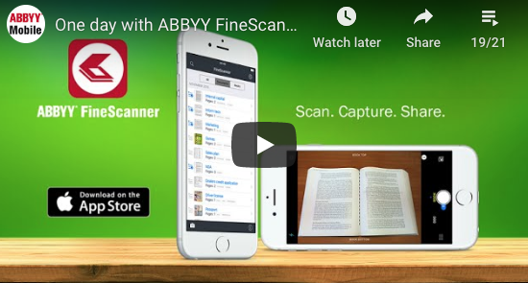

A multilingual scanning app
If you’re looking for something a little more advanced, it’s worth checking out Abbyy’s FineScanner. The software uses optical character recognition to scan text in 193 languages.
Compatible with Android and iOS, the app lets you scan both printed and handwritten text with your mobile device. FineScanner works with 12 file formats, including DOCX, PDF and TXT. The great thing about the app is that it preserves the original document formatting.
What’s more, you can access a set of easy-to-use annotation tools to add signatures and notes to text. And the iOS version of the software sports a feature called BookScan, which lets you digitize books with ease. It turns facing book pages into separate images, removing any defects.
Once you’ve conducted a scan, you can share it with anyone over email or save it to cloud storage lockers such as Dropbox, Evernote and iCloud Drive. Currently, FineScanner is free to download on Android and iOS devices, but it offers in-app purchases if you’d like to get more storage and capabilities.
- Genius Scan - https://thegrizzlylabs.com/genius-scan

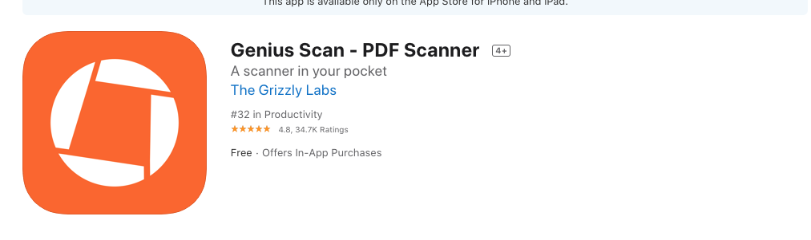
A powerful option for scanning documents
Genius Scan is yet another popular mobile scanning app, with its developers claiming that the software has digitized more than half a billion documents to date. Described as a “scanner in your pocket”, it lets you turn paper-based documents into JPG and PDF files. Headline features include smart page detection, perspective correction and image enhancement. And with patch scanning, you can create digital copies of dozens of pages within seconds. The app also enhances the legibility of documents, ensuring they’re readable, and you can keep your files organized with titles, tags and a search function. Just like FineScanner, you can upload scanned documents to a range of cloud storage platforms, including Dropbox, Evernote, Expensify, Facebook, Google Drive, OneDrive (and OneDrive for Business), OneNote, FTP, SugarSync and WebDAV.
If you’re scanning sensitive documents, you can protect them with built-in encryption and passwords (or Touch ID on iOS). It’s free to download on Android and iOS.
- Scanbot

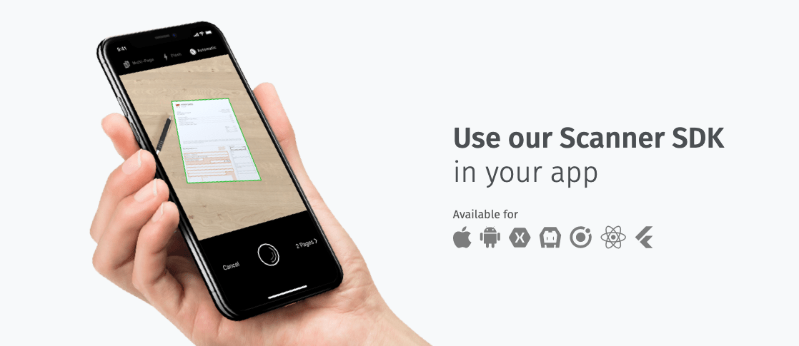
Easy-to-use document scanning software
Scanbot is positioned as an easy and fast way to create high-quality scans on iPhone, iPad and Android devices. According to the developer behind the app, it is capable of making “hundreds of decisions to capture the document perfectly”.
With the software, you can scan documents, receipts, sketches, whiteboards, business cards, labels, QR codes and barcodes. Once you’ve scanned an item, you can choose from five color modes to make it look perfect. There are also tools to crop and optimize scanned documents, all of which are automatically captured in 200+ dpi.
You’re able to save documents as PDF or JPG files, and you can upload these to a range of major cloud services. The software supports iCloud, Google Drive, Dropbox, Evernote, Amazon Drive, Slack, Todolist, OneDrive, OneNote and Box.
If you plan on using Scanbot for business purposes, you can easily fax documents directly from your mobile device in 50 supported countries. As is the case with most of these apps, Scanbot is free to download on Android and iOS, with the option of in-app purchases.
- CamScanner

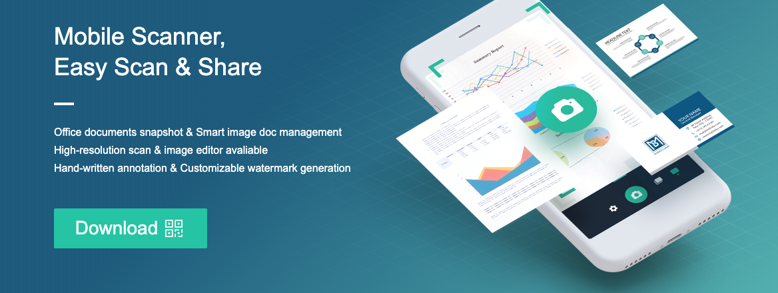
A business-grade scanning solution
As the name suggests, CamScanner is an app that turns the camera of your mobile device into a document scanner. With it, you’re able to scan a range of documents, from invoices to receipts. The software turns scanned documents into PDF files, which are automatically uploaded to cloud services such as Box, Google Drive, Dropbox, Evernote and OneDrive.
Targeted specifically at business users, the app lets you invite colleagues to view and comment on scans. However, they must have a user account to do so. There’s also an advanced editing feature, which lets you add annotations and watermarks to documents, making them look more professional. For improved security, you can add passcodes to documents.
The app is free to download on Android and iOS but you can upgrade to a premium plan to get 10GB of storage, send document links with password protection, batch download documents, and more besides.
Design Apps for Phones & Tablets
I’ve been looking at different sites, blogs and information to see the best apps for either phones or tablets; but there is such variety depending on device that you have.
I came across this guide which was published a month ago, and I feel it shows a range of free and low-cost apps that could be extremely useful for you.
I know some of you use these apps already, but there might be an opportunity to trial one or two to your advantage working offsite.
Have a go; and please if you are using any and are getting great results; I’d love to see any pictures or video of you!
Thanks, Claire
Best drawing apps of 2020

https://www.tomsguide.com/uk/round-up/best-drawing-apps

These best drawing apps turn your tablet or phone into an art studio
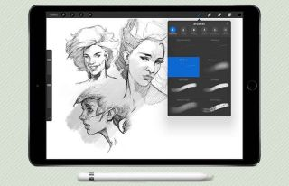
The best drawing apps for mobile devices can make all the difference when it comes to creating a work of art, no matter if your canvas of choice is the iPad Pro and an Apple Pencil, the Galaxy Note and its S Pen or a third-party stylus with your existing device.
Mobile device owners have a plethora of art and drawing apps to choose from, and it's tough to separate the gems from the fool's gold. Here are 15 of our favorite drawing apps, ranging from free and easy to use doodling tools, to high-end professional suites that can turn your mobile device into a handheld art studio.

- Astropad Studio

(Image credit: Astro HQ)
The first Astropad app did a fantastic job of turning your iPad into a video graphics tablet for your Mac, making for an excellent companion for anybody using Adobe Photoshop and similar software. Astropad has since upped its game with the new Astropad Studio, a subscription version of the app aimed squarely at graphics professionals using the iPad Pro and the Apple Pencil.
Designed to work through Wi-Fi or a USB connection, Astropad Studio boasts improved responsiveness, gesture controls, keyboard support, and more.. The app comes with a free 7-day trial, after which it will cost you $11.99 per month, or $79.99 for a year's subscription.
Download Astropad Studio: iOS
- Pixelmator
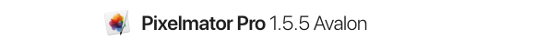
(Image credit: Pixelmator Team)
Pixelmator's iOS port delivers a powerful image editing and digital painting tool to mobile devices that syncs well with its bigger macOS version.
Pixelmator on iOS costs $4.99 and supports editing images of up to 100 megapixels in size, with numerous color correction and manipulation tools and effects, as well as handy presets for fast edits. On the painting end, the app comes with more than 100 different brushes, simulated paint effects, layers and layer effects, and support for a variety of active stylus devices like the Apple Pencil.
You can import and export Photoshop files, JPEGs, PNGs, and other popular image and photo formats, and iCloud support means your projects can sync across devices and to your Mac.
Download Pixelmator: iOS
- Autodesk Sketchbook
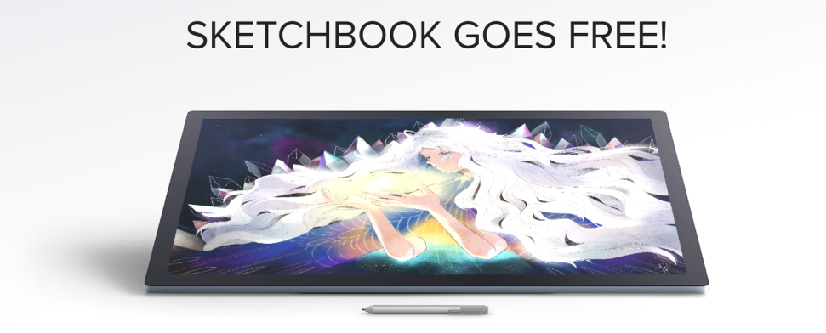

(Image credit: Autodesk)
The free Sketchbook app has all the power and ease of use you could need, as well as a unified the experience across Android and iOS. Sketchbook comes with a variety of drawing tools and brushes, all of which you can customize on the fly, pinch to zoom, a gallery organizer, and support for saving and storing your works to Dropbox or iCloud. In addition, users can create a free Sketchbook account to gain access to more features such as layer and symmetry tools. A premium Sketchbook subscription unlocks more pro tools such as an expanded brush library, and more powerful layer and selection tools.
Download Autodesk Sketchbook: Android, iOS

- Adobe Photoshop Sketch
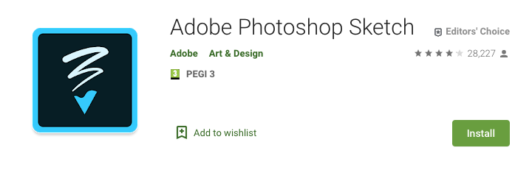
The free Adobe Photoshop Sketch ranks among the best drawing apps for giving users a set of expressive drawing tools. Users can choose from utilities that mimic a graphite pencil, ink pen or marker. The app supports a variety of Bluetooth styluses on the market such as Adobe Ink, Pencil, and others by Wacom and Adonit. Sketch aims to replicate the analog drawing experience, augmented with a few digital flourishes such as a color picker and an undo history. Users can import in assets from other Creative Cloud tools such as custom brushes and colors, and your creations can also be exported into Creative Cloud as layered PSDs to Photoshop, or flat images for Illustrator.
Download Adobe Photoshop Sketch: Android, iOS
- Adobe Illustrator Draw
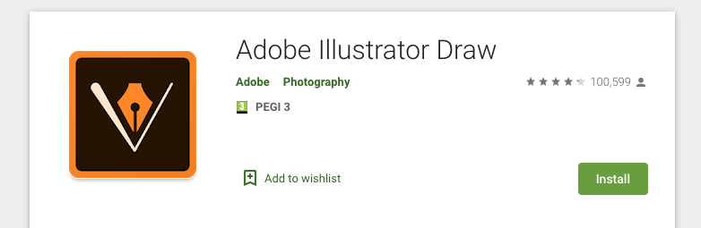
(Image credit: Adobe)
The free Adobe Illustrator Draw is a versatile vector graphics drawing app that can be further enhanced with Creative Cloud integration. You can mess around with five customizable pens and stylus support for popular devices such as Adobe Ink. You can also enjoy the ability to create up to 10 layers to create images on the app.Users can import in assets from Color CC and Shape CC, and can export drawings straight to Illustrator CC on the desktop, or PNG files to Photoshop CC. That allows you to begin a creation whenever inspiration takes you, and then flesh it out fully on a desktop rig.
Download Adobe Illustrator Draw: Android, iOS
- Ibis Paint X
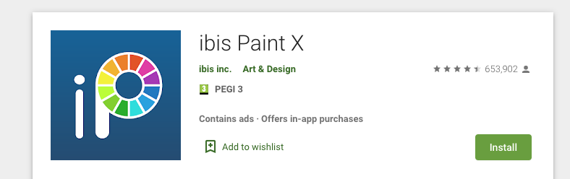
(Image credit: Ibis)
Ibis Paint X gives mobile artists a good arsenal of tools to work with on their phones or tablets, all for the low price of zero bucks. The app comes with 300-plus adjustable brushes, 58 filters, 46 screentones and 27 blending modes, unlimited layers, as well as tools for stroke stabilization, rulers, symmetry, and recording your drawing process videos to share to YouTube.
While Ibis Paint X is a free download, an in-app purchase removes advertising, and an optional Prime Membership subscription unlocks extra fonts, materials, and filters.
Download Ibis Paint X: Android, iOS
- MediBang Paint
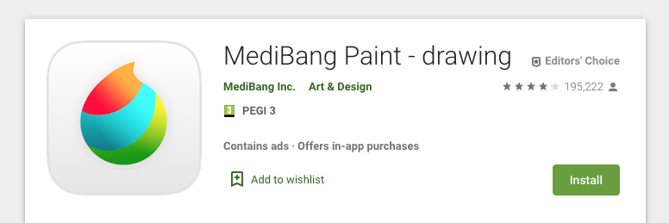
(Image credit: MediBang)
MediBang Paint is a Japanese multi-platform art app built with manga and comics art styles in mind. The app comes with the features you'd expect from a solid mobile art app, including layers, rulers, a wealth of brushes, and snap guides and tracing aides. In addition, you'll find numerous tools for things like comic panels, screen tones, lettering fonts, and more.
The free app's multi-platform support also means you can create a cloud account to transfer works between platforms, allowing you to start a sketch on a phone or tablet, and then refine your work on desktop versions of the app or share it with a collaborator.
Download MediBang Paint: Android, iPad, iPhone
- Concepts
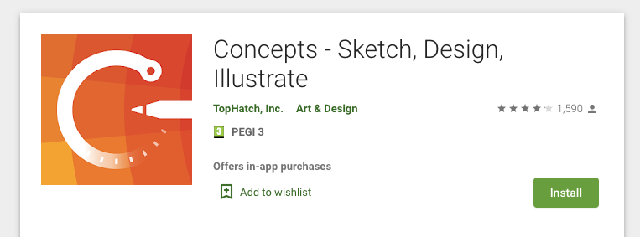
(Image credit: TopHatch)
Concepts by TopHatch is another really cool mobile art app that combines the ease of pen-and-paper-style drawing with the powerful tools of a vector graphics app. The free version is already a perfectly serviceable drawing tool, coming with five-layer support, an infinite canvas, vector brush tools, and support for a variety of Bluetooth active styli from Apple, Adonit, Fifty Three and more. A $7.99 in-app purchase unlocks the Pro Pack which adds a ton of new features, such as CAD-style tools, import and export options, transformation tools and a variety of object libraries that simplify work.
Download Concepts: Android, iOS
- Infinite Painter (Android, iOS)
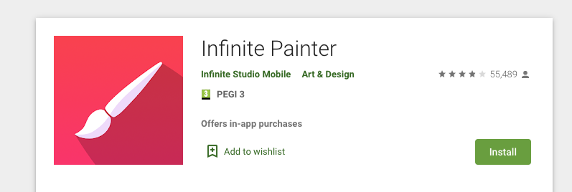
(Image credit: Infinite Studio Mobile)
Infinite Painter might not have the easy name recall of Adobe, Autodesk or any of our other best drawing apps, but it's garnered a well-deserved cult following among Android users. Infinite Painter features 80-plus natural brushes and the ability to create custom ones, infinite layer support, paper textures, a variety of transformation tools and perspective aids, color blending, pattern and gradient tools and more. Works can be exported into PSD, PNG or JPG. The app is free with a 7-day trial, after which premium features are available as in-app purchases. While originally an Android exclusive, Infinite Painter has since made the leap to iPad screens, operating under the same free trial model.
Download Infinite Painter: Android, iOS
- Adobe Fresco
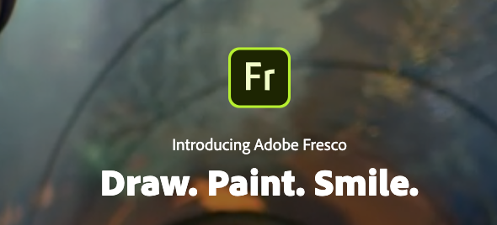
(Image credit: Adobe)
Adobe Fresco joins the ranks of the best drawing apps from Adobe, with an offering aimed specifically at iPad users, offering a combination of pixel and vector brushes, as well as tools that simulate watercolor, oil, and other traditional media. Users can import their projects from Adobe Sketch and Adobe Draw, save their work to jpg or png, and export time lapse videos of their work process.
Adobe Fresco really comes into its own when you subscribe to unlock premium features, such as cloud storage, an expanded brush library, the ability to import their custom brushes, and the ability to seamlessly move between Fresco and desktop Adobe apps like Photoshop.
Download Adobe Fresco: iOS
- Affinity Designer
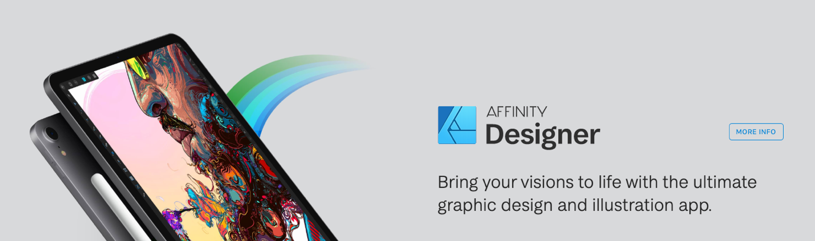
(Image credit: Serif Labs)
A powerful vector graphics design and drawing program, Affinity Designer is built to work on mobile and desktop platforms, but the iPad version takes advantage of Metal acceleration and pressure, tilt, and angle sensitivity on the Apple Pencil to provide a capable mobile design and drawing suite.
Affinity Designer lets you work with precise vector and raster modes as well as a wealth of selection, editing, history and workflow tools, all of which you can export to a variety of file formats and edit with the desktop version. At $19.99, the app may be pricey and overpowered for someone who’s just dabbling; Affinity Designer is definitely aimed more at the professional or hobbyist user.
Download Affinity Designer: iOS
- Tayasui Sketches
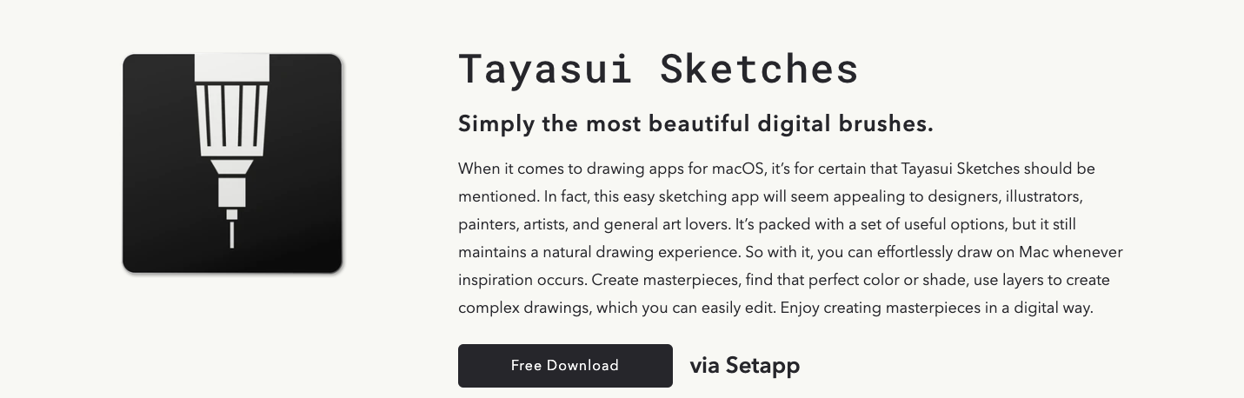
(Image credit: Tayasui.com)
Tayasui Sketches is another top drawing app that aims to mimic the feel of pen and paint on paper, with a simple slide cabinet interface for its brushes. Painting tools handle quickly and naturally, from pencil to marker to watercolor. Numerous gesture controls allow you to easily undo, redo, zoom, move the canvas and more. In-app purchases unlock further features in this free app, such as layer editing, more drawing tools and stylus pressure support for a variety of peripherals.
Download: iOS

- Artflow
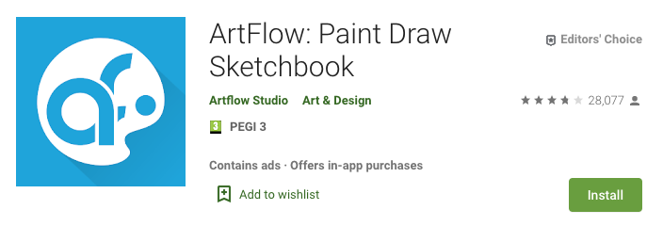
(Image credit: Artflow Studio)
The ArtFlow digital art studio for Android comes packed with features and tools, both in free and paid tiers. ArtFlow's free version is already a solid drawing app, with nine customizable brushes, a symmetry tool, color picker, six-step undo and support for two layers.
A premium version massively expands the tool selection from the free dowload, with more than 50 brushes, expanded history support, the ability to create up to 16 layers, stylus pressure support and custom palettes. That premium version has more features than any normal user would probably know what to do with, but it's great for seasoned and aspiring digital artists looking for an Android art app.
Download ArtFlow: Android
- Procreate
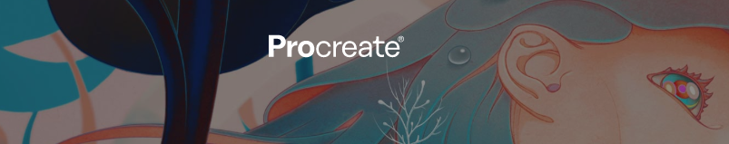
(Image credit: Savage Interactive)
More than just a clever play on words, the $5.99 Procreate brings a fast, feature-packed digital arts studio straight to your tablet. Procreate features support for ultra-high def 4K canvases, up to 128 layers, 250 levels of undo and redo, and more than a hundred customizable brushes.
From transformative tools to video capture of workflow, multi-touch gesture commands and GPU accelerated filters, Procreate offers impressive performance to artists. It's overkill if you're just looking for something to doodle with, but if you're in the market for a robust, professional-quality art app on an iPad, Procreate deserves a look.
Download Procreate: iOS

- Artrage
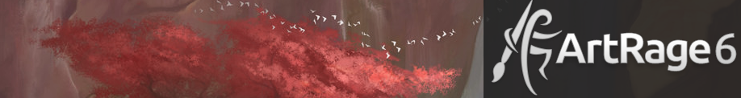
(Image credit: Ambient Design)
Where many of the best drawing apps look to take full advantage of the digital experience, the $4.99 ArtRage tries to do the reverse, delivering a set of drawing and painting tools firmly rooted in the analog art of applying graphite on paper or paint on canvas.
ArtRage features a series of tools that aim to mimic real world painting tools and mediums, such as oil paints, watercolors, a palette knife, paint rollers, and so on. The painting engine is designed to mimic the effects of paint thickness, thinner and other real-world behaviors of tools and media. That said, ArtRage doesn't totally eschew digital features, with layer control, a recording feature and undo/redo.
Download ArtRage: Android, iOS

