

Student name: BHARGAVA SAI CHEDIPOTHALA
Student ID: 2116942

Module name: Marketing Management – Assessment 1
Module code: LCMB7001
Lecturer name: Tushara Balendran

Table of Contents
NETFLIX OVERVIEW 1
VISION STATEMENT AND MISSION STATEMENT 4
NETFLIX COMMUNICATION MODEL 4
Integrated Marketing Communication of Netflix 4
New promotion strategy
This Promotional Strategy's Advantages
BRANDING OF NETFLIX 4
Brand Equity OF NETFLIX 4

NETFLIX OVERVIEW:
Netflix has grabbed everyone, allowing users to get immersed into episode upon episode, but Netflix is much more than it. Netflix's business model has proven to be successful, focusing on cutting-edge technology and innovation. Netflix is now having 222 million subscribers and also it is increasing day by day. Successful businesses must establish cutting-edge marketing strategies that appeal to a broad range of customers. Netflix marketing is a comprehensive, Because of its originality, use of leading-edge technology, inventive marketing, and present data analytics, this adaptive brand creation and customer relationship management strategy performs successfully in the age of the internet. Netflix's current marketing adjusts to market changes, where as traditional marketing strategies that only concentrate on producing a sale through one or two channels. Netflix uses continuous research and improvement to interact with customers across a number of mediums, devices, and touchpoints. Modern marketing solutions from Netflix are informational, client, personalised, and ubiquitous. According to this case study, Netflix has built innovative marketing methods for brand recognition, and also assess the user experience across several communication channels to fulfil the expectations of current and prospective consumers.
VISION STATEMENT AND MISSION STATEMENT
Netflix’s vision statement is “Becoming the best global entertainment distribution service.”
Netflix’s mission statement is “We promise our customers stellar service, our suppliers a valuable partner, our investors the prospects of sustained profitable growth, and our employees the allure of huge impact.” (RIVERA, 2019).

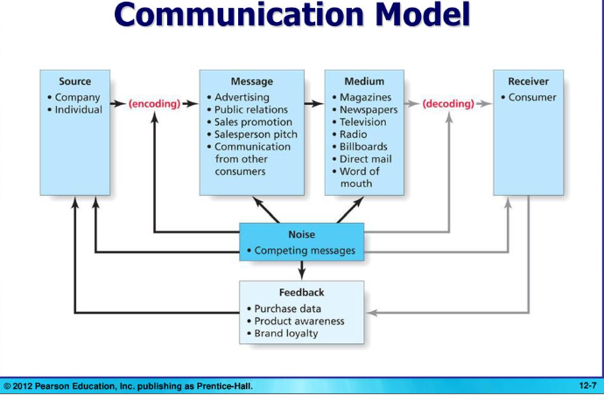
NETFLIX COMMUNICATION MODEL

We all know that the above fig shows communication model but Netflix uses different communication strategy or plan that is Strategic Communication model

NOISE

Situational analysis
With over one million members, Netflix, Inc. began as the world's largest DVD rent-by-mail business and now it is leading company in streaming. below fig shows how well Netflix established.
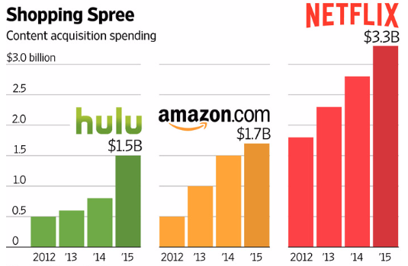

The strategic communication plan's major purpose is to help Netflix expand, which is crucial for recruiting new client groups and maybe earning income.
According to studies, just 28percent of the total of baby boomers and 38percent of total of Generation X use Netflix, posing a significant obstacle for the company's public relations efforts to boost the number of older generations that use the service, especially given how difficult it is to cater to their interests. Furthermore, the firm may establish a goal to expand the number of families that watch Netflix together, posing a new challenge to the strategic communication strategy. It's tough to use the same public relations techniques to appeal to audiences of various ages: each target group requires a unique set of procedures.
Goal
Netflix must reach out to new customers, particularly those from previous generations. Netflix's strategic communication management plan has the following major objectives:
- Netflix subscriptions and revenue should rise among families (not only by teenagers or young adults).
- Introduce the benefits of a content subscription service and how to utilise it to baby boomers and Generation X, emphasising how simple it is for these new audiences to become subscribers.
- Create and promote innovative public relations initiatives that target audiences of older individuals in order to increase their participation in Netflix memberships.
Target audience
The demographics targeted for this strategic communication technique include the baby boomer generation (adults between the ages of 53 and 71), Generation X (adults between the ages of 34 and 54), and families with children. Netflix focus on middle class people.
Message
Netflix's main message to its target audience should be that it welcomes individuals of all ages and can provide material to meet the demands of all users, regardless of generation. Many organisations that simply supply their services online fail to address the demands of older generations since they do not make up the bulk of the audience in this market. These advantages are available to Netflix.
Tactics
There will be two methods to transmit the Netflix message to its target consumers, because the techniques for recruiting complete families and members of the baby boomer or Generation X groups are typically distinct. Netflix will market its services to an older population that makes up a smaller percentage of the company's user base by placing advertising in newspapers that are widely circulated among the target demographic. The development of television advertising geared towards baby boomers and Generation X is another significant tactic that is expected to provide positive outcomes. Because the rate of adult television viewing increases beyond the age of 50.
Timing
The start of the party's campaign is vital since it sets the tone for the whole cycle of activities aimed at attracting new Netflix subscribers. While the organisation might start integrating senior adults at any moment, it's crucial to look at when families spend more time together throughout different seasons of the year.
Sequence of Campaign Tactics
Based on the Netflix audience's age split, the first phase of Netflix's marketing campaign will be to build a strong online presence and urge younger customers to spread the word about the media streaming service to their family (parents and grandparents). The next stage is to do research to establish which print and online media older generations regularly read in order to determine where Netflix should place adverts to entice new clients. The final step is to record TV commercials with genuine families and representatives from previous generations. After that, the company will work with filmmakers to develop new television series for older audiences and families. Next, a new age-based analysis of the Netflix audience will be conducted to assess if the number of older users has grown and if more families are choosing for family subscriptions.
Budget
The party's first campaign budget will be $2 million, however due to the majority of promotional activities being done through paid media, the budget may expand over time. Television commercial production is one of the most expensive forms of communication; a single commercial may cost up to $500,000 if no celebrities are involved. It's also worth remembering that a single 30-second television commercial may be rather expensive.
Evaluation
A statistical evaluation of growth, decreases, or stability in the number of Netflix members by age will be the first step in establishing if the strategic communication plan was effective. The company will also look at the link between Netflix service commercials on television or in newspapers and how users react to them.
Integrated marketing
One of the most effective methods to guarantee that you interact with your customers in a timely and relevant manner is to use marketing communications tactics. According to the American Marketing Association (AMA), integrated marketing communications is a "planning process designed to guarantee that all brand contacts a customer or prospect has with a product, service, or organisation are relevant to that individual and consistent across time." This implies that whether your target audience sees your marketing in the form of a magazine ad, a press release, a direct mail brochure, a social media post, or a sales promo commercial, the message you're trying to convey stays consistent.
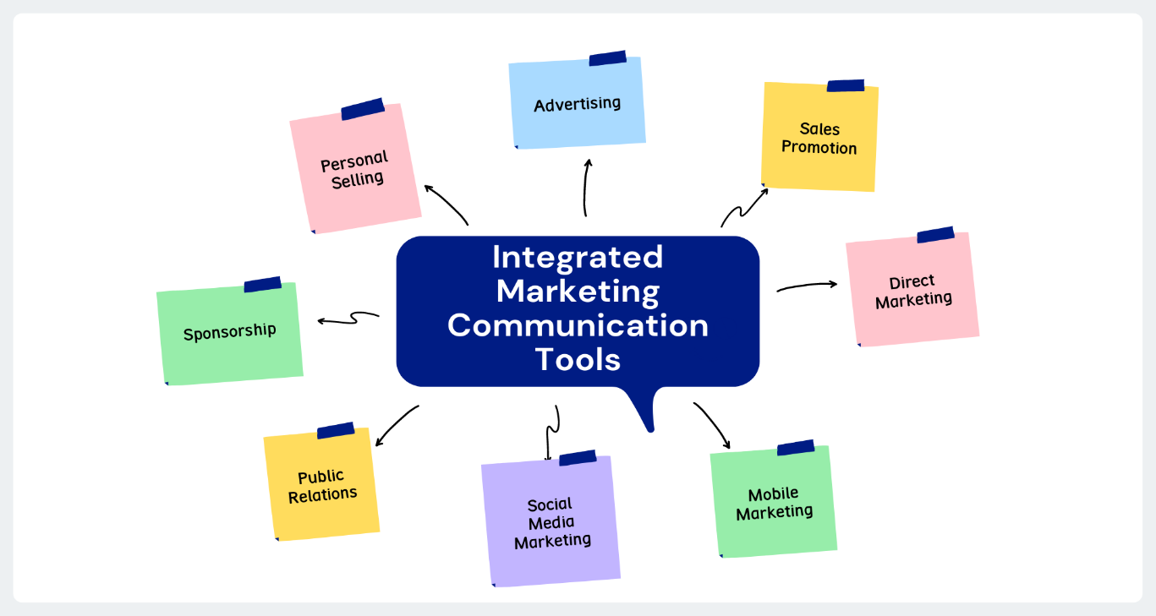
Source: dekera wed
In recent years, Netflix's marketing approach has shifted to focus on a much broader international audience. They ought to be well-known and appealing to a wide variety of sectors in order to accomplish so. To grab more targeted audience Netflix used different strategies. To start, Netflix has opted to expand its digital advertising budget in order to reach and engage its target viewers more effectively. Netflix has chosen to market its exclusive TV episodes on social media sites like Twitter and Facebook, as well as online journals, rather than using more traditional techniques of selling your brand and services (more on this later). IMC took a risk by deciding to advertise "products" rather than "brands." Netflix believes that by enticing viewers with its programming, they will become loyal fans of both its original material and the service as a whole.
Netflix's marketing plan has set the standard for how fundamental marketing principles should be executed in the future. Netflix has always prioritised buyer, integrated, and adaptive marketing.

Free trials should be reinstated.
Receiving free presents is something that everyone likes. Even if you don't want it, you accept it since it's free. Sometime viewers need push to sign up and this free trail can be boom to attract more customers.
Improved Notifications When Netflix Content Departs
Netflix should notify everyone about the contented which will be leaving Netflix so that the subscribers as well as nonsubscribers well get to know and they try to watch the stuff.
Promotional plan using guerrilla marketing
Netflix uses guerrilla marketing only to promote its content online and offline but it also has to look forward to promote the Corporate social responsibility that it is doing. As now a days social messages like poverty, human trafficking and many more information is more focused by people.by focusing on it Netflix not only gives good information to the viewers but also promotes its brand and will have position in customers mind.
Netflix combining with few foods industries
Netflix can combine with big food industries and can help the Netflix users to get great discounts and also it can promote itself in food industries which grabs many customers. It is costly but it can reduce by advertising that mega food industry brand and vis versa mega can advertise about Netflix.
Example: if you’re watching a movie in Netflix and by great advertisement you can make customer buy food or snack to enjoy the movie. In same way when u go out for having something in mega food industry by seeing Netflix and discount you get as Netflix user make you loyal to Netflix.
This Promotional Strategy's Benefits:
- stimulates ingenuity and innovation
- cost effective and efficiency.
- Long term loyalty.
- Revenue generates more than expected.
When you give free subscription to the users, they feel happy and also can become subscribers when they love the content in Netflix. As mentioned, consumers well enjoy the combination of food and cine industries. This days CSR (Corporate social responsibility) is famous to grab many customers as they became aware of many things and they are against it so environmentally friendly branding such as encouraging the use of recycled products, declaring that a portion of profits will be given away as charity or making people aware of social messages like poverty, human trafficking and many more information. It is proven that many of the users become loyal to the brand only because brands adopt what customers loves and fallows.
BRANDING:
Customers think of branding as the act of blending components like a logo, design, mission statement, and a consistent theme throughout all marketing communications to create a strong, positive image of a company, its products, or services. Strong branding allows businesses to stand out from the crowd and build a devoted audience.
BRAND EQUITY:
Brand equity is a very valued intangible asset for a company. In its simplest form, brand equity refers to the value that a firm adds to its product or service. This value is established by a company's brand recognition as well as consumer views.

Netflix Keller's Brand Equity Model
This approach "ropes up" from the positioning model to describe emotional advantages for consumers and the "something larger" that motivates. Consider the long run in this activity.
The primary tenet of According to the Brand Equity Model, you must first influence how people perceive and feel about your product in order to build a successful brand. To develop distinct, positive thoughts, sentiments, beliefs, attitudes, and opinions about your company, you must provide meaningful experiences to your customers.
Consumers that have significant brand equity are more likely to buy more from you, promote you to others, stay loyal to you, and are less likely to switch to a rival.
The fig below shows Keller’s equity model.
KELLER, KEVIN, STRATEGIC BRAND MANAGEMENT: GLOBAL EDITION, 4th, © 1901. Reprinted by permission of Pearson Education, Inc., New York, New York.

Who Are You? - Brand Identity
To express what they provide across all channels, not just the internet, the majority of firms are increasingly focusing on online brand and logo marketing. Netflix is upfront about what they have to offer, emphasising its well-known series and films. Users or consumers would be attracted to view them at their leisure on Netflix. The programmes or movies are usually broadcast at predetermined times on television. Customers can watch their favourite episodes and famous films at any time, on any device, thanks to Netflix. As a result, Netflix has established itself as a provider of on-demand digital content.

What are you? Brand meaning
Each customer must be aware of the importance of the product or service as well as how it functions. What services do they provide and how can you get them? However, there are two considerations in this case: the brand's performance and aesthetics that is Imagery.
Performance & Imagery: The company's goal is to find out what its consumers think about things like Product features, product reliability, customer service, contemporary design, and goods or services pricing are all important considerations. Netflix has spent a large part of its time adapting to advances in technology and attempting to improve all aspects of the business while still providing the best possible customer service by producing the best available shows/series/movies and original material, allowing each other to charge consumers and provide value in every way possible.

What about you? - Brand Response
What a consumer has heard from others is referred to as their "customer experience." An unfavourable point of view is described by a judgement, whereas a good point of view is described by an emotion.
Clients say Netflix offers the best content, but they give it a low rating because of the company's pricing, which they believe is expensive or has altered frequently in the past. However, the price has been reduced, making it more affordable to individuals without access to advanced technology.

What about you and me? – Brand relationship
Relationships are largely created on responses, and this is the final phase of this approach, which is difficult to continue for only a few firms. Netflix has been successful in these areas because it has been able to adapt to the macro and micro elements that impact its customers and react quickly to their benefit. Netflix has continuously delivered high-quality content that is available on all platforms. In today's world, remuneration is dependent on user feedback. Because Netflix is a customer-focused firm, obtaining the maximum degree of Killer's strategy was simple. Netflix is also committed to upholding its ideals and achieving its objectives of providing customers with the most convenient and high-quality entertainment possible.

Keller's Brand Equity Model's Benefits and Drawbacks:
This process will assist in the difficult work of enhancing the company's image. Brand positioning may help you earn consumer respect, boost your sales, maintain or enhance your value, and generate money. In terms of revenue generation, both providers and consumer’s profit. It'll also help with customer retention and brand loyalty. The biggest disadvantage is that it takes a lot of time and money to get to this point, as well as a lot of money to create a good image of the company in the hearts of consumers. (2019, by Gibson Biddle))

Customer Journey of Netflix.
It's all about the customer's journey from the minute they become aware of a brand through their lifelong commitment to it.
Netflix is well-known for its dedication to its customers. In order to make their trip as simple as possible, To make it easier for users to join Netflix, the company has been modernising and deleting or decreasing contact points. One of the client journeys will be described in the Customer Journey Map subject. Netflix has raised product recognition by broadcasting popular series or films that customers like watching on a regular basis. This was the first item that attracted their attention. Customers who were given a one-month free trial were encouraged to think about the product and were given material in a range of languages and genres. The user's decision was made easy by providing a variety of subscription options accessible from any device. Retention became difficult at first because of the large number of new service providers. Netflix, on the other hand, has been creating and releasing some fantastic original content that is not accessible anywhere else, which has kept people committed to the service. They've added a Kids area and now full-version games, allowing kids to spend more time with the rest of the family on Netflix. CSR activates play a part in decision-making when all elements are considered, not only content. In a few cases, clients' sentiments toward a company have been demonstrated to remain positive throughout such social events. People utilise advocacy to disseminate positive feedback about a product, as well as their customer service and CSR efforts.
Customer journey map:

Source::learner

The Customer Journey Map is shown in the table above. The customer journey's flow is depicted in this diagram. A friend recommended Netflix to the user since he was looking for a favourite show that had been taken off the air. He then reads the website's content and reviews to have a better understanding of the service and product they offer. During the free trial time, he'll try it out and watch some of his favourite shows. The customer is persuaded to become a client by receiving and being counselled on a wealth of information that he values, such as ideas and the top 10 people to watch in his city. He then realises that he can have access to rare and previously unseen items, and he decides to subscribe depending on his interests and gadgets, as well as share his membership with his family so that everyone has their own tab. He'll give the app a positive review and recommend it to his friends and relatives.

Customer Touch Points of Netflix:
At each stage of the customer journey, the customer contact point provides a readily accessible source for customers to engage.
Netflix has demonstrated its ability to respond to any factors that may influence a customer's decision-making process. To counsel clients and turn them into customers, it has been streamlined and made available on a variety of platforms. Netflix's Pre-Purchase Touchpoints have proven to be pretty effective. Because they are a customer-centric firm, they have always been emotionally invested in their brand's advertising. It was available on all social networking sites, as well as online advertising and personalised site suggestions, with peer referral being the quickest method of obtaining it. During the trial time, the user is engaged with short films, suggestions, and a local top ten list on the website or mobile app. Customers may quickly look for items based on their preferred language or genre. They provide new material along with trailers to keep consumers engaged, and now they've added full-version games to the mix. Following the purchase, Netflix has a dedicated team working to assist customers with online or call centre support. They also send a thank you note to the customer after the transaction to make them feel unique and valued.

Total Engagement Model:
A company's success is largely determined by whether or not customers choose to purchase its products. It's common knowledge that a company's commercial performance, including sales and growth, may explode if it focuses on nurturing engaged customers rather than attracting people to make one-time purchases. Below is a list of the primary components of the whole Engagement model.
. internal culture elements
. customer value proposition
. customer experience
. brand
(Journal of product and brand management, 2010)
Netflix is a customer-focused company that begins by emotionally connecting customers by providing the best and most popular programmes and movies, as well as well-known stars, that television stations have practically stopped showing. Customers benefit from the ability to watch content on any device, from any location, at any time. By utilising the most cutting-edge marketing strategies, the organisation has established itself as the best. Because he is offered original material, full-version games, the top 10 in the city, and suggestions based on his watching history, the consumer is never bored and is constantly interested. It completely engrosses the consumer and ensures that they get fair value for their money while maintaining a high level of content quality.

Conclusion:
Marketing is essential to improve the brand, as stated in the previous study. Netflix has been pushing both its original and well-known content in order to attract and keep subscribers, according to my study. Customers have been given additional alternatives and chances as the company has evolved. When I first started as an online streamer, it was just material, then a child’s section was added, then a top 10 list based on region was proposed, and even before that, bespoke ideas were created. The shuffle option was introduced when customers were bored and had no clue what to watch, and it randomly chose episodes or movies based on their viewing history. Following that, future excerpts were added to pique their curiosity, followed by short movies to browse through and merely watch famous and amusing sections for a short time, and finally, games with no in-app purchases and complete versions to keep the user engaged. Furthermore, customers have always recognised the importance of content, despite the fact that money has always been a problem. Furthermore, pricing has long been an issue, but customers have recognised the worth of material based on its high quality, so the company has introduced lower-cost choices with fewer logins to address this. Promoting the company's CSR initiatives will inspire current and future customers and stakeholders to think favourably of it. Customers must emotionally embrace the concept that they are indirectly contributing to society in exchange for the premium they pay. However, the corporation has always placed a premium on environmental sustainability and the education of low-income children, both of which must be addressed if the brand's image is to be improved.

- Affelt, A. (2011). Best Practices for Aligning the Mission and Marketing the Services of the Corporate Library. Best Practices for Corporate Libraries, 153-66.
- Ciejka, D. (2018). Worth Watching?: Assessing the Financial and Operational Health of Netflix.
- Ellis, K. (2015). Netflix closed captions offer an accessible model for the streaming video industry, but what about audio description?. Communication, Politics & Culture, 47(3), 3.
- Goffee, R., & Jones, G. (2015). Why should anyone work here?. What It Takes to Create an Authentic Organization.
- Grimes, M., Williams, T. A., & Zhao, E. Y. (2018). Anchors aweigh: The sources, variety, and challenges of mission drift. Academy of Management Review, (ja).
- Hawkins, D., & Fryling, T. (2017). Redefining transformation. People+ Strategy, 40(2), 46-51.
- Hoffman, M. B. (2007). The myth of factual innocence. Chi.-Kent L. Rev., 82, 663.
- Jenner, M. (2018). Netflix and the Re-invention of Television. Springer.
- Karnani, A. (2008). Essence of strategy: Controversial choices. In Learning and performance matter (pp. 101-116).
- Kato, N., Fadlullah, Z. M., Mao, B., Tang, F., Akashi, O., Inoue, T., & Mizutani, K. (2016). The deep learning vision for heterogeneous network traffic control: Proposal, challenges, and future perspective. IEEE wireless communications, 24(3), 146-153.
- Kosiarz, M. The specificity of online entertainment services. Case study: Netflix.
- Lobato, R. (2019). Netflix Nations: The Geography of Digital Distribution. NYU Press.
- Netflix – Overview.
- Onyusheva, I., & Seenalasataporn, T. (2018). Strategic analysis of global e-commerce and diversification technology: the case of Amazon. Com Inc. The EUrASEANs: Journal on global socio-economic dynamics, (1 (8)), 48-63.
- Perryman, K. (2014). Netflix.
- Radošinská, J. (2017). New trends in production and distribution of episodic television drama: brand marvel-Netflix in the post-television era. Communication Today, 8(1), 4-29.

