Mapping the relationship between fact and fiction

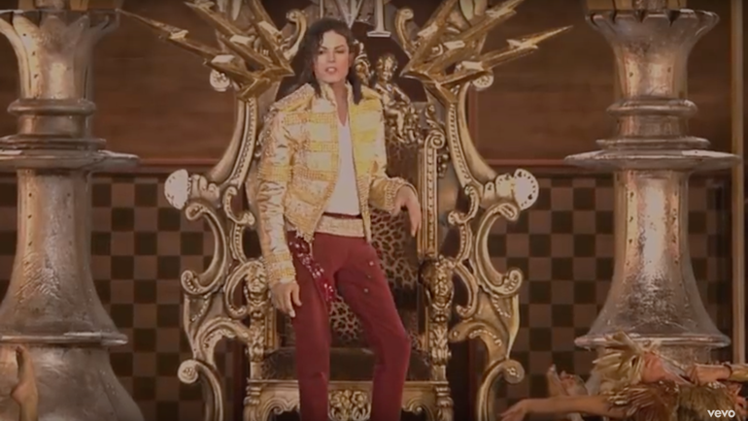
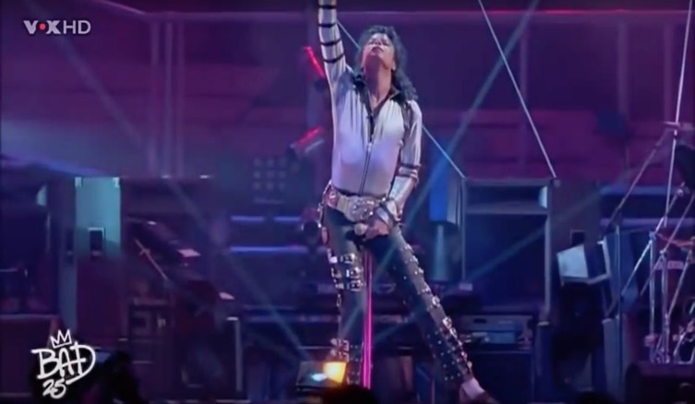
Here are two stills of Michael Jackson performing live, what if I told you that one of them was fake and that it’s a virtual model which would you think is the fake?, What would you look at specifically in these images to distinguish them is it his jacket, his hair or the lighting? How do you know that right now I’m not lying to you and both the images are actually really staged performances he’s done? Or am I lying again and they’re really both faked. You have no way of knowing this in fact you could not be reading this you could be dreaming, but then how do you know you are dreaming. How can you know that your thoughts are your own or that you’re not in someone else’s dream? These thoughts and ideas were also shared by Rene Descartes he wondered how he could figure out if he existed and came to the conclusion that all other senses were unreliable and that the only sense he could rely on was his mind a he theorised that to if he is thinking about if he exists than he must exist which brought to light the idea of “cogito ergo sum” “I think there for I am”. (Descartes2015).

Our eyes may be one of our most important assets in our, life but that doesn’t mean that they always tell us the truth. This essay aims to study the philosophy of fantasy and reality, and look into what these ideas are and how history repeats itself when it comes to people’s perspective of something. The idea that not everything we see both in real life and on screen is always what it appears to be how these methods will help in developing the story and world within my final piece.

Philosophy Of fantasy and reality

As the title suggests, this essay will be looking at how over the centuries people’s observations have been skewed by what others have said and what others have believed they’ve seen; starting with the birth of Christianity. this essay also aims to look at what people perceive to be faith and how it can be misconstrued as a need for guidance, and how in the past this could have been taken advantage of. I also want to talk about how these stigmatisms have evolved and made their way into modern society.

In the era of the bible many took this book to be the words of God himself, and many people today still take these as words to live by. However, no one really knows who wrote these entries or stories. It is a common belief that the first five books were written by Moses himself, however, how can this be claimed to be truth as there are several instances of Moses calling himself a messenger of God, and that with his help he will lead others to salvation through their struggles? A common hole in this idea however, is in the 10 commandments, when they start talking about what each is and the one which raised a flag in my mind to begin with was the first commandment “Thou shalt have no other gods before me." Deuteronomy (5:6-21). This seems very reminiscent of how cults keep their followers in line and keep them away from any form or rational thinking. For example, many famous cults end with mass suicide, but they try to ensure that they have a basis for their belief behind it. For example, Heaven's Gate believed that they would be taken to another planet (Mosher, 2008). This is very similar to how Christianity and most other religions preach that if you do what they say you will live in heaven. But where in these words of heaven or other planets is there fact? It’s because there is no evidence stating that what is preached is truth. That is because there is nothing, but fantasy preached to those seeking guidance and are at low points in their lives and use that to indoctrinate them. It is this mentality that has led many people to believe that the human race can’t deal with the idea of the unknown says Savva (2017), so people come up with ideas of what can happen afterwards, but in the long term can turn out to only benefit the leader or the creator of these stories. History is plagued throughout with people such as this,

However not all have bad intentions. For example, the Christian faith in some cases has given a lot of benefits to people’s lives. However, it doesn’t mean that the meaning behind its morals are true, but even if the morals aren’t true isn’t it better to have told a lie to benefit the mass majority? Fieser (2010) suggested that many theorists such as David Hume have pondered over this particular topic. Hume’s studies of the philosophy of religion brought him to the conclusion that it is unethical to listen to the morals and testimonies of alleged miracles from century old books telling of their events. This is because of their lack of evidence to real events and allowed for his studies to follow its own path away from faith .This statement is a perfect example of how a group who have been manipulated by a story can have a domino effect later on in history. As during Hume’s time he needed to bring his studies away from religion because it constricted how he would be able to think. (Mosher (2008)

These kinds of ideas and thoughts may be created to keep others in line. But what if these ideas are applied in such a way as not to dupe or influence people into keeping in line, but instead used to alter people’s perspective of a situation, or use it to help build the world within a story?

A whole world fakery

Many works both within and outside of film have an ethical reasoning for why they would use effects in perhaps their stage performances or within a film. However, whether or not these reasons are for good or bad reasons are up for debate. However, they are all after the same result, to try and make it believable for the viewer and not just an illusion by the performer or director..

Many magicians have been able to overcome this in ways such as, through the use of sleight of hand, or using practical effects during there performances all with the goal of trickery in mind.
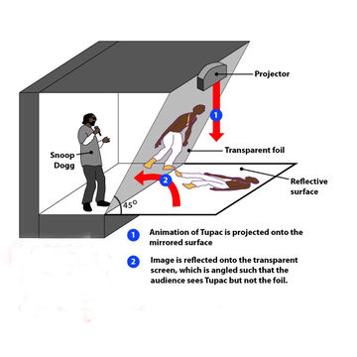
An example of this could be seen in the use of holograms. As previously discussed there was once a live stage performance by Michael Jackson however, the performance took place several years after his death. This was possible through the uses of holographic projection. How this system works is by projecting an image onto a reflective surface and then have it reflected onto a transparent foil. This allows for other performers to still be visible on stage without obscuring the projection. This method Is just one method of how people’s eyes can be easily tricked. one issue with holographic projection is that if you are not situated at the correct angle it can break the immersion and the idea that they are a real person. When these intensions of trickery are applied to a film setting however the results can be incredible.
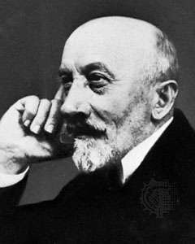
the magician George Melies was one such magician, who saw the potential that films and special effects could have on how a story could be told, and how people could be fooled into believing what was on screen to be fact. Within a span of 13 years melies made over 400 films of which the best of those were when his intellect of illusion influenced how the films should be made the most memorable of these films being Le Voyage dans la lune. In this film he realised that through the use of special effects both in practical and post, he was able to for lack of a better phrase make the impossible, possible. His reasons behind fakery were for the good of others to try and bring them away from reality for a short time. To a place where anything is possible. (Britannica 2019)

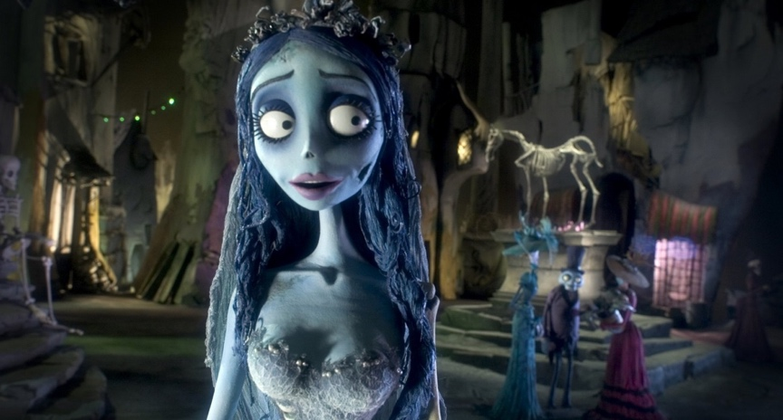
Tim burton is another film maker who shares this mentality: using cinema to bring other worlds to life For example in his film Alice in wonderland there is a heavy use of special effects to help the viewer become more immersed in the world of the film, using it to bring his ideas and fantasies to life. However, many people have said that Burtons style may seem out there or crazy for a simpler term, which he has replied “One person's craziness is another person's reality.” (Burton 2013).
Stating that to the most audience members it could seem out of the ordinary but to some this could be there reality. It is believed that his films are actually taken from the thoughts and ideas which he had at a young age. He used those thoughts to influence how it should look, to try and immerse his viewers into the world on screen; similar to how Melies’s films made people think that these events and other worlds had actually transpired, Tim burton’s films attempted to push this idea of a different world and bring them to life, but bringing it in a way which also shows how some people perceive the world, He uses the Melies’s base techniques to do this but in much more advanced means .

But there is an extent to this for example in the film Rogue One, the actor Peter Cushing was a member of the cast despite the fact that he has been dead for over 20 years. However, this is not the only actor who has been resurrected through the use of CGI and VFX. For example, Audrey Hepburn was recreated in CGI for a chocolate commercial this has now brought up issues in the world of cinema effects where it is morally right for people to bring back the dead for something as simple as a scene. Yes this is a large step in the ways in which films can be made but does that mean its morally right to do so on behalf of the deceased’s family. An example of this is actually surrounding the Rouge One film with the head of the VFX department stating “We didn’t do anything Peter Cushing would’ve objected to”(Radiotimes 2017) . Was it really there decision whether or not he would have wanted this? unfortunately this is unclear, but this is just a simple example of how VFX and fakery can have an impact on how people perceive a film, as during the film many were fooled into assuming it was the real actor. One thing is certain though, throughout each example of how editing and virtual effects have each been used as a method of storytelling, to challenge the viewer to look at the world in a different view and allow them to enter another world.

Major project

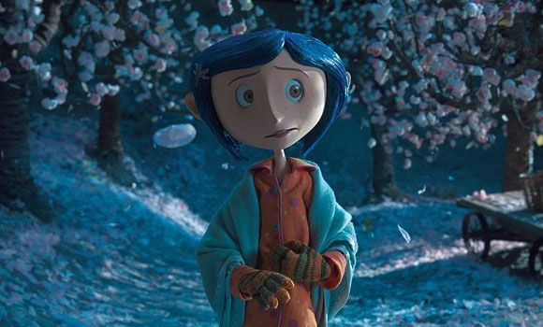
One thing I have always been inspired by in film is the idea that with it you are able to create entirely different worlds with only simple understanding of virtual effects, and it is this idea of other worlds and other perspectives that I want to look at when creating my major project, and how cinema is able to bring out an entirely different side of a person or help a person to communicate when they perhaps are un able to. I want this film to mean something to people, like how other films from Disney and Laika studios have inspired me to peruse this. What my project entails is mixing two different realities into one. A simple example of this would include films such as Who Framed roger Rabbit and Coraline. More so taking inspiration from Coraline, though its use of colour and story idea of another reality where the absurd is possible and reality is not the only option, but merely a gate to these ideas and worlds

I also hope to look more into Tim Burton’s work during this time and use his gothic slender like style in the creating of the visual aspects of the film, mainly for how I envision certain aspects of the other world within the film.

I also hope to look more into mental health and at some mental disabilities, and integrate these traits and personality’s into my characters and try to show what these are and that although these disability’s and conditions exist, it doesn’t mean that these people are any less human than the person next to them and that they only perceive the world in a different view.

Conclusion

To conclude, after looking at some of the history of fakery, trickery, optical illusions, how these have influenced modern day VFX and CGI in cinema; do I believe that this could be a worthy topic to discuss with in a dissertation? Absolutely I believe that I have only scratched the surface of what is possible through this medium of film making, and believe that there are hundreds of possibilities which I could cover However my main focus will be:

Could the use of VFX and CGI in cinema have a negative effect on the future of cinema?

What I hope to cover with this question is the idea that these methods of film making are starting to take over the existing format of film making, how they are doing this and what effects these can have on future films which could be produced.

Bibliography

- the school of life. (September 2015). Philosophy – Rene Descartes Retrieved from https://www.youtube.com/watch?v=CAjWUrwvxs4
- Deuteronomy (5:6-21), holy bible
- Live Science (2019) ’10 deadly cults’, strange news .8 April 2008. Available at: https://www.livescience.com/11370-top-10-crazy-cults.html
- Counselling Directory (2019) ‘anxiety and fear of the unknown. 11 may 2017 avalable at: https://www.counselling-directory.org.uk/counsellor-articles/anxiety-and-fear-of-the-unknown
- Fieser J (2010) David Hume’s (1711 – 1776) available at: https://www.iep.utm.edu/hume/
- Rickeitt R. (2006) special effects the history and technique. London aurumpress

- Drake E The Christian Science Monitor available at: https://www.csmonitor.com/Books/2013/0823/Tim-Burton-10-quotes-on-his-birthday/Reality
- Radio times (2017) January 17th

