

LCLM5001
Stakeholder Engagement Strategies for the Successful Launch of ConnectPlus: A Project Management Perspective at Amazon UK

Student Name: Zaffar Hussain
Student ID: 2436275

Lecture Name: Aso Abdullah

Word Count: 4174

Executive Summary
This report investigates how to engage stakeholders to make ConnectPlus, Amazon UK's AI-powered customer loyalty and engagement platform, a success. The platform is designed to enhance customer retention, strengthen decision making based on their data and give competitive solutions in local and international markets. Stakeholder engagement is a crucial element that makes projects successful, as they involve several groups of stakeholders in a vast collaboration of different stakeholders. It has been observed that effective stakeholder relations increase collaboration, long-term value co-creation, trust and coordination, especially in the context of collaborative and complex projects. The report is based on the stakeholder theory and principles of project management and identifies and prioritizes the internal and external stakeholders in ConnectPlus implementation. Taking into account frameworks like the Mendelow's Power-Interest Map and the Salience Model, the report assigns stakeholders their roles, responsibilities and expectations. A variety of engagement mechanisms (such as communication plans, the RACI matrix, and the 4C's framework) are explored and examined to uncover how collaboration and participation can be improved and how differences managed. Finally, the report assesses how stakeholders' engagement through sustainability effects organisation’s performance and concludes that good stakeholder management is crucial for innovation, moral business and durable competitive advantage of the organisation.

Table of Contents
1. Introduction to Amazon UK 4
2. SMART Objectives 5
3. Identification and Categorisation of Key Internal and External Stakeholders 5
3.1 SWOT Analysis 6
3.3 Stakeholder Identification 7
3.4 Mendelow Power-Interest Matrix 8
3.5 Salience Model 9
4. Roles, Responsibilities, Benefits and Challenges of Key Stakeholders 10
5. Critical Explanation of Stakeholder Engagement Process and Conflict Management 12
6. Evaluation of the Impact of Sustainable Stakeholder Engagement on Business Performance 16
7. Recommendations and Conclusion 18
References 20

1. Introduction to Amazon UK
Amazon UK is a market-leading retailer and ecommerce business in the United Kingdom and overseas. The company is dedicated to ongoing investment in new technologies that will improve the customer experience and continue to give them a competitive edge. Retail has seen a significant transformation through digital as digital tools have found their way into organisational activities, helping to leverage artificial intelligence, analytics and customer-centred technologies for better operational efficiency and customer engagement (Akhtar et al., 2022; Benjamin and Potts, 2020). Thus, Amazon UK is to roll out ConnectPlus, the digitally augmented customer loyalty platform which will incorporate AI-driven recommendations, mobile-based rewards and customer insight features.
ConnectPlus primary aim is to boost customer Loyalty, improve customer retention and aid in Strategic decision making with advanced Analytics. This deployment is forecast to be spread out over a period of approximately six months across selected markets globally, with the need for strong collaboration between various groups of stakeholders. Wise et al., (2020) argues that governance and interaction with stakeholders are fundamental to aligning organisations to strategy. In turn, Ali and Haapasalo (2023) stress the need to establish trust and build relationships with stakeholders to achieve successful collaborative projects.
Being the Project Manager, their role is to ensure that stakeholder involvement is a core element of project planning and delivery, as this may be affected by competing interests, different expectations and cultural environments affecting project outcome. Given that numerous parties need to be coordinated from different locations in the digital age, it is imperative that effective communication and stakeholder leadership is key in the pandemic context (Pedemonte, 2024; Galindo et al., 2021). In this context, this report critically challenges the approaches to stakeholder engagement for effective launch of ConnectPlus and appraises the potential of sustainable stakeholder relations in sustaining the business and improving organisational performance (Moorthy and Parvatiyar, 2023; Lazzarini et al., 2026).

Figure 1: Amazon site
Source: (Amazon UK, n.d.)

2. SMART Objectives
The ConnectPlus project is guided by SMART objectives to ensure effective implementation and measurable outcomes. Specific objectives include launching the AI-driven loyalty platform across selected international markets and improving customer retention through personalised recommendations and mobile rewards. Measurable targets involve increasing customer retention by 15%, improving customer engagement by 20%, and achieving active participation from at least 95% of key stakeholders. These objectives are Achievable and Actionable because Amazon UK possesses the technological capabilities, financial resources and organisational expertise required for digital transformation. They are Realistic, given Amazon UK's existing infrastructure and experience in customer-focused innovation. Finally, the objectives are Time-bound, with the platform scheduled for implementation within six months and performance indicators evaluated during the first year following launch (Ali and Haapasalo, 2023; Pedemonte, 2024).

3. Identification and Categorisation of Key Internal and External Stakeholders
Participating with stakeholders is a crucial component of project management as it is the fact that stakeholder support, co-operational and commitment are integral to project success, in order to realize project objectives. Stakeholder theory states that companies should take into account not only the viewpoints of shareholders but those of everyone who has an interest in the firm. For Amazon UK, the launch of ConnectPlus involves a large number of internal and external stakeholders impacting the project's performance and long-term value creation in the future. In digital environments that make organisations ever simpler to manage with new innovations and interdependencies, collaborative stakeholder relationships are especially relevant (Ali and Haapasalo, 2023; Wise et al., 2020).

3.1 SWOT Analysis
Table 1: SWOT Analysis for Amazon UK's ConnectPlus Platform
Strengths | Weaknesses
Strong global brand reputation and high customer trust. | High implementation costs associated with AI and digital transformation.
Advanced AI, cloud computing (AWS) and data analytics capabilities. | Dependence on customer data increases privacy and cybersecurity risks.
Extensive logistics network and financial resources support project delivery. | Integration challenges across multiple international markets and legacy systems.
Large customer base provides rich data for personalised recommendations. | Potential employee resistance to organisational and technological change.

Opportunities | Threats
Growing demand for AI-powered personalised shopping experiences. | Increasing competition from Walmart, Alibaba, Temu and other e-commerce platforms.
Expansion into emerging international markets. | Stricter global data protection regulations (GDPR, UK GDPR, CCPA).
Improved customer retention through AI-driven loyalty programmes. | Cybersecurity attacks and data breaches affecting customer trust.
Strategic partnerships with technology providers and fintech firms. | Economic uncertainty reducing consumer spending.

3.2 PESTLE Analysis
Table 2: PESTLE Analysis for ConnectPlus
Factor | Impact on ConnectPlus Project | Stakeholder Implications
Political | Government policies on AI, digital trade and taxation may influence implementation across countries. | Continuous engagement with government agencies and policymakers.
Economic | Inflation, exchange rate fluctuations and technology investment costs may affect project budgets. | Finance teams and investors should monitor project expenditure.
Social | Customers increasingly expect personalised, convenient and ethical digital experiences. | Marketing and customer service teams must understand changing customer expectations.
Technological | Rapid developments in AI, cloud computing and cybersecurity create opportunities and implementation challenges. | Close collaboration between IT, AI specialists and technology partners is essential.
Legal | Compliance with GDPR, UK GDPR, consumer protection legislation and AI governance regulations is mandatory. | Legal, compliance and regulatory stakeholders require continuous involvement.
Environmental | Stakeholders increasingly expect sustainable digital operations and responsible data centre management. | ESG reporting and environmental initiatives improve corporate reputation among investors and communities.

3.3 Stakeholder Identification
The internal stakeholders include those who are directly involved in the planning, development and implementation of ConnectPlus.The internal stakeholders are the ones, who are directly involved in the planning, development and implementation of ConnectPlus. Here are some of the stakeholders involved: senior management, project managers, product development teams, software engineers, AI experts, marketing teams, customer service teams, finance teams, and human resource managers. Internal stakeholders have high level of interest as the platform has an impact on the operational, customer satisfaction and organisational performance. Digital transformation is the joint responsibility of multiple functional areas and needs cross-functional communications and coordination of stakeholders ensuring strategic objectives are met (Benjamin and Potts, 2020; Akhtar et al., 2022).
External stakeholder is also a critical group as they play an influencing role in the acceptance and sustainability of ConnectPlus. The platform's success is influenced by customers, suppliers, logistics partners, third party sellers , regulatory authorities, tech vendors, and investors and local communities. For the customers, there is a need for personalised interactions and handling of sensitive data—suppliers and third party sellers want operational efficiency, and better market opportunities. Whether it is financial performance or competitive advantage that investors are seeking, regulators have to ensure adherence of the company's privacy and consumer protection policies. Trust and cooperation can be improved through effective stakeholder engagement by the external stakeholders working across various international markets (Moorthy and Parvatiyar, 2023; Pedemonte, 2024).
Table 3: Stakeholder Identification Table
Stakeholder | Internal / External | Interest | Influence | Expectations
Senior Management | Internal | High | High | Successful implementation
Project Manager | Internal | High | High | Deliver project on time
Product Development Team | Internal | High | High | Adequate resources
Marketing Team | Internal | High | Medium | Customer adoption
Customers | External | High | High | Personalised experience
Investors | External | Medium | High | Increased profitability
Regulatory Authorities | External | High | High | Legal compliance
Suppliers | External | Medium | Medium | Stable partnerships

3.4 Mendelow Power-Interest Matrix
The Mendelow's Power-Interest Matrix can help determine the priority of stakeholder groups based on their power and interest. Senior executives, shareholders and regulatory bodies have high power and high interests which should be monitored. Product Development teams, marketing and AI experts also have a keen interest as they play a direct role in project delivery. The power of customers and suppliers is medium, and their interest is high, so they should be involved in the project according to their interest and importance. Community organisations and groups typically have less power or interest, so should also be kept well informed, but on a regular basis to strengthen social responsibility and transparency. When implemented well, stakeholder mapping helps project managers focus resources and channels on the right people and groups (Wise et al., 2020; Ali and Haapasalo, 2023).
Table 4: Mendelow Power-Interest Matrix Table
Stakeholder | Power | Interest | Priority | Engagement Strategy
Senior Management | High | High | Very High | Manage Closely
Project Team | High | High | Very High | Manage Closely
Customers | Medium | High | High | Keep Informed
Marketing | Medium | High | High | Keep Informed
Investors | High | Medium | Medium | Keep Satisfied
Regulators | High | Medium | Medium | Keep Satisfied
Suppliers | Medium | Medium | Medium | Keep Informed
Local Communities | Low | Low | Low | Monitor

The Salience Model is also put forward by Mitchell et al., for stakeholder prioritization based on power, legitimacy and urgency. Senior management has all three attributes and so are key stakeholders who are central to the support they give. Regulatory authorities also have significant authority and legitimacy, as they guarantee adherence to the laws in intelligent techniques and information security. Suppliers and logistical partners exhibit legitimacy and degree of power, and are dependent stakeholders – their expectations need to be managed. Stakeholder prioritisation based on their salience helps organisations to react to stakeholder pressures and to handle shifting business environment (Pedemonte, 2024; Wise et al., 2020).

3.5 Salience Model
Table 5: Salience Model Table
Stakeholder | Power | Legitimacy | Urgency | Stakeholder Class
Senior Management | ✔ | ✔ | ✔ | Definitive
Customers | ✔ | ✔ | ✔ | Definitive
Regulators | ✔ | ✔ | ✔ | Definitive
Investors | ✔ | ✔ | ✖ | Dominant
Suppliers | ✔ | ✔ | ✖ | Dominant
Employees | ✖ | ✔ | ✔ | Dependent
Local Communities | ✖ | ✔ | ✖ | Discretionary

Senior management is one of the key stakeholders from a project management perspective, as strategic decisions, decisions about funding and decision-making on organisational support come from senior management. Their dedication brings about a tight allocation of resources and the consistency of the objectives set against the organisation's targets. Digital transformation initiatives involve communication and governance systems by leadership, which are critical as uncertainties and complexities typically raise stakeholders' perception of their needs. Good governance helps drive strategic alignment and builds stakeholder trust in the value to be gained from the projects (Benjamin and Potts, 2020; Wise et al., 2020).
Customers are also a key stakeholder group as the focus of ConnectPlus is to improve the customer experience and drive loyalty. By leveraging the capabilities of artificial intelligence (AI), Amazon UK hopes to offer more value and customer propositions, alongside improving customer relationships. In the digital era, customer engagement is becoming an integral part of a business strategy, as organisations are using co-creation processes and interaction increasingly to generate competitive advantages. Therefore, understanding customer expectations and building trust is crucial for successful adoption of digital platforms and for sustaining their financial success (Moorthy and Parvatiyar, 2023; Akhtar et al., 2022).

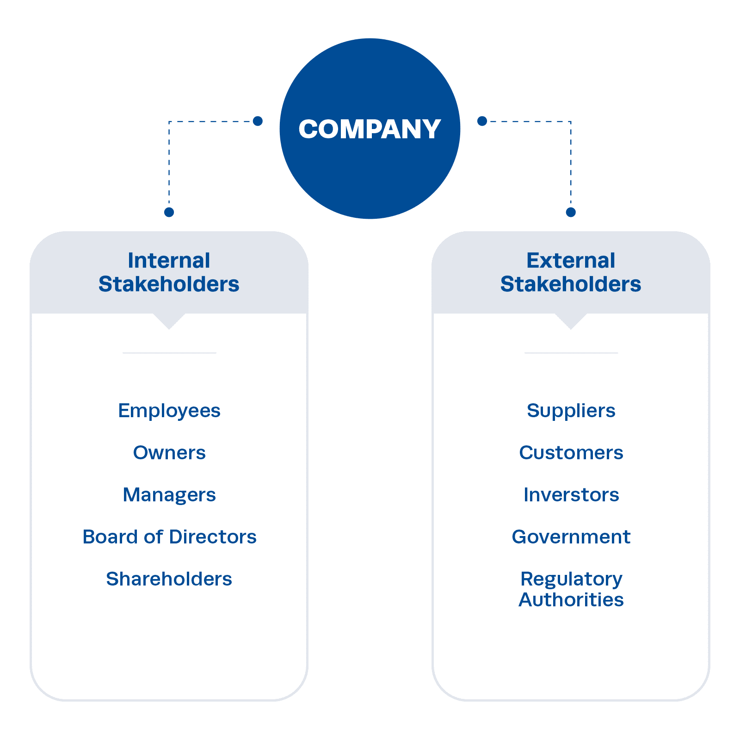
Figure 2: Identification of Stakeholders
Source: (Institute of Project Management, n.d.)

4. Roles, Responsibilities, Benefits and Challenges of Key Stakeholders
ConnectPlus' success relies on the effective engagement of a group of stakeholders with different responsibilities and expectations. Internal stakeholders plan, design and deliver the platform, while external stakeholders have an impact on the platform's adoption, compliance and market acceptance. Group or multi-stakeholder relationships are useful in ensuring the project is effective and fosters trust, communication and knowledge sharing. Digital transformation projects involve intricacy and require collaboration and adaptation across differing stakeholder groups, especially when working with complex technologies (Ali and Haapasalo, 2023; Akhtar et al., 2022).
Senior management also has a strategic role to play, setting the project goals, approving budgets and ensuring that the project is aligned with Amazon UK's corporate strategy and goals. They are involved in resource control, risk management and performance oversight, among other tasks. Leadership support is important in giving legitimacy and strength to organisational commitment which improves the chances of achieving successful implementation. But for the more senior management there may be issues relating to the balance of financial resource need vs stakeholder expectation, and especially in regard to cross-country international operational. Uncertainty is lessened, strategic coordination is enhanced, through strong governance frameworks (Wise et al., 2020; Benjamin and Potts, 2020).
The teams tasked with product development, software engineers and artificial intelligence professionals are tasked with creating and executing the technical infrastructure that will enable ConnectPlus. This skill adds value to Amazon UK as they are able to offer personalised recommendations and customer analytics that will help Amazon UK to be more competitive. Their contributions are vital to innovation and operational efficiency -- both pillars of digital transformation. However, there are limitations regarding complexity of technology, time and integration issues that could impact project performance. Thus, effective collaboration and knowledge sharing are needed to tackle technical hurdles and facilitate the effective implementation of the measures (Akhtar et al., 2022; Ali and Haapasalo, 2023).
ConnectPlus is promoted by the Marketing and Customer Service departments and is designed to give customers positive experiences. As a result of their efforts, their customers are made more aware of their brand, and they foster brand loyalty and customer retention. Such direct contact with customers help these departments to forward feedback which aids in constant improvement. But a lack of willingness for change in the organisation and a communication problem can make the coordination between departments challenging. Thus, communication and leadership among stakeholders are of critical importance for ensuring the continuity of collaboration and the quality of services delivered (Pedemonte, 2024; Moorthy and Parvatiyar, 2023). Customers represent the most important stakeholder group because the success of ConnectPlus ultimately depends upon customer acceptance and adoption.
They are involved, which leads to very valuable feedback to help Amazon UK to constantly evolve products and services. This is why customer engagement is a pillar of the development of relationships and value co-creation, which leads to competitive advantage. The implications of AI usage on privacy, cybersecurity, and ethical issues could affect consumer trust. To keep consumers' confidence and loyalty, organisations have to be transparent in communication and responsible in data management. (Moorthy and Parvatiyar, 2023; Benjamin and Potts, 2020).

5. Critical Explanation of Stakeholder Engagement Process and Conflict Management
Engagement is an ongoing activity that seeks to build trust, engagement and understanding between people or groups of people who may be collaborating on a project. Stakeholder engagement is a key element of the ConnectPlus project because of the multiple departments involved, different international markets/external partners interests and expectations. By engaging effectively, project managers can reduce uncertainty, communications challenges and stakeholder involvement throughout the entire course of the project. Collaborative relationships are more essential for digital transformation due to the increased level of reliance on collaboration and knowledge sharing arising from the complexity of technology (Ali and Haapasalo, 2023; Akhtar et al., 2022).
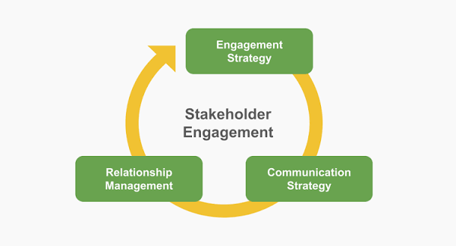
Figure 3: Stakeholder Engagement
Source: (Planyway, 2024)
The first task during the stakeholder engagement process as Project Manager would be the process of identifying the stakeholders and analysing them. Identifying the stakeholder interests, stakeholder expectations and the influence that they may have allows the project team to identify the most suitable engagement strategies. Stakeholder analysis is used to help identify communication needs and areas of possible opposition prior to implementing. Effective governance can improve stakeholder co-ordination and strategic integration (Wise et al., 2020). Likewise, Pedemonte (2024) states that communication leadership is an important factor in stimulating the involvement of stakeholders and the effectiveness of organisations in the digital age.
Once the stakeholders have been identified, a stakeholder engagement plan would be formulated and communication channels would be set up as well as how the stakeholders would be involved in the project throughout the project life cycle. The engagement plan should provide for regular meetings, workshops, and digital collaboration tools and performance reviews to ensure there is transparency and trust. Communication practices must reflect cultural differences and differing expectations by stakeholders since the development of ConnectPlus will be used in a variety of international markets (Pedemonte, 2024; Galindo et al., 2021).
The Communication Plan is an important tool to enable stakeholders to communicate effectively. There would be a strategic progress meeting with senior management, everyone in technical teams would be in daily coordination meetings, and marketing and digital campaigns would be sent out to inform customers. To facilitate smooth coordination during implementation, suppliers/logistics partners would be informed about the work under way. Clear communication #2 = less uncertainty, more trust. Communication and stakeholder leadership have been found to be critical for successful project outcomes in complex and complex/geographically dispersed settings (Pedemonte, 2024; Ali and Haapasalo, 2023).
The other essential framework to be used would be the RACI Matrix which is for revealing roles and responsibilities and enhancing accountability among stakeholders. The senior management will be responsible for strategic decisions in the ConnectPlus project, while project managers will coordinate the activities. The implementation activities are handled by the marketing teams and customer service, while technical tasks by the product development teams and AI professionals. Regulatory authorities and customers would be consulted and informed, as required. Role clarity helps eliminate ambiguity and the duplication of effort thereby enhancing efficiency and working together more harmoniously with other stakeholders in the project (Wise et al., 2020; Galindo et al., 2021).
Some of the various approaches that could be used for stakeholder involvement would be addressing the 4C's model of communication, consultation, collaboration and commitment. Communication will maintain in giving timely information to the stakeholders and giving information about the objectives of the project. Consultation enables stakeholders to have their say and share information in conversations around decisions. Team working and collective problem solving between participants both within and outside the organisation is stimulated by cooperation. Commitment is centred on relationship development with stakeholders over the long term. Together these four dimensions build trust and help to create sustainable stakeholder relationships. Collaboration as well as communication processes are vital factors in digital transformation programmes, and a crucial point in the success of these programmes (Ali & Haapasalo, 2023; Pedemonte, 2024).
The 4C's system relies on communication as its fundamental component: poor communication often results in miscommunication and resistance. Amazon UK would have digital communication channels, progress reports and meetings with the stakeholders to ensure transparency during the process. Open communication enables stakeholders have their concerns and expectations shared, which can reduce uncertainty and build confidence. The use of effective communication also enhances knowledge transfer and collaborative learning in collaborative settings (Pedemonte, 2024; Galindo et al., 2021).
A further critical element of Stakeholder engagement is consultation as this ensures involvement and an ownership of the activities of the project. Evaluation of the platform design and operating criteria would be obtained from customers, suppliers and employees. Communicating with stakeholders via surveys, workshops and pilot programmes to better understand their needs and expectations would be a learning opportunity for Amazon UK. Participatory methods can help to make better decision-making and increase involvement of stakeholders. They are of great value in an international project if stakeholders across countries and regions have varying values and perspectives (Perz et al., 2021; Fisher et al., 2020).
Effective knowledge sharing between multiple stakeholders is vital to success in digital transformation, and collaboration can be a powerful catalyst. Getting it right requires full cooperation efforts among the internal departments, such as the IT department, marketing and customer service teams. The same applies to external stakeholders (suppliers, logistics partners), who need to show their willingness to control their activities. Multi agency governance processes can improve project performance, create better trust amongst agencies and reduce conflicts. Business partnerships also create relationship-building and enhance the organisational resilience (Ali and Haapasalo, 2023; Fisher et al., 2020).
The 4 C's model's last element of commitment is related to maintaining business relationships with the stakeholders after the project has finished. Amazon UK has to prove their commitment to addressing concerns of the stakeholders, transparency in the process and provide the benefits promised. Trust and confidence increase the likelihood of developing long-term bonds, and can enhance the loyalty of stakeholders. Sustainable relationships have a pivotal role in customer-focused companies, when it comes to innovation and value co-creation, importantly. Companies that invest in stakeholder engagement are more likely to gain a competitive edge and sustainable growth (Moorthy and Parvatiyar, 2023; Lazzarini et al., 2026)
Similarly, they may also have concerns about privacy and ethical issues with AI. In the absence of control, this variation can have a negative impact on the project. There are differences and they can be resolved through a collaborative governance framework and stakeholder dialogue of mutual understanding, alignment and compromise between stakeholders (Fisher et al., 2020; Pedemonte, 2024).
ConnectPlus needs to maintain stakeholders' engagement well-being to make it successful, which will take sustained communications, collaboration and commitments throughout the lifecycle of projects. The Thomas-Kilmann Conflict Management Model is called in on the matter of conflict resolution; when conflict resolution requires collaboration, build engagement and trust: share information, reach consensus on solutions; when conflict resolution requires compromising, make timely decisions is required (Fisher et al., 2020; Ali and Haapasalo, 2023). SWANS/OWANS approaches facilitate strengths, aspirations, needs, solutions and potential barriers identification, which involves an open dialogue and stakeholder ownership (Perz et al., 2021; Galindo et al., 2021). Moreover, Communication Plans, RACI models and the 4C's model improve coordination, build relationships and foster long-term competitive advantage (Lazzarini et al., 2026; Moorthy and Parvatiyar, 2023). The implications of AI usage on privacy, cybersecurity, and ethical issues could affect consumer trust.
Table 6: SWAN Theory Table
SWAN Stage | Application to ConnectPlus
S – Stakeholders | Identify internal and external stakeholders across Amazon UK operations
W – Wants | Understand expectations regarding AI, privacy, customer value and profitability
A – Analysis | Prioritise stakeholders using Mendelow and Salience models
N – Needs | Develop engagement plans, communication schedules and conflict resolution mechanisms

6. Evaluation of the Impact of Sustainable Stakeholder Engagement on Business Performance
Creating and maintaining sustainable stakeholder relationships is crucial to improve business performance as it enables long relationships, trust and working together between persons and groups who are essential for the business to thrive. For Amazon UK, achieving ConnectPlus success is not just about the technology; it's about how the business develops and maintains effective relationships with internal and external stakeholders. By engaging key stakeholders, organisations can also ensure that their strategic decisions reflect their stakeholders' needs and that effective communication feeds into and removes uncertainty. (Wise et al., 2020; Ali and Haapasalo, 2023).
Through the use of artificial intelligence and data analytics, ConnectPlus will be used to provide personalised experiences, helping Amazon UK to improve customer satisfaction and build stronger customer relationships. The dynamic of customer engagement has shifted from mere transactional engagement to one where the customer actively contributes to product and service development, playing a role in its co-creation. Long-term customers mean higher customer retention and higher profitability as satisfied customers are more likely to stay loyal to the organisation. Moreover, the trust fosters organisational reputation and enable it to continuously improve via feedback systems (Moorthy and Parvatiyar, 2023; Akhtar et al., 2022).
Another major effect of sustainable stakeholder engagement is the improvement of their innovation and digital transformation competences. The success of a digital initiative depends on the collaboration of several stakeholders such as employees, software developer, suppliers and customers. By disseminating and using knowledge, and through joint decision making, organisations are better able to come up with new solutions and react to the evolution of the markets. Organisations are now faced with complex environments driven by digitisation, which necessitates effective cooperational of stakeholders within these complex organisations to achieve the project's effectiveness. Sustainable stakeholder relations foster organisational learning and sustain continual innovation, providing Amazon UK the ability to meet competition in the global retail sector (Akhtar et al., 2022; Benjamin and Potts, 2020).
Therefore further, employee engagement is a significant factor in business performance as motivated employees are proving to be more productive, committed and creative. ConnectPlus is being delivered with the support of a number of internal stakeholders such as project teams, software engineers and customer service. Stakeholder engagement can increase trust and communication amongst the management and staff, thereby helping to reduce member resistance to change amongst the organisation. When employees are happy and engaged, they are more likely to be open to innovation and positively contribute to the organisation's objectives. Better relationships between stakeholders, in turn, can aid to achieve efficient operationalal performance and encourage collaboration between stakeholders, laying the groundwork for shared goals and effective cooperational to achieve long-term success (Ali & Haapasalo, 2023; Pedemonte, 2024).
Strong engagement with stakeholders also leads to better engagement and can enhance supply chain resilience and operationals effectiveness. The companies involved in the supply, logistics, and third-party selling of products and services are central to Amazon UK's role in providing a seamless delivery for the companies. Partnerships with these stakeholders facilitate, for example, better collaboration, transparency, knowledge sharing and mutual learning, contributing to enhance operationalal efficiency. Relational stakeholder strategies has the emphasis on openness and trust that allows organisations to blueprint flexible responses to disruption and radical changes in the market. Cooperative relationships also help to strengthen the supply chain and ensure that mutual gains are obtained that help towards sustainability. These partnerships are increasingly crucial for companies in the global marketplace, where understanding local laws and customs (Lazzarini et al., 2026; Ali and Haapasalo, 2023) is essential.
Beyond that, sustainable stakeholder engagement can also play a part in building organisation's reputation and brand image. There is mounting demand by customers, investors and regulators for organisations operating in an ethical manner, being transparent and acting in a socially responsible way. Like all of the ConnectPlus' AI and customer data projects, confidence and caution will be essential for maintaining the reputation of Amazon UK. With good communication and stakeholder buy-in, then organisations will be able to address concerns on privacy, cyber security, and ethics. Accountability and a responsive attitude increase the likelihood of gaining valid and trusted participation of stakeholders. Their reputation strengthens their competitive positioning and their long-term business performance (Benjamin and Potts, 2020; Pedemonte, 2024).
Another key financial result of sustainable stakeholder engagement is financial performance. Good stakeholder relations minimise conflict, optimises resource use and increases project success. Trust creates better revenue generation, and business relationship with suppliers and employees is vital to operationalal efficiency and cost efficiency. Cooperative methods also reduce time-wasted and facilitate good decision making, thereby enhancing the effectiveness of organisations. Long-term stakeholder relationships give rise to shared value, sustainable profitability. So, rather than just being a stakeholder engagement endeavor, it is a strategic investment that creates either monetary or economic benefits for the organisation as well as non-economic ones (Moorthy and Parvatiyar, 2023; Lazzarini et al., 2026).

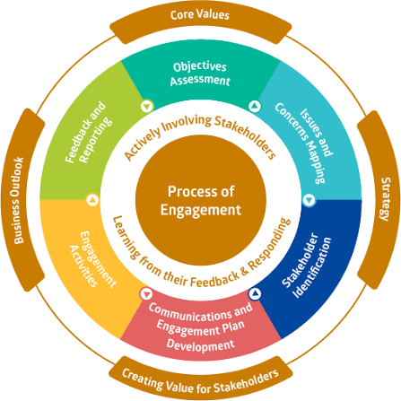
Figure 4: Process of Engagement
Source: (Blak Bernat, Qualharini and Castro, 2023)

7. Recommendations and Conclusion
Amazon UK should focus the preparation of a detailed Stakeholder Engagement Strategy to assist its successful rollout of ConnectPlus internationally. The organisation needs to enhance communications by regular meetings and use digital collaborative tools and reporting structures to keep stakeholders informed and engaged throughout the project and its development. Good communication builds trust, helps to minimise uncertainty and creates more opportunities for meeting with a variety of interested groups to formulate decisions. Moreover, Amazon UK needs to develop structured engagement programmes and feedback processes to guarantee the ongoing development and enhancement of the alignment between all stakeholders, in order to foster the long-term relationship between the organisation and other actors, adding to organisational resilience (Pedemonte, 2024; Ali and Haapasalo, 2023).
Structured training programmes should also be implemented should also be advocated and multi-departmental work groups should be established to encourage greater awareness among the stakeholders and help remove resistance to change. Furthermore, conflict management processes need to be more collaborative to address issues and increase cooperation in establishing a joint working alliance between external and internal stakeholders. These programmes encourage invention and contribute to economic sustainability in today's world economies (Benjamin and Potts, 2020; Fisher et al., 2020).
To sum up, building and managing stakeholder relationships is crucial for the effective launch of ConnectPlus. The report illustrated the importance of various stakeholders, such as the customer, employee, supplier, regulatory bodies, and management, for project results. Amazon UK can use stakeholder theory and project engagement concepts like the Power-Interest Matrix, the Salience Model, the RACI Matrix and the 4C's frameworks to increase effort and commitment of the various project stakeholders throughout the project. A process of sustainable stakeholder engagement helps foster loyalty, innovation, optimisation of efficiency and the organisation's reputation that will positively impact business performance. Therefore implementing stakeholder engagement, as a strategic capability, becomes a way for Amazon UK to get sustainable competitive advantage and long-term growth into the growing global and digital business environment (Lazzarini et al., 2026; Wise et al., 2020).

References
Akhtar, W.H., Watanabe, C., Tou, Y. and Neittaanmäki, P. (2022) ‘A new perspective on the textile and apparel industry in the digital transformation era’, Textiles, 2(4), pp. 589–611. Available at: https://doi.org/10.3390/textiles2040037.
Ali, F. and Haapasalo, H. (2023) ‘Development levels of stakeholder relationships in collaborative projects: challenges and preconditions’, International Journal of Managing Projects in Business, 16(8), pp. 58–80. Available at: https://doi.org/10.1108/IJMPB-03-2022-0066.
Amazon UK (n.d.) Our sites. Available at: https://www.aboutamazon.co.uk/workplace/our-sites (Accessed: 13 June 2026).
Benjamin, K. and Potts, H.W.W. (2020) ‘Digital transformation in government: Lessons for digital health?’, Digital Health, 6, pp. 1–6. Available at: https://doi.org/10.1177/2055207618759168.
Blak Bernat, G., Qualharini, E.L. and Castro, M.S. (2023) ‘Enhancing sustainability in project management: The role of stakeholder engagement and knowledge management in virtual team environments’, Sustainability, 15(6), Article 4896. Available at: https://doi.org/10.3390/su15064896
Fisher, J., Stutzman, H. and Vedoveto, M. (2020) ‘Collaborative governance and conflict management: Lessons learned and good practices from a case study in the Amazon Basin’, Society & Natural Resources, 33(4), pp. 538–553. Available at: https://doi.org/10.1080/08941920.2019.1620389.
Galindo, M.S., Lambert, Y., Mutricy, L., Garancher, L. et al. (2021) ‘Setting-up a cross-border action-research project to control malaria in remote areas of the Amazon: Describing the birth and milestones of a complex international project intervention’, Malaria Journal, 20, p. 216. Available at: https://doi.org/10.1186/s12936-021-03748-5.
Institute of Project Management (n.d.) What are stakeholders? Understanding their importance. Available at: https://projectmanagement.ie/blog/what-are-stakeholders-understanding-their-importance/ (Accessed: 13 June 2026).
Lazzarini, S.G., Boehe, D.M. and Pongeluppe, L.S. (2026) ‘The normative core of relational stakeholder strategies: Explaining open buyer–supplier relations in the context of the Amazon rainforest’, Business Ethics Quarterly. Available at: https://doi.org/10.1017/beq.2025.3.
Moorthy, J. and Parvatiyar, A. (2023) ‘Co-creating aftermarket value in the digital era: Managing transformative customer relationships through stakeholder engagement’, in Customer-Centric Support Services in the Digital Age. Cham: Springer, pp. 171–194. Available at: https://doi.org/10.1007/978-3-031-37097-7_8.
Pedemonte, D.F. (2024) ‘Communication for stakeholder leadership in the post-pandemic digital era’, in Organisational Communication in the Digital Era. Cham: Springer. Available at: https://doi.org/10.1007/978-3-031-58307-0_14.
Perz, S.G., Arteaga, M., Baudoin Farah, A. and Brown, I.F. (2021) ‘Participatory action research for conservation and development: Experiences from the Amazon’, Sustainability, 14(1), p. 233. Available at: https://doi.org/10.3390/su14010233.
Wise, G., Dickinson, C. and Katan, T. (2020) ‘Inclusive higher education governance: Managing stakeholders, strategy, structure and function’, Studies in Higher Education, 45(2), pp. 339–352. Available at: https://doi.org/10.1080/03075079.2018.1525698.

