International Business Communications



Course: BA Business Management
Module name: International Business Communications
Module code: LCBB6001
Lecture name: Dr Charles Nwaogwugwu
Title of report: Assignment 1
Student Name: Sali Refat
Student ID: 2122704

Table of Contents
1) British Business Communications 2
3) Introduction to the selected organisation: Unilever 3
2) Evaluation of Two EU countries 3
2.1) France: Analysis for Unilever’s Expansion 3
2.1.1) Evaluation of cultural differences between UK and France - Hofstede Framework 4
2.1.2) Communication Barriers between UK and France 5
2.1.3) Recommendation for mitigating communication barriers 6
2.2) Netherlands: Analysis for Unilever’s Expansion 6
2.2.1) Evaluation of cultural differences between UK and Netherlands - Hofstede Framework 7
2.2.2) Communication Barriers between UK and Netherlands 8
2.2.3) Recommendation for mitigating communication barriers 9
3) Recommendation & Conclusion 9
4) References 10

1) British Business Communications
Effective communication serves as the cornerstone of successful business operations, particularly in the dynamic landscape of international business. As a consultant tasked with recommending a potential EU-based country for the future business expansion for Unilever, it is imperative to first establish an understanding of the context of British business communications before proceeding into the evaluation and assessment of which country would be the preferred choice of option for expansion. This introductory section aims to provide insight into the cultural, linguistic, and contextual factors that shape communications practices within British business environments.
British business culture is characterized by a blend of tradition and innovation. At its core, British communication etiquette embodies professionalism, politeness, elusive humour and sarcasm, as well as a preference for indirect communication styles (Santander, 2019). There is a cultural inclination towards subtlety and diplomacy, which often manifest itself through the use of euphemisms, understatements, and nuanced language to convey messages effectively. Humour and sarcasm are also used frequently throughout British communications in order to lighten moods or to approach arduous subjects in a more indirect and subtle way. These inclinations often stem from the British’s strong desire to avoid conflict and to remain polite throughout discussions (Warburton, 2024). The result of this Is that people often are required to read between the lines.
Furthermore, the business culture places less emphasis on hierarchical structure being prevalent in British organizations in comparison to most countries in mainland Europe, as the British managers typically keep marginal power distance (Santander, 2019). While decisions often have a top-down approach, it is often presented in a more subtle manner disguised as guidelines or suggestions, rather than being abruptly imposed upon staff. So, there is a mixture between traditional adherence to hierarchical structure and modern growing emphasis on collaboration and inclusivity in workplaces, which is driven by the evolving societal norms and the influence of global business practices.
Understanding the context of British business communications is essential for devising effective strategies for international expansion.
3) Introduction to the selected organisation: Unilever
In the realm of multinational corporations and international business affairs, Unilever stands as a beacon of excellence that is renowned across the globe for its innovative products, broad range of highly accomplished and recognized brands, global footprint, and unwavering commitment to sustainability. With over 90 years of expertise in international business and operations (Unilever, 2024), Unilever has deep understanding of the navigation of complex markets and great capability in adapting their business, products and strategy to the local markets they are trying to penetrate and compete in (Alonso, 2023). With its highly diverse portfolio, which encompasses iconic brands such as Lipton, Dove, Knorr, Hellmann, Ben & Jerry’s, Domestos, Dove and many other flagship names, Unilever holds a prominent position in the fast-moving consumer goods (FMCG) industry (Akgün, 2018).
As we explore potential expansion opportunities for Unilever into EU-based countries, our recommendations will be aligned with the company’s values and mission, ensuring that any new ventures contribute to the realization of the overarching goals for sustainable growth and social impact that Unilever has.

2) Evaluation of Two EU countries
This section will aim to dive deep into the strategic evaluation of potential expansion opportunities for Unilever. The selected countries for evaluation and consideration for the expansion of Unilever are France and Netherlands, which both represent a compelling case and opportunity. The evaluation, and subsequently the decision, would be based on key factors related to cultural nuances, language inclinations and barriers, as well as social norms and context that shape the atmosphere in both countries, and appear to have higher compatibility with the British cultural tendencies and inclinations to ensure smoother cultural integration during the expansion process.

2.1) France: Analysis for Unilever’s Expansion
France stands as one of Europe’s largest economies and a strategic international hub for any global corporation that seeks to establish presence in the European market. It boasts with robust and diversified economy whose Gross Domestic Product (GDP) ranks among the highest in Europe (HSBC, 2023). The FMCG sector in France is characterized by steady growth and strong consumer demand for quality products across all various categories that Unilever delivers.

2.1.1) Evaluation of cultural differences between UK and France - Hofstede Framework
Hofstede’s cultural dimensions framework provides a valuable insight into the differences between the French and British cultures, offering guidance on how to navigate areas with particular cultural disparities and foster effective cross-cultural communications (Hofstede Insights, 2023). By examining key dimensions such as individualism-collectivism, power distance, uncertainty avoidance, long and short-term orientation, indulgence and motivations, Unilever can tailor its approach to business operations in each country to maximize chances of success.
As per the graph below, Hofstede’s evaluation framework outlines that in the areas of individualism versus collectivism and long-to-short term orientation the UK and France have a notable similarity in their respective cultural orientations on these 2 dimensions. The convergence of these similarities underscores the potential applicability of practices and methodologies already employed in the UK and their high likelihood to yield analogous success within the French context. Therefore, it is important to examine the areas with the largest differences, notably uncertainty avoidance and power distance, and understand how to approach the cultural gap in these aspects.
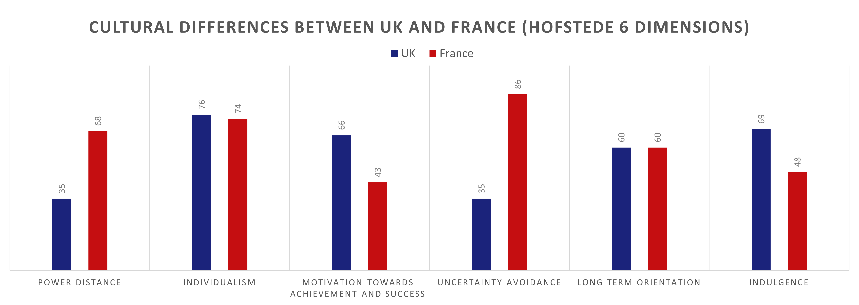
Figure 1- Evaluation of Cultural Differences between UK and France per Hofstede's Framework (Hofstede Insights, 2023)

a) Uncertainty Avoidance
By far the largest discrepancy between the British and the French is the uncertainty avoidance, which refers to each country’s tolerance for uncertainty and preference for established norms, procedures, and a cautious approach to risk-taking (Hofstede Insights, 2023). The French society values stability, predictability, and conformity. In business context this can mean higher preference for clear roles and expectations related to performance, as well as higher preference for doing things in traditional ways, rather than pursuing innovation. In contrast, the UK tends to exhibit relatively low uncertainty avoidance, which reflects their ability to embrace innovation, experimentation, and adaptability, as the British appear to be more comfortable with ambiguity and risk-taking (Hancıoğlu, Doğan and Yıldırım, 2014)
This significant difference in the Uncertainty Avoidance aspect between France and UK can impact various aspects of business operations such as decision-making, risk management, and organizational culture. The recommendation for Unilever on approaching this gap is to ensure:
- long-term sustainable innovation strategies that don’t entail radical short-term disruptions.
- Implement robust risk management procedures.
- Foster open communication channels to provide reassurance and transparency.
- Provide clear role descriptions, KPIs and communication messages.
- Invest in cultural awareness training and cross-cultural competency development.

b) Power Distance
The second largest area where significant discrepancies can be observed between British and French cultures is in the dimension of Power Distance. France tends to score fairly high on this dimension, which indicates a level of acceptance of the notion that all individuals in societies are not equal. In the work culture this alludes to greater respect, adherence and acceptance of hierarchical differences and authority (Nickerson, 2023). The French have greater expectance of clear distinction between superiors and subordinates and may be more comfortable with centralized decision-making. On the other side UK exhibits a lower score on this dimension, reflecting a preference for a more egalitarian approach to authority, as well as a tendency to value autonomy more, participate in decision-making, question authority, and expect management to have consultation on matters with subordinates (Ly, 2013).
The recommended approach to address this disparity and difference is to ensure, throughout the process of expansion, that common leadership traits from UK culture are adapted and that the management style is more oriented to align with the prevailing attitudes toward authority in France. The emphasis should be to have a more hierarchical approach with clear lines of authority and decision-making processes.

2.1.2) Communication Barriers between UK and France
The first and foremost communication barrier is the language divide between British and French business cultures. While English is widely spoken in international business environments, relying solely on English would very likely hinder effective communication in the French market. This is largely due to the linguistic pride of the French and their strong preference for conducting business in their native language (Bryant, 2021). Unless Unilever addresses this, the language barrier can impede negotiation processes and hinder relationship building efforts.
Furthermore, French business culture places high importance on a premium of formality and hierarchy, which contrasts with the more informal communication style observed in British business context. While it is common for British employees to refer to their manager by their first name, this is contrary in France where formality is highly adhered to, and hierarchies are respected in a traditional fashion (Lavaty and Kleiner, 2001). Additionally, there are differences in business etiquette, such as the importance of face-to-face interactions and the significance of socializing outside of formal meetings for the French, which necessitate a nuanced understanding of French cultural norms in order to foster effective communication and be successful in conducting business in France (Scroope, 2017).

2.1.3) Recommendation for mitigating communication barriers
Expanding into the French market presents a unique communication challenge for Unilever, which requires strategic approach to ensure that communication barriers are addressed at 2 layers. Firstly, Unilever needs to ensure effective integration of the new French employees. This can be done via several mechanisms, such as appointing individuals with cultural expertise to navigate the cross-cultural challenges during the expansion. Conducting cross-cultural communication training sessions to better understand cultural nuances, norms, styles and business etiquette in France would also be beneficial for all British employees that will be playing crucial role in the expansion process. Secondly, Unilever needs to tailor and localize its marketing materials, product descriptions and advertisements into French in order to cater to the preference of French-speaking consumers. Creation of culturally relevant content would be crucial to interact with French followers in their native language and collaborate with French influencers, bloggers or celebrities to share brand stories and connect with French audiences authentically.

2.2) Netherlands: Analysis for Unilever’s Expansion
The second country of potential choice and analysis is situated at the heart of Europe and it’s the Netherlands. It is a nation with a rich tapestry of history, culture, and innovation. The Dutch are renowned for its progressive values and liberal outlook and pride themselves as society that has principles of openness, tolerance, inclusivity diversity and multiculturalism (Business Government Netherlands, 2024)

2.2.1) Evaluation of cultural differences between UK and Netherlands - Hofstede Framework
Hofstede’s evaluation for differences between UK and Netherlands showcases great compatibility and similarity across most dimensions, with the only significant outlier being “Motivation towards Achievement and Success”, which is the dimension that indicates how much a society is driven by competition, achievement and success and whether there’s a higher priority placed on the individual standing from the crowd and winning, or on the mass of society having greater quality of life being seen as the sign of success (Hofstede and Pedersen, 2002). There appears to be a radical discrepancy in this dimension with the UK scoring medium to high of 66 points, whereas the Dutch are at the low end of the spectrum on this dimension with only 14 points per the graph below:
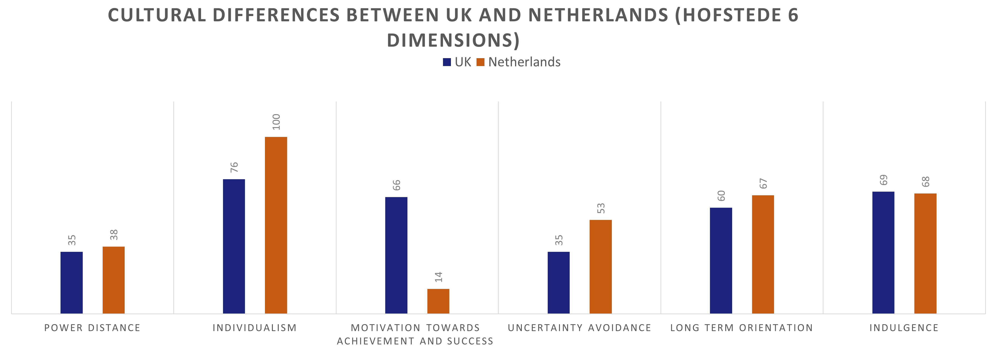
Figure 2 - Evaluation of Cultural Differences between UK and Netherlands per Hofstede's Framework (Hofstede Insights, 2023)

a) Motivation towards achievement and success
This is indicative of the fact that British people place a strong emphasis on competition, achievement, and success across different domains, with individuals motivated by the desire to excel, stand from the crowd and be recognized as the best in their field. Success in the UK is often characterized by individual accomplishments, which reflects the competitive and achievement-oriented culture and tendencies of the British. Largely in contrast with the Dutch, who score significantly lower on this dimension, suggesting that the Dutch society values caring for others and overall quality of life over competition and the achievements of a single individual. Success in Netherlands is more closely associated with quality of life and harmonious society.
Unilever’s corporate social responsibility values, approach to sustainability and employee well-being aligns well with the Dutch values and priorities relating to ethical business practices, sustainability, and community engagement. At the same time, Unilever will likely have to adjust its approach to employee motivation and management practices when entering the Dutch market. The recognition and rewarding systems should be more tailored to collaboration, work-life balance, as well as the overall promotion of a supportive and inclusive work culture to attract the best talent. Furthermore, it may be beneficial for Unilever to consider the setting of more group-oriented targets and key performance indicators, rather than individual ones in order to better align with the cultural tendencies and preferences of the Dutch.

b) Remaining Hofstede dimensions
For the remaining dimensions, the UK and the Dutch exhibit high similarities, especially in the areas of power distance, long-to-short-term orientation and indulgence. These areas of the cultural dimensions may not require as significant attention due to their similarities since the countries are compatible across these dimensions. The other remaining two are related to individualism and uncertainty avoidance. In relation to individualism while the Dutch rates with 100 points on this dimension and the UK with 76, both cultures technically cover the threshold of being classified in high rate of “individualism” above 70%. Meaning that they do not disperse across different parts of the spectrum such as the lower or middle in order to result in noticeable differences.

2.2.2) Communication Barriers between UK and Netherlands
While Dutch is the official language of the Netherlands, English proficiency is widespread, especially in business settings and there isn’t a similar sentiment to prefer conducting business in their native language to the extent of the French. Therefore, it is unlikely that the actual difference in the native languages spoken would be detrimental, since English is widely spoken and accepted in Netherlands.
The biggest communication discrepancy between the Dutch and the British would likely be in the preference for direct and indirect communications styles. Dutch communications are direct, straightforward, and blunt in nature, whereas British communication employs indirect language, politeness, and subtlety. Additionally, humour plays a significant role in British communication and is often expressed through witty remarks, irony, and sarcasm. However, these communication styles and humour preferences may not align with Dutch cultural norms. A potential negative consequence is that Dutch individuals may perceive British communications as ambiguous or evasive and their humour, if not understood correctly, can be misinterpreted as offensive or disrespectful.
Navigating these differences requires sensitivity and adaptability. British communicators interacting with Dutch counterparts should be mindful of the Dutch preference for direct communications and adjust their language accordingly to ensure and avoid misinterpretations.

2.2.3) Recommendation for mitigating communication barriers
The communication barrier related to direct versus indirect preference for communication style and the notion of subtlety versus clarity requires increased awareness of all parties in order to be properly understood and approached. Therefore, the implementation of cultural sensitivity training programs for employees should be a primary consideration for Unilever, especially for the employees that will be involved in the key cross-cultural communications between the Dutch and the British. In addition, cross-cultural team building has been proven beneficial in enhancing the understanding, trust, and collaboration between employees of different cultures (Devine and Ash, 2021). Organizing team-building exercises and promoting cultural exchange events facilitates interaction and relationship-building (Henman, 2023).

3) Recommendation & Conclusion
Based on the evaluations examined, both France and Netherlands offer compelling opportunities for Unilever’s expansion. However, taking into consideration cultural nuances, social context and profiles, diversity within workforces and the evaluation per Hofstede’s framework, the recommendation would be for Unilever to pursue expansion in the Netherlands as the preferred expansion destination. The rationale is that the Netherlands exhibits higher cultural similarities with the UK, particularly in terms of openness, innovation, and an overall progressive mindset. In contrast, France has discrepancies in more cultural dimensions in relation to the UK, which may present greater cultural challenges, communication barriers and social norms to overcome. English proficiency is far more widespread in the Netherlands, particularly in business settings, but also In relation to reaching consumers. And since Dutch individuals are generally proficient in English, this would disband any significant communication barriers.
In summary, based on evaluating overall cultural and social criteria and frameworks, the Netherlands emerges as the preferred option over France, due to its cultural similarity, language accessibility and more inclusive business environment. These factors enhance feasibility, effectiveness, and chances of success of Unilever’s expansion efforts.

4) References

Akgün, H. (2018). Mergers and Acquisitions and Open Innovation as a Business Growth Strategy. The Mega Cases of Procter & Gamble and Unilever. documentserver.uhasselt.be. [online] Available at: http://hdl.handle.net/1942/26999.
Alonso, T. (2023). Strategy Study: How Unilever Went From Soap Manufacturer To Multinational Giant. [online] www.cascade.app. Available at: https://www.cascade.app/studies/unilever-from-soap-manufacturer-to-multinational-giant#:~:text=One%20of%20the%20main%20reasons [Accessed 4 Apr. 2024].
Bryant, S. (2021). 6 differences between English and French culture. [online] Country Navigator. Available at: https://www.countrynavigator.com/blog/6-differences-between-english-and-french-culture/.
Business Government Netherlands (2024). The Dutch culture and business climate. [online] business.gov.nl. Available at: https://business.gov.nl/coming-to-the-netherlands/living-in-the-netherlands/the-dutch-culture-and-business-climate/.
Devine, P.G. and Ash, T.L. (2021). Diversity Training Goals, Limitations, and Promise: A Review of the Multidisciplinary Literature. Annual Review of Psychology, [online] 73(1). doi:https://doi.org/10.1146/annurev-psych-060221-122215.
Hancıoğlu, Y., Doğan, Ü.B. and Yıldırım, Ş.S. (2014). Relationship between Uncertainty Avoidance Culture, Entrepreneurial Activity and Economic Development. Procedia - Social and Behavioral Sciences, 150, pp.908–916. doi:https://doi.org/10.1016/j.sbspro.2014.09.100.
Henman, M. (2023). From Conflict to Cooperation: Building Stronger Cross Cultural Teams. [online] business.com. Available at: https://www.business.com/articles/from-conflict-to-cooperation-building-stronger-cross-cultural-teams/.
Hofstede Insights (2023). Country Comparison Tool. [online] www.hofstede-insights.com. Available at: https://www.hofstede-insights.com/country-comparison-tool?countries=france%2Cunited+kingdom.
Hofstede, G. and Pedersen, P.B. (2002). Exploring culture : exercises, stories and synthetic cultures. Boston: Intercultural Press.
HSBC (2023). HSBC International Business Guide: France. [online] www.business.hsbc.com. Available at: https://www.business.hsbc.com/en-gb/business-guides/france [Accessed 22 Apr. 2024].
Lavaty, S. and Kleiner, B.H. (2001). Managing and understanding the French employee. Management Research News, 24(3/4), pp.45–48. doi:https://doi.org/10.1108/01409170110782603.
Ly, A. (2013). A critical discussion of Hofstede’s concept of Power Distance. [online] ResearchGate. Available at: https://www.researchgate.net/publication/301287186_A_critical_discussion_of_Hofstede.
Nickerson, C. (2023). Hofstede’s Cultural Dimensions Theory & Examples. [online] Simply Psychology. Available at: https://www.simplypsychology.org/hofstedes-cultural-dimensions-theory.html.
Santander (2019). Business Practices in the United Kingdom - Santandertrade.com. [online] Santandertrade.com. Available at: https://santandertrade.com/en/portal/establish-overseas/united-kingdom/business-practices [Accessed Apr. 2AD].
Scroope, C. (2017). French Culture - Business Culture. [online] Cultural Atlas. Available at: https://culturalatlas.sbs.com.au/french-culture/french-culture-business-culture.
Unilever (2024). Unilever at a Glance. [online] Unilever. Available at: https://www.unilever.com/our-company/at-a-glance/.
Warburton, K. (2024). British Communication Styles. [online] World Business Culture. Available at: https://www.worldbusinessculture.com/country-profiles/great-britain/business-communication-style/.

