
MSc Engineering Project Management
Module:
Managing Engineering Projects

Assignment 2

Name:
Stephen Thomas

Student Number:
P150906

Student Email:
SThomas.150906@student.uwtsd.ac.uk
Contents

Introduction 3
Network Diagram and Gantt chart 4
Network Diagram and Gantt chart Proposal 4
Figure 1: Project Gantt chart 5
Figure 2: Network Diagram 6
Project Gantt Chart & Network Diagram Analysed 7
Project Management Communication 7
Figure 3: Price of Poor Communication (Pmi.org, 2016). 7
➢ Regular Meetings 8
➢ Inclusive 8
➢ Respectful 8
➢ Use RACI Charts 8
Benefits from Improved Communication Study 8
PERT Analysis & Risk Management Techniques 9
PERT Analysis 9
Figure 4: PERT Analysis Formula (Broadleaf.com.au, 2017) 10
PERT Analysis Studies 10
Risk Management Techniques 11
Qualitative 11
Quantitative 11
Other Risk Management Techniques 12
Cost of Project 13
Figure 6: Man-hours Cost. 14
Application of Crash Costing Techniques 15
Cost Slope 16
Figure 8: Crash Cost Results 16
Figure 9: New Crash Cost Project Gantt Chart 17
Figure 10: New Crash Cost Network Diagram 18
Resource Scheduling & Smoothing Techniques 19
Figure 11: Project Scheduled with Unsmoothed Effects 20
Figure 12: Project Scheduled with Smoothed Effects 21
Conclusion…………………………………………………………………………………………….22
Referencing 23-25

Introduction
This assignment will develop a project plan for a shutdown on Hydrotreater 1 at Valero. This plan will consist of network diagrams, Gantt charts, costs, resourcing, resource smoothing and crash costing. The roles of communication in project management will be researched with risk management techniques. Project handover issues will then be researched to establish what typical problems occur over project handovers and show how they can be managed.

Network Diagram and Gantt chart
A Gantt chart is a visual interpretation of arranged tasks over a period. Gantt charts are useful for identifying activities scheduled for a specific day and are used for planning of projects. Gantt charts allow for start and end dates to be seen without complications which allows for a better overall view of the project (Anon, 2018). A tool for identifying the critical path from project activities is known as a Network Diagram. This diagram has the benefit of making direction with owners, material dealers, engineers and sub-contractors easier to accomplish (Clough and Sears, 2014). The tracking and progress of the project from the beginning to the finish is accomplished by implementing a Network Diagram (Brighthubpm.com, 2018).

Network Diagram and Gantt chart Proposal
A Network Diagram and Gantt chart will be constructed for a shutdown based at Valero on Unit 3 (Hydrotreater 1). This process unit has a significant impact on the refineries performance output and overtime catalysts become depleted and equipment fails which results in maintenance, which can only be carried out while the process units are shut down and made safe. Hydrotreaters works on the principle of injecting high-pressure Hydrogen and bonding it with Sulphur and Nitrogen to remove impurities that may poison the catalysts, this produces low sulphur Diesel below 8ppm. To carry put this process, equipment is required such as compressors, heaters, pumps, valves, fired heaters, vessels and heat exchangers, and over time require maintenance and inspection. Therefore, the activities for his project will include catalysts replacements on two reactors, overhaul of a compressor, and vessel inspections. The project will last from the 21/01/20 – 12/02/20 pending there is no implications effecting the critical path. The project Gantt chart and Network Diagram can be seen in figure 1 and figure 2.

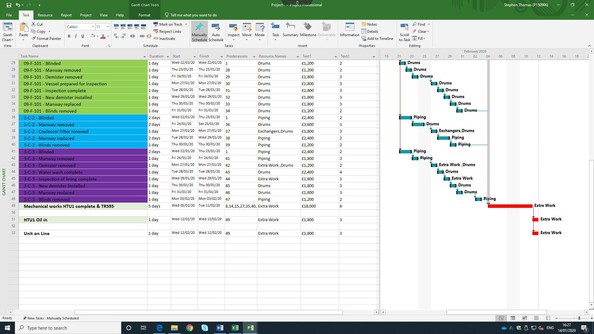
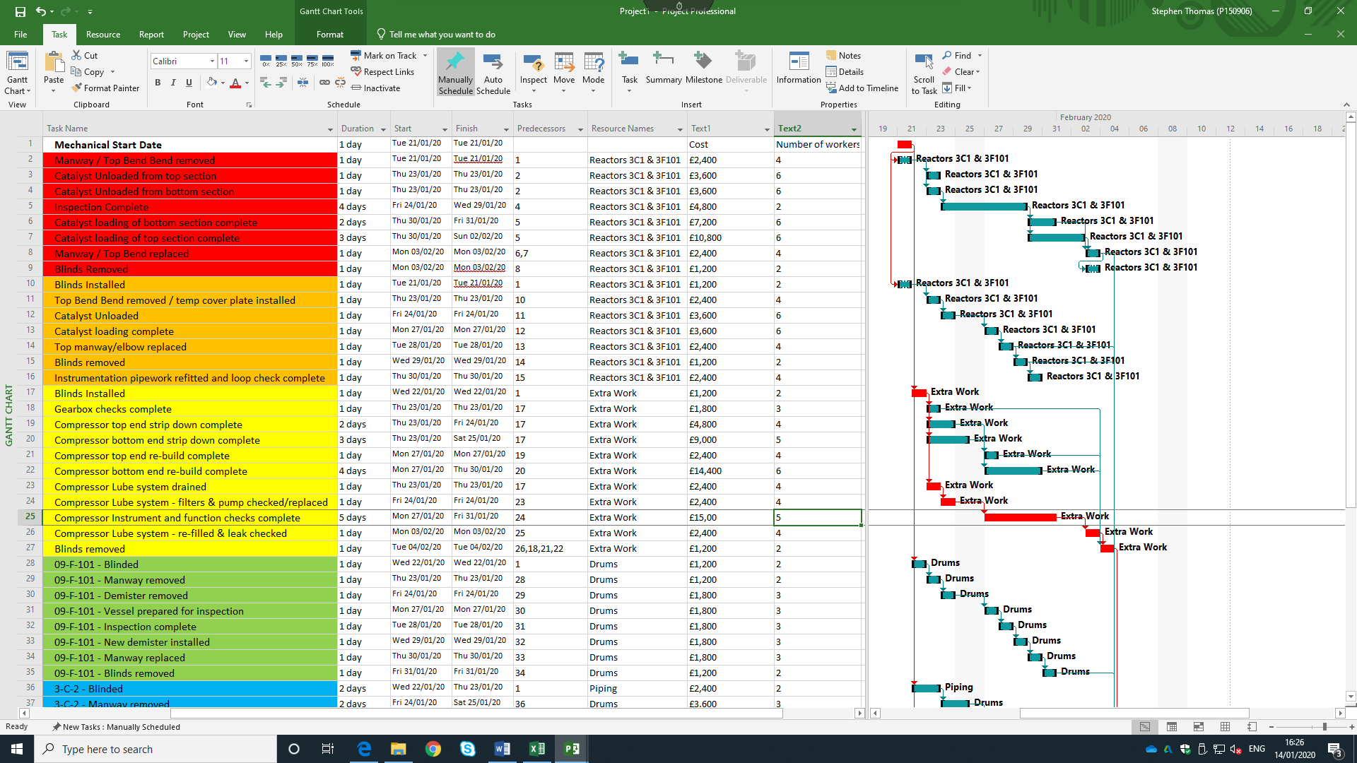
Figure 1: Project Gantt chart

Figure 2: Network Diagram
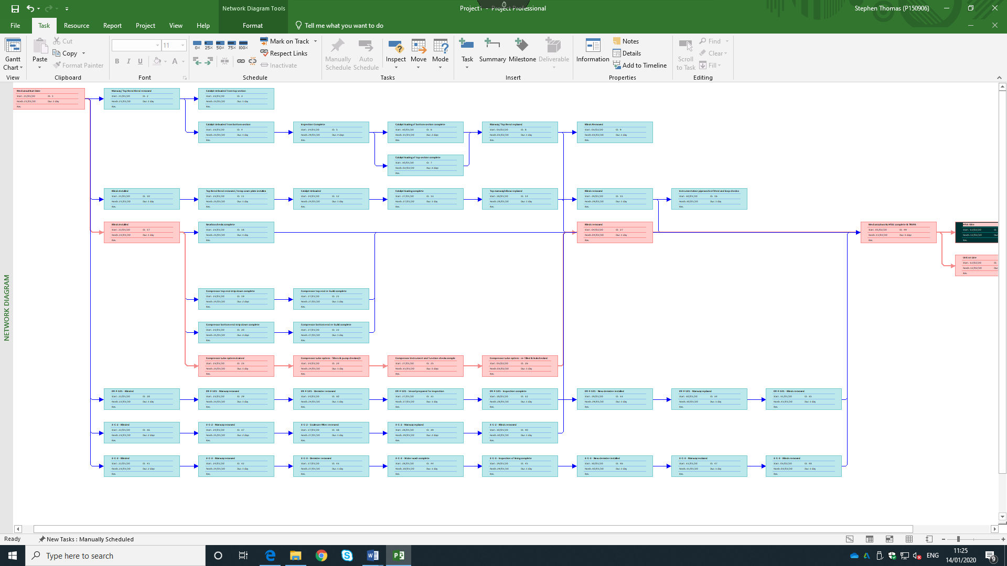

Project Gantt Chart & Network Diagram Analysed
Figure 1 is a construction of a Gantt chart that identifies activities associated with the
Shutdown of Hydrotreater 1 from using Microsoft Project. The project clearly recognises key milestones with information such as, the duration of the project, the duration for the tasks, the critical path, the activity predecessors, and resource names, number of workers, cost of each activity and total cost of project. This project plan has been constructed fundamentally with no risk management techniques taking place at this stage such as PERT analysis, Resource Smoothing and Crash Costing.

Project Management Communication
A team’s performance to deliver and manage a project is significantly impacted by communication. The project team and stakeholders must be well informed of the development by the project managers by using effective communication techniques. Lack of communication can result in the project being delayed, cost implications occurring and critical paths changing due to changes in resource management (Pmi.org, 2016).

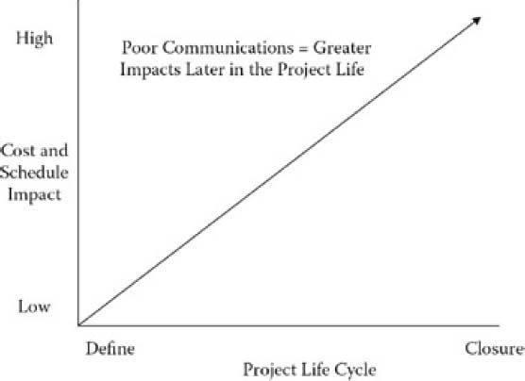
Figure 3: Price of Poor Communication (Pmi.org, 2016).

Figure 3 illustrates the link between Project Life Cycle and, Cost and Schedule Impact in terms of Communication implications. Looking at this diagram, it can be seen that poor communication results in greater implications later through the project such as missing deadlines, missing critical path, cost implications, and poor managed resources. However, there are some recognised techniques that can be incorporated into the project to ensure effective communication is achieved. These techniques are as follows:
- Regular Meetings
Project Managers are responsible for organising consistent meetings with participants of the project team to identify current development and issues that may arise. The project manager facilitates project meetings to ensure that agenda is followed correctly, and this gives the opportunity for the project team to resolve any issues. The Project manager is also responsible for the sending meeting agendas, meetings minutes, and other updates to the project team (Gregory, 2016).
- Inclusive
The project manager should ensure that inclusive communication is carried out effectively as this is an approach that seeks to create a supportive and effective communication environment, using every available means of communication to understand and be understood (Essexice.co.uk, 2020). This includes speech, body language, Gestures, singing, interactive approaches, picture and objects.
- Respectful
The ability to effectively assert your own views and fully listen to other people’s views is known as respectful communication. Project members have different opinions talents and abilities. However, the focus in the workforce should be on collaboration, using everyone’s strengths to achieve common goals (Gatty, 2016).
- Use RACI Charts
A RACI chart is a matrix used to assign roles and responsibilities to each task, milestone, or decision on a project. This matrix allows for the project manager to clearly map out the role that are involved in each task (Teamgantt.com, 2017).

Benefits from Improved Communication Study
Zulch, (2014) study on ‘Leadership Communication in Project Management’, suggest that good communication stills enable, foster and create the understanding and trust necessary to encourage others to follow the leader (Project Manager). Without effective communication, a project manager accomplishes very little and is identified as a weak leader. In fact, being able to communicate effectively is what enables managers to move to a leadership position.

PERT Analysis & Risk Management Techniques

PERT Analysis
Program Evaluation Review Technique (PERT) is an extension of CPM that incorporates variability in activity duration into project network analysis. PERT has been used extensively and successfully in practice, in PERT, the potential uncertainties in activity durations are accounted for by using three time estimates for each activity. The greater the uncertainty of an activity the wider the range of estimates (Ravindran, 2016).

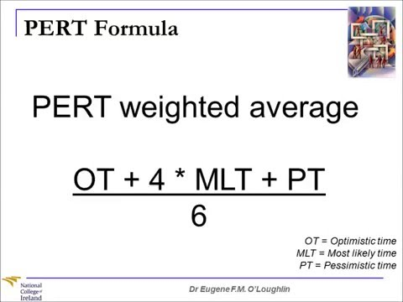
Figure 4: PERT Analysis Formula (Broadleaf.com.au, 2017)

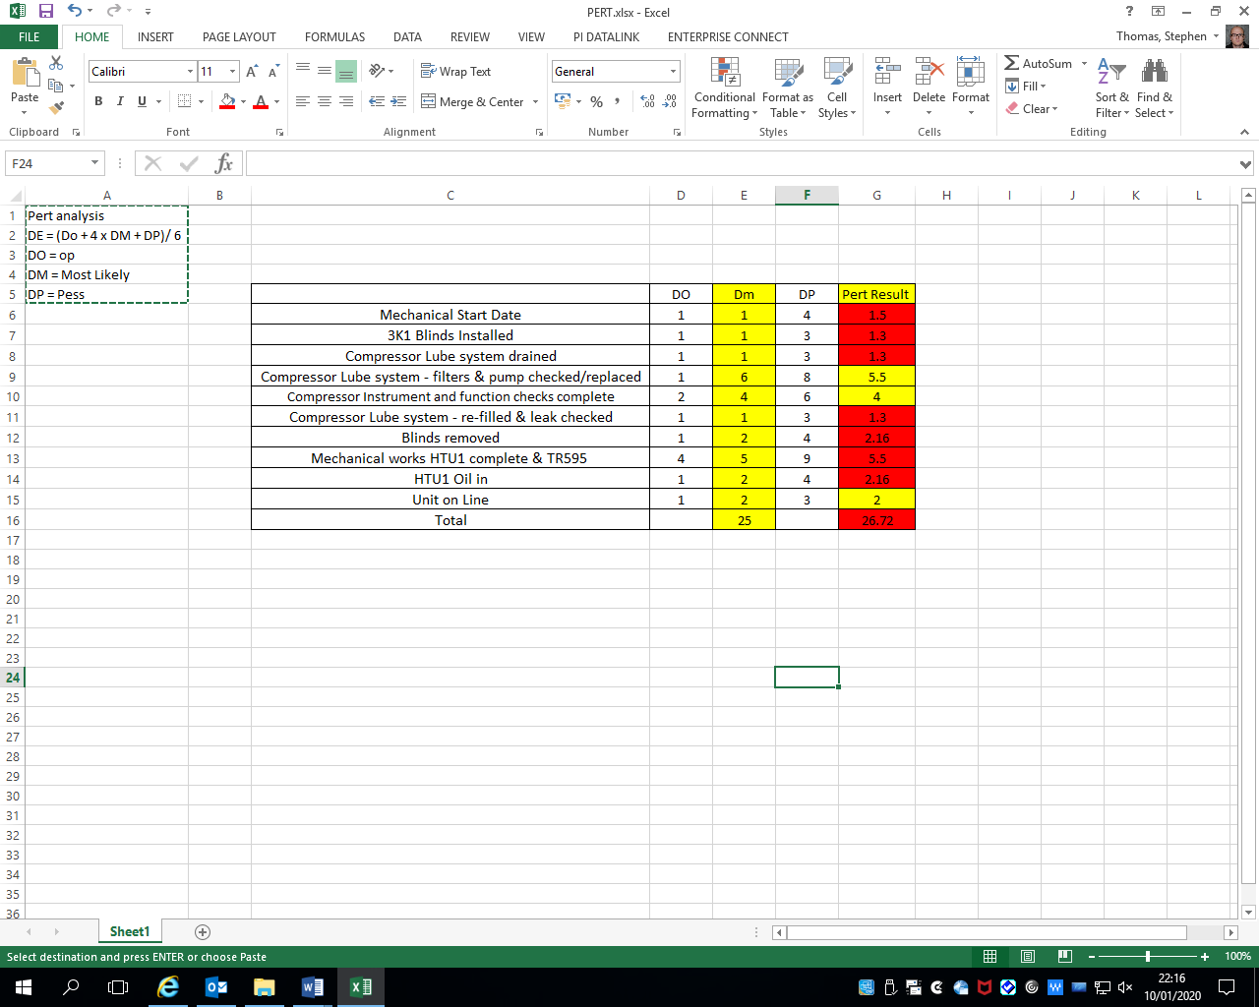
Figure 5: PERT Results
Clearly the project critical path is at risk by generating a result of 26.72 compared to the DM result of 25. The ‘Mechanical Works HTU1 Complete & TR595’ activity has the most predecessors and therefore, will have a significant impact on the critical path of the project. Resources should be prioritised for the higher risk activities, as identified on the PERT result to ensure the project does not go over the deadline and generate further cost.
- Outsourcing Risk
Risks can occur from outsourcing work to contactor companies due to lack of man power and unwanted responsibility. With this outsource comes the risk of safety associated with extra workforce and unfamiliarity. There is also risk associated with the reliance of the contractor company to ensure demands are met. Any problems will inevitably impact the outsourcing company’s performance and will result in a project altercation.
- Bottlenecks
All projects are at risk of bottlenecks occurring and this can have detrimental impacts on the companies and projects performance. Bottlenecks are setbacks or obstacles that slow or delay a process. Bottlenecks are commonly associated with logistic, manufacturing, and a process where networks of people and tasks rely upon on another to keep the work flowing. Bottlenecks can lead to lost revenue, dissatisfied customers, poor quality products or services, and stress upon team members (Mindtools.com, 2018).

PERT Analysis Studies
Studies conducted by (Wenying and Xiaojun, 2015) and (Trietsch and Baker, 2012), identified a more suitable PERT method in the risk assessments and project management sector. Wenying and Xiaojun (2015), study in particular constructed a method that calculates the activity duration by adopting a response management theory and introducing double buffering zones to gain an more approximate and realistic duration. Trietsch and Baker (2012), study constructs a PERT analysis software that again, generates a more realistic duration based on Decision Support Systems. Both these studies can help in project management durations and help establish a more realistic duration.

Risk Management Techniques
Risk management techniques are used to identify, assess and plan responses to individual tasks and overall risk (Apm.org.uk, 2020). Apm.org.uk (2020) has identified some techniques that can be used to manage risks associated with a project. The article goes on to suggest that techniques for assessing risk fall into two categories; Qualitative and Quantitative. Qualitative risk assessments focus on individual risk and is based on educated opinion an expert judgement. Qualitative and Quantitative techniques include the following:

Qualitative
- Probability & Impact Assessments
The outcome of a probability and impact matrix is an overall risk rating for each of the projects identified risks. The combination of probability and impact results in a classification usually expressed as high, medium or low. High risks are considered a red condition, medium is yellow and low risk are considered green. This ranking scale is known as ordinal scale because the values are ordered by rank from high to low (Heldman et al., 2016).
- Influence Diagrams
An influence diagram in an intuitive display of decision problem. It depicts the key elements, including decisions, uncertainties, and objective as nodes of various shapes and colors. It shows influences among them as arrows (Analytica, 2018).

Quantitative risk assessments focus on overall risk and is based on more numerical approaches. Typical Quantitative techniques include the following:

Quantitative
- Monte Carlo Analysis
Let’s you see all the possible outcomes of your decisions and assess the impact of risk, allowing for better decision making under uncertainty.
Monte Carlo simulation is a computerized mathematical technique that allows people to account for risk in quantitative analysis and decision making. (Monte Carlo Simulation, 2018)
- Decision Trees
A decision tree analysis is a specific technique in which a diagram (in this case referred to as a decision tree) is used for the purposes of assisting the project leader and the project team in making a difficult decision. The decision tree is a diagram that presents the decision under consideration and, along different branches, the implications that may arise from choosing one path or another (Project-management-knowledge.com, 2018).
- Risk Assessments
Risk assessment is the determination of quantitative or qualitative value of risk related to a concrete situation and a recognised threat. Risk assessment involves measuring the probability that a risk will become a reality (Simplilearn.com, 2017).

Other Risk Management Techniques
- Brainstorming
- 5 Why’s
- SWOT Analysis
- Root Cause Analysis
- Influence Diagrams

Cost of Project
The total cost of this shutdown is £5,000,000. This figure was generated based on materials and man-hours to complete the project in the duration set on the Gantt chart. This cost does not consider the cost generated from the unit being offline which will have a significant impact on the profit generated by the company over the year. Microsoft project was used to accumulate a cost figure based on man hours as seen in figure 6. The materials required for the project are as follows:
- Catalysts
- Vehicles
- Purging hydrocarbons (Nitrogen, Steam, and Water)
- Cleaning of heat exchangers (Materials)
- Mechanical materials (bolts, blinds, etc)

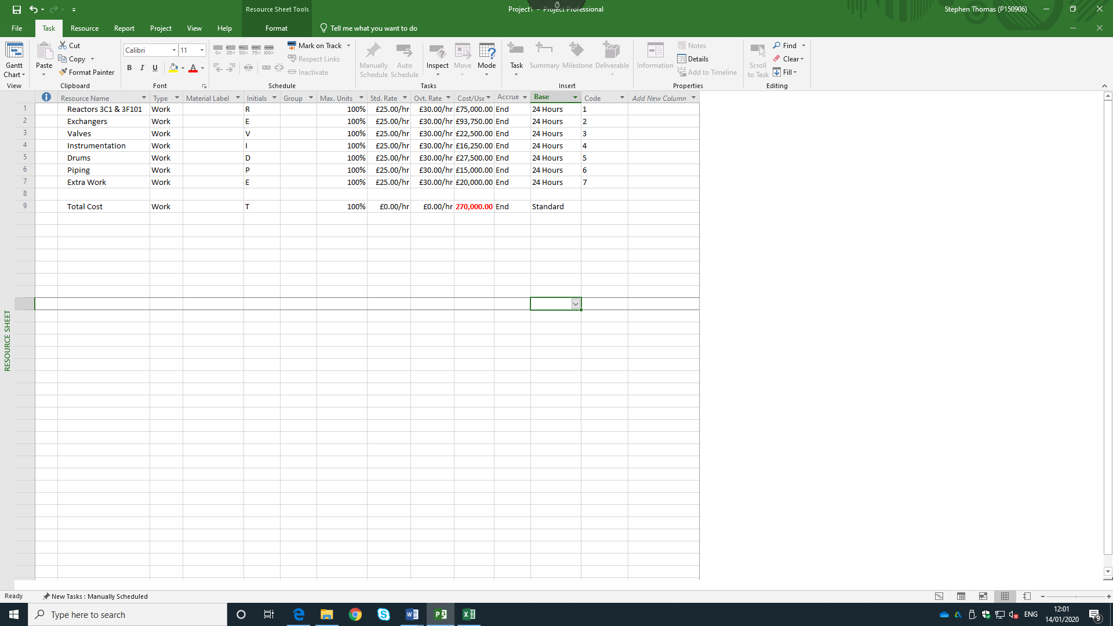
Figure 6: Man-hours Cost.

The man-hour’s generated form the shutdown has generated a cost of £270,000 with a 24-hour continuous working period. The lowest cost generated on this project is ‘Piping’ for access of vessels and removal of equipment. The highest cost generated is ‘Exchangers’ by generating a cost of £93,750 which will have a significant impact on the critical path.
Figure 7: Individual Activity Man-Hours Cost
Figure 7 identified the cost associated with induvial activities on the project which calculated a sum of £270,000 in total. Task 21 and 48 generated the most cost, both of which are subject to the critical path and will have a significant impact of the project resources. These costs will now be crashed costed to try and reduce the duration of the project by adding personnel to activities, thus increasing the cost.

Application of Crash Costing Techniques
Project crash costing is a method for shortening the project duration by reducing the time of one or more critical activities to less than their normal time. Crashing is achieved by devoting more resources. Thus, the cost associated with the project is increased (Meredith, Shafer and Mantel, 2016)

Cost Slope
In simple words, we can say that cost slope of an activity is the increase in cost of an activity by reducing the duration by one unit. Conducting a crash programme usually result in an increase in cost of those activities that are constructed under the crash programme (Essays, Research Papers and Articles on Business Management, 2017

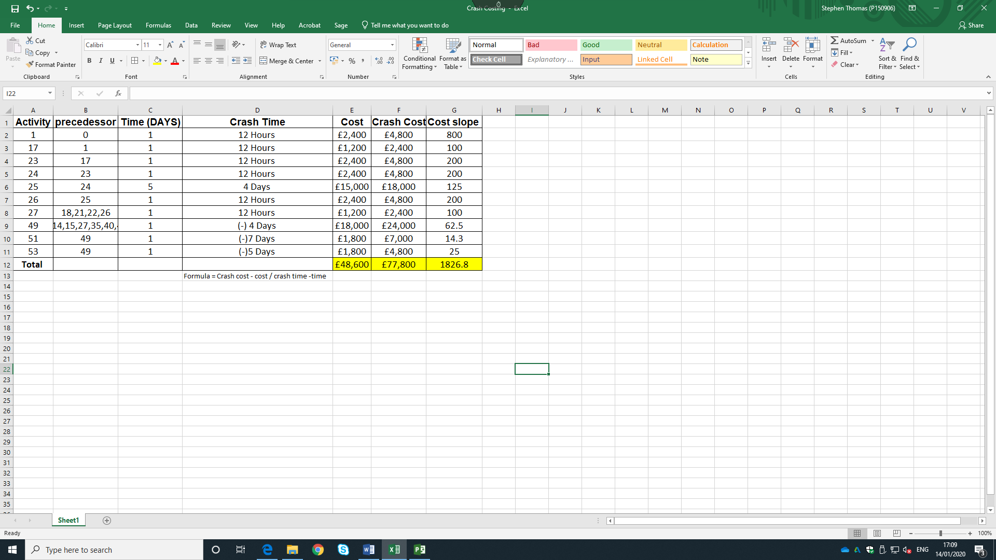
Figure 8: Crash Cost Results
Crash costing was carried out on the critical path of the project Gantt chart. This activity reduced the duration of the project by 7 days and generated a further cost of £77,800. This reduction in duration has also altered the critical path on the project which can be seen in figure 9 and the network diagram on figure 10. The total cost of the project has now increased from £270,000 to £347,800 in man-hours to total project cost of £5,347,800.00

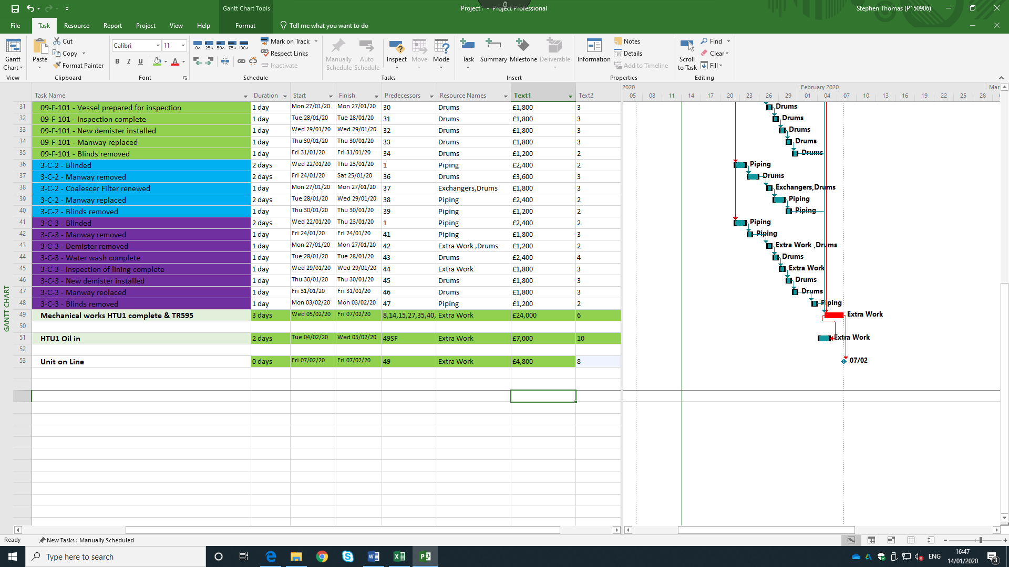
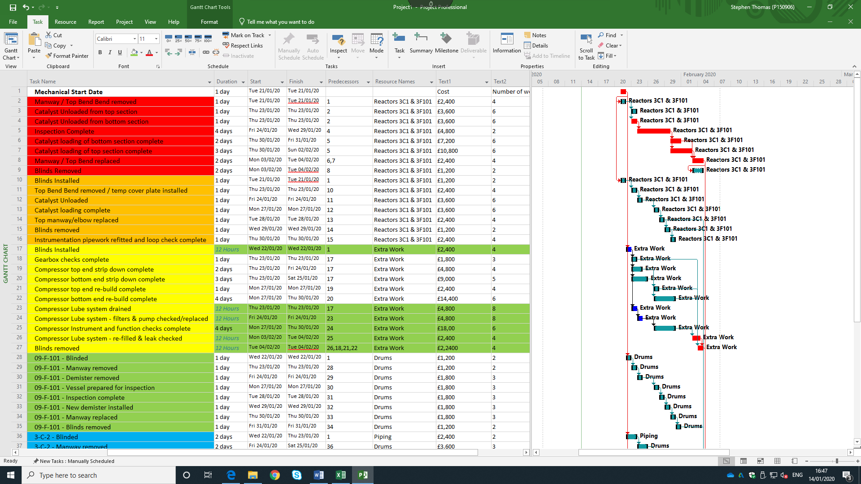
Figure 9: New Crash Cost Project Gantt Chart

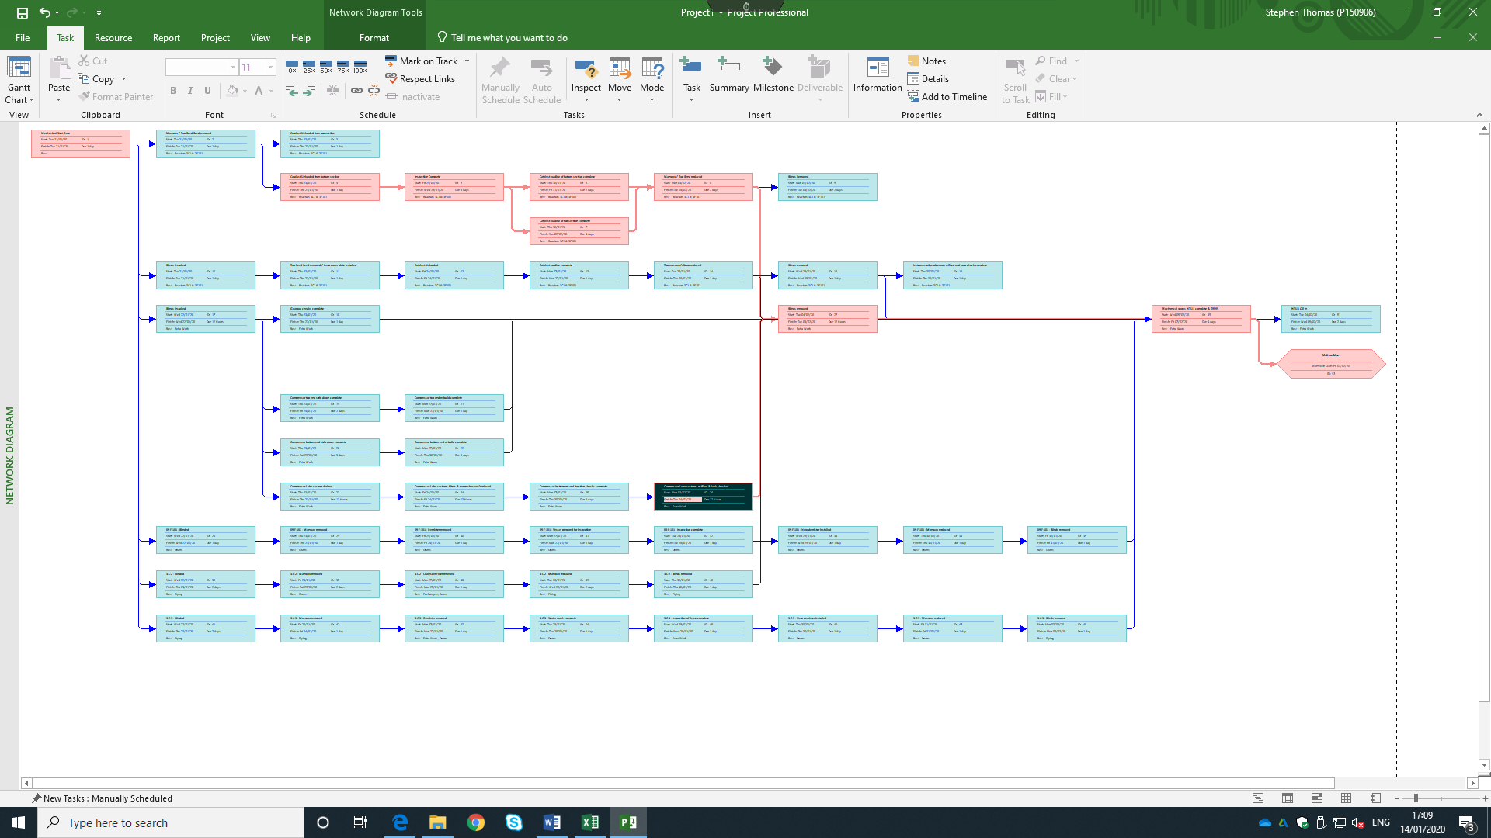
Figure 10: New Crash Cost Network Diagram

Resource Scheduling & Smoothing Techniques
Resource scheduling refers to the set of actions and methodology used by organisations to efficiently assign resources for the allocated tasks of a project and, schedule start and end dates for each task or project based on resource availability (Visual Planning - Scheduling Software, 2017). Apm.org.uk (2018), refers to a scheduling calculation that involves utilising float or increasing or decreasing the resource required for specific activities, such as the peaks and troughs or resource usage. Apm.org.uk (2018), goes on to address resource smoothing by suggesting that it is only used when the time constraints take priority. The objective is to complete work by the required date while avoiding peaks and troughs of resource demand.

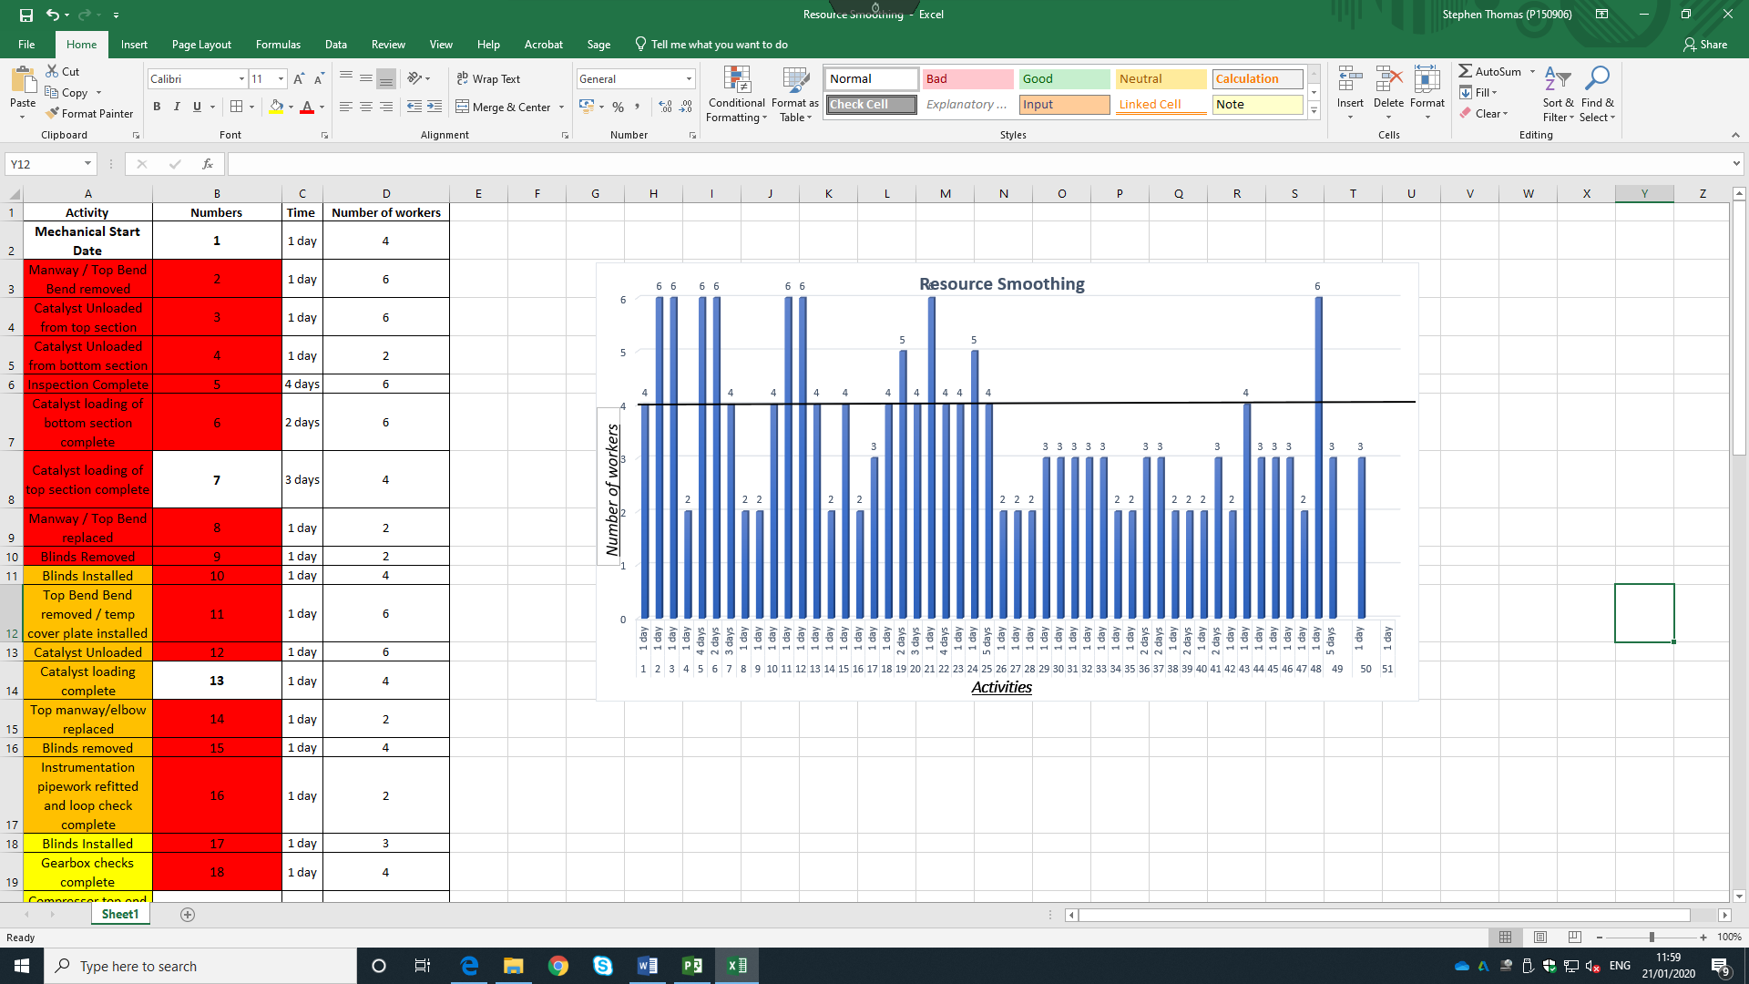
Figure 11: Project Scheduled with Unsmoothed Effects
Figure 11 illustrates the project Gantt chart with unsmoothed characteristics, clearly there is room for a more optimal resource smoothing process which will allow for a more transitioned project by assigning the adequate number of workers to each task, thus improving project efficiency and ensuring the project is completed within the deadline set. The smoothing process must ensure that the critical path has not changed, to ensure optimal performance is achieved. The allocation of workers to each task will impact the duration of a task, therefore task consideration should be considered to ensure the critical path is not affected by the reallocation of workforce.

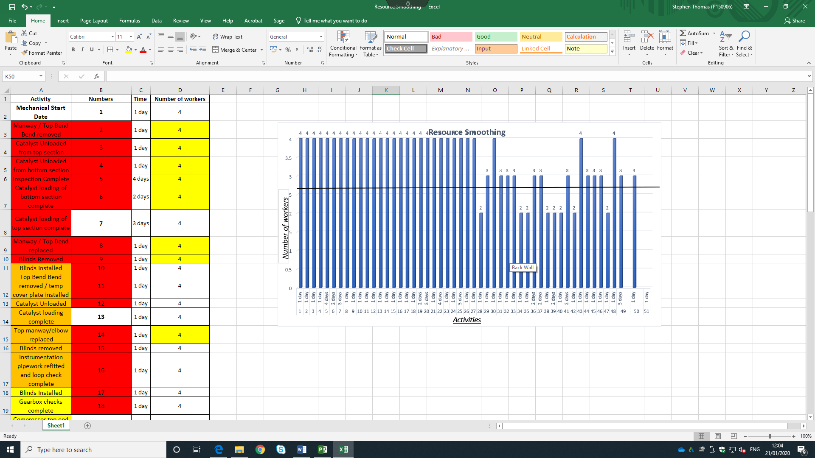
Figure 12: Project Scheduled with Smoothed Effects
Figure 12 is the results of smoothing the project and reassigning the workforce numbers for optimal performance. It can be seen that the number of workers has been reduced from 6 to 4 in some areas to improve performance. It can also be seen that the number of workers has increased in some areas to 4. Studies conducted by Li and Dong (2018) and Kastor and Sirakoulis, (2009) go on to address the comparison between different models of resource leveling by using software. The study suggest that 83% of professional project managers use project management software for planning and in the construction industry resource leveling is used by 58% for planning and 44% for project control. The research identified Primavera Project Planner and MS project are the most popular software packages used. The study concluded that the project duration depends on the software and method used with Primavera P6 outperforms MS project in terms of project management including resource smoothing. Therefore, to help reduce risk and improve performance, Primavera should be used for resource smoothing.

Project Hand over Issues
With every project comes the risk of handover, once the project has been completed and commissioned. The handover phase consists of commissioning certificates, operating instructions and maintenance instructions (ECI, 2007).
Figure 13: Key Determinants of Cost (Ec.europa.eu, 2019).
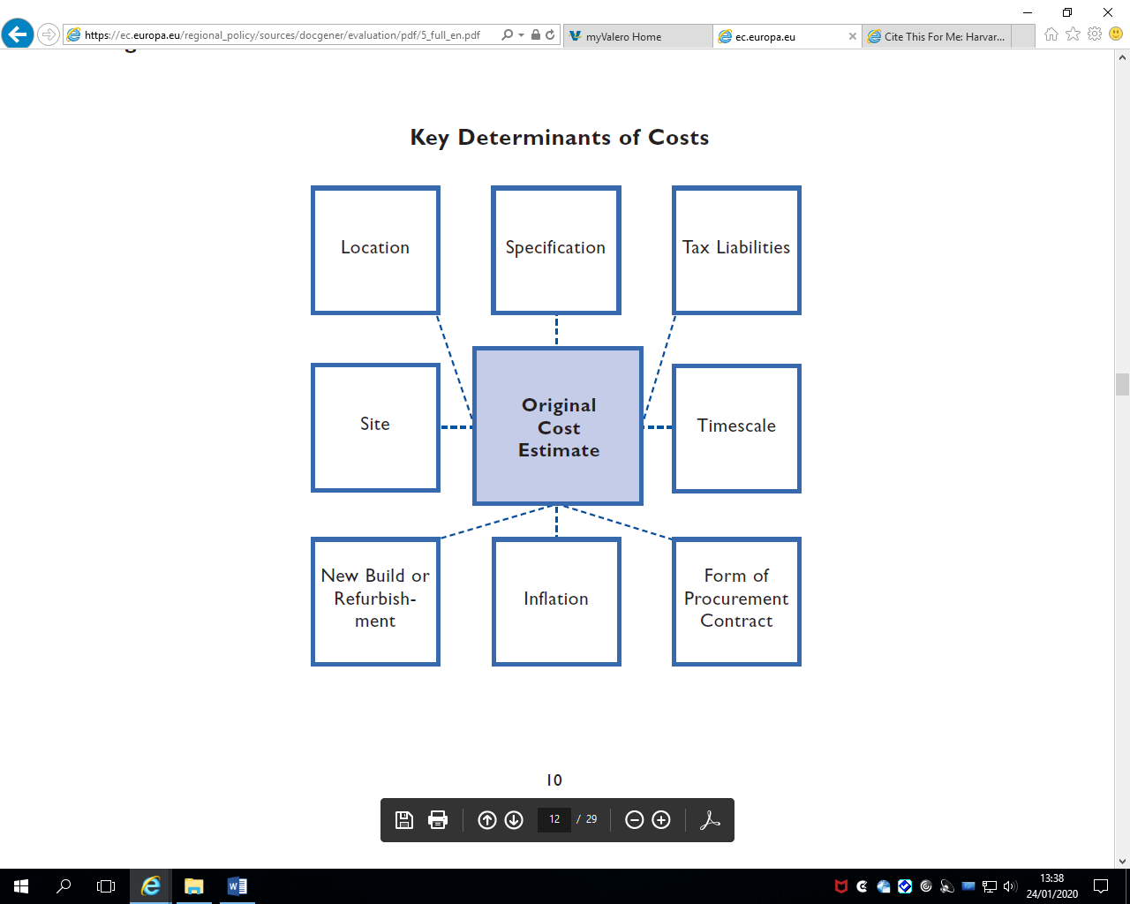

Studies conducted by (Shirkavand, Lohne and Lædre, 2016), (Kwon et al., 2019) and (Ing and Lester, 2017) have all identified key hand over issues relating to project handovers. The most common issues are as follows:
- Training
Staff need to be trained to use and operate the new project. This could include the need to recruit more staff to manage the project, this should be done at the earliest point to ensure deadlines are met and commissioning can be handed over safely and effetely (Tudor, 2015).
- Transition
Meetings should be held and set goals must be put in place for the transition period to ensure the handover is carried out effectively. This will allow the project team to evaluate the projects relation to the projects basic planning, timing and budget. Without these meetings the handover will inevitably generate risks which could include cost, communication etc. (Staff, 2019).

- Communication
Project handovers requires clear and effective communication to ensure all parties are area of the projects status and any issues can be raised to help mintage the risk of failure of information handover for training and operating purposes.
- Commercial/Contracts
Client requirements should be written into tender documentation/ contracts in as much detail and a specifically as possible including engagements requirements, data environment and any standardisation of equipment or products that the client requires. If the project handover is successful, all parties must be rewarded (Council, 2018).

Conclusion
This assignment has constructed a Gantt chart for the shutdown of Hydrotreater 1 at Valero. A critical path was identified from the Gantt chart and a network diagram was constructed based on these findings. The roles of communication in project management has been identified along with the implications associated with poor communication within a project. PERT analysis has been carried out to identify risks on the critical path and research was carried out to identify risk management techniques that can be implemented to mitigate the risk. Cost of the individual activities was generated from Microsoft Project and a total cost of the project could be seen. Crash costing was then carried out, which resulted in the project duration being reduced by 7 days with an additional cost be generated to the project. The crash costing outcome resulted in an alternative critical path and network diagram for the project. Resource smoothing was then carried out on the project with research being carried out to identify smoothing techniques to manage the risk. Finally, project handover issues was researched to identify risk and establish how these risk can be managed.

Referencing
- Analytica. (2018). Influence Diagrams - Analytica. [online] Available at: https://lumina.com/technology/influence-diagrams / [Accessed 16 Jan. 2020].
- Anon, (2018). [online] Available at: https://www.projectmanager.com › Gantt-chart [Accessed 14 Jan. 2020].
- Apm.org.uk. (2020). Risk management techniques | APM. [online] Available at: https://www.apm.org.uk/body-of-knowledge/delivery/risk-management/risk-techniques/ [Accessed 16 Jan. 2020].
- Apm.org.uk. (2018). Difference between 'resource smoothing' and 'resource levelling'. [online] Available at: https://www.apm.org.uk/resources/find-a-resource/difference-between-resource-smoothing-and-resource-levelling/ [Accessed 21 Jan. 2020].
- Brighthubpm.com. (2020). A Project Management Network Diagram Example. [online] Available at: https://www.brighthubpm.com/project-planning/12712-connecting-a-projects-parts-with-a-network-diagram/ [Accessed 14 Jan. 2018].
- Broadleaf.com.au. (2017). Beta PERT origins – Broadleaf. [online] Available at: http://broadleaf.com.au/resource-material/beta-pert-origins/ [Accessed 14 Jan. 2020].
- Clough, R., Sears, G. and Sears, S. (2014). Construction project management. New York: John Wiley & Sons, p.88.
- Council, C. (2018). Construction Industry Council - Blog. [online] Cic.org.uk. Available at: http://cic.org.uk/blog/article.php?s=2017-08-18-how-can-we-hand-over-projects-better [Accessed 24 Jan. 2020].
- ECI, E. (2007). Total project management of construction safety, health and environment. European Construction Institute, pp.7-12.
- Ec.europa.eu. (2019). [online] Available at: https://ec.europa.eu/regional_policy/sources/docgener/evaluation/pdf/5_full_en.pdf [Accessed 24 Jan. 2020].
- Essays, Research Papers and Articles on Business Management. (2017). Cost Model: Crashing of Network. [online] Available at: https://www.businessmanagementideas.com/project-management/cost-model-crashing-of-network/6514 [Accessed 18 Jan. 2020].
- Essexice.co.uk. (2020). What is Inclusive Communication? | Inclusive Communication Essex. [online] Available at: https://www.essexice.co.uk/about-us/what-is-inclusive-communication/ [Accessed 16 Jan. 2020].
- Gatty, A. (2016). How Respectful Communication Boosts Morale and Productivity in the Workplace | AllBusiness.com. [online] AllBusiness.com. Available at: https://www.allbusiness.com/respectful-communication-boosts-morale-productivity-workplace-22074-1.html [Accessed 16 Jan. 2020].
- Gregory, P. (2016). CISA Certified Information Systems Auditor All-in-One Exam Guide, Third Edition. 4th ed. John Wiley & Sons, p.246.
- Heldman, K., M, C., Patti M, B. and Jansen, P. (2016). PMP Project Management Professional Exam Study Guide. 2nd ed. Canada: Wiley Publishing, pp.198-205.
- Ing, E. and Lester, A. (2017). Chapter 44 - Project Close-Out and Handover. 6th ed. pp.40
- Kastor, A. and Sirakoulis, K. (2009). The effectiveness of resource levelling tools for Resource Constraint Project Scheduling Problem. International Journal of Project Management, [online] 27(5), pp.493-500. Available at: https://www-sciencedirect-com.ezproxy.uwtsd.ac.uk/science/article/pii/S0263786308001178.
- Kwon, O., Keenan, M., Hon, J. and Millwaters, M. (2019). Development of a new oral and maxillofacial handover application: A quality improvement project. British Journal of Oral and Maxillofacial Surgery, [online] 57(10), p.e49. Available at: https://www-sciencedirect-com.ezproxy.uwtsd.ac.uk/science/article/pii/S0266435619305340
- Li, H. and Dong, X. (2018). Multi-mode resource leveling in projects with mode-dependent generalized precedence relations. Expert Systems with Applications, [online] 97, pp.193-204. Available at: https://www-sciencedirect-com.ezproxy.uwtsd.ac.uk/science/article/pii/S0957417417308539
- Meredith, J., Shafer, S. and Mantel, S. (2016). Project management. 2nd ed. NY, USA: John Wiley & Sons, p.352.
- Mindtools.com. (2018). Unblocking Bottlenecks: Fixing Unbalanced Processes. [online] Available at: https://www.mindtools.com/pages/article/newTMC_76.htm [Accessed 21 Jan. 2
- Monte Carlo Simulation. (2018). Monte Carlo. [online] Available at: https://www.palisade.com/risk/monte_carlo_simulation.asp [Accessed 16 Jan. 2020].
- Pmi.org. (2016). Art of communication in project management. [online] Available at: https://www.pmi.org/learning/library/effective-communication-better-project-management-6480 [Accessed 16 Jan. 2020].

- Project-management-knowledge.com. (2018). Decision Tree Analysis - Project Management Knowledge. [online] Available at: https://project-management-knowledge.com/definitions/d/decision-tree-analysis/ [Accessed 18 Jan. 2020].
- Ravindran, A. (2016). Operations research applications. Boca Raton: CRC Press, pp.15-18.
- Shirkavand, I., Lohne, J. and Lædre, O. (2016). Defects at Handover in Norwegian Construction Projects. Procedia - Social and Behavioral Sciences, [online] 226, pp.3-11. Available at: https://www-sciencedirect-com.ezproxy.uwtsd.ac.uk/science/article/pii/S1877042816308412
- Simplilearn.com. (2017). Risk Assessment in Project Management. [online] Available at: https://www.simplilearn.com/risk-assessment-project-management-article [Accessed 18 Jan. 2020].
- Staff, T. (2019). Project handover: how to manage it. [online] Twproject: project management software, bug tracking, time tracking, planning. Available at: https://twproject.com/blog/project-handover/ [Accessed 24 Jan. 2020].
- Teamgantt.com. (2020). RACI Chart Definition, Template, & Example | TeamGantt. [online] Available at: https://www.teamgantt.com/blog/raci-chart-definition-tips-and-example [Accessed 16 Jan. 2017].
- Trietsch, D. and Baker, K. (2012). PERT 21: Fitting PERT/CPM for use in the 21st century. International Journal of Project Management, [online] 30(4), pp.490-502. Available at: https://www-sciencedirect-com.ezproxy.uwtsd.ac.uk/science/article/pii/S026378631100127X
- Tudor, D. (2015). Agile project and service management. 3rd ed. Norwich, UK: TSO, pp.35-40.
- Visual Planning - Scheduling Software. (2017). What is resource scheduling? - Visual Planning - Scheduling Software. [online] Available at: https://www.visual-planning.com/en/software/what-is-resource-scheduling [Accessed 18 Jan. 2020].
- Wenying, L. and Xiaojun, L. (2015). Progress Risk Assessment for Spliced Network of Engineering Project Based on Improved PERT. Systems Engineering Procedia, [online] 1, pp.271-278. Available at: https://www-sciencedirect-com.ezproxy.uwtsd.ac.uk/science/article/pii/S2211381911000439.
- Zulch, B. (2014). Leadership Communication in Project Management. Procedia - Social and Behavioral Sciences, 119, pp.172-181.

