Introduction to Health and Social Care

Shellymae Mulcare

2434948

Ambulance Service Poster

LCHS4003

Debrah Odeh

10-10-2025

Ambulance Services: Lifelines on Wheels

Introduction

Ambulance services form the backbone of emergency healthcare systems worldwide. They are often the first point of medical contact for individuals experiencing life-threatening emergencies, playing a vital role in saving lives through rapid response, skilled clinical care, and safe patient transportation. Ambulances bridge the critical gap between the scene of an emergency and hospital care, ensuring that essential medical interventions are delivered when every second counts.
In modern healthcare, ambulance services extend far beyond emergency response—they also support non-emergency patient transport, public health initiatives, and community-based care. As healthcare demands increase, these services face mounting pressure to deliver fast, efficient, and high-quality care under challenging circumstances. This poster explores the history, current functioning, and key challenges of ambulance services, highlighting their indispensable role in maintaining public health and safety.

What Are Ambulance Services?
Ambulance services are emergency medical transport systems designed to provide immediate medical care and rapid transportation of patients to healthcare facilities. They ensure critically ill or injured individuals receive prompt medical attention before and during transport (NHS England, 2023). They also act as the link between communities and hospitals, providing continuity of care.
Key roles include:

• Pre-hospital emergency care (CPR, oxygen therapy, trauma stabilization)
• Non-emergency patient transport for those requiring medical supervision
• Coordination between community and hospital-based care

A Brief History of Ambulance Services
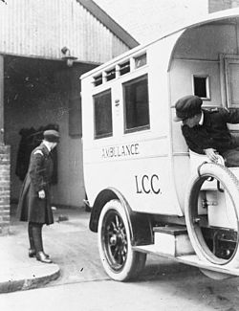
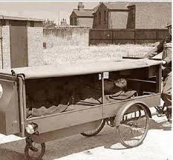
The first civilian ambulance service began in 1897 here in the United Kingdom (UK) specifically in london
In 1487 the Spanish armed forces began using horse-drawn carts, also known as ambulancia. They used these to transport the injured soldiers (Mackenzie, 2019).

The origins of ambulance services trace back to 1487, when Spanish armies used horse-drawn carts known as ambulancias to transport injured soldiers (Mackenzie, 2019). The first civilian ambulance service began in London in 1897, and the 20th century saw the development of motorized ambulances and trained paramedics. By the 1960s, modern emergency medical services (EMS) emerged, complete with communication systems like 999 in the UK and 911 in the US. Today’s ambulances are mobile intensive care units equipped with advanced life-support systems and GPS navigation.

Current Functioning of Ambulance Services

Ambulance services operate through Emergency Operations Centres (EOCs), which receive emergency calls, dispatch ambulances, and coordinate responses.

Workflow:

Emergency call (999/112/911) received

Call handler triages based on urgency

Nearest ambulance dispatched via GPS

Paramedics assess, treat, and stabilize patients

Transport to an appropriate healthcare facility.

Types of ambulances include:

• Basic Life Support (BLS)
• Advanced Life Support (ALS)
• Air Ambulance
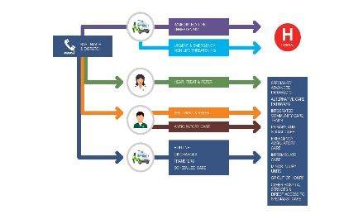
• Patient Transport Services.Key professionals: Paramedics, Emergency Medical Technicians (EMTs), and Control Room Staff.

Challenges Faced by Ambulance Services
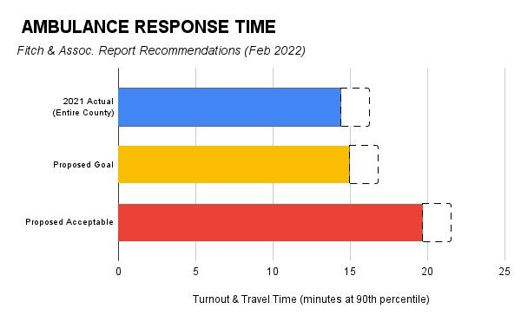
Challenge 1: Rising Demand and Delayed Response Times Ambulance services are under increasing pressure due to rising emergency calls, aging populations, and hospital congestion. In the UK, average response times for Category 1 emergencies often exceed the 7-minute target, reaching 10–12 minutes (NHS Digital, 2024).


Challenge 2: Workforce Shortages and Staff Burnout High workloads and exposure to trauma contribute to stress and burnout among ambulance staff. Over 60% of UK paramedics reported symptoms of mental distress in 2023 (College of Paramedics, 2023). Recruitment and retention remain critical challenges.

Innovations and the Future of Ambulance Services

Future developments in ambulance services focus on technology, sustainability, and preventive care:

• Digital transformation with AI-assisted dispatch and real-time GPS routing
• Telemedicine for remote hospital consultation during transport
• Green fleets using electric and hybrid vehicles (NHS Net Zero, 2024)
• Community Para medicine providing in-home care to reduce hospital visits.

Conclusion
Ambulance services are the frontline of emergency healthcare, saving countless lives annually. Despite advancements in training and technology, challenges persist—notably in managing demand and supporting workforce wellbeing. Continued innovation, investment, and policy support are essential to ensure these services remain efficient, compassionate, and sustainable.

References (Harvard Style)
College of Paramedics (2023) *State of Paramedic Wellbeing Report 2023.* Available at: https://collegeofparamedics.co.uk/ (Accessed: 19 October 2025).
King’s Fund (2023) *The NHS Ambulance Service: Key Facts and Challenges.* Available at: https://www.kingsfund.org.uk/ (Accessed: 19 October 2025).
Mackenzie, G. (2019) ‘History of Ambulance Services’, *Journal of Emergency Medicine,* 56(4), pp. 234–240.
NHS Digital (2024) *Ambulance Quality Indicators.* Available at: https://digital.nhs.uk/ (Accessed: 19 October 2025).
NHS England (2023) *Ambulance Services Overview.* Available at: https://www.england.nhs.uk/ (Accessed: 19 October 2025).
NHS Net Zero (2024) *Sustainable Ambulance Fleet Strategy.* Available at: https://www.england.nhs.uk/greenernhs/ (Accessed: 19 October 2025).

Origins and Structure of the National Health Service (NHS)

Introduction

The National Health Service (NHS) represents one of the most transformative social reforms in British history. Founded in 1948, it was built on the principles of universality, accessibility, and equity, ensuring that medical care was available to all citizens, free at the point of use. The NHS reflected post-war ideals of social justice and collective welfare, becoming a model for publicly funded healthcare worldwide. This essay explores the historical origins and key principles behind the NHS and critically examines its current structure and functioning.

Historical Origins of the NHS

Before 1948, healthcare in Britain was fragmented and unequal. Access largely depended on income, with private care for the wealthy and charitable or local authority hospitals for the poor (Baly, 1995). The National Insurance Act 1911 marked the first state involvement in health provision, covering only employed men, leaving many—especially women and children—uninsured (Webster, 2002). This inequality highlighted the need for a comprehensive national system.

The Second World War accelerated healthcare reform. Wartime emergency medical services showed the efficiency of central coordination, convincing policymakers that a unified approach was both possible and necessary (Ham, 2014). In 1942, Sir William Beveridge’s report proposed a national system to combat “disease” and promote social welfare through a publicly funded health service (Beveridge, 1942). This vision inspired post-war reconstruction efforts and gained political momentum.

In 1946, Aneurin Bevan, Minister of Health in the Labour government, introduced the National Health Service Act, establishing a state-funded, universal health service that began operating on 5 July 1948. Bevan aimed to make healthcare a right, not a privilege, financed through general taxation rather than private insurance (Bevan, 1952). He defined three key principles that continue to guide the NHS:

- It meets the needs of everyone.

- It is free at the point of delivery.

- It is based on clinical need, not ability to pay (NHS England, 2023).

Current Structure and Functioning

Today, the NHS operates as four separate systems across the UK—England, Scotland, Wales, and Northern Ireland—each with devolved responsibility for healthcare policies and budgets (Greer, 2016).

In England, the NHS is overseen by the Department of Health and Social Care (DHSC), which directs NHS England, responsible for strategic planning, commissioning services, and setting national priorities. Since 2022, Integrated Care Boards (ICBs) have replaced Clinical Commissioning Groups, bringing together local authorities, hospitals, and primary care providers to deliver joined-up health and social care (Ham, Alderwick and Dunn, 2021).

The NHS is primarily funded through general taxation and National Insurance contributions. Spending in 2023–24 was around £180 billion, accounting for roughly 40% of government expenditure (House of Commons Library, 2024). Most services remain free, though patients pay for prescriptions, dental, and optical care in some regions.

The NHS delivers services through primary care (GPs and community services), secondary care (hospitals and specialists), and tertiary care (specialised and research hospitals). It also plays a vital role in medical education, research, and public health initiatives (Black, 2016).

Critical Evaluation

Despite its enduring success, the NHS faces major challenges. Rising demand, driven by an ageing population and chronic conditions, has placed pressure on capacity and funding (The King’s Fund, 2023). Staff shortages and burnout following the COVID-19 pandemic have affected service delivery (Iacobucci, 2021). Long waiting times and delayed hospital discharges highlight inefficiencies in system coordination.

Critics argue that repeated structural reforms and increased private sector involvement risk fragmenting care and undermining the founding principle of equality (Pollock, 2013). However, supporters maintain that innovation, digital transformation, and community-based care are essential for sustainability. To remain effective, the NHS must adapt to new challenges while protecting its founding values.

Conclusion

The NHS emerged from the social ideals of post-war Britain, built on the belief that healthcare should be universal and free for all. Over 75 years, it has improved life expectancy and reduced inequalities, standing as a symbol of national pride. Yet, sustaining these achievements requires continued reform, investment, and commitment to Bevan’s vision. The NHS remains a cornerstone of British society—an enduring embodiment of compassion and collective responsibility.

References

Baly, M. (1995) Nursing and Social Change. 3rd edn. London: Routledge.
Beveridge, W. (1942) Social Insurance and Allied Services. London: HMSO.
Bevan, A. (1952) In Place of Fear. London: Heinemann.
Black, N. (2016) ‘The legacy of the NHS: Achievements and challenges’, British Medical Journal (BMJ), 352, pp. 1–4.
Greer, S.L. (2016) ‘Devolution and health in the UK: Policy divergence and system performance’, Social Policy and Administration, 50(2), pp. 174–194.
Ham, C. (2014) Health Policy in Britain. 7th edn. London: Palgrave Macmillan.
Ham, C., Alderwick, H. And Dunn, P. (2021) Integrating Care: Next Steps to Build Strong and Effective Integrated Care Systems. London: The King’s Fund.
House of Commons Library (2024) NHS Funding and Expenditure Statistics. Available at: https://commonslibrary.parliament.uk (Accessed: 15 October 2025).
Iacobucci, G. (2021) ‘Covid-19: NHS staff shortages and burnout threaten long-term recovery’, BMJ, 372, pp. 1–2.
NHS England (2023) About the NHS: Our Principles and Structure. Available at: https://www.england.nhs.uk/ (Accessed: 18 October 2025).
Pollock, A. (2013) NHS plc: The Privatisation of Our Health Care. London: Verso.
The King’s Fund (2023) The NHS at 75: Priorities for the Future. Available at: https://www.kingsfund.org.uk/ (Accessed: 18 October 2025).
Webster, C. (2002) The National Health Service: A Political History. 2nd edn. Oxford: Oxford University Press.

