  Report | Student No: | 2240761
 | Module Title: | Sustainable Hospitality & Tourism Management
 | Module Code: | BMIH5006
 | Lecturer: | Kathryn Roberts
 | Words: | 2163

I use the Al tool (Chatgpt) to check grammatical errors in my essay, February 20 – 22, 2025, using the following prompt.
- Please go through the writing carefully to see if my work has any grammatical errors.
On the other hand, I will certainly say that I did properly list each of my sources and did not include any Al-inspired language in the report.

Executive Summary
Being a part of the hospitality industry, cruise ships provide luxurious travel experiences carried out by millions of passengers annually. But their operations do have a big impact on environmental degradation. It addresses the ecological impact of emissions of carbon dioxide (CO₂) and sulfur oxide (SOx) elements of air pollution, untreated waste and ballast, and ecological disturbs from sewage discharge, hazardous waste discharge, saline ballast water release, and anchor damage. Additionally, by exploring industry-led initiatives aimed at lessening the adverse effects, for instance, the use of liquefied natural gas (LNG) as a cleaner fuel alternative; advanced waste management systems; exhaust gas cleaning technologies; and the use of shore power connections this report also discusses. The purpose of this sustainable practice is to accomplish the balance between economic and environmental responsibilities.

Contents
Executive Summary 2
Introduction 1
Environmental Impact of Cruise Ships 2
Air Pollution 3
Water Pollution 5
Ecological Disturbances 5
Industry Initiatives and Solutions 6
Adoption of Cleaner Fuels 6
Advanced Waste Management Systems 7
Regulations and Eco-Friendly Standards 7
Recommendation 9
Conclusion 9
References 10

Introduction
Hospitality transport is an important factor for tourism and leisure activities and includes all modes such as air, road, maritime transportation etc. (Maclean, 2019). In this line, cruise ships turned out to be the most popular of these, since these provide combined transportation, accommodation and entertainment to passengers in a single package (Genç, 2016). In the past few decades, the cruise industry has been booming, and millions of passengers have been taking voyages every year. Yet cruise ships are attractive, but have a heavy ecological footprint through their air, water and waste pollution, excess waste generation and ecological disturbances (Inkson and Minnaert, 2018). Heavy fuel oil dependence, loose waste management procedures and clear marine ecosystem disruption are the sustainability challenges (Han, Lee and Kim, 2017). With the growing concern for environmental issues globally, it is crucial for us to deeply criticise the operations of the cruise ships and come up with answers that will serve to reduce the environmental effect of the cruise ships without inhibiting their economic and recreational benefits for the cruise hotel industry.

Environmental Impact of Cruise Ships
Though tourism is depicted as positively impacting the environment, this impact is only seen superficially. To explain it further, it usually positively affects the environment since it supports conservation and pushes sustainability. Mass tourism is over-tourism, habitat destruction and excessive consumption of resources, outweighing the benefits (Gössling and Hall, 2006). Cruise tourism, for example, is polluting hugely and generates unimaginable quantities of this pollution, and the pollution emitted by one ship is equivalent to that emitted by one million cars in a day (Transport & Environment, 2024). Although tourism has some environmental benefits, overall, it is an overwhelmingly negative development because of pollution, the overrun of natural resources and ecological disruption. While it is a means to conserve natural areas and collect money to protect natural areas, it also results in pollution, depletion of resources, and destroying the ecosystem (Cooper, 2021).
Due to carbon emissions and air pollution, cruise ships dramatically affect the environment. An average cruise passenger emits approximately 421.43 kg of CO₂ per day, substantially higher than land-based vacationers (Ukpanah, 2024). Carnival Corporation’s ships emit nearly 10 times more sulfur oxides surrounding the coasts of Europe than all of Europe’s 260 million cars produced in 2017 (Transport & Environment, 2024). In addition, the 218 Europe cruise ships emitted 223,000 tons of sulfur oxides in 2022, the equivalent of 1 billion of Europe’s cars (Transport and Environment, 2024).
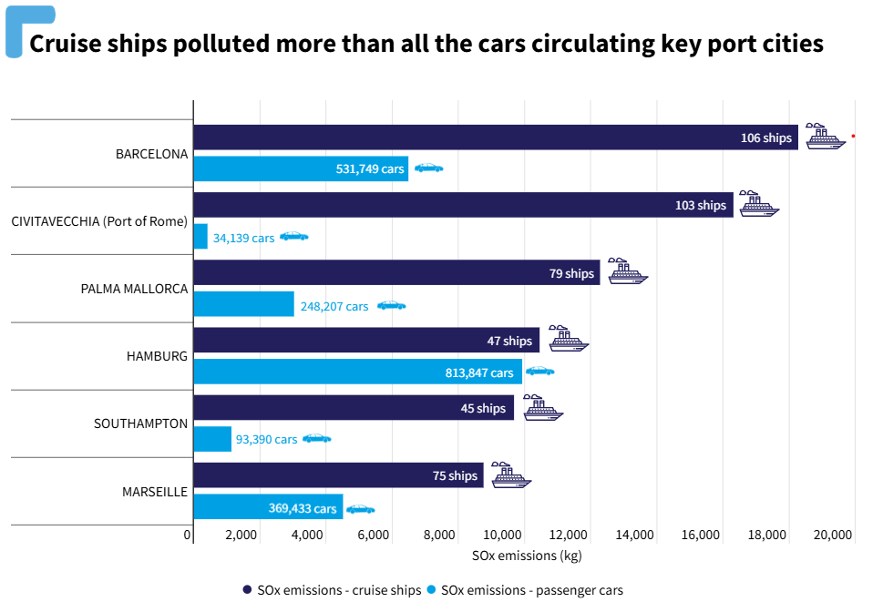
Figure: Comparison between cruise ships and car pollution (Transport and Environment, 2024)

Air Pollution
Combustion of heavy fuel oil (HFO) used in cruise ships is the main source of air pollution due to the release of different pollutants into the atmosphere (Comer et al., 2017). Since these emissions degrade air quality marine ecosystems and human health in general, air pollution from cruise tourism is widely considered one of the most important environmental issues linked to this mode of tourism.
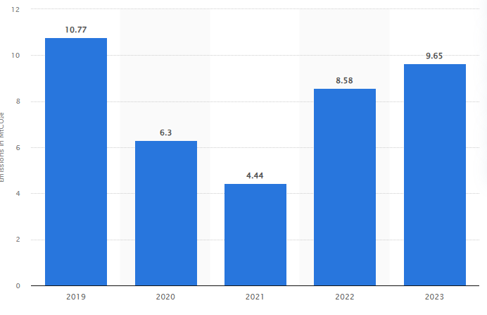
Figure: Carnival Corporation & plc’s greenhouse gas emission (Statista, 2023)
The cruise industry is a major source of CO₂ emissions which is the cause of the warming of the planet and climate change. Carnival Corporation, the world’s largest cruise operator, in 2017 emitted some 10 million metric tons of CO₂, more than some small countries produce in a year (Statista, 2023). Climate change is made worse by the greenhouse gases released annually by the entire cruise industry which has released millions of tons of greenhouse gases. Sulfur oxides produced during the combustion of HFO are also responsible for acid rain, ocean acidification, and respiratory diseases (Abdul Jameel et al., 2019). Carnival Corporation’s cruise ships released roughly 10 times more SOₓ around European coasts in 2017 than all the 260 million European cars. These emissions have intense environmental and public health consequences, especially in port cities where air pollution levels are already high (Transport & Environment, 2024). Fine particulate matter such as PM2.5 and PM10, emitted from cruise ships is capable of deeply penetrating the lungs and bloodstream to cause serious respiratory and cardiovascular diseases (Vinicius, 2020). Air quality on cruise ship decks can be worse than in some of the biggest pollution cities in the world, studies have shown that passengers and crew can be subjected to hazardous conditions. These are damaging to air quality and present dangerous health risks to passengers, crew and port communities (Scutti, 2019). Arguing the impact of cruise industries' air pollution requires cleaner fuel alternative implementations, shore power connections, and emission control technologies.

Water Pollution
Various waste streams are produced on cruise ships that are capable of causing serious pollution of marine environments. So, in an average solicitation, the average cruise ship carries 3,000 passengers and crew who produce, on average, 21,000 gallons of sewage and 255,000 gallons of grey water a day (Fox, 2022). Discharges that are not treated or treated poorly can introduce pathogens, nutrients, and chemicals to marine ecosystems where eutrophication and harm to marine life occur. Cruise ships produce large amounts of solid waste. In 2019, 2,100 tons of garbage were deposited in the local landfill by cruise ships visiting Victoria, Canada, the equivalent of over 100 fully loaded garbage trucks. Each cruise ship passenger on average creates more than two pounds of solid waste per day that is not hazardous (Engelson, 2023). Hazardous waste is materials such as paint and cleaning agents as well as batteries. If not disposed of properly, some substances can be released into the ocean and affect marine organisms whilst possibly being present in the human food chain. There are, on average, over 100 gallons of hazardous or toxic waste generated per week on a cruise ship (Beachapedia, 2022). Due to these waste streams being a significant threat to marine ecosystems and human health, these waste streams require strict waste management and regulatory oversight in the cruise industry.

Ecological Disturbances
Ballast water discharge and anchor damage can impair marine and coastal ecosystems among other things. Ballast water is taken in at one location and discharged at another, potentially introducing exotic species into new environments. Every year about 10 billion tons of ballast water is shipped around the world, enough to fill an Olympic-sized swimming pool about 4 million times. One new introduction every 9 weeks leads to imported ballast water and 7,000 aquatic species in ballast water per hour every day of the year (Neis and Cleary, 2023). Physical damage to coral reefs is possible as anchoring in sensitive areas. Virgin Islands National Park is marked by a scar, which is 128 meters long and 3 meters wide, that was created by a cruise ship dropping its anchor on a coral reef on October 15, 1988. Ten years later, the live coral cover in the scar was lower than in the pristine reef, but not lower than the cover within the scar itself (Rogers and Garrison, 2001). Because these disturbances impair both biodiversity and the livelihoods supported by reef-related tourism and fisheries, they can cause loss of biodiversity.

Industry Initiatives and Solutions
Strategic CSR is a type of CSR that goes beyond mere compliance and philanthropy, rather, it involves the incorporation of social and environmental aspects into the company’s business model for long-term value (Haski-Leventhal, 2018). In tourism, CSR is instrumental in promoting sustainability, protecting the destinations as well as ensuring ethical business practices (Wickham, Donnelly and French, 2020). However, the cruise industry does recognize the environmental challenges and for that reason has started to implement various measures to decrease its ecological footprint.

Adoption of Cleaner Fuels
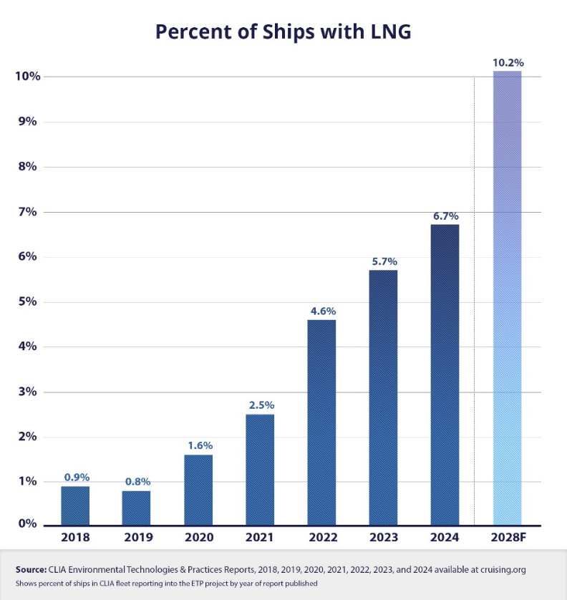
Figure: Per cent of ships with LNG (Cruise Line Industry Association, 2024)
To lessen its environmental effects, the cruise industry is proactively moving from dirty fuels. The fact that it is cleaner fuels that emit less carbon dioxide (CO₂) and virtually zero sulfur oxide (SOₓ) and particulate matter make LNG an alternative to traditional marine fuels (Oladipo, 2024). In 2023, LNG engines and fuel supply systems integrated on 48% of new cruise ship capacity will make these vessels part of the transition from heavy fuel oil to renewables in the proximity of 2030 (Cruise Line Industry Association, 2023). Research into Biofuels, Synthetic, and Hydrogen continues and certain companies are testing the feasibility and the environmental benefits. However, the industry has been held back from its goal of achieving net zero carbon emissions by 2050 because there is not yet sufficient alternative fuel. These advancements have not translated to the adoption of cleaner fuels by the cruise industry. These are major barriers, the limited availability of alternative fuels or the high costs of transitioning to new technologies (Zelinski, 2024). Further, the supporting infrastructure to make this fuel source widespread is still not available. Finally, while the cruise industry is starting to explore cheaper fuels like LNG as well as biofuels and hydrogen, it is likely to be a long time before the environmental impacts of industry are greatly reduced, and much work is to be done concerning technological innovation and supporting infrastructure.

Advanced Waste Management Systems
The cruise lines are installing advanced waste management systems that will reduce the environmental impact. Royal Caribbean offers a "Save the Waves" program to reduce waste and recycle so there is 'zero waste to landfills'. For more than 30 years, this has been a cornerstone of their sustainability effort. Solid waste on the newest ships of Royal Caribbean, such as Icon of the Seas and Silver Nova is turned into energy onboard using the waste-to-energy system (Yeginsu, 2024). It lowers the responsibility for the disposal of waste and it is an alternative energy source for the ship. The goal of "WIN on Waste" is to halve food waste over five years. To do this, portion control, menu redesign, donation of food etc., are some of the strategies. The technology used for the program is for effective monitoring and management of food waste (Royal Caribbean, 2023). By generating less waste and promoting clean practices of waste management, all of these initiatives reflect cruise industry efforts towards making the practices sustainable.

Regulations and Eco-Friendly Standards
The International Maritime Organization (IMO) is one of the key industry players in establishing the global standards of the shipping industry, including the cruise one. The IMO had set ambitiously a target of reducing the GHG emissions in international shipping by 50 per cent in 2050 compared to about 2008 levels in 2018 (IMO, 2021). The IMO’s effort to tackle climate change and promote sustainable shipping is part of this target. Altogether, IMO is seeking energy efficiency and cleaner fuels to reduce emissions, there are currently two of the main ways that the IMO is working to reduce emissions. In terms of the GHG reduction goal, the IMO has also taken action in terms of the 2020 Sulphur Cap stipulating that the sulfur content in marine fuel will be limited to a maximum of 0.5% (Bilgili, 2021). Marine fuels were once able to include up to 3.5 per cent sulfur, which was a huge difference from the now permitted 0.1 per cent sulfur and can greatly pollute coastal and port areas. To mark the SMM 2023, it’s estimated that the Sulphur Cap could cut the global sulfur emissions from shipping by 77% (European Commission, 2023). The Ballast Water Management Convention is another essential regulation that takes care of the subject of the transportation of invasive species using the ballast water of ships. Ships are required under this convention not to damage the ecological environment of the marine environment by treating ballast water before discharge (McBride, 2025). The BWM Convention, adopted in 2004, has been an important tool in the preservation of marine biodiversity.

Recommendation
This report provides the suggestions below to improve the sustainability of the tourism industry:
- As government safety incentives get accelerated for the switch towards biofuels and hydrogen, cruise lines should speed up investment in Alternative Fuels.
- The regulations should become stricter and be accompanied by stiffer penalties, fines or contraventions for these industries to be called to task.
- The Government should set the eco-certifications independently to spur responsible environmental practice as well as industry transparency.
- The proper use of Passenger Awareness Campaigns should inform travelers about greener cruise options which can encourage consumer demand for sustainable cruise operations, thereby leading to further incentives from cruise companies to adopt eco-friendly initiatives.

Conclusion
Cruise ships are of course, which are naturally great harm to the ocean, as they cause air and water pollution, as well as destruction of marine life. In addition, it discharges air that hurts (stains) air quality and produces wastewater and hazardous waste that pollutes the marine environment. IMO Sulphur Cap and Ballast Water Management Convention are strict regulations, which are answering all these problems. As such, while not demanded by ITU, it amounts to the industry having to spend on cleaner technologies like LNG as well as improving waste management. For innovation of the cruise industry and minimizing its environmental footprint, the cruise industry will be involved with environmental organizations continuously to meet the industry’s long-term sustainability.

References
Abdul Jameel, A.G., Alkhateeb, A., Telalović, S., Elbaz, A.M., Roberts, W.L. and Sarathy, S.M. (2019) ‘Environmental Challenges and Opportunities in Marine Engine Heavy Fuel Oil Combustion’, Lecture Notes in Civil Engineering, pp. 1047–1055. [online] Available at: https://www.springer.com/series/15087 (Accessed: 10 February 2025).
Beachapedia (2022) Cruise Ship Pollution. [online] Available at: https://beachapedia.org/Cruise_Ship_Pollution (Accessed: 15 February 2025).
Bilgili, L. (2021) ‘Life cycle comparison of marine fuels for IMO 2020 Sulphur Cap’, Science of The Total Environment, 774, p. 145719. [online] Available at: https://www.sciencedirect.com/science/article/abs/pii/S0048969721007865 (Accessed: 5 March 2025).
Comer, B., Olmer, N., Mao, X., Roy, B. and Rutherford, D. (2017) Prevalence of heavy fuel oil and black carbon in Arctic shipping, 2015 to 2025. [online] Available at: https://repository.oceanbestpractices.org/handle/11329/1896 (Accessed: 01 February 2025).
Cooper, C. (2021) Essentials of Tourism. London: Pearson.
Cruise Line Industry Association (2023) ‘New environmental data report confirms step change in cruise industry uptake of new environmental technologies’. [online] Available at: https://cruising.org/en-gb/news-and-research/press-room/2023/september/new-environmental-data-report-confirms-step-change-in-cruise-industry (Accessed: 25 January 2025).
Cruise Line Industry Association (2024) Environmental Technologies and Practices CLIA Global Oceangoing Cruise Lines - August 2022. [online] Available at: https://cruising.org/en/Sustainability-Data (Accessed: 25 February 2025).
Engelson, A. (2023) ‘The terrible toll of the cruise ship industry’, High Country News. [online] Available at: https://www.hcn.org/articles/ocean-the-terrible-toll-of-the-cruise-ship-industry/ (Accessed: 5 March 2025).
European Commission (2023) Cleaner Air in 2020: 0.5% sulphur cap for ships enters into force worldwide. [online] Available at: https://transport.ec.europa.eu/news-events/news/cleaner-air-2020-05-sulphur-cap-ships-enters-force-worldwide-2020-01-09_en (Accessed: 5 March 2025).
Fox, A. (2022) ‘Cruise Ship Water Pollution’, Friends of the Earth. [online] Available at: https://foe.org/blog/cruise-ship-water-pollution/ (Accessed: 15 February 2025).
Genç, R. (2016) ‘Sustainability in Cruise Ship Management’, International Journal of Social Science Studies, 4(6). [online] Available at: https://core.ac.uk/download/pdf/216960116.pdf#page=73 (Accessed: 25 January 2025).
Gössling, S. and Hall, M.C. (2006) Tourism and Global Environmental Change. Taylor & Francis. [online] Available at: https://library.oapen.org/handle/20.500.12657/24073 (Accessed: 25 January 2025).
Han, H., Lee, M.J. and Kim, W. (2017) ‘Antecedents of Green Loyalty in the Cruise Industry: Sustainable Development and Environmental Management’, Business Strategy and the Environment, 27(3), pp. 323–335. [online] Available at: https://onlinelibrary.wiley.com/doi/epdf/10.1002/bse.2001 (Accessed: 5 March 2025).
Haski-Leventhal, D. (2018) Strategic Corporate Social Responsibility. London: SAGE.
IMO (2021) Reducing greenhouse gas emissions from ships. [online] Available at: https://www.imo.org/en/MediaCentre/HotTopics/Pages/Reducing-greenhouse-gas-emissions-from-ships.aspx (Accessed: 15 February 2025).
Inkson, C. and Minnaert, L. (2018) Tourism Management. London: SAGE.
Maclean, M.A. (2019) Sustainable hospitality and tourism management. Oakville, ON: Society Publishing.
McBride, O. (2025) ‘Revised Ballast Water Regulations Set to Impact Shipping Industry’, The Fishing Daily - Irish, UK and European Fishing Industry News. [online] Available at: https://thefishingdaily.com/irish-fishing-industry-news/revised-ballast-water-regulations-set-to-impact-shipping-industry/ (Accessed: 20 February 2025).
Neis, U. and Cleary, R. (2023) ‘The use of power ultrasound for wastewater and biomass treatment’, Elsevier eBooks, pp. 817–832. [online] Available at: https://www.sciencedirect.com/science/article/abs/pii/B9780128202548000269 (Accessed: 15 February 2025).
Oladipo, D. (2024) ‘World’s largest cruise ship sets sail, bringing concerns about methane emissions’, Reuters. [online] Available at: https://www.reuters.com/business/environment/worlds-largest-cruise-ship-sets-sail-bringing-concerns-about-methane-emissions-2024-01-27/ (Accessed: 25 February 2025).
Rogers, C.S. and Garrison, V.H. (2001) ‘Ten years after the crime: Lasting effects of damage from a cruise ship anchor on a coral reef in St. John, U.S. Virgin Islands’, Bulletin of Marine Science, 69(2), pp. 793–803. [online] Available at: https://www.researchgate.net/profile/Caroline-Rogers-2/publication/233687433_Ten_years_after_the_crime_Lasting_effects_of_damage_from_a_cruise_ship_anchor_on_a_coral_reef_in_St_John_US_Virgin_Islands/links/00b7d52b42f6daaf44000000/Ten-years-after-the-crime-Lasting-effects-of-damage-from-a-cruise-ship-anchor-on-a-coral-reef-in-St-John-US-Virgin-Islands.pdf (Accessed: 15 February 2025).
Royal Caribbean (2023) Royal Caribbean’s next-gen cruise ship will advance the goal of creating sustainable cruising. [online] Available at: https://www.royalcaribbeanblog.com/2023/04/26/royal-caribbean-creating-sustainable-cruise-ship (Accessed: 25 February 2025).
Scutti, S. (2019) ‘The air quality on cruise ships is so bad, it could harm your health, undercover report says’, CNN. [online] Available at: https://edition.cnn.com/2019/01/24/health/cruise-ship-air-quality-report/index.html (Accessed: 15 February 2025).
Statista (2023) Carnival Corp plc GHG emissions 2023. [online] Available at: https://www.statista.com/statistics/1404444/emissions-of-carnival-corp-plc-worldwide/ (Accessed: 5 February 2025).
Transport & Environment (2024) One corporation to pollute them all. [online] Available at: https://www.transportenvironment.org/articles/one-corporation-pollute-them-all (Accessed: 26 January 2025).
Transport and Environment (2024) ‘Europe’s luxury cruise ships emit as much toxic sulphur as 1bn cars’, Transport and Environment. [online] Available at: https://www.transportenvironment.org/articles/europes-luxury-cruise-ships-emit-as-much-toxic-sulphur-as-1bn-cars-study (Accessed: 26 January 2025).
Ukpanah, I. (2024) ‘Are Cruise Ships Bad For The Environment? Stats, Trends, And Facts’, GreenMatch.co.uk. [online] Available at: https://www.greenmatch.co.uk/blog/maritime-sustainability (Accessed: 31 January 2025).
Vinicius, M. (2020) Commuter’s exposure to short-lived climate pollutants in maritime transport. [online] Available at: https://repositorio.utfpr.edu.br/jspui/bitstream/1/5126/1/LD_PPGEA_M_Oliveira%2C_Marcus_Vinicius_Batista_2020.pdf (Accessed: 25 February 2025).
Wickham, M., Donnelly, T. and French, L. (2020) ‘Strategic sustainability management in the event sector’, Event Management, 25(3). [online] Available at: https://doi.org/10.3727/152599519x15506259856318 (Accessed: 25 February 2025).
Yeginsu, C. (2024) ‘Can the World’s Largest Cruise Ship Really Be Climate-Friendly?’, The New York Times, 24 January. [online] Available at: https://www.nytimes.com/2024/01/23/travel/icon-of-the-seas-cruise-ship-sustainability.html (Accessed: 25 February 2025).
Zelinski, A. (2024) ‘Cruise industry’s adoption of biofuel has limited range’, Travel Weekly. [online] Available at: https://www.travelweekly.com/Cruise-Travel/Cruise-adoption-biofuel-has-limited-range (Accessed: 25 February 2025).

