Master of Business Administration
LCMB7035

The Role of Ayurveda in Strengthening Preventive Healthcare Practices in India: A Secondary Qualitative Analysis

Student Name:
Student ID:
Table of Contents
1. Introduction 3
1.1 Background 3
1.2 Aim and Objectives 4
1.3 Research questions 4
1.4 Rationale and Significance 4
1.5 Process of this research 5
2. Literature review 5
2.1 Ayurveda’s impact on lifestyle practices for healthcare 5
2.2 Impact of policy and the government's efforts on Ayurveda 6
2.3 Challenges and opportunities in the wide implication of Ayurveda 6
2.4 Theoretical Foundation 7
2.5 Literature Gap 8
3. Methodology 9
3.1 Research Approach 9
3.2 Data collection method 9
3.3 Data Analysis Technique 9
3.4 Ethics 10
4. Expected findings 10
5. Limitations 11
6. Timeframe 11
7. Conclusion 12
8. References 13

1. Introduction

1.1 Background
Ayurveda, which literally means the science of life is the ancient system of Indian medicine with its origin in the Indian subcontinent; and the focus of Ayurveda is on holistic health, lifestyle balance and prevention of disease (Department of AYUSH, 2024). According to a survey by PIB (2024), the consumption of ayurvedic medicine is 40.5% and 45.5% in the rural and urban areas respectively.
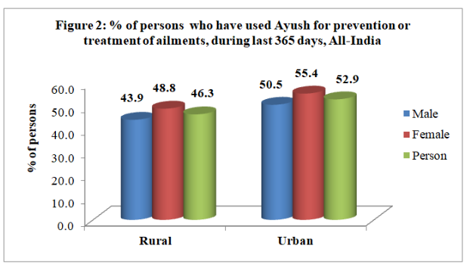
Figure 1: Use of Ayurveda
(Source: PIB, 2025)
Ayush Ayurveda intends to avail Medicare services to the US population using Ayurvedic, Unani, and Homoeopathic medicine (Department of AYUSH, 2025). In addition, Ayurvedic practitioners certified are more than 500,000, the majority of which operate in India (PIB, 2023). Over the last few decades, India has experienced an increasing number of non-communicable diseases (NCDs), as well as ongoing problems of communicable diseases, maternal and child health conditions, and ageing (Saxena et al., 2024). Western doctors may help prevent diabetes, hypertension, and obesity by incorporating Ayurvedic traditions and making dietary, daily habits, and seasonal changes to stay healthy (Ahuja, 2024). This is a pointer of the rising productivity and popularity of this type of healthcare treatment in the world.

1.2 Aim and Objectives
Aim
The main aim of this research is to examine the role of Ayurveda in strengthening preventive
healthcare practices in India.
Objectives
- To examine the contribution of Ayurvedic principles and lifestyle practices in promoting preventive healthcare in India.
- To analyse existing policies, programs, and institutional efforts supporting the integration of Ayurveda into preventive healthcare systems in India.
- To identify the key challenges and opportunities in strengthening the integration of Ayurveda within India’s preventive healthcare framework.

1.3 Research questions
- What is the contribution of Ayurvedic principles and lifestyle practices in promoting preventive healthcare in India?
- What are the existing policies, programs, and institutional efforts supporting the integration of Ayurveda into preventive healthcare systems in India?
- What challenges and opportunities exist in integrating Ayurveda effectively into India’s mainstream preventive healthcare system?

1.4 Rationale and Significance
As mentioned earlier, India is experiencing a marked shift from communicable to NCDs, emphasising the need for stronger preventive healthcare initiatives. According to Verma et al. (2024), the ancient system of Ayurveda offers lifestyle-based regimens and holistic wellness approaches, making it particularly relevant for prevention and health promotion. However, challenges in standardising Ayurvedic practices include variations in formulations, lack of scientific validation for many treatments, distrust, operational coordination issues, technical incompatibilities, and regulatory obstacles, making integration with mainstream medicine difficult (Verma et al., 2024). The issue is timely because the government in India is trying to mitigate these issues by improving the supply chain, accessibility and improving stakeholders' trust through integrating Ayush with Modern Medicine (PIB, 2024). This research can positively contribute by systematically analysing the role of Ayurveda in preventive healthcare, offering evidence-based insights and recommending actionable pathways for better integration and utilisation.

1.5 Process of this research
This study will undertake a secondary qualitative analysis by systematically reviewing peer-reviewed literature, policy documents and institutional reports relating to Ayurveda and preventive healthcare in India. Key themes will be coded and analysed to explore three domains, such as Ayurvedic lifestyle and preventive practices, policy and institutional integration of Ayurveda into public health, and lastly, the challenges and opportunities for mainstreaming Ayurveda in preventive healthcare. The findings will be synthesised to develop evidence-based recommendations for policymakers and healthcare practitioners.

2. Literature review

2.1 Ayurveda’s impact on lifestyle practices for healthcare
Ayurveda is an ancient Indian health tradition that is oriented towards preventive medicine based on personalised treatment, dietary modifications, herbal medicine, and lifestyle, as opposed to curative health care as practised by modern medicine. Sharma (2021) defines some of the main principles, such as Dinacharya, Ritucharya, and Sadvritta, as advocates of long-term health maintenance and wellness. Sharma (2021) further stated that clinical validation of Ayurveda has increased due to the development of scientific interest, and studies on herbs like Ashwagandha, Brahmi, and Guduchi have shown that these have neuro-protective and anti-inflammatory properties, highlighting the role of Ayurveda in improving brain health. According to a report by The Times of India (2025), the pandemic has made more people interested in holistic wellness and traditional systems of healing in India, especially in Ayurveda, Yoga, Unani, Siddha, and Homoeopathy (AYUSH). People sought better and stronger health and found it in the AYUSH practices and herbal remedies to prevent and cure illnesses. Nevertheless, the report also added that weaknesses such as the absence of standardisation and evidence of Ayurvedic formulations, regulations, and infrastructure requirements are also a challenge, which is an adverse factor in its implication.

2.2 Impact of policy and the government's efforts on Ayurveda
In the last decade, the Ayurveda industry has expanded tremendously in particular, particularly following the formulation of policies and governmental initiatives. The National Health Policy 2017 determines the use of Ayush services in the public healthcare sector (Kumar et al. 2025). Recent developments have been the establishment of 12,500 Ayushman Arogya Mandirs, Ayush sections at the new AIIMS, and Ayush recommendations in conformity with the Indian Public Health Standards of Ayush. This expansion is reflected in increased budgetary allocations, a rise in exportation of herbal medicines, building of hospitals and educational facilities, among others (Kumar et al., 2025). Conversely, Gupta et al. (2023) expounded that the Ministry of Ayush (MoA) has been undertaking Ayush interventions since 2007-2008 through grants to governmental and non-governmental organisations in undertaking public health-centric programmes. Public health initiatives (PHIs) include a multifaceted strategy that includes the treatment, prevention, awareness, and development of a healthcare system (Gupta et al., 2023). Taken together, these activities indicate very high institutional support, but there is very little systematic assessment of their preventive-health outcomes.

2.3 Challenges and opportunities in the wide implication of Ayurveda
Ayurveda has made its way into preventive care despite the promise of enduring success due to the policy momentum and promise based on lifestyle. According to Singh (2024), regulatory barriers, intellectual property issues, lack of scientific validation, gaps in knowledge among medical practitioners, and economic barriers such as high cost of certification, and low insurance coverage in Ayurvedic treatment (mainstreaming) are some of the policy issues of Ayurvedic mainstreaming. Nevertheless, Katiyar and Dubey (2023) stated that the Ayurvedic market is growing due to the growing global incorporation of holistic health care, natural products, and the necessity to get personalised and traditional healing procedures. In addition, research and technological innovations are also proving Ayurvedic practices and making them more believable within conventional medicine.

2.4 Theoretical Foundation
The study under consideration is based on the Health Promotion Model (HPM) developed by Pender, the analysis of which revolves around individual behaviours and motivations that contribute to health promotion and the prevention of diseases. The Health Promotion Model by Pender is considered one of the most popular models of studying, identifying, and changing harmful habits and promoting health (Chen and Hsieh, 2021). The Ayurvedic preventive principles of balanced lifestyle, diet, and mindfulness are linked with how the model focuses on the perceived benefits, self-efficacy, and situational effects. The HPM application is useful to explain the proactive health behaviours and resilience based on Ayurvedic practices and support preventative healthcare objectives. The theoretical perspective enhances the capacity of the study to examine the influence of Ayurveda as a strategy of promoting sustainable, self-directed healthcare-based on a health-maintenance system that is experiencing changes in India.

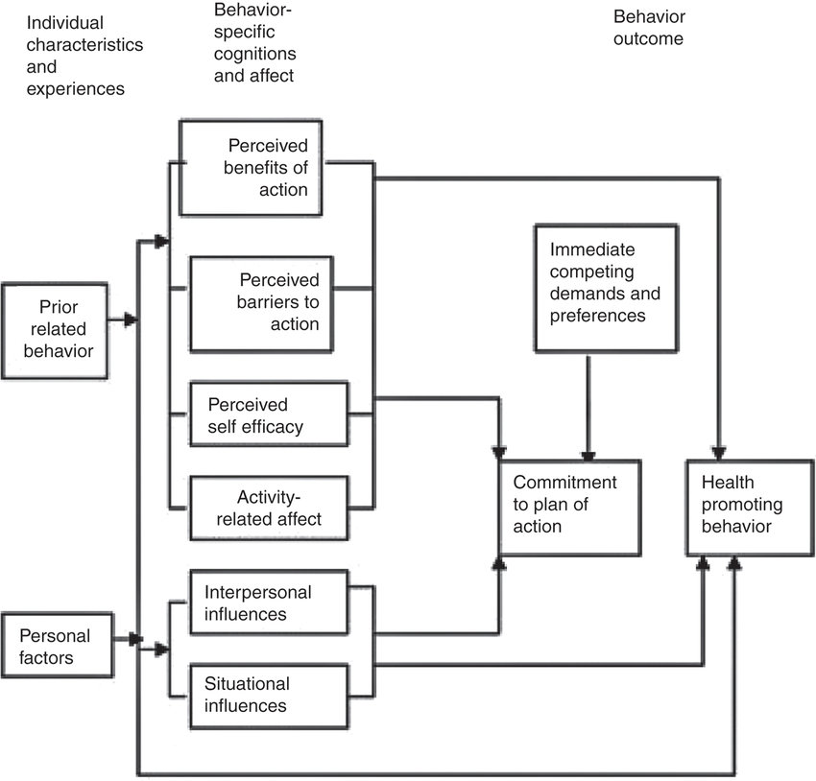
Figure 3: Pender's health promotion model
(Khoshnood et al., 2018)

2.5 Literature Gap
As the literature review portrays, various journals and articles are found on the Ayurvedic industry with images of benefits, integration of policies, challenges and opportunities, but there is a major gap in the literature to analyse the role of Ayurveda in enhancing preventive healthcare practices in India. Some studies, such as Sharma (2021), have discussed long-term health maintenance and wellness, without providing an insight into preventive care. This research will help to reduce this gap.

3. Methodology

3.1 Research Approach
This paper will use secondary qualitative research to address how Ayurveda can be used to reinforce preventive health in India. The reason is that a qualitative approach would be the most appropriate as it allows an in-depth analysis of meanings, cultural backgrounds, and practices within an institution instead of a statistical assessment (Lim, 2025). The paper will examine the role of Ayurvedic philosophy, government programs and integration of the population in health promotion in preventive healthcare. The secondary qualitative approach is a method that enables the researcher to use previously published textual research material, including government reports, journal articles, and institutional publications, in order to derive new meanings without collecting original information. The methodology will make the study viable and valid within the time constraints of this study.

3.2 Data collection method
The data collection method will utilise the secondary method to gather information from already existing research. Information obtained from pre-existing literature and sources, as opposed to being directly acquired by researchers, is referred to as secondary data (Ganesha and Aithal, 2022). Census data, electronic archives, governmental and private organisations, yearly reports, historical records, and scholarly literature are examples of sources of secondary data (Ganesha and Aithal, 2022). Data will be gathered from reputable secondary sources, including academic journals, Government documents, ministry documents of Ayurveda, AYUSH publications, and prior research studies pertaining to Ayurveda and preventative healthcare. The sources will be screened using the inclusion criteria of relevance to Ayurveda and preventive health, publication year post-2020, and accessibility in full-text English versions. This method ensures that the research draws from the most current and authoritative materials and generates impactful findings.

3.3 Data Analysis Technique
To identify, classify, and analyse patterns and themes in Ayurvedic treatment to strengthen preventive healthcare practices in India, thematic analysis will be included in the data analysis. Thematic analysis is a qualitative research methodology aimed at identifying and elucidating patterns and meanings inherent in data (Finlay, 2021). This approach was selected due to its capacity to collect qualitative data from many sources, including newspapers, reports, and articles, and generate themes based on them to extract findings. Thematic analysis will help in organising the data into categories such as Ayurvedic preventive principles, policy integration, and implementation challenges to interpret their meaning systematically.

3.4 Ethics
The research work will thoroughly maintain ethical considerations on data privacy, copyrights, and legal access to journals and government databases. According to Hasan et al. (2021), ethical considerations ensure the research findings' validity, reliability, trustworthiness, and accuracy. All the data utilised for this research will be collected through publicly accessible databases, and the researchers of the journal and articles will be given credit for using them in the current study. The used journal and articles will be from trusted resources, and only the literature after 2019 will be considered for quality and efficiency for this research. Since no primary data will be collected for this research, it will not include any confidentiality or privacy risks.

4. Expected findings
The main objective of the study will be to explore how Ayurveda can be used to reinforce preventive healthcare in India. Depending on the literature review and the current policy initiatives, it is expected that the findings will identify the emerging role of Ayurveda as a supplementary and integrative method of preventing health among the population. It is anticipated that the study will demonstrate that Ayurvedic concepts, like lifestyle control (Dinacharya and Ritucharya), nutritious eating, and psychological wellness, have a beneficial impact on preventive health, especially prevention of the risks of non-communicable diseases.
It is also expected that secondary data analysis will demonstrate the progress of the government via the Ministry of AYUSH and the National AYUSH Mission, which have increased the institutional integration and the understanding of Ayurveda-based preventive healthcare to the masses. Nevertheless, the results can also determine what the long-running issues are, including inconsistent enforcement of policies, insufficient empirical support of Ayurvedic practices, and unequal availability throughout the regions.
In general, the study is likely to offer valuable insights into both the opportunities and gaps in the integration of Ayurveda in the preventive healthcare model of India that can be utilised by policymakers and healthcare professionals to sustain the preventive health ecosystem.

5. Limitations
This study could also encounter some limitations which could be mainly because of the use of secondary qualitative data. The research relies on literature and policy papers that are available and of good quality, and this might not offer all the recent or unpublished developments in Ayurveda-based preventive healthcare. As well, interpretations may be biased by the possibility of biases in earlier research. Lack of primary data collection inhibits the possibility of collecting the first-hand views of practitioners or policymakers. To mitigate these issues, the research will ensure critical source evaluation, inclusion of diverse databases, and triangulation of findings to enhance validity and maintain analytical objectivity.

6. Timeframe
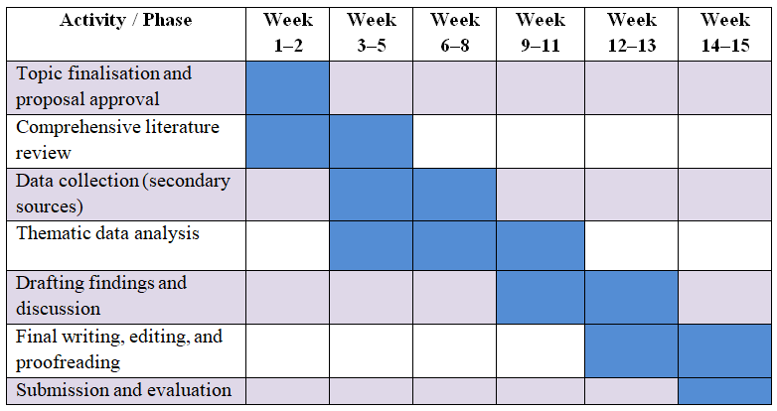
Table 1: Gantt chart
(Source: Author)
This 15-week schedule will make sure that every stage, including approval of the proposal to the ultimate submission is done in a systematic way. Distributed work will make the research process more efficient and consistent. It contains flexibility on how it can be revised and incorporated feedbacks, so that the study can not only achieve its objectives within the suggested period, but also be academically rigorous.

7. Conclusion
The study will critically examine the role of Ayurveda in enhancing the use of preventive healthcare practices in India based on secondary qualitative analysis. It is anticipated to present evidence-based information regarding the integration of Ayurvedic, the effectiveness of the policies, and the implementation issues, which will eventually become a part of the development of the sustainable, holistic, and preventative health strategies in the context of the changing Indian public healthcare system.

8. References
Ahuja, N. (2024) Integrating Ayurveda for lifestyle disease prevention. Available at: https://www.ayurveda-awareness.com.au/integrating-ayurveda-for-lifestyle-disease-prevention/ (Accessed: 6 November 2025).
Ahuja, N. (2024) Integrating Ayurveda for Lifestyle Disease Prevention. Available at: https://www.ayurveda-awareness.com.au/integrating-ayurveda-for-lifestyle-disease-prevention/ (Accessed: 6 November 2025).
Chen, H.H. and Hsieh, P.L. (2021) ‘Applying the Pender’s health promotion model to identify the factors related to older adults’ participation in community-based health promotion activities’, International Journal of Environmental Research and Public Health, 18(19), p.9985. Available at: https://doi.org/10.3390/ijerph18199985
Department of AYUSH (2024) AYURVEDA: The Science of Life. Available at: https://ccras.nic.in/wp-content/uploads/2024/07/AYURVEDA_The_Science_of_LifeDossier.pdf (Accessed: 6 November 2025).
Department of AYUSH (2025) Objectives. Available at: https://ayush.telangana.gov.in/content.php?U=15%20&&%20T=Objectives (Accessed: 6 November 2025).
Finlay, L. (2021) ‘Thematic analysis: the “good”, the “bad” and the “ugly”’, European Journal for Qualitative Research in Psychotherapy, 11, pp. 103–116. Available at: https://doi.org/10.24377/EJQRP.article3062
Ganesha, H.R. and Aithal, P.S. (2022) ‘How to choose an appropriate research data collection method and method choice among various research data collection methods and method choices during Ph. D. program in India’, International Journal of Management, Technology, and Social Sciences, 7(2), pp. 455–489. Available at: https://doi.org/10.5281/zenodo.7277944
Gupta, P.K., Karthik, K.P., Sahu, R., Shrikrishna, R. and Mahapatra, A.K. (2023) ‘Public health initiatives and Ayush: Projects to policy’, International Journal of Ayurveda Research, 4(3), pp. 146–154. Available at: https://doi.org/10.4103/ijar.ijar_64_23
Hasan, N., Rana, R.U., Chowdhury, S., Dola, A.J. and Rony, M.K.K. (2021) ‘Ethical considerations in research’, Journal of Nursing Research, Patient Safety and Practice (JNRPSP), 1(01), pp. 1–4. Available at: https://doi.org/10.55529/jnrpsp11.1.4
Katiyar, C.K. and Dubey, S.K. (2023) ‘Opportunities and challenges for Ayurvedic industry’, International Journal of Ayurveda Research, 4(3), pp. 123–131. Available at: https://doi.org/10.4103/ijar.ijar_114_23
Khoshnood, Z., Rayyani, M. and Tirgari, B. (2018) ‘Theory analysis for Pender’s health promotion model (HPM) by Barnum’s criteria: a critical perspective’, International Journal of Adolescent Medicine and Health, 32. Available at: https://doi.org/10.1515/ijamh-2017-0160
Kumar, S., Singh, R., Kampani, S. and Gopal, K.M. (2025) ‘Policy mandates for Ayush in National Health Policy-2017: Achievements, impediments, and future prospects’, Journal of Family Medicine and Primary Care, 14(5), pp. 1597–1603. Available at: https://doi.org/10.4103/jfmpc.jfmpc_1234_24
Lim, W.M. (2025) ‘What is qualitative research? An overview and guidelines’, Australasian Marketing Journal, 33(2), pp. 199–229. Available at: https://doi.org/10.1177/14413582241264619
Press Information Bureau [PIB] (2023) ‘AGNI’ initiative to promote innovations by Ayurveda practitioners. Available at: https://www.pib.gov.in/PressReleaseIframePage.aspx?PRID=1978802 (Accessed: 6 November 2025).
Press Information Bureau [PIB] (2024) Results of survey on AYUSH (July 2022 to June 2023) released. Available at: https://www.pib.gov.in/PressReleaseIframePage.aspx?PRID=2025076 (Accessed: 6 November 2025).
Press Information Bureau [PIB] (2025) Integration of Ayush with modern medicine. Available at: https://www.pib.gov.in/PressReleasePage.aspx?PRID=2154258 (Accessed: 6 November 2025).
Saxena, V., Misra, P., Naveen, K.H., Sumanth, M.M., Das, A. and Jain, V. (2024) ‘Strengthening AYUSH integration with preventive medicine’, Indian Journal of Community Medicine, 49(Suppl 2), pp. S183–S190. Available at: https://doi.org/10.4103/ijcm.ijcm_748_24
Sharma, D.R. (2021) ‘The role of Ayurvedic science in preventive healthcare: An evidence-based approach’, Educational Administration: Theory and Practice, 27(2), pp. 1191–1200. Available at: https://doi.org/10.53555/kuey.v27i2.10732
Singh, V.B. (2024) ‘Mainstreaming Ayurveda: Policy challenges in global acceptance’, Journal of Ayurvedic and Herbal Medicine, 10(4), pp. 103–106. Available at: https://doi.org/10.4103/JAHM.JAHM_6_24
Times of India (2025) ‘Yoga, Ayurveda and wellness tourism: India’s new global identity’, The Times of India, 25 October. Available at: https://timesofindia.indiatimes.com/life-style/health-fitness/health-news/yoga-ayurveda-and-wellness-tourism-indias-new-global-identity/amp_articleshow/124085467.cms (Accessed: 6 November 2025).
Verma, S.K., Pandey, M., Sharma, A. and Singh, D. (2024) ‘Exploring Ayurveda: principles and their application in modern medicine’, Bulletin of the National Research Centre, 48(1), p.77. Available at: https://doi.org/10.1186/s42269-024-01231-0

