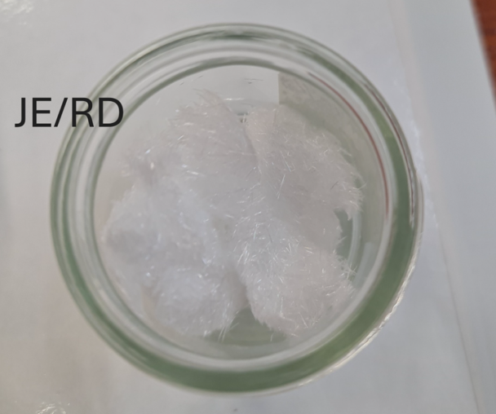  Lab 3  methyl-3-nitrobenzoate and nitroguanidine | Abstract  This report covers both the physical experiment and the theory of nitration and electrophilic substitution.  Rebecca Dingwall (2217521)  ACDA6020

Table of Contents
1. Introduction 2
1.1 Aim 2
1.2 Hypothesis 2
2. Theory 2
2.1 Basic Concepts & Principals 2
2.2 Chemical equations 3
2.3 Applications and relevance to OME. 3
2. Materials & Method 4
3. Results 5
4. Discussion 6
5. Conclusion 7
6. Bibliography 8

1. Introduction
This report covers both the physical experiment and the theory of nitration and electrophilic substitution.

Aim
The aim of this experiment was to synthesise methyl-3-nitrobenzoate and nitroguanidine through nitration reactions.

1.2 Hypothesis
These experiments have potential to become contaminated or for impurities to be left within the samples. It is known that Nitroguanidine is water soluble [1] as part of the process the crystals are required to be washed with ice water, this could reduce overall yield.

2. Theory

2.1 Basic Concepts & Principals
Using an organic molecule, nitration is a chemical process that adds a nitro group to the original organic molecule [2].
Experiment 1 the hydrogen atom is replaced by electrophilic substitution.
An electrophile is a species that seeks out areas of high electron density.
Electrophilic substitution reactions are common in aromatic compounds, during this reaction the electrophile replaces an atom, commonly a hydrogen atom, this reaction can preserve the rings overall aromaticity. This is due to the stability of the aromatic rings as addition would require breaking the stable bonds of the system [3]. This reaction can be seen in figure 1. Appendix 1 shows the step-by-step substitution as drawn in the lab book (figure 4).
Experiment 2 uses highly concentrated acid to nitrate the guanidine nitrate. During the reaction, one water molecule is removed from the structure, and a nitro group is introduced [4], as seen in figure 2.
Reagents and solvents play a vital role in the recrystallisation process after nitration. Primarily exploiting differential solubility, so essentially the solvent will only dissolve the impurities and hold them in the solution, leaving the final product free from impurities [5]. Reagents and solvents have also been shown to play a vital role in facilitating recrystallisation [6]. It is vital that the nitration process is kept cool. Common nitrations are exothermic, without controlling the temperature of the reaction the mixture could progress into an uncontrolled thermal runaway [7]. Thermal runaway could cause fire and especially relevant in this case, explosions.

2.2 Chemical equations

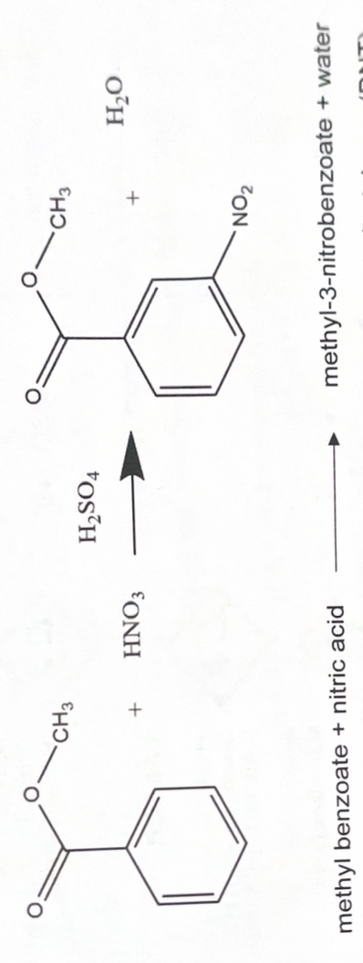
Figure 1 Formation of Methyl-3-Nitrobenzoate using electrophilic substitution.
Figure 2 Formation of Nitroguanidine using nitration.

2.3 Applications and relevance to OME.
Nitration in both forms as described in the previous section is a common way to produce explosives and propellants, for example nitroguanidine is found in triple-based propellants and the electrophilic substitution in experiment 1 is used in the preparation of Di-nitrotoluene, a precursor for TNT. For example, had toluene been used as the starting material for experiment 1, nitro toluene, di-nitrotoluene, and trinitrotoluene would be the likely products.

2. Materials & Method
Experiment 1: Synthesis of methyl-3-nitrobenzoate
Label glassware appropriately throughout the practical.
- In a recirculation fume cupboard, weight out 2.7g of methyl benzoate into a 25cm³ conical flask using a Pasteur pipette.
- In the ducted fume cupboard, measure out 5 cm³ of concentrated sulfuric acid using a 10 cm³ measuring cylinder, add to the methyl benzoate.
- Swirl the flask gently to mix and cool the mixture by placing the conical flask in ice.
- In a separate 5cm³ conical flask, prepare the nitrating mixture. Using a 10 cm³ measuring cylinder, measure 2cm³ of conc. sulfuric acid and transfer to the conical flask labelled mixed acid.
- To this add 2 cm³ of concentrated nitric acid, you can use the same measuring cylinder to measure both acids.
- Cool the mixed acids to 5°C by placing the conical flask in ice. Turn the water bath on. During the nitration process make a note of any colour changes.
- When the methyl benzoate mixture reaches 5°C add the nitrating mixture drop by drop to the solution of methyl benzoate using a pipette, ensuring the nitrating mixture does not get into the rubber teat.
- Stir the mixture with a glass rod keeping the temperature below 10 °C. Allow the mixture to cool to 5 °C between additions.
- When all the nitrating agent is added, leave the mixture to stand at room temperature for 15 minutes. This will be a very slow process for the first half of the mixed acid addition which will take about 1 hour until equilibrium when addition generates less heat and addition is much faster.
- During the 15 min wait weigh out 25g of crushed ice and place into 100 cm³ beaker.
- Pour the reaction mixture from the conical flask onto the ice stir until all the ice has melted and crystalline methyl-3-nitrobenzoate has formed.

Recrystallisation procedure
- Move the filtration equipment from your bench into the ducted fume cupboard. Fit the Buchner funnel into a Buchner flask and clamp it to prevent it falling over. Place the filter paper in the Buchner funnel and damp with a little chilled, distilled water. Connect the flask to the vacuum line with the tubing supplied.
- Gently open the vacuum, pour the contents of the beaker into the filter funnel.
- Wash the crystals thoroughly with cold distilled water and remove excess water using the vacuum on high for 5 minutes.
- Transfer the crystals to a 50cm³ beaker.
- Place 15 cm³ of ethanol into a small conical flask stand on the hot water bath to warm the ethanol to 50°C.
- Place the beaker containing the sample on the water bath and pour small portions of the hot ethanol onto the crystals, stirring with a clean glass rod until the solid just dissolves.
- Remove the beaker from the water bath and place onto a white ceramic tile. Leave the solution to cool to room temperature then immerse the beaker in ice water to allow the crystals of pure methyl nitrobenzoate to form.
- Place the used Buchner funnel & flask at the back of the fume cupboard. Set up a clean Buchner funnel and flask, with a clean filter paper in the funnel. Damp the filter paper with a small portion of ethanol before turning on the vacuum. Filter the product under vacuum, dry the product by leaving the vacuum on for a few minutes. Transfer the product into a labelled, weighed sample bottle.
- Sample is then dried in a vacuum desiccator.
Experiment 2: Synthesis of Nitroguanidine
- In the fume cupboard, carefully measure out 5cm³ of concentrated sulphuric acid using the measuring cylinder. Pour into a 50cm³ beaker and place into the ice on the bench, taking care not to spill any acid. Using the thermometer wait for the temperature to fall below 5°C.
- While the acid is cooling, weigh out 4 grams of guanidine nitrate into the weighing bottle.
- When the acid has cooled, add small portions of guanidine nitrate with stirring to break up any solid lumps, ensuring that the temperature does not exceed 10°C.
- When all the solid has been added, allow the mixture to stand for 2-3 minutes Meanwhile place a filter paper into a Buchner funnel and damp it with a little distilled water. Clamp the Buchner flask, to prevent it falling over, and then fit the funnel to the flask using a rubber collar. Connect the flask to the vacuum line using the thick rubber hose.
- After 2-3 minutes, pour out the mixture into a second 50cm³ beaker containing 30 cm³ of water with a little ice and mix well with the glass rod. Ensure the product has full precipitated by repeatedly pouring between the beakers.
- Open the vacuum up and pour the contents of the beaker slowly into the funnel. Us a spatula to remove as much of your product from the beaker as possible.
- Wash the crude product with a little cooled distilled water. then remove the water by vacuum filtration

Recrystallisation procedure
- Transfer the crude product into a 150cm³ beaker. Add hot distilled water until the solid just dissolves, with stirring and heating on the boiling water bath.
- When all the product has been dissolved remove the beaker from the heat, allow it to cool to room temperature, then place the beaker in the ice. Crystals of the product will begin to form as the solution cools.
- Clean the Buchner flask and funnel and place a clean filter paper into the funnel.
- When recrystallisation is complete filter the product under vacuum. Wash the material with a little cool distilled water and dry the product by maintaining the vacuum in the filter apparatus.
- Transfer the partially dried product into a weighed labelled bottle.
- Sample is then dried in a vacuum desiccator.

3. Results
The results of the final mass:
Mass of methyl benzoate | 2.700g
Mass of labelled glass bottle | 8.378g
Mass of glass bottle & dried sample | 10.293g
Mass of Methyl-3-nitrobenzoate | 1.915g

Figure 3 Nitroguanidine Crystals

4. Discussion
Unfortunately, the final yield of Nitroguanidine could not be weighed. This is disappointing as the sample could have been weighed pre and post final wash as this could provide some data to the original hypothesis of the water-soluble NQ being lost during the final wash. To collect data on the volume of impurities in the samples further experiments would be required, for example the determination of melting point as this shows if the samples have a lower melting point, they contain more impurities.
To improve the yield and reduce experimental errors from both nitration processes there are a few options available.
Optimize reaction conditions- lower and consistent control of temperature [8].
Control of reagent ratios. Systems to control flow or stirring. These measures can optimize the process, but they are not always practical or financially viable.
Some post processing of nitroguanidine is required to use it in propellants, figure 3 shows the crystalline structure of nitroguanidine, needle like crystals. These NQ crystals have a low packing density around 0.30 g/cm³ [9]; this poor density leads to the formation of hotspots within the propellant. This can be negated by grinding the needles into a powder, there are more recent studies showing a more complex recrystallisation method forming spherical particles known as high bulk density nitroguanidine (HBNQ) with a packing density of 0.81 to 0.97 g/cm³ [9].

5. Conclusion
As previously mentioned, the next step to collect data on the volume of impurities in the samples further experiments would be required, for example the determination of melting point. There was a good overall yield of 1.915g of methyl-3-nitrobenzoate, this could be improved with better cooling and mixing systems in the future.

6. Bibliography

[1] | R. T. Williams, A. R. MacGillivray and W. E. Sisk, “Degradation of Nitroguanidine Wastewater Components,” Springer, 1988. [Online]. Available: https://link.springer.com/chapter/10.1007/978-1-4899-0824-7_67. [Accessed 09 12 2025].
[2] | S. Mannan, “Nitration, Process Design (Lees' Loss Prevention in the Process Industries),” Butterworth Heinemann , 2005. [Online]. Available: https://www.sciencedirect.com/topics/chemical-engineering/nitration#:~:text=Nitration%20is%20defined%20as%20a%20chemical%20process,the%20production%20of%20nitroaromatic%20compounds%20and%20explosives.. [Accessed 09 12 2025].
[3] | N. Stamenković, P. Ulrih N and J. and Cerkovnik, “An analysis of electrophilic aromatic substitution: a “complex approach”,” Royal Society of Chemistry , 07 01 2021. [Online]. Available: https://pubs.rsc.org/en/content/articlehtml/2021/cp/d0cp05245k. [Accessed 09 12 2025].
[4] | M. WARMAN, S. SEMEL, J. LECCACORVI, R. MOTTO and R. HUTCHINSON, “CONVERSION OF GUANIDINE NITRATE TO NITROGUANIDINE WITH RECYCLE OF SPENT ACID,” US ARMY , 10 1975. [Online]. Available: https://apps.dtic.mil/sti/tr/pdf/ADA016888.pdf. [Accessed 10 12 2025].
[5] | University of York , “Choice of recrystallisation solvent,” University of York , [Online]. Available: https://chemtl.york.ac.uk/techniques/purification/recrystallisation/solvent-choice. [Accessed 10 12 2025].
[6] | University of York, “Single-solvent recrystallisation,” University of York, [Online]. Available: https://chemtl.york.ac.uk/techniques/purification/recrystallisation/single-solvents. [Accessed 11 12 2025].
[7] | G. M. Mule and D. a. K. A. Kulkarnia, “An assessment of a multipoint dosing approach for exothermic nitration in CSTRs in series,” Royal Society of Chemistry , 2022. [Online]. Available: https://pubs.rsc.org/en/content/articlelanding/2022/re/d2re00045h#:~:text=Abstract,highly%20exothermic%20reactions%20are%20given.. [Accessed 10 12 2025].
[8] | A. A. Kulkarni, “Continuous flow nitration in miniaturized devices,” BEILSTEIN JOURNAL OF ORGANIC CHEMISTRY, 14 02 2014. [Online]. Available: https://www.beilstein-journals.org/bjoc/articles/10/38#:~:text=This%20helps%20to%20maintain%20the,different%20depending%20upon%20the%20mechanism.. [Accessed 11 12 2025].
[9] | J.-S. Li, S.-W. Wu and K.-T. Lu, “Study on Preparation of Insensitive and Spherical High Bulk Density Nitroguanidine with Controllable Particle Size,” International Pyrotechnics society , 13 10 2015. [Online]. Available: https://onlinelibrary.wiley.com/doi/full/10.1002/prep.201500153. [Accessed 11 12 2025].

Appendix 1.
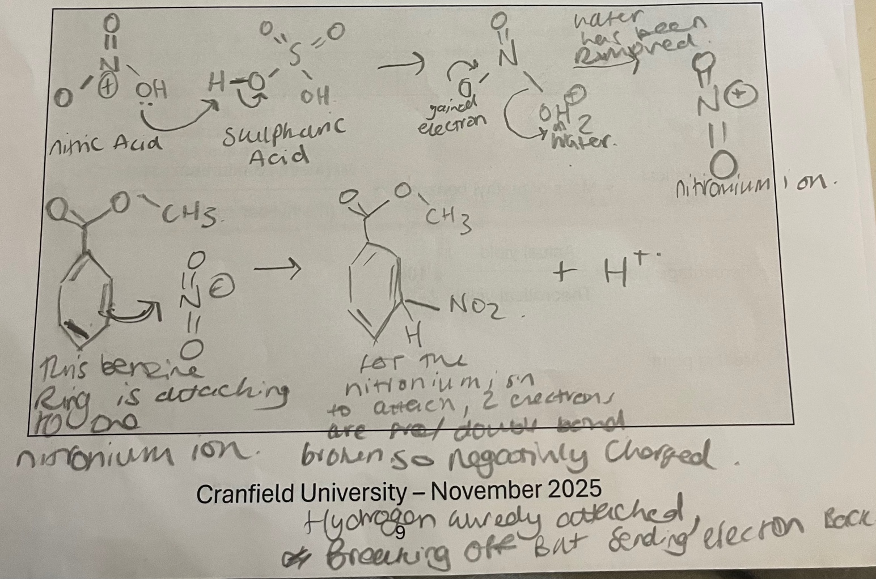
Figure 4: Appendix 1. Lab Book Substitution

