

Mohammed Abdul Farhan
Civil Engineering & Environmental Management
Site Production and Project Management

Assignment 1 Case Study
Constructing the Loughor Bridge

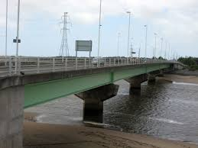

Lecturer- Dr Juan A Ferriz-Papi
Site Production and Project Management (M5X01875)

Content Page

- Title..............................................................3
1.1 Abstract……….3
2.0 Introduction..................................................3
3.0 Construction Method…………………………………4
Figure 1……………..4
Figure 2……………..5
Figure 3……………..5
Figure 4……………..5
Figure 5……………..6
Figure 6……………..7
4.0 Table Construction of Loughor Bridge………..8
5.0 Gantt Chart………………………………………………..10
6.0 Results & Conclusion………………………………….11
7.0 Reference and Bibliography……………………….12

1.0 Title - Construction of the Loughor Bridge

1.1 Abstract

The aim of this written report will be to outline the main construction methods in which is used the best to construct the bridge. Along with looking at the construction methods, there will need to be a Gantt Chart allocating the duration of the build, along with the cost expenditure and the work force. This will then give a more detailed and better interpretation of the specific time required, amount of material and workforce needed to complete the bridge, with a start and finish point. Will there be problems along the way? How will problems arise and be prevent and put right? Will the budget be met? The questions will be descriptively answered along the way towards to the conclusion.

2.0 Introduction

The Loughor bridge is located in the middle between Swansea and Llanelli, the bridge is constructed to allow access to go into Bynea, Llanelli and also a route to go to Carmarthen. The normal access to get to Llanelli would be via the M4 by Penllergear Services, this bridge being constructed gives a quick access via a low bridge. Parallel with the bridge there is a train line which goes past, Bynea and into Llanelli Station road. The area of the size in which is given to build this bridge is roughly 15 metres. The importance of the bridge is to allow a link via small bridge to get access to the certain location within ease. The main purpose is for local residents to use that bridge instead of the M4 and waste time going the long distance and route. This bridge saves time and money for the long run and also the link works well to go to Gowerton, Swansea and Loughor Gorseinon.

3.0 Construction Method

Truly understanding the bedrock and the type of soil which will be dealt with is crucial, this can allow the correct procedures to be put in place. If this is not looked into carefully there can be problems later on, causing deformation and the life span decreases in addition leading to extra maintenance cost on top.

There are a few rules and regulations which need to be considered before starting any construction site work. If rules are not abided by it can lead to various problems occurring and the final outcome may not be achieved to its full potential. In this scenario, building a bridge on water, there’s careful considerations needed to be taken in place along with precautions. Using the correct materials is vital due to longer life span and less maintenance however if using a poor quality material, it can lead to further future maintenance and be very cost effective for the long run. Bridges are mainly divided broadly into 3 parts, Foundation, transfers the loads to the bearing strata, shallow or deep foundations depending on the geotechnical properties of the bearing strata and usually piles or well foundations. Substructure, supports the superstructure and transfers loads to the foundations mainly piers and abutments. Finally, the superstructure supports traffic also includes deck, slab and grinders.

Understanding that building this bridge is not a straightforward procedure, it is vital to know exactly what is needing to be built and fully needs to be understood. You don’t go straight into the excavation and laying the foundations, creating a plan and sequence to follow showing when to start and finish each individual stage. Setting up an office for the site managers and project managers to do their everyday work, along with an office for labourers. Getting the planning permissions form the council and also getting consent to start work, as this is the GO start to enable work to begin. As there will be materials to be dealt with and hot work to amend piers and abutments, getting the permit for each of the following is important. (permit to excavate, permit to perform hot works and permit to load). These need to be considered first as you can see from Table.1. (Page 6). Figure 1
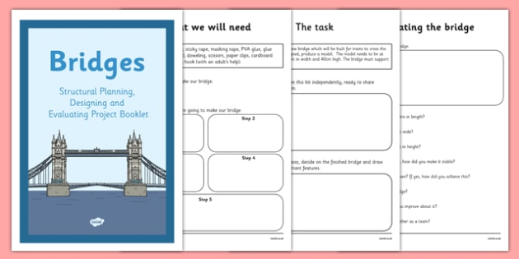

Building the Loughor bridge, it is crucial to understand that there is a huge volume of water below, there are many ways to retain this water, from using a water suction equipment and loading the water and retaining until further instruction. The main reason in doing this and retaining water is the fact that there is less water problems when excavating and laying down the foundations. If water was not retained more water can mean more water pressure, this can have an effect on the cofferdam if this type of deep excavation is used. The abutments would be careful considered as this is the substructure at each end of a bridge and where the decks rests on and contacts provide vertical and lateral support for the bridge and acts as a retaining wall. The typical gravity abutment is ideal for the Loughor Bridge as it includes the bridge seat, back wall, footing and wing walls to hold the bridges deck along with a retaining wall for the embankment. Typically, with the wing walls they are located parallel to the bridge seat or could even be at a slight and backward angle into the embankment.
Figure 2. (image to show what a typical gravity abutment looks like)
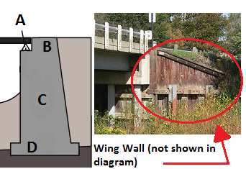

The next stage once the abutments have been constructed is to get the excavation work in place for the 4 piers. There are various methods which can be used to plan an excavation for an underwater pier. Piers are commonly made of concrete, masonry or treated timber and are eventually installed into prepared holes and shafts to sit in place. For this bridge to be supported by the pier they are made in the form of caissons and are put into place to the bearing stratum by excavating mainly from the interior. Caisson is the main base and the most likely used excavation submerged in water. Once the caisson is in place work can begin and the piers will be put up at the right stages to ensure that the excavation is complete. The piers support the deck and all loads are transferred from them to the bottom of the foundations. If there is access to slender piers it would be more ideal for the life span of the bridge to use slender piers as they have enough flexibility to allow temperature, shrinkage and creep effects to be transmitted to the abutments. The pin joints will be considered so that the deck bending moments are not transmitted. Horizontal loads can also transmit bending moments.
Figure 3. (image shows where the caissons are located and a selection of bridge).
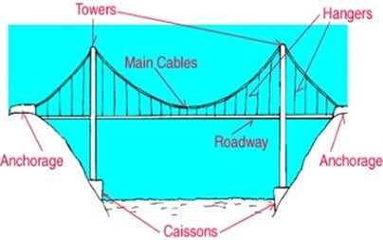
The climbing formwork system would be used to work the way up the piers and construct in a structural way. It is an effective solution for structures that require seamless walls and have a very repetitive form.
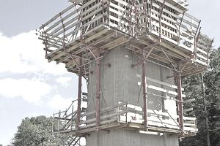
Figure 4. (representation of a climbing formwork)
Once both sides of the bridges abutments have been constructed with the correct loads in place, the next step would be to get the pier pillars in place. For the construction of each pier there will be a required number of labourers which can be found in Table.1. The piers are formed once the cofferdams are in place and the excavation is undertaken under the water which in the scenario has a depth of 3 metres. The duration for each pier will take between 5-7 days. Pilling is then used and it is important that the pier sits about 3-4 inches above the highest level the water will reach. Measuring from the bottom under the water to the maximum water line, and then add on the depth that it going to bury the pilings to get their total height. Once the pilings are in place getting a pvc to guide the concrete to pour it inside to get the pier to the strength after a period of time. There will be a minimum of 2 labourers needed for each pier. One labourer will be guiding the piling and the pillars whilst another pours the concrete from the required depth to the level in this case which will be around 7/8 metres in height. Finally, when the pier caissons are clear of all materials reinforcement bar cages and pumped concrete to create solid foundations for the new bridge. Once this section was complete footing was to be build above the caissons. Footing is the transition component from the caissons to the pier column.
Figure.5 (Bridge foundation elements)
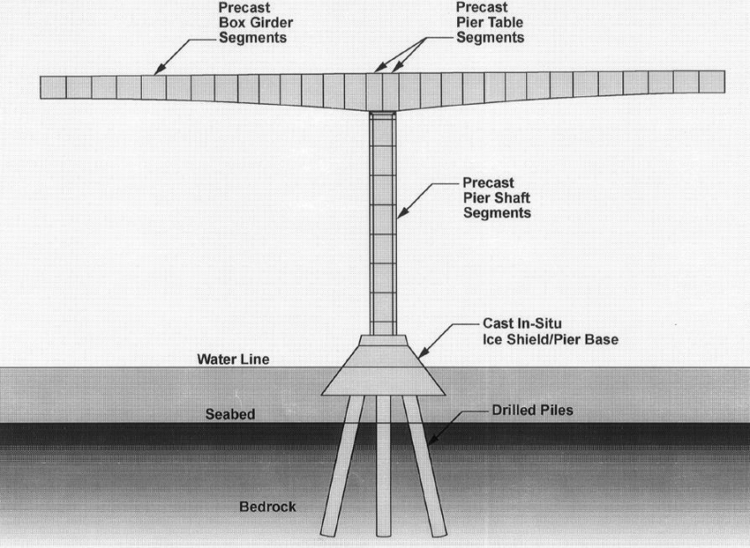

For the work to move forward in a safe manner it is important to remove all the excess water, in order to do this an installation of a box like structure is created around the pre-fabricated deck, they then lower the structure until it reaches the bottom of the river. This structure is then known like a cofferdam. The prefabricated deck used as a work surface up to this point and because the base to building the footing at the river beneath.

Figure 6. (cofferdam construction).
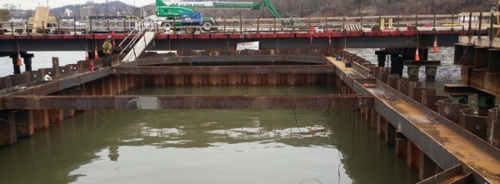

A cofferdam is known as a structure that keeps water and soil which allows the area which is focused on to be pumped out and ready for excavation work. They are used broadly but mainly for construction of bridge piers and other support structures which are made within water. Cofferdams must ensure a good overview before any work begins. Various effects must be considered such as weather problems, ground movement, forces which can cause deformation along with the loads as well.
With this bridge it concluded that there will be 4 piers and two of the central piers which are parallel to each other will be placed into the water. The correct method which will be used is sheet pile. To begin with, the sheet pills will be driven into the soil to the bedrock to enable a vertical and strong position. The sheet pills will be locked into place to create less air problems and sealed very tight. Once this is done the box is constructed and water will be removed from inside this is done to prevent any seepage of water creeping into the works, concrete will be poured to ensure that it is sealed properly.
Column will be constructed above the footings in the river, when the pier column is above the river the cofferdam walls will be removed allowing the water to flow around the piers.
On top of each pier there will be steel form and epoxy coated rebar would be put in place. Lastly, concrete will be poured over the rebar inside the column and once it has hardened and has gained the correct structural strength the next stage can be undertaken, during this process is it widely known as curing stage. The climbing formwork is then moved to complete the next stage. This is done until both the water piers are built to the correct height.

The bridge bearings are extremely important and needs to be thoroughly thought about to ensure stability, they are formed between the substructure and superstructure. Bridge bearings are used to transfer loads and control the various movements which are involved within the bridge. There can be so many displacements including vertical and horizontal movements, this is all depending on the loads which take place such as self-weight, earthquake loads and also weather conditions. Translation movements are taken in place. Thermal expansion along with contraction can be considered and would need to be identified within the bridge and come up with ways to prevent these from occurring to the best of the ability by the engineers.

To end, the bridge would need to be fully assembled and this is done by composite. This involves the binding of the steel structure and the material such as concrete which acts as reducing deflections along with increasing strength for the life span. Shear connectors are fixed on to the steels and are embedded to the concrete either by the following welding or by modern day fixing bolts and nuts which can be supplied by various engineering companies which specialise in bridge construction.
Table.1 (Table for the construction of the Loughor Bridge).
Task Name | Duration | Start | Finish | Cost | Number of labourers | Labour Hours completed | Units
Construction of Loughor Bridge | 3M | 12/02/19 | 10/05/19 | £242426.32 | 145 | 3496 | £20.82(Labour wage)
Mandatory Project Activities | 5W | 12/02/19 | 07/03/19 | £10511.60 | 20 | 600 | £60.90(PH)
Setting up the work office | 1W | 12/02/19 | 18/02/19 | £1624 | 2 | 80 | £20.30(PH)
Site Surveying | 1W | 15/02/19 | 21/02/19 | £1624 | 2 | 80 | £20.30(PH)
Geo Invs | 1W | 15/02/19 | 21/02/19 | £1624 | 2 | 80 | £20.30(PH)
Human Resource Acquisition | 1W | 15/02/19 | 21/02/19 | £1617.60 | 2 | 80 | £40.44(PH)
Technical Staff | 1W | 15/02/19 | 21/02/19 | £808.80 | 1 | 40 | £20.22(PH)
Non-Technical Staff | 1W | 15/02/19 | 21/02/19 | £808.80 | 1 | 40 | £20.22(PH)
Design and Licenses Acquisition | 2W | 21/02/19 | 06/03/19 | £4022 | 5 | 200 | £100.55(PH)
Design Process | 1W | 21/02/19 | 27/02/19 | £804.40 | 1 | 40 | £20.11(PH)
Consent to discharge | 1W | 21/02/19 | 27/02/19 | £804.40 | 1 | 40 | £20.11(PH)
Permit to excavate | 1W | 21/02/19 | 27/02/19 | £804.40 | 1 | 40 | £20.11(PH)
Permit to perform hot works | 1W | 27/02/19 | 06/03/19 | £804.40 | 1 | 40 | £20.11(PH)
Permit to load | 1W | 27/02/19 | 07/03/19 | £804.40 | 1 | 40 | £20.11(PH)
Mandatory project activities complete | 1D | 07/03/19 | 07/03/19 | £0 | 0 | 0 | 0
Excavation Works | 2W | 07/03/19 | 20/03/19 | £92299.56 | 20 (Labourers) | 800 | £75,568
Pier 1 | 1W | 07/03/19 | 13/03/19 | £23074.89 | 5 (1 gang) | 200 | £18,892
Pier 2 | 1W | 07/03/19 | 13/03/19 | £23074.89 | 5 (1 gang) | 200 | £18,892
Pier 3 | 1W | 13/03/19 | 20/03/19 | £23074.89 | 5 (1 gang) | 200 | £18,892
Pier 4 | 1W | 13/03/19 | 20/03/19 | £23074.89 | 5 (1 gang) | 200 | £18,892
Excavation complete | 1D | 21/03/19 | 21/03/19 | 0 | 0 | 0 | 0
Foundation Construction | 4W | 21/03/19 | 17/04/19 | £62415.44 | 40 | 992 | £41760
Piles 1 Boring | 4D | 21/03/19 | 24/03/19 | £8293.72 | 3 | 96 | £6295
Piles 2 Boring | 4D | 22/03/19 | 25/03/19 | £8293.72 | 3 | 96 | £6295
Piles 3 Boring | 4D | 25/03/19 | 28/03/19 | £8293.72 | 3 | 96 | £6295
Piles 4 Boring | 4D | 28/03/19 | 31/03/19 | £8293.72 | 3 | 96 | £6295
Steel fixing Piles 1 | 2D | 31/03/19 | 01/04/19 | £2112.48 | 4 | 64 | £780
Steel fixing piles 2 | 2D | 01/04/19 | 02/04/19 | £2112.48 | 4 | 64 | £780
Steel fixing piles 3 | 2D | 03/04/19 | 04/04/19 | £2112.48 | 4 | 64 | £780
Steel fixing piles 4 | 2D | 04/04/19 | 05/04/19 | £2112.48 | 4 | 64 | £780
Concrete pouring piles 1 | 3D | 05/04/19 | 07/04/19 | £1687.36 | 2 | 48 | £688
Concrete pouring piles 2 | 3D | 07/05/19 | 09/04/19 | £1687.36 | 2 | 48 | £688
Concrete pouring piles 3 | 3D | 09/04/19 | 11/04/19 | £1687.36 | 2 | 48 | £688
Concrete pouring piles 4 | 3D | 11/04/19 | 13/04/19 | £1687.36 | 2 | 48 | £688
Pile cap for piles 1, 2, 3, 4 | 5D | 13/04/19 | 17/04/19 | £14039.20 | 4 | 160 | £10708
Foundation construction complete | 1D | 18/04/19 | 18/04/19 | 0 | 0 | 0 | 0
Construction of Piers | 1W | 18/04/19 | 26/04/19 | £37738.80 | 36 | 448 | £22592
Binding layer for pier 1 | 2D | 18/04/19 | 19/04/19 | £4206.24 | 2 | 32 | £3540
Binding layer for pier 2 | 2D | 18/04/19 | 19/04/19 | £4206.24 | 2 | 32 | £3540
Binding layer for pier 3 | 2D | 19/04/19 | 20/04/19 | £4206.24 | 2 | 32 | £3540
Binding layer for pier 4 | 2D | 20/04/19 | 21/04/19 | £4206.24 | 2 | 32 | £3540
Steel fixing pier 1 | 1D | 21/04/19 | 22/04/19 | £1896.24 | 4 | 32 | £1230
Steel fixing pier 2 | 1D | 21/04/19 | 22/04/19 | £1896.24 | 4 | 32 | £1230
Steel fixing pier 3 | 1D | 22/04/19 | 23/04/19 | £1896.24 | 4 | 32 | £1230
Steel fixing pier 4 | 1D | 22/04/19 | 23/04/19 | £1896.24 | 4 | 32 | £1230
Concrete pouring pier 1 | 2D | 23/04/19 | 24/04/19 | £1877.36 | 3 | 48 | £878
Concrete pouring pier 2 | 2D | 23/04/19 | 24/04/19 | £1877.36 | 3 | 48 | £878
Concrete pouring pier 3 | 2D | 23/04/19 | 24/04/19 | £1877.36 | 3 | 48 | £878
Concrete pouring pier 4 | 2D | 24/04/19 | 25/04/19 | £1877.36 | 3 | 48 | £878
Piers complete | 1D | 18/04/19 | 26/04/19 | 0 | 0 | 0 | 0
Deck Construction | 2W | 21/04/19 | 05/05/19 | £39460.92 | 29 | 656 | £21659
Installation of steel beams | 3D | 21/04/19 | 23/04/19 | £12148.40 | 5 (1 gang) | 120 | £9650
Painting steel beams | 2D | 23/04/19 | 24/04/19 | £3335.60 | 5 (1 gang) | 80 | £1670
Installation of bridge deck | 5D | 25/04/19 | 29/04/19 | £11614 | 5 (1 gang) | 200 | £7450
Fixing parapet | 3D | 29/04/19 | 01/05/19 | £2968.72 | 4 | 96 | £970
Construction of joints | 4D | 30/05/19 | 03/05/19 | £4030.20 | 5 (1 gang) | 160 | £699
Surfacing of the deck | 1W | 03/05/19 | 10/05/19 | £5364 | 5 (1 gang) | 200 | £1200

Gantt Chart

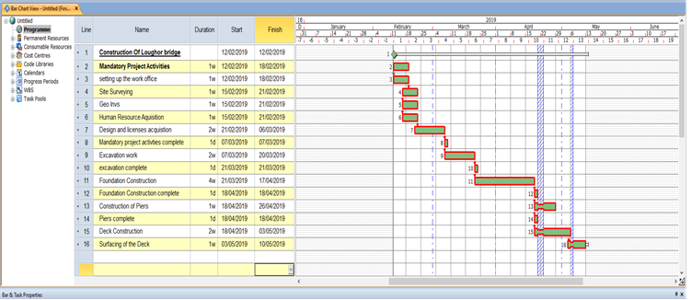
Results and Conclusion

From the analysis of the Loughor bridge construction, the results which have been obtained for the costing is cheap. This is mainly due to realising that the bridge is taken into consideration to be only 15m and not 150m. The total cost was £242426.32, however if we were to multiply this by 10, we would end up with £2,424,263.20 which is the correct costing for a bridge being 150m long and this would include good quality materials along with the labourers wage.

Calculating the 4 piers.
For one pier- £23074.89
200 hours
total cost including labourers (1 gang of 5 labourers) for 1 week

The standard hourly rate for a skill 4 site engineer £20.82PH
The labourers work a total of 8 hours each day, this is for one labourer, so for all the labourers they work a total of 40 hours a day. They worked for 5 days (1 week) the total hours is 200.
£20.82 x 200 = £4164 this is the total pay a week for 5 labourers
£4164 + £18,892 = £23074.89 this is total cost for the pier
£18,892 this cost includes material, the pile cap, setting of concrete, reinforcement material, concreting material, pouring of concrete and the climbing formwork.

So to calculate all 4 piers the total for one pier was £23074.89 x 4 = £92299.56

If the scale was looked at properly the results would just have to be times by 10 to give the full 150m length. The limitations were not knowing whether there would need to be 2 or 8 labourers for a pier, but this was then thought about and reconsidered into the project. The time period for this build started from 12/02/19 and would be finished 10/05/19 this is fairly a quick time scale due to the scaling of the bridge only being 15m however this as said before would be times by 10 and give us the proper time and costing for the 150m bridge.

Overall the bridge would be finished and used within 14 days of finishing once all curing process have been completed.

References and bibliography

https://study.com/academy/lesson/bridge-abutment-design-types-examples.html - Typical abutment- page 5. (Sourced from ‘study.com’ Friday 8th Feb 2019)

https://www.twinkl.co.uk/resource/t2-d-071-structures-planning-designing-and-evaluating-a-bridge-booklet - Bridge image planning- Page 4. (sourced from ‘Twinkl’ Friday 8th Feb 2019)

https://www.designingbuildings.co.uk/wiki/Caisson - Caisson information - page 5. (sourced from ‘Designing Buildings Wiki’ Friday 8th Feb 2019)

Spon’s Civil Engineering and Highway Works Price Book 2019 – By Aecom 33rd Edition- pricing for the different stages of work for the Loughor bridge.

https://theconstructor.org/geotechnical/caisson-types-construction-advantages/503/ - Caisson location on a a bridge design page 5. (Sourced from ‘The Constructor Civil Engineering Home’)

