

Name: Vency Deepak Jain
Candidate ID: 2239376
Subject: Strategic Management
Subject Code: LCMB7003
professor: Dr. Jaya Gopalkrishnan
Submission Date: 03/01/2024

Index

1.Introduction 3
2.Royal park background 4
2.1 Mission statement 4
2.2 Vision Statement 6
2.2 Objective 6
3.Environmental audit 8
3.1 Macro analyses 14
3.1 porters five forces model 14
4 Advantage using Porter’s Generic Strategy 12
5 Critical analyses using effective framework 27
5.1 BCG matrix model 18
5.2 Ansoff model 21
5.3 VRIO Analyses 23
5.4 SWOT Analyses 27
5.5 Value Chain Analyses 27
6 Implementation & execution of strategy 32
7 KPI Monitoring tools 32
7.1 Critical Evaluation of Green Strategy, Sustainability, and CSR activities 27
8 Conclusion 32
9 References 32

- INTRODUCTION

Before the 2020 coronavirus (COVID-19) epidemic, the UK restaurant and food service sector had seen a period of expansion, with revenues indicating an upward trend over time. Nevertheless, even prior to the epidemic, eateries were having difficulty surviving; in fact, a large number of them closed in 2018 and 2019. The insolvencies of independent restaurants and the closure of numerous large chain stores are attributed to a number of factors, including rising expenses, declining consumer spending, and an oversaturated market from the rise in casual dining brands in the years prior. The industry's future is less secure now that Brexit and an unanticipated pandemic are looming. 2020 restaurant business revenues were predicted to decline by almost 33%, but the outlook anticipated a complete recovery by 2024

- ROYAL PARK BACKGROUND

An very popular Indian eatery with a flourishing flagship store in London has earned a stellar reputation for its genuine tastes and faultless service. The eatery, which prides itself on using only the best ingredients and time-honored recipes, is set to grow throughout the United Kingdom. Works in tandem with skilled interior designers and architects to craft a warm, culturally diverse atmosphere in each of its new sites by skillfully fusing modern and traditional design elements. The expansion plan focuses on important cities and combines local sourcing and sustainable building methods with attention to detail. concentrating on preserving the genuineness of its food while adjusting to regional preferences. The restaurant wants to reach more people with its authentic Indian food. An excellent financial plan and a keen understanding of consumer preferences and industry trends support this objective.

  - Mission statement
The aim is to offer reasonably priced, wholesome, expertly cooked meals made using premium ingredients. To keep our space clean, hygienic, and welcoming for both visitors and employees. to guarantee prompt, amiable, and courteous service for every guest. To guarantee that every visitor and employee receives the appropriate level of decency and respect. to express gratitude to each visitor for the chance to be of service. By adhering to these goals, we will guarantee a just profit that will enable us to make contributions to the community we serve.

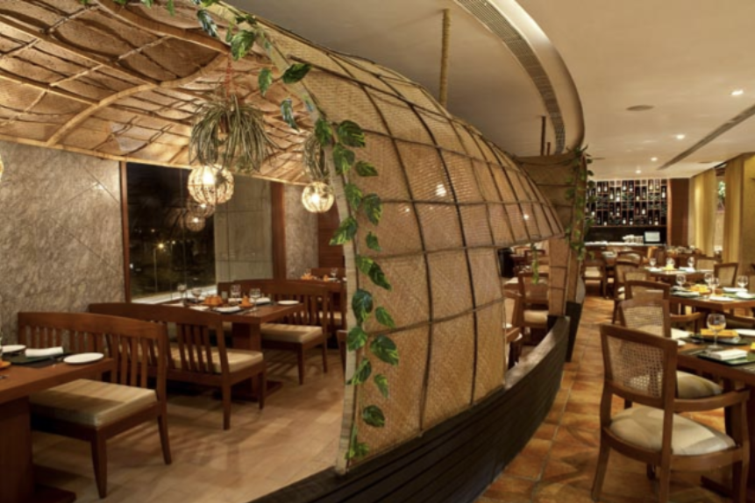
Source: Myself ( Restaurent Ambiance)

  - Vision statement
"Crafting Unforgettable Experiences: Redefining Indian Fine Dining in the UK with a Fusion of Tradition and Elegance."Our goal is to completely reinvent Indian fine dining by ingeniously fusing innovation and tradition. Our goal is to be the pinnacle of culinary creativity, with every meal being a harmonious blend of tastes, textures, and eye-catching details.

  - Objective
Our goal in bringing Indian fine dining to the UK is to become a globally recognized culinary brand that is associated with quality, originality, and creativity. By skillfully fusing classic Indian tastes with modern refinement, we hope to enthrall a broader audience while remaining committed to providing outstanding dining experiences. Our objective is to establish new benchmarks in the UK fine dining scene by means of strategic expansion. We want to leave a lasting impression on our guests by continuously maintaining the highest caliber of food and service.
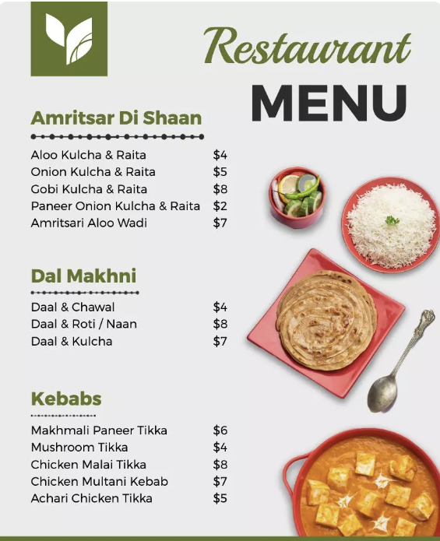
Source: Myself (Restaurant Menu)

- ENVIRONMENTAL AUDIT
  - MACRO ANALYSES
A business may forecast changes in the market and create plans to reduce risks and seize opportunities by analyzing the macro-environment (Hitt et al., 2017).

PESTLE ANALYSES - PESTLE is one of the most popular models for assessing the extremely dynamic external business environment and is utilized as a method of situational analysis for business assessment purposes. During its operations, an organization engages with its external environment, and it has no control over these external forces (Perera, R.,2017). PESTLE analysis takes into account external elements which include Political, Economic, Sociological, Technological, Environmental and legal factors.

Figure 1 : pestle analyses

- Political - favourable

In the two years leading up to the end of 2021, Brexit had increased UK food bills by about £6 billion. Border delays, administrative burdens, and other expenses caused food prices to rise by roughly 3% annually (The Guardian.2020). Growing food prices have an impact on consumer spending power and behavior for non-essentials. The UK government launched the Eat Out to Help Out program on August 4, 2020, as a major effort to support the restaurant business. As a consequence, the number of people dining in restaurants in the UK increased significantly (Matheson, J. 2020). Reasonably priced products that uphold health and safety might be a good fit for growth.

- Economical - unfavourable
Food inflation reached a 45-year high in the UK due to a lack of vegetables, which exacerbated already high prices (BBC,2023). Growing food inflation suggests that raising employee compensation is necessary to counteract the rising prices. This will result in increased costs for employee benefits and salaries.

- Social - favourable
Due to the pandemic, a greater proportion of people reported eating better than normal. Approximately one in five consumers stated they were choosing healthier options. (Poinski,2020) The recognition of healthy and hygienic components has increased due to the increased demand for fresh and healthful meals, and a larger selection of goods, including more vegan and vegetarian options.

- Technology - favourable
Many firms are moving more quickly to use automation technology like robotics and intelligent software due to the labor crisis and the need to recruit and retain staff (Kugler, L. 2022). By reducing labor expenses, using automation in its manufacturing facilities may lower total production costs.

- Environmental - favourable
The 2021 SDG progress report was been released by the United Nations Economic and Social Council. They recognized that, as we recover from the coronavirus (COVID-19) epidemic, the business community will play a critical role in reaching the global SDG objectives. Every country is required to implement the SDGs, and every sector must contribute to their realization. The UK is in charge of supporting the Goals' worldwide accomplishment as well as attaining them domestically (Gov.uk,2019). It has to maintain control over food waste and reduce carbon footprints in order to meet the UN Sustainable Development Goals.

- Legal - unfavourable
A nation's rules and regulations comprise its legal environment.the research provides information on laws and policies that will affect how a company makes and markets its goods. (Buye, R. 2021)

  - PORTERS FIVE FORCES MODEL

Professor Michael Porter of Harvard Business School created the five forces theory, which was initially published in the Harvard Business Review in 1979. Using the outside-in perspective, the five forces framework is a powerful and simple tool for identifying specific powers that align with a certain business circumstance (Johnson et al., 2008).

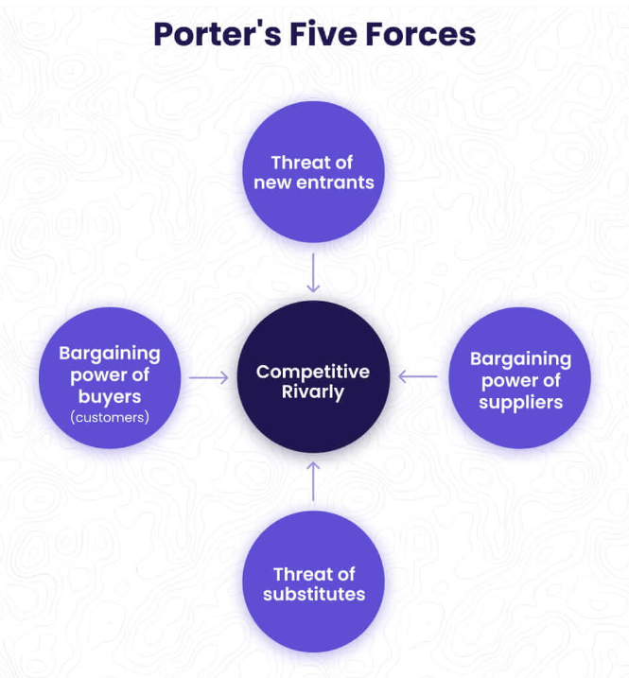
Figure 2 : porters five forces model (Alonso, T. 2023)

- Competitive Rivarly - High
According to Peter Harden, the publisher of his own restaurant recommendations, "We've gone very quickly from a time five years ago when charging over £100 a head was the outlier, to now, when £200 pounds a head is becoming the norm for the very top restaurants." (The Guardian. 2022). The restaurant business in London is quite competitive, with a wide variety of upscale restaurants, and international cuisines.

- Threat of New Entrants - Low
Building a posh dining venue in the heart of London takes millions. However, as a very general estimate, budget between £100,000 and £200,000 to launch a respectable-sized restaurant (Hawley, A. 2017). Due to variables including high initial capital needs, the restaurant business in London has substantial entry barriers, which severely limit new entrants.

- Bargaining powers of Suppliers - Moderate
This force analyzes a supplier’s power and control over price increases. This force also assesses the available number of suppliers of raw materials and other resources. Businesses are in a better position when there are many suppliers (Martin, M.2023). Although there are many food providers in London, their negotiating strength may be limited.

- Bargaining powers of Buyers - Low
This force investigates how pricing and quality are impacted by consumer power. When there are fewer suppliers, customers have the advantage since it is simple for them to go to another vendor.Each consumer's buying power decreases when a business's customer base grows. (Martin, M.2023). For a restaurant to have moderate to high negotiating power, it must provide a distinctive dining experience with excellent ambiance and services.

- Threat of Substitutes - High
The immediate and long-term switching costs as well as the propensity of customers to switch are factors that contribute to the danger of alternatives (Martin, M, 2023). Because London offers a wide variety of eating alternatives, the danger of a substitute is not as high. That threat may be lessened, though, by a distinctive and genuine fine dining experience.
An Indian restaurant in the UK has a dynamic competitive landscape, according to Porter's Five Forces study. A major obstacle is the fierce rivalry amongst already-existing restaurants, as several locations compete for the same market share. with potential clients being drawn away by alternative dining options such as Mediterranean, Asian, or British cuisines. All things considered, strategic differentiation, cost control, and an attention to consumer preferences are essential for success in the UK's Indian restaurant market.

STRATEGIC OPTIONS AVAILABLE TO ACHIEVE SUSTAINABLE COMPETETIVE ADVANTAGE USING PORTER’S GENERIC STRATEGY

Whether a profitability exceeds or falls short of the industry average depends on where the company stands in relation to its industry. Long-term above-average profitability is essentially based on a durable competitive edge.

- Cost Leadership
A company that wants to lead its industry in cost leadership aims to become the lowest cost manufacturer. There are several different sources of cost advantage, and they rely on how the industry is set up (University of Cambridge 2016).

- Differenciation
Using a differentiation strategy, a business aims to stand out from the competition in a few key areas that consumers find appealing(University of Cambridge 2016). Offering distinctive and superior Indian food may help the business stand out from the competition. This might entail developing distinctive dishes, combining various regional cuisines, or highlighting real and traditional cooking techniques.

- Focus
The generic strategy of focus is based on the selection of a limited industry-wide competitive scope. The focuser chooses a section of the industry, or groups of segments, and designs its approach to serve those segments at the expense of others (University of Cambridge 2016). A restaurant might target a certain consumer base by concentrating on a particular market sector, such as serving health-conscious patrons or specialising in Indian ethnic food. Having this specialty may increase client loyalty.

- Differenciation strategy to be focused

Offering a distinctive and genuine eating experience that targets a particular target demographic within the broader UK audience can help the Indian restaurant stand out from the competition. This might be offering a posh dining experience, specializing in certain regional Indian cuisines, or fusing cultural aspects into the entire restaurant experience. By emphasizing uniqueness, the restaurant may stand out from more generic rivals and draw in diners looking for a genuine and culturally rich Indian eating experience.

Key implementation points
- Menu Innovation: Provide unique, premium meals that highlight the variety and genuineness of Indian cooking.

- Cultural Ambiance: Create a distinctive and engrossing dining experience by designing the restaurant area to represent the diversity of Indian culture.

- Personalized Service: To improve the entire eating experience, offer individualized and conscientious customer service.

- Strategic Marketing: Aim your marketing at consumers that value and actively seek out distinctive, genuine, and culturally immersing eating experiences.
- CRITICAL ANALYSES USING EFFECTIVE FRAME WORK.
  - BCG MATRIX MODEL
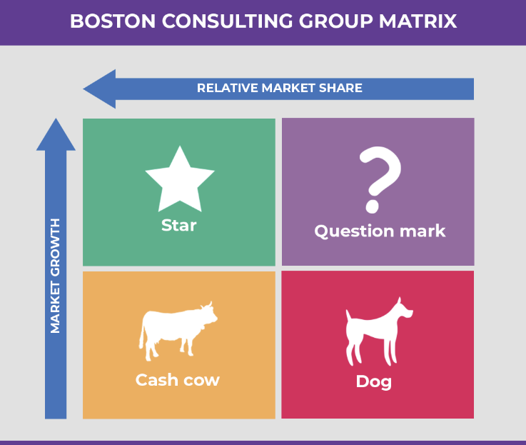
Source:(Team, P.F. 2023).
- Star
Attaining a substantial market share in a rapidly expanding industry serves as an indicator. They are thought to provide the greatest chances for the company's expansion and advantages.They generate significant amounts of revenue in this scenario to maintain a substantial market share (Mohajan,2018). Dishes that are considered signature or offer distinctive culinary experiences that have become more popular in London's fine dining scene.Creative products or themed eating events that are drawing in more and more patrons.Menu changes often to keep up with gastronomic fads and tastes.
- Question mark
Question marks, also referred to as wild cats or problem children, are company units with a limited market share in a rapidly expanding industry. In their industry, they do not attempt to make a lot of money (Mohajan,2018). Emerging concepts, menu items, or services that are attracting interest but have not yet established a strong market position.programs aimed at certain clientele or distinctive eating establishments with room for expansion but in need of further funding.

- CashCow
They have a sizable portion of the market in an industry that is slowly expanding but is still mature.They generate large amounts of cash that may be used to invest in other company units with relatively little initial commitment. Product creation is seen as a compelling approach for reliable cash cows (Mohajan,2018). Dishes or services that are well-known and have a steady market share in the present fine dining scene in London.Essential menu items that boost sales and are appealing to a wide range of customers.

- Dog
They stand for business practices in mature sectors with little to no market growth or poor market shares. Because of their poor business plan, they are unable to produce or spend substantial sums of money. Because of their weak interior and outward positions, they are known as dogs (Mohajan,2018). Menu products or services that are highly competitive or may have lost their charm.Underperforming projects that might need to be repositioned or reevaluated.

  - ANSOFF MATRIX MODEL
A strategic tool for determining a company's strategic alternatives is the Ansoff matrix (De Waal, 2016). The matrix is derived from Igor Ansoff's name. Four growth options are shown in this matrix to help a company expand (Ansoff, 1957).

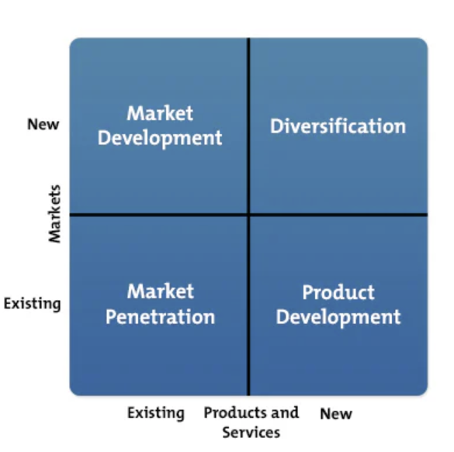
Source: MindTools (2022)

- Market penetration
This keeps current consumers in the market by selling more to them, but it also draws in new ones by competing on goods and services without straying from the organization's current focus (Ansoff, 1965).However, if done carelessly, challenging a customer's perception of a product or service that is not openly attacked out of avarice might lower a company's profit margin. However, keeping current customers on consumers' goods is less expensive. "Market penetration in the existing market" is only useful and goal-oriented if the caliber of the goods and services is raised; this is often accomplished by launching aggressive marketing campaigns to gain market share (Lynch, 2009).
- Product development growth
The establishment and maintenance of a business depend heavily on the strong customer relationships and the goodwill and trust that they foster.Our goal is to extend the life cycle of our business both now and in the future by expanding our customer base beyond the current niche we serve by luring new clients into the food restaurant's services and market penetration among our current clientele.

- Market development analyses
The products' life cycle and value are expanded into a new market to enable for growth in that market and to extend the product's lifespan via innovation. With development and expansion methods that include value-adding, repackaging, promotion, new market segmentation, and selling the same goods and services in an enhanced new market, it's a low-risk approach.
Our business prospects include increasing sales and revenue, enhancing goods and services, and strategically preparing for the expansion and development of markets. Strategies that prepare for competitive appeals such promotion, distribution, and price while still maintaining the business with high projected profit are known as competitive advantages. These strategies are based on information obtained and analyzed in connection to business segments (Audu, et al. 2014).

- Diversification series
In terms of investment, cultivating new skills and connections is the most difficult, costly, and dangerous option. While risky, it may foster a business partnership that would boost earnings and facilitate plans. But this isn't a choice that our organization has yet to explore. (Audu, et al. 2014).

- Evaluation
The Indian restaurant may strategically join the UK market by utilizing Ansoff's Market Development Strategy, which helps to reduce the risks involved in launching a new product. The goal is to meet the specific needs of the UK market while utilizing the advantages of the current Indian cuisine. The implementation of this development plan will depend heavily on doing in-depth market research, comprehending the purchasing habits of local consumers, and creating efficient marketing and distribution channels.

  - VRIO ANALYSES

Vrio Analysis is a clever and analytical method for assessing the assets and competencies of the business that provide it a competitive edge.

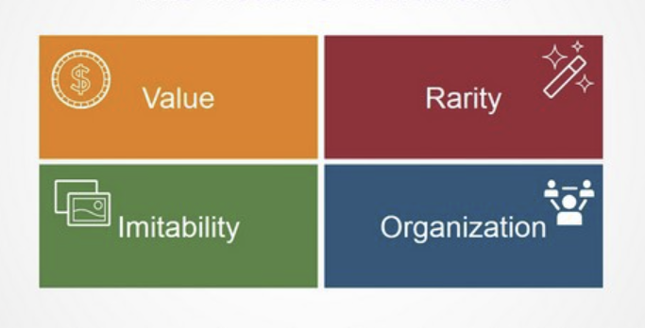
Source:

- Value
The V in the Vrio Analysis framework provides answers to the fundamental issues of whether or not the company's resources and competencies are beneficial for its growth and development (Bhasin, H. 2019). Offering genuine Indian cuisine that sets it apart in the market and builds a strong brand linked to quality and authenticity, the restaurant showcases its considerable culinary knowledge.

- Rarity
The idea of rarity gives the company a competitive edge as it possesses a priceless collection of really rare resources and skills (Bhasin, H. 2019).A group of talented cooks with a focus on Indian cooking may be a rare and invaluable asset, particularly if they can contribute original recipes or cooking methods.

- Imitability
The fundamental and central concern regarding imitability is whether companies without special resources and competencies have to pay more to acquire or develop them than their rivals who already have them (Bhasin, H. 2019). Imitation is hindered if the restaurant uses exclusive recipes or cooking techniques that are hard to duplicate.If the restaurant has a distinct and diverse ambiance, rivals can find it difficult to capture the same vibe.

- Organisation
The organization, which includes a wide range of elements such as the firm's overall management control systems, pay policies, and management reporting structure, is the next element in the Vrio Analysis framework (Bhasin, H. 2019).The restaurant's organizational strength is enhanced if it has developed effective supply chain procedures for obtaining real Indian products.

  - SWOT ANALYSES

One comprehensive assessment of a business, conducted both internally and externally, is the SWOT analysis, which covers the company's opportunities, threats, weaknesses, and strengths (Kotler, et al. 2016).

- Strength
- real food: With a distinctive and varied menu that makes an impression on the UK market, the restaurant is able to serve real Indian food.
- Skilled Culinary Team: The quality and authenticity of the food may be enhanced by having chefs who are knowledgeable about Indian culinary customs.
- Cultural Appeal: By taking advantage of the public's rising fascination with a variety of cultural experiences, the restaurant may be able to draw clients looking for a real Indian meal.

- Weakness
- Cultural Misalignment: Keeping authentic while catering to local tastes can be difficult, necessitating a delicate balance to prevent cultural misalignment.
- Competition: The Indian cuisine market is well-established, and there is competition in the UK restaurant business. Finding a distinctive selling proposition is necessary if you want to stand out.
- Supply Chain Challenges: The restaurant must have trustworthy supply chain relationships in order to ensure a steady supply of genuine Indian products, which might be difficult to come by

- Opportunity
- Growing Interest in Ethnic Cuisine: The restaurant has a chance to meet customer demand for real Indian food by leveraging the growing trend of experimenting with different cuisines.
- Online Presence: The restaurant may reach a wider audience and increase its reach by utilizing online platforms and meal delivery services.
- Culinary Events and Partnerships: Taking part in regional food festivals or forming alliances with other companies may broaden your brand's appeal and draw in new clients.

- Threats
- Economic Factors: Shifts in the economy, particularly in light of the effects of events such as Brexit, may have an impact on the purchasing patterns of consumers.
- Changing Customer Preferences: The restaurant may need to be flexible in how it adjusts its menu and offers due to quick changes in culinary trends and preferences.
- Regulatory Compliance: Complying with municipal laws, such as those pertaining to health and safety and licensing, may be difficult and time-consuming.

  - VALUE CHAIN ANALYSES

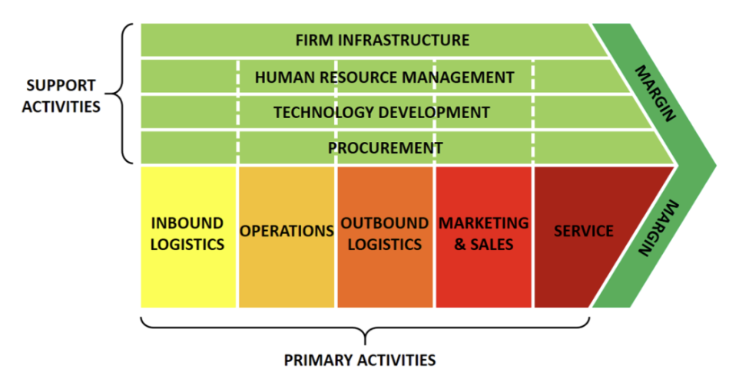
Source: Bruin, L. de (2019).

- Inbound logistics
All operations pertaining to receiving, storing, and delivering commodities from suppliers are collectively referred to as inbound logistics (Yoon, et al. 2020). For a steady and excellent supply of fresh, genuine Indian ingredients, develop solid ties with your suppliers.Effective inventory control will reduce waste and preserve ingredient freshness.

- Operations
The transformation processes that convert inputs into outputs that are subsequently sold to clients are included in operations (Yoon, et al. 2020). Hire talented chefs to create traditional Indian cuisine with an emphasis on consistency, presentation, and flavor.Simplify kitchen operations to increase productivity and cut down on client wait times.

- Outbound logistics
The process of storing and transporting the finished product to customers is known as outbound logistics (e.g., warehousing and store management) (Yoon, et al. 2020). To increase reach, streamline the takeout order delivery procedure and think about collaborating with meal delivery services.Make sure the packaging is both eye-catching and useful to preserve the food's quality while it is being transported.

- Marketing & sales
Through the creation of messages and the delivery of offers, marketing activity educates consumers about goods and services and encourages them to make purchases (Yoon, et al. 2020). Make advantage of social media, internet channels, and user-friendly websites to raise awareness and draw clients.

- Service
The term "service" refers to any activity that keeps or adds value to a product by providing warranties, repair services, training, and updated product information (Yoon, et al. 2020). In order to improve the entire environment and dining experience, train workers to deliver exceptional customer service.

- Best Suitable strategy to be focused

In order to increase growth and market share in London, the BCG Matrix advises concentrating on preserving the present high-quality offers in the flagship restaurant while introducing novel and expensive meals. An Ansoff matrix shows how product development—introducing distinctive culinary experiences—and market development—targeting new consumer categories by organizing exclusive events for corporate clients. In order to maintain a competitive edge, VRIO analyses place a major emphasis on utilizing the restaurant's unique and valuable assets, such as talented chefs and a solid brand name. SWOT assessments emphasize the need of addressing possible weaknesses, such the need for improved marketing, while focusing on strengths, like the restaurant's well-known food. Value chain analysis suggest strategically investing in marketing and customer service to create value while improving procurement and operational efficiency to preserve the fine dining experience. Combining product creation, market research, and operational optimization yields the most appropriate plan, guaranteeing a steady and well-rounded growth in London's cutthroat fine dining industry.

- IMPLEMENTATION AND EXECUTION OF STRATEGY
- Customer Service & Traning
A workforce that is enthusiastic about serving customers must be hired, trained, and led by restaurant management to ensure that they deliver an exceptional degree of professionalism. Raining demonstrates to staff members how to optimize sales and raise their own pay by providing exceptional client experiences. Every employee will be equipped with the skills and resources necessary to provide exceptional customer service each and every day (Lewin, J. 2014).

- Systems, Software, and Management Controls.
A restaurant's profitability is mostly determined by the caliber of its food and dining experience, but tiny modifications can yield big returns if business and financial elements are given careful consideration.The use of "Restaurant POS" systems—which let you precisely track and analyze transactions, reduce labor costs, manage inventory, handle payroll, monitor marketing initiatives, and offer real-time entry and reporting functions—must be detailed in your company strategy. To keep food expenses under control and guarantee uniformity, meal preparation staff will adhere to standardized recipes created by the master chef or business owner (Lewin, J. 2014).

- Operating Standards
To protect the health and safety of all visitors and staff, uphold a 100% compliance policy for food handling and sanitation. Every employee will understand and adhere to your strict standards for service and operational processes if you have a continuous program of education and training in place. The ideals and standards of service will be reinforced daily in staff meetings (Lewin, J. 2014).

- Innovation
The business has a "Creative and Artistic Director." "Idea generation, attribute development, and food product stylization based on concept board development, historical and social research, material selection, and menu writing" are some of her main duties (Olsen et al. 2008)

  - Organisation culture
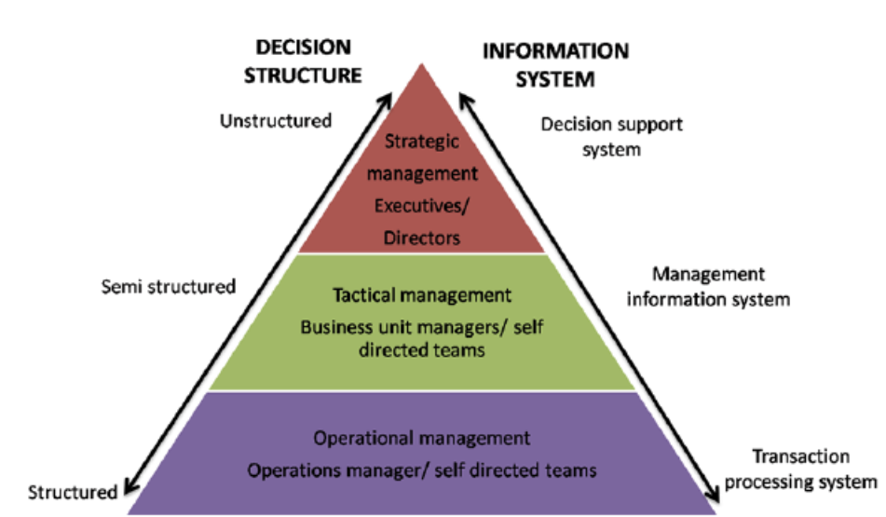
Source: Shurrab, H. (2014)

As previously said, an organization's customs make up its organizational culture. From a conceptual standpoint, anthropology and sociology are two separate fields that inform organizational culture. In order to comprehend the significance of organizational behavior and what made businesses distinct, researchers started examining organizational culture.It's an apt representation of the local situation. It is a reflection of the dominant ideology that permeates society (Koutroumanis, 2009). a leadership group with a Chief Financial Officer (CFO) managing finances, a Chief Operations Officer (COO) directing daily operations, and a Chief Executive Officer (CEO) setting strategic direction. The Executive Chef oversees Kitchen Operations, the Front-of-House Manager oversees Front-of-House Operations, and the Supply Chain and Procurement department makes sure that high-quality products are obtained efficiently. The effectiveness of an organization is enhanced by support services like IT and technology, marketing and sales, and human resources (HR). Branch or regional managers may be in charge of many sites, and cross-functional teams work on certain projects. The effectiveness of the organizational structure is attributed to performance measurements, training initiatives, open lines of communication, and a dedication to ongoing development. These elements guarantee efficient coordination and adaptability to the particular issues faced by the UK.
- KPI MONITORING TOOLS
- Cost of sales : Close stock management, waste reduction, portion control, and menu planning and budgeting are all necessary ways to keep costs under control (Gosling, D. 2017).
- Wages: To make sure that staffing levels are at their ideal, business owners should periodically examine the amount of customers they serve during the day and week (Gosling, D. 2017).
- Software for Customer Relationship Management (CRM): To manage customer contacts, collect feedback, and examine customer behavior, use CRM systems like HubSpot, Salesforce, or Zoho. This improves the whole eating experience and aids in knowing consumer preferences.
- Systems for Online Reservations: Platforms for reservations such as Resy or OpenTable can offer information on client demographics, peak hours, and booking trends. Staffing and table turnover may be optimized with the use of this information.

  - Critical Evaluation of Green Strategy, Sustainability, and CSR activities that can be undertaken
- Green strategy

When restaurants implement green practices, they must do so with the intention of successfully lowering the environmental and social issues that result from their operations, whether directly or indirectly. For instance, implementing an eco-friendly management strategy aids in the decrease of air pollution, water and energy consumption, solid waste, and waste production. Buying eco-friendly items, such as sustainably produced food, non-toxic cleaning and chemical products, and products made from agricultural waste, not only improves the restaurant's reputation internally but also extends green practices higher up the supply chain.

- Sustainable and CSR activities

Energy Conservation & Efficiency : Using sustainable energy sources, like solar or wind power, is one approach to do this. Restaurants may create their own electricity by using the sun or wind, which will lessen their reliance on fossil fuels and greenhouse gas emissions. In the long term, renewable energy helps restaurants save money on energy bills in addition to helping the environment (barak, 2023).

Local and Sustainable Ingredient Sourcing : By sourcing locally, restaurants can sow the seeds of sustainability into the culinary scene and reap the rewards of eco-consciousness. Restaurants may guarantee that the products they use are produced in a way that respects the environment and the welfare of animals by making the decision to support ethical agricultural methods (barak, 2023).

Programs for Waste Reduction and Recycling : Reduce the quantity of garbage that ends up in landfills by appropriately sorting and disposing of waste items. This will support sustainable waste practices. Recycling initiatives demonstrate to the community and your consumers your dedication to sustainability while also aiding in resource conservation (barak, 2023).

- CSR Activities

- Ecological Sourcing:Adopt ethical and sustainable procurement methods for food ingredients. This entails obtaining organic and locally produced foods and backing fair trade programs.

- Recycling and Waste Reduction:Reduce food waste by controlling portion sizes, composting organic waste, and recycling items like paper, glass, and plastic to implement waste reduction strategies. Additionally, several eateries give their leftover food to nearby nonprofits.

- Energy Effectiveness:Reduce the entire carbon footprint of the restaurant by implementing energy-efficient practices including LED lighting, energy-efficient equipment, and the use of energy-saving technology.

- CONCLUSION
In summary, Porter's Five Forces, PESTLE analysis, BCG Matrix, and Porter's Generic Strategies are all incorporated into a thorough strategic study for the UK development of an Indian restaurant. The competitive dynamics are emphasized by Porter's Five Forces, which also emphasize the significance of cost leadership and strategic differentiation in navigating the fierce rivalry and buyer bargaining power. PESTLE analysis guides the restaurant's adaptation to the local market by taking into account external elements such as socio-cultural trends, economic conditions, and regulatory impacts. The BCG Matrix supports resource allocation, helps discover important meals that drive revenue, and helps manage portfolios. Lastly, the restaurant's competitive advantage—whether it comes from cost leadership, distinctiveness, or focus—is defined with the aid of Porter's Generic Strategies. By integrating the findings from various models, a comprehensive approach can be adopted, allowing the Indian restaurant to adjust its development plan, build on its advantages, reduce risks, and prosper in the competitive and diversified UK market.

- REFERENCES
Alonso, T. (2023). Porter’s 5 Forces: Find Your Strategy Focus. [online] Cascade. Available at: https://www.cascade.app/blog/porters-5-forces [Accessed 9 Dec. 2023].
Ansoff, H.I., 1957. Strategies for diversification. Harvard business review, 35(5), pp.113-124.
Asoff, H.I., 1965. An Analytical Approach to Business Policy for Growth and Expansion. McGraw-Hill New York: Edited 2002.
Audu, A.A. and Hassan Rakiya Altine Umar, M.S. (2014). Small Business Start-up and Future Option: An Example of Food Restaurant Formation in South-East Cape-Town, South Africa. IOSR Journal of Business and Management, 16(9), pp.45–49. doi:https://doi.org/10.9790/487x-16924549.
barak (2023). The Importance Of Restaurant Sustainability Practices. [online] SavorEat. Available at: https://savoreat.com/the-importance-of-restaurant-sustainability-practices/ [Accessed 30 Dec. 2023].
BBC (2023). What is the UK’s inflation rate and why is the cost of living going up? BBC News. [online] 23 Mar. Available at: https://www.bbc.co.uk/news/business-12196322 [Accessed 9 Dec. 2023].
Bhasin, H. (2019). What is VRIO Analysis? The VRIO Framework explained in Detail. [online] Marketing91. Available at: https://www.marketing91.com/vrio-analysis-and-vrio-framework/.
Bruin, L. de (2019). Value Chain Analysis EXPLAINED with EXAMPLES | B2U. [online] B2U - Business-to-you.com. Available at: https://www.business-to-you.com/value-chain/.
Buye, R. (2021). Critical examination of the PESTEL Analysis Model. [online] ResearchGate. Available at: https://www.researchgate.net/publication/349506325_Critical_examination_of_the_PESTEL_Analysis_Model [Accessed 9 Dec. 2023].
DE WAAL, G.A. (2016). AN EXTENDED CONCEPTUAL FRAMEWORK FOR PRODUCT-MARKET INNOVATION. International Journal of Innovation Management, 20(05), p.1640008. doi:https://doi.org/10.1142/s1363919616400089.
Gosling, D. (2017). Key Performance Indicators for Restaurants. [online] Menzies LLP. Available at: https://www.menzies.co.uk/key-performance-indicators-for-restaurants/.
Gov.uk (2019). UK Voluntary National Review of Progress Towards the Sustainable Development Goals - GOV.UK. [online] Www.gov.uk. Available at: https://www.gov.uk/government/topical-events/uk-voluntary-national-review-of-progress-towards-the-sustainable-development-goals [Accessed 9 Dec. 2023].
Hawley, A. (2017). How to open and run a restaurant in 2021. [online] Startups.co.uk. Available at: https://startups.co.uk/guides/how-to-start-a-restaurant/ [Accessed 9 Dec. 2023].
Hitt, M.A., Ireland, R.D. and Hoskisson, R.E. (2017). Strategic Management: Concepts and Cases: Competitiveness and Globalization. Nelson Education.
Johnson, G., Scholes, K. and Whittington, R. (2008). Exploring Corporate Strategy: Text & Cases |Request PDF. [online] ResearchGate. Available at: https://www.researchgate.net/publication/272353374_Exploring_Corporate_Strategy_Text_Cases [Accessed 9 Dec. 2023].
Kotler, P. and Keller, K.L. (2016). Marketing management. 15th ed. Harlow, England ; London ; New York ; Boston ; San Francisco ; Toronto ; Sydney [U.A.] Pearson.
Koutroumanis, D.A. and Alexakis, G. (2009). Organizational Culture in the Restaurant Industry: Implications for Change. Journal of Organizational Culture, Communications and Conflict, 13(2), p.45.
Kugler, L. (2022). Addressing labor shortages with automation. Communications of the ACM, 65(6), pp.21–23. doi:https://doi.org/10.1145/3530687.
Lewin, J. (2014). Execution Makes a Good Restaurant (and its Business Plan) Great. [online] Cayenne Consulting. Available at: https://www.caycon.com/blog/execution-makes-a-good-restaurant-and-its-business-plan-great [Accessed 28 Dec. 2023].
Lynch, R., 2009. Strategic Management, Pearson Education Limited.
Martin, M. (2023). Porter’s Five Forces: Analyzing the Competition. [online] Business News Daily. Available at: https://www.businessnewsdaily.com/5446-porters-five-forces.html [Accessed 9 Dec. 2023].
Matheson, J. (2020). How has coronavirus affected pubs, cafes and restaurants? [online] Economics Observatory. Available at: https://www.economicsobservatory.com/how-has-coronavirus-affected-pubs-cafes-and-restaurants [Accessed 9 Dec. 2023].
MindTools (2022). MindTools | Home. [online] Mindtools. Available at: https://www.mindtools.com/a2gy5ya/the-ansoff-matrix.
Mohajan, H.K. (2018). An Analysis on BCG Growth Sharing Matrix. Noble International Journal of Business and Management Research. [online] Available at: https://www.researchgate.net/publication/322695566_An_Analysis_on_BCG_Growth_Sharing_Matrix#pf6..
Olsen, M. and Zhao, J. (2008). Handbook of Hospitality Strategic Management. [online] Google Books. Routledge. Available at: https://books.google.co.uk/books?hl=en&lr=&id=OtAsBgAAQBAJ&oi=fnd&pg=PA333&dq=implementation+and+execution+of+restaurant+business&ots=U1ZaXsIQ5-&sig=lCTNnY_w9Vyrvsp2v0SMmtejJIQ#v=onepage&q=implementation%20and%20execution%20of%20restaurant%20business&f=false [Accessed 2 Jan. 2024].
Perera, R. (2017). The PESTLE Analysis. Nerdynaut.
Poinski, M. (2020). Coronavirus changed 85% of consumers’ food habits. [online] Food Dive. Available at: https://www.fooddive.com/news/coronavirus-changed-85-of-consumers-food-habits/579532/ [Accessed 9 Dec. 2023].
Shurrab, H. (2014). Figure 5: A four level pyramid model of different types of information... [online] ResearchGate. Available at: https://www.researchgate.net/figure/A-four-level-pyramid-model-of-different-types-of-information-systems-based-on-the_fig5_270566506.
Statista (2022). Topic: Restaurants in the UK. [online] Statista. Available at: https://www.statista.com/topics/3131/restaurant-industry-in-the-united-kingdom-uk/#topicOverview.
Team, P.F. (2023). What is the BCG Matrix? Explaining its Components and Quadrants. [online] Peak Frameworks. Available at: https://www.peakframeworks.com/post/bcg-matrix [Accessed 22 Dec. 2023].
The Guardian (2020). Brexit has fuelled surge in UK food prices. [online] Available at: https://www.theguardian.com/business/2022/dec/03/brexit-has-fuelled-surge-in-uk-food-prices-says-bank-of-england-policymaker#:~:text=Researchers%20at%20the%20LSE [Accessed 9 Dec. 2023].
The Guardian. (2022). Prices at UK’s top restaurants ‘have doubled since Brexit’. [online] Available at: https://www.theguardian.com/food/2022/nov/10/prices-at-uks-top-restaurants-have-doubled-since-brexit [Accessed 9 Dec. 2023].
University of Cambridge (2016). Porter’s Generic Competitive Strategies (Ways of Competing). [online] University of Cambridge. Available at: https://www.ifm.eng.cam.ac.uk/research/dstools/porters-generic-competitive-strategies/.
Yoon, B., Chung, Y. and Jun, K. (2020). Restaurant Industry Practices to Promote Healthy Sustainable Eating: A Content Analysis of Restaurant Websites Using the Value Chain Approach. Sustainability, [online] 12(17), p.7127. doi:https://doi.org/10.3390/su12177127.

