Jekaterina Jakusenoka
1707391
26.11.2018

Intercultural communications
When in Dubai or Beijing

Executive summary

Table of Contents

Introduction
The report is describing how the head of Marketing of TBG Tours Ltd from America prepare for intercultural meeting during their forthcoming business development trips to Dubai and China. The social psychologist G. Hofstede conducted studies at global level to analyse cross-cultural values on basis of geographical and social beliefs, in which distinctive organisational cultural values were considered. Hofstede identified four dimensions of the differences between cultures. There are: power-distance, uncertainty –avoidance, masculinity and individualism. (Manrai & Manrai, 2011)And one more dimension was identified a long-term orientation to short-term orientation. The number of researches on culture are greatly increasing and will be considered very important to understand culture. (Mooij & Hofstede , 2011).Therefore, it is very significant to understand culture to deal with the problems in the businesses at global level .Ashough, it is help avoid barriers, stereotypes and creates environment for better cooperation. (Gill, 2018).Managers must know about the distinctive culture for better understanding their international partners and improve managerial skills. National culture has great impact on management behaviour and organisation. (Aycan, et al., 2014).The purpose of the report to show cultural differences between United states, China and Dubai in the view of Hofstede theory to apply better marketing strategies.

1.Disscusion
1.1 Culture.
Hofstede (Hofstede, 2010) (p1342) explained that culture is a mental collective programming that differentiates every human group from another one. Furthermore, Kroeber and Kluckholm, (Carla.umn.edu, 2018) states that culture is a way of feeling, reacting and thinking that are adopted by emblem that make different achievements and values of specific human groups.
  - Hofstede culture dimensions.
Masculine vs Feministic Culture.
The dimension defines the Masculinity when in the society is quite distinctive regarding genders. The concept of the society; men should be confident, focused on materialistic success while woman should be tender, modest and more concerned about quality of life. Individuals from Masculine society prefer heroism, achievements and materialistic. However, femininity culture society in which gender roles are overlapped. In that kind of society both men and women are to be more concerned to quality of life. (Hofstede, 2001)

Individualistic vs Collectivist Culture
According to individualism the member of society is only careful about themselves or their family. (Hofstede, 2001).On the other hand, in the collectivist culture the members have strong and cohesive groups from their birth throughout lifetime to be careful about each other without questioning loyalty. (Hofstede, 2001) Individualistic societies, like USA, where personal time, values, independence and individual pleasure are valued. In contrary to individualist society, collectivist prefers respect for traditions and sense of belonging. Individualist believes that Democracy should be shared but it is more typical to conceptualise it collectivist society like China. (Hofstede, 2001).
. Power distance The dimension the collective beliefs of less powerful members about in-equal distribution of power from any institution or organisation in any country. (Hofstede, 2001)(p85) The countries with large power distance like China accept equality in their society. From other hand countries like USA are in the less power distance. (Hofstede, 2001).

Uncertainty Avoidance
In accordance to Uncertainly Avoidance dimension individuals in certain society have feeling of threat from unknown and uncertain condition. (Hofstede, 2001)The society in this situation feels endangered by unknown situations and they try at their best level to avoid these situations by the adaptation of strict behaviour code, beliefs on absolute truth in which establishment of formal rules and intolerance of deviant acts and ideas. Members of those societies in which individuals highly avoid uncertain situations, they are more concerned with security, the highly feel of agreements and written rules and they are likely to take less risk. On the other hand, individuals from low uncertainly avoidance societies they are more risk tolerance, very less concerned about rules and security. (Hofstede, 2001).
Long term vs Short Term Orientation .Firstly Hofstede identified 4 cultural dimensions, but latest dimension was added and called Confucian dynamism or “ Long term Vs Short Term (Hofstede & Bond, 1984)(p45).According to short term orientation, encouragement of dignity related present, past, fulfilment of social obligations and honour of traditions. On the other hand, Long term orientation regards the dignity with respect of rewards in future more importantly thrift and perseverance.

2.Cultural Distance between China and United States in Hofstede Model.
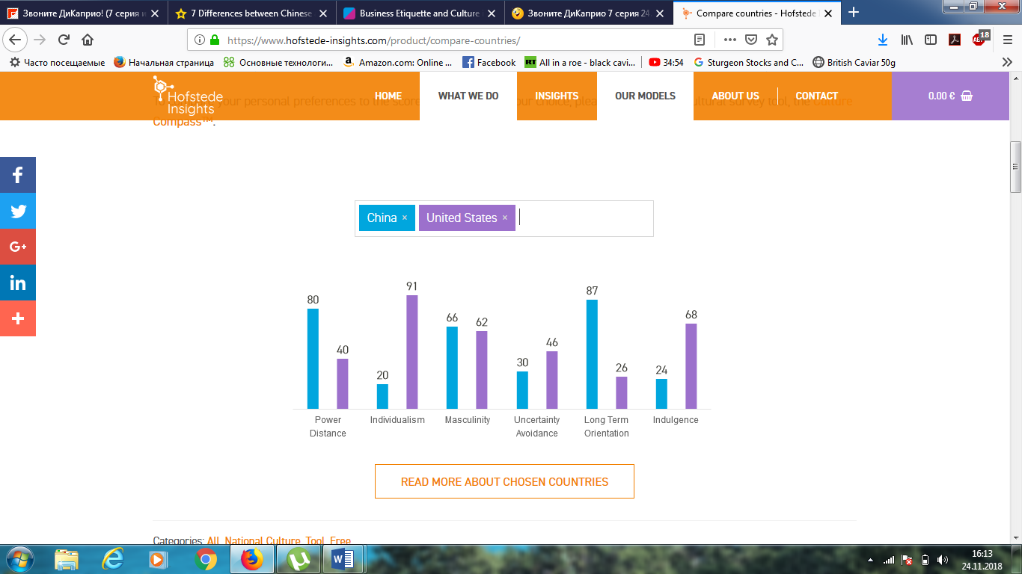
2.1Power distance
The culture of United States is characterised into lower power distance, in contrary to China. China has highly power distance culture, they believe that every individual, group or society should be indifferent and behaviour of every person should be according to his or her social status. The United States culture of lower power distance with the mixture of individualism have a great impact on managerial processes
2.2Uncertainly avoidance
United States has higher uncertainty avoidance dimension in comparison of China.
2.3Individualistic vs Collectivist Culture
The society of United States is based on individualism, however, Ghina is a collectivism societal country. Chinese value group goals, saving face, respect, friendship and long term objectives. Ashough, they try to make decisions in the long-term perspectives and collective goals of the organisation. (Khairullah & Khairullah, 2013) Chinese have ancient thoughts that every person is dependent on a particular group or society.
.
2.4Masculine vs Feministic Culture
United States has masculine dimension of culture with a little difference from China. It is due to tough competition that is everywhere for economical market like in China as well United States

Low /high context culture.
Low context culture, non–verbal clues speak volume. Pay attention to people’s tone and facial expressions because they carry deeper meanings than words, especially when expressing dissatisfaction because the China tend to maintain harmony.

Negotiations

3.Cultural differences Dubai from United States.
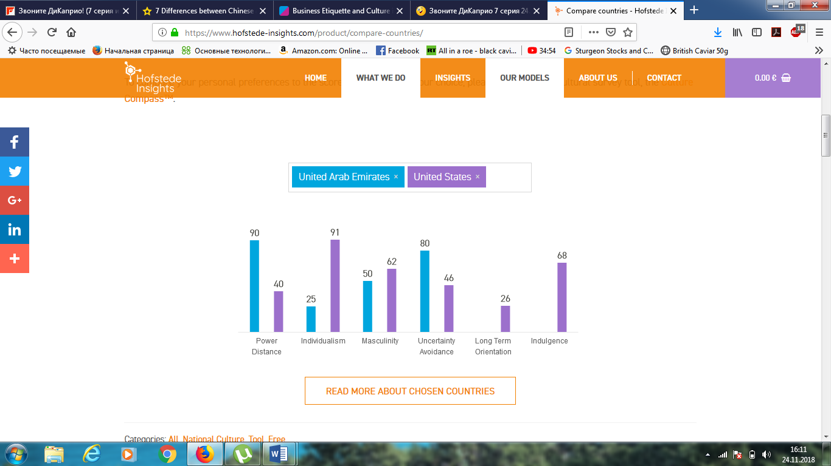
Figure 1 (Insights, 2018)
It is a fact that there are only four indices of cultural dimensions available for Dubai, therefore only four dimensions of culture are taken into consideration (Hofstede, 2001; Hofstede et al., 2010).
3.1Power distance
Citizens of Dubai have greater power distance in comparison of United States (Figure 1). These all facts shows that the citizens of Dubai regarding power distance are in favour of in-equal distribution of power, sources and authorities.

3.2Uncertainly avoidance
In the same way, Dubai also have higher score of uncertainty avoidance than United States.

3.3 Individualistic vs Collectivist Culture
The citizens of Dubai are based on collectivism their beliefs support the living standards as a group or society.
United States has higher score in individualism in comparison of Dubai.
3.4Masculine vs Feministic Cultur
There is very little difference between Dubai and United States in the scores of Masculinity.
Finally, the citizens of Dubai feel more threatened rather than the citizens of United States. The results show that the citizens of Dubai are the followers of their traditions and the social system of power division. They do not question their authorities and are more loyal to their elders or leaders who are superior to them in their society.

2.6 Low /high context culture
2.7 Negotiations (peregovori) Meetings may not always begin in as timely a fashion as elsewhere, but it’s always good to turn up promptly with a good supply of patience and humour. Avoid scheduling meetings during prayer times. Hospitality is a prized tradition in Dubai, so you will likely be offered Arabic coffee and dates, chocolates and other refreshments. Indulge and show appreciation and ensure you always offer refreshments if the meeting is held in your own offices.

Once a meeting gets underway, it’s important to greet the most senior person first and work your way around the room from there. Once regular business is established, it is important to spend time chatting to your clients about their families and their activities – relationship building is key. (Visitdubai.com, 2018)

Conclusion.
The Cultural dimensions between the United States, and China and Dubai are completely different.

References
Aycan, Z., Kanungo, R. and Mendonca, M. (2nd.). Organizations and management in cross-cultural context. (2nd ed.) (Hofstede, 2001) London: Sage, pp.220-251.
Carla.umn.edu. (2018). The Center for Advanced Research on Language Acquisition (CARLA). [online] Available at: http://carla.umn.edu/culture/definitions.html [Accessed 23 Nov. 2018].
Gill, G. and Gill, G. (2018). Knowing Other Cultures is Important in Business/Personal Dealings. [online] Gobinder Gill - Diversity Works. Available at: https://www.gobindergill.com/knowing-other-cultures-is-important-in-businesspersonal-dealings/ [Accessed 23 Nov. 2018].

Hofstede, G. (2010). The GLOBE debate: Back to relevance. Journal of International Business Studies, 41, 1339-46.
Hofstede, G. (2011). Dimensionalizing Cultures: The Hofstede Model in Context Online Readings in Psychology and Culture, 2(1). p 8.

Hofstede, G. (2001). Culture’s Consequences: Comparing Values, Behaviors, Institutions, and Organizations Across Nations. (2nd ed.) Sage Publications.

Hofstede, G. and Bond, M. (1984). Hofstede's Culture Dimensions: An independent validation using Rokeach's value survey Journal of Cross-Cultural Psychology, 15(4), pp.417-433.

Hofstede Insights. (2018). Compare countries - Hofstede Insights. [online] Available at: https://www.hofstede-insights.com/product/compare-countries/ [Accessed 24 Nov. 2018].

Khairullah, D. and Khairullah, Z. (2013). Cultural Values and Decision-Making in China. International Journal of Business, Humanities and Technology, 19(2),p 7

Manrai, L. & Manrai, A., 2011. Hofstede's Cultural Dimensions and Tourist Behaviour:A Review and Conceptual Framework. Journal of Economics, Finance and Administrative Science, 16(31), p. 26.
Mooij, M. & Hofstede , G., 2011. Cross-Cultural Consumer behaviour : a Review of Research Findings. Journal of International Consumer Marketing, Volume 23, pp. 181-192.
Visitdubai.com. (2018). Business Etiquette and Culture in Dubai. [online] Available at: https://www.visitdubai.com/en/business-in-dubai/grow-your-business/setting-up/business-culture?fbclid=IwAR0S1V6csG53jMeNmaO_XunizfmVzRH6E1AhFrqUNPK_wCJJNZ-VH7TuEPw [Accessed 24 Nov. 2018].

Appendix.



