Evaluation: “Shit is fucked up and bullshit”
Our brief for this project was to create an A3 poster on Adobe InDesign or Adobe photoshop under the title “Shit is fucked up and bullshit.” To start this project off I began to think of things that I felt were wrong with society or the world, that would fit under the title. I originally had a few ideas such as pay for grades, pollution, politics, social media and gender norms/roles. I ended up going with focussing purely on the gender issues and roles that come with the society and the things that we have all been brought up to believe.

Within my poster I wanted to touch on how everything is assigned to a certain gender such as men can’t wear makeup which makes it directed for females or how if a woman doesn’t wear makeup it means they aren’t trying or care for their appearance and men don’t have that pushed on to them. Obviously, there are many other stereotypes that effect todays’ world, but I could not focus on all of them so decided to change up a little bit and disfigure/ change someone’s features representing ‘the rise in gender neutral beauty ‘ (Annie Simons, 2018) which is also a news article that I found by the independent that inspired the words that are across my poster. At first, I was going to write “Redefining the face of society” but I felt the article fitted the poster better as what I was trying to achieve was that how you look, what you wear doesn’t define your femininity or masculinity meaning that things should just be things and not have to fit a gender.

During one of our sessions in Brecon we learnt about Dada and photomontage which really influenced the way I wanted to set my poster out or the background of my poster, which is where I got the idea to merge some images that I collected online or had taken myself. The focus behind this was to make the poster look weird but also fitted and to highlight areas to show a statement to show that there doesn’t have to be certain things for each gender and that its all equal.

I used a couple of photos that I found online that I used in my work which are:

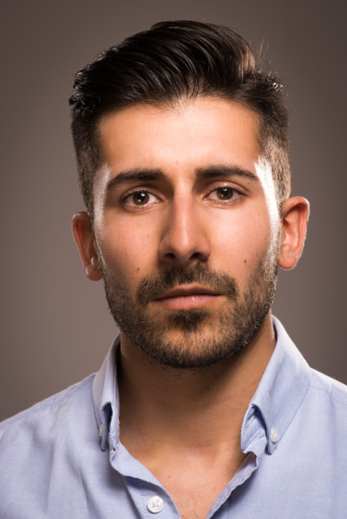

Taken by Andrew mason
I took the eye from this as I wanted a male’s eye
to go along the female to show a range and how
normal it is.

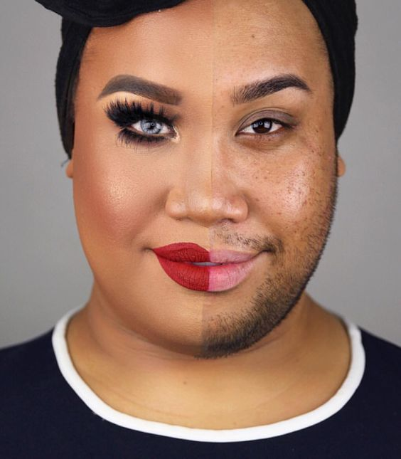
https://www.andrew-mason.com/tag/headshot-photography/

Patrick Starr by cover girl

https://www.pinterest.co.uk/pin/744501382124276045/?lp=true
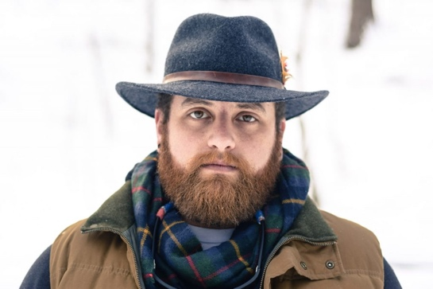

picture used from Article

http://thevivant.com/men-really-are-wearing-hats-again

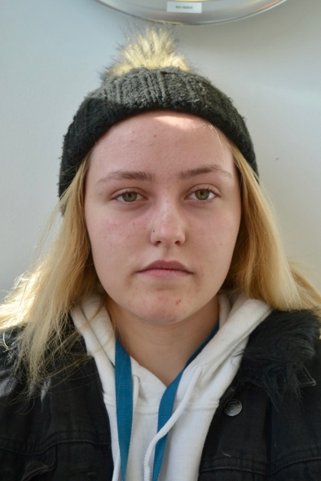

taken by me
n Model: Brittany

Outcome:
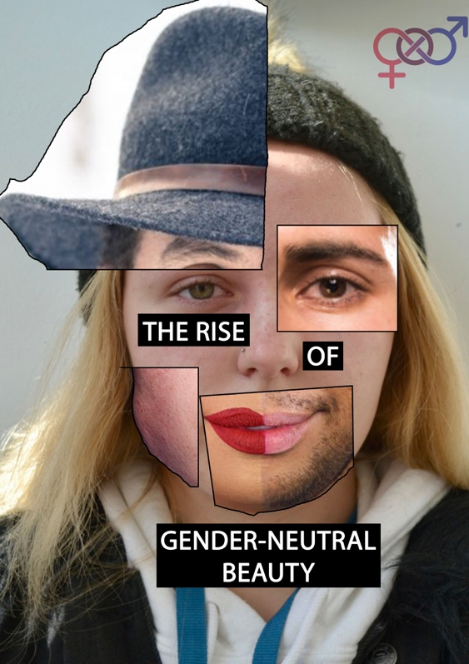

Overall, to sum up this project I feel I was able to create an interesting poster that goes nicely under the title “Shit is fucked up and Bullshit”. I feel this was a real learning curve for me as I haven’t really done anything quite like it or worked as thorough in photoshop as I did for this project. I think it came together quite well and represents what I wanted to get across. I think there are 1 or two things that I’d change which would be add more writing or change the title to one that instantly catches attention.

