
PROGRAMME: MSC PUBLIC HEALTH AND SOCIAL CARE IN PRACTICE
MODULE: HEALTH CARE SYSTEM ORGANISATION AND LEADERSHIP
MODULE CODE: LCHS7002
ASSIGNMENT TITLE: CASE STUDY ANALYSIS REPORT
CHOSEN CASE STUDY: CASE STUDY NUMBER 1
NAME : VIDHI GONDALIYA
STUDENT ID :2521864
Executive summary
The report is focusing on an evaluation of the chosen case study that is concentrated on a critical event, which happened to a 4-week old baby in the North East and Yorkshire area where an oral solution of morphine sulphate was given in an excess of twenty times the necessary dose. Transformational leadership is centred on motivation and inspiration of teams in reaching a common vision especially in enhancing patient safety. Furthermore, transactional leadership focuses on rules, procedures, and performance surveillance, which is of high importance in high-risk clinical situations. Moreover, situational leadership emphasises the fact that leaders have to adjust their style according to the situation, particularly in times of crisis or complicated events.

Table of Contents
1. Introduction 5
1.1 Introduction of the background and purpose 5
1.2 Explanation of leadership-means in influencing shared goals in health and social care 5
1.3 Description of centralisation and decentralisation and key leadership theories and styles (transformational, transactional, situational) 5
1.4 Discussion on choosing the right leadership style and its importance for success in changes or crisis situations 5
1.5 Specification of points that are addressed within report 6
2. Main Body and Analysis 6
2.1 Identification of the Problem and Setting the System Context-Applying Systems Thinking and the Rich Picture 6
2.1.1 Explanation of global statistical information reveal about the problem 6
2.1.2 Explanation of national statistical information reveal on the problem 7
2.1.3 Explanation of figures from national organisations reveal on the problem in connection to worldwide presentation 8
2.1.4 Explanation of this problem reflects systemic weaknesses 9
2.1.5 Identification of the level of governance (local, regional, or national) that influenced the problem 9
2.1.6 Analysis of data on underlying challenges (staff shortages, patient safety outcomes, or budget constraints) to illustrate underlying challenges 10
2.2 Centralisation or Decentralisation within the Case Study 10
2.2.1 Centralised systems 10
2.2.2 Decentralised systems 11
2.2.3 Critical analysis 12
2.3 Leadership Theories and Application to the Case Study 13
2.3.1 Application and critique of leadership theories relevant to the case 13
2.3.2 Appropriateness of the chosen theories in the situation 14
2.3.3 Leaders reactive (command-driven) or proactive (purpose-driven) 15
2.3.4 Relevant data to leadership effectiveness 16
2.3.5 Distributed or emotionally intelligent leadership based analysis 16
2.4 Improvement, and Lessons Learned 16
2.4.1 Critical evaluation of how leadership and governance interacted to produce the outcomes seen in case 16
2.4.2 Identification of the missed opportunities and evidence-based solutions and present a discussion highlighting the problems, solutions and relevant data 18
3. Recommendation 19
3.1 Summary what should be done next in the chosen organisation 19
3.2 Recommendation of the most effective leadership style(s) for sustaining improvement 20
3.3 Suggestion of ways to strengthen governance, communication, and systems integration 20
3.4 Proposal of actions to enhance technical and allocative efficiency 21
3.5 Inclusion of methods for continuous learning, stakeholder engagement, and co-production 21
4. Conclusion 21
4.1 Summary 21
4.2 Importance of leadership, governance, and systems thinking in driving change 22
Reference list 23

1. Introduction

1.1 Introduction of the background and purpose
Medication errors are one of the most significant challenge in health and social care systems since they frequently result in avoidable injuries, especially those of vulnerable groups like infants (Antonopoulou, 2024). The chosen case study is concentrated on a critical event, which happened to a 4-week-old baby in the North East and Yorkshire area, where an oral solution of morphine sulphate was given in excess of twenty times the necessary dose (Altamimi et al. 2023). This report aims to critically examine this case using the leaders, governance, and systems thinking.

1.2 Explanation of leadership means in influencing shared goals in health and social care
Health and social care leaders can be described as the capacity to influence others and teams to accomplish the common objectives, especially in the provision of safe, efficient, and patient-centred care (Aika and Enato, 2022). According to Adams (2022), developing an organisational culture of safety, encouraging collaboration, accountability and leading healthcare professionals, are all aspects of effective leadership.

1.3 Description of centralisation and decentralisation, and key leadership theories and styles (transformational, transactional, situational)
The meaning of centralisation in healthcare is that the decision-making power is centralised at a higher level, usually in specialised or hospital-based services, where control and standardisation should be ensured by whom?. On the contrary, decentralisation spreads the power among various levels, where there is flexibility and reduced decision-making time (Altamimi et al. 2023). Transformational leadership is centred on the motivation and inspiration of teams in reaching a common vision, especially in enhancing patient safety (Desy, 2024). Furthermore, transactional leadership focuses on rules, procedures, and performance surveillance, which is of high importance in high-risk clinical situations (Alison, 2026). Moreover, situational leadership emphasises the fact that leaders have to adjust their style according to the situation, particularly in times of crisis or complicated events (Bennett, 2023).

1.4 Discussion on choosing the right leadership style and its importance for success in changes or crisis situations
Different leadership styles, such as transformational, transactional, and situational leadership, influence how effectively teams respond to change and crisis situations in healthcare. Selecting the most appropriate style is essential to ensure patient safety, effective decision-making, and successful outcomes during high-risk events. Ineffective leadership style may result in ineffective communication, accountability, and a high probability of mistakes as experienced in this case refer to the case. On the other hand, a competent leadership contributes to better coordination of the team, adherence to safety measures, and risk-taking activities (Essandoh et al. 2023). Thus, leadership styles may have to be combined in high-risk situations, like medication administration, and maintain high adherence to procedures as well as improvement (Desy, 2024).

1.5 Specification of points that are addressed within report
This report will review the stated issue within the perspective of systems thinking and statistical data, discuss the issue of centralisation and decentralisation. It will also discuss the relationship between leadership and governance, the essential lessons learned, and give recommendations that can be made based on evidence to enhance patient safety.

2. Main Body and Analysis

2.1 Identification of the Problem and Setting the System Context-Applying Systems Thinking and the Rich Picture

2.1.1 Explanation of global statistical information reveal about the problem
Medication errors have been identified as one of the significant patient safety issues in the world and one of the leading causes of preventable injuries and deaths. The World Health Organisation estimates that the cost of medication errors is approximately 42 billion a year across the globe and that the errors impact millions of patients annually (WHO, 2026). Medication safety has also been listed among global priorities by the WHO in its Medication Without Harm program with a goal of cutting severe, preventable medication-related harm by half (WHO, 2026). These mistakes happen at any point of medication such as during prescribing, dispensing, and administration, and in many instances, they result due to system malfunction and not the fault of a single person (Essandoh et al.2023).
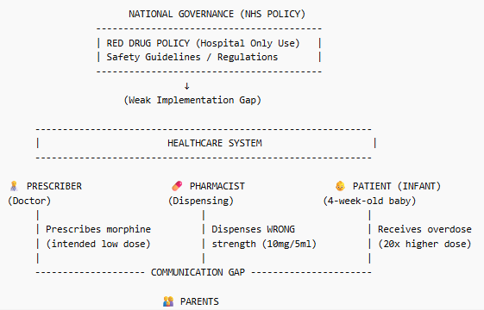
Figure 1: Visual representation of the current challenge of the case
(Source: Self-developed)
As shown in the figure above, medications with high risk—particularly opioids such as morphine—are especially susceptible to serious consequences when errors occur.. Low weight bodies, immature physiology, and the need to have accurate doses mean that infants and neonates are highly vulnerable (Bereda, 2022). Research around the world indicates that the number of medication errors among children is higher than in adults, with the most common one being dosing errors (Guntschnig et al. 2025).
Globally, medication errors have led to serious incidents, such as fatal overdoses of chemotherapy drugs in the United States and incorrect intravenous medication administration in the United Kingdom, often linked to dosing miscalculations and communication failures. Similarly, in countries like Australia and India, reported cases highlight errors in paediatric dosing and drug preparation, reinforcing that this is a widespread systemic issue across healthcare systems.

2.1.2 Explanation of national statistical information reveal on the problem
On the national level, medication errors remain a consistent problem in healthcare facilities like the National Health Service (NCBI, 2024). This is largely due to the complexity of medication processes, high patient volumes, workforce pressures, and variations in communication and standardisation across care settings. Studies have shown that hundreds of millions of medication errors are witnessed each year in England, with a good percentage of them happening in the primary care setting (Elliott et al., 2018; NHS England, 2021). Considering this case, the fact that the incidences of morphine overdose recurrence, in the five related instances since 2018, including one case that resulted in a death, is an indication of a pattern of ineffectiveness, rather than an isolated error (EASL, 2026). Some errors do not harm, but many of them cause moderate or serious consequences in patients, such as hospitalisation and death (Hobusch et al. 2024).
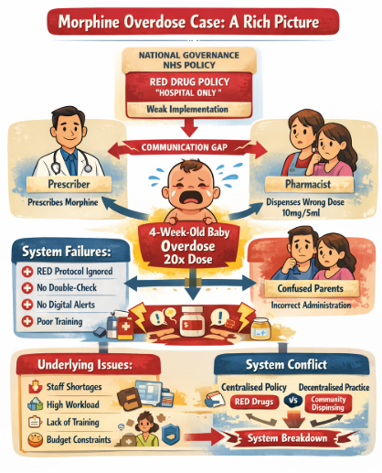
Figure 2: Rick picture on the current issue of the case
(Source: Self-developed)

2.1.3 Explanation of figures from national organisations reveal on the problem in connection to worldwide presentation
Organisations, including the Institute of Healthcare Improvement, also give additional insight by stating that medication errors can be prevented to a great extent in case of the existence of well-established systems and safety cultures (Huettermann et al. 2024). According to the HSSIB (2025) , communication failure, non-standardisation and poor safety systems are prevalent contributory factors in the world (Lega and Pirino, 2022). Comparing UK information with the international trends, one can understand that the reasons behind the occurrence of medication errors are the same in all healthcare systems. As an example, global and national data points to system design weaknesses, human factors, and insufficient safety inspections as the significant factors (Wen et al. 2022).

2.1.4 Explanation of this problem reflects systemic weaknesses
The case study shows a number of institutional flaws that played a role in the overdose incident. Firstly, communication between the healthcare professionals at various levels of care, especially, between the prescribers and the dispensers, was not effective (Hazen et al. 2024). Secondly, accountability and governance failed, with laid down procedures of dealing with RED drugs not being observed (Magola-Makina et al. 2022). Moreover, the system was not provided with efficient safety measures, including the possibility of checking the orders twice or electronic prescriptions, and only the inappropriate drug strength was dispensed. The occurrence of the repetitive cases also indicates a weakness in organisational learning where the mistakes made were never properly analysed and leveraged to make the improvements.

2.1.5 Identification of the level of governance (local, regional, or national) that influenced the problem
The incident was pre-determined by various tiers of governance in the healthcare system. On the ground, health facilities had the mandate to provide correct prescribing and dispensing activities. Nevertheless, the lack of compliance with the protocols denotes a lack of local control and responsibility. Clinical commissioning groups and regulatory bodies at the regional level have the role of implementing and monitoring medication safety policies (Makrani et al. 2025). The fact that similar situations happened indicates that the systems of regional governance could have been inadequate in the enforcement of compliance or dealing with perceived risks. On the national level, there are policies concerning the classification and management of the RED drugs to guarantee patient safety (World Health Organisation, 2023). Although such policies are there, the case indicates that there is a disconnect between policy and practice.
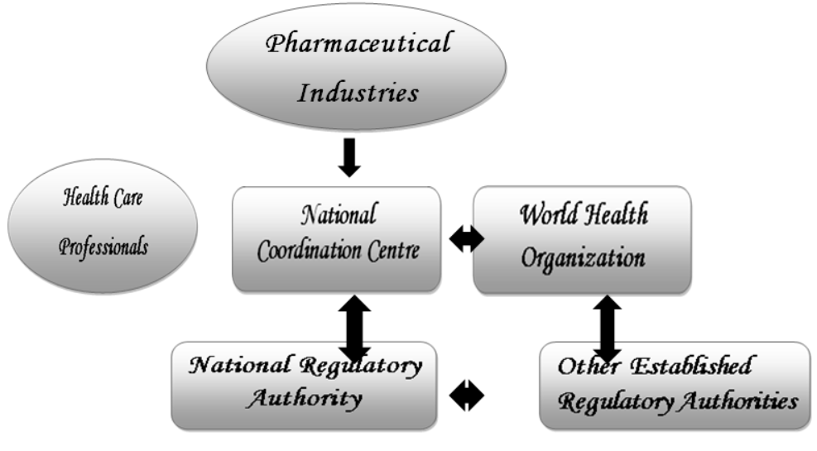
Figure 3: Clinical health based regulatory aspects
(Source: World Health Organisation, 2023)

2.1.6 Analysis of data on underlying challenges (staff shortages, patient safety outcomes, or budget constraints) to illustrate underlying challenges
A number of underlying difficulties have added to the incident, which further depicts weaknesses in the system. Staff workload and pressure are one of the major problems, as this can lead to the increase in chances of error, especially in hectic clinical settings (Mawuena and Mannion, 2022). Research has indicated that workload and time limitations decrease the efficiency of safety checks and cause more use of assumptions. Lack of training and knowledge on high-risk medications is another causative factor (Naseralallah et al. 2023). In some cases, healthcare professionals may not be fully in the know of the requirements that come along with the RED drugs and hence make incorrect decisions with regard to prescription or dispensing. Also, the patient safety outcomes data indicate that medication errors do not always get reported, which restricts organisational learning and improvement.

2.2 Centralisation or Decentralisation within the Case Study

2.2.1 Centralised systems
Centralisation in healthcare is a system whereby decision making powers are vested in higher levels of the organisation, usually in specialised services or in hospitals (Ramsay et al. 2025). The method is especially significant in dealing with high-risk drugs, when close regulation, standardisation, and professional monitoring is necessary to enhance patient safety. As per the case study, morphine sulphate oral solution at the concentration of 100 micrograms/ml is a Red drug, it should only be prescribed, dispensed and monitored in the secondary care facilities only by the specialists (Cambridges, 2026). Such a system is centralised and displays this classification to reduce the risks of potent medications.
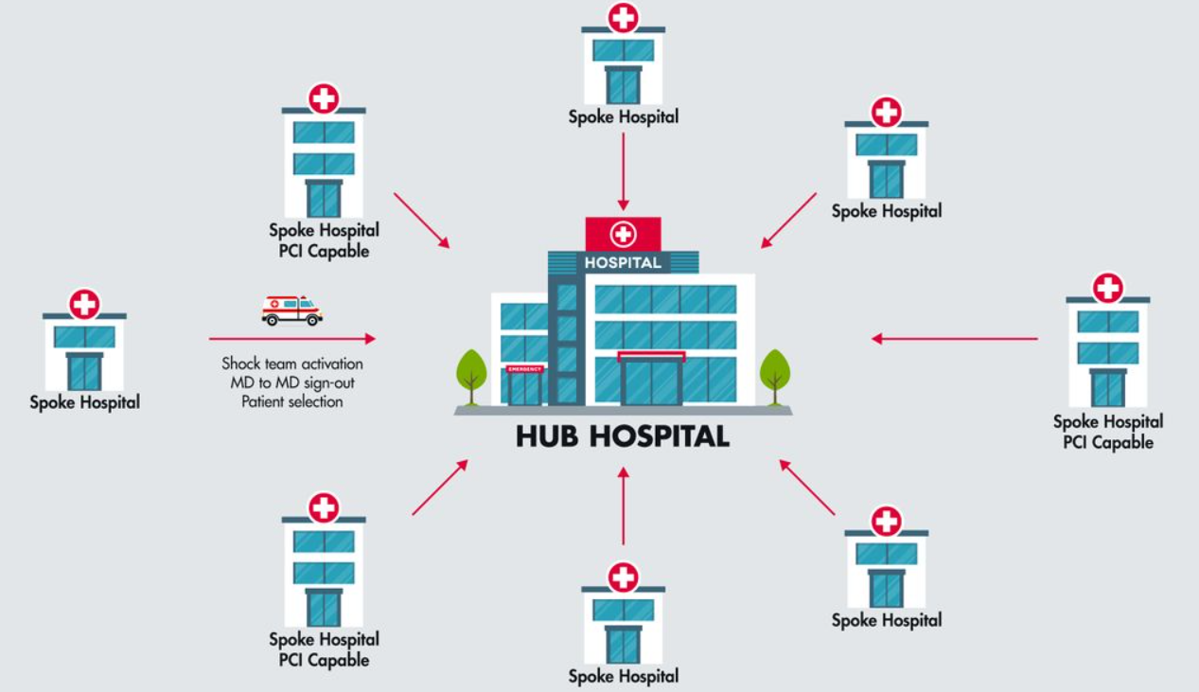
Figure 4: Centralised aspects in healthcare setup
(Source: Ramsay et al. 2025)
The benefits of centralisation in the case are enhanced clinical expertise because specialists are more conversant with dosing requirements of high-risk drugs, and increased standardisation that minimises the chances of making mistakes. The World Health Organisation recommends that medication errors may be minimised through standardised medication systems, especially in high-risk units like neonatal units (Alison, 2026). Moreover, centralisation enables greater authority and responsibility because there are distinct procedures and chains of command.
According to NHS patient safety reports data, it has been shown that a considerable percentage of medication errors are made during transitions of care (BMJ, 2026). Nevertheless, the centralisation has its drawbacks as well. A disadvantage is that there is a possibility of breakdown in communication between various levels of care, especially when the patients are moving out of the hospital environment to the community setting. Here, the problem lies in the fact that a drug which is meant to be used in a hospital was distributed outside the centralised system and this means communication and coordination lapse (Aika and Enato, 2022). Moreover, centralised systems may occasionally create stalling in decision-making where decision approvals and decision actions have to arrive at hierarchical arrangements.

2.2.2 Decentralised systems
Decentralisation of healthcare entails the decentralisation of decision making authority to various levels such as primary care providers, pharmacists as well as the community healthcare professionals (Aika and Enato, 2022). This will be more flexible and responsive and will help the healthcare providers to make decisions, according to the local needs and situations. Practically, decentralisation manifests in the participation of the general practitioners and the community pharmacies in dispensing medications and prescribing them.
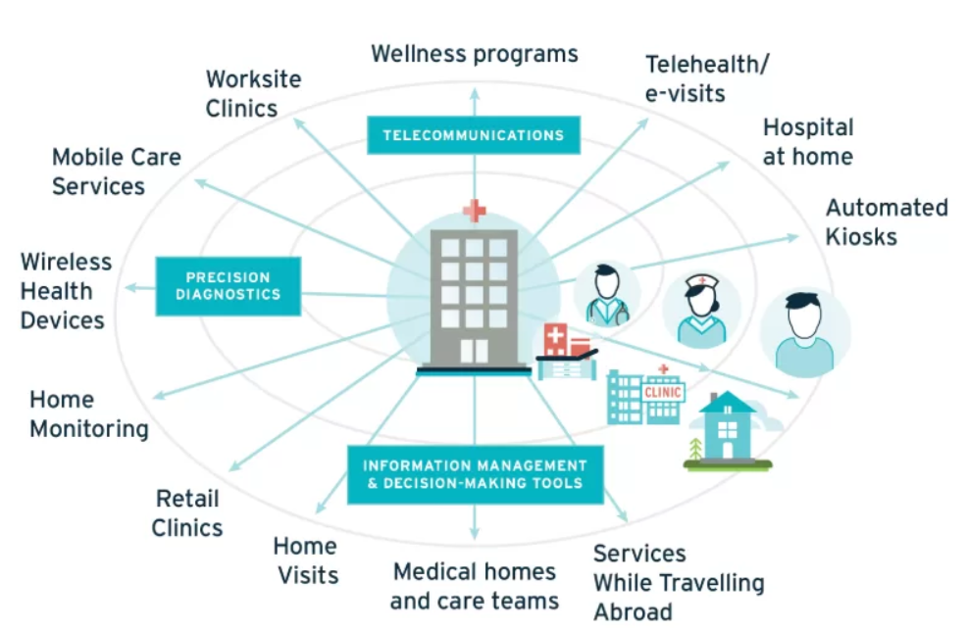
Figure 5: Decentralised setup in healthcare
(Source: Aika and Enato, 2022)
Decentralisation in the case study was also evidenced by the dispensation of the medication out of the intended hospital. Though the system was meant to be centralised concerning RED drugs, the participation of primary care and community pharmacy were found to be decentralised factors. Such a change enabled the wrong morphine concentration (10mg/5ml) to be dispensed, which eventually caused the overdose (HSSIB, 2025). Nevertheless, there are also great risks of decentralisation especially with the handling of high-risk drugs. The first drawback is that there is a possibility of inconsistency in practice given that various providers might possess a certain degree of knowledge and expertise (HSSIB, 2025). The ignorance or the non-observance of RED drug procedures in the de-centralised environment in this case helped in the mistake. Moreover, the decentralised systems can also be characterised by poorer supervision and responsibility and it is more challenging to guarantee observing the safety standards.

2.2.3 Critical analysis
As it has been shown in the case study, the interaction between the centralised and decentralised systems had a significant impact on the crisis management, decision-making, and accountability. Although the policy framework of RED drugs was evidently centralised, its implementation has been unsuccessful because it involves decentralised processes, which have not been properly controlled and integrated (Moury and Escada, 2023). The decentralised aspects of the system would interfere with the early detection and avoidance of the mistake based on a crisis management perspective. The difficulty of the safety checks being carried out at the dispensing point permitted the wrong medication to be received by the patient. According to World Health Organisation data, medication errors can be avoided by as many as 50% with a proper system protection in place, which implies that more rigorous centralisation of the main and decentralisation of the secondary systems would have helped avert the risk (WHO, 2023).
The decentralised structure also gave the frontline professionals free hand in terms of decision-making, albeit without adequate guidelines or supervision. This Inco-ordination led to decisions that were not in tandem with the laid down procedures. NHS safety statistics also point out that hundreds of millions of medication errors are taking place every year in England and a large percentage of this error is associated with communication and system design failures (Goodier, 2022). This highlights the necessity to have transparent decision making structures which integrate decentralised actions with centralised policies.
In general, the case indicates that centralisation and decentralisation cannot provide the necessary level of safety to patients individually. Rather, a suitable approach to the healthcare system involves a middle way, with centralist policies backed by a well-coordinated decentralist practice (Hobusch et al. 2024). To reduce the gap between the two approaches, strong leadership, effective communication, and governance mechanisms are needed. The inability to balance this in the case study was the ultimate cause of the medication error, which shows the paramount significance of system integration in healthcare delivery.

2.3 Leadership Theories and Application to the Case Study

2.3.1 Application and critique of leadership theories relevant to the case
The leadership functions are important in determining the outcomes of safety among patients especially in high-risk clinical environments like medication management (Ahmed and Tamim, 2025). The morphine overdose incident, in this case, points at both the systemic and leadership failures. Transformational leadership is based on motivating and inspiring employees in an attempt to realise a common vision, especially on patient safety (Desy, 2024). Leaders who follow this style foster the culture of openness, learning and constant improvement. Nevertheless, due to the repetition of similar cases, it is possible to conclude that such leadership was not in place, and an active safety culture was not successfully implemented.

Figure 6: Transformational leadership style in healthcare
(Source: Desy, 2024)
On the other hand, transactional leadership focuses on observing the rules, policies, and procedures by monitoring and managing the performance (Dong, 2023). This practice is requisite in the high risk setting such as medication administration to ensure the observance of the protocols including RED drug policies. Nevertheless, it has been demonstrated that transactional leadership is not always enough, as its performance requires strict implementation and regular observation of it.
Situational leadership entails gaining some flexibility in leadership according to the situation and the risk involved (Klarström et al. 2025). Leaders are supposed to be more directive and controlling in complicated and risky scenarios like prescribing opioids to infants. It has been found that situational leadership may enhance safety behaviours when the situational needs are considered by the leaders who vary their leadership approach to suit needs of that situation.

2.3.2 Appropriateness of the chosen theories in the situation
The combination of leadership approaches would have been most suitable in the context of this case. Transformational leadership will be especially useful in establishing a high-quality patient safety culture, and transactional leadership will be critical in the process of guaranteeing adherence to medication safety measures. Situational leadership plays a key role also in aligning the behaviour of leadership to risky situations. It has been indicated that healthcare organisations that have good leadership have patient outcomes that are 14% better and this points to the need to ensure that the right leadership styles are chosen (NHS, 2026). The lack of a combined leadership strategy in this scenario is also a factor that led to the collapse of the system. Whereas transactional leadership would have guaranteed the adherence of the RED drug policies, transformational leadership would have led to the development of the culture where employees are encouraged to challenge and report the possible mistakes.
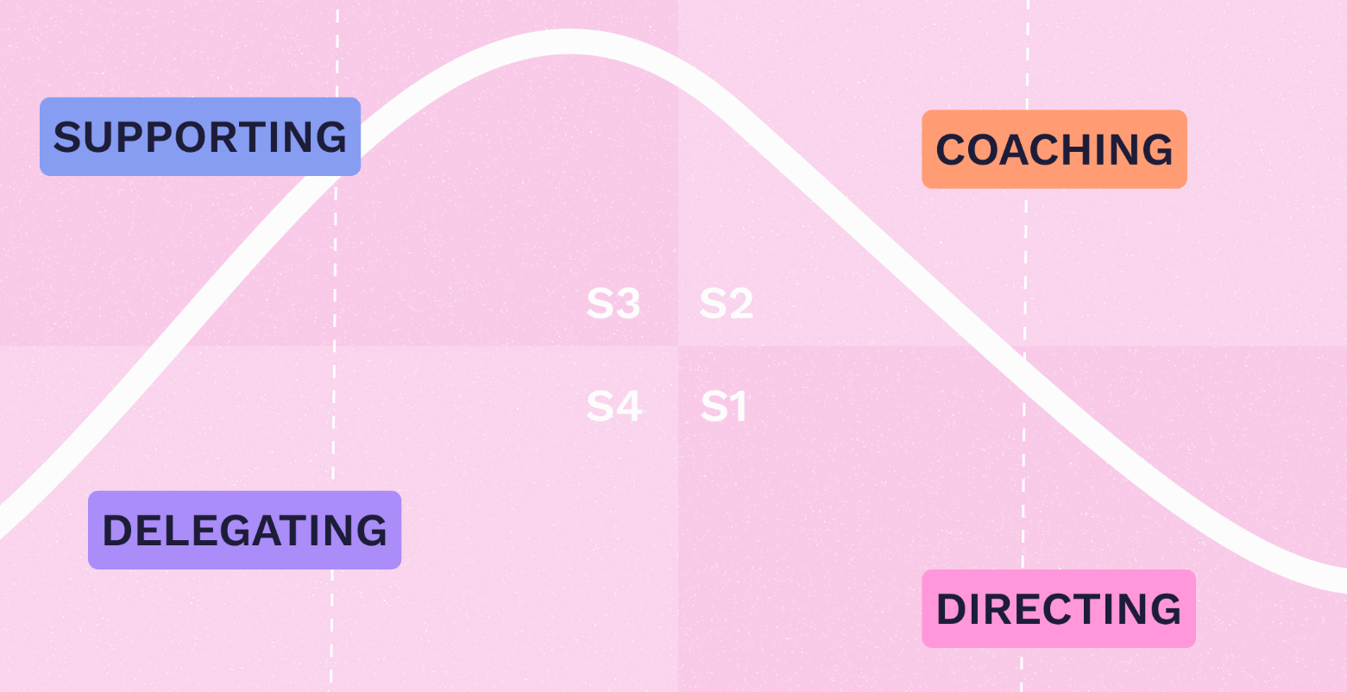
Figure 7: Situational leadership style
(Source: Sørensen and Boe, 2026)

2.3.3 Leaders reactive (command-driven) or proactive (purpose-driven)
The leadership was noticed in the case as to be mostly reactive (command-driven) as opposed to proactive (purpose-driven). Reactive leadership is aimed at caring about the response to the incidents, as they happen but not prevent them beforehand (Sørensen and Boe, 2026). The fact that similar cases had happened several times since 2018 signifies that the system has been reacting to the mistakes, not adequately tackling the causes of each of the mistakes. Conversely, proactive leadership is the ability to foresee risks, prevent risky situations and develop a safety culture. The Institute of Healthcare Improvement believes that proactive leadership is crucial to the prevention of medical errors and the enhancement of patient safety because it aims at redesigning the system and learning continuously.

2.3.4 Relevant data to leadership effectiveness
There is empirical evidence that is very strong to support the correlation between leadership and patient safety outcomes. Research indicates that the quality of leadership has a direct impact on the communication, teamwork, and compliance with safety measures. As an illustration, studies have shown that only 43% of nurses say they commit errors, which is usually because of fear of reproach or lack of supportive leadership (BMA, 2025). This points to the role of leadership in establishing a non-punitive culture where employees feel free to report incidences. Moreover, leadership has been cited as the major element in minimising medical errors and research indicates that inadequate leadership is an issue that leads to system malfunctions and avoidable damages (BMA, 2025). Yet again, hundreds of thousands of incidents related to patient safety are estimated to take place every year in the NHS and a significant part of them is associated with systemic and leadership-related issues.

2.3.5 Distributed or emotionally intelligent leadership based analysis
The concept of distributed leadership involves the decentralisation of leadership roles among groups of individuals within teams such that various participants can help in decision-making and resolving problems (Huettermann et al. 2024). This method can improve communication, collaboration and accountability in healthcare. Nevertheless, distributed leadership does not seem to have worked in this situation because the roles were not properly allocated, and accountability and supervision lapses appeared. Leadership that is based on emotional intelligence, on the contrary, prioritises self-awareness, empathy, and effective communication (Antonopoulou, 2024). There is some evidence indicating that leadership styles conducive to open communication and psychological safety can have a major positive impact on patient safety outcomes. In such a scenario, the lack of emotionally intelligent leadership was one of the factors that led to failure in communication and the lack of a robust safety culture.

2.4 Improvement, and Lessons Learned

2.4.1 Critical evaluation of how leadership and governance interacted to produce the outcomes seen in case
The case with the morphine overdose indicates a serious failure in the process of interaction of leadership and governance that eventually led to the negative experience. Healthcare governance offers the context of policies, regulations, and systems of accountability that promote safe and effective care (Asamoah, 2025). Leadership on the other hand has the duty of putting these structures into practice. Here, the governance structure (classification of RED drugs) was well set but the leadership was unsuccessful in implementing this structure.
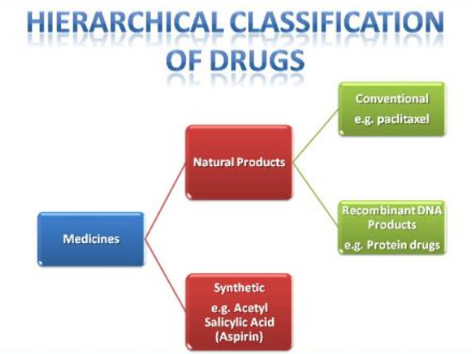
Figure 8: Classification of RED drugs
(Source: NHS, 2025)
On a governance level, policies established that dangerous drugs such as morphine sulphate oral solution (100 micrograms/ml) can only be prescribed and dispensed in secondary care (NHS, 2025). Nonetheless, the incident demonstrates that there is a disconnect between policy and practice, which means low enforcement and monitoring. The World Health Organisation states that ineffective governance and accountability are some of the major causes of medication errors within the world (WHO, 2025). According to the WHO, the proportion of medication-related harm could be avoided by placing more stringent controls on the system and leadership.
The failure of leadership manifests itself in the absence of proactive risk management, insufficient control over medication procedures. Leadership must be effective in making staff know and follow the laid down procedures (Tvedt et al. 2023). Nevertheless, the repetition of the similar events indicate that organisational learning or continuous improvement was not one of the priorities of leadership. The system seems to have reacted to single incidences as opposed to identifying the root causes. Moreover, the mechanisms of governance including auditing, reporting and feedback were either weak or ineffective. The statistics of the National Health Service show that hundreds of millions of medication error cases arise every year (Manchester, 2025). The repetitive character of morphine-related incidences implies that the administration framework failed to provide appropriate oversight on compliance or corrective measures. Loss of interaction can thus be described as poor and ineffective between leadership and governance. As much as the rules were availed through governance, leadership did not help turn them into safe clinical practice. This discrepancy resulted in the establishment of a system whereby errors were able to happen and recur in the long run compromising patient safety.

2.4.2 Identification of the missed opportunities and evidence-based solutions and present a discussion highlighting the problems, solutions and relevant data
Problem 1: Noncompliance with the RED drug protocols.
- Evidence: NHS safety reports show that a major percentage of medication errors entail disobedience of the laid down prescribing and dispensing standards (NHS, 2025). Drugs that pose high risk are especially linked with extreme damage in case of not adhering to protocols.
- Missed opportunities: The leadership did not provide a high level of conformity to the RED drug policies and the governance systems were not effective in controlling compliance.
- Solution: Adopt electronic prescribing systems that involve clinical decision support, which will raise any high-risk medications and avert wrong prescribing or dispensing. Digital health technologies were suggested by the WHO as one of the major measures to decrease medication errors on a global level.
Problem 2: Ineffective communication in the care settings.
- Evidence: WHO declares the communication failures one of the main reasons of medication errors as one of the major causes of adverse events all over the world (AMCP, 2025). Likewise, the NHS statistics indicate that mistakes at the transition stage between primary and secondary care are a common occurrence.
- Missed Opportunity: There was a communication gap between the health practitioners especially in terms of categorising and managing the drug.
- Resolution: Implement standardised communication procedures like formalised handover systems and well defined labelling behaviours. Also, electronic records can be integrated to guarantee access to all healthcare providers with the right and reliable information.
Problem 3: Repeat occurrence and absence of organisational learning.
- Evidence: The fact that a similar situation with morphine overdoses has been happening since 2018, with one of them being fatal, signifies the lack of experience on learning the lesson (Ocando Monaco, 2024). The NHS stresses that underreporting and poor analysis of incidents put a restraint on the prospect of improvement.
- Missing Opportunity: The leadership failed to instil a good safety culture that promotes reporting and learning to make mistakes.
- Solution: Work on creating a non-punitive reporting culture that has the backing of the leadership and employees are motivated to report incidents without the fear of being blamed. It has been indicated that organisations that have good reporting cultures have a greater patient safety outcome.
Problem 4: Lack of proper safety and system protection.
- Evidence: WHO estimates that 50% of medication errors can be avoided by proper interventions of the system level (WHO, 2025).
- Missing Opportunity: The fact that the system had no mechanisms of checking and automatic alerts enabled the error to go through the system.
- Solution: Implement multi-layered safety solutions, such as the implementation of the doubled verification process, barcode medication administration, and automatic warning of high-risk drugs.
Problem 5: Human resources and training issues.
- Evidence: NHS workforce data reveal shortages of workforce and excessive workload as some of the most significant contributors of patient safety incidents (Kings Fund, 2025). Clinical decision-making is less effective because fatigue and time pressure are likely to result in errors.
- Missing Opportunity: The leadership failed to meet the workforce pressures or provide adequate training on high-risk medications.
- Solution: Investment in the training and staffing of staff and ensuring that medical professionals are qualified in the use of high-risk drugs and that staffing is adequate to facilitate safe care.

3. Recommendation

3.1 Summary what should be done next in the chosen organisation
The organisation needs to be interested in a system-wide approach to safety improvement, which targets high-risk medication to avoid the need to repeat the same medication errors (Guntschnig et al. 2025). The steps that should be undertaken in the short-run are to strengthen the RED drug procedures, adopt digital prescribing, and enhance primary-to-secondary care communication. An extensive root cause analysis of the past incidents should also be performed by the organisation to detect recurring trends and to deal with the systemic failures. Moreover, the leadership should make sure that every medical worker is properly trained to be a medication safety expert, especially towards the work with high-risk medications like morphine (Bennett, 2023). It will also be necessary to create a strong incident reporting and monitoring system in order to identify errors before they occur in order to facilitate organisational learning. Comprehensively, the organisation needs to move towards a reactive management model to a proactive and prevention-oriented model that will focus on patient safety throughout the care delivery process.

3.2 Recommendation of the most effective leadership style(s) for sustaining improvement
The blended leadership strategy should be adopted which includes transformational, transactional and situational leadership. Transformational leadership needs to be emphasised to establish a robust safety culture, in which the staff would want to focus on patient safety and be encouraged to report any concerns without having to fear it (Ystaas et al. 2023). The strategy promotes innovation, teamwork and improvement. Strict adherence to the laid down protocols especially when dealing with high-risk drugs requires the involvement of transactional leadership. There should be strict rules, surveillance, and responsibility measures that are implemented on a regular basis.

3.3 Suggestion of ways to strengthen governance, communication, and systems integration
Governance structures should also be reinforced in order to achieve successful execution of policies to enhance the safety of patients. This includes:
- Increased policy compliance: Audits and compliance checks must be carried out regularly to guarantee compliance with the RED drug procedures (Tawade et al. 2023).
- Effective accountability structures: There must be well-defined roles and responsibilities of medication safety at all levels of care.
- Integrated digital systems: By implementing electronic health records and e-prescribing systems, it is possible to minimise the number of errors through real-time notification and uniformity of data.

3.4 Proposal of actions to enhance technical and allocative efficiency
Governance structures should also be reinforced in order to achieve successful execution of policies to enhance the safety of patients. This includes:
- Increased policy compliance: Audits and compliance checks must be carried out regularly to guarantee compliance with the RED drug procedures (Tawade et al. 2023).
- Effective accountability structures: There must be well-defined roles and responsibilities of medication safety at all levels of care.
- Integrated digital systems: By implementing electronic health records and e-prescribing systems, it is possible to minimise the number of errors through real-time notification and uniformity of data.

3.5 Inclusion of methods for continuous learning, stakeholder engagement, and co-production
Continuous learning and teamwork is needed in the culture of sustainable improvement. The organisation is supposed to put in place:
- Constant programmes in professional development in order to make sure staff are aware of daily best practice in medication safety.
- Incident reviews and feedback loops undertaken on a regular basis, whereby lessons learned on errors will be used in future practice.
- Making decisions based on the collected data, with the help of the performance indicators and safety indicators to track the progress and address the areas that require enhancement.
Engagement of the stakeholders is also required. This includes involving:
- Medical practitioners in decision-making.
- Patients and families in comprehending drug use and safety.
- Policymakers and regulatory agencies in enhancing the governance structures.

4. Conclusion

4.1 Summary
The incident of a morphine overdose involving a 4-week-old infant was critically analysed in this report and showed that the preventable mistake of the healthcare system happened as a result of failures on several dimensions. The investigation has revealed that the major issue was not the initial human mistake but a consequence of systemic flaws, such as ineffective communication, inappropriate compliance to RED drug guidelines, and the absence of safety measures. Using systems thinking, it was notable that the communication among individuals, processes and organisational structures provided environments in which the error was possible to happen and be repeated.

4.2 Importance of leadership, governance, and systems thinking in driving change
The case highlights the importance of the role of leadership, governance, and systems thinking as essential for sustainable change implementation in healthcare organisations. It requires effective leadership to translate policy into practice, to ensure a culture of safety and to make sure that the staff are empowered to identify and respond to risks. Even the best designed governance frameworks can never deliver their intended results without effective leadership. To achieve high standards of care, governance provides the structure and accountability required, but its efficiency relies on its continued implementation and monitoring. In the meantime, systems thinking helps healthcare organisations to perceive the multifaceted interdependencies in the system and to work at the root causes of a problem instead of treating its symptoms. All of these are the key constituents in safe and effective healthcare provision. The case shows that to enhance the safety of patients, a coordinated and integrated approach is needed, in which the leadership, governance, and systems thinking collaborate to avert errors, improve accountability, and ensure continuous improvement.

Reference list
Adams, D.E., (2022). Leadership for reducing medical errors via organizational culture: a literature review. Measuring Business Excellence, 26(2), pp.143-162.
Ahmed, R. and Tamim, T.R., (2025). Enhancing medication safety: the role of community and hospital pharmacists in modern healthcare systems. Radinka Journal of Health Science, 2(3), pp.328-355.
Aika, I.N. and Enato, E., (2022). Health care systems administrators perspectives on antimicrobial stewardship and infection prevention and control programs across three healthcare levels: a qualitative study. Antimicrobial Resistance & Infection Control, 11(1), p.157.
Alison, M., (2026) High-Risk Medicines and Technology-Related Prescribing Errors in 2 Pediatric Hospitals. Available at: https://publications.aap.org/pediatrics/article/157/2/e2024070043/206125/High-Risk-Medicines-and-Technology-Related?autologincheck=redirected [Accessed on: 27 March 2026]
Altamimi, H., Liu, Q. and Jimenez, B., (2023). Not too much, not too little: Centralization, decentralization, and organizational change. Journal of Public Administration Research and Theory, 33(1), pp.170-185.
AMCP, (2025) Medication Errors. Available at: https://www.amcp.org/concepts-managed-care-pharmacy/medication-errors [Accessed on: 27 March 2026]
Antonopoulou, H., (2024). The value of emotional intelligence: Self-awareness, self-regulation, motivation, and empathy as key components. Technium Education and Humanities, 8, pp.78-92.
Asamoah, D., (2025). The role of health services regulation in healthcare delivery. Electr J Med Dent Stud, 14(1).
Bennett, J., (2023). Development of a medication management program for developmental support workers.
Bereda, G., (2022). Pediatrics pharmacokinetics and dose calculation. J Pediatr Neonatal Cares, 12, pp.96-102.
BMA, (2025) Doctors’ views on working in the NHS. Available at: https://www.bma.org.uk/media/2035/bma-caring-supportive-collaborative-survey-report-sept-2018.pdf [Accessed on: 27 March 2026]
BMJ, (2026) 237+ million medication errors made every year in England. Available at: https://www.bmj.com/company/%20newsroom/237-million-medication-errors-made-every-year-in-england/ [Accessed on: 27 March 2026]
Cambridges, (2026) Transdermal opioids. Available at: https://www.cambridgeshireandpeterboroughformulary.nhs.uk/chaptersSubDetails.asp?FormularySectionID=4&SubSectionRef=04.07.02&SubSectionID=A100#439 [Accessed on: 27 March 2026]
Desy, K.N., (2024). The influence of transformational leadership on nurses’ performances in Indonesia. American Journal of Physical Education and Health Science, 2(1), pp.11-16.
Desy, K.N., (2024). The influence of transformational leadership on nurses’ performances in Indonesia. American Journal of Physical Education and Health Science, 2(1), pp.11-16.
Dong, B., (2023). A systematic review of the transactional leadership literature and future outlook. Academic Journal of Management and Social Sciences, 2(3), pp.21-25.
EASL, (2026) EASL Clinical Practical Guidelines on the management of acute (fulminant) liver failure. Available at: https://easl.eu/wp-content/uploads/2018/10/LiverFailure-English-report.pdf [Accessed on: 27 March 2026]
Essandoh, S., Sakyi, J.K., Ibrahim, A.K., Okafor, C.M., Wedraogo, L., Ogunwale, O.B., Babalola, A.S. and Adenuga, M.A., (2023). Analyzing the Effects of Leadership Styles on Team Dynamics and Project Outcomes. Journal not specified.
Goodier, M., (2022) Almost 6,000 people harmed by prescription errors in NHS last year. Available at: https://www.theguardian.com/society/2022/sep/26/almost-6000-people-harmed-by-prescription-errors-in-nhs-last-year [Accessed on: 27 March 2026]
Guntschnig, S., Barbosa, R., Jenzer, H., Greening, M., Hayde, J., Heery, H., Serrano, M.C.I., Lajtmanová, K., Rossin, E., Tentova-Peceva, S. and Kohl, S., (2025). Tackling medication errors: how a systems approach improves patient safety. European Journal of Hospital Pharmacy.
Hazen, A.C.M., Sloeserwij, V.M., De Groot, E., De Gier, J.J., De Wit, N.J., De Bont, A.A. and Zwart, D.L.M., (2024). Non-dispensing pharmacists integrated into general practices as a new interprofessional model: a qualitative evaluation of general practitioners’ experiences and views. BMC health services research, 24(1), p.502.
Hobusch, U., Scheuch, M., Heuckmann, B., Hodžić, A., Hobusch, G.M., Rammel, C., Pfeffer, A., Lengauer, V. and Froehlich, D.E., (2024). One Health Education Nexus: enhancing synergy among science-, school-, and teacher education beyond academic silos. Frontiers in Public Health, 11, p.1337748.
HSSIB, (2025) Unintentional overdose of morphine sulfate oral solution. Available at: https://www.hssib.org.uk/patient-safety-investigations/unintentional-overdose-of-morphine-sulfate-oral-solution/investigation-report/ [Accessed on: 27 March 2026]
Huettermann, H., Berger, S., Reinwald, M. and Bruch, H., (2024). Power to the people—And then? A multilevel leadership perspective on organizational decentralization. Human Resource Management, 63(2), pp.333-353.
Kings Fund, (2025) NHS workforce in a nutshell. Available at: https://www.kingsfund.org.uk/insight-and-analysis/data-and-charts/nhs-workforce-nutshell [Accessed on: 27 March 2026]
Klarström, L., Adnan, S. and Ek, A., (2025). Leadership Adaptation in Organizational Crises: A Situational Leadership Perspective on Decision-Making.
Lega, F. and Pirino, A., (2022). Developing and Engaging Clinical Leaders in the “New Normal” of Hospitals: Why It Matters, How to Do It. Emerald Group Publishing.
Magola-Makina, E., Abuzour, A.S., Ashcroft, D.M., Dunlop, J., Brown, P. and Keers, R.N., (2022). Exploring the challenges to safer prescribing and medication monitoring in prisons: A qualitative study with health care staff. PLoS One, 17(11), p.e0275907.
Makrani, M.F., Goyal, A. and Sayeed, S.Y., (2025). A comparative overview of global regulatory authorities: Ensuring quality, safety, and efficacy in medicines. International Research Journal of Pharmacy and Medical Sciences, 8(2), pp.93-99.
Manchester, (2025) More than 200 million medication errors occur in NHS per year, say researchers. Available at: https://www.manchester.ac.uk/about/news/more-than-200-million-medication-errors-occur-in-nhs-per-year-say-researchers/ [Accessed on: 27 March 2026]
Mawuena, E.K. and Mannion, R., (2022). Implications of resource constraints and high workload on speaking up about threats to patient safety: a qualitative study of surgical teams in Ghana. BMJ quality & safety, 31(9), pp.662-669.
Moury, C. and Escada, M., (2023). Understanding successful policy innovation: The case of Portuguese drug policy. Addiction, 118(5), pp.967-978.
Naseralallah, L., Stewart, D., Price, M. and Paudyal, V., (2023). Prevalence, contributing factors, and interventions to reduce medication errors in outpatient and ambulatory settings: a systematic review. International Journal of Clinical Pharmacy, 45(6), pp.1359-1377.
NCBI, (2024) Medical Error Reduction and Prevention. Available at: https://www.ncbi.nlm.nih.gov/books/NBK499956/ [Accessed on: 27 March 2026]
NHS, (2025) BNF CHAPTER 4: CENTRAL NERVOUS SYSTEM. Available at: https://www.coch.nhs.uk/media/172784/4-central-nervous-system.pdf [Accessed on: 27 March 2026]
NHS, (2025) Learning from medication errors. Available at: https://resolution.nhs.uk/2023/03/30/learning-from-medication-errors/ [Accessed on: 27 March 2026]
NHS, (2026) Leadership Development. Available at: https://www.england.nhs.uk/wp-content/uploads/2018/03/leadership-development.pdf [Accessed on: 27 March 2026]
Ocando Monaco, M.D.L.A., (2024). Out of Sight, Out of Mind: An Anthropological Exploration of Overdose Prevention Experiences and Perceptions Among People Who Use Drugs in Orlando, Florida.
Ramsay, A.I., Ramsay, A., Tomini, S.M., Tomini, S., Gandhi, S., Fulop, N.J., Fulop, N. and Morris, S., (2025). Centralisation of specialised healthcare services: a scoping review of definitions, types, and impact on outcomes. Health and Social Care Delivery Research, (43), pp.1-70.
Sørensen, K.M. and Boe, O., (2026). Reactive Behaviour When Operating a Proactive Method during Crisis: Learning through Reactivity to Proactivity. Athens Journal of Education, 13(1), pp.121-133.
Tawade, M., Pandya, S. and Scholar, P.G., (2023). Optimizing pharmaceutical quality audits: Enhancing compliance and performance through best practices. Journal for New Zealand Herpetology, 12(3), pp.6514-6522.
Tvedt, I.M., Tommelein, I.D., Klakegg, O.J. and Wong, J.M., (2023). Organizational values in support of leadership styles fostering organizational resilience: a process perspective. International Journal of Managing Projects in Business, 16(2), pp.258-278.
Wen, J.X., Marono, M., Moretto, P., Reinecke, E.A., Sathiah, P., Studer, E., Vyazmina, E. and Melideo, D., (2022). Statistics, lessons learned and recommendations from analysis of HIAD 2.0 database. International journal of hydrogen energy, 47(38), pp.17082-17096.
WHO (2023) Patient safety. Available at: https://www.who.int/news-room/fact-sheets/detail/patient-safety [Accessed on: 27 March 2026]
WHO, (2025) Medication Safety in Polypharmacy. Available at: https://www.who.int/docs/default-source/patient-safety/who-uhc-sds-2019-11-eng.pdf [Accessed on: 27 March 2026]
WHO, (2025) WHO launches global effort to halve medication-related errors in 5 years. Available at: https://www.who.int/news/item/29-03-2017-who-launches-global-effort-to-halve-medication-related-errors-in-5-years [Accessed on: 27 March 2026]
WHO, (2026) Medication Without Harm. Available at: https://www.who.int/initiatives/medication-without-harm [Accessed on: 27 March 2026]
World Health Organization, (2023). Global celebrations of world patient safety day, 17 September 2022 (No. WHO/UHL/IHS/2023.1). World Health Organization.
Ystaas, L.M.K., Nikitara, M., Ghobrial, S., Latzourakis, E., Polychronis, G. and Constantinou, C.S., (2023). The impact of transformational leadership in the nursing work environment and patients’ outcomes: a systematic review. Nursing Reports, 13(3), pp.1271-1290.

