5010 health and well being- Practice Log
Students are required to present a Practice Log which draws upon a health/wellbeing issue that you have been introduced to in your youth work practice.

This log researches the effects of mental health on young people’s well being, and how conflicts can lead to changes in group dynamics within social groups. My placement is a social community project, called ‘Youtoo’, which is a student led group to develop social activity on campus. Currently there is a small core group, with a number of members feeding directly from the Social and Communication Support Group (SOCOM). With knowledge of this, I have already identified group members with mental health or social needs. According to the National Institute of Mental Health (NIH) (2016) social anxiety can result in the individual feeling “embarrassed, judged, rejected or fearful of offending others”. Due to this, it is vital as a practitioner that I must ensure the group dynamic is relaxed and not overly stimulating, but equally entertaining and educative. As a social group, it is important that a comforting and positive atmosphere is provided in order for each individual to develop their social skills and communicate effectively. If any disagreement occurs between members, it could effect the relationship and views they hold towards each other, disrupting progress and allowing for further issues to develop.
The incident that occurred was an argument between two members within the group, which led to those members avoiding one another whilst holding negative thoughts. The initial argument occurred outside of my practice hours, however the backlash from the event was brought into the group, therefore I had to ensure policy was followed in controlling the behaviour of the individuals in order to prevent further conflict. I needed to ensure both members would not react too swiftly towards each other and diminish the group’s sense of security. The importance of monitoring the issue was key to ensure the well-being of the group, as conflicts would raise concerns, anxiety and effectively damage the mental well-being of the surrounding members of the group. Therefore, ensuring I maintained control was important to protect all who were present, and also provided me with the opportunities to support the young people involved and resolve the argument. When the conflict was occurring, it was evident members of the group had anxious feelings towards those involved, and reacted differently towards them at the time. Noticing this I encouraged the group to maintain their relationships, and attempt to overlook the situation whilst I supported it’s resolve.
Reflecting upon the incident, I find that my response as a practitioner was slow and methodical. After identifying the issue, I informed the head of the group during a meeting to ensure all staff were aware of the situation, which allowed for them to be prepared to respond. I decided to proceed with delicacy, as I knew the young people involved had anxious thoughts and would not feel comfortable discussing what happened openly, it would therefore have taken time for them to approach the staff. I decided it would be easier to remain an observer to the group members, and be prepared to become involved should anything escalate or occur within my practice. By doing so I remained neutral in the eyes of the young people who disagreed with one another, so they could both feel comfortable and maintain their trust with me should they have decided to discuss their argument. I felt that having identified those involved and their current emotional well-being, I was prepared to support them if they were to display a need for further support. As for the core group, I ensured that I remained present, so that they were comforted and aware that I could engage with any subsequent conflict, or provide support to anyone else who felt anxious at the time, In accordance to the National Occupational Standards (LSIS, 2012) policy of making time available to support others.

Forsyth (2006) states that:
As these individuals interact with one another, their diverse interests and preferences can pull them in different directions. Instead of working together, they compete against one another…Instead of accepting each other for who they are, members they treat those they like better than those they dislike.
(Forsyth, 2006)

The issue with small arguments similar to the incident, is they can lead to negative backlash towards surrounding group members, as inappropriate comments could be misinterpreted or be damaging to a young person’s well-being. When a docile environment turns to a more hostile situation, young people will immediately begin to feel uncomfortable and develop different views of the environment in which they associate the incident with. It is key to intervene a conflict before it begins to escalate (see figure 13.1, appendices) When meeting individuals for the first time, a passive atmosphere is expected and poor behaviour is not generally anticipated. When incidents like this occur, depending on the strength of a relationship between young people it could cause them to be ousted from a group, or treated differently based on their actions. This is known as prejudice, which according to Vernelle (1994) can ‘produce painful relationships between some group members, or scapegoating of someone who is different’.
Working with young people who have anxious thoughts, situations where there is conflict can become increasingly stressful, leading to panic attacks or discomfort within the group. During practice it’s important to be able to recognise the signs of anxiety in order to identify and support young people who may be concerned. Anxiety is a mental health condition in which individuals will feel a certain unease or discomfort with a potential outcome, as ‘they expect to feel embarrassed, judged, rejected, or fearful of offending others’ according to NIH (2016). When a calm environment rapidly changes an anxious young person will grow concerned and may panic if not attended too, therefore during these situations it is key to be attentive towards anxious members and provide reassurance to them, in order to monitor their behaviour. When conflict occurs, it is within the University of Wales Trinity Saint David (UWTSD) health and safety policy (2015) to ‘ facilitate the measurement of its safety performance both reactively (when things go wrong) and proactively (before things go wrong). ‘By doing so staff ensure that escalation in conflicts does not occur and that any situation is monitored and regulated accordingly. If the encounter does not improve, separating individuals to another location to avoid adverse effects on the dynamics of the group is considered to ensure the safety and well-being of all in the group.
By intervening we can establish control and ensure the well-being of each individual is monitored and protected, and that there is no further escalation in the conflict. Whilst running the project it is important to control discussions and gossip, ensuring no comments are taken negatively or that delicate subjects are treated as such, to prevent any conflict or offense towards others.
When preventing conflicts whilst socialising, social groups naturally involve a large amount of discussion and social interaction, allowing for young people to improve their social skills and confidence in engaging with other people. It provides them with a sense of security and inclusiveness, to become a part of a community that allows them to be more engaged in social affairs, and prevents them from becoming isolated in their accommodation. Social exclusion has several negative effects on mental health, often a result of self-defeating behaviour being used as a coping mechanic, according to Abrams (2005) ‘poor self-regulation and the selection of counter-productive strategies based on a misunderstanding of self and the world’ are results of social exclusion, leading to self harm, substance abuse and suicide. Social exclusion has become a growing issue for students attending Universities, as they travel to new locations, live with new people and adapt to a complete change in environment with little transition. Anxious students, or students less outgoing and more introverted are becoming more isolated, and may not be as easily identified due to their withdrawal. In order to counter isolation, community groups must develop a supportive network in order to identify and support these students and encourage their social development. According to Peirson (2005), the aims of networking include ‘Drawing on strengths, getting the big picture…and reflect their perspective’. In order to become more engaged, I can develop a network system with young people to ensure they are supervised and inform them that support is available, which in turn encourages them to develop their well being and counters the effects of isolation on health.
Reflecting upon my actions, I have identified that my approach to the situation was appropriate, and followed in accordance with the policies and guidelines of my practice. According to LSIS (2012), the values of Youth work encourage I “promote access and information and support, and safeguard the health and welfare of young people’. With knowledge of this, it’s important for me as a practitioner to signpost support which is available to students who have mental health concerns, such as anxiety or worries of social withdrawal (See appendices for list of available support).
Methodically I decided it would be ideal to inform colleagues of the incident, so all where aware that an issue has arisen and that the group should be monitored. I considered the factors that with a unbalance between two group members, It would be for the best to ensure that I remained a neutral observer in the incident, so both parties of the conflict would not be concerned of my position within the argument. This then ensures I am able to receive information from both young people, and maintain that they are comfortable speaking to me as a youth worker, ready to support their needs and help resolve the issue between them. I remained within my boundaries, ensuring both young people were aware of who to turn to in need of support, and assisting them were it were possible. As I was aware the individuals involved had struggled with anxiety, I was ensuring the situation did not appear to escalate and that they were re-assured. Across the sessions that preceded the event, I developed a brief programme to support the young people in understanding how to manage, adapt and how to appropriately react in a conflict. By doing so I encouraged their learning and simultaneously supported the development between the two young people. Afterwards I ran a session based on relationships, educating the group on how to maintain friendships with others, and how to prevent disruptions between them. This strengthened the young people’s network between one another, and also provided them the opportunity to reflect upon their actions, and how they value members of their community, from friends, family to acquaintances.
The use of drama workshops were effective as it allowed the participating young people to provide a visual representation of their emotions and display how they valued members of the group. Once able to discover how each member valued each other, I could identify who to work more closely with to encourage the development of relations between members of the group whom had weaker connections. By doing this, I encourage the connectivity between young people and expand their social circles, which in turn will support and counter the effects of anxiety, as they would feel more comfortable within the group having better understanding of each other. In review, I consider the programme was effective in neutralising tensions between group members, and encouraged their social development to support their well being within and outside of my placement.
To conclude, I think the presented issue of anxiety and mental health has been clearly identified and monitored within my placement in accordance to my professional and ethical boundaries, ensuring those who were displaying concerning factors of poor mental health were supported sufficiently and provided links to additional resources and groups who could be of use to them. With the running of a short programme based on the identified needs of the young people, I consider my actions were effective in supporting their well-being and improving their general social skills, by developing their confidence and strengthening their relationships within the group.
I responded appropriately to the issue, having identified it was within my potential to engage and support the young people’s anxiety and prepared the appropriate response in order to resolve the conflict and enhance their personal well-being with a engaging and participative programme orientated towards their health. Ensuring my colleagues were informed of the issue I had identified was an effective move to ensure all were aware of the ongoing problem affecting the young people within the group. The project thrives by providing peer to peer support to students, which allows for participants to be more inclined to open up and seek assistance when in need. By allowing my staff to become informed, they were all able to formulate a response alongside with me, preparing workshops that were appropriate to provide a calm, educative and effective solution to the conflict. Simultaneously, the programme supported the development of the young people’s mental health within the group, and improved the relationships between them, therefore leading to a strong, supportive community group. In future, I aim to adapt my methodology further, and attempt to be more engaging with the young people and develop more direct approaches towards situations that may arise. By doing so I will be able to respond more quickly and provide support towards young people as soon as it’s needed, in hopes of resolving issues more effectively and quickly. I find that in this instance with the issue presented, it was more ideal to lead a in-direct approach to avoid affecting the anxiety of the young people, maintaining a relaxed atmosphere was more effective. However this may not always be the most effective strategy in regards to other well-being issues that may be more severe, which may require a more prompt response to support the young people.

References
Abrams.D, Hogg, M.A, Marques, J.M (2005) The Social Psychology of Inclusion and Exclusion East Sussex: Hove, Psychology Press pg.35
Brown,R (2000) Group Processes: Dynamics within and Between groups. 2nd edn. Oxford: Blackwell Publishing.
Elster,J (2007) Explaining Social Behaviour: More Nuts and Bolts for the Social Sciences Cambridge: Cambridge University Press
Forsyth,D.R (2006) Group Dynamics. 5th edn. Belmont: Wadsworth Cengage Learning
Hazler, R.J & Denham S.A, (2002) ‘Social Isolation of Youth at Risk: Conceptualizations and Practical Implications’ Journal of Counselling & Development, 2002, Vol.80(4), P.403-410

Learning and Skills Improvement Service (2012) National Occupational Standards for Youth Work. Coventry: LSIS. pgs. 6, 17.

Miles,M.B, (1981) Learning to Work in Groups: A Practical Guide for Members and Trainers, New York: Teachers College Press.

Miller, S.R, Tserakhava,V ; Miller, C.J (2011) ‘My Child is Shy and has no Friends: What Does Parenting Have to do with it?’, Journal of Youth and Adolescence, 2011, Vol.40(4) p.442-453

Motoca, L.M , Williams, S , Silverman, W.K, (2012) ‘Social Skills as a Mediator Between Anxiety Symptoms and Peer Interactions Among Children and Adolescence’, Journal of Clinical Child & Adolescent Psychology, 2012, Vol.41(3), p.329-337

National Institute of Mental Health (2016) Anxiety Disorders. Available at: https://www.nimh.nih.gov/health/topics/anxiety-disorders/index.shtml (Accessed: 22 May 2018)

Park, E.S & Hinsz, V.B (2015) ‘Group Interaction sustains positive moods and diminishes negative moods’, Group Dynamics: Theory, Research, and Practice, Vol 19(4), Dec,2015. Pp.290-298.

Pierson,J (2005) Tackling social exclusion, Abingdon: Routledge

Stasulane. A (2017) ‘Factors Determining Children and Young People’s Well-being at School, Journal of Teacher Education for Sustainability, 2017, Vol.19(2) p.165-180

Sutton.R , Douglas,K. (2013) Social Psychology. Basingstoke: Palgrave Macmillan.

Vernelle,B (1994) Understanding and Using Groups. Pg.169 London: Whiting & Birch Limited

Welsh Government, (2016) Well-being Of Future Generations (Wales) Act 2015 , Available at : https://gov.wales/topics/people-and-communities/people/future-generations-act/?lang=en (Accessed : 22 May 2018)

Appendices
Figure 13.1 pg 381, Forsyth, D.
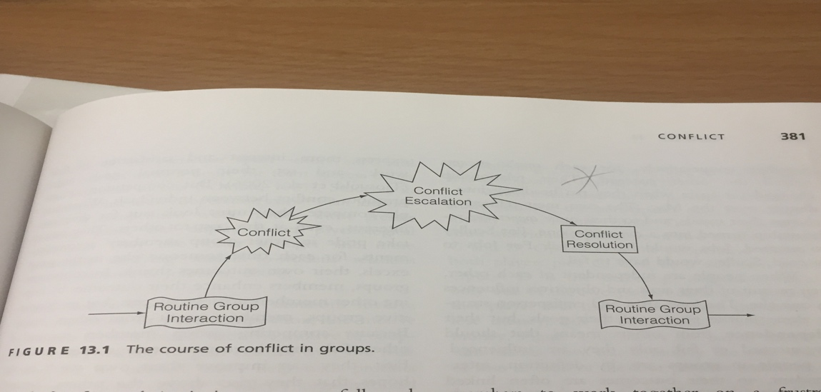
This diagram shows how conflict occurs. Intervention should occur as soon as possible to resolve the conflict, and to prevent escalating issues effecting the well-being of others.

Student Services, University of Wales Trinity Saint David (UWTSD) : 01267 676830

https://www.mind.org.uk/ (2013) support for mental health.

