Academic and Employability Skills
Task 3 – Reflective Report
BMSW4001_BIRM
Student’s Name – Andrew Tolise
Student Number - 2129056
Lecturer’s Name – Terkimbi Atonde

Table of Contents
Introduction 3
Reflective Writing 3
Model of Reflection 4
Reflection on Writing Task 2 5
Reflection on Group Presentation 6
Personal Development Plan 8
Conclusion 9
References 10

Introduction
I cannot hesitate to state that this has been a moodle that was congruent with the knowledge and skills gain in my academic life. The moodle involved learning in groups, individually, and completing assignments. These learning activities did not only help me gain knowledge as a student but also enhanced my employability skills. As suggested by Tuckman’s theory, I experienced the development of a team that I worked in to complete a presentation, I also completed an individual report. The current report seeks to give a reflection on my learning experiences in completing the report and working with others to give a presentation. It will also develop a plan of how I intend to develop areas of my weaknesses.

Reflective Writing
Reflective writing refers to the practice of examining one’s memory, event, or experience and analysing their impact and meaning (Kuk & Holst, 2018). To have good reflection, reflective writing can be based on one of the various reflective models. Foremost, it can be based on Gibb’s reflective model that involves describing, evaluating, analysing the learning experience through six stages, and reflective writing can also be based on Kolb’s model of reflection that involves experimental learning. Kolb’s model divides the learning experience into four stages (Morris, 2020). Other models used in reflection include Schon model, Driscoll model, and Atkins & Murphy model. Driscoll’s model is also known as what model because it involves three phases, namely - what, so what, and now what. The Schon model involves reflecting in action and reflection on action (Watts, 2019).
There are three levels of reflection (Kuk & Holst, 2018). Firstly, reflection can be at a technical level where knowledge and principles are applied for learning. Secondly, it can be at an interpretative level where assumptions and meanings are made to choose a certain choice. Thirdly, it can be critical. Gibb’s reflective model involved all these levels.

Model of Reflection
In this reflective piece, I chose to use Gibbs model of reflection, which was developed by Graham Gibbs in 1988 (Markkanen et al., 2020). The model involves six stages (Markkanen et al., 2020). The first stage is the description of what occurred in the event that made one learn. The second stage is a description of the feelings and thoughts of the learner during the event. The third stage evaluates the process of learning, identifying its positive and negative aspects. The fourth stage is an analysis of what can be learnt or made from the event. The fifth stage concludes what will be done differently in a similar event. The final stage describes plans and actions for improvement. The diagram below illustrates this model.
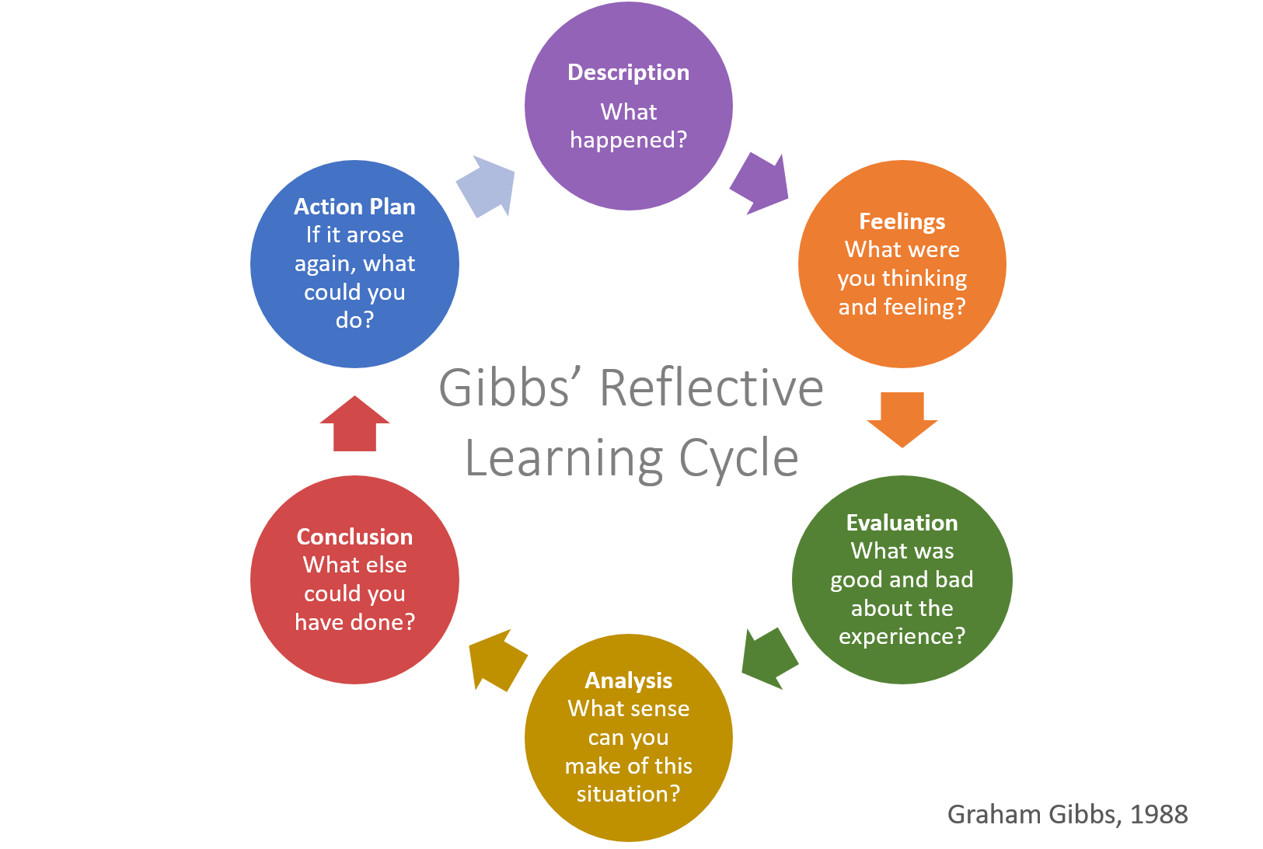
Figure 1: Gibbs Reflective Model

Reflection on Writing Task 2
Description
A key learning event was Task 2 which involved preparing an academic report about the challenges of motivating staff in any workplace. We were given four sources to use in the report. I used the sources to determine what to write in the report and referenced them.

Feelings
At first, I thought that it would be difficult for me to reference my work. Moreover, I felt that I will have difficulties editing the draft to produce the final report.
Evaluation
I read the sources that were given carefully and got the knowledge of how employees are motivated. I then transferred the information into my draft report. I edited the draft properly to produce the final report. However, I had some difficulties referencing my work and I had to refer to the referencing guide.
Analysis
I gained research skills from this experience. I learnt how to use previous studies and how to reference them in the report. Moreover, my writing and note-taking skills improved significantly. According to Kuswardani et al., (2018), an effective writing process involves writing a draft and then editing it. I use the points from the sources that were given to design a draft report. I then proof-read the draft and edited it to produce the final report. This helped me to learn how to edit a report. Research reports need to be properly referenced for academic integrity (Marsh, & Campion, (2018). I learnt how to reference research reports and I can attest that my research skills improved through the experience.
Conclusion
I could have planned the writing before I start writing. I will be planning my writing to properly manage time.

Action Plan
To further improve my research skills, I will research and write a 2000-word report on ‘If digital technology training is needed for older students at UWTSD’. I will manage my time in writing the report by having a planned schedule from start to finish.

Reflection on Group Presentation
Description
This moodle involved an activity where we worked in a group to design a job advert and present it to my colleagues. We worked together and divided the task among the members of the team. After the presentation, I received feedback from my colleagues.

Feelings
During the presentation, I felt confident but was not able to manage my allocated time effectively as this will go on to affect the performance of other team members.
Evaluation
I participated properly in the team, although some stages of the team development involved some disagreements, especially when the team was starting. Some of the negative comments that I received from colleagues showed that I failed to manage my time during presentation effectively. The presentation was well prepared with graphics and concepts were put in bullet points.

Analysis
I learnt that a team develops through stages based on how our team was developing. Tuckman’s theory suggests that five stages are involved in the development of a team (Donald & Carter, 2020). Moreover, I learnt that teamwork involved dividing the task among the members of the team. Through previous research, I knew that there are nine different roles that members of a team can hold according to Belbin’s theory (Muñoz-Mata & Pech, 2019). Participating in the presentation made me realize that I hold the role of a specialist as I designed the presentation. According to Belbin’s theory, a specialist offers skills and knowledge that are in rare supply (Muñoz-Mata & Pech, 2019).
Conclusion
I need to work on my time management skills when giving presentations. When I get a chance for another presentation, I will manage my time well and I also need to improve my public speaking skills.

Action Plan
I will practice presentation on my own to better manage my time and I will also put my name forward as the class representative to enable me to improve on my confident level in public speaking.

Personal Development Plan
Personal Target | How will I achieve this? | How will this improve my academic or employability prospects? | How will I know that I have achieved this? | When will I achieve this by?
Presentation skills | I will put my name forward for the class representative position | I will observe and learn from other class representatives of how to improve this skill during briefs and presentations | I will assess my feelings when I give presentations. | 10/12/2022
Confidence skills | Frequent public speeches. | I will become used to speaking in public and this will improve my confidence. As a class representative, I will get frequent appointments to speak in public. I will make a speech on employee motivation during the university’s career fair to develop confidence in speaking to a large audience. | I will assess my feelings when I speak in public. | 10/12/2022
Time-management skills | Following my schedules | I will be making daily and weekly schedules and prioritise the most important activities in the schedule by following 4Ds of time management. | I will examine how I meet deadlines and how I attend events in time. | 12/01/2023

Conclusion
I feel that this moodle made me more employable and a better student by equipping me with skills that are required in academics and in the workplace. I improved my teamwork abilities by working with colleagues on a group task. Presenting in front of other students improved my presentation skills. Planning and writing task two improved my research and writing skills. Specifically, task two taught me how to reference and the process that is involved in academic writing. However, I feel that I need to improve my presentation, confidence, and time management skills. I will be a class representative in the next term to enhance my presentation skills and also get a chance of frequently speaking in public for the improvement of my confidence level. I will be scheduling my activities and give priority to important activities.

References
Donald, E. J., & Carter, A. (2020). Overview of Common Group Theories. Group Development and Group Leadership in Student Affairs, 17.
Kuk, H. S., & Holst, J. D. (2018). A dissection of experiential learning theory: Alternative approaches to reflection. Adult Learning, 29(4), 150-157.
Kuswardani, R., Abida, F. I. N., Purwati, O., Fauzia, N., Darma, D. B., Fahri, F., & Hilmi, M. A. (2022). The Development of Portfolio Evaluation Tools to Improve Expository Writing Skills. ELS Journal on Interdisciplinary Studies in Humanities, 5(2), 265-270.
Markkanen, P., Välimäki, M., Anttila, M., & Kuuskorpi, M. (2020). A reflective cycle: Understanding challenging situations in a school setting. Educational Research, 62(1), 46-62.
Marsh, J. D., & Campion, J. (2018). Academic integrity and referencing: Whose responsibility is it?. Journal of Academic Language and Learning, 12(1), A213-A226.
Morris, T. H. (2020). Experiential learning–a systematic review and revision of Kolb’s model. Interactive Learning Environments, 28(8), 1064-1077.
Muñoz-Mata, M. A., & Pech, J. P. U. (2019, October). Influence of Belbin’s Roles in the Quality of the Software Requirements Specification Development by Student Teams. In Trends and Applications in Software Engineering: Proceedings of the 8th International Conference on Software Process Improvement (CIMPS 2019) (Vol. 1071, p. 91). Springer Nature.
Watts, L. (2019). Reflective practice, reflexivity, and critical reflection in social work education in Australia. Australian Social Work, 72(1), 8-20.

