Student Name: Stanimira Yuliyanova Dimitrova
Student Number: 1909125
Lecture Name: Edward Goka
Module Name: Living with Care: The Older Person
Module Code: BMHP6009 (LON)
Assessment Component: 1 Written report
Submission date: 10. January.2022

Page content
Introduction………………………………………………………………………………………3
Older persons……………………………………………………………………………………3
What it means to be an elderly person in the United Kingdom…………………………….4
What it means to be an elderly person in Bulgaria………………………………………….4
Demographic United Kingdom………………………………………………………………...6
Demographic Bulgaria………………………………………………………………………….7
Challenges for old people in United Kingdom……………………………………………….7
Challenges for old people in Bulgaria………………………………………………………...8
Policies in United Kingdom…………………………………………………………………….9
Policies in Bulgaria…………………………………………………………………………….10
Technologies in United Kingdom…………………………………………………………….10
Technologies in Bulgaria……………………………………………………………………...11
Loneliness. How to be reduced recommendations.........................................................11
Conclusion……………………………………………………………………………………...12
References……………………………………………………………………………………...12

Introduction
This academic report will focus on older people in the UK compared to older people in Bulgaria. Before we start with comparisons, we will discuss what it is like to be an adult and how an individual's life changes as he or she grows older. The report will critically assess the impact of loneliness faced by the elderly and the social isolation imposed by Kovid-19. Current policies and care provided in both countries will be discussed. The report will focus on what programs exist for older people and how they can be improved. Could the loneliness disappear with the technologies the elderly have access to today?

Older persons
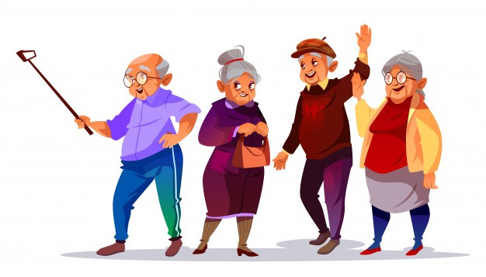
According to the UNHCR, (2020) an adult is an individual who is over sixty years of age or older. As each nation has its traditions and understandings of this concept and the way they call the elderly varies. Visually, each age at a different rate, some faster due to traumatic experiences, diet, and other individuals have years but visually look young. All members of the older generation have invaluable experience and life wisdom, which is always needed by others. Probably that is why they deserve our respect and support. It is the elderly who give us all the necessary knowledge, experience and mistakes from which the young can learn and be better. At the same time, the needs of older people are always neglected, perhaps because of their social status and the fact that they do not have very high incomes. Is this the right attitude towards these people?
(Monet, 2019).

What it means to be an elderly person in the United Kingdom
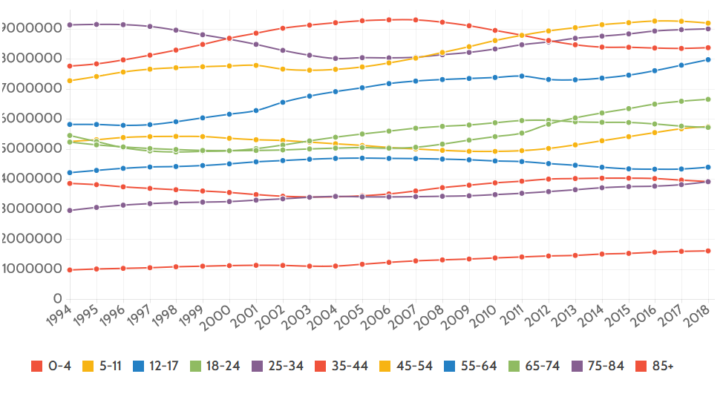
According to Lewis, et al. (2021) statistics show that the population of the United Kingdom is facing ageing. The reason for this is the improved lifestyle of the adults and the reduced fertility. According to UKHSA, (2020) the life expectancy in the United Kingdom is 81 years. Compared to 2009 in 2019, the number of elderly people has increased by 23 per cent. The forecast is that the number of elderly people will increase and the birth rate will decrease, which will lead to a larger number of elderly people in the country.
(CURRENT UK POPULATION, 2014).

In the United Kingdom, the opportunity for people to grow old healthy and increase their lives is common. The fact is that there are people who have very long-term illnesses, as well as chronic ones, but in general the care for the elderly is at a very good level. Help, as well as information on how people maintain good shape and independence, is available to all so that people can stay physically and mentally healthy. Institutions such as NHS England, Age UK, Public Health England and the Association of Chief Firefighters and the elderly themselves are joining forces on healthy ageing and helping the population (NHS, 2021).

What it means to be an elderly person in Bulgaria
Bulgaria is a country in Southeast Europe, where the population is drastically melting and aging. The reason for this is the large number of people who have emigrated to other countries, as well as the low birth rate due to the departure of young people. According to the World Bank (2021), life expectancy in Bulgaria is 75 years. Bulgaria in a country where 58 percent of people are old adults. The state does not have much money to take care of the elderly, it is not like in the United Kingdom and the minimum standard of living is difficult to achieve. This is the reason why most 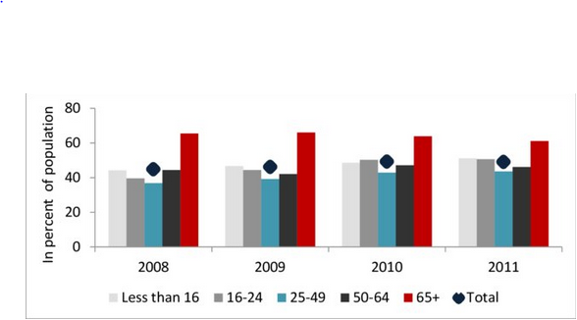adults live in poverty or even extreme poverty (Caucaso, 2021).
(ResearchGate, 2013).

According to Eurocarers (2021), in the next fifty years, the share of the elderly in Bulgaria will be three times higher than at this moment. In Bulgaria, the long-term care system is very underdeveloped. This is the reason why the services and care are provided by various institutions and programs for the elderly. And the services themselves are limited by quality and scope, they do not meet the needs of the population of Bulgaria. Thus, the entire responsibility for caring for adults falls on the family and loved ones. Unfortunately, there is currently no classification or definition of long-term care in Bulgarian legislation. Long-term care for the elderly is offered but in the form of social services. If they stay for more than three months, they belong to long-term care. These include personal assistants, social assistants, home assistants, home care, centers for adults with disabilities, daycare centers for the elderly and centers for social rehabilitation and integration. And health services in the country are provided by the health care system in various types of specialized medical institutions, such as long-term and long-term treatment hospitals, rehabilitation hospitals, state psychiatric hospitals, mental health centers and hospices, which are key institutions for long-term care in the country (Eurocarers, 2021).
Demographic United Kingdom
The population of the United Kingdom is growing, even if 0.6 per cent per year, growth is projected to continue throughout the century (World Population Review, 2021). Migrants living in the country have made a major contribution to England's growth, with net migration contributing to population change for five years in a row. As we have already mentioned in the report, people in the United Kingdom are living longer and better. This leads to an ageing population of over 15.5 million people aged 60 or over, which is twenty-three per cent of the population (MHA, 2021). England has not yet reached the ageing boom, it is expected to reach three million people in the next twenty years, including many people with chronic and long-term illnesses (MHA, 2021).
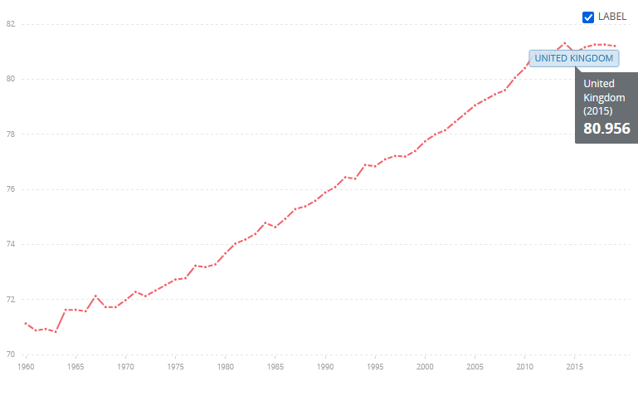
(WORLDBANK, 2021).

Demographic Bulgaria
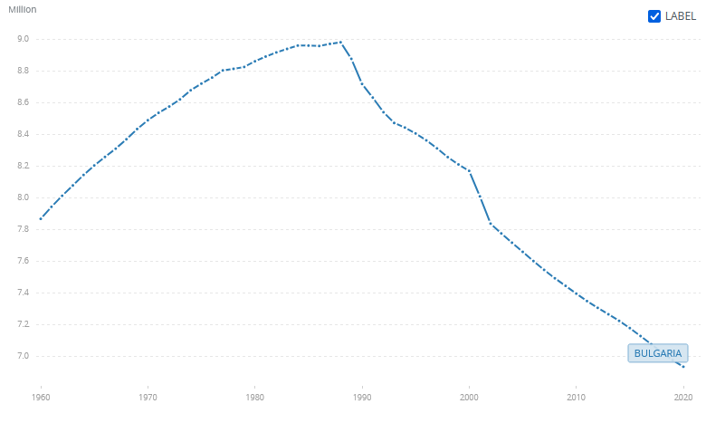 Bulgaria's population is declining dramatically every year. Statistics show that this is 11.5 per cent for a decade, and currently, the nation consists of 6.5 million compared to 7.3 million in the previous census (Balkan Insight, 2021). The leading reasons for this are, first of all, migration, hence the decrease in the birth rate and the high mortality rate. In Bulgaria, 23 per cent of the population is elderly people aged 65 or over (Balkan Insight, 2021).
(WORLDBANK, 2021).
Challenges for old people in United Kingdom
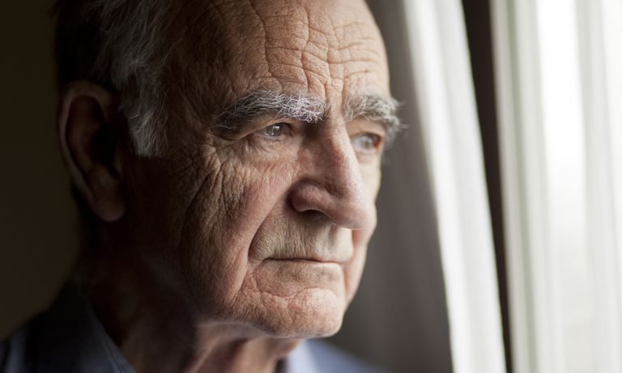
Despite the improved way of life and the possibility of people living much longer in England, people face many obstacles. As the years go by, a sense of purpose is lost, loneliness and isolation are major difficulties for older people. Despite a good way of life in the United Kingdom, adults also face financial difficulties, which is why many of them are willing to work but are not given that opportunity. The reason for this is their difficulties with mobility and dexterity. Some older people even have difficulty with their daily tasks. From this, we can connect the loneliness they feel because when people cannot meet their daily needs, what is left for their social life or hobbies, interests or activities. Once individuals lose their independence, they begin to need someone to take care of them. There are also elderly people who have specific diseases and require professional supervision and care. Tissue diseases are Alzheimer's, dementia, strokes and many more. In England, there are many nursing homes or caregivers who come to a person's house, these people are qualified and have the necessary knowledge. However, older people do not always feel good because they lose their mobility, some have chronic diseases, others have lifelong illnesses. Older people go through a difficult process, but at the same time, they have the opportunity to be in their home, among everything known or in a nursing home where they can be observed for ten to four hours by specialists. Sometimes healthcare is a long and complicated process that they have to go through, constant medication is normal for adults, but in England, the government takes good care of people and provides them with access to the necessary medicines. In most cases, the necessary medicines are free, while others are half price. Last but not least, individuals begin to think about the end of their lives and how it all ends for them. This can lead to depression, but it is good that they do it because their families know their wishes and have a clear idea of ​​how they want to be buried and how much it will cost them (Smith Life Homecare, 2020).
(Robinson, 2019).
Challenges for old people in Bulgaria
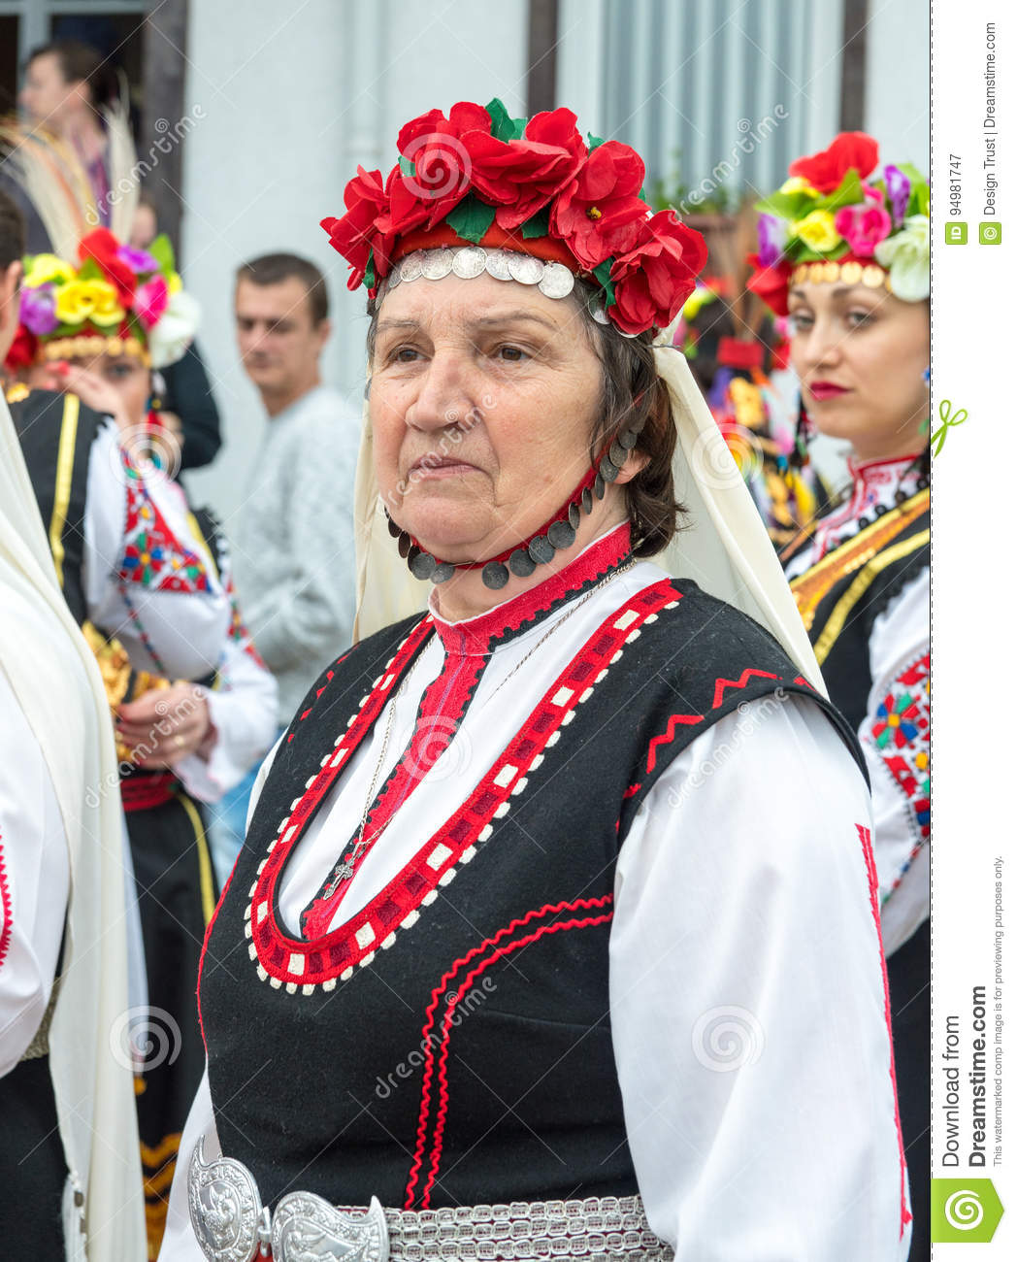
Many elderly people in Bulgaria who live their old age quietly, forgotten in their homes. Many of them live in loneliness, poverty and disease. Older people in Bulgaria face countless obstacles and challenges. There are many political, social and economic challenges for the elderly there. The support that adults have has drastically decreased because the younger generations are moving to live abroad due to a better way of life and work. The traditional values ​​of the Bulgarians predict that the young people in the family will take care of the elderly, in most cases, this is also due to the financial point of view because in Bulgaria the monetary remuneration is minimal. The pensions that the streets take are also minimal, for comparison, we will say that it varies around one hundred euros. This is the reason why many of them cannot afford the care of a specialized person or enter a home for the elderly. However, there is a very large deficit of such homes, because they are not widespread in Bulgaria, and all migrants who cannot take care of their relatives must do something for them and the best solution, in this case, is to enter a care home. The state needs economic renewal for healthy ageing policies and long-term services and support to work in Bulgaria (Georgieva et al., 2018). According to OAMIMS, (2021) a study was conducted among the elderly in Bulgaria, most Bulgarians have a decent health education. The personal commitment of the elderly Bulgarian regarding his illnesses is good, regardless of whether they are one, two or more, chronic or not. The informed commitment of the elderly to their health is quite good, but it is a fact that the system in Bulgaria is not well done and does not support them. All examinations by doctors are paid either in full or an examination fee. Which makes them difficult to access for someone and they are left alone with their pain to live out their old age without medical supervision. Those who visit a doctor face another big problem and that is medicines. Medicines in Bulgaria are not as easily available as in England. The reason for this is their price, there the Bulgarian has to pay the full amount or in the best case half and the drugs themselves are very expensive, especially for people with permanent illnesses. People in Bulgaria face countless irregular and unjust daily problems. In some cases, they lead to depression, loneliness, isolation and more. They should also think about their funerals, set aside money from their entourage, and not because someone forces them to. In most families, older people themselves give money to their children about these issues because they do not want to burden their children's budgets. As my grandmother jokes, this is her money for her wedding. The more she saves, the bigger wedding (funeral) will be.
(Dreamstime, 2000-2021).

Policies in United Kingdom
The United Kingdom celebrates Elderly Day on the first of October and everyone is encouraged to celebrate it. Nowadays, more and more of everything is happening online. This is about shopping, banking, booking an hour for blood, at the GP doctor or taking prescribed medications. According to Department for Work and Pensions, (2016) The government in England is trying to help older people learn to use online services, but internal time is stored and not online for people without the ability to use the internet. The government itself allocates a lot of money for people's pensions, the purpose of which is to be active and not exposed to loneliness and isolation. Many programs help adults at risk of long-term loneliness and social exclusion to stay active, maintain good health and well-being. According to Andrew, (2018) statistics show that nearly ninety per cent of retirees in the UK own the home in which they live. The government practices youth work with adults, the reason for which is the unification of people and the National Understanding of Adults. The United Kingdom also works with other countries and organizations that have older people and their lives. This includes „Madrid International Plan of Action against Aging, which sets out the 10 commitments agreed by governments to implement the changes needed to address the challenges and opportunities of an ageing society “and “Declaration on the European Year for Active Aging and Solidarity between the Generations: The Way Forward” (Department for Work and Pensions, 2016). In the United Kingdom, paying for adult care is expensive, but many adults are entitled to assistance in their care. The NHS health care system helps fund some individuals if they meet certain conditions. If the individual does not meet the conditions, and still needs care, the NHS can help again by paying directly to the nursing home (Age UK, 2019).

Policies for elderly people in Bulgaria
The political, social and economic history of the Bulgarian population has a huge impact on ageing and adult care in the country. People in Bulgaria suffer mainly from cardiovascular disease, cancer, stroke, lung problems, cirrhosis, diabetes and many others. The health care system itself consists of compulsory coverage, but much of the coverage is voluntary. All citizens in the country have compulsory insurance, the elderly and the socially disadvantaged are covered free of charge. Covering many things related to adults is not included in the free ones, because most of them are private. An example of this is the homes for the elderly, they are all private and to enter an individual must give his entire pension, which is not always sufficient and needs the help of relatives or friends (Pitheckoff, 2017). At the same time, the homeownership ratio in Bulgaria has increased to 84.10 per cent (tradingeconomics, 2021). In some cases, elderly patients are forced to sell their property to enter a care home and receive the necessary attention. As we have already said, the medicines and some of the examinations are taken by the person in need. The same applies to nursing homes, the state does not support the admission of persons to such a home.

Technologies in United Kingdom
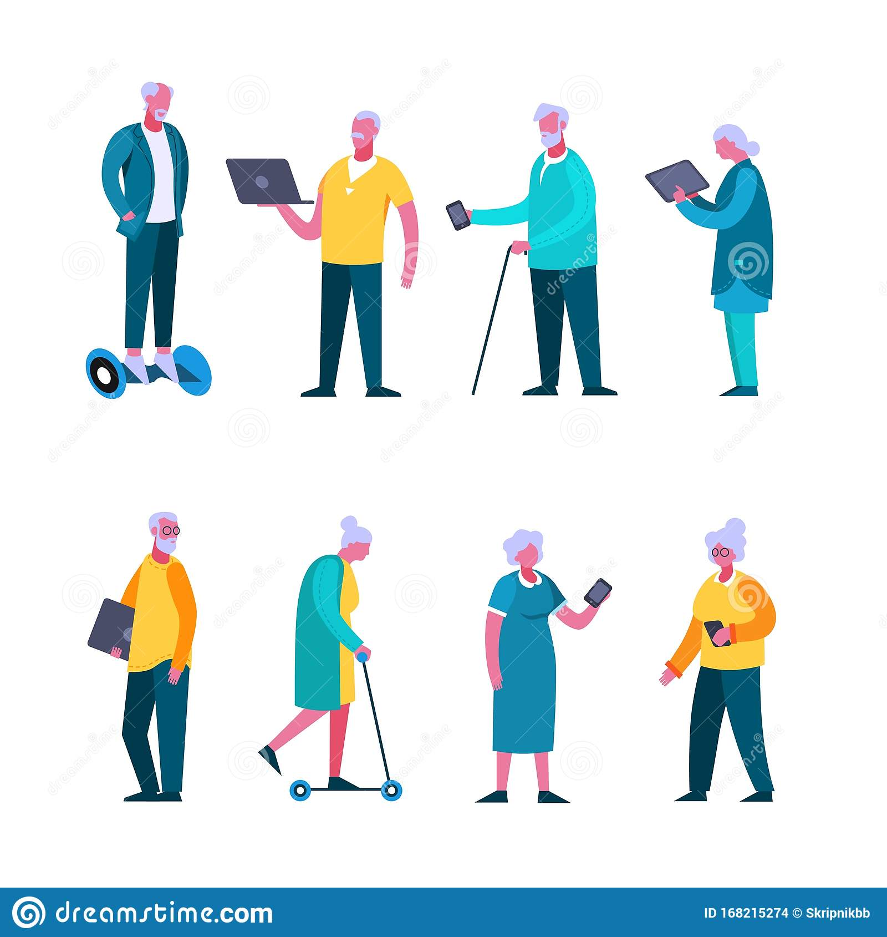
In the United Kingdom, health monitoring is something common and used in every hospital or hospice. As well as monitoring, online excess, electronic care plans, GP monitoring. According to AGEUK, (2019) surveys, 39 per cent of older people in the UK do not feel confident in using smartphones and the features that are offered online. This confidence prevents many older people from having fun with their hobbies and interests. Everything can be much easier for older people when they use the Internet. There is no need to carry heavy bags with grocery purchases because through smartphones, they can order everything to be delivered to their door. Also, the threshold of loneliness is very high in the elderly, technology can help adults stay in touch with family and friends despite the distances and obstacles of communication or mobility.
(Dreamstime, 2000-2021).

Technologies in Bulgaria
In Bulgaria, health monitoring and the warning system are something new that is entering private hospices and old people's homes (innovasjonnorge, 2021). Older people themselves are not very interested in technology, perhaps because it is an additional expense. Both the Internet and the device that will be used are expensive for the Bulgarian pensioner. There are exceptions, of course, those who are interested are taught by children, grandchildren or relatives. The system itself is not designed as in England, people do not educate so much online and even if the elderly have devices, they will not get all the good sides of advanced technology.

Loneliness. How to be reduced recommendations
Older people are very prone to loneliness and social isolation. As a result, some adults develop health problems that need to be continued and stopped. The reasons for isolation can be many, from the loss of a neighbor, leaving work due to disability or illness and many others. The problem is growing because most older people live alone, family members do not look for them often, as do friends. There are many ways for the elderly to diversify, to do something useful such as hobbies, to communicate with relatives or friends, or to create new ones. According to the NHS, (2021) older people can reduce loneliness if they smile more often, so they will make new friends and have the opportunity to invite them for tea. They need to talk more often on the phone to avoid loneliness, another plus will be the use of computers to reach the younger generation, to see who publishes what online and can use video calls with people or just watch the sheep. Each municipality has different types of activities and activities for the elderly, they need to get involved to do something new and different. Some universities have programs for the third age, this would also help them escape from the grey everyday life and do something new. Volunteering is also a good thing that will not harm an adult, on the contrary, it will even diversify it.
(Dreamstime, 2000-2021).

Conclusion
There are all sorts of stereotypes and thinking about older people, all of which can suppress some individuals. It is difficult for all of them to accept that the young people are gone, they are old, they have pain, in some cases long-term illnesses and they start to feel unnecessary and neglected. This is what young people need to do, devising innovative ways to include older people in the community through social events. We can not only help the young generation maintain a sense of identity and self-confidence, but also touch the wealth of knowledge and experience that adults have, which is so vital for the development of society. Last but not least, let's not forget that we are following in their footsteps and with a little luck we will be like them someday.
References
Age UK (2019) Paying for permanent residential care | Paying for a care home | [Online] Available at: https://www.ageuk.org.uk/information-advice/care/paying-for-care/paying-for-a-care-home/. (Accessed: 20 December 2021).

AGEUK (2019) Helping older people gain digital confidence [Online] Available at: https://www.ageuk.org.uk/information-advice/work-learning/technology-internet/helping-older-people-gain-digital-confidence/.
(Accessed: 22 December 2021).

Andrew, T. (2018) Almost 90% of lowest earning pensioners own property - ONS [Оnline] Pensions Age Magazine. Available at: https://www.pensionsage.com/pa/Almost-90-of-lowest-earning-pensioners-own-property-ONS.php
(Accessed: 20 December 2021).

Balkan Insight (2021) Bulgaria’s Population Shrinks by 11.5 per cent in Decade [Online] Available at: https://balkaninsight.com/2022/01/06/bulgarias-population-shrinks-by-11-5-per-cent-in-decade/
(Accessed: 17 December 2021).

Caucaso (2021) Elderly Bulgarians: the lost generation [Оnline] OBC Transeuropa. Available at: https://www.balcanicaucaso.org/eng/Areas/Bulgaria/Elderly-Bulgarians-the-lost-generation-167744.
(Accessed: 16 December 2021).

CURRENT UK POPULATION (2014) [Online] agediscrimination.info. Available at: http://www.agediscrimination.info/current-uk-population.
(Accessed: 15 December 2021).

Department for Work and Pensions (2016) 2010 to 2015 government policy: older people. [Online] Available at: https://www.gov.uk/government/publications/2010-to-2015-government-policy-older-people/2010-to-2015-government-policy-older-people.
(Accessed: 20 December 2021).

Dreamstime (2000-2021) Bulgaria. An Elderly Participant Of The Concert In A Festive National Costume At The Nestenar Games In The Village Of Bulgarians Editorial Photography - Image of buses, beauty: 94981747 [Online] Available at: https://www.dreamstime.com/editorial-photography-bulgaria-elderly-participant-concert-festive-national-costume-nestenar-games-village-bulgarians-image94981747
(Accessed: 20 December 2021).

Dreamstime (2000-2021) Old People Selfie. Senior People Taking Smartphone Photo, Happy Laughing Group Of Seniors Cartoon Illustration Stock Vector - Illustration of portrait, camera: 138923208 [Оnline] Available at: https://www.dreamstime.com/old-people-selfie-senior-people-taking-smartphone-photo-happy-laughing-group-seniors-cartoon-illustration-old-people-selfie-image138923208
(Accessed: 22 December 2021).

dreamstime (2000-2021) Set Of Elderly Cartoon People Enjoying Modern Device And Digital Technology Isolated On White Stock Vector - Illustration of cartoon, mobile: 168215274. [Online] Available at: https://www.dreamstime.com/set-elderly-cartoon-people-enjoying-modern-device-digital-technology-isolated-white-active-female-male-old-character-image168215274 (Accessed: 26 December 2021).

Eurocarers (2021) Towards carer-friendly societies. Eurocarers country profiles Bulgaria [Online] Available at: https://eurocarers.org/country-profiles/bulgaria/
(Accessed: 16 December 2021).

Georgieva, E., Dimitrova, D., Georgieva, L., Hristov, N. and Pesheva, P. (2018) Demographic and social problems of aging in Bulgaria. European Journal of Public Health, 28(suppl_4). [Online] Available at: https://academic.oup.com/eurpub/article/28/suppl_4/cky214.238/5186812 (Accessed: 20 December 2021).

innovasjonnorge (2021) Bulgaria: Innovative welfare technology for elderly people [Оnline] Available at: https://www.innovasjonnorge.no/en/start-page/eea-norway-grants/success-stories/innovative-welfare-technology-for-elderly-people/
(Accessed: 22 December 2021).

Lewis, A., Barton, C. and Cromarty, H. (2021) Housing an ageing population: a reading list [Online] Available at: https://commonslibrary.parliament.uk/research-briefings/cbp-9239/. (Accessed: 15 December 2021).

MHA (2021) Facts & Stats - Older People in the UK [Online] Available at: https://www.mha.org.uk/get-involved/policy-influencing/facts-stats/.
(Accessed: 17 December 2021).

Monet, M. (2019). Are Older People Happier Than People In Their 20’s? [online] Thirty over Fifty. Available at: https://medium.com/thirty-over-fifty/are-older-people-happier-than-people-in-their-20s-ed365cad74d
(Accessed: 15 December 2021).

NHS (2021) Loneliness in older people [Online] Available at: https://www.nhs.uk/mental-health/feelings-symptoms-behaviours/feelings-and-symptoms/loneliness-in-older-people/. (Accessed: 22 December 2021).

NHS (2021) NHS England» Healthy ageing and caring [Online] Available at: https://www.england.nhs.uk/ourwork/clinical-policy/older-people/healthy-ageing-caring/. (Accessed: 16 December 2021).

OAMIMS (2021) Commitment of the Elderly People in Bulgaria to their Own Health | Open Access Macedonian Journal of Medical Sciences [Online] Available at: https://oamjms.eu/index.php/mjms/article/view/5645
(Accessed: 20 December 2021).

Pitheckoff, N. (2017) Aging in the Republic of Bulgaria. The Gerontologist, [Online] 57(5), pp.809–815. Available at: https://academic.oup.com/gerontologist/article/57/5/809/3859739.
(Accessed: 22 December 2021).

ResearchGate (2013) Mitigating the Economic Impact of An Ageing Population: Options for Bulgaria [Оnline] Available at: https://www.researchgate.net/publication/256374400_Mitigating_the_Economic_Impact_of_An_Ageing_Population_Options_for_Bulgaria/
(Accessed: 16 December 2021).

Robinson, L. (2019) Depression in Older Adults: Signs, Symptoms, Treatment [Online]. Available at: https://www.helpguide.org/articles/depression/depression-in-older-adults.htm.
(Accessed: 17 December 2021).

Smith Life Homecare (2020) What are the Biggest Challenges for Elderly People in Our Society? [Online] Available at: https://www.smithlifehomecare.com/what-are-the-biggest-challenges-for-elderly-people-in-our-society/.
(Accessed: 17 December 2021).

tradingeconomics (2021) Bulgaria Home Ownership Rate | 2022 Data | 2023 Forecast | 2005-2021 Historical [Оnline] Available at: https://tradingeconomics.com/bulgaria/home-ownership-rate
(Accessed: 22 December 2021).

UKHSA (2020) Life expectancy in England in 2020 - UK Health Security Agency [Online] Available at: https://ukhsa.blog.gov.uk/2021/03/31/life-expectancy-in-england-in-2020/.
(Accessed: 16 December 2021).

UNHCR (2020) UNHCR|Emergency Handbook [Online] Unhcr.org. Available at: https://emergency.unhcr.org/entry/43935/older-persons.
(Accessed: 15 December 2021).

World Population Review (2021) United Kingdom Population 2020 (Demographics, Maps, Graphs) [Online] Available at: https://worldpopulationreview.com/countries/united-kingdom-population.
(Accessed: 17 December 2021).

Worldbank (2021) Life expectancy at birth, total (years) - Bulgaria | Data. [Online] Available at: https://data.worldbank.org/indicator/SP.DYN.LE00.IN?locations=BG.
(Accessed: 16 December 2021).

WORLDBANK (2021) Life expectancy at birth, total (years) - United Kingdom | Data. [Online] Available at: https://data.worldbank.org/indicator/SP.DYN.LE00.IN?end=2019&locations=GB&start=2019&view=map
(Accessed: 17 December 2021).

WORLDBANK (2021) Population, total - Bulgaria | Data [Online] Available at: https://data.worldbank.org/indicator/SP.POP.TOTL?locations=BG. (Accessed: 17 December 2021).

