University of Wales Trinity Saint Davids
Wales Institute of Science and art


Project Planning
Engineering Management – ACHA5012

Cody Surridge
2304028
17.11.2024

Table of Contents
1 Introduction 2
2 Group’s Roles and Responsibilities 3
2.1 Group Roles and Responsibilities 3
2.2 My Role and Belbin’s Model 3
3 Group Tasks 5
4 My Role (Structural Design) 6
5 Milestones and Gateways 8
5.1 Milestones 8
5.2 Gateways 8
6 Risks and Concerns 9
7 Gantt Charts 10
8 References 11

Table 1- Group Roles and Responsibilities 3
Table 2- Belbin's Model 3
Table 3- Group Tasks and Dates 5
Table 4- Personal Tasks 7
Table 5- Milestones 8

Figure 1- Individual Gantt Chart 10

Introduction

In this report I will be covering the roles and responsibilities involved with the design and test a rear wing group project. This involves going into detail about my role within the group and the personality traits that are required. Furthermore, I will be detailing the individual tasks that I am required to complete for the project to progress. This involves detailing milestones that I and the rest of the group must achieve all while outlining any concerns/risks I may have throughout the project to achieve my goals. Finally, I will be making two Gantt charts, one a general summary of the overall group project and another of an in-depth view of my involvement in the project.

Group’s Roles and Responsibilities

Group Roles and Responsibilities
Role | Responsibilities
Project Manager  - Callum Jones | Ensuring everyone understands what they are doing  Making sure deadlines are followed
Aerodynamics  - Aron Evans + Nick Davey | Determining the wing profile  CFD Testing  Comparing CFD to real data
Control Systems and Mechatronics  - Kowsar Kashim + Jake Hicks | Creating electronic program that will move the wing  Testing codes and script for different angles  Determining the components that will cause the wing to move  Testing different components force different materials and weight
Structural Design  - Cody Surridge | Material investigation  FEA testing  Wing mounts  Housing of components  Manufacturing wing mounts
Vehicle Performance Assessment  - Aeron Tollett | Identify the forces the morgan uses around the track  Test different forces applied to the morgan  Acquire data for different velocities
Table 1- Group Roles and Responsibilities

My Role and Belbin’s Model

My role in the group project is the structural design. This means that I must demonstrate resilience as I will come across times when a design fails, or a material does not work like it should. Therefore, I must learn from those mistakes and improve the design or choose a different material. Additionally, I must demonstrate an ability to work within a time limit. This is due to there being a finite quantity of time to get the project done and it means that if another member of the team requires any of my work it will not slow down the project by keeping people waiting.
Team Roles | My Score | Average
Implementer | 15 | 10
Coordinator | 6 | 8.8
Shaper | 9 | 11.6
Plant | 8 | 7.3
Resource Investigator | 7 | 7.8
Monitor Evaluator | 7 | 8.2
Team Worker | 4 | 10.9
Complete Finisher | 14 | 5.5
Green = Above average
Red = Below average
Table 2- Belbin's Model
This is then shown in Belbin’s model which is where “Dr Meredith Belbin defines a 'Team Role' as one of nine clusters of behavioural attributes identified by his research at Henley as being effective to facilitate team progress” (N/A, 2024). Belbin’s nine roles are: “Resource Investigator, Team worker and Co-ordinator (the Social roles); Plant, Monitor Evaluator and Specialist (the Thinking roles), and Shaper, Implementer and Completer Finisher (the Action or Task roles).” (N/A, 2024). Belbin’s model shows that I am predominantly a complete finisher and implementer meaning that in the business end of the project I can focus and get on with my tasks efficiently and comfortably. Furthermore, me being an implementer means that at the start of the task I am comfortable getting things going. Moreover, this means that I can effectively work by myself to get things done in the time frame from start to finish. Despite this, I am predominately not a team worker meaning I may struggle to function in a team environment.

Group Tasks
TASK | START DATE | END DATE
Aerodynamics
Discover the Morgan's downforce characteristics | 14.10.2024 | 04.11.2024
Choose/Create a wing Profile | 30.09.2024 | 02.12.2024
Experimentally test the final selected wing | 06.01.2025 | 03.02.2025
determine the position of the wing | 03.02.2025 | 24.03.2025
Electrical Control Systems and Mechatronics
On Ramp and Self Study | 14.10.2024 | 13.12.2024
Creation and finalisation of Coded Model | 28.10.2024 | 07.02.2025
Creation and finalisation of physical model | 28.10.2024 | 07.02.2025
Creation of finalised prototype | 08.02.2025 | 21.03.2025
Project Management
Allocation of roles and responsibilities | 14.10.2024 | 21.10.2024
Group meetings and meeting minutes | 21.10.2024 | 17.03.2025
Offering assistance to team members | 02.11.2024 | 10.11.2024
Presentation preparation | 28.01.2024 | 30.03.2025
Structural Design
Investigate materials to identify a suitable one | 14.10.2024 | 31.10.2024
Design a wing mount | 13.01.2025 | 10.02.2025
Perform FEA testing to simulate how a mount acts when a force is applied to the rear wing | 01.11.2024 | 10.02.2025
Use the workshop to test materials to check if they function how they are supposed to. | 31.01.2025 | 28.02.2025
Vehicle Performance
Build car in OptimumLap | 28.10.2024 | 11.11.2024
Build car and track models in VI Grade | 18.11.2024 | 01.01.2025
Program wing angles and differing coefficient | 02.01.2025 | 09.01.2025
Observe effects around Donington Park | 09.01.2025 | 16.01.2025
Table 3- Group Tasks and Dates

My Role (Structural Design)
Task + Start and End Date | Description | Estimated Time | Bill of Materials | Equipment
Material Research  Start: 12.10.2024  End: 31.10.2024 | Researching Materials to identify the correct material for each component.  Involves researching Weight, Cost and availability, Modulus of Elasticity, Flexibility | 17 hours | N/A | Computer
Material Testing  Start: 31.1.2025  End: 28.2.2025 | Using resources in the workshop I will perform tests of materials to identify  deformation in the material and how it functions under a force | 28 hours | Aluminium  Steel  Carbon fibre  Iron | A Variety of Materials  Weights
Designing Wing Mounts  Start: 13.1.2024  End: 10.2.2025 | I will be designing multiple iterations of wing  mounts to be able to present the ideas to the group and receive feedback. This also allows me to work with the electrical control people to create a shape which can contain the components | 25 hours | N/A | CAD software e.g. SolidWorks
FEA Testing Wing Mounts  Start: 1.11.2024  End: 10.02.2025 | Using Cad software such as SolidWorks I will  simulate how forces are applied to the wing mounts and compare it to real life data | 20 hours | N/A | CAD software e.g. SolidWorks. Pen, Paper, Calculator.  Wing Mount Designs
Final Design Wing Mounts  Start: 10.02.2025  End: 17.02.2025 | Designing final iteration of the Wing Mounts  to be able to manufacture a scale model. | 5 hours | N/A | SolidWorks
FEA Test the Final Design  Start: 10.02.2025  End: 17.02.2025 | I will be using SolidWorks to simulate how the  wing may act under the required force that the  morgan will produce. This I will then compare  to real data to further prove if the simulation and data is correct | 5 hours | N/A | CAD software e.g. SolidWorks. Pen, Paper, Calculator.  Final Mount Design
Manufacturing a Model  of the Wing Mounts  Start: 20.02.2025  End: 15.03.2025 | I will be manufacturing a scale model of the wing mounts to be able to visualise it and see how it connects to the rear wing. | 10 hours |  | 3D printer
Test the Model of the Wing mounts  Start: 15.03.2025  End: 22.03.2025 | I will be putting the model under a constant force  to simulate how the forces applied to the wing  react. This then allows myself to know if my  designs will work in real life | 10 hours | Variety of mounts mad from different materials | The model of the wing mount.  Weights
Research ways of conjoining 2 components  Start: 20.02.2025  End: 15.03.2025 | research ways of joining 2 components including  bolts, rivets and soldering and finding which is  best for the rear wing | 5 hours | N/A | Computer
I have allocated 4 hours a week for group meetings and sessions with supervising staff.
Table 4- Personal Tasks

Milestones and Gateway

Milestones
Milestone | End Date
Determining Roles and responsibilities | 21.10.2024
Material Selection | 31.10.2024
Final Wing Profile Design | 02.12.2024
VIVA slides completed/uploaded | 07.12.2024
Practicing VIVA slides | 08.12.2024
Interim VIVA | 09.12.2024
Finding Simulated Forces applied | 16.01.2025
Final Wing Mount Design | 17.02.2024
Manufacturing the Wing Mount Model | 15.03.2025
Deciding on a Conjoining Method | 15.03.2025
Manufacturing the whole scale model | 21.03.2024
Attending meetings | 30.03.2025
Report and Final VIVA | 30.03.2025
Table 5- Milestones

Gateway

One gateway for my section of the project is during FEA testing the wing mount designs. During this stage of the project, I will be using the CAD software SolidWorks to perform FEA testing on a variety of wing mount designs. I will be using FEA testing to find out the materials displacement and by applying a force the stress on the wing mounts.
Milestones within this gateway include material selection, where I’ll need to test multiple materials for multiple different designs to attempt to identify the material and design that has the lowest displacement while spreading out the force, so stress is minimal. Another milestone contained in this task is working towards the final design. This involves working through multiple iterations of designs to identify which will store the components inside the best, while also keeping the required structural integrity due to the forces applied to the component. Finally, I will also have to test the different model which contain different ways of conjoining the mount to the Morgan such as bolts of soldering.
For, this gateway to be achieved the wing mounts should not have more than 0.05mm lateral movement so that it will not affect aerodynamics performance within the wing profile by any unforeseen movement. Additionally, the wing mount must not be under a stress greater than 6.5x10^4 Nm^-2. This is so that the wing doesn’t begin to deform under a heavy load as this would cause the wing to become unpredictable with how it will act and if the force is great enough cause the wing to shear off the Morgan. Finally, the wing must be able to house any required electrical components all while remaining strong enough to support itself and the main wing profile without deformation and shearing off. allowing us to know the parameters of what we can work to by knowing the maximum force it can take before breaking away from the Morgan and endangering the driver by having breaking components fall off the car.

Risks and Concerns

One risk / concern is when doing FEA testing for the wing mounts the values for the stress and displacement do not match up to the values calculated using data found online. This could be as the data found online is incorrect, despite this, it can be mitigated by finding multiple different values online and using the most common value. Another way is if I make a mistake in my calculations, which is highly likely. I could mitigate making the mistakes by taking more time to do the calculations by double checking each one to ensure it is correct. Furthermore, I could get other people in my group to check the maths to point out any mistakes. Finally, the mesh size could cause discrepancies to the value I expect. I could mitigate this by using different dimensions for the mesh and creating an average from the values that I receive and compare that to my values. This could cause delays to myself by making me spend longer for a material as I must check for errors with my calculations and inaccuracies with the CAD software meshes and data found online.
Secondly, another risk / concern is if a material doesn’t function like the data suggests. For example, a material could fail before getting to the appropriate force required or after reaching the force it becomes permanently deformed. This would cause the project to become delayed as we would need to find a different suitable material that may work as a replacement, but this may not be ideal. This could be mitigated by doing practical testing of the material to ensure that it will work as intended. Additionally, I could mitigate the risk by having multiple materials that have similar properties so that on the chance a material doesn’t work as intended there are other materials that can be used as a replacement.

Gantt Charts
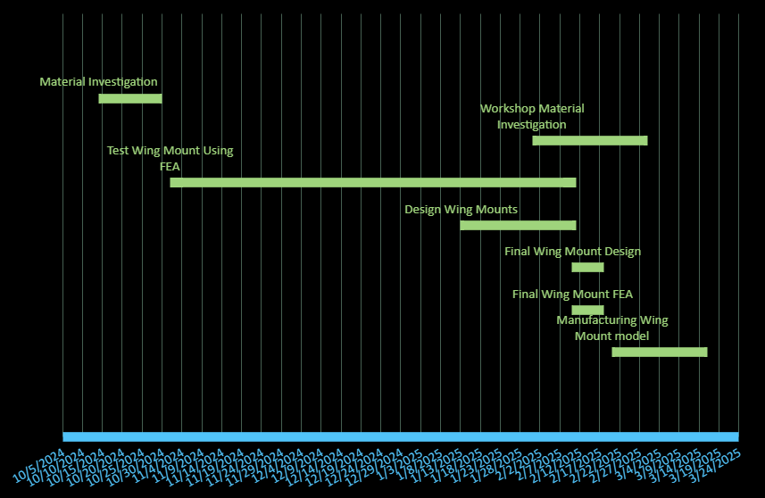
Figure 1- Individual Gantt Chart
Figure 2-Group Gantt Chart (Full Version can be found at Gant chart all tasks.xlsx)

References
N/A, 2024. Belbin.com. [Online]
Available at: https://www.belbin.com/about/belbin-team-roles
[Accessed 5 November 2024].

