Joe Doyle
2103077
HND Web Development
Web assignment

Contents
Introduction 2
Requirements 2
Evaluation 3

Introduction

The provided code snippets represent different sections of a comprehensive Cricket Website, dedicated to sharing the passion and excitement of cricket with enthusiasts worldwide. Each section offers unique insights into the sport, making the website a valuable resource for both seasoned fans and those new to the game.

Requirements

Report on the Cricket Website

This report analyses four HTML documents that together form a Cricket Website. The website provides information about cricket, including its history, governing body, players, and cricket videos. Each HTML document represents a specific section of the website. The website is structured with a consistent header and navigation bar, allowing users to navigate easily between different sections.

1. Cricket Website (index.html)

The "Cricket Website" section serves as the homepage of the website. It includes the main heading "Welcome to Cricket Website" and a navigation bar with links to other sections, such as About, Players, Videos, and Contact. The introductory paragraph briefly describes cricket, its origin in England, and its global popularity. It highlights the strategic complexity of the sport and its various formats like Test matches, ODIs, and T20 matches. The paragraph concludes by emphasizing cricket's massive following and cultural significance in cricket-loving nations.
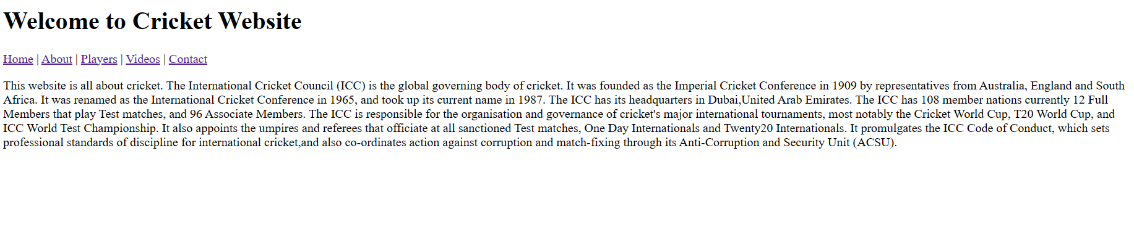

2. About Cricket (about.html)

The "About Cricket" section provides detailed information about the sport. The navigation bar allows easy navigation to other sections. The content focuses on the International Cricket Council (ICC), the global governing body of cricket. It outlines the ICC's history, from its establishment as the Imperial Cricket Conference to its current name and headquarters in Dubai, UAE. The section explains the ICC's responsibilities, including organizing major international tournaments like the Cricket World Cup, T20 World Cup, and ICC World Test Championship. It also highlights the ICC's role in appointing umpires and referees and its actions against corruption and match-fixing through the Anti-Corruption and Security Unit (ACSU).
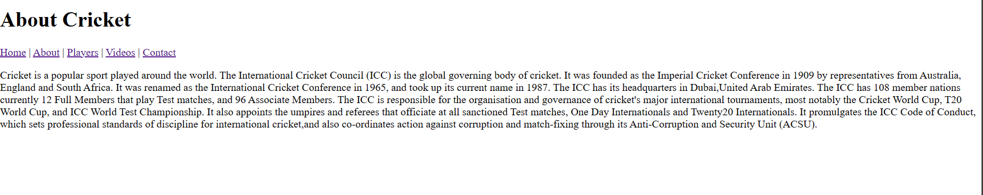

3. Cricket Players (players.html)

The "Cricket Players" section celebrates cricket players as the true heroes and legends of the sport. The navigation bar facilitates easy navigation to other sections. The section features images of the England, Australia, and India cricket teams. The content praises cricket players for their exceptional skills, dedication, and passion for the game. It mentions the diverse talents exhibited by players, including batsmen known for their grace and precision, and fast bowlers with thunderous deliveries. The section acknowledges the pressure players face on the field and their mental fortitude to excel in high-stakes situations. It also highlights players' off-field contributions as social influencers and role models.
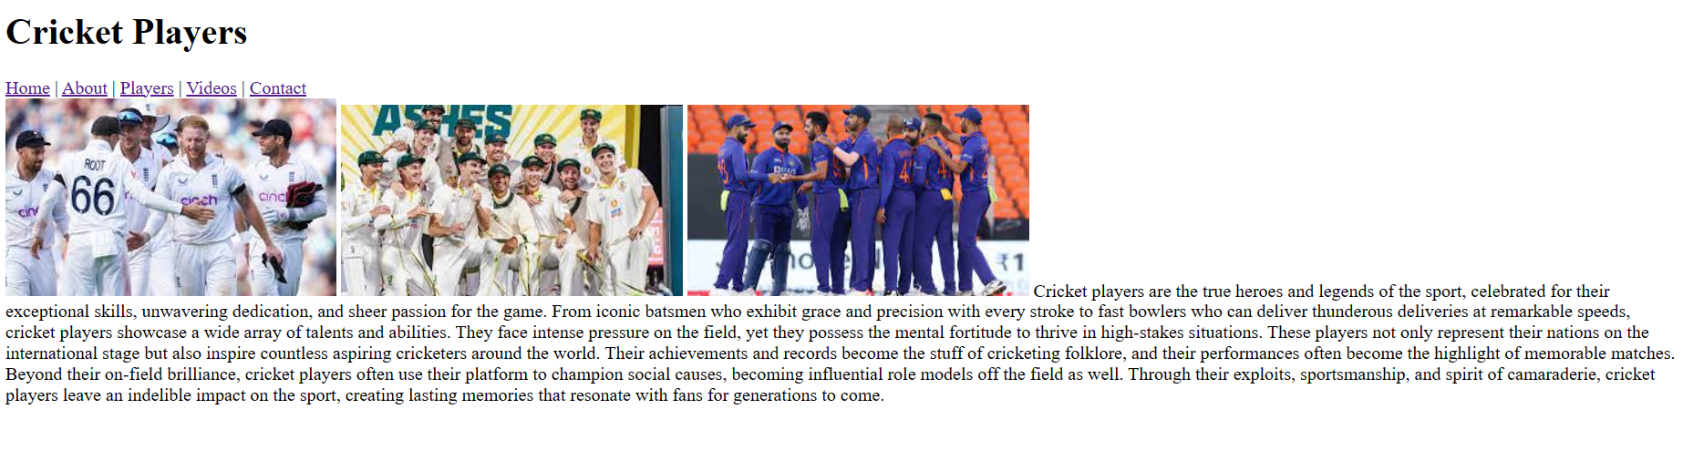

4. Cricket Videos (videos.html)

The "Cricket Videos" section provides engaging visual content related to cricket. The navigation bar allows easy navigation to other sections. The section includes two embedded YouTube videos showcasing cricket highlights and top batting shots. The videos add a dynamic element to the website, allowing visitors to watch exciting cricket moments. The videos feature incredible catches and remarkable batting performances, adding excitement and entertainment to the website.
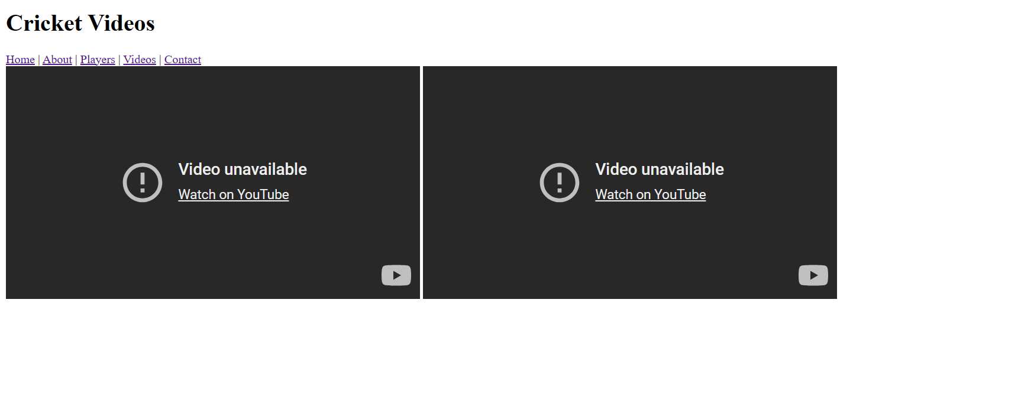

5. Contact Us (contact.html)

The "Contact Us" section provides a form for visitors to get in touch with the website administrators. The navigation bar allows easy navigation to other sections. The form includes fields for users to input their name, email, and message. The form aims to facilitate communication and feedback from visitors, allowing the website administrators to improve the website based on user input.


Conclusion

The Cricket Website offers a comprehensive platform for cricket enthusiasts to explore various aspects of the sport. The well-organized navigation bar enables easy access to different sections, such as information about cricket, cricket players, and engaging cricket videos. The website provides valuable insights into cricket's history, governance, and iconic players. Additionally, the interactive content, such as embedded YouTube videos and the contact form, enhances user engagement. To further improve the website, future enhancements may include additional interactive elements, more cricket-related content, and optimizations for different devices and screen sizes to cater to a broader audience of cricket enthusiasts.

Evaluation
Usefulness (Usability and Utility): The design of the Cricket World website is functional, providing clear navigation and informative content. However, improvements can be made to enhance utility, usability, and content. Some recommendations include:
- Enhancing the navigation by making it more intuitive and consistent across pages.
- Improving the organization of information and ensuring the content is comprehensive and up to date.
- Incorporating interactive elements, such as forms or interactive scoreboards, to increase user engagement.
Search Engine Optimization (SEO): The implemented website can benefit from on-page SEO techniques to improve its visibility and search engine rankings. Examples of applied techniques include:
- Utilizing each page's appropriate meta tags (e.g., meta title, description, and keywords) to optimize search engine visibility.
- Incorporating relevant keywords within the website content to improve organic search engine traffic.
- Ensuring proper URL structures and implementing descriptive anchor texts for internal and external links.

