
Skills for the Workplace
Module Assignment Submission
Student Name: | Andrew McKay
Student Number: | 2014519
Module No: | BMSK4007
Module Title: | Digital Skills and Personal Branding

Statement of Confirmation of Authenticity
By the act of making this submission, the student declares that this is the work of the student named above. The work has not, in whole or in part, been knowingly presented elsewhere for assessment, or where assessment has been built on a previous assessment, this has been identified. Where materials have been used from other sources it has been properly acknowledged. If this statement is untrue, the student acknowledges that an assessment offence has been committed.
Attention is drawn to the plagiarism and unfair practice policies of both the University and of ILM.
Permission for ILM to use this script
ILM uses learners’ submissions – on an anonymous basis – for assessment standardisation. By submitting, both the centre and the learner agree that ILM may use this script on condition that identifying information is removed. However, if you are unwilling to allow ILM use this script, please refuse by ticking the box: □

Table of Contents
What has been the impact of 21st Century Technologies on the modern workplace? 3
Evaluate the appropriate use of modern technologies and social media in the workplace generally Error! Bookmark not defined.
Explore the use of modern technologies and social media in own workplace Error! Bookmark not defined.
How can Personal branding help YOU? 7
Your LinkedIn Profile to promote your Personal Brand 7
Evaluate the value of other social media platforms to enhance networking and career prospects 7
Examine the impact of Personal Branding on your own employability 12
Discuss personal and professional security and safety online. 12
References 14
Appendix 1 15
Appendix 2 15

What has been the impact of 21st Century Technologies on the modern workplace?

Evaluate the appropriate use of modern technologies and social media in the workplace generally.

Explore the use of modern technologies and social media in own workplace

At the very beginning of the 21st century the internet was recognised as a force in the transformation of the term “work” as information and technology (ICT) became a platform for innovation (HENG, 2004). Previously, computers and printers required a lead that was plugged into a dial up telephone system anchoring workers to desks. Saving work was on a floppy disk or hardcopy. Later, memory sticks helped reduce the amount of paper. Computers were usually contained within your office environment and accessible to all. Today technology allows the worker to be flexible or mobile. This has been achieved through the internet, WiFi and cloud access.

WiFi, in particular with the expansion of 3/4/5G network services, has allowed mobility, and generalising can see the improvements in different working environments like shops, who now have hand held scanners that allows the shopper to use the scanner to record their purchases and pay without having to go to a till operated by a person. In addition, there is also a facility where once again the shopper scans their own purchases and pay at a self-service check out. The advent of “Click and Collect” allows shoppers to order on line through their devices and attend the store purely to collect their goods (Walsh, 2020)
Within the travel industry it is now possible to purchase your ticket on your mobile device. An app allows a scanned version of your ticket to be stored on your phone which in return you present to a scanner at your airport or train station.

Colleague’s opinions were asked of the benefits and cons of technology. Opinions were generally in agreement and focussed on home working (McKay, 2021). The positives of technology were:
- Less time on commuting
- reduced carbon imprint
- less travel costs
- Less stressful mornings
- Having time to have breakfast with the family
- Reduced office costs
- Greater flexibility
- Employers providing technology
- Tax relief
- New networks
- Thinking creatively – new ways of working
- More work achieved and quieter
Some of the negative aspects of technology were:
- Isolation
- No interaction with colleagues
- WiFi connectivity is different depending on your area
- Sharing ideas reduced
- No clear home/work barriers
- Distractions – children, eating more,
- No ‘work place’/facilities/storage
- Not taking breaks/irregular breaks
- Detrimental to eyes – particularly those with eye conditions, headaches
- Losing work digitally
- Increased costs – buying own technology, home bills
- Motivation- No one around to push you on or be competitive against
The organisation that the writer is employed by, BAD Bikes, recognises many of the benefits and negatives quoted, however they also recognise that without good management there is the possibility of creating a culture of mistrust. Our lone working policy highlights the need for a worker to Clock on and off daily with a member of the management team. They also need to run through what they have been doing, with reports to support as evidence. We are aware that some businesses would require access to the workers emails and that in some cases the workers have hit/ met their targets. By far the most highlighted point that everyone made in the consultation was the feeling of Isolation. Isolation as suggested by Employees (Mazzitti & Sullivan EAP 2018) makes the worker feel less connected with the office and their co-workers which in return lowers their morale. Workers in an office feel a better connection for the company when at that companies’ office where they are able to connect with those same co-workers.

The favoured technology for our organisation is mobile phones, laptops, WiFi, internet, cloud and social media. Both mobiles and laptops rely on connectivity to the internet via a Wi-Fi connection. Being mobile allows the worker to become responsive to the client’s needs. Mobility allows the worker to develop their own networks and partnerships in addition to being more readily available and contactable. Developing a network of colleagues helps the worker to gain confidence and build up effective relationships at a pace that suits them. Mobile devices and cloud enable the worker to record conversations, contact partner agencies, research any enquiries, stay in contact with co-workers and trustees and access work documents without having to return to an office. The benefits such as time saving or reducing office costs are instantly obvious to both the stakeholders and organisation. BAD Bikes also offers internet access at our office to community members which increases our engagement within that community just as offering free Wi-Fi at a café can increase customers.

The benefits for all parties can be summarised as follows: One of the biggest benefits of offering free WiFi is that it increases the time spent on premises. Consumers tend to stay longer if they can use their tablets and laptops via WiFi. Of the businesses surveyed, almost 62 percent said that customers spent more time in their shop or facility once WiFi was introduced. (Campbell 2016)
According to Duffin (2019), WiFi allows businesses like restaurants, cafes, and pubs to attract new customers. According to a survey, 53 percent of people are happy to sit alone in restaurants and cafes if WiFi is available. Free WiFi access helps to connect with friends removing the stigma of sitting alone (Campbell 2016).

BAD Bikes doesn’t use a wide range of social media, because the management of these platforms would require time, energy and incur costs for our small organisation / charity that we simply don’t have or we can ill afford both monetary and workers skills. We recognise those that are more accessible or widely used platforms by young people, however due to a varied WiFi service within our community sometimes they are not successful means of engagement/marketing to young people. However, young people seem to use a variety of social media i.e., Facebook, tiktok, Instagram as do colleagues i.e., Facebook, LinkedIn and twitter. We do however recognise those benefits that would/could see an increase in demand for the project and raise its profile amongst funders, colleagues and potential corporate sponsors as demonstrated by bigger organisations than ourselves. Larger organisations have the resources to employ a dedicated worker for marketing, and have all of the above platforms with potential to encompass a more varied and wider audience/customer to their organisation/business.

Digital Marketing Institute (2018) states that, Facebook is ideal for businesses that want to generate leads and build relationships. Being active on social media has a number of benefits for business, and there are many things you can accomplish with your social presence, such as performing customer service, engaging customers, generating leads, expanding your audience, driving sales, increasing web traffic, gaining valuable insights and feedback.

How can Personal branding help YOU?

Your LinkedIn Profile to promote your Personal Brand.

Evaluate the value of other social media platforms to enhance networking and career prospects

Personal Branding is not what you are but who you are. In developing your brand, the following factors should be taken into consideration.
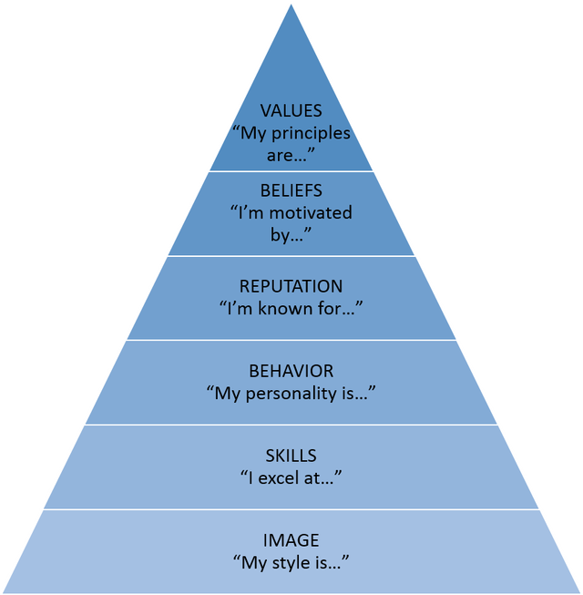
(Wong, 2007)
The career goals or path an individual has can affect or motivate their Behaviour, Image, Skills, Reputation Beliefs, and Values, and these in turn can affect the individual’s career success. Jeff Bezos, the founder of Amazon suggests that “Your brand is what people say about you when you’re not in the room.” (Open University, 2021). A personal brand is the unique combination of skills and experiences that make you who you are. It is how you present yourself to the world. Effective personal branding will differentiate you from the competition and allow you to build trust with perspective clients and employers. (Castrillion, 2019).
For example, the writer identifies that image can change and depends on who you are and your career goals as demonstrated across a variety of sectors (depending on where you are and who you are with differences across many sectors.) For instance, a Youth worker may dress informally when working with young people. They may be unshaven, unkept hair style, piercings or body art could be on show, however, they may dress differently when attending a presentation, where their hair could be styled, piercings removed, body art covered and be clean shaven as seen in Appendix 1. Chefs would have no jewellery on, they would cover their hair and wear appropriate clothing and look clean. Similarly, Nurses would be required to wear a uniform, nails would be cleanly kept, and their hair would be tied back. Their grooming would be to a satisfactory standard.
Values in shift workers would encourage punctuality including that time to hand over another important commodity that is recognised by employers is flexibility it could be as simple as undertaking someone else’s work which in return identifies that worker as literally having a skill set. Reliability would also be a recognised trait, employers like workers who turn up when and where they are supposed to be. Consistency may be measured by productivity or quality of work.
The report writer recognised their values and skills by undertaking a worksheet called ‘Values Identification’ by Synergy Institute (2007) and previously they had completed a SWOT analysis. One of the key benefits of undertaking this exercise is, once personal values have been established and by identifying the values of an employer, then if aligned there is an exceptional chance that the person would be a good fit within that company and “Happy employees=Happy customers=Successful company” (HRTechGirl, 2021).
In summary the way you brand yourself is important to your career development. Positive images will make you attractive to similar minded employers bringing personal and career rewards associated with success. Reflection within your own experiences, or work colleagues who may have been inspirational or others who may not have conducted themselves accordingly, can be yard sticks to your own values and how you build your personal brand.
Social media is recognised as the tool to promote yourself as a professional, however as suggested by Castrillon (2019). It is also the first port of call for many prospective employers to check before interviewing or offering employment. This in itself is a valid reason to control how you have portrayed yourself on social media in the past. With the writer’s social media profile being in its infancy they now recognise the importance of building a positive image across social media sites. Unfortunately for many this is not the case and photos and quotes have not only affected their chances of employment but in some high-profile cases have had a negative impact on those peoples branding and standing within societies. For example, the report on 3 Dec 2020, suggest that the captain and two teammates of the Argentina rugby team were suspended following "discriminatory and xenophobic" remarks on social media sites between 2011 and 2013 (BBC, 2020).
By creating a personal website your able to build and promote your brand by showcasing your skills, experience and add value to your audience, however it would benefit your cause greatly if you clean up your past history on social media as you don’t want anything to negatively impact your presence, as suggested by Heitzman (2019). A good example of the importance of ‘Online Screening-Social footprint’ Dragons Den BBC2 03/01/21 where entrepreneurs had developed a system that erased embarrassing histories on social media. Each “Dragon” could see the value within this opportunity and spoke about how histories on social networks can affect the employment opportunities of future professionals (BBC, 2021).
This aside by creating a professional brand we are able to engage with likeminded professionals. This is an opportunity to sell oneself, build up a portfolio of leaders and peers, stay in touch with thinking and recognised improvements within the chosen field. Social media is an opportunity to promote yourself, your values as a creative thinker, sharing your ideas, knowledge, experiences and learning. Social media platforms such as LinkedIn, offer an environment for professionals eager to learn and potential employers to recognise you as a professional. It can link you with someone that could offer career opportunities, enhance the experiences and direction of your career.
An overview by Walden University (2021) on how to use social media professionally, explains that individuals must use social media in a respectful way no matter what the platform, use productive language within the content of all posts and comments. To help with your career use social media to discuss and debate, disagreeing with someone is not against the rulebook and if presented correctly will be well received and add a dimension of your personal side making you more interesting and memorable to other professionals. These traits should also be apparent when meeting at conferences or at your workplace, being consistent will enhance your reputation on social media and improve your career prospects.
There are a variety of social media that both a professional and a business could use to promote themselves as seen below:
Platform | Description | Professional or Personal use | Pros | Cons
Facebook | Largest social media platform. Text, images, videos Live videos and stories. Allows advertising | Both | Popular with around 65 million Business users and 2 billion followers (Aboulhosn, 2020) | Can cross into personal life so requires management which is time consuming. Observations that can get personal which in return can affect Mental Health and reputation.
You Tube | Video sharing | Both | Second largest search engine behind Google. (Wanger, 2017) | Limited to Videos. Time consuming by time you have shot your video edited it (including music if appropriate) and then upload.
WhatsApp | Messaging, Group chats  Video calls | Both | Group people together ie: Personal, Professional colleagues.  Remote meetings, Easier communications. | No advertising personal or professional brand. Time consuming responding to individual messages  You must know who you are contacting so no opportunity to develop new networks
Messenger | Messaging  Group Chats  Video calls | Both | Group people together ie: Personal, Professional colleagues.  Remote meetings, Easier communications  Can work with Facebook so extending your network is possible. | Time consuming responding to individual messages.  No advertising.
LinkedIn | Professional profile, Messaging and employment opportunities | Professional | Professional networking, Post CV and work experience, Search jobs, 77% of employees reference LinkedIn to find employees (Elmers, 2021)

The writer prefers use the following platforms for their personal branding; Facebook, Messenger, LinkedIn and WhatsApp and has become aware that their profile requires building on social media, and to create a brand. In order to create an online presence that promotes your brand, expands your network and offers career opportunities you would require a social media site that is a recognised sole provider of the requisite. LinkedIn is an extremely popular social media platform with professionals. Not only does it market them it acts as a site for advertising jobs where professionals can network, share and advertise employment opportunities. It’s a platform where your customers or clients can make recommendations therefore highlighting you or your business as creditable and attractive as suggested by Wordstream (2021).
LinkedIn has been used to create a professional profile that promotes the writer to fellow professionals. Within the content of their profile, they have included a unique selling point, a skill set, values and an employment, education and training history. The created profile allows the writer to reflect on their own personal use of social media and make changes when and where necessary as seen in Appendix 1. The writer has identified they need to expand their network on social media. Their unique selling point would include those skills, achievements, certificates education, training, connections and personal resources and in writing it they would explore their attitude, experience, approach and philosophy in order to ask the following: How do I use this factor to my advantage? How do I communicate this to my audience? But critically asks What sets me apart from my audience? (University of Wales, Trinity Saint David, 2021).
The writer also recognises that some professions may need a more informal platform to promote themselves for example, a councillor would want to be more easily available, promoted widely and using a platform such as Facebook could be more beneficial i.e. Appendix 2.

Examine the impact of Personal Branding on your own employability

Discuss personal and professional security and safety online. GDPR.

Although there are many professional benefits to using social media, there can be a negative side within the wider use of IT and social media. There are a variety of risks both personally and professionally when we discuss safety online. Some suggestions to safeguard your personal information is to never disclose your bank, personal details or passwords and to ensure that it is a safe site by looking for a small padlock in the internet address bar. For some platforms on social media, you can make changes to the security settings so that only certain contacts can see certain posts. For example, acquaintances and work colleagues can only see professional posts. Family and friends could see all posts however settings allow you to set, that approval is required of all posts and photos that you are tagged in before publicly posting. Regular monitoring of your personal and professional social media sites is necessary as in some cases people with a grudge could post malicious remarks or some damaging content. This can tarnish your reputation on both a personal and professional level. changing privacy settings on social media so that only certain contacts can see certain posts. i.e., acquaintances and work colleagues can only see professional posts, family and friends can see all posts and set that you approve all posts and photos that you are tagged in before publicly posting.

“Cybersecurity is important because it encompasses everything that pertains to protecting our sensitive data, personally identifiable information (PII), protected health information (PHI), personal information, intellectual property, data, and governmental and industry information systems from theft and damage attempted” (Tunggal, 2020). And with this in mind, it is important to consider the management of data and information available online both for yourself and others. Professionally, you could consider a policy that reflects good working practises and should include child protection and data protection during a digital age that is reflected in the updated general Data Protection Regulations Act, 2018. The GDPR Act 2018 is paramount if you store information about individuals. At the heart of the act is the protection of personal data, which was updated in 2018 to reflect the technology that we can use to store this information.

There are 7 key factors contained within the GDPR they are:
• Lawfulness, fairness and transparency.
• Purpose limitation.
• Data minimisation.
• Accuracy.
• Storage limitation.
• Integrity and confidentiality (security)
• Accountability.
(Information Commissioners Office, 2021).

Barclays have a free online service that was created to increase your knowledge and skills in working and home life. It looks at elements on safety they are: Online safety, creating secure passwords, Business data privacy, Keeping your Business safe and Socialising on social media. (Barclays, 2020)

In conclusion, researching this essay has left the writer in no doubt of the impact of 21st Century Technologies on the modern workplace. Different technologies and the internet have made everything easier to source, increased the reach of networks and customers, marketing by companies has made buying and selling at the touch of a button, communication more efficient and business connections easily established; However, with the availability of personal information and informal nature of platforms such as Facebook, the need to safeguard information and a self-awareness of image needs to be considered as negative or disparaging remarks can ruin both individuals and businesses. The need for these technologies is accompanied with the need to constantly be vigilant; upgrading policies, procedures and protecting of personal data of both yourself and customers. The ability through WiFi to connect almost anywhere anytime makes it attractive to those who are literally constantly on the move, however services in remote areas can be sporadic. The opportunity to engage with fellow professionals allows new learning experiences, and career opportunities but also comes with the added pressure of being contactable every minute of everyday which can be wearing on an individual. Communication is easier and more flexible. It’s made positive changes in terms of economic growth, sustainability and communication which can only be good for business and career opportunities. “With technology today, one can say the world is a global village.” (Leslie, 2018).

References

Aboulhosn, Sarah. 2020. 18 facebook statistics every marketer should know in 2020. Sproutsocial. https://sproutsocial.com/insights/facebook-stats-for-marketers/ [Last accessed: 28th January 2021]

Barclays, 2020. Barclays Digital Wings Programme. Barclays http/digital.wings.uk.barclays [Last accessed: 28th January 2021]

BBC, 2020. Pablo Matera reinstated as Argentina captain as his and team-mates' suspensions lifted. BBC. https://www.bbc.co.uk/sport/rugby-union/55170028#:~:text=Pablo%20Matera%20has%20been%20reinstated,made%20between%202011%20and%202013. [Last accessed 28th January 2021]

BBC, 2021. Dragons’ Den. YouTube. https://www.youtube.com/watch?v=nJ4qA-S-KmE [Last accessed: 28th January 2021]

Campbell, Anita. 2016. Study: Yes, there are benefits to offering free WiFi. Small Business Trends. https://smallbiztrends.com/2014/06/benefits-of-offering-free-wifi.html [Last accessed: 28th January 2021]

Castrillion, Caroline. 2019. Why personal branding is more important than ever? Forbes. https://www.forbes.com/sites/carolinecastrillon/2019/02/12/why-personal-branding-is-more-important-than-ever/?sh=77f00c402408 [Last accessed: 28th January 2021]

Digital Marketing Institute, 2018. 10 ways small businesses can improve their social media presence. Digital Marketing Institute. https://digitalmarketinginstitute.com/blog/10-ways-small-businesses-can-improve-their-social-media-presence [Last accessed: 28th January 2021]

Duffin, Rebecca. 2019. How to measure footfall more accurately using WiFi.
WiFiSpark. https://www.wifispark.com/blog/how-to-measure-footfall-more-accurately-by-using-wifi [Last accessed: 16th January 2021]

Elmers, Danielle. 2021. The job search statistics all job seekers should know. Top Resume. https://www.topresume.com/career-advice/7-top-job-search-statistics [Last accessed: 28th January 2021]

Employees, 2018. Disadvantages of Remote Work. Mazzitti & Sullivan EAP mseap.com › disadvantages-remote-working [Last accessed: 28th January 2021]

Heitzman, Adam. 2019. What is personal branding & 4 reasons why it’s important. Search Engine Journal. https://www.searchenginejournal.com/what-is-personal-branding-why-important/327367/#close [Last accessed: 28th January 2021]

Heng, Stefan. 2004. The 21st Century and its challenges. SRRN Electronic Journal. https://www.researchgate.net/institution/Duale_Hochschule_Baden-Wuerttemberg_Mannheim [Last accessed: 14th January 2021]

HRTechGirl, 2021. Happy employees=Happy customers=Successful company. HRTechGirl. https://hrtechgirl.com/2014/08/07/happy-employees-happy-customers-successful-company-2/ [Last accessed: 28th January 2021]

Information Commissioners Office, 2021. At a glance. Information Comissioners Office. https://ico.org.uk/for-organisations/guide-to-data-protection/guide-to-the-general-data-protection-regulation-gdpr/principles/ [Last accessed: 28th January 2021]

Leslie, Epie. 2018. Is technology making the world smaller or bigger? Quora. https://www.quora.com/profile/Epie-Leslie [Last accessed: 28th January 2021]

McKay, Andrew. 2021. Facebook. http://m.facebook.com/story.php?story_fbid=883454955760397&id=100022877014292 [Date accessed: 15th January 2021]

Open University, 2021. What is a personal brand? Open University. https://www.open.edu/openlearn/ocw/mod/oucontent/view.php?id=78682&section=2 [Last accessed: 28th January 2021]

Synergy Institute, 2007. Values Identification Worksheet. Synergy Institute Online. http://integrativehealthpartners.org/downloads/values%20workbook.pdf [Last accessed 28th January 2021]

Tunggal, Abi Tyas. 2020. Why is cybersecurity important? Upguard. https://www.upguard.com/blog/cybersecurity-important#:~:text=Cybersecurity%20is%20important%20because%20it,from%20theft%20and%20damage%20attempted [Last accessed: 21st January 2021]

University of Wales Trinity Saint David, 2021. Digital Skills and Personal Branding. Your Image and USP. Slide 14

Wagner, Adam. 2017. Are you maximising the use of video in your content marketing strategy? Forbes. https://www.forbes.com/sites/forbesagencycouncil/2017/05/15/are-you-maximizing-the-use-of-video-in-your-content-marketing-strategy/?sh=22a16f293584 [Last accessed: 28th January 2021]

Walden University, 2021 How to use social media professionally. Walden University. https://www.waldenu.edu/programs/resource/how-to-use-social-media-professionally [Last accessed: 16th January 2021]

Walsh, Sophie. 2020. How does click and collect work? Square. https://squareup.com/gb/en/townsquare/how-does-click-and-collect-work [Last accessed: 28th January 2021]

Wong, Leigh. 2012. Personal Brand Pyramid. Me Inc. https://incsights.wordpress.com/tag/personal-branding/ [Last accessed: 28th January 2021]

Wordstream, 2021. Social Media Marketing for Business. Wordstream. https://www.wordstream.com/social-media-marketing [Last accessed: 21st January 2021]

Appendix 1
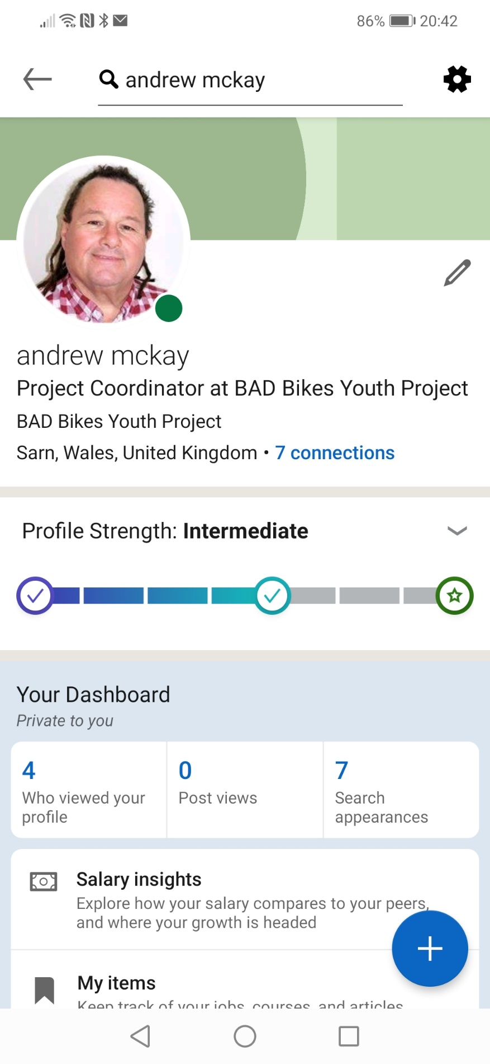

Appendix 2


