Project and Construction Management
Year 2
BREEAM New Construction Assessment/Energy Assessment

BREEAM Principles

CONTENTS PAGE

INTRODUCTION – PAGE 3

BREEAM – PAGE 4

PASSIVHAUS – PAGE 6

COMPARISON – PAGE 7

REFERENCES – PAGE 7

Introduction
This report will cover the certifications for BREEAM and PASSIVHAUS standards and how they are used all over the world to create better living environments and to reduce the cost of living and how these certifications can be achieved. It is vital to compare both certificates as they both tackle the role of sustainability within the construction sector.

BREEAM
BREEAM (Building Research Establishment Environmental Assessment Method) is the world’s longest established method of assessing, rating and certifying the sustainability of buildings. First published in the UK in 1990, BREEAM has developed a high standard certificate which has been awarded to over 250,000 buildings and over a million a registered for certification. From its original focus of individual buildings, BREEAM covers the whole life cycle of a building to ensure sustainability is at its highest, from planning to in-use and refurbishment. It targets the mass market to ensure the best environmental practice which goes beyond regulations by considering a wider range of environmental concerns during and after construction. This certification is highly flexible as the BREEAM standards can be applied to virtually any building and location from new builds to existing builds including refurbishments and large developments.
BREEAM has its own team of independent licensed assessors who assess a range of categories determined to be vital for sustainability using a weighting system, which include;
- Management (12%) – encourages the adoption of sustainable management practices in connection with the design, construction, commissioning, handover and aftercare to ensure robust sustainability objectives are set.
- Energy (15%) – recognise and encourage the installation of energy sub-metering that facilitates the monitoring of operational energy consumption.
- Health & wellbeing (15%) – improve the quality of life in homes by using refurbishment methods that encourage a healthy and safe internal environment.
- Transport (9%) – encourage the development of good public transport networks, helping reduce pollution and congestion.
- Water (7%) – to reduce the consumption of water through sanitary use, introducing water efficient components and water recycling systems.
- Materials (13.5%) – the use of responsibly sourced materials for key building elements.
- Waste (8.5%) – to promote resource efficiency through the reduction of construction waste.
- Land use and ecology (10%) – to encourage the use of previously used or contaminated land and reduce the use of green sited land.
- Pollution (10%) – ensuring appliances such as lights are concentrated in appropriate areas to reduce light pollution and energy consumption
- Innovation (10%) – to support innovation within the construction industry which relate to sustainable benefits.

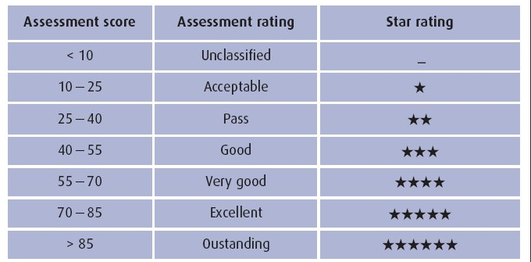
These categories are individually assessed and scored on their environmental use and sustainability which is added to make a score up to 105, in which contributes to what Home Quality Mark is given to the building to provide a credible, environmental label for buildings. BREEAM rates and certifies buildings in two stages, during the design stages and post-construction, using a scale of ‘Pass’, ‘Good’, ‘Very Good’, ‘Excellent’ and ‘Outstanding’. These benchmarks are constantly being pushed to improve greater sustainability and innovation in the built environment, buildings can gain innovation credits through exemplary performance requirements.
A BREEAM assessor will have a deep understanding and competency of the schemes available and their role is to manage the formal assessment process against criteria defined in the technical manual to then apply for certification on behalf of the client. An assessor will not have direct association with the build itself but will guide the project manager and design team achieve BREEAM standards. BREEAM assessors will consult with the project manager and design team to gain information about the building and then evaluate using a BRE designed checklist.
BREEAM standards can be applied to different buildings in different design or construction stages using different schemes put in place for certain builds, such as BREEAM New Construction in which the sustainability of new, non-residential buildings in the UK are assessed at key stages in the design and procurement process to evaluate, measure and improve the performance of their building. BREEAM Refurbishment also provides a design and assessment method for making housing refurbishment projects more sustainable through cost effectiveness and improving the environmental performance of existing dwellings.
The BREEAM in-use scheme is used when dealing with buildings that are in-use. This BREEAM scheme is carried out in 3 parts which include asset performance (the building), building management performance (the operation of the building) and organisational effectiveness (how activities are managed within a building). The criteria used to assess buildings depends on the type of scope you use as BREEAM covers a large area of sustainability.

PASSIVHAUS
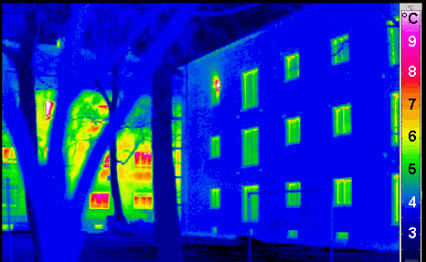
PASSIVHAUS or ‘Passive House’, developed in Germany in 1991 it assesses buildings on its energy and thermal performance, reducing ecological footprint and can be adopted in dwellings, commercial, industrial and public buildings throughout the world resulting in ultra-low energy buildings that require little energy for space or cooling. Currently the fastest growing energy performance standard in the world, its certificates have been given out to over 30,000 buildings since the turn of the century. PASSIVEHAUS standards are strong due to their simple approach to energy performance using mechanical ventilation to improve thermal performance and airtightness of a building. This type of approach to the energy performance creates a robust building that minimises the heating demand needed. Using mechanical ventilation systems and heat recovery, they are able to recover and circulate warm air around buildings while lowering energy costs. They can achieve sufficient indoor air quality conditions through post-heating and post-cooling methods without the recirculation of air. As well as being an energy performance standard PASSIVEHAUS can also provide brilliant indoor air quality by reducing the air infiltration rates and then supplying fresh air which is filtered and post-heated by the MVHR unit.
PASSIVEHAUS standards can be achieved by measures including;
- Shading – ensuring over hangs and shading appliances such as blinds reduce overheating.
- Pre-cooling of air supply – ventilation systems pre-cooling air before circulating.
- Night purging – keeping windows and other passive ventilation openings closed during the day but open at night to flush out warm air, keeping a cool thermal mass for the next day.
- Natural ventilation – to provide and control natural ventilation through windows and doors.
- Air-tightness – ensuring that all thermal energy is kept inside the building and not escaping through windows.
- Mechanical ventilation heat recovery – installing MVHR systems to reduce energy costs and provide fresh air around a dwelling.
- Insulation
- Avoidance of thermal bridges
- Passive solar gains – solar gains through sun light
- Exploitation of internal heat sources – using essential appliances to draw heat

In all cases the primary energy demand target must be met in principles of passive design, the performance of the building can also depend on values such as the building fabric, doors and glazing, ventilation and thermal bridging.

COMPARISON
Both BREEAM and PASSIVHAUS are supplying standards which go towards building a greener living environment for everyone around the world and both have similar advantages such as long-term cost savings through energy consumption, reduced waste water through utility uses and also introduce and push for innovation in the construction industry. These standards are also able to meet the client’s original wishes and views on their building without changing the whole layout eg, if a client wanted a large window installed with a panoramic view you would have to consider the heat loss through the windows large surface, the solution being to add an extra wall or roof to the surrounding areas. BREEAM is great as it runs with the UK’s legislation and best practice, keeps within quantitative thresholds, its main application is in the UK and also involves the role of an assessor in whom can give you information and guidance onsite.
In terms of disadvantages, BREEAM and PASSIVHAUS certification is not cheap and can cost a client a lot of money especially through refurbishment of a property. Getting a certificate for a refurbished property will be more costly as with BREEAM the construction materials are always changing to keep it as sustainable as possible, and PASSIVHAUS encourage the use of ventilation systems which can come at some cost depending on the size of space which is to be ventilated (£3000 for a domestic dwelling). PASSIVHAUS is a voluntary certificate you can apply for but BREEAM will require you to pay for the certification, not including the costs of the changes to be made to gain a higher score. Training periods to become a BREEAM assessor can be lengthy and require a great amount of knowledge in construction and sustainability.

References
https://en.wikipedia.org/wiki/Passive_house#/media/File:Passivhaus_thermogram_gedaemmt_ungedaemmt.png – image taken to show thermal losses in buildings
https://www.bsria.co.uk/news/article/breeam-in-use-closing-the-loop/ - image showing BREEAM scoring table
http://www.heatspaceandlight.com/much-mvhr-hrv-ventilation-cost-buy-install/ - information on the costs of a MVHR

